TATA TECHNOLOGIES LTD.
TECH PULSE FY-26 | AI/ML Capstone Project
PROJECT SYNOPSIS

Student Details
Institute/University: Pimpri Chinchwad College of Engineering (PCCOE), Pune
Programme / Batch: Computer Engineering-Regional Language 2023-2027
Student Name: Yadnesh Patil
PRN: 123B1D034
1. Case Study ID and Project Title / Topic
Case Study ID (CS1 to CS5): CS1
Project Title / Topic: AUTOSAR HLD Document Analysis Assistant - a locally hosted RAG system with cited answers, architecture inventory and consistency checks
2. Objectives
Define the specific objectives and focus areas of the allocated AIML case study.
Objectives
- Reduce the manual effort of reviewing long AUTOSAR High-Level Design (HLD) documents by answering architecture questions in natural language, every answer with document, section and page citations.
- Create a structured and searchable repository of architecture knowledge: components, ports, interfaces, signals and their dependencies, extracted from approved documents only.
- Improve traceability and review quality with deterministic consistency checks (missing producer, undefined interface or component, data type conflict, timing mismatch, safety-level gap, missing verification) and a revision comparison.
- Keep documents, embeddings and answers inside the organisational boundary, with role-based access, an audit trail and human approval of consequential outputs.
3. Scope
Clearly state what will be implemented in the project and what will not be covered. Respect mandatory controls such as citations, human review, and approved or synthetic data.
In Scope – To Be Implemented
- Controlled ingestion of PDF, Markdown and text documents with page-aware, section-aware chunking and an instruction-injection scan.
- Extraction of components, ports, interfaces and signals with provenance; dependency map, impact analysis and CSV/JSON export.
- Cited question answering using hybrid retrieval (BM25 + vectors) and deterministic tools, with confidence, groundedness and refusal when evidence is missing.
- Consistency and completeness checks, revision comparison, reviewer workflow (confirm / reject), roles, project isolation and audit log.
- Evaluation harness: ground-truth question set, extraction and seeded-issue checks, unit tests.
Out of Scope – Will Not Be Implemented
- Automatic approval of architecture decisions or release of any design (a human architect always decides).
- Modification of the source HLD documents.
- Replacement of formal architecture governance.
- OCR of scanned pages and interpretation of diagrams inside PDFs (listed as future work); use of real or confidential OEM documents; any cloud or external LLM API.
4. Proposed Approach
Pre-trained model (name, version, local/private hosting)
Default: no generative model. Answers are composed deterministically from retrieved evidence and parsed facts (extractive mode), so an answer can never contain text that is not in the approved documents. Optional: a locally hosted open model through Ollama (llama3.2 3B, 4-bit; qwen2.5 is an alternative), switched on with HLD_LLM_PROVIDER=ollama.
A model answer is accepted only if every citation tag refers to retrieved evidence; otherwise the system falls back to the extractive answer. No external API is called; the optional model runs on localhost. Provider and model name are recorded in Model_Prompts_Config/config.json.
Embedding model
Default: offline hashing TF-IDF embeddings (2048 dimensions, signed feature hashing, unigrams and bigrams, identifier-aware tokenisation so that SWC_DoorLockCtrl also matches 'door lock'). No download is needed.
Optional: BAAI/bge-small-en-v1.5 through sentence-transformers for better paraphrase matching. Both are fused with BM25 (weights 0.55 BM25 / 0.45 vectors).
Vector store (FAISS / ChromaDB)
Per-project collection with exact cosine search in NumPy (default) or a FAISS IndexFlatIP (optional, HLD_VECTOR_STORE_BACKEND=faiss). Each chunk keeps metadata: document, version, page, section id and title.
Structured data (users, documents, chunks, findings, answers, audit trail) is stored in SQLite. Projects are indexed separately so that one program cannot retrieve another program's documents.
RAG pipeline and/or AI-agent design – brief description
Ingest approved PDFs, remove running headers and footers, split by section headings, chunk (max 900 characters, 1 line overlap) with page numbers, embed and index. At question time: detect entity identifiers and refuse unknown ones, route to a deterministic tool when the question is structured, otherwise retrieve the top passages with hybrid search.
Evidence is numbered [S1]...[Sn]; the answer carries those tags; confidence is computed from query-term coverage, BM25 and vector similarity; below a threshold the system refuses. An engineer can accept or reject each saved answer.
Service layer and UI (e.g., FastAPI / Flask / Streamlit)
A Python 3 HTTP API built on the standard library (ThreadingHTTPServer) with JSON endpoints, PBKDF2 password hashing, roles (viewer, tester, architect) and an audit log. FastAPI/Flask were not used so that the project runs with only numpy and pypdf installed.
A responsive single-page web interface in plain HTML, CSS and JavaScript (no external libraries or fonts): Ask, Architecture with dependency map, Checks, Compare revisions, Documents, Evaluation and Audit pages.
Tools / deterministic rules, if applicable
Deterministic tools over the parsed inventory: who produces or consumes a signal, ports of a component, dependencies, safety level, verification cases, timing, definition lookup and downstream impact analysis (graph traversal).
Eleven consistency rules (orphan consumer, undefined interface, undefined component, timeout shorter than period, type conflict, duplicate definition, unconnected provider, missing verification, signal missing in catalogue, safety-level gap, suspicious instruction-like text).
Proposed System / Architecture
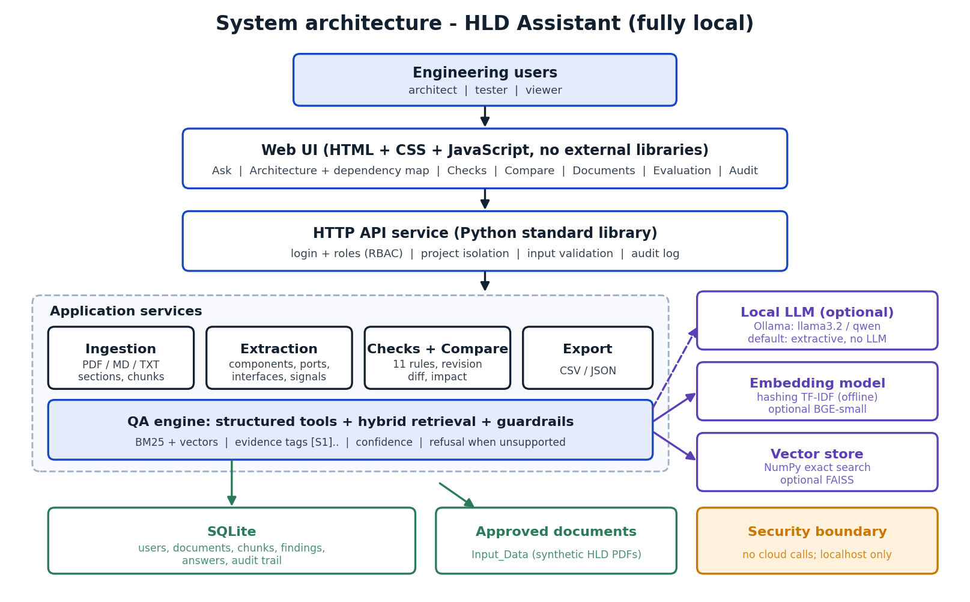
5. Input Data / Knowledge Base
Use approved or synthetic data only.
Data / Knowledge Sources
Synthetic AUTOSAR HLD documents generated by Code/scripts/generate_synthetic_data.py: HLD-BCM-001 Door and Access Control (v1.0 and v1.1), HLD-DCM-003 Diagnostic Communication and Gateway (v1.0) and HLD-BMS-002 Battery Management System (v1.0), in two projects.
No real OEM, customer or standards content is used. Twelve defects are deliberately seeded in the approved documents so that the checks can be measured.
Approximate Size and Format
4 PDF files, 23 pages in total, about 100 text chunks; 14 components, 32 ports, 17 interfaces and 17 signals across the active documents.
Template-based text with key/value lines and pipe-separated signal tables; ground-truth files are JSON, evaluation outputs JSON and CSV.
Preprocessing and EDA Planned
Text extraction with pypdf, removal of repeated headers and footers, heading detection, joining of wrapped lines, section/page chunking, prompt-injection pattern scan.
EDA: counts of entities per project, chunks per section, signal producers and consumers, manual inspection of extraction output against the source PDFs.
6. Expected Outcomes and Evaluation Plan
Expected Outputs – aligned to the case study
Component and interface inventory, dependency map and impact analysis, searchable cited Q&A, potential inconsistency report, revision comparison and structured CSV/JSON export.
Reviewer decisions (accepted / rejected findings and answers) stored with user and time.
Evaluation Method – test question set / ground truth / metrics / validation approach
43 ground-truth questions (27 direct, 10 paraphrased without identifiers, 6 out-of-scope). Metrics: retrieval hit@k and MRR, answer pass rate (expected facts present and gold section cited), citation accuracy, groundedness, refusal accuracy, latency.
Entity extraction precision/recall/F1 against the generator's data model, recall and precision of the 12 seeded issues, and 17 automated unit and integration tests. Failed cases are reported.
Responsible AI Measures – grounding and citations / privacy / security / human oversight
Grounding: answers use only approved documents, every statement has a source tag, unsupported questions are refused. Privacy: fully local, no cloud calls. Security: password hashing, role-based access, project isolation, upload validation, security headers, instruction-injection guard.
Human oversight: architects confirm or reject findings and answers before use; all actions are written to an audit trail.
MLOps / Deployment Elements Planned – versioning / Docker / tracking
Document versioning (version labels, superseded status, SHA-256 checksums), configuration and prompts kept in versioned JSON files, evaluation results written to files after every run.
Dockerfile and docker-compose.yml for container deployment, run scripts for Windows and Linux, automated tests.
7. Planned AI-Tool Usage
Mention the AI tools / models used for coding assistance and specify the purpose and project artifact affected. This information will be carried into the final AI-tool usage declaration.
AI Tool / Model
Claude (Anthropic) used as a coding and documentation assistant. The application itself calls no external AI service.
Purpose
Scaffolding of code modules, generation of the synthetic data script, test cases, UI code and drafting of documents; all output is reviewed, run and understood by the student.
Artifact Affected
Code/ (application, scripts, tests), Input_Data generator, Documentation/ and this synopsis.
Student Declaration
☐ I will not change the approved case-study scope, major methodology, or implementation approach without prior faculty approval.
☐ I confirm that the work submitted under this synopsis represents my own understanding and contribution, and I will be responsible for explaining every significant part of the selected case study and its implementation.

Name and Signature: Yadnesh Patil  Date: 11-10-2026

