TATA TECHNOLOGIES LTD.
TECH PULSE FY-26 | AI/ML Capstone Project
TECHNICAL REPORT
Field | Details
Institute / University | Pimpri Chinchwad College of Engineering (PCCOE), Pune
Programme / Batch | Computer Engineering-Regional Language 2023-2027
Student Name | Yadnesh Patil
PRN | 123B1D034
Case Study ID (CS1–CS5) | CS1
Project Title | AUTOSAR HLD Document Analysis Assistant - locally hosted RAG with cited answers, architecture inventory and consistency checks

1. Problem Statement and Intended Users
AUTOSAR High-Level Design (HLD) documents describe software components, ports, interfaces, signals, dependencies and functional flows. They are often hundreds of pages long and kept as unstructured PDFs. Architects, developers, integrators and testers read them by hand, which is slow and makes it hard to see mismatches, missing dependencies, inconsistent definitions and incomplete test coverage. Knowledge stays with a few experienced people.
This project builds an AI-assisted application that answers architecture questions in natural language with page and section citations, extracts the architecture into a structured inventory and dependency map, checks it for inconsistencies, and compares document revisions. It supports engineers; it does not approve designs. Everything runs locally so that engineering documents never leave the organisation.
Intended users: system architects, AUTOSAR architects, software developers, integration engineers, test engineers and engineering managers. Three roles are implemented: viewer (ask and read), tester (plus export) and architect (plus upload, run checks, approve or reject).

2. Input Data / Knowledge Base
Item | Description
Sources | Synthetic AUTOSAR HLD documents generated by Code/scripts/generate_synthetic_data.py (no real OEM or standards text): HLD-BCM-001 Door and Access Control v1.0 and v1.1, HLD-DCM-003 Diagnostic Communication and Gateway v1.0 (project PRJ-BODY) and HLD-BMS-002 Battery Management System v1.0 (project PRJ-ENERGY). Twelve defects are seeded on purpose. See Input_Data/DATA_CARD.md.
Size and format | 4 PDF files, 23 pages, 101 chunks (74 searchable in the active documents; v1.0 is superseded and one chunk with instruction-like text is excluded). Active documents contain 14 components, 32 ports, 17 interfaces and 17 signals. Ground truth: JSON files in Evaluation_Results/ground_truth.
Preprocessing / EDA done | pypdf text extraction per page; removal of running headers and footers (lines repeated at page edges); heading detection by section number; joining of lines wrapped by the PDF layout; prompt-injection pattern scan; manual comparison of extracted entities with the source PDFs. Entity counts per project and section structure were inspected before building the rules.
Chunking strategy | Section-aware chunks: a chunk never crosses a heading. Maximum 900 characters, one line of overlap, page number kept per chunk. A context header (document id, section number and title) is added to the text that is embedded but not to the text shown to the user.

3. Solution Architecture

Component | Choice (name, version, hosting)
Pre-trained model | Default: none (extractive answer composer, deterministic). Optional: llama3.2 3B through a local Ollama server (HLD_LLM_PROVIDER=ollama), temperature 0, answer rejected if any citation tag is not in the retrieved evidence. The optional path was tested with a mock server only, not with a real model.
Embedding model | Default: offline hashing TF-IDF, 2048 dimensions (signed hashing, unigrams and bigrams, identifier splitting). Optional: BAAI/bge-small-en-v1.5 via sentence-transformers (not used in the reported results).
Vector store (FAISS / ChromaDB) | NumPy exact cosine search, one collection per project (default). Optional FAISS IndexFlatIP. Hybrid fusion with BM25: 0.55 BM25 + 0.45 vector. Metadata and workflow data in SQLite.
RAG pipeline / AI-agent design | Entity detection and refusal guard, then deterministic tool router (producers, consumers, ports, dependencies, safety level, tests, timing, definitions, impact) or hybrid retrieval of the top 5 passages. Evidence is numbered [S1]..; confidence from query coverage, BM25 and vector scores; refusal below 0.30.
Service layer and UI | Python 3.12 standard-library HTTP API (JSON, PBKDF2 login, roles, audit log) and a plain HTML/CSS/JavaScript single-page UI. FastAPI and Streamlit were not used, so only numpy and pypdf have to be installed. Docker files provided (not executed in the authoring environment).
Tools / deterministic rules | Parsing of components, ports, interfaces and signals; graph traversal for impact analysis; 11 consistency rules; revision comparison; prompt-injection guard (6 patterns in Model_Prompts_Config/prompts.json).

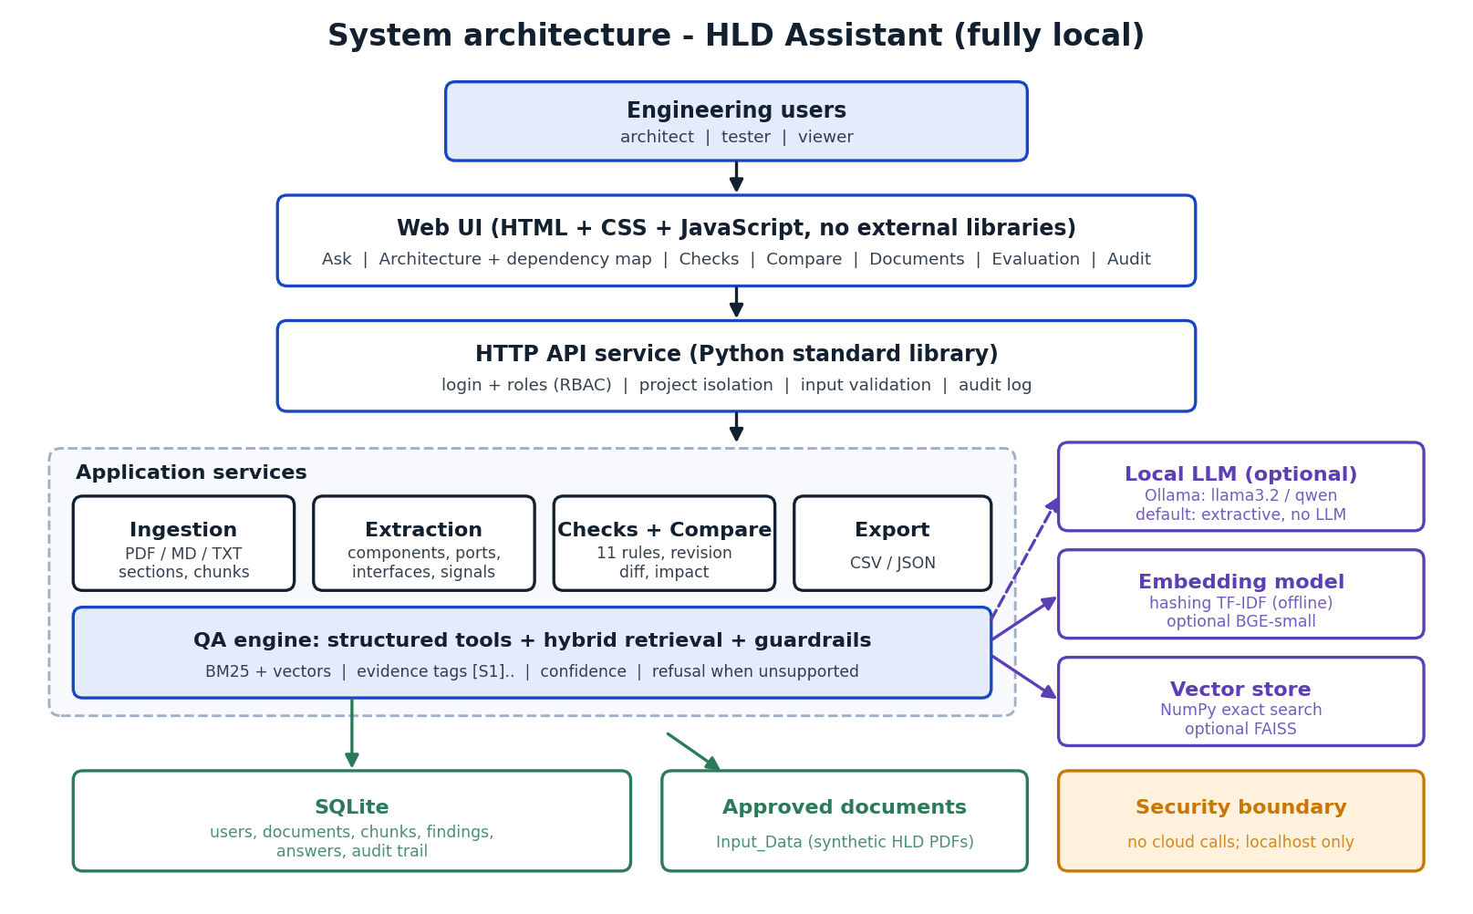
Figure A: System architecture of the HLD Assistant

4. Implementation and Configuration
The application is a Python package (Code/hldassist) with one module per responsibility: ingest.py (extraction, sections, chunks), extract.py (entities with provenance), graph.py (producer/consumer resolution and impact), checks.py (11 rules), compare.py (revision diff), embeddings.py and vectorstore.py (vectors), retrieval.py (BM25 + vector fusion), qa.py (tool router, evidence, confidence, refusal), llm.py (optional local model), service.py (orchestration), auth.py and db.py (users, SQLite, audit) and app.py (HTTP API). The web UI is in Code/web.
Configuration is kept outside the code in Model_Prompts_Config/config.json (models, chunk size, retrieval weights, thresholds) and prompts.json (system prompt, refusal text, guard patterns). Any value can be overridden by an environment variable HLD_<SECTION>_<KEY>. The workflow diagram below shows indexing and answering.

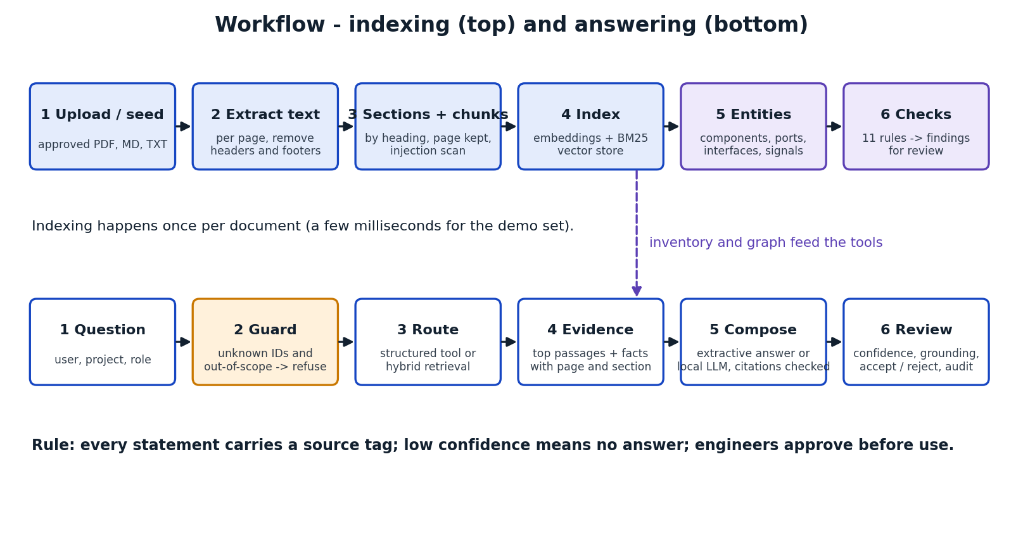
Figure B: Indexing and answering workflow
How to run: cd Code, then run.bat (Windows) or bash run.sh (Linux/macOS), open http://127.0.0.1:8000 and sign in as alice / demo123. Tests: python -m unittest discover -s tests -v. Evaluation: python scripts/run_evaluation.py. Library versions used for the reported results: Python 3.12.3, numpy 2.4.4, pypdf 5.9.0, reportlab 4.4.10.

5. Evaluation Steps and Results
Test set: 43 questions written with the knowledge base (Evaluation_Results/ground_truth/ground_truth_qa.json): 27 direct questions with identifiers (descriptive, structured, flow, impact), 10 paraphrased questions without identifiers (IDs starting with P) and 6 out-of-scope questions that must be refused (IDs starting with N). Each answerable question has a gold section and expected facts. An answer passes if it is not refused, contains all expected facts and cites the gold section. Extraction is scored against the generator's data model and the checks against 12 seeded defects. Because the author wrote both system and questions, the scores are optimistic; the paraphrased set and the failure below show where the system is weak.
# | Test question / scenario | Expected answer / behaviour | Result (Pass/Fail, notes)
Q02 | Which components produce SIG_VehicleSpeed? | Contains: SWC_SpeedSignalAdapter. Cites HLD-BCM-001 section 4.4 | PASS. Route: signal producers; confidence 0.92; retrieval rank 7
Q05 | What is the safety level of SWC_DoorLockCtrl? | Contains: ASIL B. Cites HLD-BCM-001 section 4.3 | PASS. Route: safety lookup; confidence 0.92; retrieval rank 1
Q08 | Describe the remote unlock flow. | Contains: SIG_KeyFobCmd, SWC_CentralLockArb. Cites HLD-BCM-001 section 7.1 | PASS. Route: rag; confidence 0.753; retrieval rank 3
Q10 | If SWC_SpeedSignalAdapter changes, which components are impacted? | Contains: SWC_CentralLockArb, SWC_DoorLockCtrl, SWC_BcmGateway. Cites HLD-BCM-001 section 4.4 | PASS. Route: impact analysis; confidence 0.92; retrieval rank 1
Q15 | Where is SWC_BcmGateway defined? | Contains: HLD-BCM-001, HLD-DCM-003. Cites HLD-BCM-001 section 4.5, HLD-DCM-003 section 4.4 | PASS. Route: definition lookup; confidence 0.92; retrieval rank 1
Q16 | How does the system handle a loss of the vehicle speed signal in automatic locking? | Contains: disabled. Cites HLD-BCM-001 section 4.2 | PASS. Route: rag; confidence 0.736; retrieval rank 1
P01 | Which software unit combines key fob, speed and crash inputs into a single lock command? | Contains: SWC_CentralLockArb. Cites HLD-BCM-001 section 4.2 | PASS. Route: rag; confidence 0.537; retrieval rank 1
P03 | Which function remembers the child safety setting after the ignition is switched off? | Contains: non-volatile. Cites HLD-BCM-001 section 4.6 | PASS. Route: rag; confidence 0.496; retrieval rank 1
P05 | What is the worst-case processor load of the door and access functions? | Contains: 12 percent. Cites HLD-BCM-001 section 8 | PASS. Route: rag; confidence 0.818; retrieval rank 1
P09 | Which unit measures the current flowing through the battery pack? | Contains: SWC_CurrentSensorAdapter. Cites HLD-BMS-002 section 4.2 | FAIL. Route: rag; confidence 0.415; retrieval rank 5. gold section not cited; fact recall 0.00
N01 | What is the capital of France? | Refuse: no support in the approved documents | PASS. Route: refusal; confidence 0.0; refused
N02 | What is the safety level of SWC_AirbagCtrl? | Refuse: no support in the approved documents | PASS. Route: refusal; confidence 0.0; refused

Metric | Score / observation
Answer pass rate (all expected facts and gold section cited) | 97.3% (36 of 37 answerable questions)
Retrieval hit rate, text search only (tools off) | hit@1 67.6%, hit@3 83.8%, hit@5 97.3%, MRR 0.783
Citation accuracy / groundedness | citation accuracy 97.3%; groundedness 1.00 (high by construction in extractive mode, since statements are copied from evidence)
Out-of-scope refusal / false refusals | 6 of 6 refused; 0% of answerable questions wrongly refused
Entity extraction precision / recall / F1 (components, ports, interfaces, signals) | 1.00 / 1.00 / 1.00 on synthetic templated PDFs (upper bound for real documents)
Seeded issue detection | recall 12/12; all 12 high and medium findings are seeded issues; 5 informational findings (unconnected providers)
Latency (answer end to end, local) | mean 2.9 ms, p95 3.6 ms with hashing embeddings and extractive answers. Latency with a local LLM was not measured.
Automated tests | 17 of 17 unit and integration tests pass (parsing, checks, QA, refusal, role and project access, upload validation, LLM fallback with a mock server)
Failure analysis. P09 ("Which unit measures the current flowing through the battery pack?") failed: the document says the component "reads the pack current sensor", and the hashing embeddings and BM25 match words, not meaning, so the right section ranked fifth and the answer cited a wrong section. Remedies: BGE embeddings (already supported by configuration, not evaluated), query expansion with an AUTOSAR glossary, and a re-ranker. Without the structured tools the plain text search gets the right section first for only 67.6% of questions, so the deterministic tools carry much of the accuracy on identifier questions. Confidence thresholds were chosen by hand and checked on the same question set.

6. Responsible AI Measures
Area | Measure adopted in this project
Grounding and citations | Answers use only approved, active documents. Every statement carries a source tag with document, version, section and page; clicking a tag opens the evidence text. Unknown identifiers and out-of-scope questions are refused. Confidence and a groundedness figure are shown. In optional LLM mode an answer with an invented citation is discarded.
Privacy | All processing is local: no cloud calls, no telemetry, data stays in Code/data. Only synthetic data is used. Roles limit who can see or change what; passwords are stored as PBKDF2 hashes.
Security | Project-level isolation (a user sees only assigned projects, checked on every request and refused attempts are audited), role-based permissions, upload validation (type, size, PDF header, identifier format), path-traversal protection, security headers, error messages without stack traces, and an instruction-injection guard that excludes suspicious passages from answers and raises a finding. Limitation: demo-grade authentication over plain HTTP on localhost.
Human oversight / review | Architects confirm or reject every finding and can accept or reject saved answers; testers and viewers cannot approve. The system never changes source documents and never approves a design. All logins, questions, reviews, uploads and refused accesses are written to an audit trail.

7. Innovation Highlights
What did you add beyond the baseline? Custom tools, agent behaviours, prompt design, guardrails, UI features.
- Structured tool router: questions about producers, consumers, ports, dependencies, safety levels, tests and impact are answered from the parsed inventory and graph (with citations) instead of free text, which removes guessing for the most common architect questions.
- Eleven deterministic consistency rules, including timeout versus update period, data type conflicts across documents and safety-level gaps between provider and consumer, with reviewer workflow and stable fingerprints so decisions survive re-runs.
- Refusal by design: unknown identifiers and low-confidence questions get no answer; a confidence meter and groundedness score are shown with every answer.
- Revision comparison and version control: new versions supersede old ones, entity-level and text-level differences are shown, and checks are re-run automatically.
- Prompt-injection guard: instruction-like text inside a document is detected at ingestion, excluded from answers and reported as a finding (one such sentence is planted in HLD-DCM-003 to prove it).
- Interactive dependency map and impact analysis, hover-to-highlight citations, role-based UI, audit trail and an in-app evaluation page; works offline with only two Python packages.

8. Screenshots, Logs and Evidence
Add labelled screenshots: UI with a cited answer, retrieval logs, evaluation run, Docker/MLOps evidence. Add a one-line caption to each.
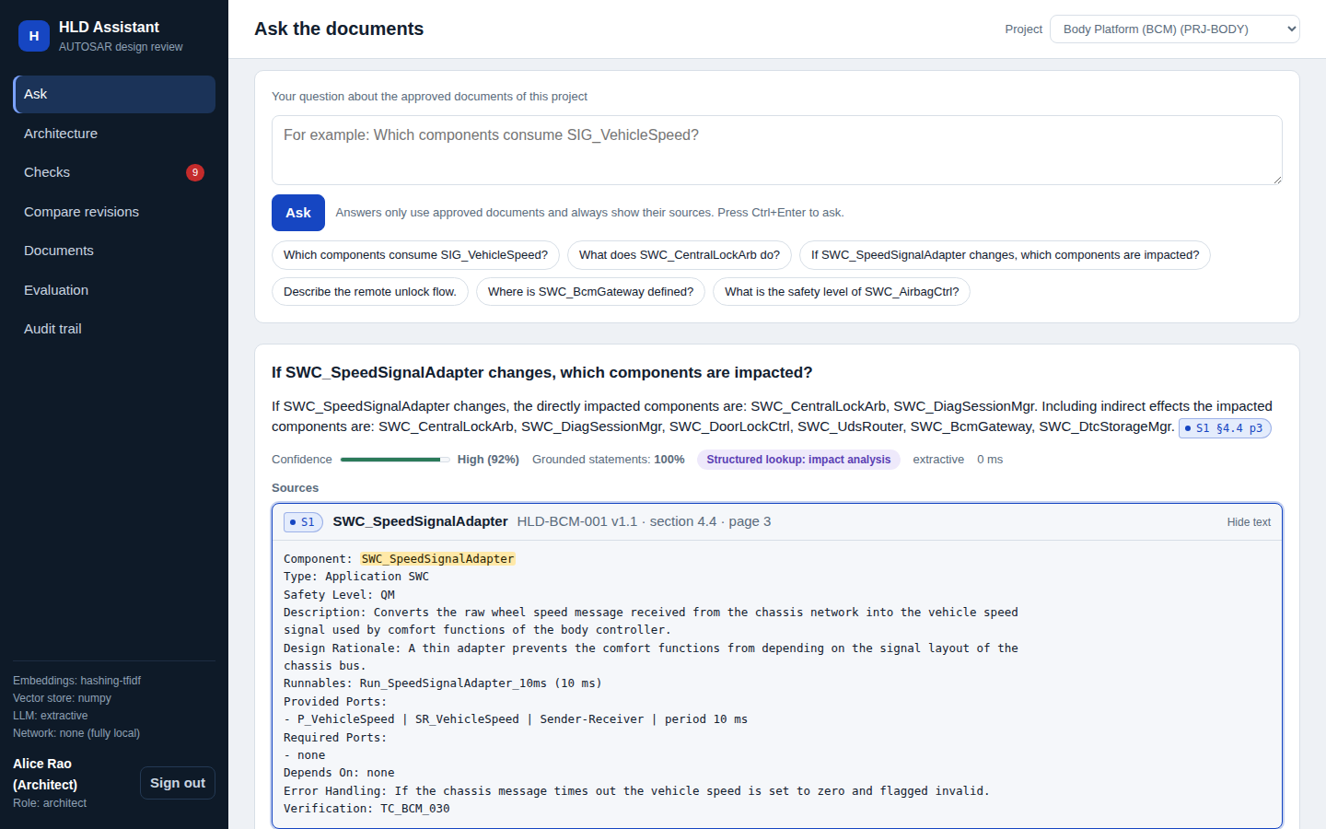
Figure 1: Ask page - structured answer with source tag S1 and the highlighted evidence passage, confidence and grounding shown

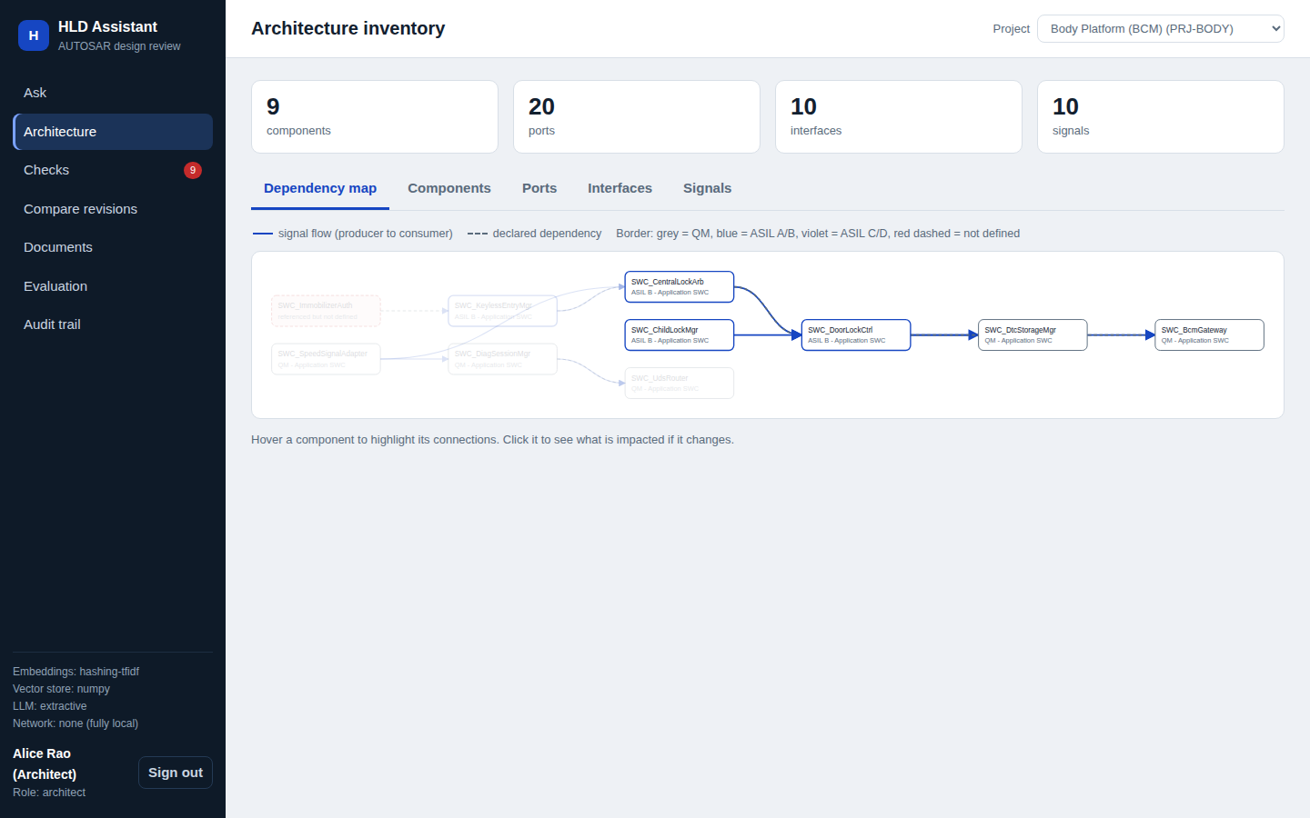
Figure 2: Dependency map with hover highlighting (project PRJ-BODY); red dashed node = component referenced but not defined
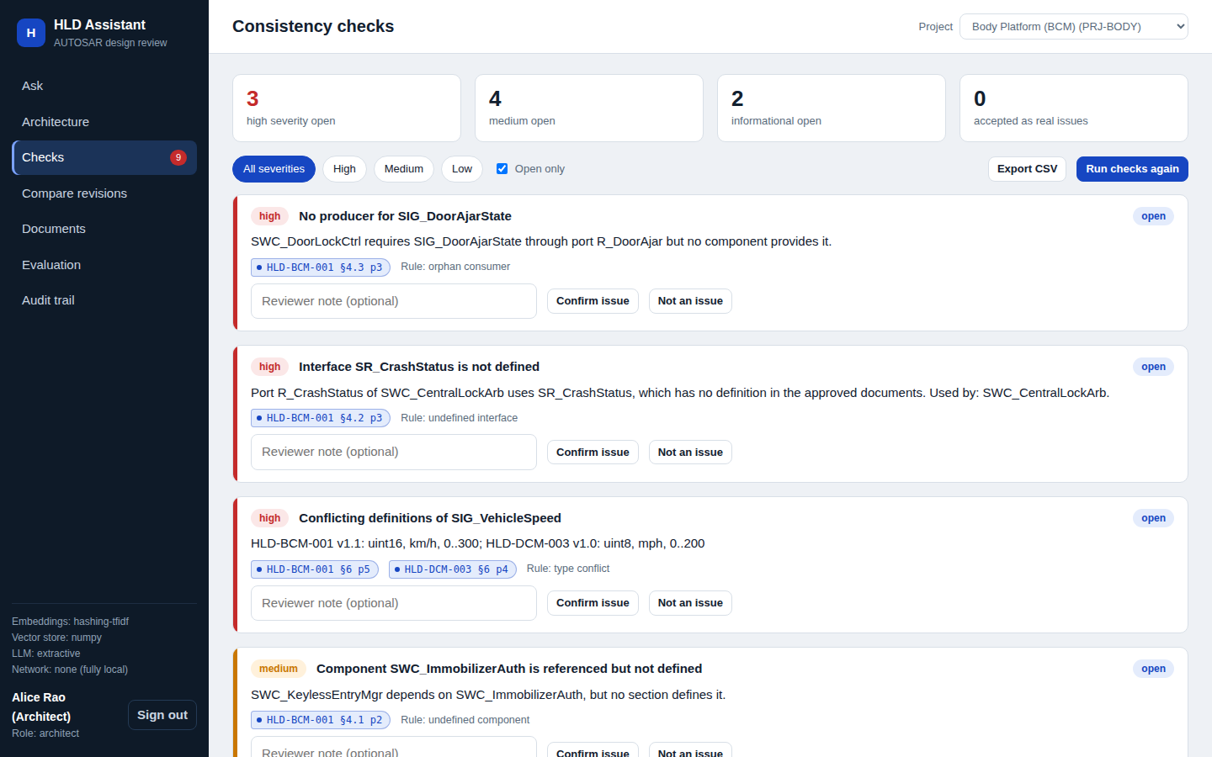
Figure 3: Consistency checks - findings with severity, evidence tags and reviewer actions
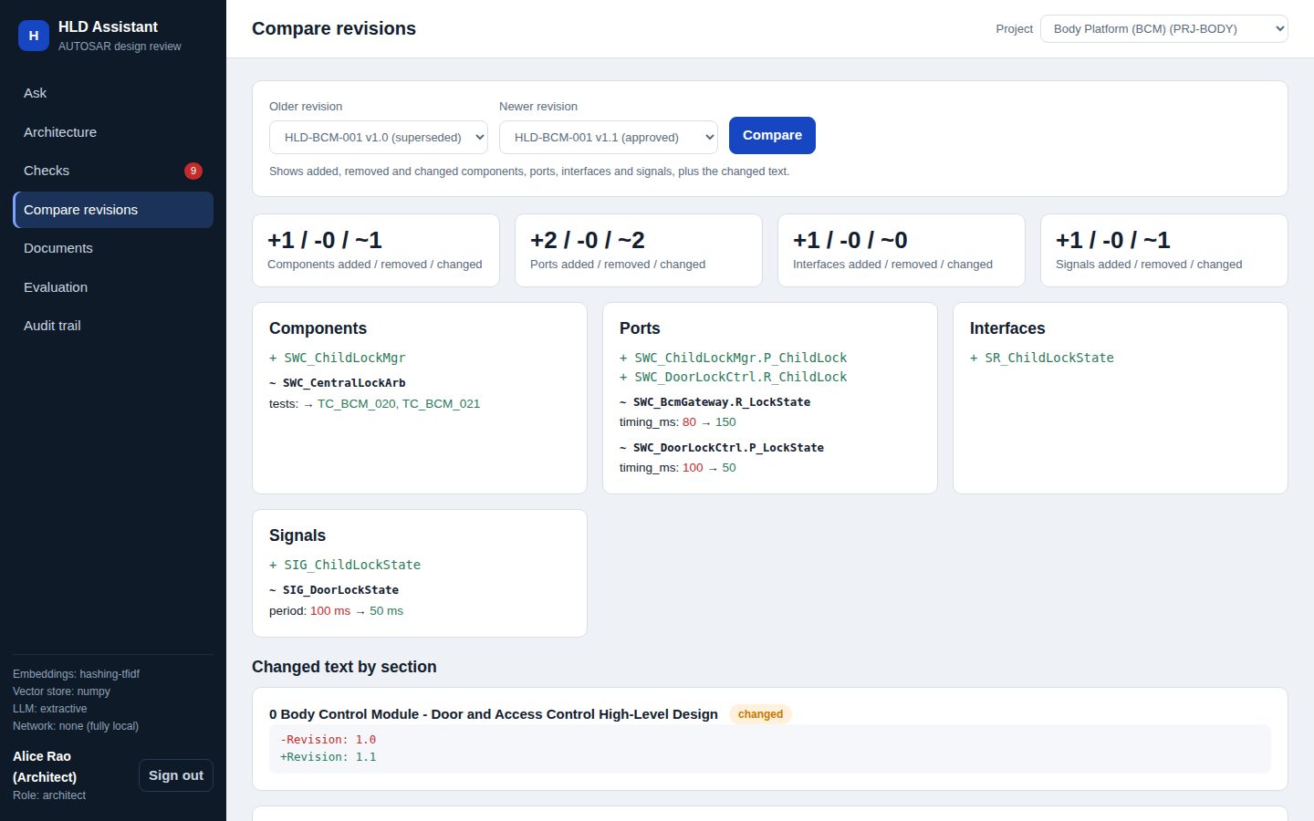
Figure 4: Revision comparison HLD-BCM-001 v1.0 to v1.1
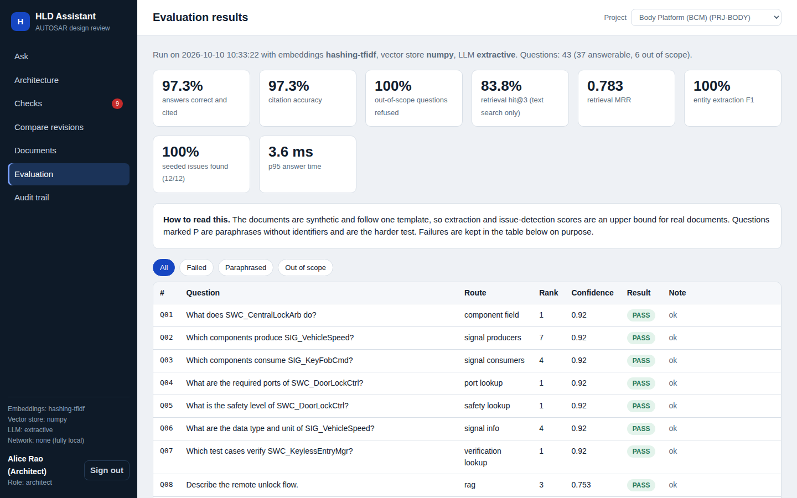
Figure 5: Evaluation page showing metrics and the per-question table including the failed case
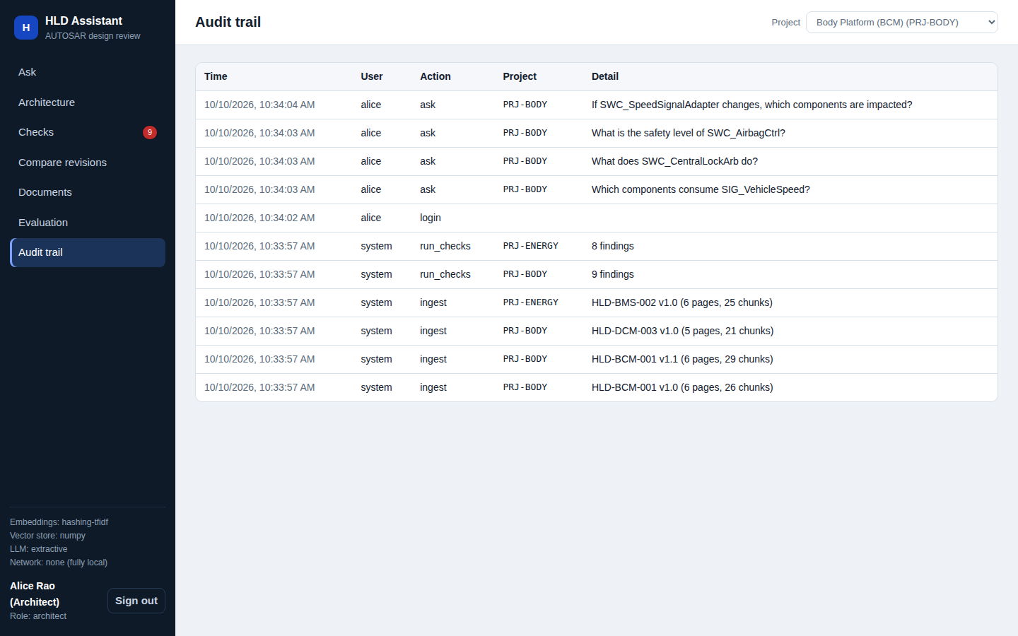
Figure 6: Audit trail (architect only) including refused cross-project access
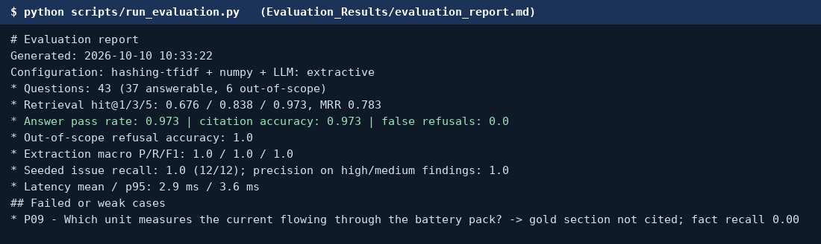
Figure 7: Console output of python scripts/run_evaluation.py
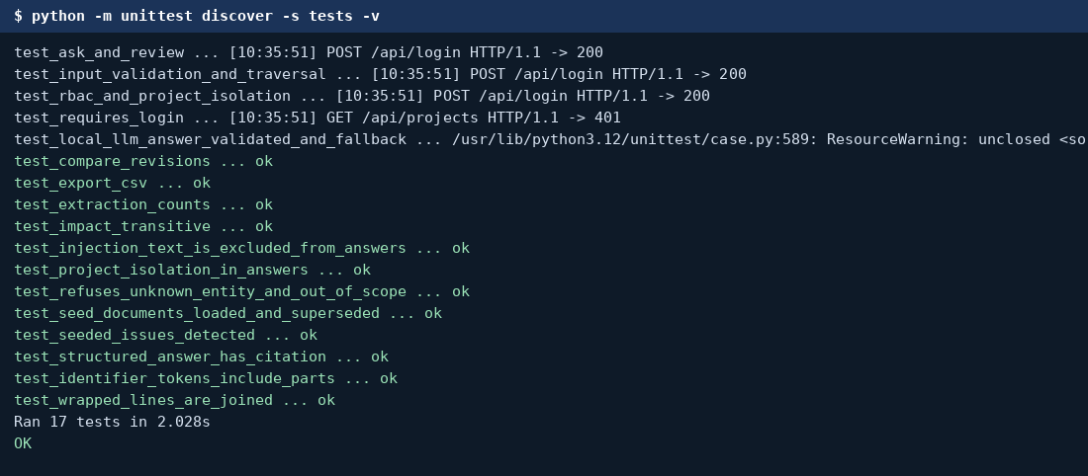
Figure 8: Console output of the 17 automated tests

9. Reflection and Conclusions
Key learnings, challenges faced, limitations, and future improvements.
Learnings: a RAG system is only as good as its parsing and evaluation. Splitting questions into those answered from structured facts and those answered from retrieved text made behaviour predictable and easy to test. Wrapped PDF lines and repeated page headers caused two real bugs (lost fields and cut sentences) that were found by looking at the extracted text, not by the metrics.
Challenges: designing a synthetic knowledge base that is realistic enough to be useful but still honest about being synthetic; deciding when the assistant must refuse; keeping the application runnable with very few installed packages.
Limitations: documents are synthetic and templated, so extraction and issue-detection scores are an upper bound; scanned pages, tables drawn as images and diagrams are not read (no OCR); hashing embeddings do not capture meaning (failure P09); the questions were written by the author; the optional local LLM path was tested with a mock server only; authentication is demo-grade; Docker files were not executed.
Future work: evaluate BGE or E5 embeddings with FAISS and a re-ranker, add OCR and diagram understanding, test with real HLD documents and an independent question set from domain experts, add a graph database for cross-artifact traceability to safety and cybersecurity work products, and integrate enterprise identity.

10. AI-Tool Usage Declaration
AI tool / model | Purpose | Artifact affected | Verified by Student (Y/N)
Claude | Coding assistant: scaffolding of application modules, web UI, unit tests, synthetic data generator | Code/, Input_Data generator, /ground_truth | Yes
Chatgpt | Drafting of the synopsis, this report, README | Synopsis/, Documentation/, README.md | Yes

11. Student Declaration
I confirm that this report represents my own understanding and contribution, that the work follows the approved case-study scope, and that I can explain every significant part of the implementation.

Signature: |  | Date: | 13-10-2026
Name: | Yadnesh Patil | PRN: | 123B1D034

