TECHNICAL IMPLEMENTATION BLUEPRINT

System Architecture
AI Career Coach | Verifiable skills, real jobs, live GitHub updates
VERSION | DATE | STATUS
1.0 | 16 October 2026 | Proposed / not yet implemented

Architecture principle The database owns assessment state, source-cited observations and job requirement snapshots. AI can interpret evidence but cannot create citations not grounded in retrieved source code.

Architecture at a glance
LAYER | PROPOSED MVP
Browser | Next.js + Tailwind; dashboard and event-status polling or SSE
HTTP service | FastAPI; auth, job ingest, assessment reads and webhook verification
Integrations | Read-only GitHub App; approved employer job URLs / permitted API
Analysis | Python / SQL / route heuristics + bounded LLM + optional Tree-sitter
Persistence | PostgreSQL (Supabase acceptable); job records, code citations, snapshots, audit
Async execution | PostgreSQL-backed task queue for MVP; Redis/Celery can follow

Operating constraints
- A real internship URL and confirmed requirement text are mandatory: no invented job descriptions or manual fixture-only reports.
- A selected GitHub App installation and authentic repository push are mandatory: polling is an acceptable fallback but a manual refresh alone is not.
- The AI component must ground its job-skill mapping and explanations in parsed job text and code observations; verified citations are backend-generated.
- Verdicts evaluate demonstrated abilities inside a disclosed repository + branch + commit scope, never personal aptitude or hiring probability.
- Every event produces visible status and traceable assessment versions; partial failures do not silently change verdicts.

1 High-level component diagram
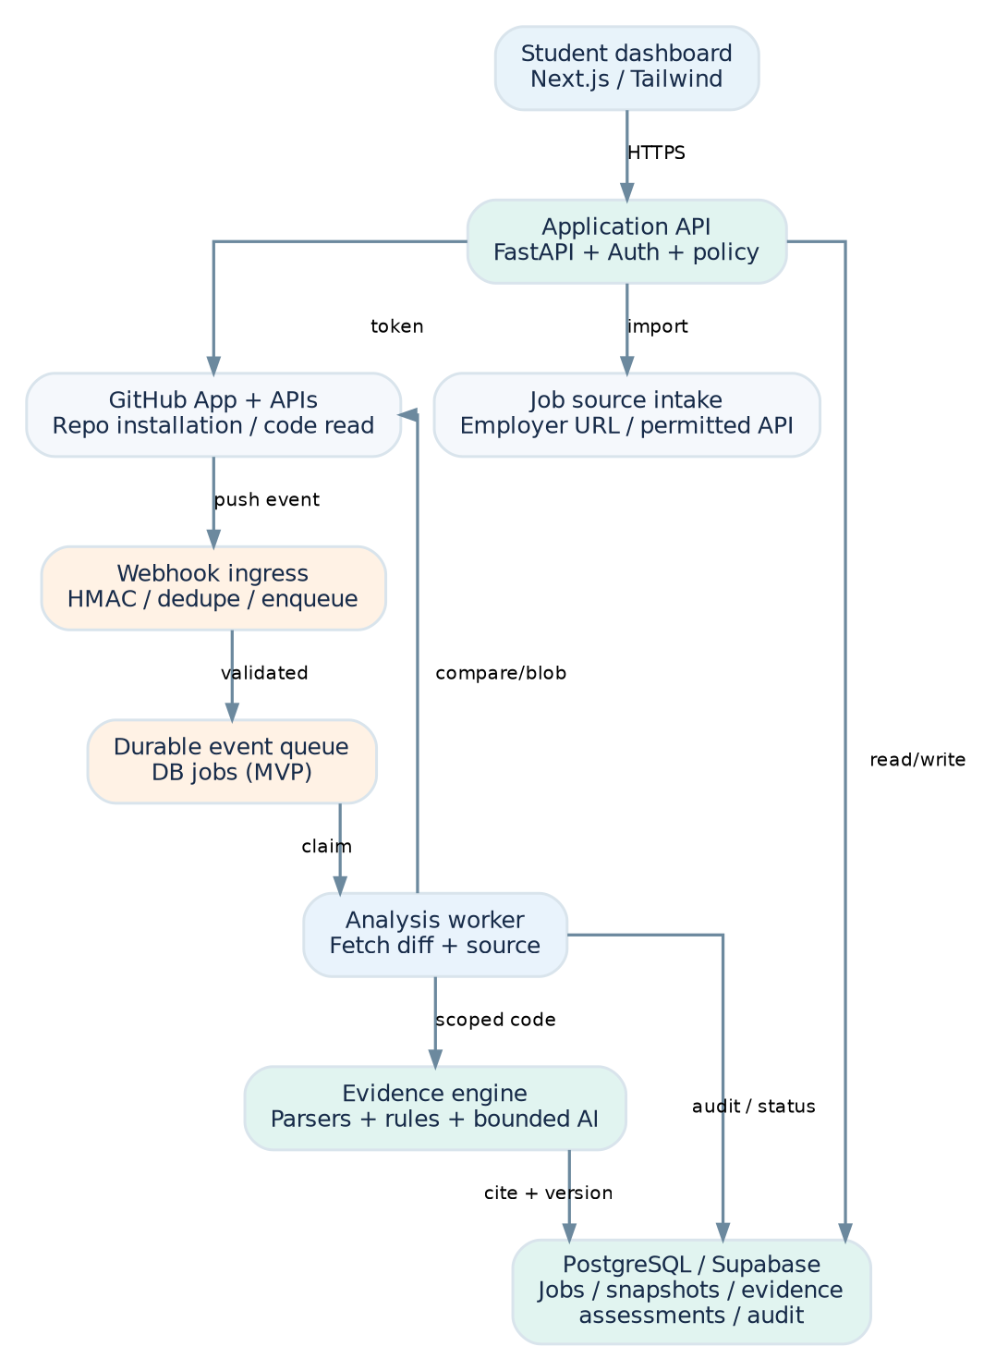
Figure 1. Proposed production-shaped MVP: signed GitHub event -> durable work -> evidence reassessment.
The GitHub App scopes repository access to selected installations. The API handles user-facing job and assessment requests. A webhook endpoint independently verifies push deliveries and enqueues work; it must not perform expensive parsing inline. The worker then fetches only required repository blobs/diffs and stores a new versioned evaluation.

2 Technology decisions and reasons
TECHNOLOGY | WHY CHOOSE IT | ALTERNATIVE / TRADEOFF
Next.js | Quick functional student UI, route views, simple event polling. | React + Vite also works; deployment is simpler in some teams.
FastAPI | Python ecosystem for code parsing and LLM integration. | Node API fits full-TS teams; one framework is enough.
PostgreSQL | Relational provenance joins and transactional event updates. | Supabase provides hosted Postgres + auth.
GitHub App | Install-on-selected-repositories, least privilege, webhook integration. | Personal token is simpler but poor for multi-user permission management.
Tree-sitter (optional) | AST-based extraction for nontrivial code patterns. | Regex/rules for MVP must be conservatively scoped.
LLM reasoning | AI maps job wording and explains bounded code findings. | Model is never the sole source of a positive verdict.
DB worker queue | Avoids additional infrastructure; enough for one live demo. | Redis + Celery for higher throughput; add after MVP.

3 Main flows

3.1 Initial job-to-evidence assessment
- Student connects GitHub App to an explicitly selected repository; store installation ID and repo ID, not long-lived plaintext access tokens.
- Student submits a real internship URL or selects an authorized feed result. Validate URL, fetch permitted content, capture retrieval time and source.
- Extract job requirements (e.g., Python, SQL, REST APIs). Link each to original job text, allow student review, normalize skill aliases.
- Fetch selected repository default-branch HEAD SHA, enumerate relevant files with a bounded allowlist, and cache blob metadata by SHA.
- Run parsers/rules on route handlers, queries, db calls and tests. AI interprets job wording and explains observations, while the backend derives and verifies immutable path/line citations.
- Join each requirement to qualifying observations. Save assessment version and expose status/reasons on the dashboard.

3.2 Push-driven incremental reassessment
Figure 2. Delivery progression. Live UI subscribes to processing status and shows changed verdicts.
- GitHub sends push event to HTTPS /api/webhooks/github with event type and delivery ID.
- Webhook endpoint validates HMAC-SHA256 (X-Hub-Signature-256) over raw bytes using constant-time comparison; reject invalid deliveries.
- Check installation/repository permission, branch policy and delivery idempotency, then durably enqueue before acknowledging.
- Worker obtains before/after SHA, enumerates file changes via GitHub compare / Git trees as needed and detects deletes/renames.
- Invalidate cached evidence from changed or deleted blobs; map changed file types and import paths to potentially affected skill requirements.
- Run targeted analysis and merge with still-valid evidence at the new SHA; reevaluate every impacted job requirement.
- Transactionally store new snapshot, status, reason, citations, event outcome and before/after diff; UI updates without manual reassessment.
Key behavior A deleted SQL file can downgrade a previously demonstrated SQL subskill. A failed fetch should retain the last verified assessment but mark the new run as failed/stale, not declare SQL missing.

4 Component contracts
COMPONENT | INPUT | OUTPUT / RESPONSIBILITY
Job ingestion | URL or permitted provider result | Job posting + verbatim requirement spans + observed_at
GitHub connector | Installation, repo, ref/SHA | Trees, blobs, compare changes, immutable file URLs
Evidence analyzer | Source + language + requirement taxonomy | Typed observations with spans, rule id and limits
Matcher | Job requirements + evidence set | Per-requirement status and explanation
Webhook verifier | Raw event, signature, delivery id | Authenticated event or 4xx rejection
Queue worker | Validated change event | New repo snapshot + assessment version + audit
UI / API | Assessment ID or repo ID | Structured statuses, stable citations and job sources

5 Proposed HTTP API contracts
Endpoints below are application-design proposals; they are not GitHub API endpoints and do not exist until implemented. All student endpoints require an authenticated user session and enforce repository ownership. Webhook is independently authenticated by GitHub HMAC.
METHOD / ROUTE | REQUEST | RESPONSE
POST /api/jobs/import | {url: https://employer.example/careers/123} | 201 {job_id, requirements[], source_url, checked_at}
GET /api/github/repos | none; uses app installation mapping | 200 {repositories:[{id, name, default_branch}]}
POST /api/assessments | {job_id, repository_ids:[...] } | 202 {assessment_id, state:"queued"}
GET /api/assessments/{id} | none | 200 {version, requirements[], evidence[], scope, state}
GET /api/assessments/{id}/history | none | 200 {versions[], changed_requirements[]}
GET /api/events/{id} | none | 200 {delivery_id, sha_before, sha_after, state}
POST /api/webhooks/github | GitHub signed raw JSON body | 202 accepted (or 401 invalid signature)

Example requirement assessment payload
{
"requirement": "SQL query writing",
"status": "demonstrated",
"scope": "owner/repo @ 9f3... on main",
"reason": "Parameterized SELECT and JOIN in executed query path",
"evidence": [{"path":"database/queries.sql", "lines":[4,13],
"commit_sha":"9f3...", "url":"https://github.com/.../blob/9f3.../database/queries.sql#L4-L13"}],
"limits": "Does not establish database administration expertise"
}

6 Database model (MVP)
ENTITY | KEY FIELDS / LINKS
users | id, auth_subject, created_at
github_installations | id, user_id FK, installation_id, permissions_snapshot
repositories | id, user_id FK, installation_id FK, github_repo_id, full_name, default_branch, last_verified_sha
jobs | id, user_id FK, source_url, employer, title, fetched_at, original_text_hash, retrieval_status
job_requirements | id, job_id FK, skill_key, requirement_text, source_context, requirement_scope
repo_snapshots | id, repo_id FK, commit_sha, branch, analyzer_version, status, started_at, finished_at
evidence | id, snapshot_id FK, skill_key, blob_sha, path, start_line, end_line, evidence_type, rationale, limitation
assessments | id, user_id FK, job_id FK, repo_scope, version, evaluated_at, state, scan_scope
requirement_verdicts | id, assessment_id FK, requirement_id FK, status, reason, evidence_ids, uncertainty
webhook_events | id, delivery_id UNIQUE, repo_id FK, before_sha, after_sha, ref, status, error, received_at
audit_log | id, user_id, actor_type, action, object_id, payload_hash, created_at

Suggested integrity rules: unique(repo_id, commit_sha, analyzer_version) for snapshots; unique(delivery_id) for GitHub events; (assessment_id, requirement_id) unique for verdicts. Create new assessment versions rather than updating previous verdicts in place. Use database transactions to prevent stale event results from overwriting newer repository heads.

7 Evidence engine logic

7.1 Source selection and grounding
- Allowlist candidate files by language and path; skip .env*, tokens/keys, binaries, generated folders, vendored dependencies, lock files and oversized blobs.
- Derive line ranges from parsed source content at an exact commit SHA; never fabricate line references from LLM output.
- Link to GitHub blob permalinks with commit hash; a moving default-branch URL is not immutable proof.
- Store explicit scan exclusions and unsupported files; display incomplete coverage as a limitation.
- LLM receives only minimized code snippets and structured observations when user consent and provider policy allow. Repository content and job pages are untrusted instructions.

7.2 Sample rules (narrow claims)
SKILL | POSITIVE SIGNAL | DOES NOT PROVE
Python implementation | Nontrivial functions/classes with meaningful data handling; optional tests. | Production Python expertise or original authorship.
SQL query writing | Real SELECT/JOIN/WHERE/parameterized query used in a code path or SQL file; tests improve confidence. | DB scaling, schema design or SQL administration.
REST API implementation | Actual framework route handlers with methods, request/response logic and validation. | API security, uptime or production scaling.
Testing | Runnable tests that exercise target implementation behavior. | Comprehensive coverage or correctness in all conditions.

7.3 Verdict algorithm (proposed)
for requirement in confirmed_job_requirements:
observations = evidence_index.find(requirement.skill_key)
if scan_failed_or_unsupported(requirement, scope):
status = "unable_to_assess"
elif passes_narrow_qualification_rules(observations, requirement):
status = "demonstrated"
elif has_relevant_but_insufficient_observations(observations):
status = "partial"
else:
status = "not_demonstrated_in_reviewed_scope"
persist(version, status, observations, scan_scope, limitations)

8 Incremental analysis and failure handling
EDGE CASE | REQUIRED BEHAVIOR
Duplicate delivery | Use X-GitHub-Delivery as idempotency key; acknowledge duplicates, do not apply twice.
Non-default branch | Ignore for MVP and record an explicit reason, unless configured as a scanned branch.
Deleted / renamed file | Invalidate old evidence, re-evaluate affected skills and cite new paths if applicable.
Force push / invalid comparison | Re-snapshot current head and recalculate; never pretend truncated diff is complete.
New push while worker busy | Serialize per repository or use expected head guard; display latest processed SHA.
GitHub rate limit / unavailable | Backoff/retry; mark run delayed or failed, keep prior verified version visible.
Webhook outage | Periodic reconciliation checks default branch HEAD and schedules missing scan.
Job URL unreachable | Keep captured source and timestamp; flag stale, do not invent replacement text.
Prompt injection in code | Treat snippets as untrusted data; LLM cannot call tools or override verdict rules.

9 Security, access control and privacy
- GitHub App requests minimum repository metadata and read-only contents permissions for the selected repositories; use installation tokens server-side.
- Verify X-Hub-Signature-256 over the exact raw request body using a stored high-entropy secret and constant-time comparison. Protect endpoint with HTTPS.
- Validate user session and per-user ownership at every read and write endpoint. For Supabase, configure row-level security rather than assuming front-end visibility is authorization.
- Protect job URL fetches against SSRF: accept only public HTTPS URLs, validate redirects and DNS/IP targets, enforce timeouts and size caps. Respect job source terms.
- Avoid logging source code, tokens or private file contents. Retain derived observations and minimal metadata; define user disconnect/delete workflow.
- Sanitize explanations displayed as Markdown/HTML to avoid cross-site scripting. Never execute fetched repository code as part of evidence scanning.
- Separate scan errors from negative findings; show evaluator version, commit hash and source retrieval times.

10 Deployment, operations and tests
PART | DEPLOYMENT / CHECK
Frontend | Vercel or equivalent HTTPS host; environment-specific backend URL.
Backend + webhook | Public HTTPS FastAPI service, with fixed webhook callback URL.
Database | Hosted Supabase/PostgreSQL with schema migrations and secret isolation.
Worker | Second process or background runner reading durable jobs; not in ephemeral request memory.
Secrets | Server-only GitHub App key, webhook secret, DB credentials and optional LLM key.
Telemetry | Log delivery ID, repo ID, SHA pair, transitions, durations and errors (no code).
Health | Expose /health; monitor webhook acceptance, queue backlog, scan failures and stale HEAD.

Essential test matrix
TEST | EXPECTED RESULT
Initial scan | SQL not demonstrated when repo lacks qualifying SQL evidence.
Real push adds SQL + test | Signed delivery -> processing -> SQL query-writing demonstrated, with exact links.
Delete SQL evidence | Verdict falls back based on remaining qualifying observations.
Invalid signature | Webhook rejected, zero scan jobs created.
Replay same delivery | One logical event / assessment application.
Unscannable repo | Unable to assess or partial coverage, never unsupported negative claim.
Broken source citation | QA catches citation mismatch before presenting evidence.
Slow or rate-limited GitHub | Retry and display queued/failed state while retaining last verified snapshot.

11 Recommended repository/module layout
career-coach/
web/ # Next.js UI: jobs, repos, evidence, timeline
api/ # FastAPI routes, auth, webhook validation
services/github.py # GitHub App installation tokens + GitHub API
services/jobs.py # real job-source normalization
workers/ # durable event processing and retries
analyzers/ # Python / SQL / REST rules and parser adapters
matcher/ # requirement-to-evidence verdict rules
db/ # tables, migrations, repositories
tests/ # unit, contract and end-to-end webhook tests
docs/ # architecture, API contracts, demo evidence
README.md # local setup, env example, demo and limitations

12 Hackathon delivery map
MILESTONE | DEMONSTRABLE OUTPUT
M1: Ground truth | Import a live internship link and connect a real repo.
M2: Initial skill passport | Show precise file and commit citations and honest missing signals.
M3: Live loop | New commit triggers authenticated webhook and revised assessment.
M4: Quality | Deletion/duplicate/failed-fetch tests and audit screen.
M5: Submission | Running build, README, architecture figure, job URL, before/after screenshots and 5-minute script.

13 Alternatives, assumptions and references
Assumptions: One student, one real job, one selected GitHub repository and three initial skill families are sufficient for the demo. Default-branch pushes are in scope. All examples are illustrative and do not represent live ingested job records or implemented APIs.
Tradeoff: a queue backed by PostgreSQL reduces hackathon complexity but requires careful claiming/retry logic. Redis/Celery is suitable after proving correctness. Rule-based analysis limits coverage but increases citation trustworthiness; LLM prose is helpful when constrained to observed evidence.
Planning inputs: AI_Career_Coach_Existing_Solutions_Research.pdf and AI_Career_Coach_Flaws_and_Solutions.pdf.
GitHub webhook validation: https://docs.github.com/en/webhooks/using-webhooks/validating-webhook-deliveries
GitHub webhook best practices: https://docs.github.com/en/webhooks/using-webhooks/best-practices-for-using-webhooks
GitHub App permissions: https://docs.github.com/en/apps/creating-github-apps/registering-a-github-app/choosing-permissions-for-a-github-app

