Low Level Document (LLD)

Personal Portfolio Website

Version number: 1.0

Yadnesh Wani

Dnyanesh Bachhav

Sanika Khirit

**DECLARATION**

We declare that this written submission represents us ideas is our own words and where others' ideas or words have been included, we have adequately cited and referenced the original sources.

We also declare that we have adhered to all principles of academic honesty and integrity and have not misrepresented or fabricated or falsified any idea/data/fact/source in my submission.

We understand that any violation of the above will be cause for disciplinary action by the Institute and can also evoke penal action from the sources which have thus not been properly cited or from whom proper permission has not been taken when needed.

**Revision History**

|  |  |  |  |  |  |
| --- | --- | --- | --- | --- | --- |
| **Version** | **Date** | **Author** | **Reviewer** | **Approver** | **Comments** |
| 0.1 | 20-07-2022 | Dnyanesh Bachhav | Yadnesh Wani | Sanika Khirit | Draft version |
| 0.2 | 24-01-2022 | Yadnesh Wani | Sanika Khirit | Dnyanesh Bachhav | Suggested some component and attribute to be added |
| 0.3 | 04-08-2022 | Dnyanesh Bachhav | Sanika Khirit | Yadnesh Wani | Suggested document format related comments like correction of version. |
| 0.4 | 8-08-2022 | Sanika Khirit | Yadnesh Wani | Dnyanesh Bachhav | Suggested some changes  in contact section and also solve the issue regarding Email JS |
| 1.0 | 14-08-2022 | Yadnesh Wani | Dnyanesh Bachhav | Sanika Khirit | Baseline version |

Table of Contents

1. Introduction 5

1.1 Scope of the document 5

1.2 Intended Audience 5

1.3 System Overview……………………………………………………………………………………5

1. Project Briefing………………………………………………………………………………. 6
2. Problem Statement………………………………………………………………………….. 6
3. Problem Solution…………………………………………………………………………….. 6
4. Objective of Project………………………………………………………………………….. 6
5. Scope of Project……………………………………………………………………………… 7
6. Block Diagram………………………………………………………………………………… 8-9
7. Requirements Gathering……………………………………………………………………. 10
8. Analysis………………………………………………………………………………………. 11
9. Final Screenshot of Project Output………………………………………………………… 12-14

# Introduction:

## Scope of the Document

* This section will cover details regarding scope of the document
* Low level design document will be at component level i.e., for website portal there will be one LLD

## Intended Audience

* This section will cover categories of audiences who will be referring/reviewing this document

**1.3 System Overview**

* This section will capture overview of system application i.e for what system is being developed
* Who are the stake holders of system?
* What are other external Systems through which this will be interacting

1. **Project Briefing:**

A personal portfolio is a place for you to share your web design story. Some designers prefer to keep things simple and businesslike. Others prefer to go off the beaten path and tell a story by showing their personality and sharing their personal passions and design styles.

And if you believe reading is not enough to understand what an inspirational portfolio website is, please take a look at these stunning examples.

A personal portfolio website is a professional website that provides information about what you do, what services you may offer, and how to contact you or your company.

Portfolio websites are an easy way to promote yourself, your brand, or your business. You'll increase your visibility for clients, managers, or employers to find you organically. Essentially, it's a digital business card and project portfolio all in one that's accessible, sharable, and drives results.

1. **Problem Statement:**

To create the Personal Portfolio Website to showcase developers skills, education, projects, & contact-Info etc.

1. **Problem Solution:**

Develop the Personal Portfolio Website to show the online presence of a developer. Person who a visit a website can have a better understanding about a developer.

1. **Objective of the Project:**

A portfolio is a living and changing collection of records that reflect your accomplishments, skills, experiences, and attributes. It highlights and showcases samples of some of your best work, along with life experiences, values and achievements.

1. **Scope of Project:**

The portfolio website should consist of our main parts such as personal information, including short cv and professional skills, portfolio showcase, and contact information including feedback form.

The goal is to create a unique online presence that represents our personality and display design work in detail, while of course serving as a promotional medium to gain more exposure and business.

1. **Block Diagram:**

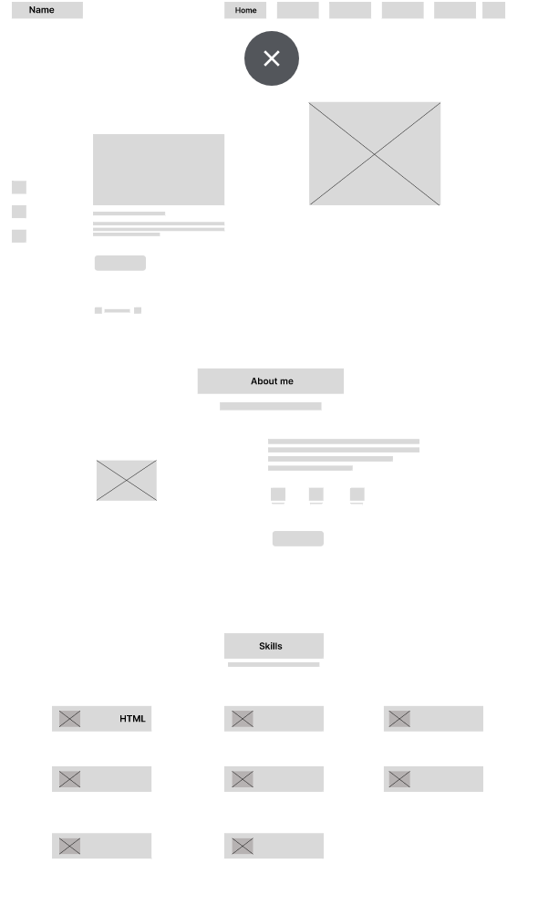

1. **Requirements Gathering:** 
   * Window 10 Operating system
   * Visual studio software
   * 3 Team members for the research part
   * Project integration idea from IEEE website
   * Few Github Non copyrighted source codes

1. **Analysis:**

In this project we are using Next JS Framework which provide many features like SSG, SSR, Image Optimization, etc. With the Next JS we are also using Technologies like Tailwind, Node JS, etc Tailwind Enables Building Complex Responsive Layouts Freely: The Tailwind CSS framework uses a default mobile-first approach. The availability of utility classes makes it easier to build complex responsive layouts freely. Node JS provides a performant Run Time Environment on top of that next JS provides a Fast and easy way to build application which are SEO (Search Engine Optimization) Friendly and comes with built in image optimization.

So, that the website will get Ranked in the search results as well as it will get load faster on user machine.

1. **Final Screenshot** Graphical user interface, application, Teams

   Description automatically generated**of** Graphical user interface

   Description automatically generated

