Celebal Excellence Internship
Data Engineer
Week 3 Assignment

Name | Yadnyesh Sawant
Student ID | CT_CSI_DE_1015
Domain | Data Engineering
Batch | Batch 1
Start Date | 15/6/2026
Status | Active
Contact No | 8888047246
Email ID | 1272250066@mitwpu.edu.in
College Name | MIT-WPU
Stream | MCA
Passing Out Year | 2027
CELEBAL EXCELLENCE INTERNSHIP DATA ENGINEER
Week 3 Assignment

Problem Statement
Use Subqueries, CTEs, and Window Functions to analyze sales data from the Superstore dataset.

- Objective: Analyze sales data using SQL by applying Subqueries, CTEs, and Window Functions to solve business queries.

Step-by-Step Instructions

- Load the Dataset: Load Superstore dataset into a table (superstore_raw).
- Create Table: customers, orders, products from the dataset.
- Insert data: Insert data into these tables using SELECT DISTINCT.
- subqueries: Apply subqueries to filter data (above average sales, highest order per customer)
- CTE: Use CTEs to compute aggregations (total sales per customer).
- Window Functions: Apply window functions (ROW_NUMBER, RANK) for ranking and analysis.
- Combined Query: Combine JOIN + CTE + Window Functions for final result (customer, total sales, rank).
- Mini Project: Customer Sales Insights: Solve business queries (top customers, low customers, single-order customers, above-average sales).
Resources
- Dataset: https://www.kaggle.com/datasets/vivek468/superstore-dataset-final
- Assignment Document: https://celebaltech.sharepoint.com/:w:/s/Celebal-LMS/IQCWMVcUnj73TIwEKov5Gb9lAfCEoSPfGEK8guscFuPLoSI?e=Paq82Y
Outputs
- SQL Script or Jupyter Notebook
- Query Results
- Brief Insights
- Word file with screenshots as suggested in the Saturday’s 27-06-2026 meeting.
Tasks
Step 1: Setup Data
- Import the Superstore dataset into a table named superstore_raw.

CREATE TABLE superstore_raw (
row_id INT,
order_id VARCHAR(30),
order_date VARCHAR(20),
ship_date VARCHAR(20),
ship_mode VARCHAR(50),

customer_id VARCHAR(20),
customer_name VARCHAR(100),
segment VARCHAR(50),

country VARCHAR(100),
city VARCHAR(100),
state VARCHAR(100),
postal_code VARCHAR(20),
region VARCHAR(20),

product_id VARCHAR(30),
category VARCHAR(50),
sub_category VARCHAR(50),
product_name VARCHAR(255),

sales DECIMAL(10,2),
quantity INT,
discount DECIMAL(5,2),
profit DECIMAL(10,4)
);

LOAD DATA LOCAL INFILE 'C:/Users/yadny/Downloads/Sample - Superstore.csv/Sample - Superstore.csv'
INTO TABLE superstore_raw
CHARACTER SET latin1
FIELDS TERMINATED BY ','
ENCLOSED BY '"'
LINES TERMINATED BY '\r\n'
IGNORE 1 ROWS
(
row_id,
order_id,
order_date,
ship_date,
ship_mode,
customer_id,
customer_name,
segment,
country,
city,
state,
postal_code,
region,
product_id,
category,
sub_category,
product_name,
sales,
quantity,
discount,
profit
);

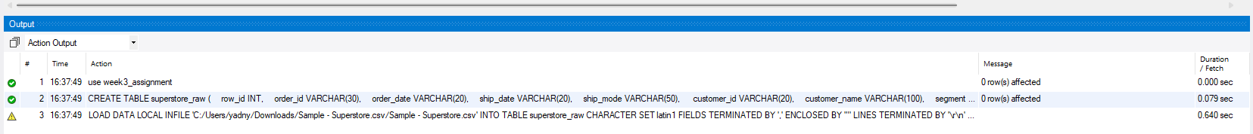
- Create these 3 tables from it:
  - Customers
CREATE TABLE customers (
customer_id VARCHAR(20) PRIMARY KEY,
customer_name VARCHAR(100),
segment VARCHAR(50)
);

  - Orders
CREATE TABLE orders (
row_id INT PRIMARY KEY,
order_id VARCHAR(30),
order_date DATE,
ship_date DATE,
ship_mode VARCHAR(50),

customer_id VARCHAR(20),
product_id VARCHAR(30),

sales DECIMAL(10,2),
quantity INT,
discount DECIMAL(5,2),
profit DECIMAL(10,4),

FOREIGN KEY (customer_id) REFERENCES customers(customer_id),
FOREIGN KEY (product_id) REFERENCES products(product_id)
);
  - products
CREATE TABLE products (
product_id VARCHAR(30) PRIMARY KEY,
category VARCHAR(50),
sub_category VARCHAR(50),
product_name VARCHAR(255)
);



- Insert data into these tables using SELECT DISTINCT.
INSERT INTO customers
SELECT
customer_id,
MAX(customer_name),
MAX(segment)
FROM superstore_raw
GROUP BY customer_id;

INSERT INTO products
SELECT
product_id,
MAX(category),
MAX(sub_category),
MAX(product_name)
FROM superstore_raw
GROUP BY product_id;

INSERT INTO orders
SELECT
row_id,
order_id,
STR_TO_DATE(order_date, '%m/%d/%Y'),
STR_TO_DATE(ship_date, '%m/%d/%Y'),
ship_mode,
customer_id,
product_id,
sales,
quantity,
discount,
profit
FROM superstore_raw;

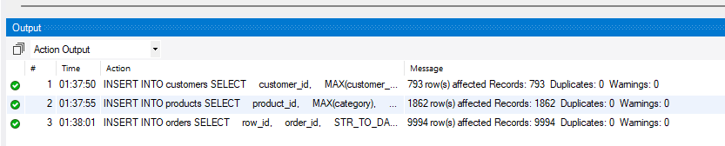

Step 2: Perform Required Queries

Write and execute SQL queries for each of the following:

- Find all orders where sales are greater than the average sales. (Subquery)
SELECT *
FROM orders
WHERE sales >
(
SELECT AVG(sales)
FROM orders
);

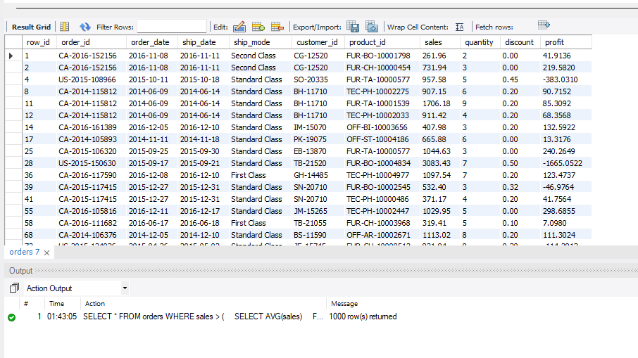

- Find the highest sales order for each customer. (Subquery)
SELECT
o.customer_id,
c.customer_name,
o.order_id,
o.sales
FROM orders o
JOIN customers c
ON o.customer_id = c.customer_id
WHERE o.sales =
(
SELECT MAX(sales)
FROM orders
WHERE customer_id = o.customer_id
);
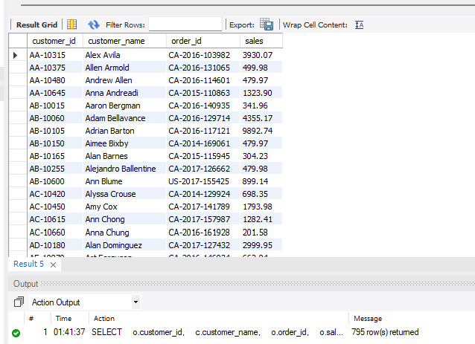

- Calculate total sales for each customer. (CTE)
WITH customer_sales AS
(
SELECT
customer_id,
SUM(sales) AS total_sales
FROM orders
GROUP BY customer_id
)

SELECT
cs.customer_id,
c.customer_name,
cs.total_sales
FROM customer_sales cs
JOIN customers c
ON cs.customer_id = c.customer_id
ORDER BY total_sales DESC;

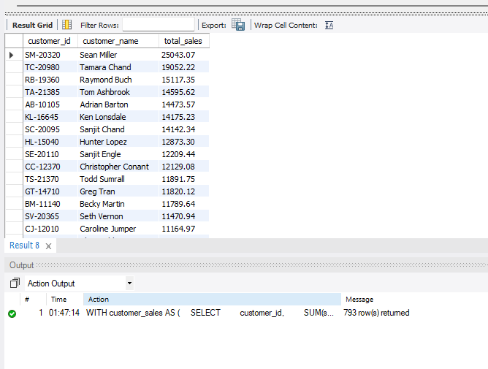
- Find customers whose total sales are above average. (CTE + Subquery)
WITH customer_sales AS
(
SELECT
customer_id,
SUM(sales) AS total_sales
FROM orders
GROUP BY customer_id
)

SELECT
cs.customer_id,
c.customer_name,
cs.total_sales
FROM customer_sales cs
JOIN customers c
ON cs.customer_id = c.customer_id
WHERE total_sales >
(
SELECT AVG(total_sales)
FROM customer_sales
)
ORDER BY total_sales DESC;

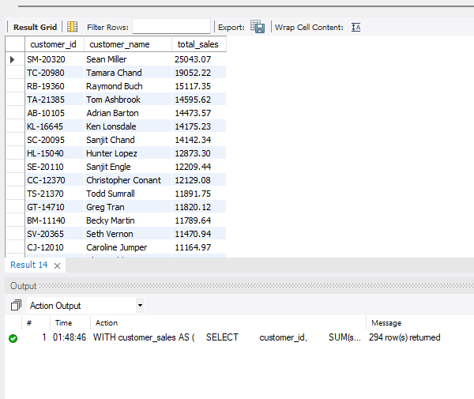

- Rank all customers based on total sales. (Window Function)
WITH customer_sales AS
(
SELECT
customer_id,
SUM(sales) AS total_sales
FROM orders
GROUP BY customer_id
)
SELECT
cs.customer_id,
c.customer_name,
cs.total_sales,
RANK() OVER (ORDER BY total_sales DESC) AS sales_rank
FROM customer_sales cs
JOIN customers c
ON cs.customer_id = c.customer_id;

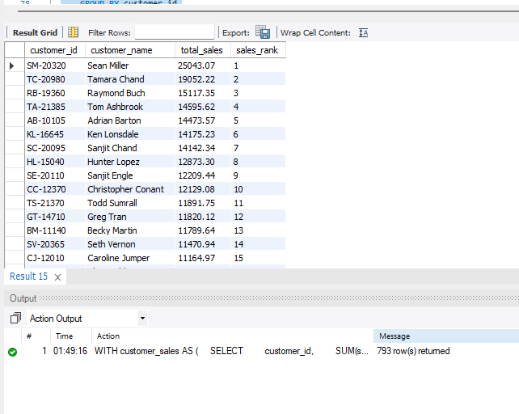

- Assign row numbers to each order within a customer. (Window Function + PARTITION BY)
SELECT
customer_id,
order_id,
order_date,
sales,
ROW_NUMBER() OVER
(
PARTITION BY customer_id
ORDER BY order_date
) AS order_number
FROM orders;
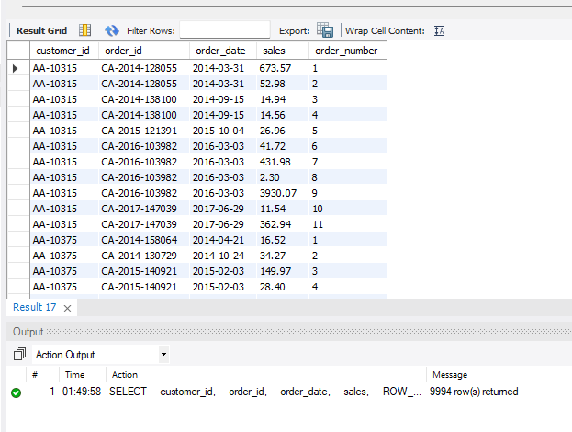

- Display top 3 customers based on total sales. (Window Function)
WITH customer_sales AS
(
SELECT
customer_id,
SUM(sales) AS total_sales
FROM orders
GROUP BY customer_id
)

SELECT *
FROM
(
SELECT
cs.customer_id,
c.customer_name,
cs.total_sales,
RANK() OVER (ORDER BY total_sales DESC) AS sales_rank
FROM customer_sales cs
JOIN customers c
ON cs.customer_id = c.customer_id
) ranked_customers
WHERE sales_rank <= 3;

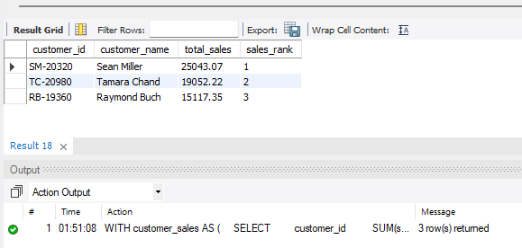
Step 3: Final Combined Query
Write one final query that shows:
- Customer Name
- Total Sales
- Rank
(Use JOIN + CTE + Window Function together)
WITH customer_sales AS
(
SELECT
customer_id,
SUM(sales) AS total_sales
FROM orders
GROUP BY customer_id
)

SELECT
c.customer_name AS "Customer Name",
cs.total_sales AS "Total Sales",
RANK() OVER (ORDER BY cs.total_sales DESC) AS "Rank"
FROM customer_sales cs
JOIN customers c
ON cs.customer_id = c.customer_id
ORDER BY "Rank";
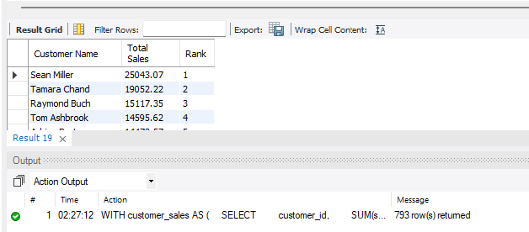

Mini Project: Customer Sales Insights
Answer the following using SQL:
- Who are the top 5 customers?
SELECT
c.customer_name,
SUM(o.sales) AS total_sales
FROM orders o
JOIN customers c
ON o.customer_id = c.customer_id
GROUP BY c.customer_name
ORDER BY total_sales DESC
LIMIT 5;

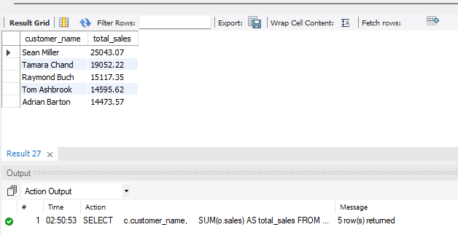

- Who are the bottom 5 customers?
SELECT
c.customer_name,
SUM(o.sales) AS total_sales
FROM orders o
JOIN customers c
ON o.customer_id = c.customer_id
GROUP BY c.customer_name
ORDER BY total_sales ASC
LIMIT 5;
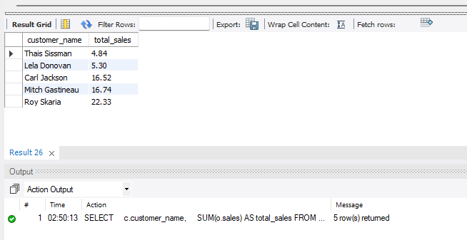

- Which customers made only one order?
SELECT
c.customer_name,
COUNT(DISTINCT o.order_id) AS total_orders
FROM orders o
JOIN customers c
ON o.customer_id = c.customer_id
GROUP BY c.customer_name
HAVING COUNT(DISTINCT o.order_id) = 1;
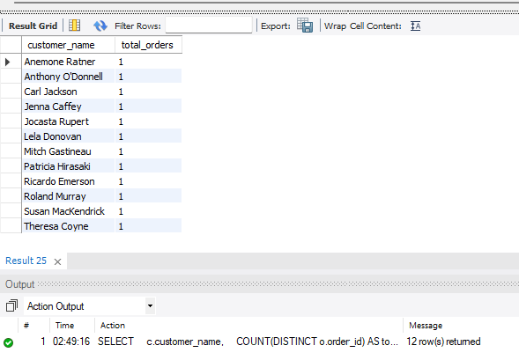

- Which customers have above-average sales?

WITH customer_sales AS
(
SELECT
customer_id,
SUM(sales) AS total_sales
FROM orders
GROUP BY customer_id
)

SELECT
c.customer_name,
cs.total_sales
FROM customer_sales cs
JOIN customers c
ON cs.customer_id = c.customer_id
WHERE cs.total_sales >
(
SELECT AVG(total_sales)
FROM customer_sales
)
ORDER BY cs.total_sales DESC;
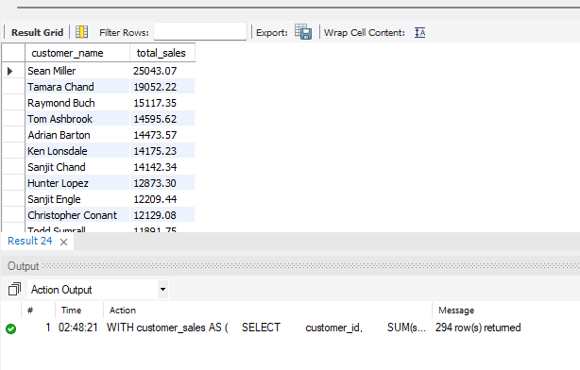

- What is the highest order value per customer?
WITH order_totals AS
(
SELECT
customer_id,
order_id,
SUM(sales) AS order_value
FROM orders
GROUP BY customer_id, order_id
)

SELECT
c.customer_name,
MAX(ot.order_value) AS highest_order_value
FROM order_totals ot
JOIN customers c
ON ot.customer_id = c.customer_id
GROUP BY c.customer_name
ORDER BY highest_order_value DESC;

