Celebal Excellence Internship
Data Engineer
Name | Yadnyesh Sawant
Student ID | CT_CSI_DE_1015
Domain | Data Engineering
Batch | Batch 1
Start Date | 15/6/2026
Status | Active
Contact No | 8888047246
Email ID | 1272250066@mitwpu.edu.in
College Name | MIT-WPU
Stream | MCA
Passing Out Year | 2027

CELEBAL EXCELLENCE INTERNSHIP DATA ENGINEER
Week 2 Assignment

Task 1 from LMS Portal

Problem Statement
SQL-based data analysis using filtering, aggregation, and basic business queries

- Objective: Analyze sales data using SQL by applying filtering, aggregation, sorting, and business queries to generate meaningful insights

Step-by-Step Instructions

- Load the Dataset: Import the Superstore dataset into a SQL database.
- Explore the Data: View the table schema and display sample records.
- Apply WHERE Filters: Filter data based on region, category, order date, and sales.
- Perform Aggregations: Use GROUP BY to calculate total sales, total quantity, and average sales.
- Sort and Limit Results: Identify top products, top categories, and highest sales using ORDER BY and LIMIT.
- Solve Business Use Cases: Analyze monthly sales trends, identify top customers, and detect duplicate records.
- Validate Results: Verify row counts, check for duplicates, and perform basic data quality checks.

Resources
- Dataset: https://www.kaggle.com/datasets/vivek468/superstore-dataset-final
- Assignment Document: https://celebaltech.sharepoint.com/:w:/s/Celebal-LMS/IQDQ_Co-E08_RZo3eKklxGR-AQ09RkM5df72wSBZjaL9LYc?e=04TLA8

Outputs
- SQL Script or Jupyter Notebook
- Query Results
- Brief Insights
- Word file with screenshots as suggested in the Saturday’s 27-06-2026 meeting.
- Load the Dataset: Import the Superstore dataset into a SQL database.

Used the word file as reference for the table and data.

- Explore the Data: View the table schema and display sample records.

DESCRIBE customers;
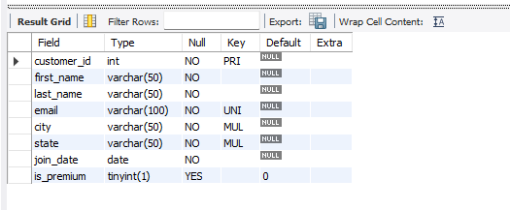

DESCRIBE products;
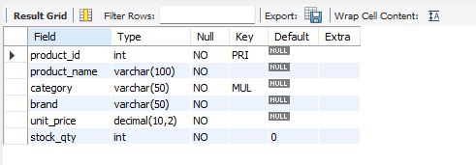

DESCRIBE orders;
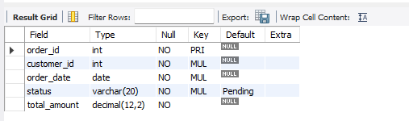

DESCRIBE order_items;
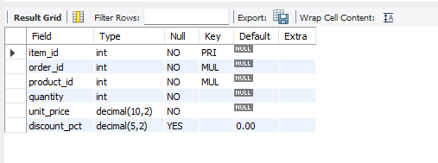

- Apply WHERE Filters: Filter data based on region, category, order date, and sales.

SELECT * FROM customers WHERE state = 'Maharashtra';
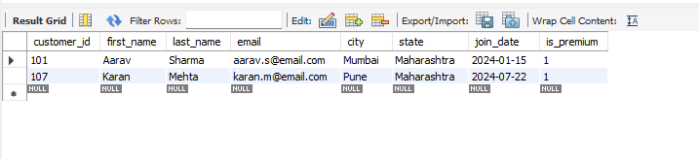

SELECT * FROM products WHERE category = 'Electronics';
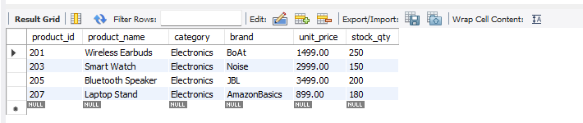

SELECT * FROM orders WHERE order_date BETWEEN '2024-08-01' AND '2024-08-31';
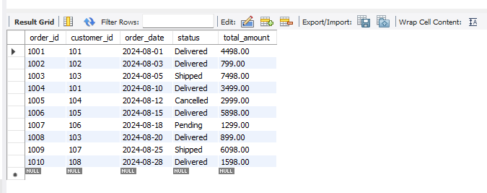

SELECT * FROM orders WHERE total_amount > 1000;
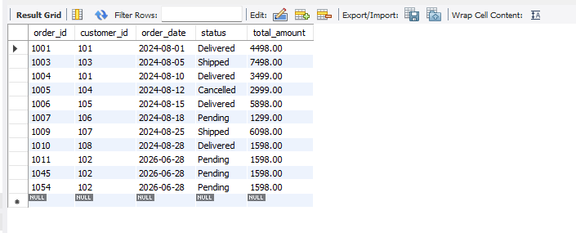

SELECT * FROM customers WHERE is_premium = TRUE;
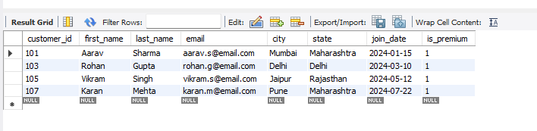

- Perform Aggregations: Use GROUP BY to calculate total sales, total quantity, and average
sales.
SELECT status,SUM(total_amount) AS total_sales FROM orders GROUP BY status;
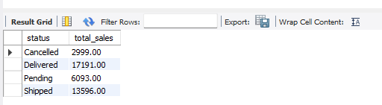

SELECT product_id,SUM(quantity) AS total_quantity FROM order_item GROUP BY product_id;

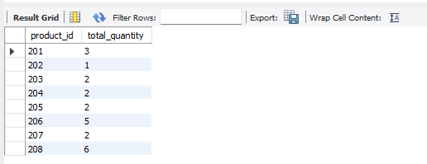

SELECT AVG(total_amount) AS average_order_value FROM orders;

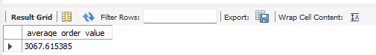

SELECT customer_id,SUM(total_amount) AS total_sales FROM orders GROUP BY customer_id;

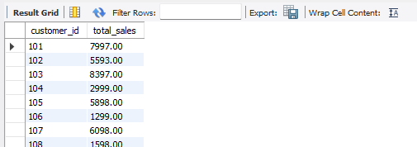

SELECT category,COUNT(*) AS total_products FROM products GROUP BY category;

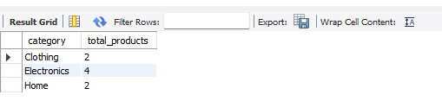

- Sort and Limit Results: Identify top products, top categories, and highest sales using ORDER BY and LIMIT.

SELECT * FROM products ORDER BY unit_price DESC LIMIT 5;

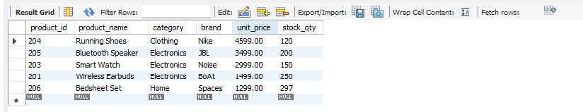

SELECT * FROM orders ORDER BY total_amount DESC LIMIT 5;
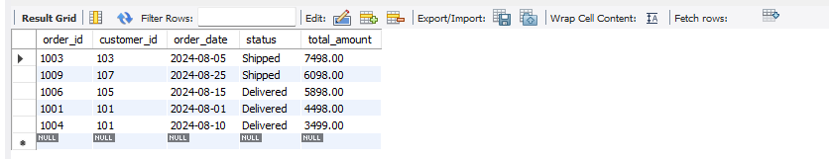

SELECT customer_id,SUM(total_amount) AS total_spent FROM orders GROUP BY customer_id ORDER BY total_spent DESC LIMIT 5;

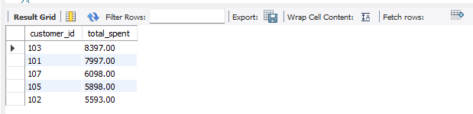

SELECT category,COUNT(*) AS total_products FROM products GROUP BY category
ORDER BY total_products DESC;

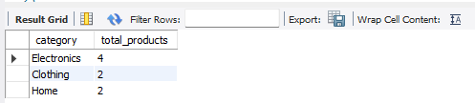

- Solve Business Use Cases: Analyze monthly sales trends, identify top customers, and detect duplicate records.

SELECT YEAR(order_date) AS Year, MONTH(order_date) AS Month, SUM(total_amount) AS Monthly_Sales FROM orders GROUP BY YEAR(order_date), MONTH(order_date) ORDER BY Year, Month;
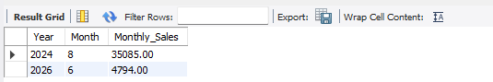

SELECT c.customer_id, CONCAT(c.first_name,' ',c.last_name) AS Customer_Name, SUM(o.total_amount) AS Total_Spent FROM customers c JOIN orders o ON c.customer_id=o.customer_id GROUP BY c.customer_id, Customer_Name ORDER BY Total_Spent DESC LIMIT 5;

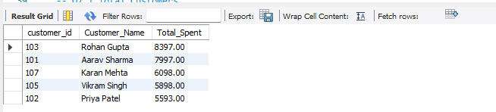

SELECT p.product_id, p.product_name, SUM(oi.quantity) AS Total_Quantity_Sold FROM products p JOIN order_items oi ON p.product_id=oi.product_id GROUP BY p.product_id, p.product_name ORDER BY Total_Quantity_Sold DESC;
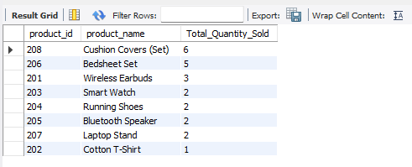

SELECT email, COUNT(*) AS Duplicate_Count FROM customers GROUP BY email HAVING COUNT(*)>1;
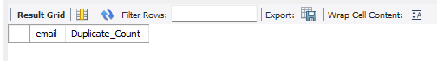

SELECT order_id, COUNT(product_id) AS Number_Of_Products FROM order_items GROUP BY order_id HAVING COUNT(product_id)>1;

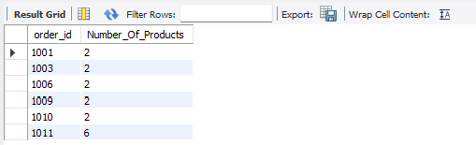

- Validate Results: Verify row counts, check for duplicates, and perform basic data quality checks.
SELECT COUNT(*) AS Total_Customers FROM customers;

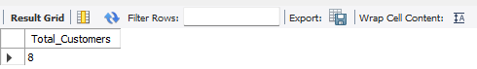

SELECT COUNT(*) AS Total_Products FROM products;
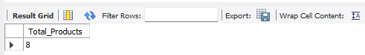

SELECT COUNT(*) AS Total_Orders FROM orders;

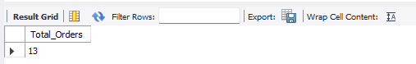

SELECT COUNT(*) AS Total_Order_Items FROM order_items;

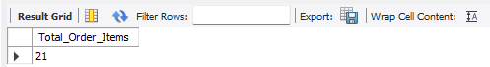

SELECT * FROM customers WHERE email IS NULL;
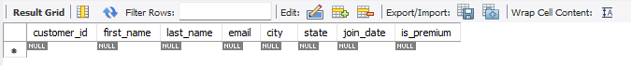

SELECT * FROM products WHERE stock_qty < 0;
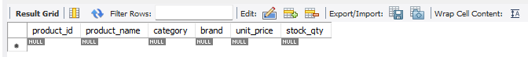

SELECT * FROM orders WHERE total_amount < 0;
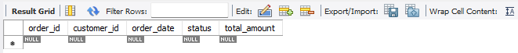

SELECT oi.* FROM order_items oi LEFT JOIN orders o ON oi.order_id=o.order_id WHERE o.order_id IS NULL;
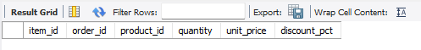

SELECT oi.* FROM order_items oi LEFT JOIN products p ON oi.product_id=p.product_id WHERE p.product_id IS NULL;
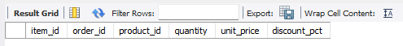

SELECT product_id, COUNT(*) AS Duplicate_Count FROM products GROUP BY product_id HAVING COUNT(*)>1;
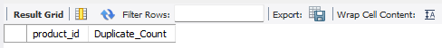

Task 2 from Word File

use week2_assignment;
CREATE TABLE customers (
customer_id INT PRIMARY KEY,
first_name VARCHAR(50) NOT NULL,
last_name VARCHAR(50) NOT NULL,
email VARCHAR(100) UNIQUE NOT NULL,
city VARCHAR(50) NOT NULL,
state VARCHAR(50) NOT NULL,
join_date DATE NOT NULL,
is_premium BOOLEAN DEFAULT FALSE
);

-- Index for filtering by city/state
CREATE INDEX idx_customers_city ON customers(city);
CREATE INDEX idx_customers_state ON customers(state);

CREATE TABLE products (
product_id INT PRIMARY KEY,
product_name VARCHAR(100) NOT NULL,
category VARCHAR(50) NOT NULL,
brand VARCHAR(50) NOT NULL,
unit_price DECIMAL(10,2) NOT NULL CHECK (unit_price > 0),
stock_qty INT NOT NULL DEFAULT 0 CHECK (stock_qty >= 0)
);

-- Index for filtering by category
CREATE INDEX idx_products_category ON products(category);

CREATE TABLE orders (
order_id INT PRIMARY KEY,
customer_id INT NOT NULL,
order_date DATE NOT NULL,
status VARCHAR(20) NOT NULL DEFAULT 'Pending'
CHECK (status IN ('Pending','Shipped','Delivered','Cancelled')),
total_amount DECIMAL(12,2) NOT NULL CHECK (total_amount >= 0),

FOREIGN KEY (customer_id) REFERENCES customers(customer_id)
);

-- Index for date-based filtering and sorting
CREATE INDEX idx_orders_date ON orders(order_date);
CREATE INDEX idx_orders_status ON orders(status);

CREATE TABLE order_items (
item_id INT PRIMARY KEY,
order_id INT NOT NULL,
product_id INT NOT NULL,
quantity INT NOT NULL CHECK (quantity > 0),
unit_price DECIMAL(10,2) NOT NULL CHECK (unit_price > 0),
discount_pct DECIMAL(5,2) DEFAULT 0 CHECK (discount_pct BETWEEN 0 AND 100),

FOREIGN KEY (order_id) REFERENCES orders(order_id),
FOREIGN KEY (product_id) REFERENCES products(product_id)
);

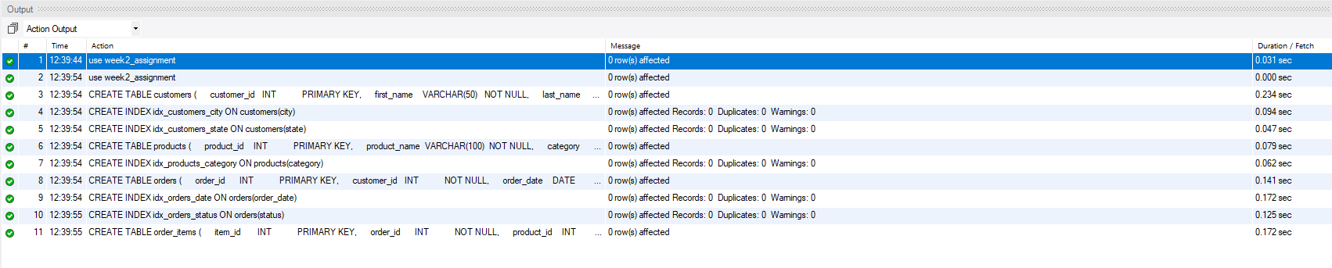
-- ========== INSERT: customers ==========
INSERT INTO customers VALUES
(101, 'Aarav', 'Sharma', 'aarav.s@email.com', 'Mumbai', 'Maharashtra', '2024-01-15', TRUE),
(102, 'Priya', 'Patel', 'priya.p@email.com', 'Ahmedabad', 'Gujarat', '2024-02-20', FALSE),
(103, 'Rohan', 'Gupta', 'rohan.g@email.com', 'Delhi', 'Delhi', '2024-03-10', TRUE),
(104, 'Sneha', 'Reddy', 'sneha.r@email.com', 'Hyderabad', 'Telangana', '2024-04-05', FALSE),
(105, 'Vikram', 'Singh', 'vikram.s@email.com', 'Jaipur', 'Rajasthan', '2024-05-12', TRUE),
(106, 'Ananya', 'Iyer', 'ananya.i@email.com', 'Chennai', 'Tamil Nadu', '2024-06-18', FALSE),
(107, 'Karan', 'Mehta', 'karan.m@email.com', 'Pune', 'Maharashtra', '2024-07-22', TRUE),
(108, 'Divya', 'Nair', 'divya.n@email.com', 'Kochi', 'Kerala', '2024-08-30', FALSE);

-- ========== INSERT: products ==========
INSERT INTO products VALUES
(201, 'Wireless Earbuds', 'Electronics', 'BoAt', 1499.00, 250),
(202, 'Cotton T-Shirt', 'Clothing', 'Levis', 799.00, 500),
(203, 'Smart Watch', 'Electronics', 'Noise', 2999.00, 150),
(204, 'Running Shoes', 'Clothing', 'Nike', 4599.00, 120),
(205, 'Bluetooth Speaker', 'Electronics', 'JBL', 3499.00, 200),
(206, 'Bedsheet Set', 'Home', 'Spaces', 1299.00, 300),
(207, 'Laptop Stand', 'Electronics', 'AmazonBasics', 899.00, 180),
(208, 'Cushion Covers (Set)', 'Home', 'HomeCenter', 599.00, 400);

-- ========== INSERT: orders ==========
INSERT INTO orders VALUES
(1001, 101, '2024-08-01', 'Delivered', 4498.00),
(1002, 102, '2024-08-03', 'Delivered', 799.00),
(1003, 103, '2024-08-05', 'Shipped', 7498.00),
(1004, 101, '2024-08-10', 'Delivered', 3499.00),
(1005, 104, '2024-08-12', 'Cancelled', 2999.00),
(1006, 105, '2024-08-15', 'Delivered', 5898.00),
(1007, 106, '2024-08-18', 'Pending', 1299.00),
(1008, 103, '2024-08-20', 'Delivered', 899.00),
(1009, 107, '2024-08-25', 'Shipped', 6098.00),
(1010, 108, '2024-08-28', 'Delivered', 1598.00);

-- ========== INSERT: order_items ==========
INSERT INTO order_items VALUES
(5001, 1001, 201, 2, 1499.00, 0),
(5002, 1001, 207, 1, 899.00, 10),
(5003, 1002, 202, 1, 799.00, 0),
(5004, 1003, 203, 1, 2999.00, 0),
(5005, 1003, 204, 1, 4599.00, 5),
(5006, 1004, 205, 1, 3499.00, 0),
(5007, 1005, 203, 1, 2999.00, 0),
(5008, 1006, 201, 1, 1499.00, 10),
(5009, 1006, 204, 1, 4599.00, 5),
(5010, 1007, 206, 1, 1299.00, 0),
(5011, 1008, 207, 1, 899.00, 0),
(5012, 1009, 205, 1, 3499.00, 0),
(5013, 1009, 208, 2, 599.00, 15),
(5014, 1010, 206, 1, 1299.00, 0),
(5015, 1010, 208, 1, 599.00, 0);
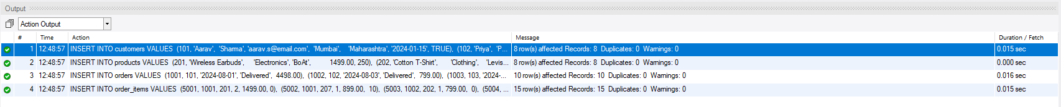

Section A — SQL Basics (SELECT, Constraints, Primary Keys)
These questions test your understanding of basic data retrieval, table structure, and database constraints.
Q1. Write a query to display all columns and rows from the customer's table.

SELECT * FROM customers;

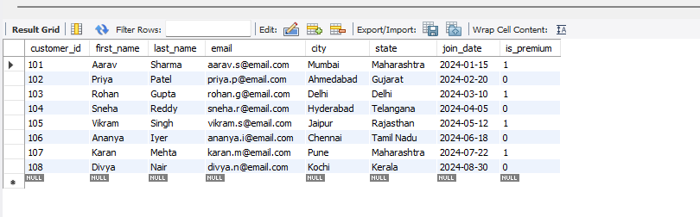

Q2. Retrieve only the first_name, last_name, and city of all customers.

SELECT first_name,last_name,city FROM customers;

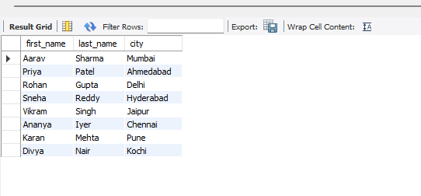

Q3. List all unique categories available in the products table.

SELECT DISTINCT category FROM products;

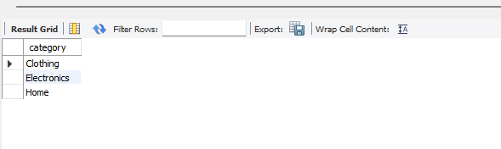

Q4. Identify the Primary Key of each table in the schema. Explain why a Primary Key must be unique and NOT NULL.
Answer:
The Primary Key of each table is defined in its CREATE TABLE statement. The primary keys in the schema are:
- Customer table: customer_id
- Product table: product_id
- Orders table: order_id
- Order_Items table: item_id

A Primary Key must be unique and NOT NULL because it uniquely identifies each record in a table. The Uniqueness prevents duplicate records, while the NOT NULL constraint ensures that every row has a valid identifier and the primary key is not left empty while inserting the data to the table. This helps maintain data integrity and enables accurate relationships between tables through foreign keys.

Q5. What constraints are applied to the email column in the customers table? What would happen if you tried to insert a duplicate email?
Answer:
The email column in the customers table has the following constraints:
- UNIQUE – Ensures that each email address is unique and cannot be repeated in the table.
- NOT NULL – Ensures that every customer must have an email address, NULL values are not allowed.
If you try to insert a duplicate email address, the database will reject the operation and return a UNIQUE constraint violation error. This prevents duplicate customer records and helps maintain data integrity.
Example if duplicate email inserted:
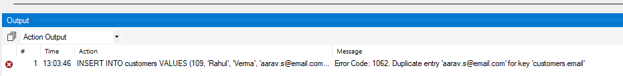

Q6. Try inserting a product with unit_price = -50. What happens and which constraint prevents it? Write both the INSERT statement and explain the error.

INSERT INTO products VALUES (209, 'USB Cable', 'Electronics', 'Boat', -50, 100);

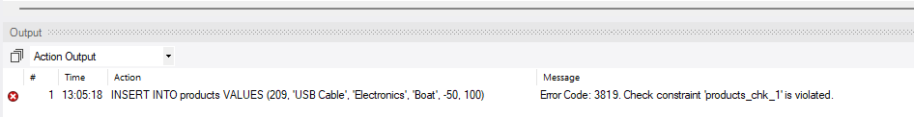

Explanation:
When this statement is executed, the database rejects the insertion and displays the following error:
Error Code: 3819. Check constraint 'products_chk_1' is violated.
This occurs because the unit_price column has the following constraint:
CHECK (unit_price > 0)
The value -50 does not satisfy this condition since the unit price must be greater than zero. The CHECK constraint (products_chk_1) prevents invalid data from being inserted into the table, ensuring that all product prices are positive or greater than 0.

Section B — Filtering & Optimization (WHERE, Indexes)
These questions test your ability to filter data effectively and understand how indexes improve query performance.

Q7. Retrieve all orders with status = 'Delivered'.

SELECT * FROM orders WHERE status = 'Delivered';

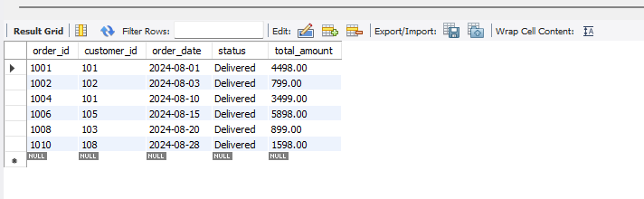

Q8. Find all products in the 'Electronics' category with a unit_price greater than ₹2000.

SELECT * FROM products WHERE category = 'Electronics' AND unit_price > 2000;

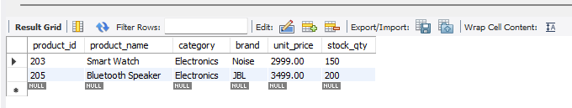

Q9. List all customers who joined in the year 2024 and belong to the state 'Maharashtra'.

SELECT * FROM customers WHERE join_date BETWEEN '2024-01-01' AND '2024-12-31'
AND state = 'Maharashtra';

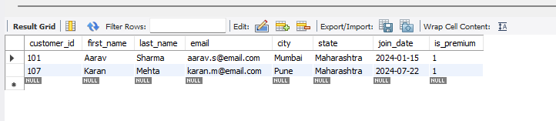

Q10. Find all orders placed between '2024-08-10' and '2024-08-25' (inclusive) that are NOT cancelled.

SELECT * FROM orders WHERE order_date BETWEEN '2024-08-10' AND '2024-08-25'
AND status <> 'Cancelled';

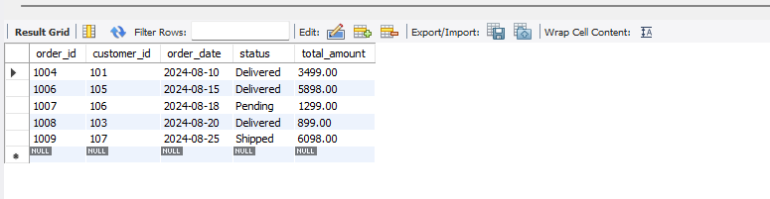

Q11. Explain what the index idx_orders_date does. How would it improve the performance of a query that filters orders by order_date? Write a sample query that would benefit from this index.
Answer:
The idx_orders_date index is created on the order_date column in the orders table.
CREATE INDEX idx_orders_date ON orders(order_date);
This index makes searching for orders by date faster. Instead of checking every row in the table, the database uses the index to directly find the matching records. This improves the performance of queries that filter orders based on the order_date, especially when the table has a large amount of data.
Example Query:
SELECT * FROM orders WHERE order_date BETWEEN '2024-08-10' AND '2024-08-25';
This query uses the order_date column in the WHERE clause, so the idx_orders_date index helps retrieve the matching records more quickly.

Q12. If you run: SELECT * FROM customers WHERE YEAR(join_date) = 2024; — would the index on join_date be used? Explain why or why not, and rewrite the query to be index-friendly (SARGable).

Answer:
No, the index on join_date would not be used because the YEAR() function is applied to the join_date column. When a function is used on an indexed column, the database cannot use the index properly and has to check every row in the table.

SELECT * FROM customers WHERE YEAR(join_date) = 2024;

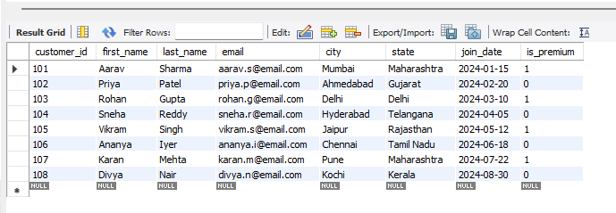

A better way to write the query is:

SELECT * FROM customers WHERE join_date BETWEEN '2024-01-01' AND '2024-12-31';

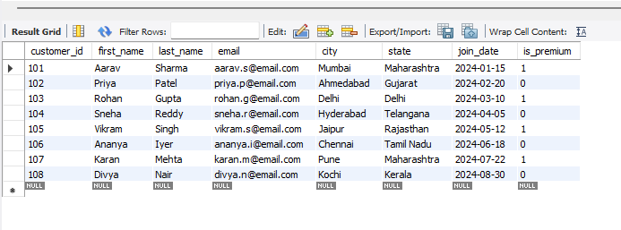

This query is SARGable because it compares the join_date column directly without using any function. If there is an index on join_date, the database can use it to find the required records faster.

Section C — Aggregation (GROUP BY, SUM, COUNT, AVG, MIN, MAX)
These questions test your ability to summarize and aggregate data.

Q13. Count the total number of orders in the orders table.

SELECT COUNT(*) AS total_orders FROM orders;

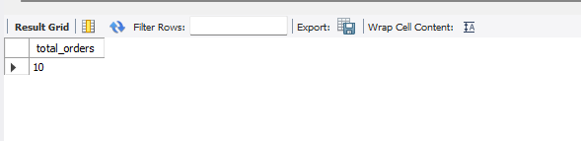

Q14. Find the total revenue (SUM of total_amount) from all ‘Delivered’ orders.

SELECT SUM(total_amount) AS total_revenue FROM orders WHERE status = 'Delivered';

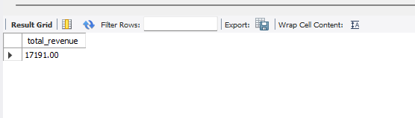

Q15. Calculate the average unit_price of products in each category.

SELECT category, AVG(unit_price) AS average_price FROM products GROUP BY category;

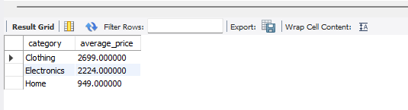v

Q16. For each order status, find the count of orders and the total revenue. Sort the result by total revenue in descending order.

SELECT status, COUNT(*) AS order_count, SUM(total_amount) AS total_revenue FROM orders GROUP BY status ORDER BY total_revenue DESC;

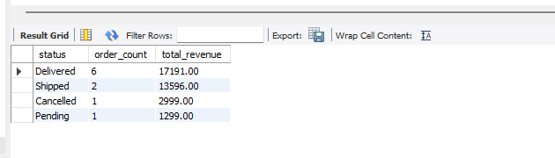

Q17. Find the most expensive (MAX) and cheapest (MIN) product in each category.

SELECT category, MAX(unit_price) AS highest_price, MIN(unit_price)
AS lowest_price FROM products GROUP BY category;

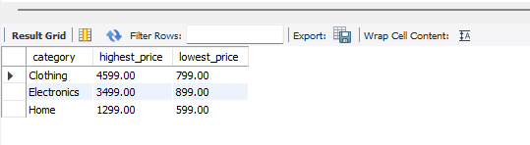

Q18. List all product categories where the average unit_price is greater than ₹2000. (Hint: Use HAVING clause)

SELECT category, AVG(unit_price) AS average_price FROM products GROUP BY category HAVING AVG(unit_price) > 2000;

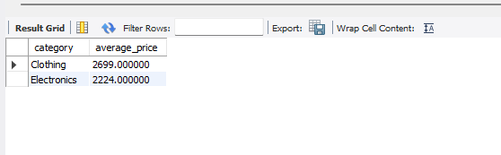

Section D — Joins & Relationships
These questions test your ability to combine data from multiple tables using different types of JOINs.
Q19. Write an INNER JOIN query to display each order along with the customer's first_name and last_name. Show: order_id, order_date, first_name, last_name, total_amount.

SELECT o.order_id, o.order_date, c.first_name, c.last_name, o.total_amount FROM orders o INNER JOIN customers c ON o.customer_id = c.customer_id;
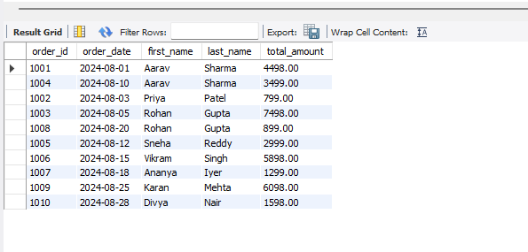

Q20. Using a LEFT JOIN, list ALL customers and their orders (if any). Customers with no orders should still appear with NULL values for order columns.

SELECT c.customer_id, c.first_name, c.last_name, o.order_id, o.order_date, o.status, o.total_amount FROM customers c LEFT JOIN orders o ON c.customer_id = o.customer_id;

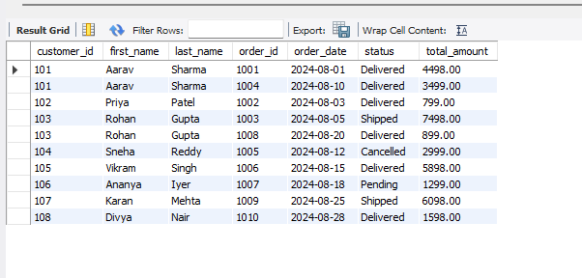

Q21. Write a query using JOINs across three tables (orders → order_items → products) to show: order_id, product_name, quantity, unit_price, and discount_pct for each order item.

SELECT o.order_id, p.product_name, oi.quantity, oi.unit_price, oi.discount_pct
FROM orders o JOIN order_items oi ON o.order_id = oi.order_id JOIN products p
ON oi.product_id = p.product_id;

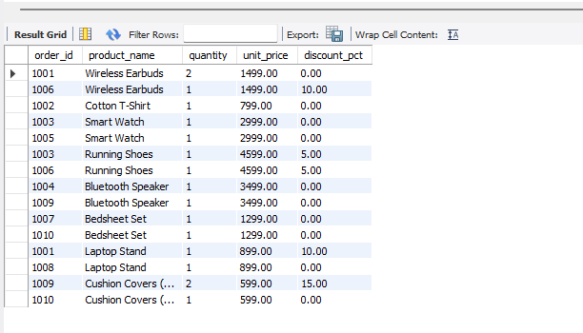

Q22. Explain the difference between LEFT JOIN and RIGHT JOIN with an example from this schema. When would you use a FULL OUTER JOIN?
Answer:
- A LEFT JOIN returns all records from the left table and the matching records from the right table. If there is no matching record in the right table, the result will contain NULL values.
Example:
SELECT c.customer_id, c.first_name, o.order_id FROM customers c LEFT JOIN
orders o ON c.customer_id = o.customer_id;
This query shows all customers, even if they have not placed any orders.

- A RIGHT JOIN returns all records from the right table and the matching records from the left table. If there is no matching record in the left table, the result will contain NULL values.
Example:
SELECT c.customer_id, c.first_name, o.order_id FROM customers c
RIGHT JOIN orders o ON c.customer_id = o.customer_id;
This query shows all orders, even if there is no matching customer.

- A FULL OUTER JOIN returns all records from both tables. If a row does not have a matching row in the other table, the missing values are shown as NULL.

- A FULL OUTER JOIN is used when we want to see all customers and all orders, including customers who have not placed any orders and orders that do not have a matching customer.

Q23. Identify all Foreign Key relationships in the schema. Explain what would happen if you tried to insert an order with customer_id = 999 (which doesn't exist in customers).
Answer:
The schema has the following Foreign Key relationships:
- orders.customer_id references customers.customer_id
- order_items.order_id references orders.order_id
- order_items.product_id references products.product_id
These foreign keys ensure that the related record exists in the parent table before a record can be inserted into the child table.
If you try to insert an order with customer_id = 999 and that customer does not exist in the customers table, the database will reject the insertion and display a Foreign Key constraint error.
Example:
INSERT INTO orders VALUES (101, 999, '2024-08-20', 'Pending', 500.00);
Since customer_id = 999 is not present in the customers table, the insert operation will fail. This helps maintain referential integrity by preventing orders from being linked to non-existent customers.

Section E — Advanced Concepts (CASE, ACID, Transactions)
These questions test your understanding of conditional logic, database reliability principles, and transaction management.

Q24. Write a query using CASE to classify products into price tiers:
• 'Budget' : unit_price < 1000
• 'Mid-Range' : unit_price BETWEEN 1000 AND 3000
• 'Premium' : unit_price > 3000
Display: product_name, unit_price, price_tier.

SELECT product_name, unit_price, CASE WHEN unit_price < 1000 THEN 'Budget'
WHEN unit_price BETWEEN 1000 AND 3000 THEN 'Mid-Range' ELSE 'Premium'
END AS price_tier FROM products;

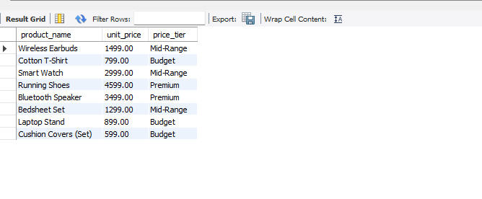

Q25. Using a CASE statement inside an aggregate function, count how many orders are 'Delivered' vs 'Not Delivered' (all other statuses). Display the result in a single row.

SELECT SUM(CASE WHEN status = 'Delivered' THEN 1 ELSE 0 END)
AS delivered_orders, SUM(CASE WHEN status <> 'Delivered' THEN 1 ELSE 0 END)
AS not_delivered_orders FROM orders;

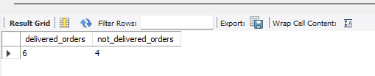

Q26. Explain each letter of ACID:
• A – Atomicity
• C – Consistency
• I – Isolation
• D – Durability
Give a real-world example (e.g., bank transfer) showing why each property is important.
Answer:
ACID is a set of properties that ensures database transactions are processed correctly and reliably.
- A – Atomicity:
A transaction is completed fully or not at all. If any part of the transaction fails, all changes are rolled back.
- C – Consistency:
A transaction moves the database from one valid state to another, ensuring that all rules and constraints are maintained.
- I – Isolation:
Multiple transactions can run at the same time without affecting each other. One transaction should not interfere with another.
- D – Durability:
Once a transaction is committed, the changes are permanently saved, even if there is a system crash or power failure.
Real-World Example
Bank Transfer:
Suppose ₹5,000 is transferred from Account A to Account B.
- Atomicity: If the money is deducted from Account A but cannot be added to Account B due to an error, the entire transaction is cancelled, and the ₹5,000 is returned to Account A.
- Consistency: After the transfer, the total money in both accounts remains correct, and no invalid data is created.
- Isolation: If two people are transferring money at the same time, each transaction is processed independently without affecting the other.
- Durability: Once the transfer is completed successfully, it is permanently stored in the database and will not be lost even if the system crashes immediately afterward.
Q27. Write a SQL transaction that does the following atomically:
1. Insert a new order (order_id=1011, customer_id=102, today's date, 'Pending', 1598.00)
2. Insert two order items for that order
3. Update the stock_qty of the purchased products
4. If any step fails, ROLLBACK the entire transaction. Otherwise, COMMIT.
Write the complete BEGIN...COMMIT/ROLLBACK block.
START TRANSACTION;
INSERT INTO orders VALUES (1054, 102, CURDATE(), 'Pending', 1598.00);
INSERT INTO order_items VALUES (5043, 1011, 206, 1, 1299.00, 0);
INSERT INTO order_items VALUES (50, 1011, 208, 1, 299.00, 0);
UPDATE products SET stock_qty = stock_qty – 1 WHERE product_id = 206;
UPDATE products SET stock_qty = stock_qty – 1 WHERE product_id = 208;
COMMIT;

