Celebal Excellence Internship
Data Engineer
Week 5 Assignment

Name | Yadnyesh Sawant
Student ID | CT_CSI_DE_1015
Domain | Data Engineering
Batch | Batch 1
Start Date | 15/6/2026
Status | Active
Contact No | 8888047246
Email ID | 1272250066@mitwpu.edu.in
College Name | MIT-WPU
Stream | MCA
Passing Out Year | 2027

Q1: What are the key limitations of traditional MapReduce that make Spark a preferred choice for modern big data processing?
Answer:
Traditional MapReduce is a framework used to process large amounts of data, but it has some limitations that make it less efficient for modern applications.
The main limitations are:
- High Disk Usage: MapReduce stores intermediate results on disk after every processing stage, which increases execution time.
- Slower Performance: Frequent disk read/write operations make MapReduce slower, especially for large datasets.
- Not Suitable for Iterative Tasks: Machine learning and data analysis often require multiple iterations, but MapReduce reads data from disk every time, reducing efficiency.
- Complex Programming Model: Developers need to write separate Map and Reduce functions, making the code lengthy and difficult to maintain.
- Limited Real-Time Processing: MapReduce is mainly designed for batch processing and is not suitable for real-time analytics.
Why Spark is Preferred:
Apache Spark overcomes these limitations by using in-memory processing, which stores intermediate data in RAM instead of writing it to disk after every step. This makes Spark much faster and more efficient. Spark also provides easy-to-use APIs in Python, Java, Scala, and R, supports real-time processing, machine learning, SQL, and graph processing within a single framework.
Q2: Explain how Spark uses In-Memory Computing to speed up iterative machine learning algorithms compared to disk-based systems.
Answer:
Apache Spark uses In-Memory Computing, which means it stores intermediate data in the system's RAM instead of writing it to disk after every operation. This reduces the time required to read and write data, resulting in much faster processing.
In machine learning, algorithms often need to process the same dataset multiple times before producing the final result. In a disk-based system like MapReduce, the data is read from and written to disk during every iteration, which increases execution time.
In contrast, Spark keeps the data in memory and reuses it for each iteration. This minimizes disk I/O operations and significantly improves performance. As a result, Spark can execute iterative machine learning algorithms much faster than traditional disk-based systems.

Q3: Write a code snippet to remove all duplicate rows from a DataFrame based on a specific set of columns: user_id and transaction_date.
Answer: used superset dataset, so columns used in the questions are
"Customer ID", "Order Date"

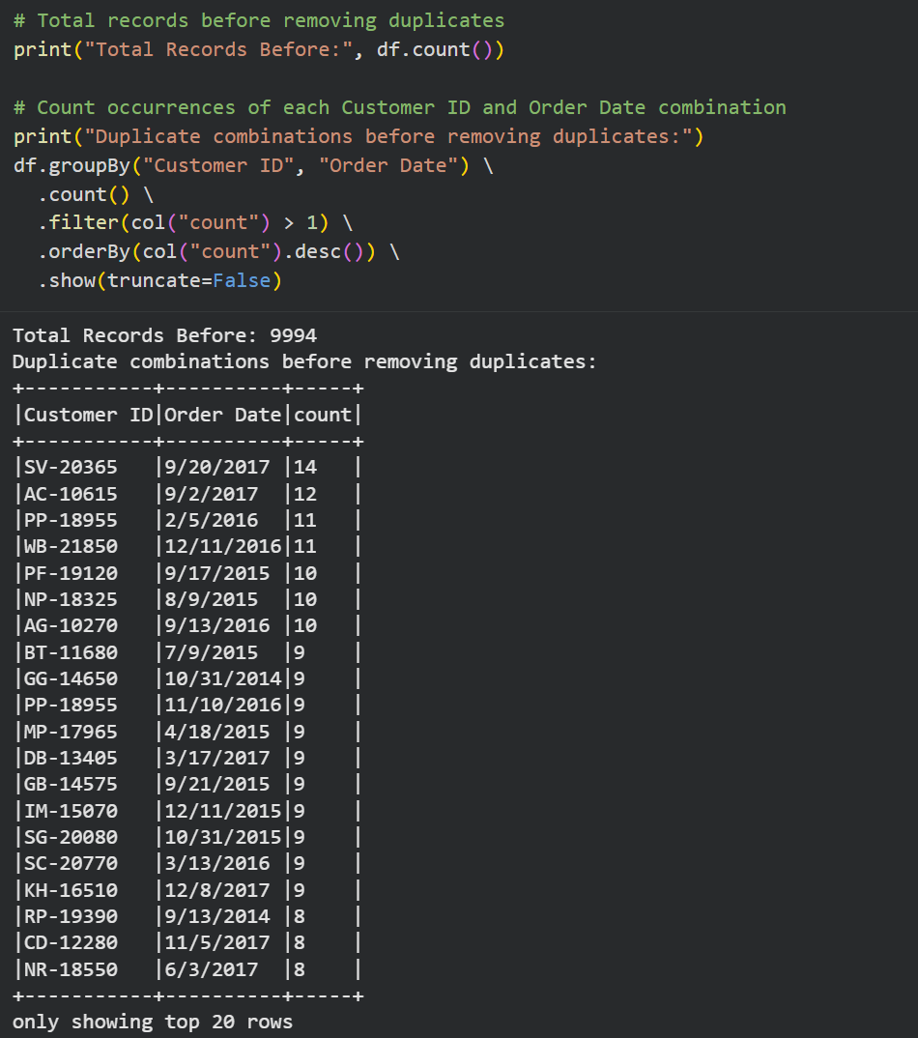

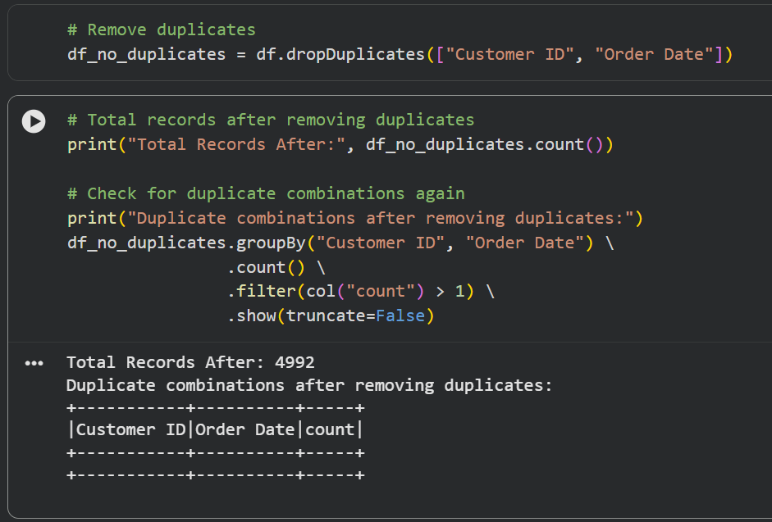
Q4: Given a DataFrame df_sales, write a query to filter for rows where the region is 'West' and then group by product_category to find the average sale_amount.
Answer:
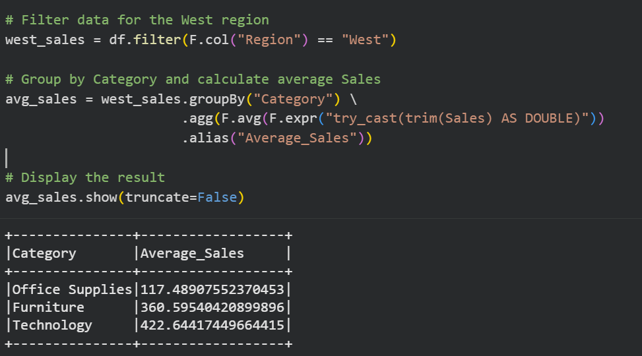

Q5: What is the difference between .na.drop() and .na.fill()? Provide a code example of filling null values in a status column with the string 'Unknown'.
Answer:
- .na.drop() removes rows that contain null values in one or more columns. It is useful when incomplete records should not be included in the analysis.
- .na.fill() replaces null values with a specified value instead of removing the entire row. This helps preserve data while handling missing values.
In the Superstore dataset, there is no Status column. Therefore, the Category column is used to demonstrate the na.fill() operation.
Q6: Write a query to find the total count of records for each city in a DataFrame, but only for cities where the count is greater than 100
Answer:
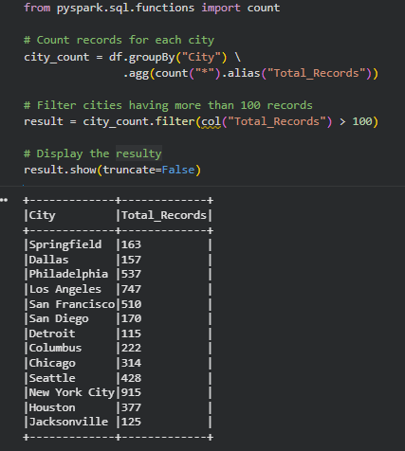
Q7: How does the immutability of Spark DataFrames affect how you perform "data cleaning" steps like dropping columns or renaming them?
Answer:
Spark DataFrames are immutable, which means their data cannot be changed after they are created. Instead of modifying the existing DataFrame, every operation such as dropping a column, renaming a column, or filtering data creates a new DataFrame.
During data cleaning, we need to assign the result of each operation to a new DataFrame or overwrite the existing DataFrame variable. The original DataFrame remains unchanged unless we explicitly replace it.
# Rename a column
df_renamed = df.withColumnRenamed("Sales", "Total_Sales")
# Drop a column
df_cleaned = df.drop("Postal Code")

In the above code:
- withColumnRenamed() creates a new DataFrame with the renamed column.
- drop() creates another new DataFrame without the specified column.
- The original df remains unchanged.

Q8: Write a Spark command to filter a dataset for rows where the age is between 18 and 30 (inclusive) and the subscription is 'Premium'.
Answer: Since the Superstore dataset does not contain Age and Subscription columns, the following code filters records where Region = 'West' and Category = 'Technology' to demonstrate the same filtering operation.
# Filter records where Region is 'West' and Category is 'Technology'
filtered_df = df.filter(
(col("Region") == "West") &
(col("Category") == "Technology")
)
# Display the filtered records
filtered_df.show(10, truncate=False)

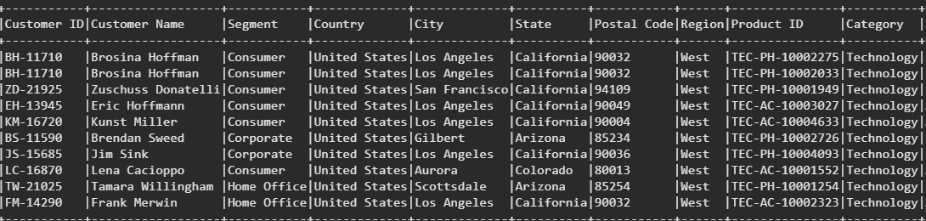

Q9: When cleaning a dataset, why is it often better to handle null values before performing mathematical aggregations like sum() or avg()?
Answer:
  - Handling null values before performing mathematical aggregations is important because null values can affect the accuracy of the results. If missing values are not handled properly, the calculated sum, average, or other statistics may not correctly represent the data.
  - By replacing or removing null values before aggregation, we ensure that the calculations are performed on clean and consistent data. This improves the reliability of the analysis and helps avoid unexpected results or errors during data processing.

Q10: Write the code to revise a column named raw_timestamp by casting it to a TimestampType and renaming it to event_time.
Answer: Since the Superstore dataset does not have a raw_timestamp column, I have used the Order Date column instead to demonstrate the same operation
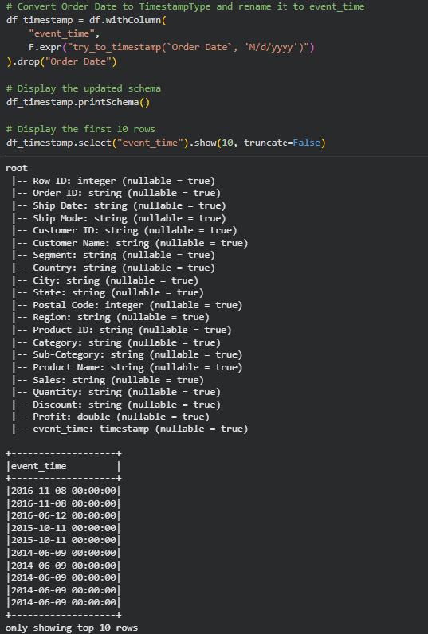

Q11: Explain the "Shuffle" process that occurs during a grouping operation. Why is it considered a wide transformation?
Answer:
In Apache Spark, shuffle is the process of moving data between different partitions during operations like groupBy(), join(), and reduceByKey(). When we perform a grouping operation, Spark collects all records with the same key and brings them together into the same partition before performing the calculation.
For example, if we group the Superstore dataset by Category, Spark moves all records belonging to the same category into one partition to calculate values such as total or average sales.
Shuffle is called a wide transformation because the output depends on data from multiple input partitions. Unlike narrow transformations, where data remains in the same partition, a wide transformation requires data to be transferred across different partitions. This data movement increases network communication and processing time, making shuffle one of the most expensive operations in Spark.
Example:
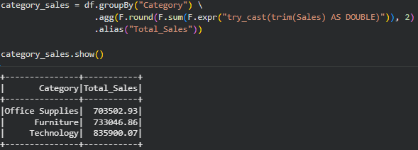
Q12: Write a code snippet that identifies and removes rows where the email column contains null values OR the username is an empty string.
Answer
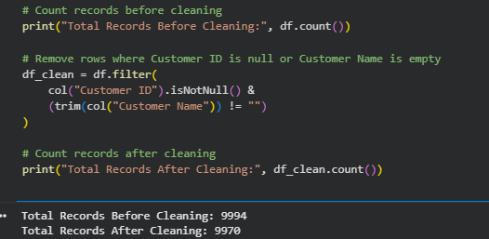
Q13: How do you use the .agg() function to calculate multiple statistics at once, such as the min, max, and mean of the price column?
Answer:
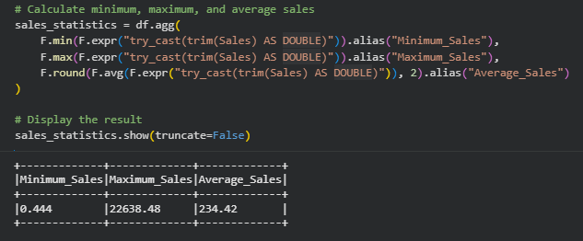
Q14: In the context of cleaning a dataset, what is the risk of using inferSchema=true when your source data contains messy or inconsistent date formats?
Answer:
The inferSchema=true option allows Spark to automatically detect the data type of each column while reading a dataset. This works well when the data is clean, but it can cause problems if the date column contains different date formats.
For example, if a dataset has dates like 01/05/2024, 2024-05-01, and May 1, 2024, Spark may not correctly identify the column as a date. Instead, it may treat the entire column as a string.
If the date column is stored as a string, operations like sorting, filtering, and date calculations may not work correctly. Therefore, it is better to convert the column to the required date or timestamp format manually using functions like to_date() or to_timestamp().
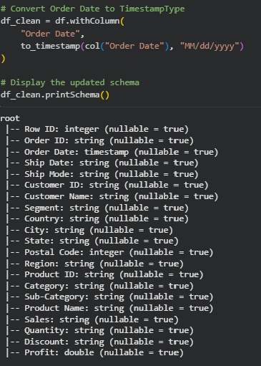
Q15: Write a final processing pipeline that:
- Filters out duplicates.
- Fills null prices with 0.
- Groups by store_id to calculate total revenue.
Answer:
