Game Design Document

Fill up the Following document

1. Write the title of your project.

Covid Destroyer

1. What is the goal of the game?

The goal of the game is to destroy corona virus

1. Write a brief story of your game?

Neighboring communities are suffering from Novel coronavirus (Covid - 19). Your community needs your help for protecting your community. Save your community by spraying disinfectant on the coronavirus.

1. Which are the playing characters of this game?

* Destroyer is the playing characters in the game.

|  |  |  |
| --- | --- | --- |
| Number | Character Name | What can this character do? |
| 1 | Destroyer | Sprays disinfectant |
| 2 | Disinfectant | Destroys the coronavirus |

1. Which are the Non Playing Characters of this game?

* coronavirus, PPE kit, Mask, Gloves are the non playing characters in the game.

|  |  |  |
| --- | --- | --- |
| Number | Character Name | What can this character do? |
| 1 | Coronavirus | Infects the Destroyer |
| 2 | PPE kit | It gives 2 lives |
| 3 | Mask | It gives a life |
| 4 | Gloves | It gives a life |

Draw your imagination of this game. What does this game look like?

* Draw the game either on your computer or on paper,
* Add images of scenes of the game to show each of the playing and non-playing characters at least once.

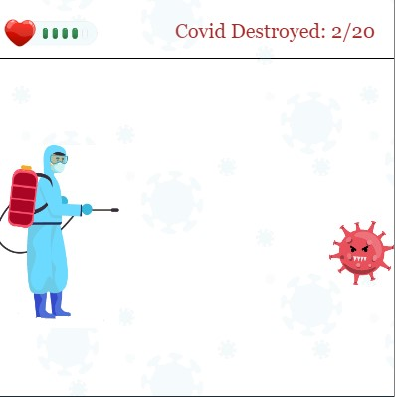

How do you plan to make your game engaging?

We all know that the world is suffering from Covid-19.

This is a game where you can destroy the coronavirus and save your community from the pandemic.