<!DOCTYPE html>

<html>

<head>

<meta charset="utf-8">

<meta name="Viewport" content="width=device-width, initial scale=1.0">

<meta http-equiv="X-UA-Comaptible" content="ie-edge">

<title>Document</title>

</head>

<body>

</body>

</html>

“<!DOCTYPE html>

” tells that document is html

“head” contains metadata and some links, styling some script

“body” in here you write your code to design application

“<meta name="Viewport" content="width=device-width, initial scale=1.0">

“ above line tells fit the html content into device screen

Title will be shown in brwoser window, if you don’t give filename for html by default filename will be printed, here you have given Document so it will get printed.

Writing text in website page

For heading we got different tags like h1 h2,….

Executing in Sublime text After typing-> right click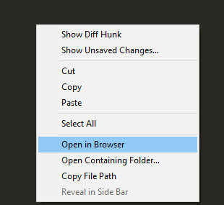

Always save file and Execute, then only you can see changes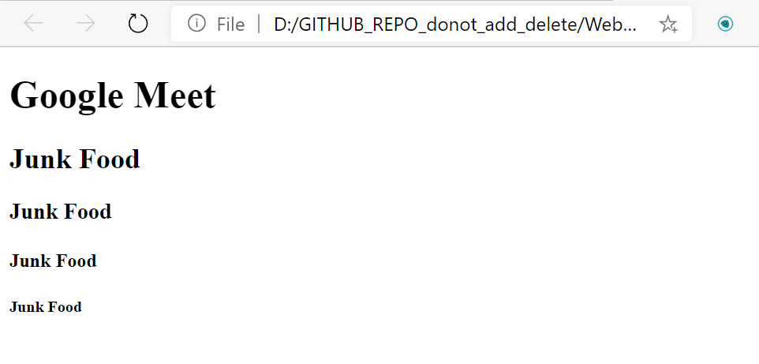

To change browser-> right click on file in folder-> click open with-> select browser.

To make pages stylish

<div> defines a section

#landing-section {

background-color: rgb(78, 172, 221);

which gives background color to text

<!DOCTYPE html>

<html>

<head>

<meta charset="utf-8">

<meta name="Viewport" content="width=device-width, initial scale=1.0">

<meta http-equiv="X-UA-Comaptible" content="ie-edge">

<title>My First Website</title>

<style>

#landing-section {

background-color: rgb(78, 172, 221);

}

#landing-section-heading {

font-family: "Dr Sugiyama", cursive;

color: rgb(255,255,234);

font-size: 62px;

font-weight: 500;

line-height: 1.1;

}

</style>

</head>

<body>

<div id='landing-section'>

<h1 id="landing-section-heading "> Google Meet</h1>

</div>

</body>

</html>

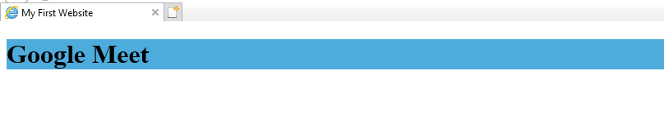

Giving width and height: