Seacrch with #1. or #that number to go to that topic.

#1. Introduce
#2. Create react app
#3. Components and Templates
#4. Dynamic values in Templates
#5. Multiple Components
#6. Adding Styles
#7. Click Events
#8. Using State
#9. React Dev Tools
#10. Outputting Lists
#11. Props
#12. Resusing Components
#13. Fuctions as Props
#14. UseEffect Hook
#15. UseEffect Dependencies
#16. Using Json Server
#17. Fetching Data with useEffect
#18. Conditional Loading messages
#19. Handling fetch errors
#20. Making a custom hook
#21. The React Router
#22. Exact Match routes
#23. Router Links
#24. UseEffect cleanup
#25. Route Parameters
#26. Reusing custom hooks
#27. Controlled inputs
#28. Submit events
#29. Making a post request
#30. Programatic redirects
#31. Deleting blogs
#32. Pages & next pages

Make this document as clean as possible for reading.

#1. Introduction.

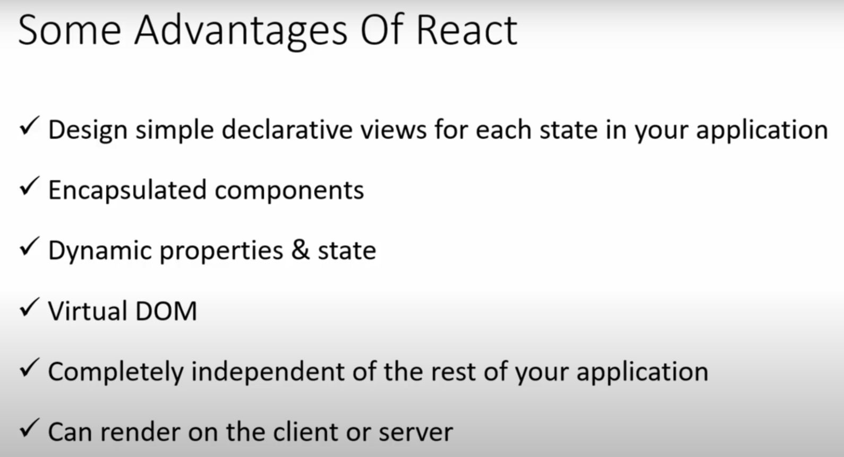

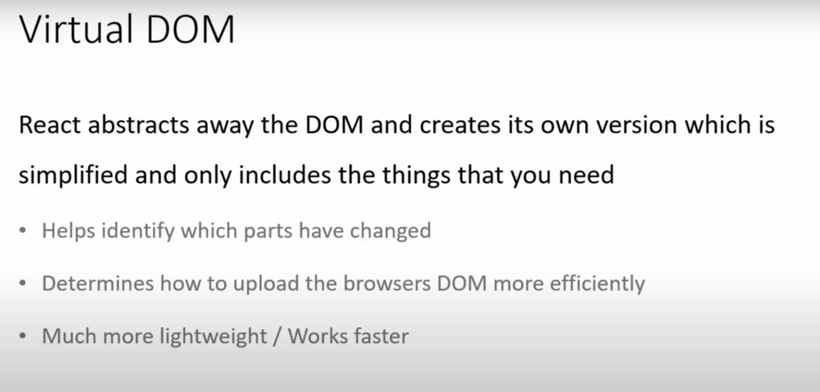

DOM : document object manipulation

When we update our components instead of refreshing entire app React can look at what change what are the changes in original dom which are new and then react will just re render this new part.

Install Simple React Snippet vs code extension in vs code

Inside vs code-> preferences -> settings -> type emmet and inside Emmet: Include Languages add
Item: javascript Value: javascriptreact
This allows us to use any inside React components when we generate template in jsx.

#2. Creating react app:

Create react app command :
Before using this we need to install nodejs in our system.

Terminal open this vs code new terminal

npx create-react-app my-blogs

Type cd my-blogs to go inside your projet

Inside project my-blogs : “node_modulues” this is where all of our project dependencies including react library live.
If we will install any package it’ll also live inside this folder.

“public” folder: all our public files, public to the browser including “index.html” will be here.

Index.html: this is one html file that will be served to the browser and then all of our react code will injected into this one file inside div with id=’root’
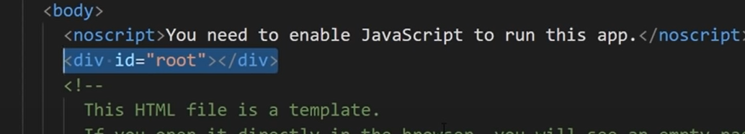

“src folder” : 99% of code which we write will go to this folder. All of our components will live here.

App.js this is how one component looks like.
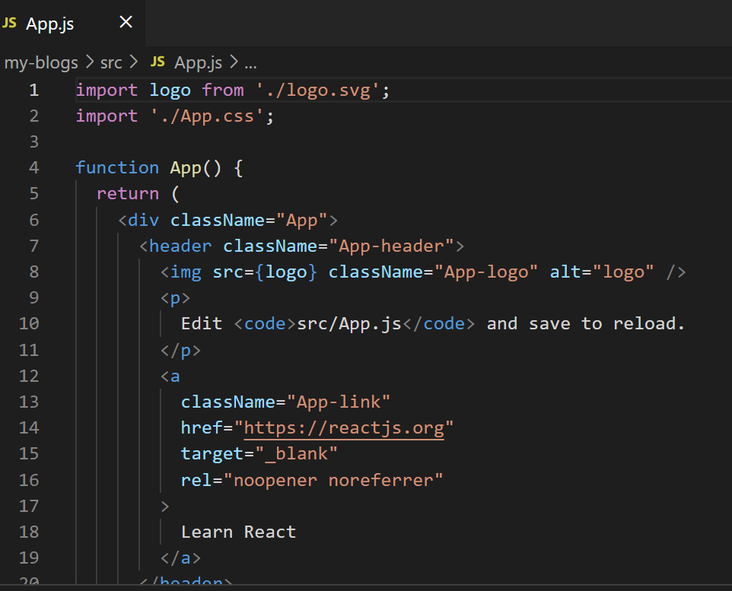

Inside this src folder we also have css file test file

We also have index.js file: this is kind of file which starts our react application. This file responsible to take all of our react components and mounting them to DOM
Inside index.js

ReactDOM.render(
<React.StrictMode>
<App />
</React.StrictMode>,
document.getElementById('root')
);

In above code we see <App /> which takes App component and it is render it to the ReactDOM and it does that it in ‘root’ div.

Where ‘root’ is id of div present inside public-> index.html that’s where it’s rendering

logo.svg is used inside app.js inside that component
We don’t need reportWebvital.js you can delete it if you delete that file delete inside index.js line
“import reportWebVitals from './reportWebVitals';

Next we have “setupTests.js” which also I don’t use it now.

Inside src-> index.js file we have
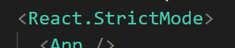

Means react does additional checks during development and gives us warning down in the console if there are any warnings reports.

We have “gitignore” version control with git.

After that we have “package.json” it does few things it lists all the dependencies of the application so anything our project depends on which all live inside node_modules so if you want you can delete node_modules but don’t delete package.json it’s very important.

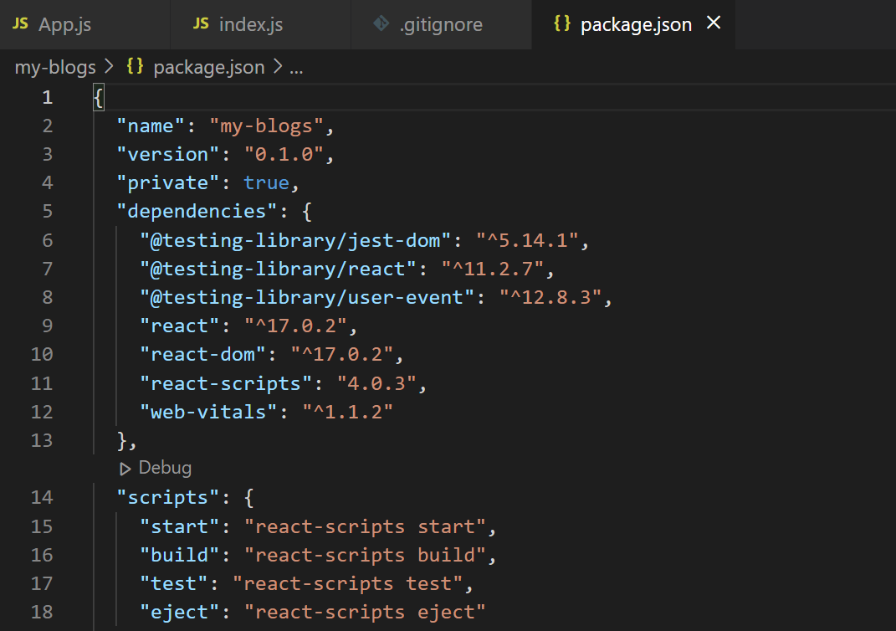

Inside that we have testing libraries.
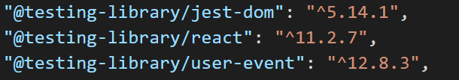

We also have scripts:
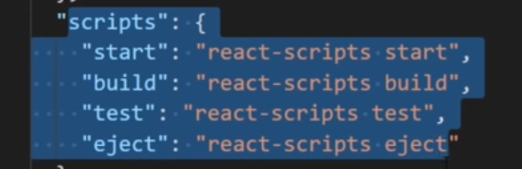

We can use this scripts to preview our application in browser or the local server or build our app for production

Now running above command

Go to project directory after that “npm run start” will start our server.

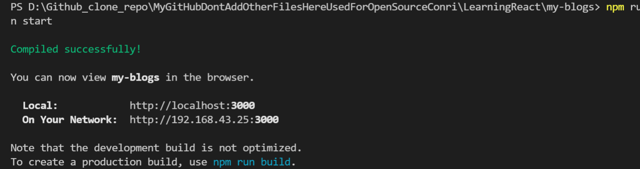

Local development server starts

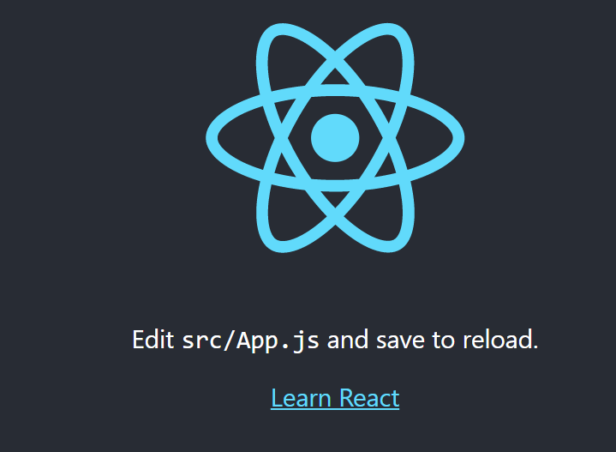

Above image is from browser which is coming from app.js component it’s all been injected into one html file inside the public folder

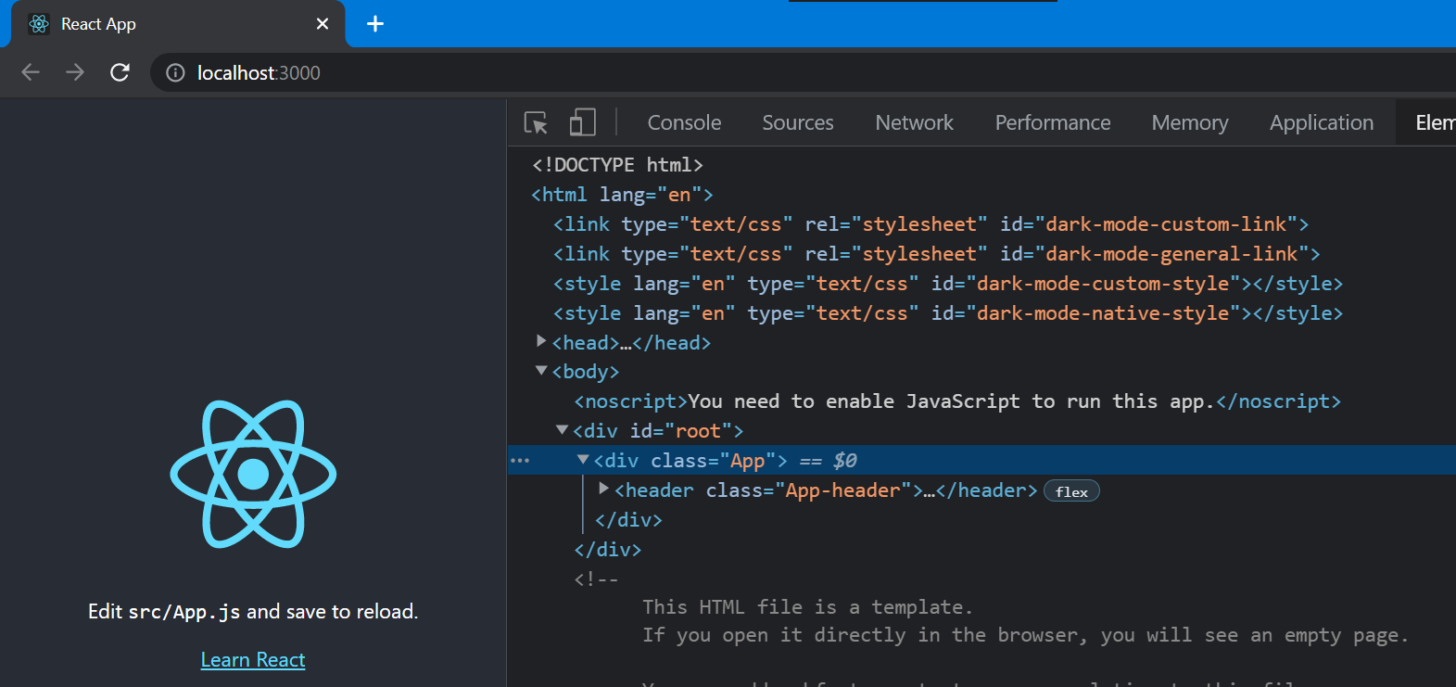

While inspect element In browser we can see App component injected into root div

In index.js we see those rendering of ‘App’ into root using render method and all

Changes you make to App.js and save it will appear in browser

Suppose if you delete “node_modules” folder you’ll get lot of errors because all of our project dependencies will live in that module including react itself.

When you download react projects in git hub we don’t include node_modules because of it’s large size

How to get back deleted folder node_modules
Type command: “ npm install”
This will look inside packagae.json folder which remember about all project dependencies and it will install all of them again it creates node_modules folder now
That’s how package.json file so useful

After that npm run start our server will start

Important: always when you download React project from git hub first run command npm install because all project dependencies will be save in package.json and that will install node_modules folder for us

#3. Component:

Components are like heart of any React application

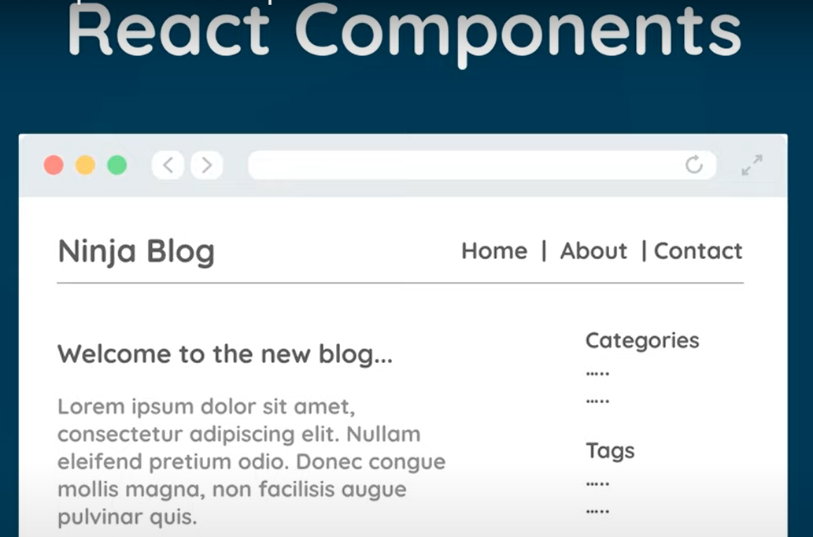

There can be several components in react web page. Each components is self contained section of contents. Here in above image navbar top bar showing Home and all might be one component, articles written like “welcome. . . “ might be a component, sidebar including “categories” might be a component.

It’s our job to create components which are render to the dom and shown in the web page

Each template conists:
- Template
- Logic

Because navbar will contain it’s own html templtes and js logic involved in it.

Funtion which may run when logout button is clicked.

Inside src folder index.js this is our file which starts our application, so all components inside App.js will be render to the browser in index.js

Those contents are
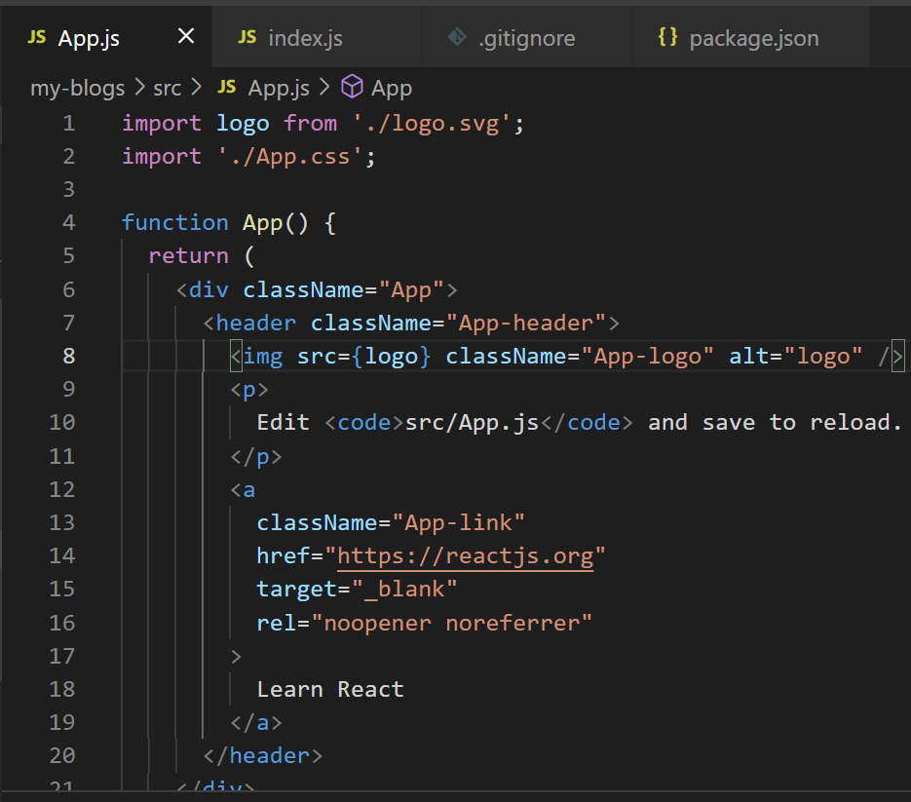

Above is known as root component

Inside above image or App.js we see function App that returns something looks like html code method always here starts with capital letter.

But that is not html it is called as “jsx” it looks similar to html there are so many diffrences

Jsx easitly allows us to easily create html style template to the component, and in the background a transpiler called babel converts all these jsx template to html file and renders to the dom.

Big difference way we add classes: in jsx we use className <div className="App">
We use like this because class is reserved key in javascript and we’re inside js file right there so we can’t use class. When this is converted to html it changes attribute className to just class while inspecting in browser you can see just class in browser.
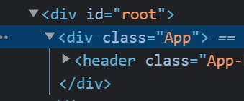

It doesn’t have className in browser

In older versions of react we had to import react at the top of the file but in newer version we don’t import react we import only required items like images and all.

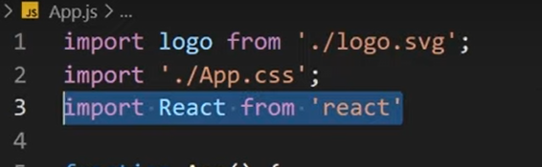
Above image in older versions.

In vs code if you type div.content it types automatically full div emit setup
function App() {
return (
<div className="App">
<div className="content">
<h1> App component</h1>
</div>
</div>
);
}

Type like above in App method inside App.js save it and refresh browser you can also remove import logo we don’t use it anymore

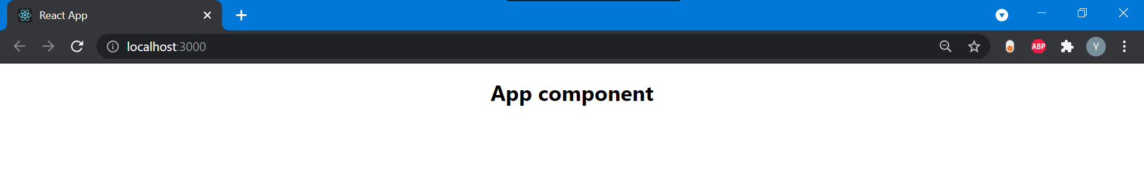

Above is one signle component

#4. Dynamic values in templates

To output title of blog use
const= “welcome to react blog”
Later to return const you can use {} inside h1 tag
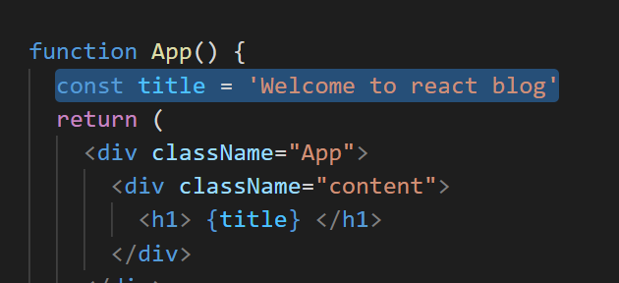

Also added likes

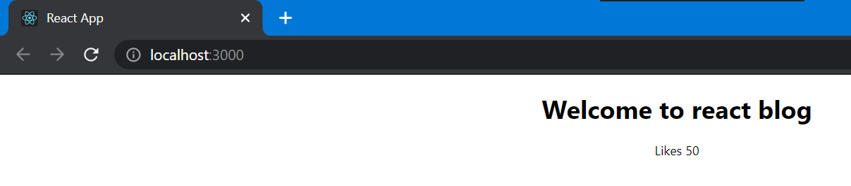

We can use string or integers, but we can’t use dictionary lilke object it gives error:
If you use const = {name:’ram’ , age:30}
Gives error in browser

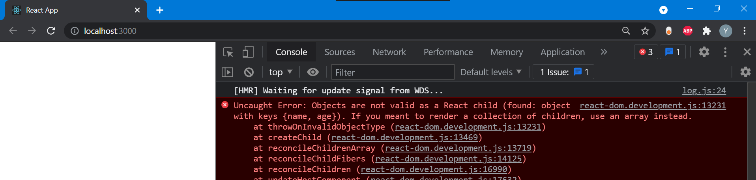

In console you can find that error

We can also write js string or const values inside p tag or h1 tag inside calibraces
<p> { Yadu} </p>
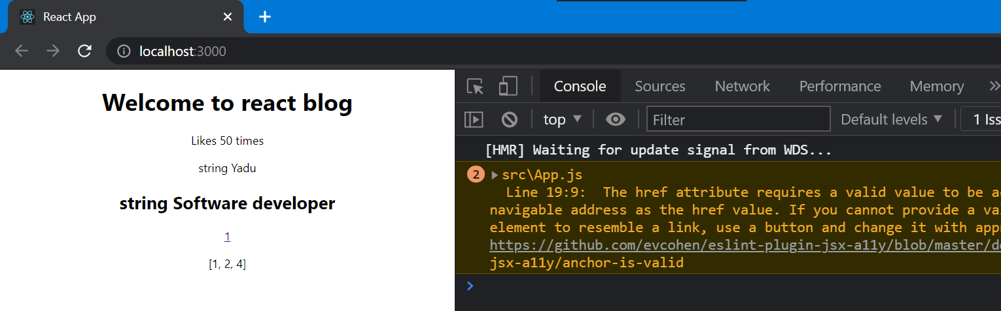

#5. Multiple Components

App is the first component of the application meaninig it’s the first component that is rendered to the dom and sits at the very top of our application this will get rendered inside index.js file

So app is the root component
If we want to add more components it will sit inside app.js that is rooot cpmponent

Which is like nested tree

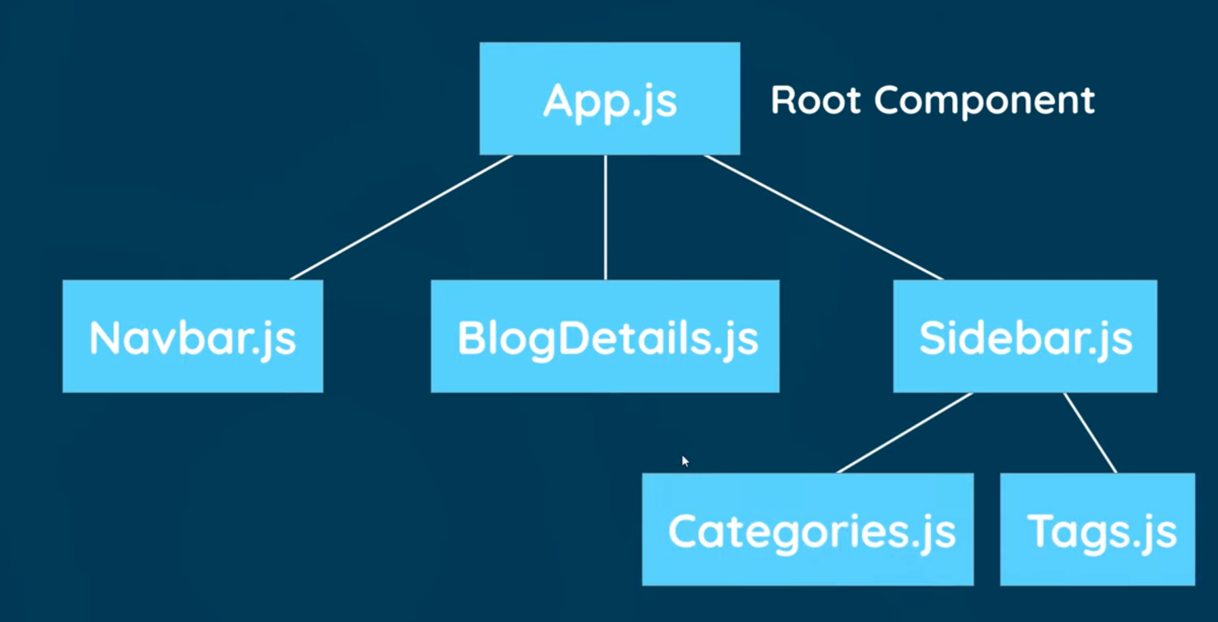

Above image looks like a tree which has many components

So create a new file inside src folder with name navbar.js

Component is just a funtion which returns a jsx template that function is exported at the bottom of the file

I installed vs package simple react snippets I’ll use it now

Type sfc
Which creates a template known as stateless funtion component
const NavBar = () => {
return ( );
}

export default NavBar;

Where you can see NavBar is an arrow funtion
Inside return you can use some kind of template

Type nav.navbar which creates nav tag with navbar class
After that inside div create a tag to navigate

After this import this navbar in app component and also inside App mehthod which is like template
import NavBar from './NavBar';

./NavBar to tell current diretory

We put above content class because navbar should appear at top of the page
You can use any of this inside App.js
<NavBar /> or <NavBar></NavBar> but you need to close it.

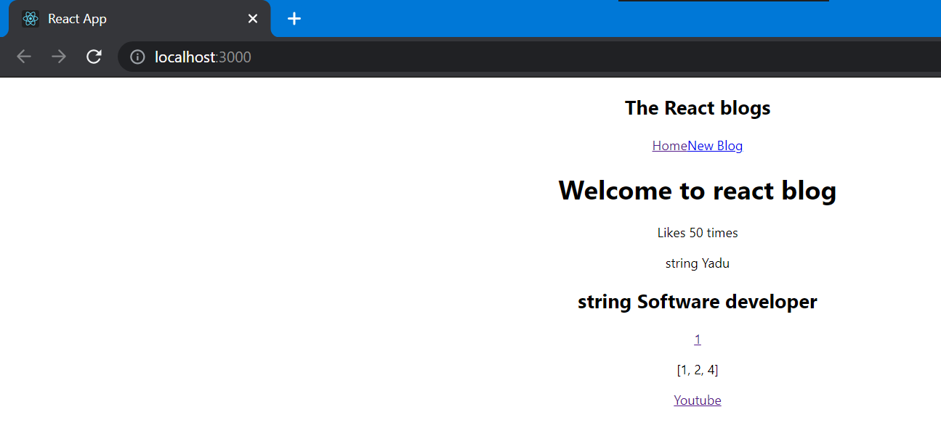

Now I’ll create separate component for Home if I do every thing inside App.js code will not look good

Create a file for home.js here also type sfc and space automatic code will be generated

Type Home
After that inside return type div.home
And now we’ll nest home inside App method
First import it and use it

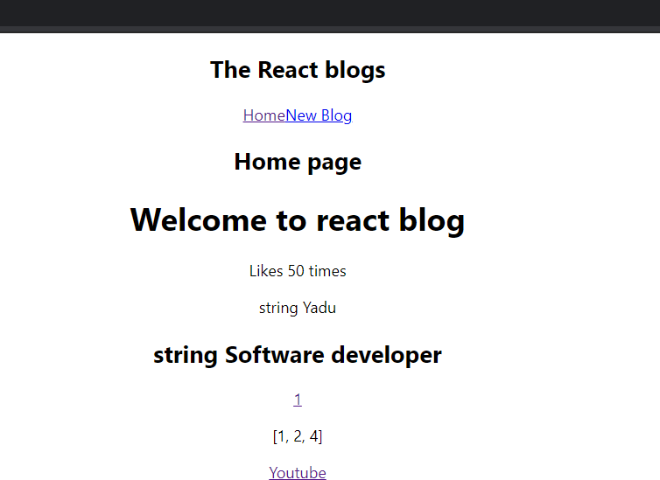

You can see home

#6. Adding styles

Our root component app.js
In our App.js we can see
import './App.css';

When we created react app these styles came by inbuilt
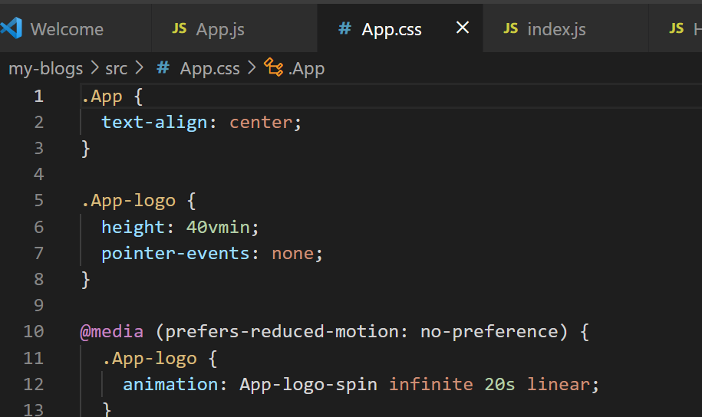

So whatever styles present in app.js not only applied to app.js but for all files which are in browser at that time.

These above css codes in browser under developer tools or press ctrl+shift+c you can find html elements used in that code under that
You can see <head> section inside that you can see <style> if you press on that you will see all css codes means it will come with app.js file to

There is another css file index.css
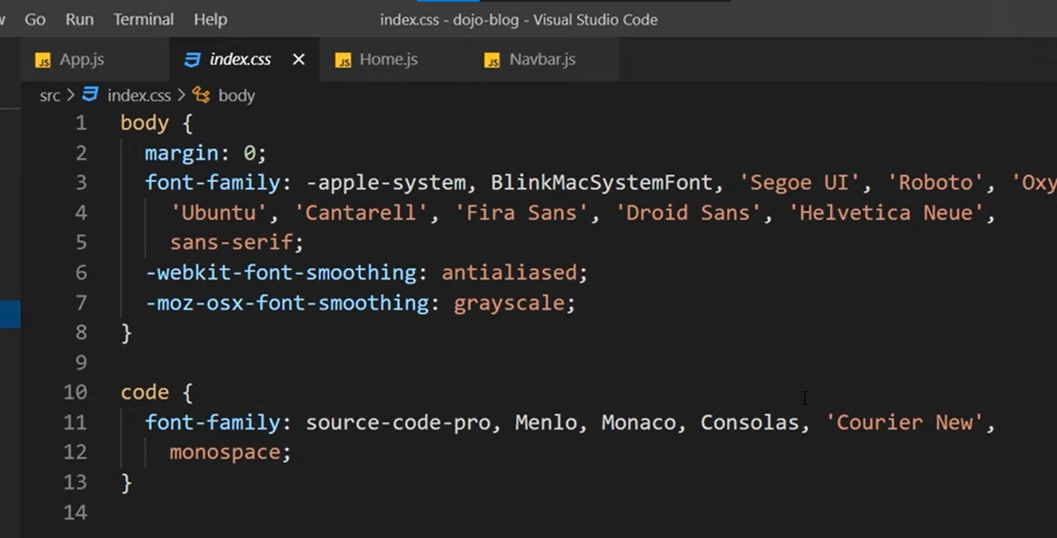
This is something like global style sheet it would applied all of the components.
Because this index.css file is imported to index.js file

What it does it takes all of those styles, adds them inside head again of the web page

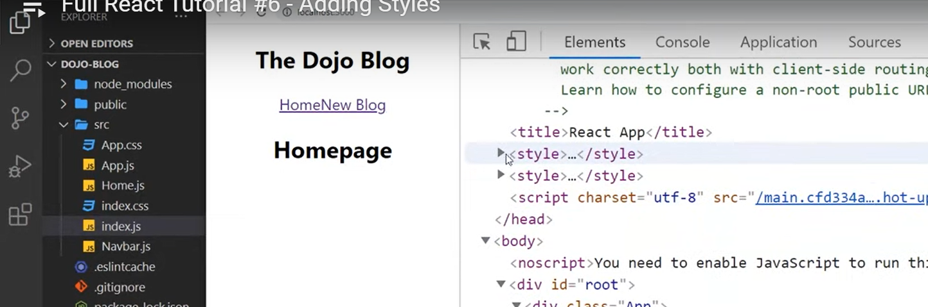

In above image we can see 2 styles used one from index.css other fro app.css

And here I’ll use index.css for all of my style

And in that erase existing css codes and add new css

Add this which google fonts

https://fonts.googleapis.com/css2?family=Quicksand:wght@300;400;500;600;700&display=swap

Import with code like below:

@import url('https://fonts.googleapis.com/css2?family=Quicksand:wght@300;400;500;600;700&display=swap')

Type above in index.css

In js and react “;” semicolon is very very important for above code I didn’t use ; so it was throwing error.

When you use this below code for margin:
*{margin : 0;
font-family:"Quicksand";
color:#333;
}

Page looks

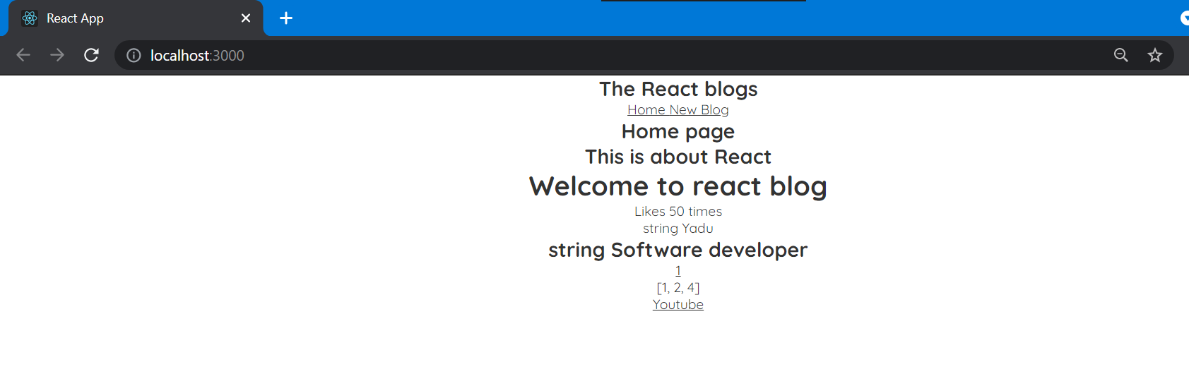

With navbar code navbar moves little bit:
.navbar{
padding:20px;
display: flex;
align-items: center;
max-width: 600px;
margin: 0 auto;
border-bottom: 1px solid #f2f2f2;
}

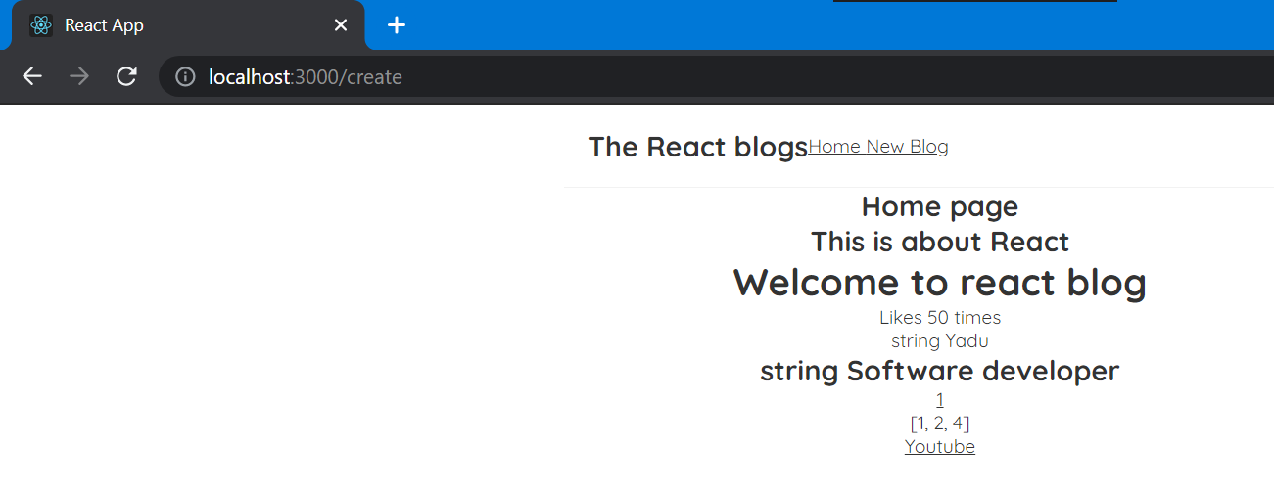

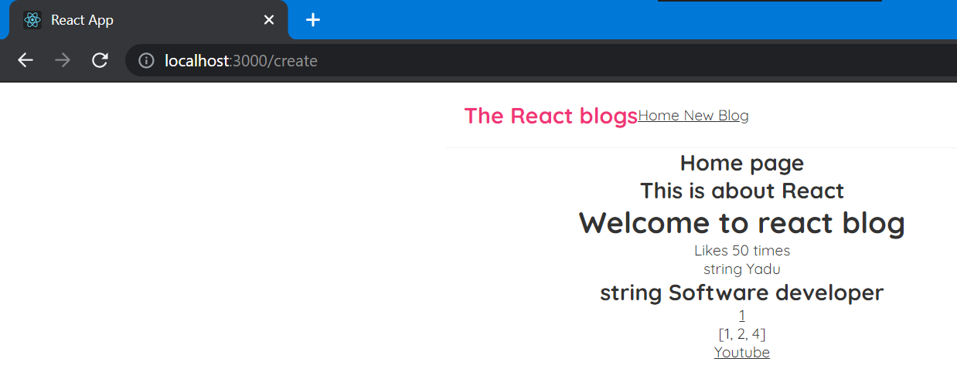

Above happens with code
.navbar h1{
color: #f13578;
}

For displalying link left side:
.navbar .links{
margin-left: auto;
}

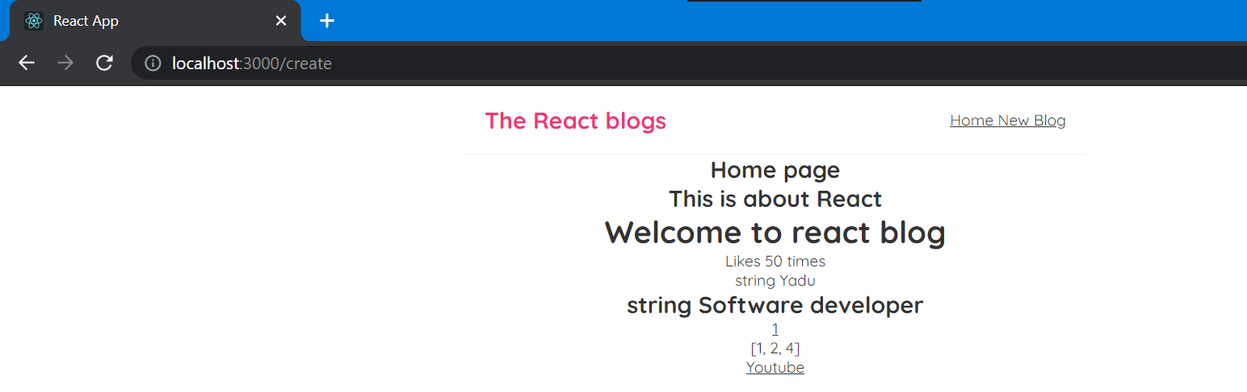

Next by giving style to navbar a tag home and new blog will get some gap
.navbar a{
margin-left: 16px;
text-decoration: none;
padding: 6px;
}

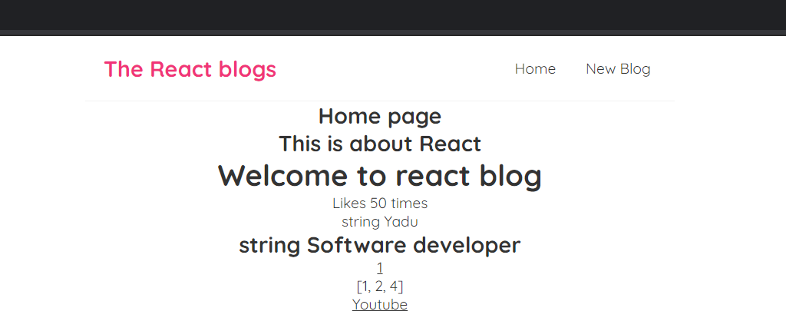

When hover mouse on home and new blog
.navbar a:hover{
color: #f13578;
}

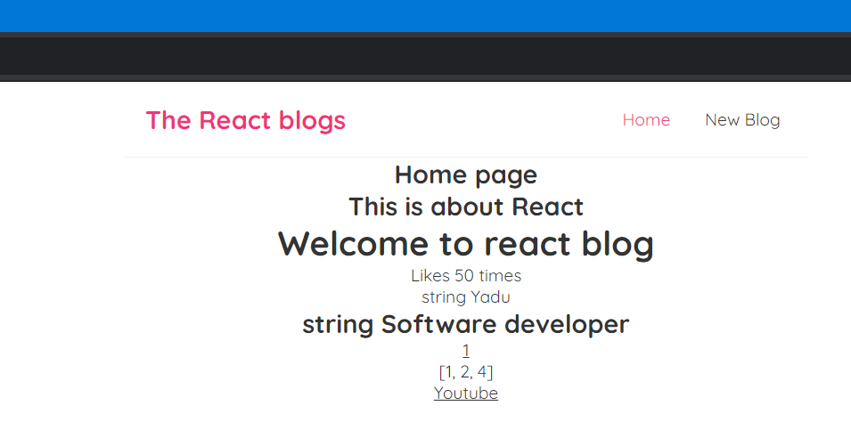

Now giving style to content in App.js
.content{
max-width: 700px;
margin: 40px auto;
padding: 20px;
}

Finally looks like this:
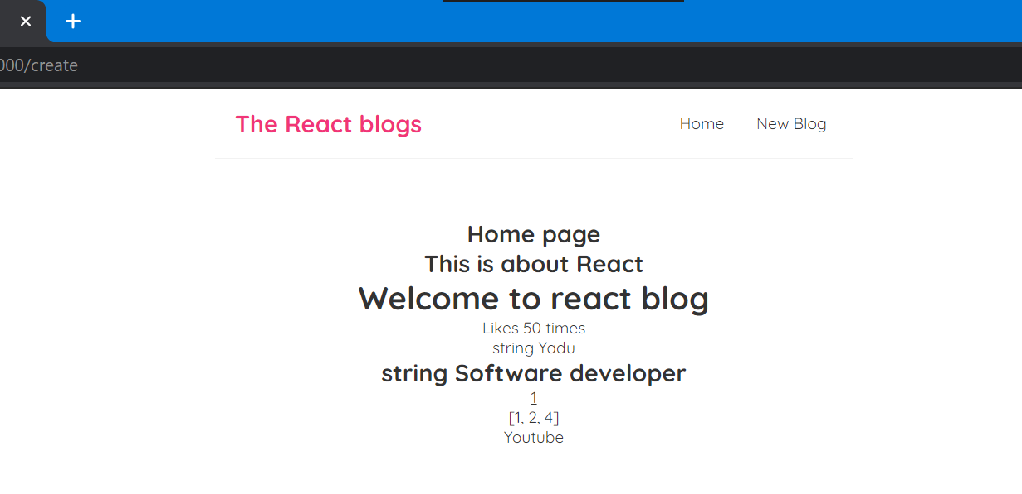

We can add style also inside navbar.js file for “New blog”

Inside a tag we can use style like normal html but with braces.

In regular html we use style=”” but here

It can be dynamic value when we dynamic value we use calibrace {}

So style={} but value is gonna be object itself so we need another pair of {}

So style={{}} this is how we use style in react

Outer one will tell we are using dynamic value inside one will tell we use object of js

Inside this object we use different kery value pair. Key is css property and value is our number css value.

Inside navbar.js
<a href="/create" style={{

color:"white",
backgroundColor:"#f1356d",
borderRadius:'7px'
}}>New Blog </a>



