Seacrch with #1. or #that number to go to that topic.
Net ninjas youtube
Next read: #22. Exact Match routes

#1. Introduce
#2. Create react app
#3. Components and Templates
#4. Dynamic values in Templates
#5. Multiple Components
#6. Adding Styles
#7. Click Events
#8. Using State
#9. React Dev Tools
#10. Outputting Lists
#11. Props
#12. Resusing Components
#13. Fuctions as Props
#14. UseEffect Hook
#15. UseEffect Dependencies
#16. Using Json Server
#17. Fetching Data with useEffect
#18. Conditional Loading messages
#19. Handling fetch errors
#20. Making a custom hook
#21. The React Router
#22. Exact Match routes
#23. Router Links
#24. UseEffect cleanup
#25. Route Parameters
#26. Reusing custom hooks
#27. Controlled inputs
#28. Submit events
#29. Making a post request
#30. Programatic redirects
#31. Deleting blogs
#32. Pages & next pages

Make this document as clean as possible for reading.

#1. Introduction.

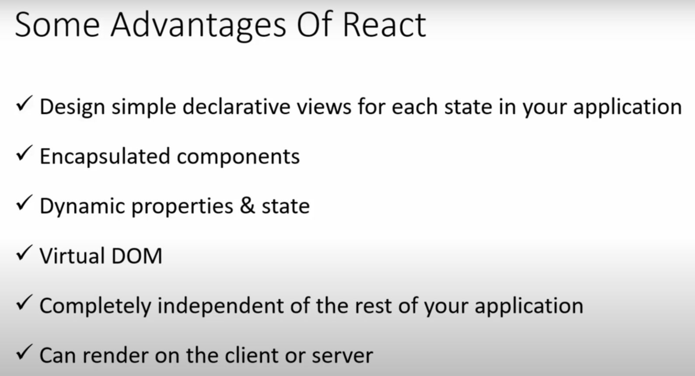

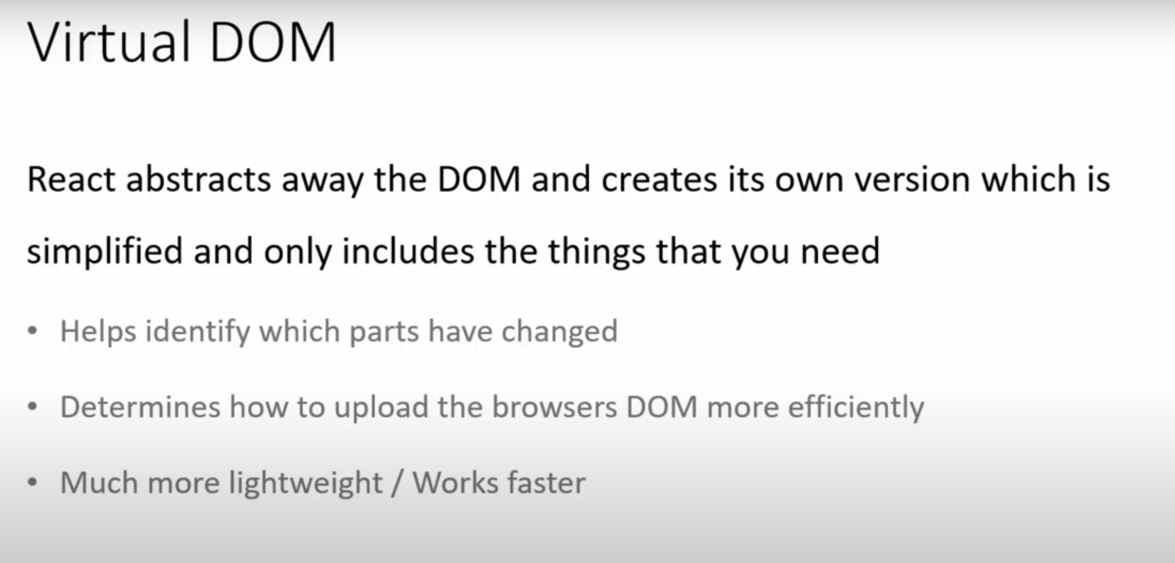

DOM : document object manipulation

When we update our components instead of refreshing entire app React can look at what change what are the changes in original dom which are new and then react will just re render this new part.

Install Simple React Snippet vs code extension in vs code

Inside vs code-> preferences -> settings -> type emmet and inside Emmet: Include Languages add
Item: javascript Value: javascriptreact
This allows us to use any inside React components when we generate template in jsx.

#2. Creating react app:

Create react app command :
Before using this we need to install nodejs in our system.

Terminal open this vs code new terminal

npx create-react-app my-blogs

Type cd my-blogs to go inside your projet

Inside project my-blogs : “node_modulues” this is where all of our project dependencies including react library live.
If we will install any package it’ll also live inside this folder.

“public” folder: all our public files, public to the browser including “index.html” will be here.

Index.html: this is one html file that will be served to the browser and then all of our react code will injected into this one file inside div with id=’root’
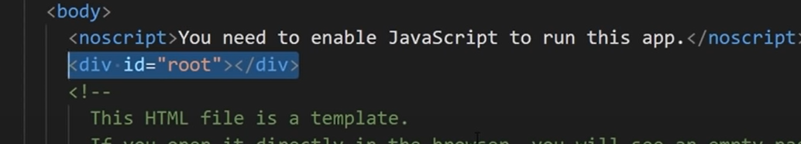

“src folder” : 99% of code which we write will go to this folder. All of our components will live here.

App.js this is how one component looks like.
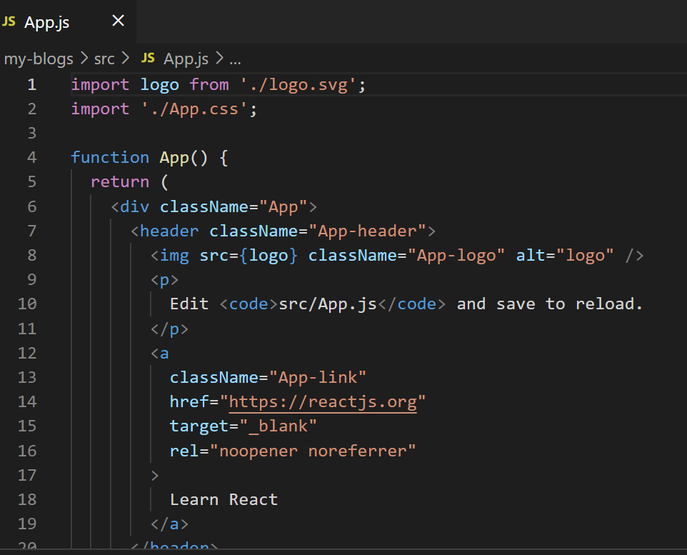

Inside this src folder we also have css file test file

We also have index.js file: this is kind of file which starts our react application. This file responsible to take all of our react components and mounting them to DOM
Inside index.js

ReactDOM.render(
<React.StrictMode>
<App />
</React.StrictMode>,
document.getElementById('root')
);

In above code we see <App /> which takes App component and it is render it to the ReactDOM and it does that it in ‘root’ div.

Where ‘root’ is id of div present inside public-> index.html that’s where it’s rendering

logo.svg is used inside app.js inside that component
We don’t need reportWebvital.js you can delete it if you delete that file delete inside index.js line
“import reportWebVitals from './reportWebVitals';

Next we have “setupTests.js” which also I don’t use it now.

Inside src-> index.js file we have
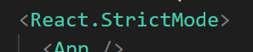

Means react does additional checks during development and gives us warning down in the console if there are any warnings reports.

We have “gitignore” version control with git.

After that we have “package.json” it does few things it lists all the dependencies of the application so anything our project depends on which all live inside node_modules so if you want you can delete node_modules but don’t delete package.json it’s very important.

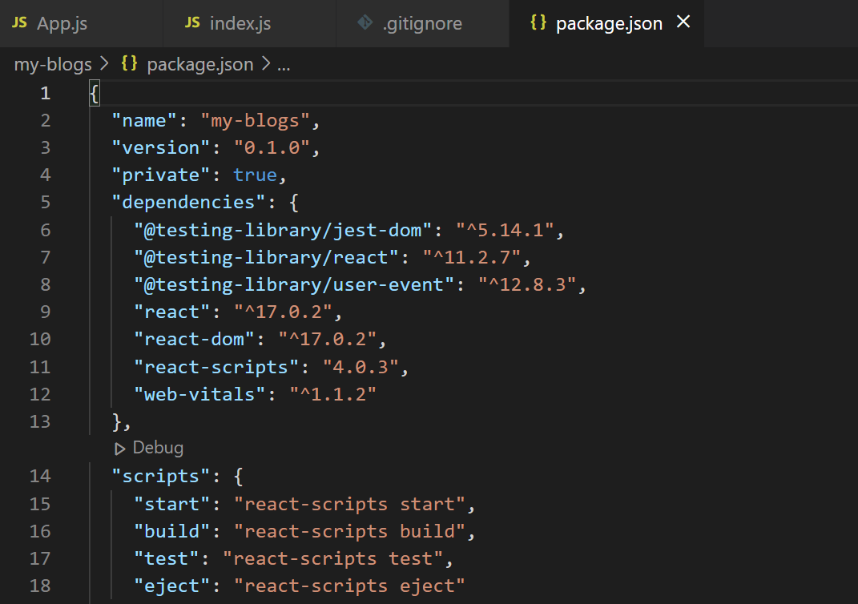

Inside that we have testing libraries.
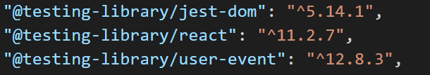

We also have scripts:
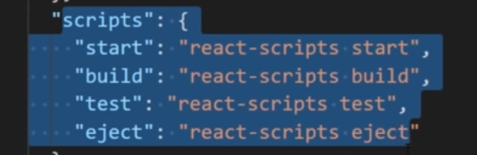

We can use this scripts to preview our application in browser or the local server or build our app for production

Now running above command

Go to project directory after that “npm run start” will start our server.

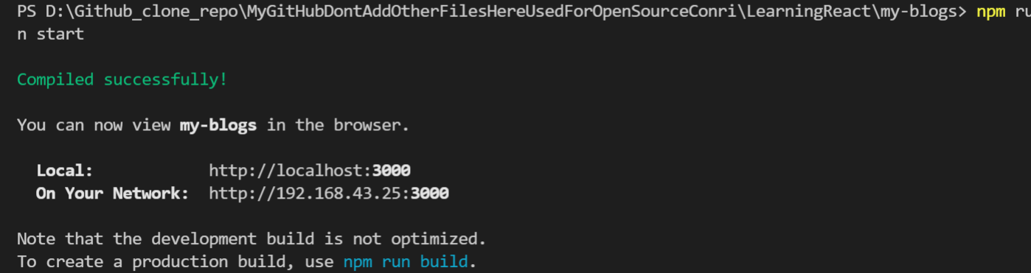

Local development server starts

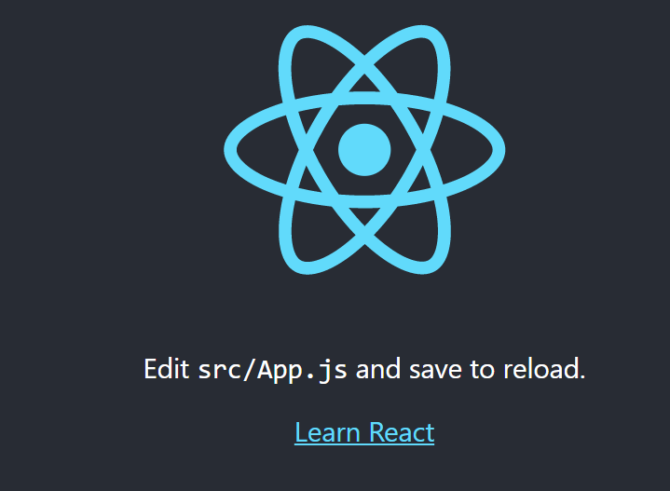

Above image is from browser which is coming from app.js component it’s all been injected into one html file inside the public folder

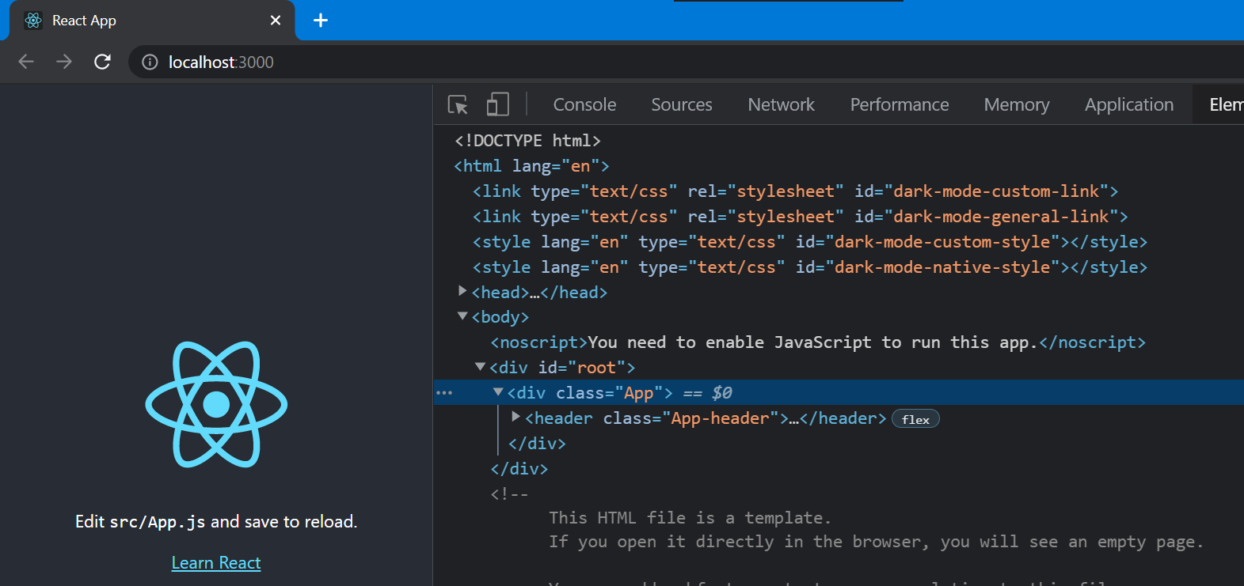

While inspect element In browser we can see App component injected into root div

In index.js we see those rendering of ‘App’ into root using render method and all

Changes you make to App.js and save it will appear in browser

Suppose if you delete “node_modules” folder you’ll get lot of errors because all of our project dependencies will live in that module including react itself.

When you download react projects in git hub we don’t include node_modules because of it’s large size
How to get back deleted folder node_modules
Type command: “ npm install”
This will look inside packagae.json folder which remember about all project dependencies and it will install all of them again it creates node_modules folder now
That’s how package.json file so useful

After that npm run start our server will start

Important: always when you download React project from git hub first run command npm install because all project dependencies will be save in package.json and that will install node_modules folder for us

#3. Component:

Components are like heart of any React application

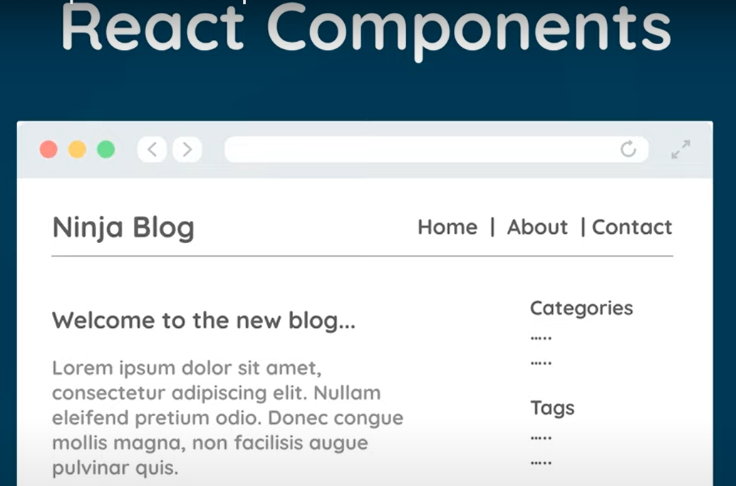

There can be several components in react web page. Each components is self contained section of contents. Here in above image navbar top bar showing Home and all might be one component, articles written like “welcome. . . “ might be a component, sidebar including “categories” might be a component.

It’s our job to create components which are render to the dom and shown in the web page

Each template conists:
- Template
- Logic

Because navbar will contain it’s own html templtes and js logic involved in it.

Funtion which may run when logout button is clicked.

Inside src folder index.js this is our file which starts our application, so all components inside App.js will be render to the browser in index.js

Those contents are
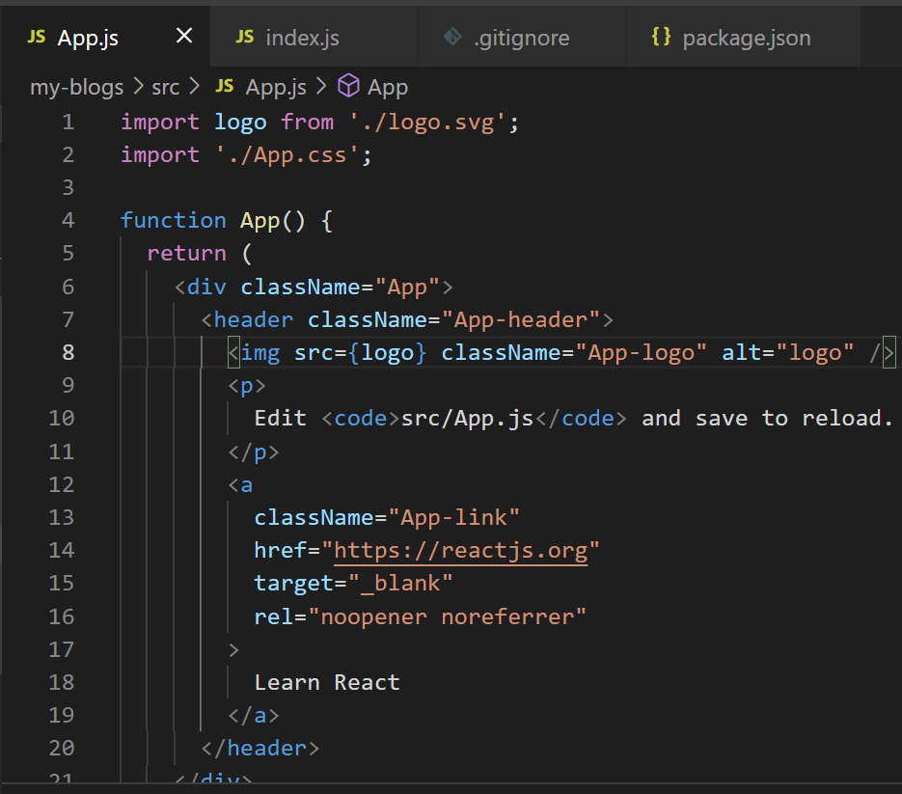

Above is known as root component

Inside above image or App.js we see function App that returns something looks like html code method always here starts with capital letter.

But that is not html it is called as “jsx” it looks similar to html there are so many diffrences

Jsx easitly allows us to easily create html style template to the component, and in the background a transpiler called babel converts all these jsx template to html file and renders to the dom.

Big difference way we add classes: in jsx we use className <div className="App">
We use like this because class is reserved key in javascript and we’re inside js file right there so we can’t use class. When this is converted to html it changes attribute className to just class while inspecting in browser you can see just class in browser.
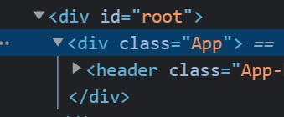

It doesn’t have className in browser

In older versions of react we had to import react at the top of the file but in newer version we don’t import react we import only required items like images and all.

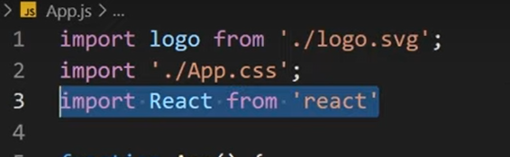
Above image in older versions.

In vs code if you type div.content it types automatically full div emit setup

function App() {
return (
<div className="App">
<div className="content">
<h1> App component</h1>
</div>
</div>
);
}

Type like above in App method inside App.js save it and refresh browser you can also remove import logo we don’t use it anymore

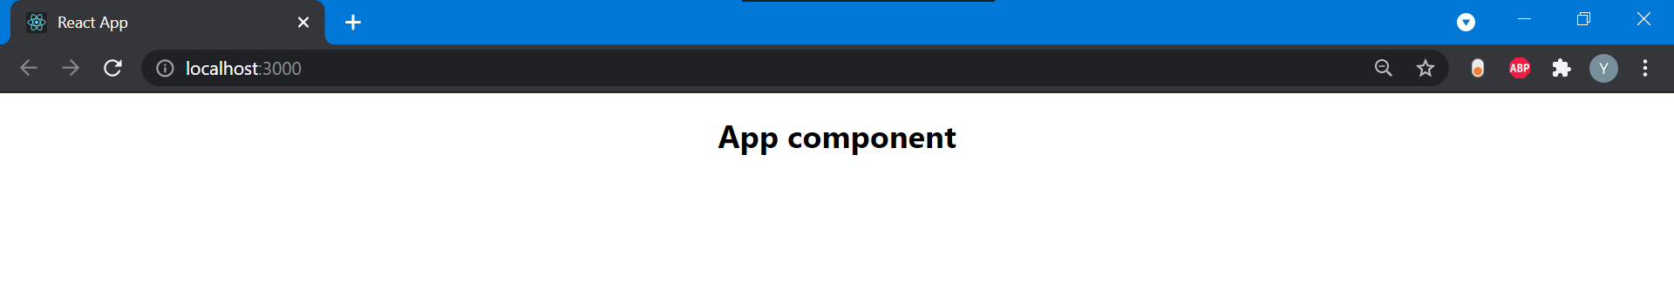

Above is one signle component

#4. Dynamic values in templates

To output title of blog use
const= “welcome to react blog”
Later to return const you can use {} inside h1 tag
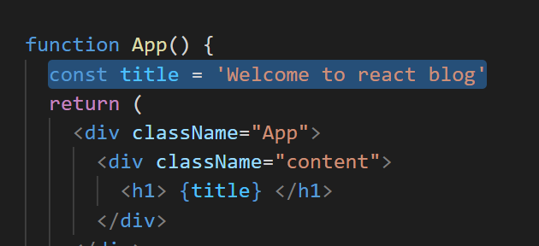

Also added likes

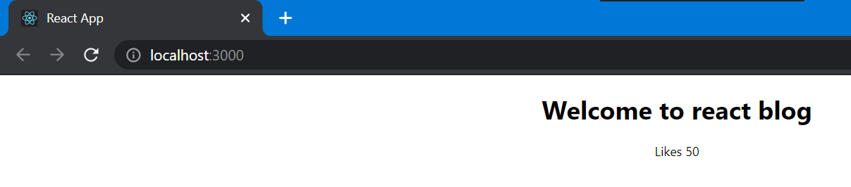

We can use string or integers, but we can’t use dictionary lilke object it gives error:
If you use const = {name:’ram’ , age:30}
Gives error in browser
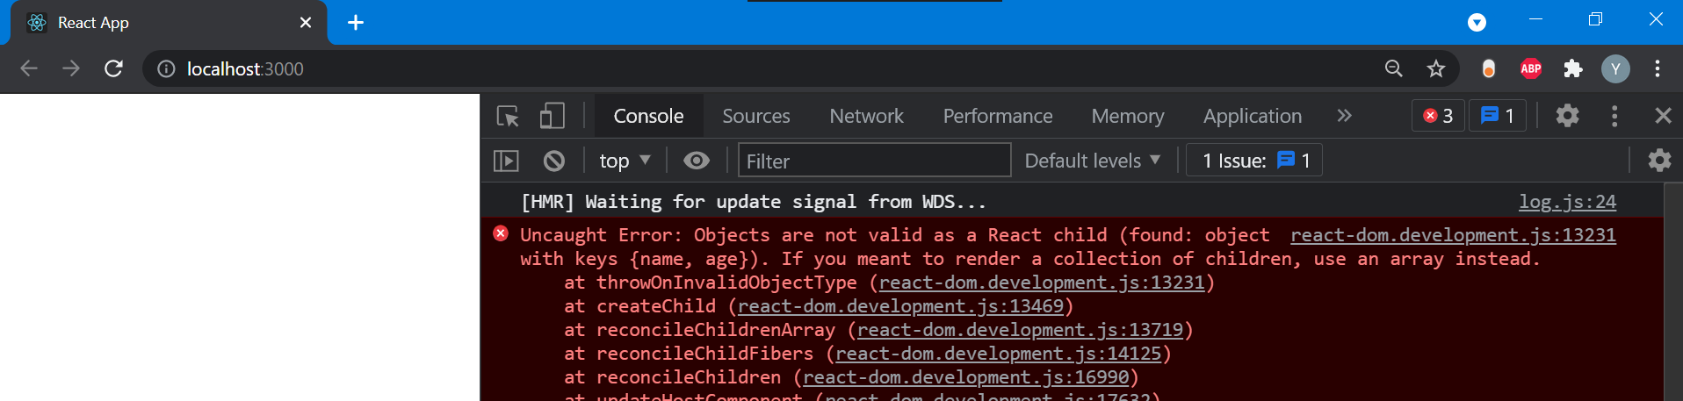

In console you can find that error

We can also write js string or const values inside p tag or h1 tag inside calibraces
<p> { Yadu} </p>
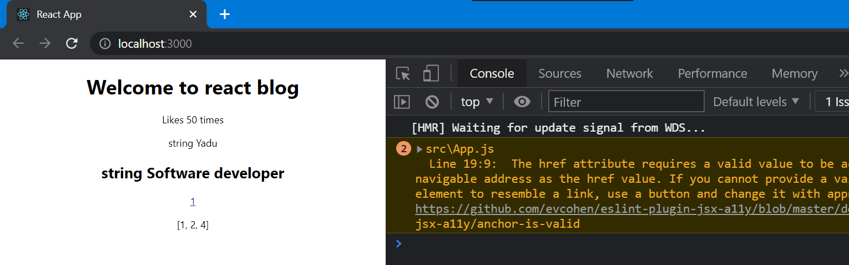

#5. Multiple Components

App is the first component of the application meaninig it’s the first component that is rendered to the dom and sits at the very top of our application this will get rendered inside index.js file

So app is the root component
If we want to add more components it will sit inside app.js that is rooot cpmponent

Which is like nested tree

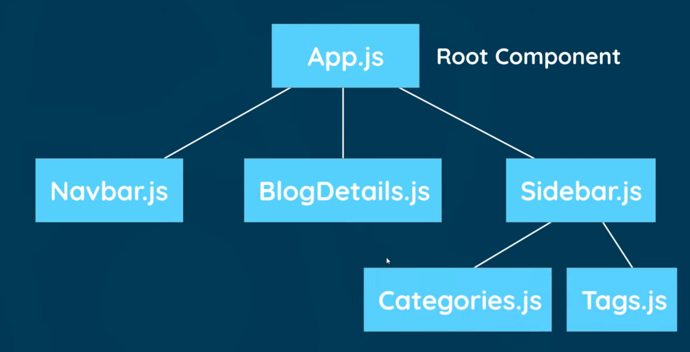

Above image looks like a tree which has many components

So create a new file inside src folder with name navbar.js

Component is just a funtion which returns a jsx template that function is exported at the bottom of the file

I installed vs package simple react snippets I’ll use it now

Type sfc
Which creates a template known as stateless funtion component
const NavBar = () => {
return ( );
}

export default NavBar;

Where you can see NavBar is an arrow funtion
Inside return you can use some kind of template

Type nav.navbar which creates nav tag with navbar class
After that inside div create a tag to navigate

After this import this navbar in app component and also inside App mehthod which is like template
import NavBar from './NavBar';

./NavBar to tell current diretory

We put above content class because navbar should appear at top of the page
You can use any of this inside App.js
<NavBar /> or <NavBar></NavBar> but you need to close it.

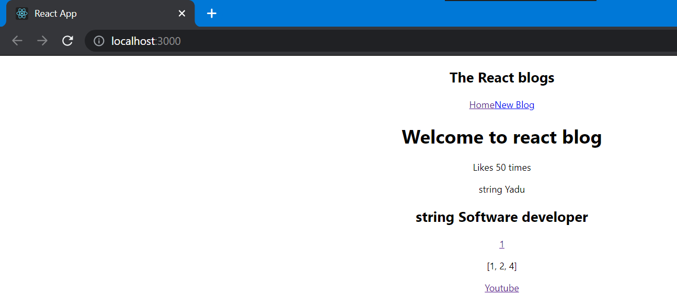

Now I’ll create separate component for Home if I do every thing inside App.js code will not look good

Create a file for home.js here also type sfc and space automatic code will be generated

Type Home
After that inside return type div.home
And now we’ll nest home inside App method
First import it and use it

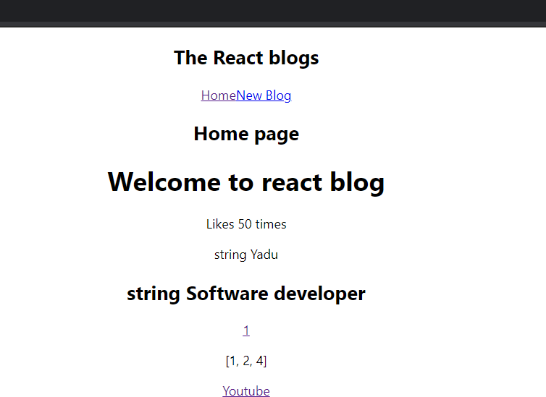

You can see home
#6. Adding styles

Our root component app.js
In our App.js we can see
import './App.css';

When we created react app these styles came by inbuilt
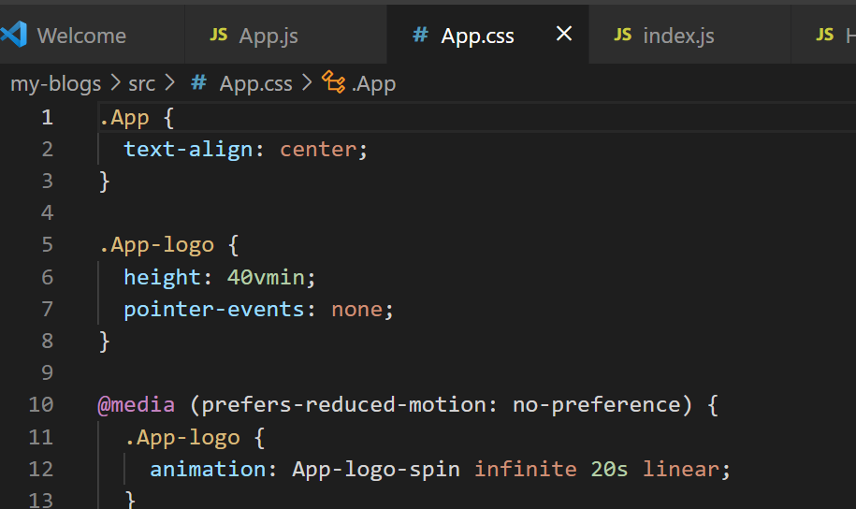

So whatever styles present in app.js not only applied to app.js but for all files which are in browser at that time.

These above css codes in browser under developer tools or press ctrl+shift+c you can find html elements used in that code under that
You can see <head> section inside that you can see <style> if you press on that you will see all css codes means it will come with app.js file to

There is another css file index.css
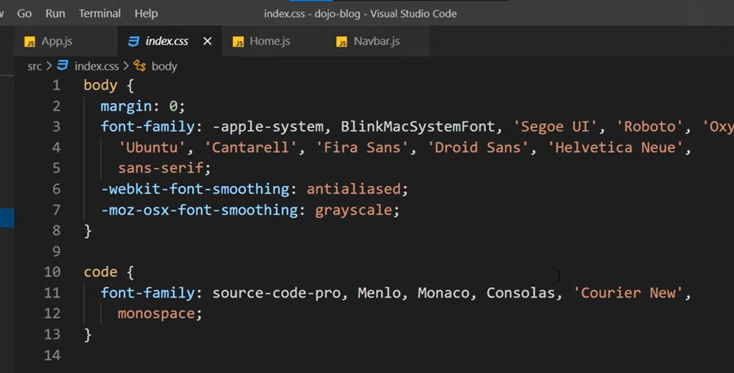
This is something like global style sheet it would applied all of the components.
Because this index.css file is imported to index.js file

What it does it takes all of those styles, adds them inside head again of the web page

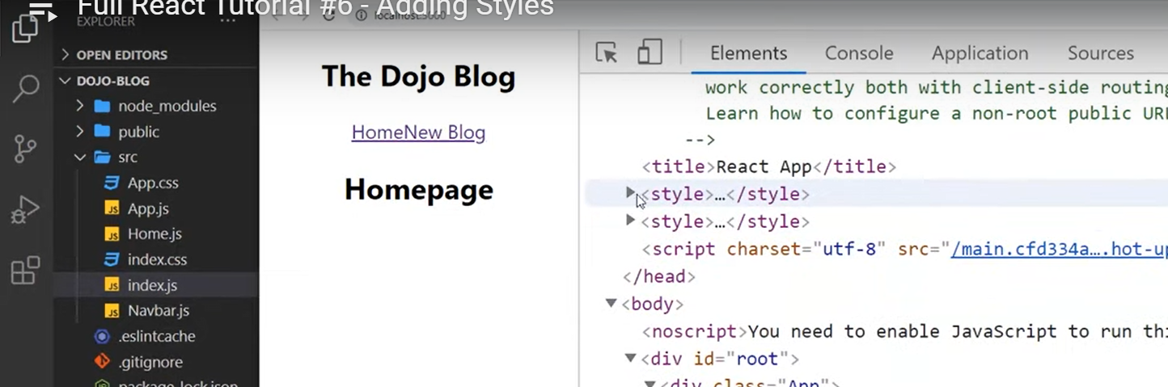

In above image we can see 2 styles used one from index.css other fro app.css

And here I’ll use index.css for all of my style

And in that erase existing css codes and add new css

Add this which google fonts

https://fonts.googleapis.com/css2?family=Quicksand:wght@300;400;500;600;700&display=swap

Import with code like below:

@import url('https://fonts.googleapis.com/css2?family=Quicksand:wght@300;400;500;600;700&display=swap')

Type above in index.css

In js and react “;” semicolon is very very important for above code I didn’t use ; so it was throwing error.

When you use this below code for margin:
*{margin : 0;
font-family:"Quicksand";
color:#333;
}

Page looks

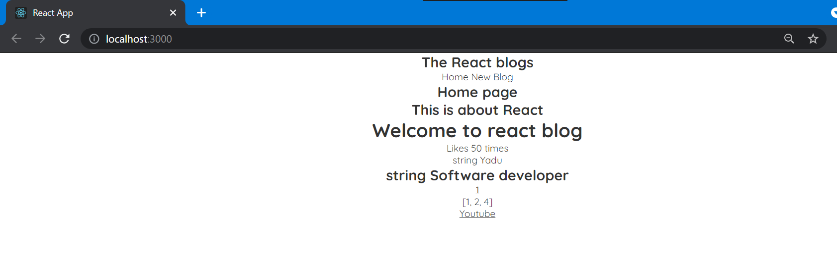

With navbar code navbar moves little bit:
.navbar{
padding:20px;
display: flex;
align-items: center;
max-width: 600px;
margin: 0 auto;
border-bottom: 1px solid #f2f2f2;
}

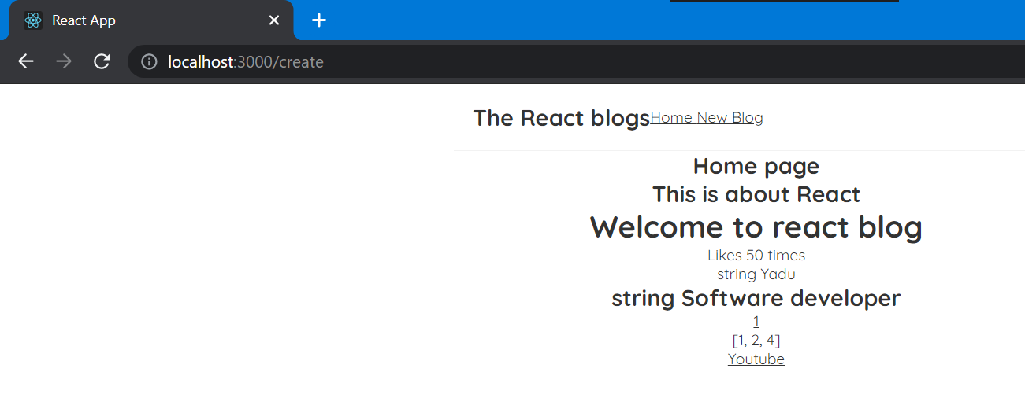

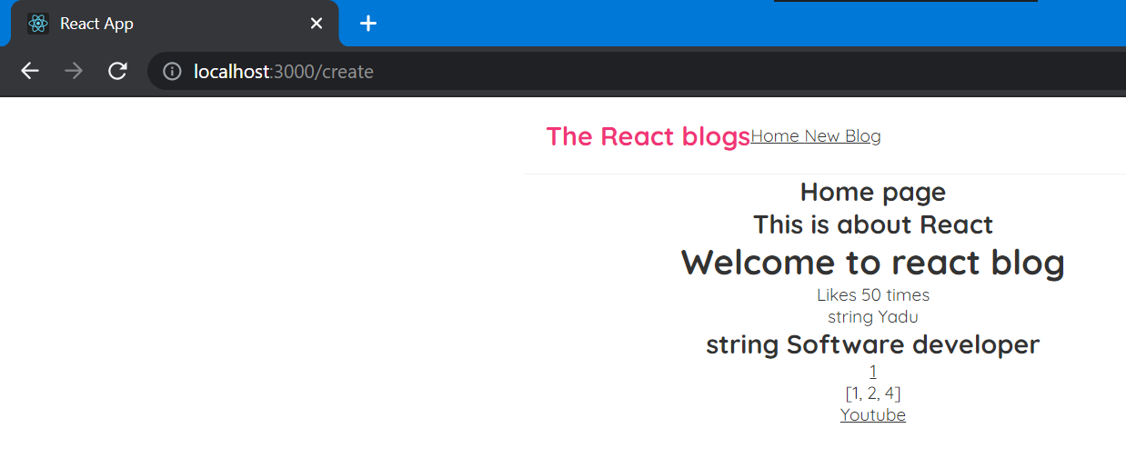

Above happens with code
.navbar h1{
color: #f13578;
}

For displalying link left side:
.navbar .links{
margin-left: auto;
}

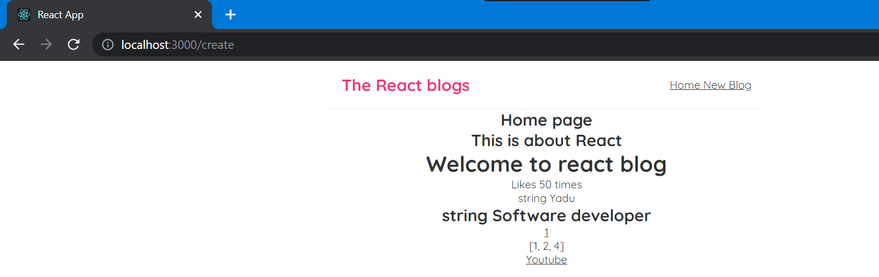

Next by giving style to navbar a tag home and new blog will get some gap
.navbar a{
margin-left: 16px;
text-decoration: none;
padding: 6px;
}

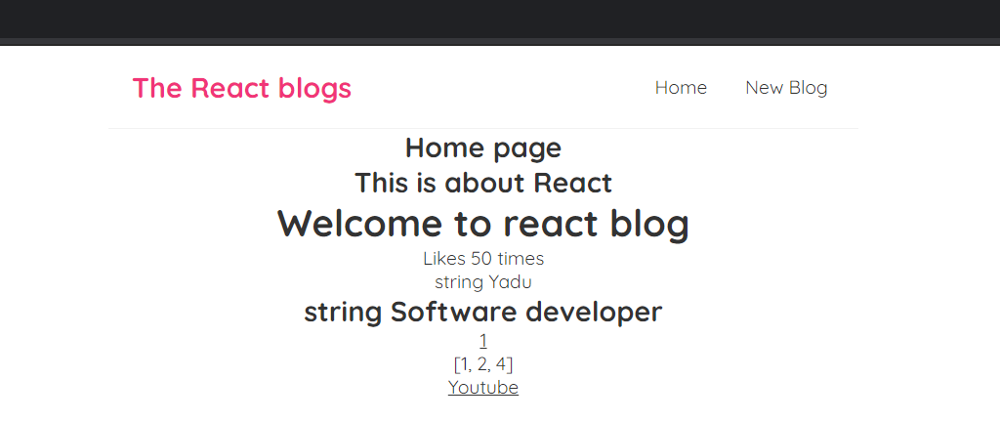

When hover mouse on home and new blog
.navbar a:hover{
color: #f13578;
}

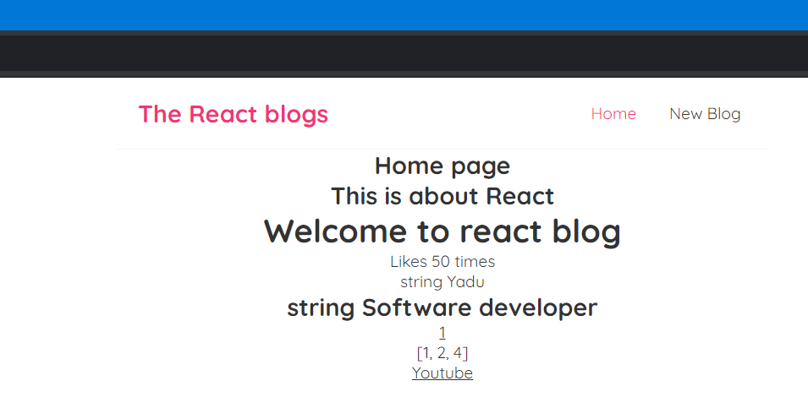

Now giving style to content in App.js
.content{
max-width: 700px;
margin: 40px auto;
padding: 20px;
}

Finally looks like this:
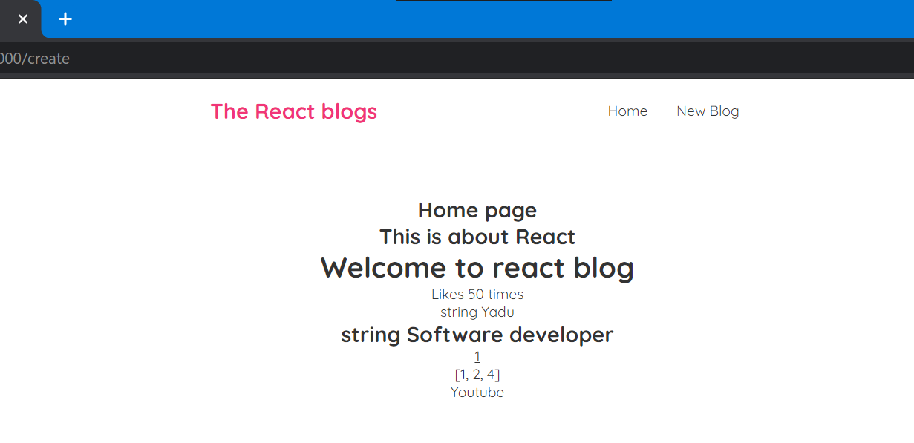

We can add style also inside navbar.js file for “New blog”

Inside a tag we can use style like normal html but with braces.

In regular html we use style=”” but here

It can be dynamic value when we dynamic value we use calibrace {}

So style={} but value is gonna be object itself so we need another pair of {}

So style={{}} this is how we use style in react

Outer one will tell we are using dynamic value inside one will tell we use object of js

Inside this object we use different kery value pair. Key is css property and value is our number css value.

Inside navbar.js
<a href="/create" style={{

color:"white",
backgroundColor:"#f1356d",
borderRadius:'7px'
}}>New Blog </a>



#7. click events

In github for this #7. clickl events I have given name check that itself since for every next part of learning I’ll delete or change that code you can’t see it here but in github you can see those changes.

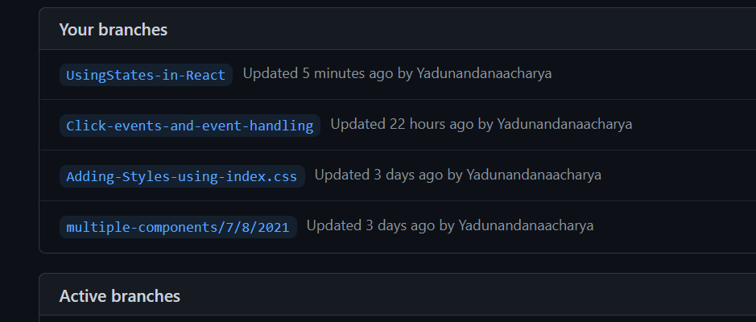

This is better use of git hub in my old brach that is click events I can see all code related to that branch.
Inside home componet create a button click me we also fire a funtion when we click on that it will log message on cosole
const handleClick = () => {
console.log("Hi, Yadu!");
}

<button onClick={handleClick()}>Click me </button>

Method and invoking that method inside button

Above could be wrong whenver you load page it will print that message
<button onClick={handleClick}>Click me </button>

Above will do correct.

Passing an argument:

But if we want to wish with some name we can’t use name inside parenthesis like : handleClick(‘Yadu’) because parenthesis invoke the funtion right away so before clikcing button it’ll print so we can’t use () if we want to pass argument

So we can wrap that inside anonymous funtion

If we use anonymous function it does not invoke the function if we click the button then only it will print in the console
Important: below is anonymous method
const handleClick = () => {}

Example: only when you press it will print using anonymous

<button onClick={()=>{
console.log('Hi! this is calling anonymous when cliked')
}}>Click me for anonymous call </button>

When page loads nothing printed:
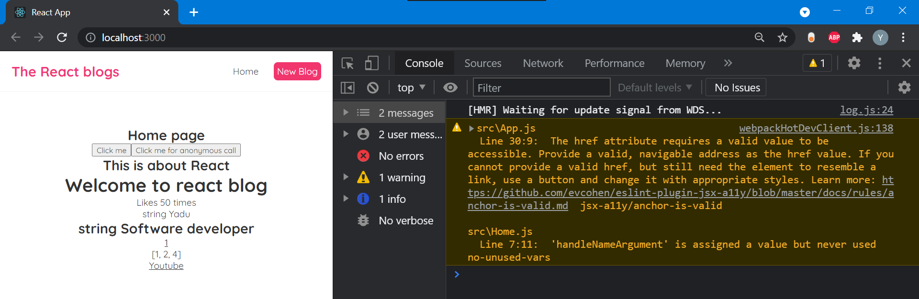

When we click on button ‘click me for anonymous call’
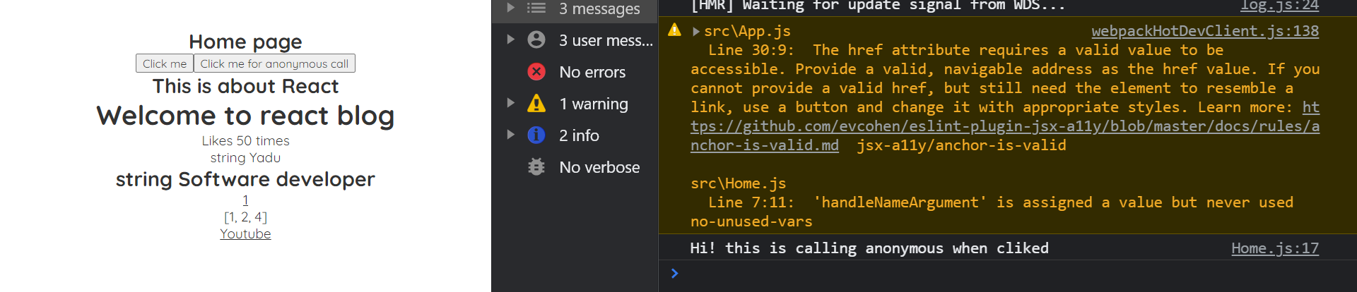

We print

Like this now we can print name

Calling method and pass arguments inside anonymous method
<button onClick={()=>{
handleNameArgument("My name Yadu I'm calling inside anonymous")
}}>Hi! Click to know my name</button>

When clicked on this button

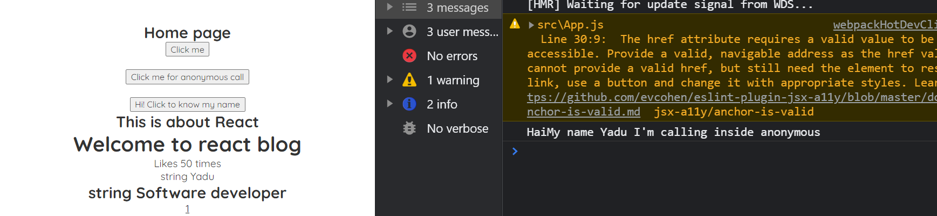

{} this will treat anything as dynamic value

Events parameter: events object , we automatically get access inside this funtion when an event occurs

Like you can return button event with this. You can use it as e and pass it as e.

Code: How to use it inside anonymous funtion
const usingEvent = (e) => {
console.log('Using event here ' , e);
}

Inside return using button:

<button onClick={usingEvent}> Here click to display event</button>

Output: there are many properties in events
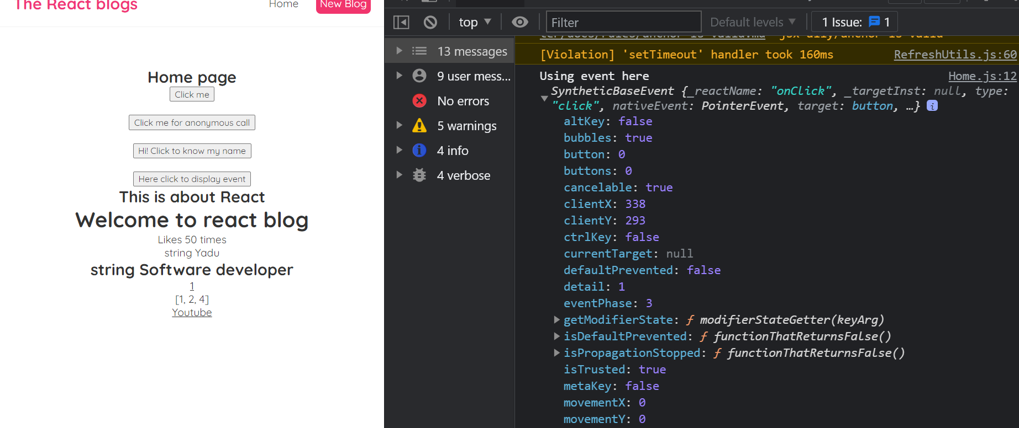

Using when passing argument:
const displayButtonEvent = (name,e) => {
console.log("We used "+name, e.target);
}

Inside return I.e. button
<button onClick={(e)=>{displayButtonEvent('Yadu ',e)}}>Click to display Button event</button>
<h2>This is about React</h2>

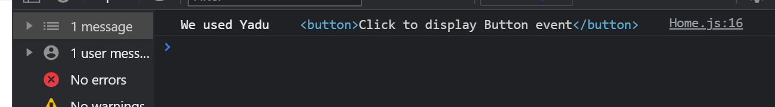

When we click on button

Important: I was getting some error when I opened my project in gitkraken. May be it opened old code later I executed this command
So everything worked properly

npm install react-scripts --save

This was deleted in package.json
Error: 'react-scripts' is not recognized as an internal or external command, operable program or batch file. npm ERR! code ELIFECYCLE

#8. using state

If you want to see more difference watch video

State means data being used In a component at that point in time, they could be real values, strings any other data

What if we want to use data that changes over time or in reaction to some event or user clicking a button

In github for this #8. using state I have given name check that itself since for every next part of learning I’ll delete or change that code you can’t see it here but in github you can see those changes.

This is better use of git hub in my old brach that is click events I can see all code related to that branch.

We have button click me when you click on that
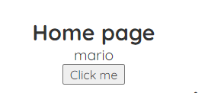

When we click ont that our text should change to Hanuman how can we do this

First we created mario
let name= 'mario';

And we display it using p tag
return (
<div className="home">
<h2>Home page </h2>

<p>{name}</p>
<button onClick={handleClick}>Click me </button>

</div>
);

Output the name
It looks like above name in image of browser

Now when we click on button name should change

For thta we try to use handleclick funtion inside that function

const handleClick = () => {
name = 'Hanuman';
// setName('Hanuman');
}

But with above changes if I click on the button nothing will change in browser but insted name will change in console

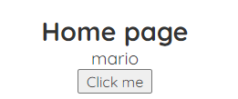

Text is as it is

If we log it to console name
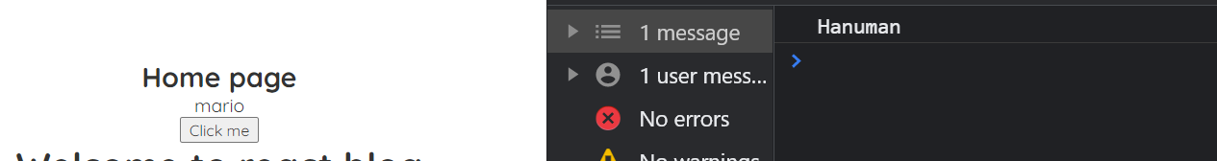

Hanuman displayed in console

Because name we used with variable name is not reactive, react doesn’t watch it that’s why we continue seeing old value in browser

Way react detects that variable and rerenders the template where we put that value in our P tag and receiving the value in browser

For that we use hook:hook is special type of funtion that does the job

This allows us to change value what we want
For using useState we need to import it at top of the file

import {useState} from 'react';

We use it like
useState('mario');

But now we want to change this so first we save this in one variable to change it further

const [name, setName] = useState('mario');

Use like above first value is initial value that is name
Second value is funtion which we can use and change that value i.e set and value which we want to change I.e. name so setName

Now to change name mario we can use setName funtion to do that
Use this inside handleclick

const [name, setName] = useState('mario');

const handleClick = () => {
// name = 'Hanuman';
// console.log(name);
setName('Hanuman');
}

value is reactive that is state value mario if it changes at any point
It gonna change In template as well

Now In browser if you click on button


Value changes to hanuman

We can use this hook as many times we need for different values
That value could be anything it can be array, object, bool
Datatype doesn’t matter

Next we use age to change use it as anumber

Before click :


After click


#9. React developer tools

https://chrome.google.com/webstore/detail/react-developer-tools/fmkadmapgofadopljbjfkapdkoienihi

After adding above we can see components in our browser
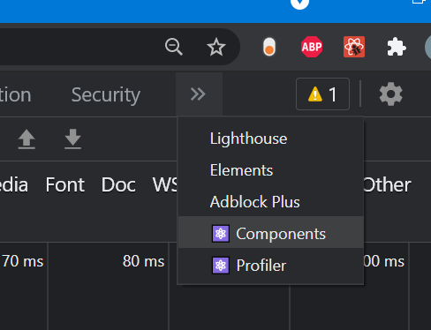

When you click on components you see
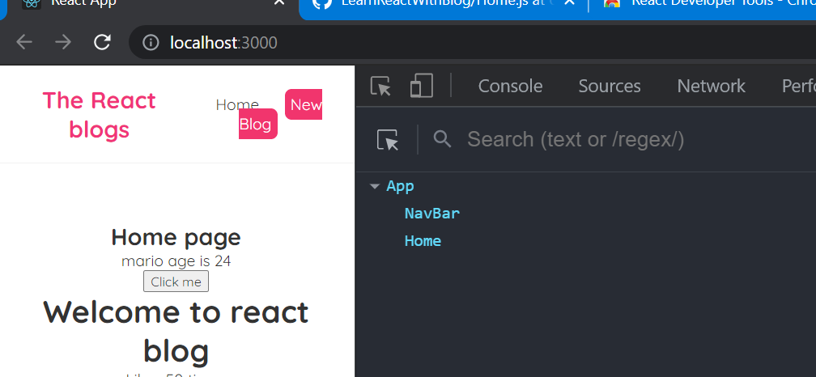

When you hover mouse on NavBar shade will appear on navbar of your page

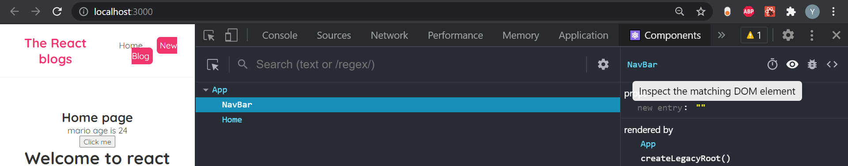

After pressing on navbar on right side if you preess on eye symbol it grabs all code relaaated to navabar

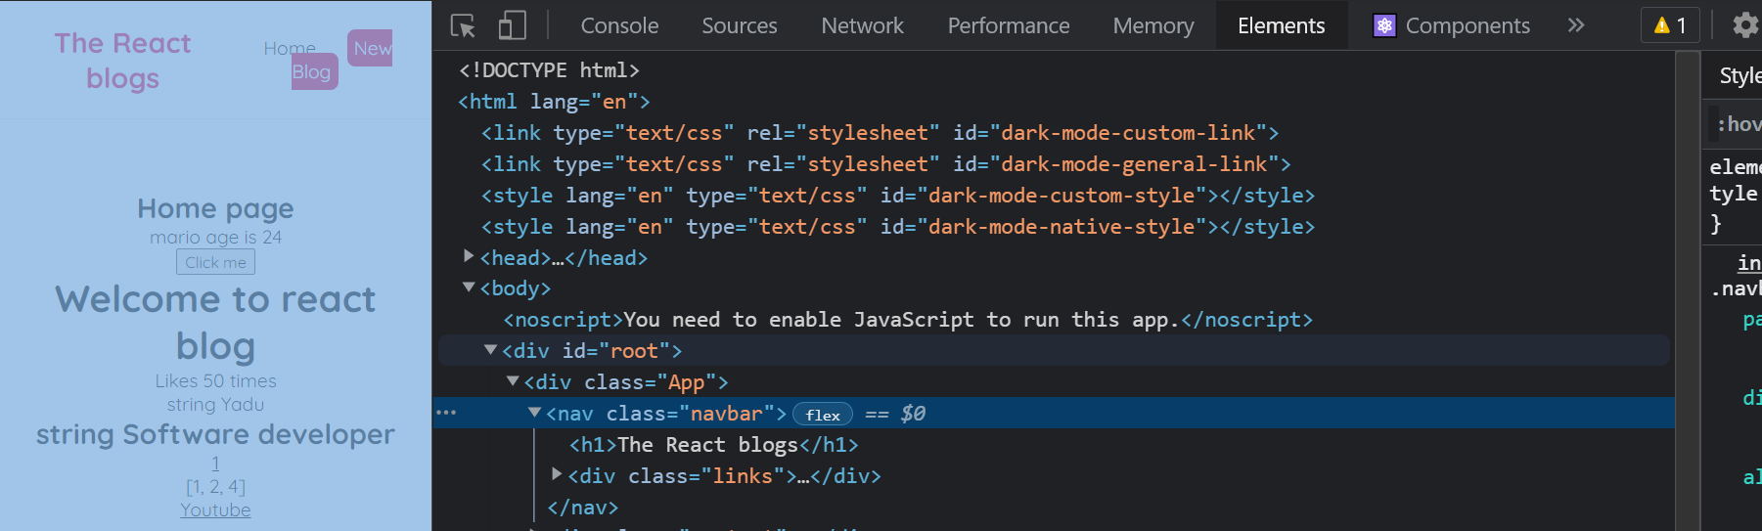

Like above it gets code of navbar

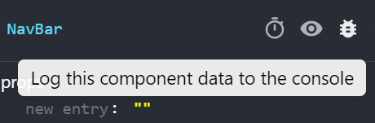

If I click on near symbol to the eye and after that go to console
Then we can see all info about app component
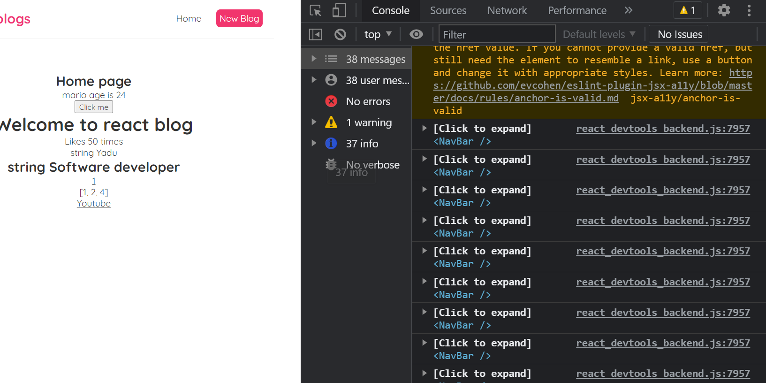

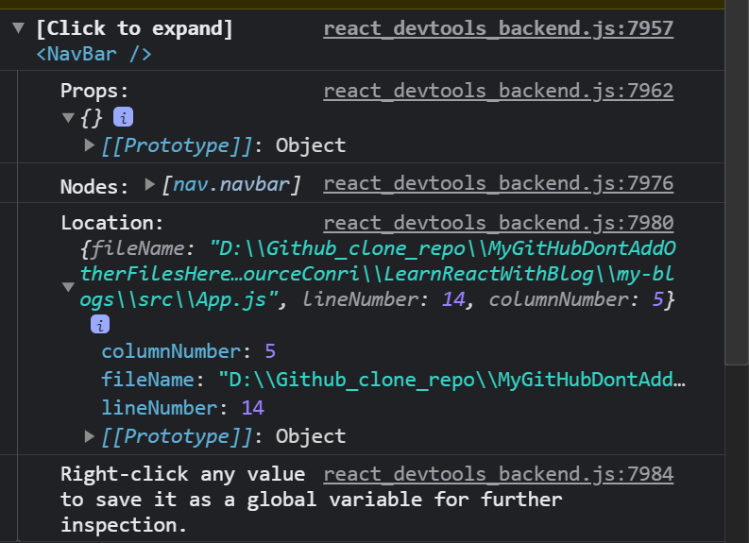

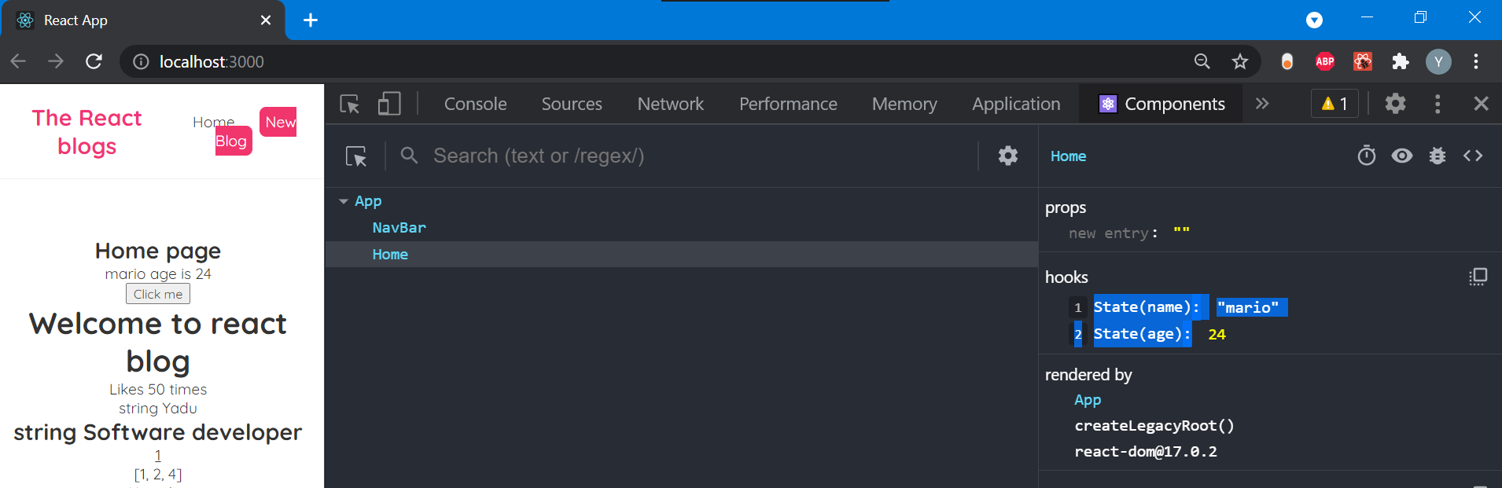
We can see hooks properties mario and age 24
And we have stater hook in our code that’s why it shows state hooks

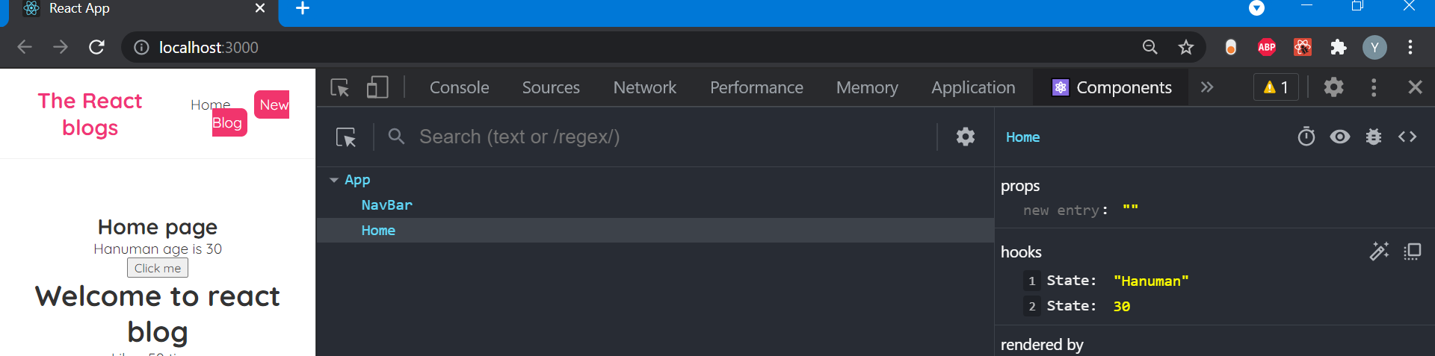
When I click on button hooks values will also change



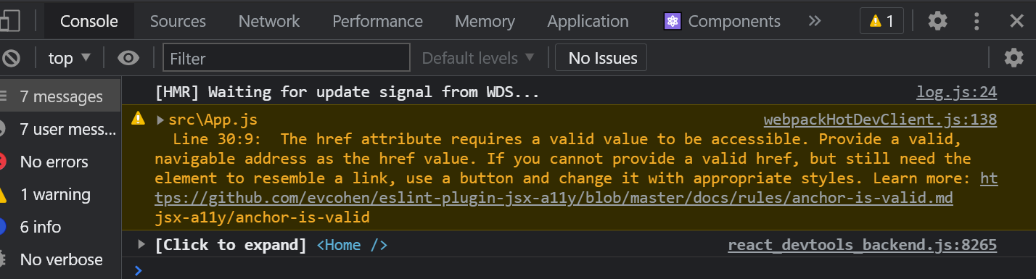
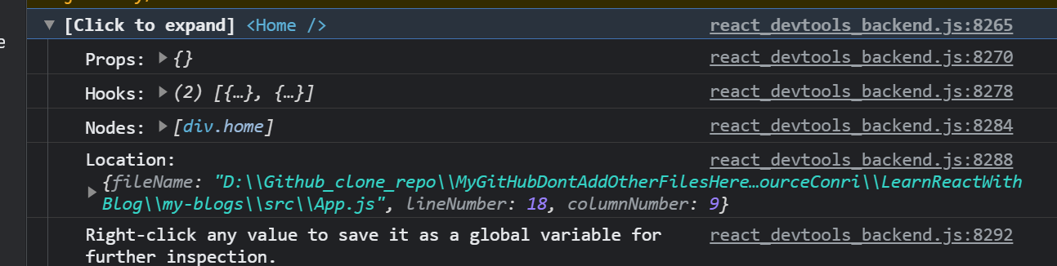

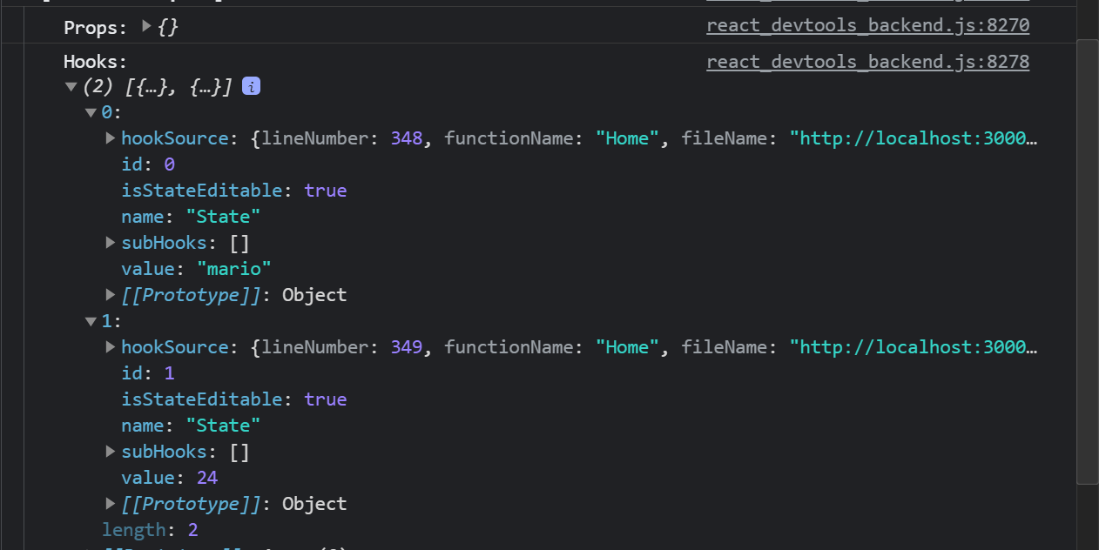
What happens If you clcik on spider symbol you can see every hook in concole as array of object

This things is very useful when you debug react apps

#10. Outputting Lists

We gonna need list of blogs to o utput the template
We use state to represent these blogs for that we use useState hook
That is

Go to home.js at the top of the funtion we’re going to create state

const Home = () => {
const[blogs,setBlogs] = useState();

Like above we type in home.js where useState we have imported at the top

so inside usestate drop this list:
[ { title: 'My new website', body: 'lorem ipsum...', author: 'mario', id: 1 }, { title: 'Welcome party!', body: 'lorem ipsum...', author: 'yoshi', id: 2 }, { title: 'Web dev top tips', body: 'lorem ipsum...', author: 'mario', id: 3 } ]
So initial value of state will be list of blogs

In list each object represent single blog and each one has title property
Body and author property
Each id needs to be unique

How to ouput these data in the template
We hardcode with one div for one item
This is not good hardcoding as it will take time and data might change
And if you delete it won’t delete since you have hardcoded

Instead we would cycle thorough this array and output those
We do this using map method of javascript

Do like this
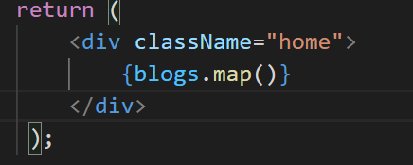
Map method cycles through the array
Inside map callback funtion to go through each item
Parenthesis is jsx template

{blogs.map((item)=>(
))}

Above code item will iterate through each blog of lists with item we get access to title property body author and id

What do we output first of all div type this : div.blog-preview which will create div tag in vs div with class blog-preview

When we output a list using a map method each root element must have key property this key property react uses to keep track of each item at the dom as it outputs it
So when you add key property it should be unique not repeated here we use id property of list items so id must be unique for each item

<div className="blog-preview" key={item.id}
We use like above
Inside div put h2 to output title of blog
And use paragraph to output author

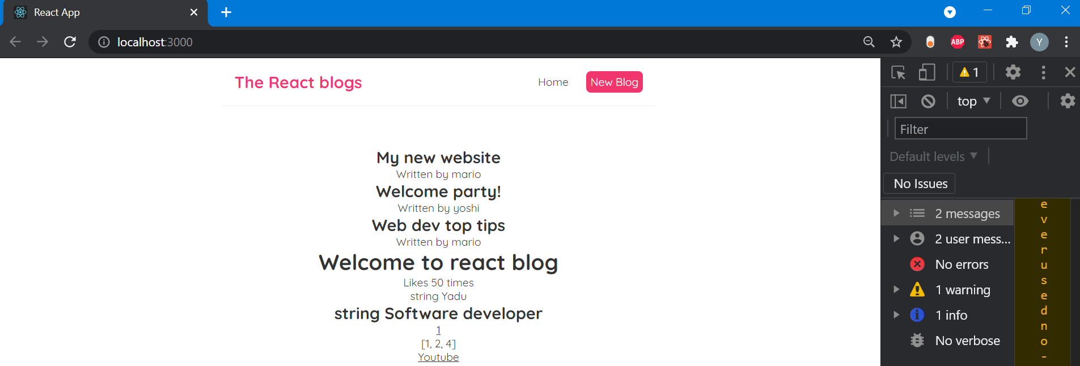
When you save it, it looks lilket his
With all 3 lists

So we take lists, store that in useState, and then we map through that data, and we take each item into that as we map through it and output bit of template and for each one it has key property like id in this example

And we add little bit css for that
Go to index.css use styleing for class blog preview

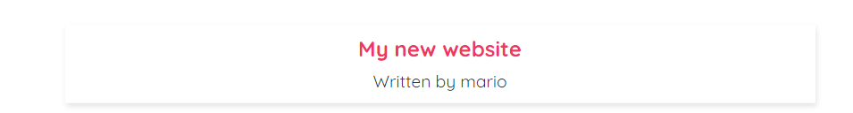
With these style it looks like when you hover over title of blog it looks like tab

#11. Props

Previously we have created blogs with
{blogs.map((item)=>(
<div className="blog-preview" key={item.id}>
<h2>{item.title}</h2>
<p>Written by {item.author}</p>
</div>
))}

Above code inside home.js, we are directly outputting lists, but if we have to do the same in suppose in other place such as about page or in search page or in some other page then we have to use above same code again so it won’t be reusable.

So we will make that component reusable component
Like if we have one blog component and we can use it anywhere inside the project with little code and reuse it again anywhere in project

If I have tag page and if I have to use blog there then we drop component there and we use blog there also

We use that in the form of props

In home page we are using one type of ouput lists with blogs let’s say in home page we use blogs of music so we use blog component there and display it but in about page we would like to display lists of blogs with topic movies with different topic but with blog component
So we can pass data to the external component as well in the form of props

{blogs.map((item)=>(
<div className="blog-preview" key={item.id}>
<h2>{item.title}</h2>
<p>Written by {item.author}</p>
</div>
))}

But first we create bloglist.js file to have all of logic of blog template like above
Create this file BlogList.js inside that type sfc means stateless functional component
Type BlogList
But inside return create type div.blog-list and isnide div paste templat
Inside return paste above template

After this we nest this bloglist component inside home.js file so remove above blog template code in home.js
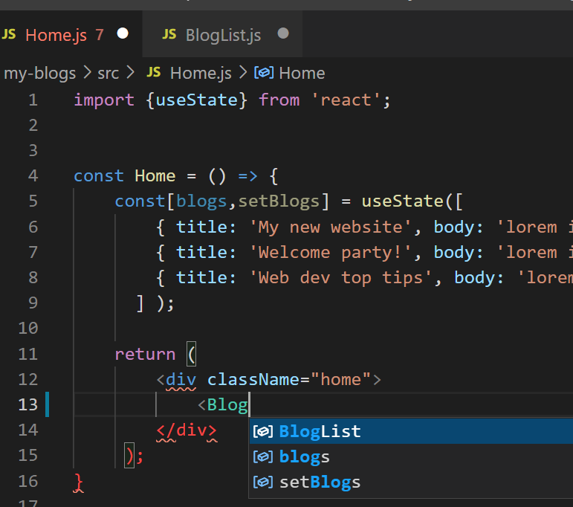
When you type like above bloglist will come there

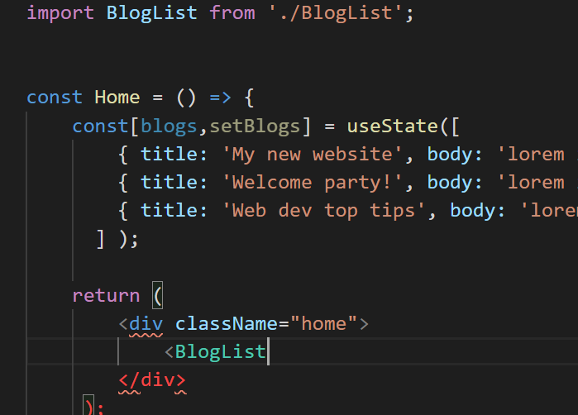
With this pressing entere on that it will automatically import that in top you can see that
And close that

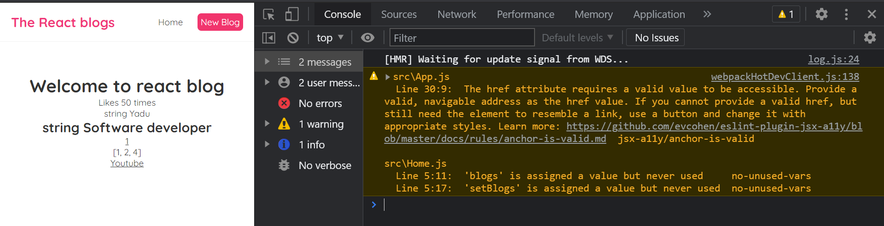
When you save and run we get error we have not yet done

Our blogs also not displayed
Because In bloglist component we try to map through blogs but we never passed it from anywhere
And inside that bloglist component blogs is not defined

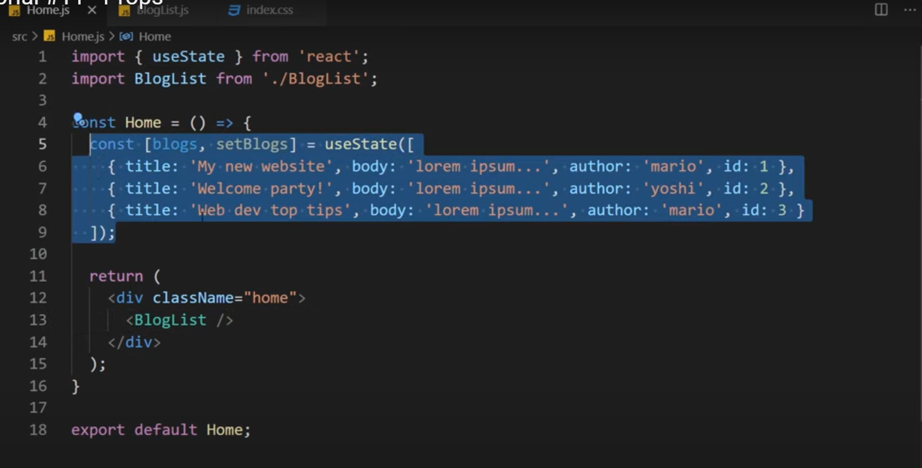
In home.js we defined list of blogs it can’t reach bloglist

So there are 2 ways to do that one in above image selected part we are redeclaring inside bloglist.js but this won’t be reusable and efficient

Second option Is to use props where we pass data of blogs to bloglist from home component using <BlogList /> present in home component

Doing like this uses of that: bloglist component become more reusable

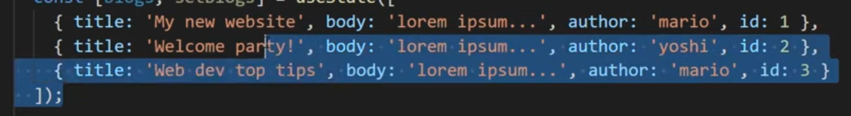
It allows us to use above data in home component in future if needed
Allows to show how to use props

So pass one property to <BlogList usePropsForBlogs={} /> bloglist tag we call it as usePropsForBlogs you can call it anything and blogs={} is gonna be dynamic value and it’s value is

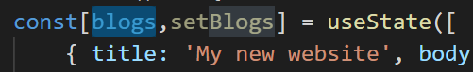
Above one blogs is value for that

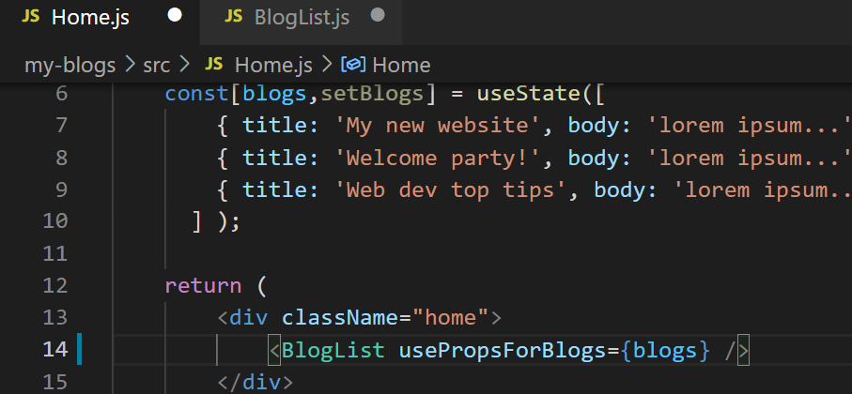
Now with this this is being passed to bloglist component as a prop

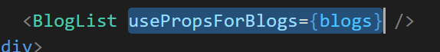
Selected region above is prop

Now we need to receive it inside blog component
And pass one argument as props

Our property usePropsForBlogs will be inside that props object inside bloglist component

I was getting error so using props in bloglist

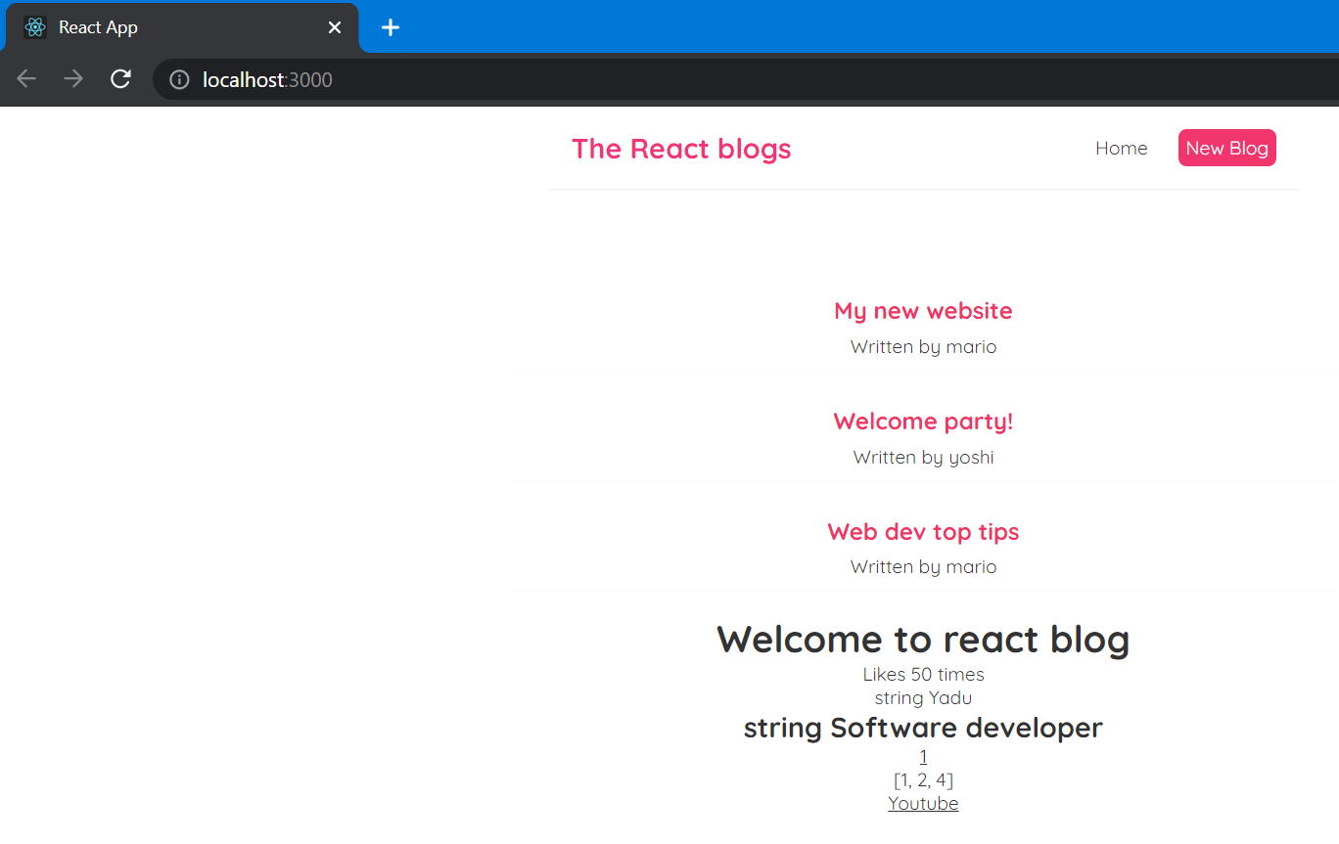
Now with using props page looks like this

// const BlogList = ({ blogs, title}) => {

If we don’t wan t to use blogs title separately we can use like this
It will do the same job

#12. Resusing Components

With using props code becomes more reusable

Now we use this props In different places and we pass different data to it

When you download react codes as zip file from google after setting path before run it use this code to download all packages used by it or else you get error
npm install react-scripts --save
Above code

Title error solved I din’t use title inside Bloglist.js inside return after using it title displaying

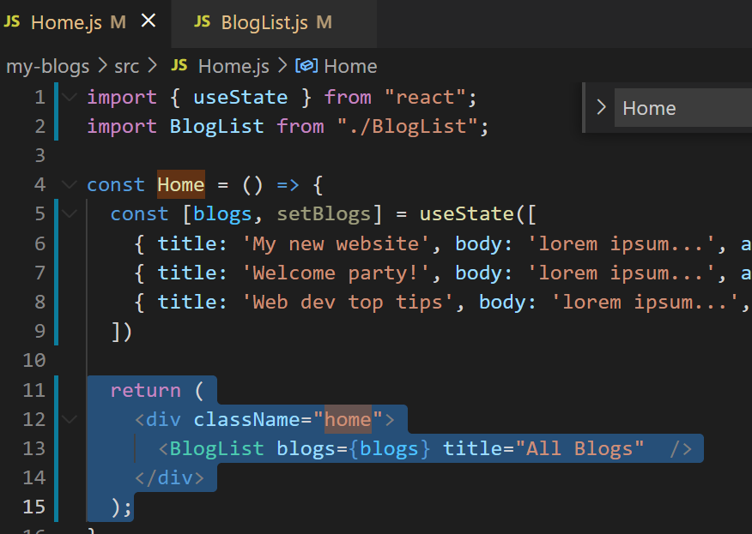
In home.js if you call title in div then

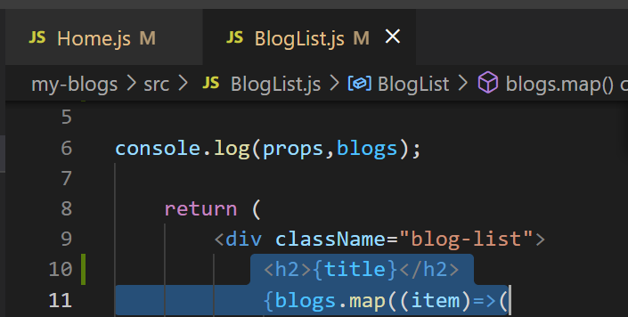
Inside bloglist we call inside title in h2

Now inside home.js we use 2 props 2 title 2 different data lists

In second title with “Mario’s blogs” we display only data with author mario

<BlogList blogs={blogs.filter()} title="Mario's blogs" />

We use filter for that and this filter will use one call back function
Here if we return true for the item it keeps in the array

Here if we return false for the item it fills it out of the array and it wil return new array with the item that we don’t filter out to be included
And we pass that data as prop

So we return true for mario so it includes and put false for yoshi
Inside callback take blog as argument after that return true or false

<BlogList blogs={blogs.filter((blog) => blog.author === 'mario')} title="Mario's blogs" />

Now above code returns true for mario and false for yoshi

And new filtered array will be passed through as the blogs data into this component so first time it will all of them and then underneatht there just gonna be mario’s blogs

So this is how we use bloglist component as reuse and not mix it and with different data

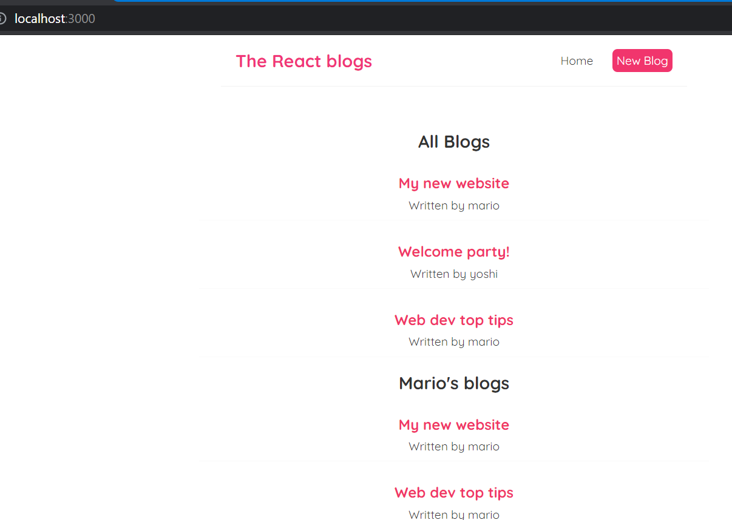
Thsi is how displays in page with 2 title s

#13. Fuctions as Props

Now first remove that extra blog of mario

Then what if I wish to delete those blogs in page with clicking on button

First of all we need button for each blog so we put it in bloglist.js

<button onClick={}>Delete blog</button>

Like this we type inside bloglist.js
{} it is for dynamic in react
Inside bracket we write anonymous funtion
And we pass one argument for custom funtion because we want to pass id of blog item which we want to delete and find that id in the array and delete it

Create one handleDelete method and pass blog.id where we have access to blog in bloglist and id we get it from list present inside home.js

<button onClick={ ()=> handleDelete(blogs.id)}>Delete blog</button>

With code we know which blog to delete
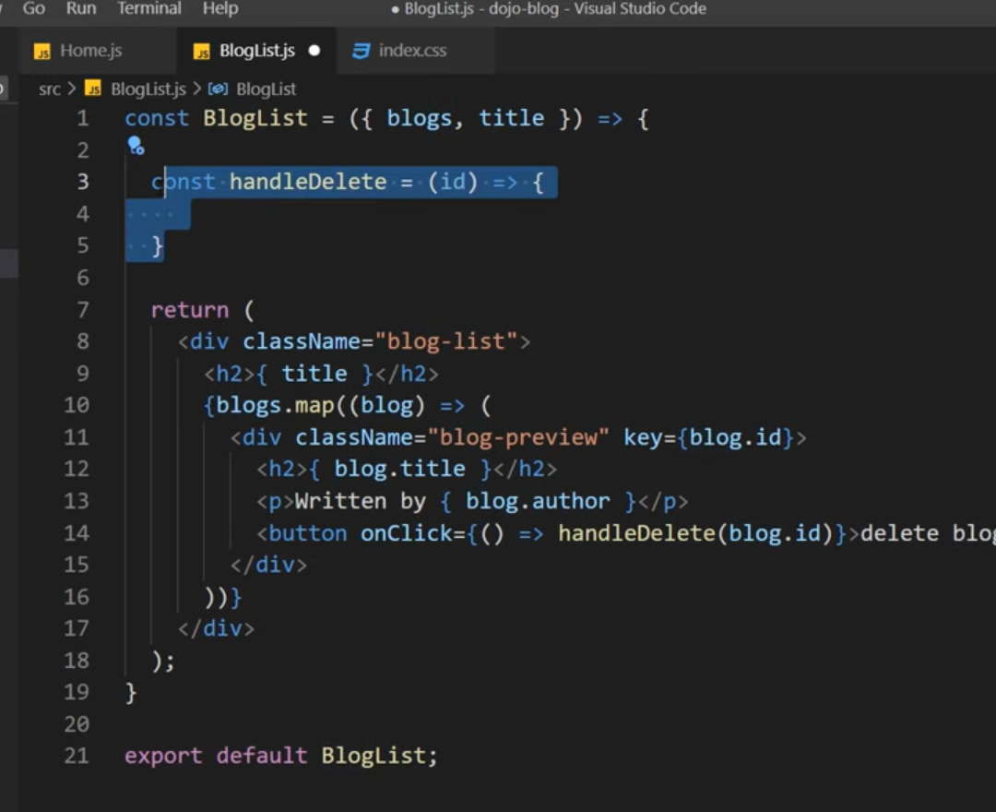
So now where to create handledelte method if we create inside bloglist.js we don’t get useState so not possible to delete

So we write this method inside home.js because setBlogs and usestate is there in home.js
So that we can interact with data directly
Later we can pass handledelete as a props to bloglist.js

<BlogList blogs={blogs} title="All Blogs" handleDeleteProp={handleDelete}/>

This is how we do handledelteprop and handledelte method

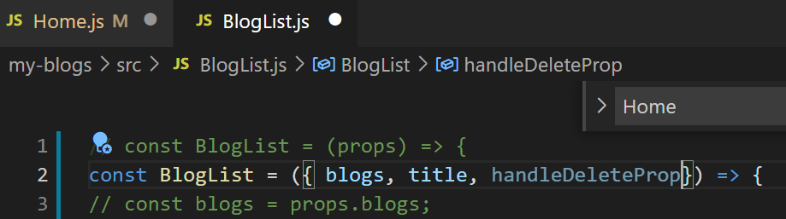
And then in bloglist.js accept that funtion as prop

Now what happens is with above prop we invoke handledelete funtion present in home.js and we have called it in bloglist.js

So inside home.js method handledelte method we can use setBlogs funtion to update useState and we can remove one blog with id

We do this by using filter method
We use const newBlogs to store new array for temporarily
So this doesn’t change original data
We display new array based on main array
So if id matches and true then we remove if it doesn’t match no remove

So when you click on one blog it’s id we get to bloglist.js’s handledelte button from there it will go to home.js

const handleDelete = (id) =>{
const newBlogs = blogs.filter(blog => blog.id !== id)
}

So inside above filter method;: if id doesn’t match then it will remain in array if it matches they we delete it
const handleDelete = (id) =>{
const newBlogs = blogs.filter(blog => blog.id !== id)
setBlogs(newBlogs);
}

And we set newblogs with using setblogs passing newblogs to setblogs

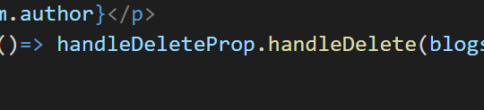
I’m using like this because if I use handledelteprop alone then it gives error handledelte not called or

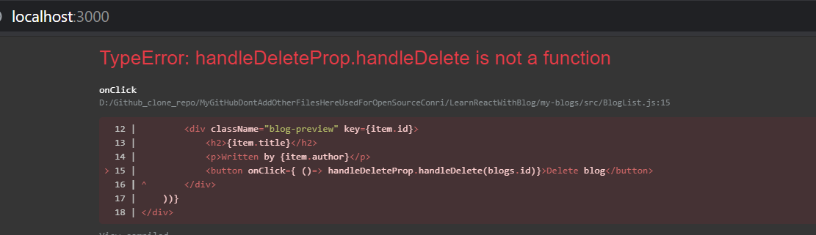
But using like above also gives errror

You have to use prop’s name same as method name
Else you can name prop’s name as handledelte same as method name

Some errors are there check it with code from github
Inside bloglist I need to change some codes :

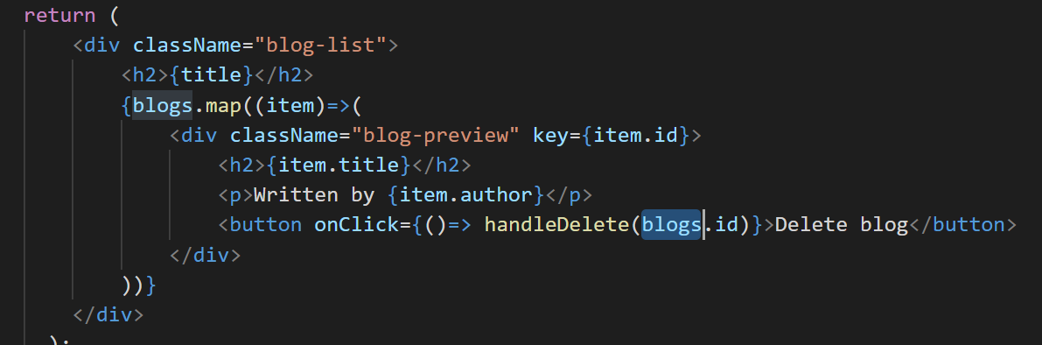
Inside bloglist everywhere to access every blogs I have used item to iterate but for handledelete method I have passed blogs.id which is not iterator so it can’t get id of blog which we clicked so If you change blogs with item then delete will work

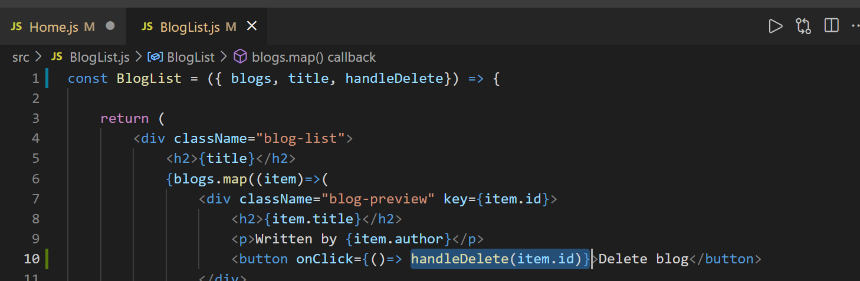
Above code

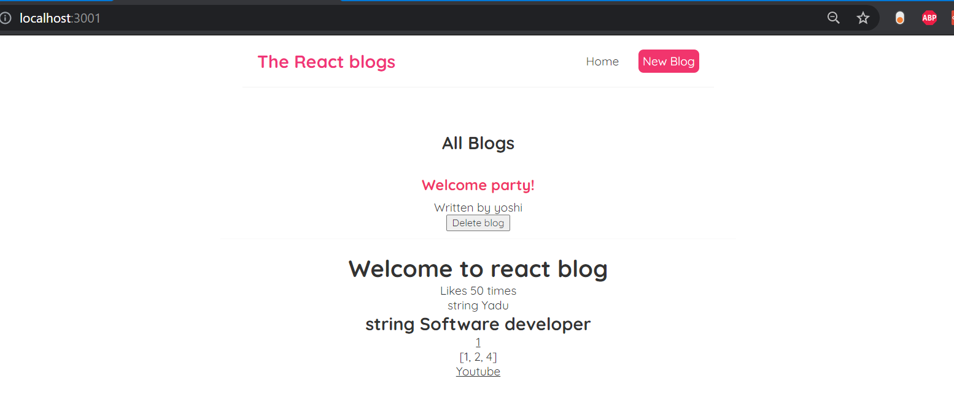
Works

#14. UseEffect Hook

Until now I used usestate now I will know useeffect
This hook runs a funtion in every render of the component

Component renders initially when It first loads and renders all of codes inside return of home.js to dom

But then also happens when the state changes it rerenders the dom then we can obtain that state in browser so this useeffect hook is a way to run the code on every render and that could used for many different reasons

import { useState, useEffect } from "react";

How to use It import it first at the top
Use it before return and pass as an argument one call back funtion
And this funtion gonna run every time when there Is rerender initially when the component loads thereafter any time data changes

useEffect(()=> {
console.log("use effect ran");
});

Write code like

Inside useeffect we could do something like fetch data or communicate with some kind of authentication and these things are known as side effects in react


Now go to page and inspect and clear everything on console by pressig on above button and refresh and see console

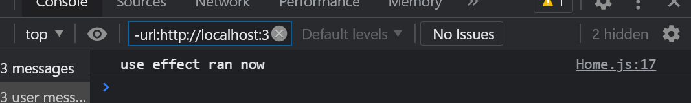
Whne page loads that time
Because useeffect fires it
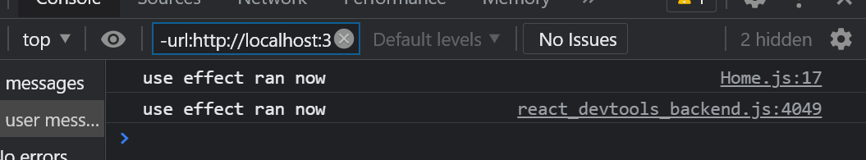
And when we click on delete
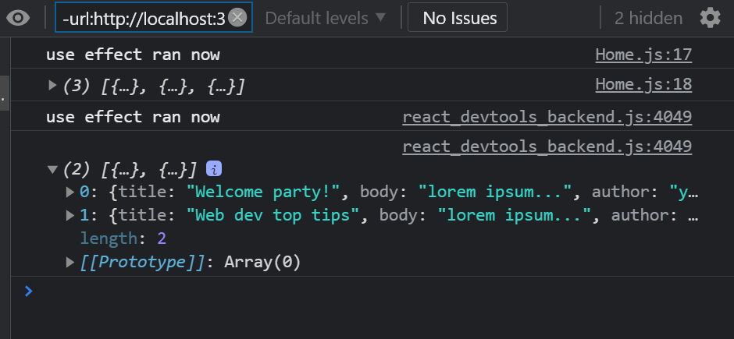
You can also print blogs inside here so that when page loads you see all blogs and when you delete one blog you see only 2 blogs printed out there

One important thing is using state inside useeffect
Because you could end up in continuous loop of renders

So initially component renders to the dom and that’s what triggers useEffect to run and that’s what then obtain the state and the state would change and that what trigger rerender and that rerender again triggers the useeffect then we change the state and that again rerenders this rerender triggers the useeffect …… this end up in continuous loop

#15. UseEffect Dependencies

Useeffect will run after every render but we don’t want to run useeffect after every single render may be we can only for certain render
For that we can use something called dependencies array

This is basically an array we can pass into useeffect hook and as an second argument
First only pass an empty array and check what happens

useEffect(()=>{
console.log("use effect ran now");
console.log(blogs)
},[]);

With this when page loads we see

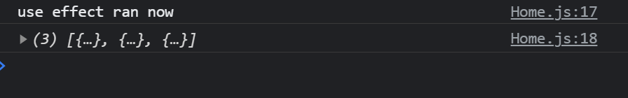
Output

First time when page loads above

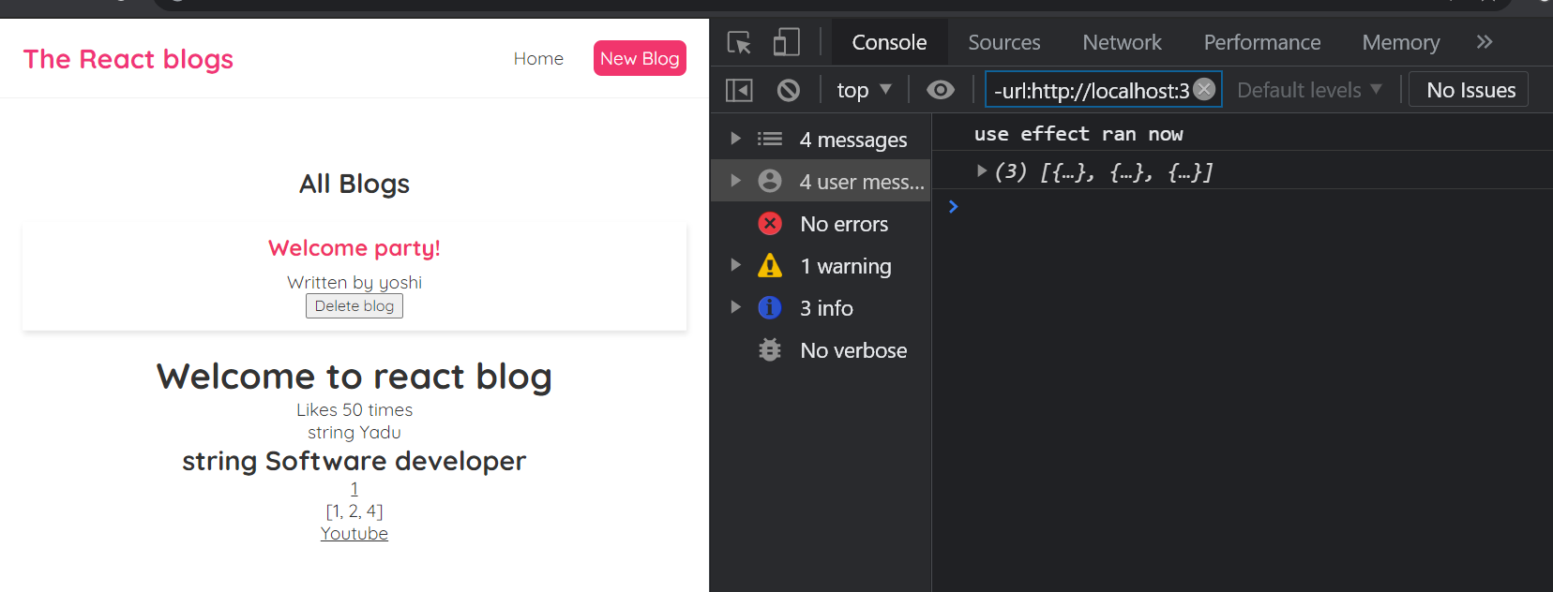
Whne we refresh that time also we see message only once because of passing empty array

After deleting also we see only once use effect ran now

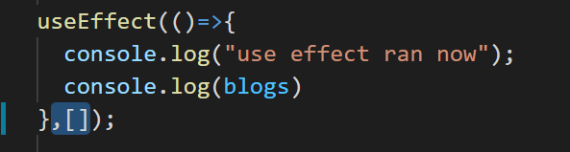
So what empty dependecy array does it’s make sure that this hook right here only runs the fucntion after first initial render after that if the state chagnes it won’t run the function agai n

Another option is to use actual dependency to that array
Means any state values that should trigger these useeffect funtion to run and they change for this we create anothe state

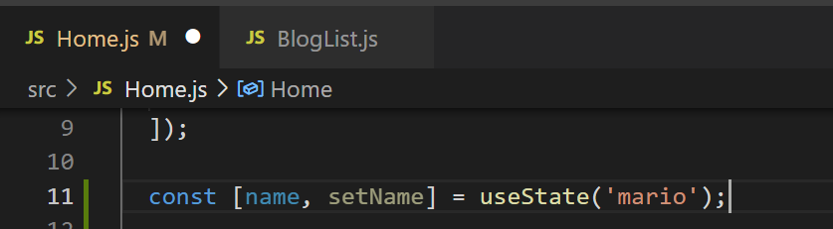
State with name create funtion inside named as setName and initial value of this state will be mario

Now I can able to change thsi state to do that we create one button at bottom of the state and attac click event to this insie that call an anonymous funtion which sets the name and new name we pass which is Sri Ram


And using p tag output that name when we clikc on button name changes to sriram

Now if I want to run useeffect at beginning when the component first renders and also when certain value changes so we will run setname funtion inside useeffect because it’s state changes so add name isnide depenedency array

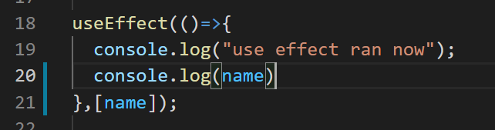
Like above
Now useeffect gonna watch this value and if it changes it will run useeffect funtion now we print name inside useeffect

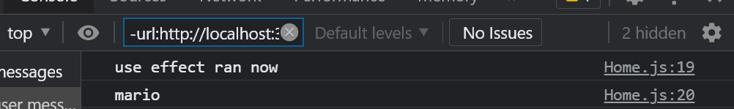
Now when we run first time
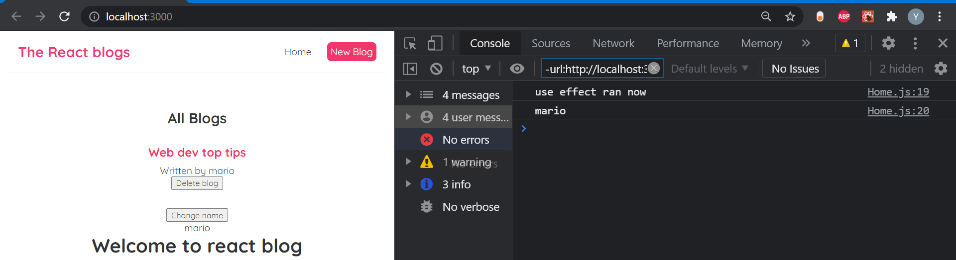
When we delete nothing will be printed since we didn’t add blogs to dependecy array

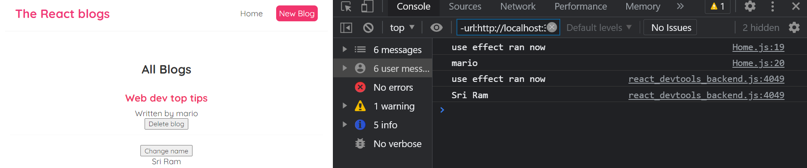
But when we click on change name it runs the funtion since we added name to dependecy array

When you click on button again it does not run because setname is already pointing to it’s passed name

#16. Using Json Server

Useeffect is best place to fetch the data because it runs the function when component first renders,
So when data renders we can use it in our application using useeffect instead of the data which we stored as list blogs because in web app we don’t hardcode like blogs list instead we will fetch from database or api or etc…

Here we use package which is json server which allows us to build fake rest api

So in the root of directory of my-blogs create a new folder call it as data
Inside that create one file db.json and paste data there data contains blogs with 2 objects
Here blogs is like resource

Next we include json server package to watch file and wrap it with some endpoints

To install json errror open a different terminal
Type like this in terminal:
npx json-server --watch data/db.json --port 3001
Watch to watch file, include path of file where data is there and port no is different because 3000 port number our page is running
So we’re telling to watch data of db.json file

npx json-server --watch src/data/db.json --port 3001
Important : if you give path like above it gives error so include src in path
When you type above in terminal

Home
http://localhost:3001

Type s + enter at any time to create a snapshot of the database
Watching...
Above will come in terminal

So if we wan’t to send get request to get all of the blogs we would use endpoint like this
You can go to browser and paste this : http://localhost:3001/blogs
You can see all data

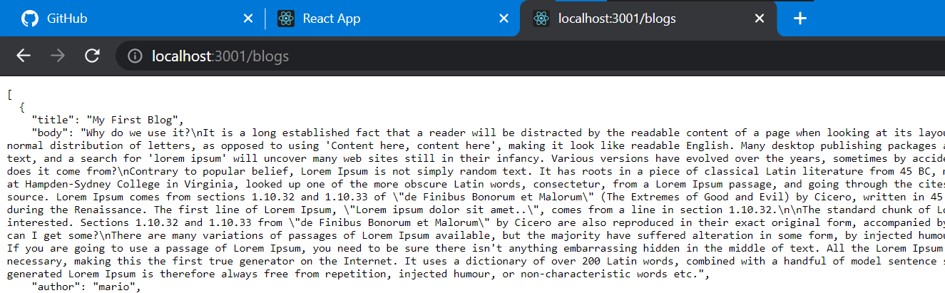
Sometime it takes little time to display data

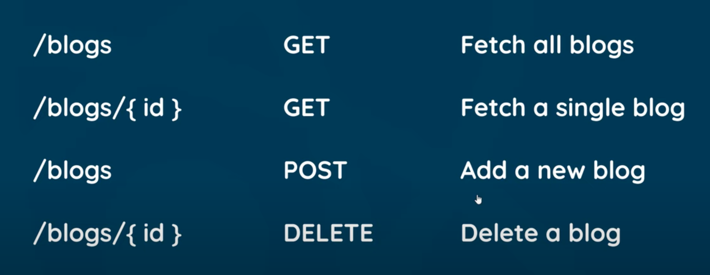
I’ll use above endpoints in here

#17. Fetching Data with useEffect

Now we have json server running and watching our db.json file we have different endpoints now I’ll try to fetch data inside this useeffect when the component first renders that’s the only time we can run because we have the empty dependency array inside it

Now delete list of blogs inside usestate we don’t use that furthere
And set it’s value as null

Once when we fetch data from db.json we update this blogs using setBlogs

useEffect(()=>{
fetch('http://localhost:3001/blogs');
},[]);
Inside useeffect make fetch request use url of fetch
Now this fetch of url will return us a promise so to take it we use .then

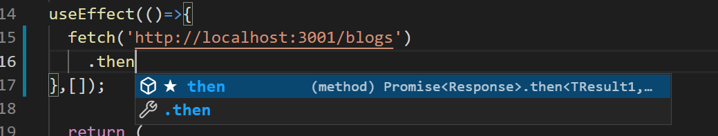
Like above

Promise is :
Above will fire a funtion once this promise has result in it

So create one response object it’s not data it’s response object
To get the data res.json() and this passes json data into js object and return it
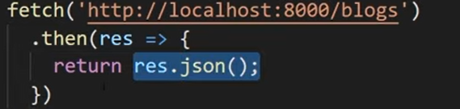
Now above entire thing is another promise because res.json is async
So for that tack on
Another time use then and inside that we get data from respons object
So this data contains data of db.json file
For understanding you can use console.log(data)
When you run you can see data of db.json because of console.log(data)

Now we can do like update the state with data inside usestate to do that we can use setblogs now this is not going to call infinite loops because we have empty dependency array means fire that funtion only at initial render not whenever data changes

Alll we doing Is setblogs(data) : taking array objects and update in blogs state with the array

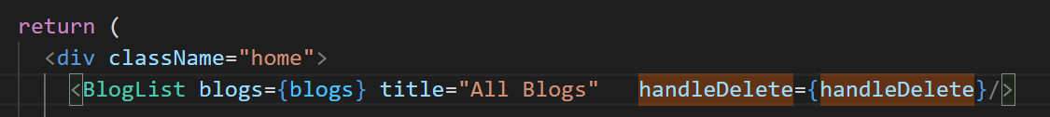
But with above we might get error

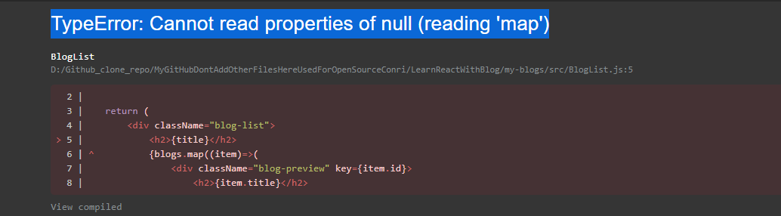
Like above error

Because we set value of blogs at beginning as null and in return at down we pass null when app first loads and
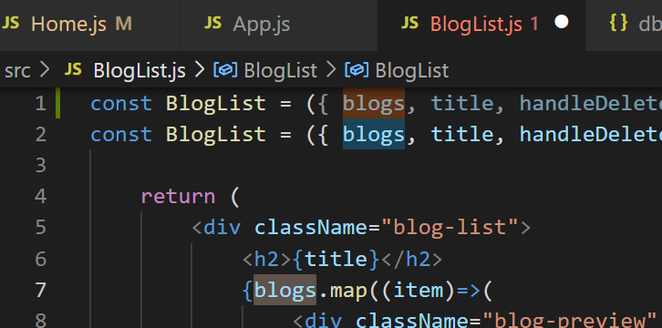
Inside bloglist.js we try to use map method for null

So how can we solve this error really we don’t want to output <Bloglist>
<BlogList blogs={blogs} title="All Blogs" handleDelete={handleDelete}/>
as tag in home.js we can do it as dynamic in js inside template we use {}
{ <BlogList blogs={blogs} title="All Blogs" handleDelete={handleDelete}/>}
So use like

{blogs && <BlogList blogs={blogs} title="All Blogs" handleDelete={handleDelete}/>}
And we use like this with above our bloglist will display normally
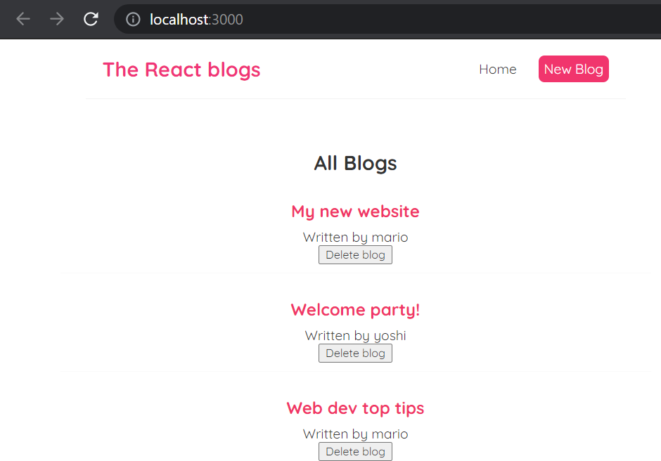
Like this

Above using && is called conditional templating in react logical and evaluates the left first and if left is false it doesn’t bother about right thing present after && since blogs is null
Always it will display only if left side is true something like that

Now we remove handledelet and delte button and remove prop as well
And in bloglist we don’t need handledelte also button at the bottom

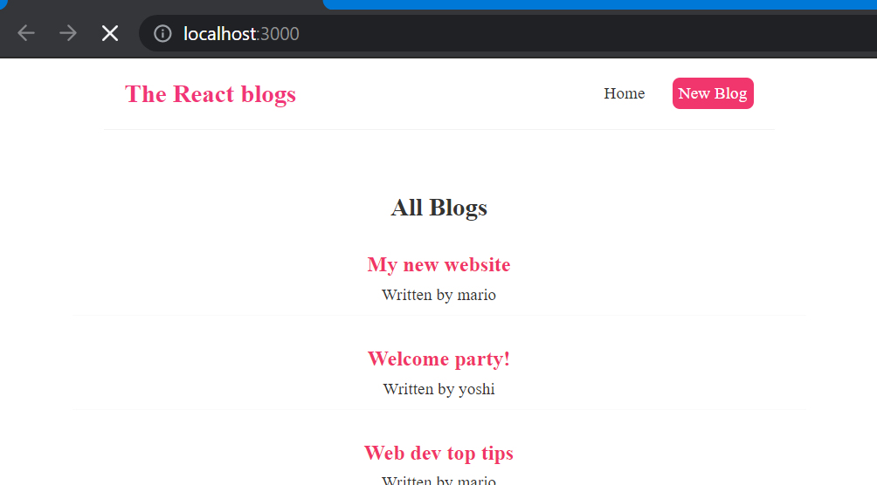
Only display blogs

#18. Conditional Loading messages

Currently in our page we render the blog once when we have blogs data until that we don’t render it

Currently fetch is very quick because we fetch data from our own another file but when we fetch data from another server over the internet it’ll be slower in that case user will see that loading message when we fetch data

To do that create another usestate inside home component name it as isloading

const [isLoading, setIsPending] = useState(true);
Add like above

And in last return use conditional template also like using logical and
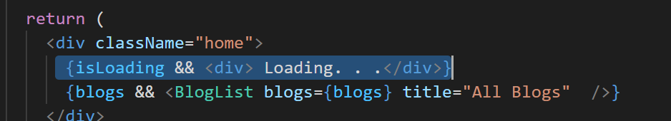
Doing like above

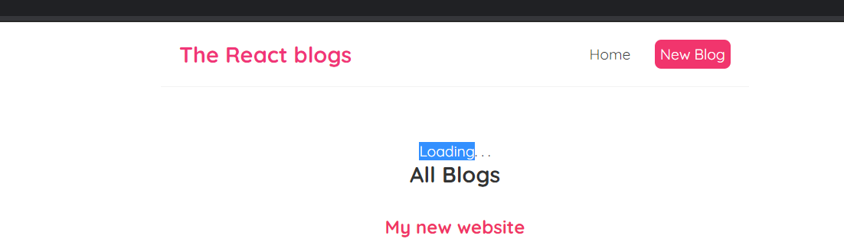
But while preview in page it looks like this
But we don’t want like this, we want to show loading only when fetch is going on not after data is rendered in page

So once we have data inside data of useeffect we can set ispending as false we can do that inside useeffect

//here above deleted listed data which is hardcoded from here onward displaying data like
//it's coming from an API. So run this command in another port by pressing on + sign on terminal
//npx json-server --watch src/data/db.json --port 3001
//we're running 2 ports one for react another for like server data we display data from
//data folder db.json file

Keep above in mind
We’re running 2 ports one for react other for db.json

Now when you refresh page only for few seconds you’ll see loading after that it disappears
Because setispending will be false

So now we try to mock or simulate how from a real time server data loads by using timeout inside useeffect
For that we use settimeout method with 1000ms with this after 1000ms settimeout fires and it’ll fetch data so that we can see loading text for 1000ms

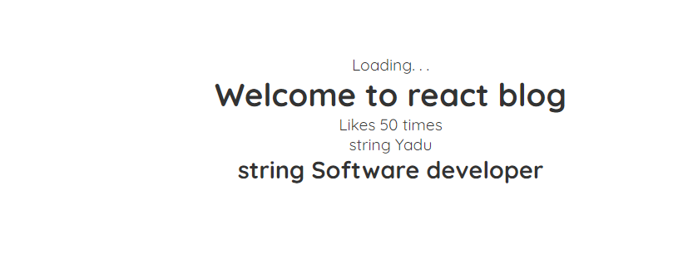

Now because of using 5000ms

useEffect(()=>{
setTimeout(()=>{
fetch('http://localhost:3001/blogs')
.then(res =>{
return res.json();
})
.then(data =>{
setBlogs(data);
setIsPending(false);
})
},5000);
},[]);

Code is ^
But don’t do this in real time app simple we wait user to wait for some seconds

#19. Handling fetch errors

When starting start both react and db.json or else data won’t be displayed

Error could be connection errror or promiser error
That time we would get to know the user what type of error it is.
So we use catch block here
Next line of fetch give one tab and after setispending type catch() there

And put that error inside that catch funtion as parameter
And then log it to console
This will catch any kind of network error

Now we will mock this kind of error now press on ctrl+c to disconnect db.json which is like disconnecting server.

https://github.com/Yadunandanaacharya/LearnReactWithBlog/pull/19/conflicts
In github with above link I’m getting conflicts because of removing blog lists and replacing it with null same was happening in visual studio with ipas project also >>>>>>>>>>>>>>> this symbol with old code and new codes were there I deleted old code and pressed one buttton solved merge conflicats and pressed button merge

useEffect(()=>{
setTimeout(()=>{
fetch('http://localhost:3001/blogs')
.then(res =>{
return res.json();
})
.then(data =>{
setBlogs(data);
setIsPending(false);
})
.catch(error => {
console.log(error.message);
});

},5000);
Code is

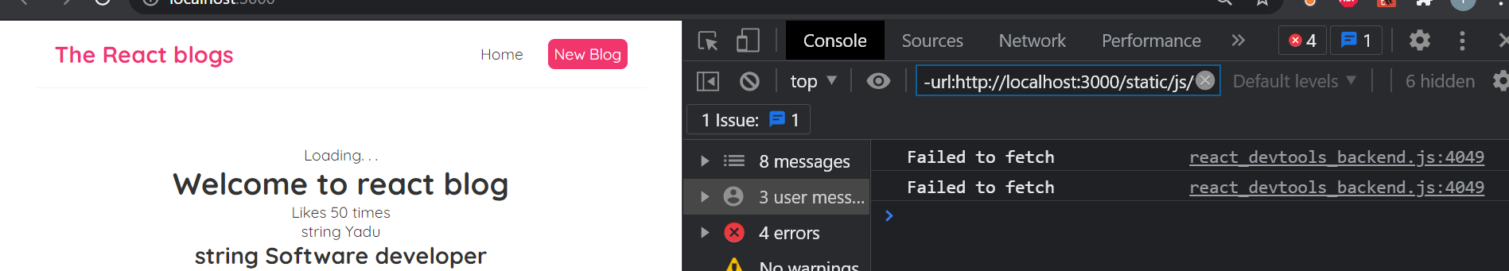
Output is since we stop server of db.json it’ll tell can’t fetch data

Another kind of error if our request reaches the server but it sends the error like endpoint we try to fetch doesn’t exist or if the request is denied in that case our above catch block doesn’t automatically catch that error because it’s still reaching the server and server is still sending response object back to us and response doesn’t contain the data and it contains different status in this case we need to check response object

So after res we can type an if
Now make db.json watch with npx and do belwo
But now just now do console.log(res)
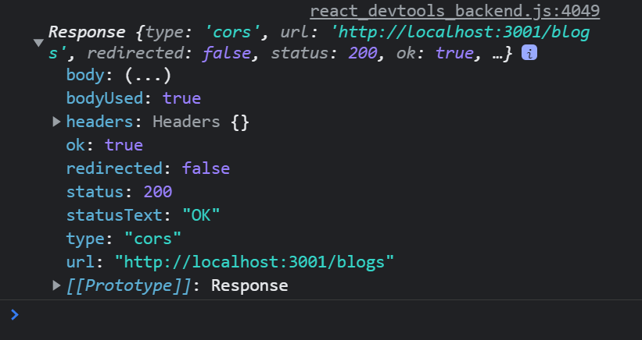
In page console
Notice in above we get notice property that means fetch is ok that’s true if all are fine but if we send an request to an endpoint which is faulty or doesn’t exist then ok will false

So currently we will do that if ok is false then we throw an error

.then(res =>{
// console.log(res);
if(!res.ok){
throw Error('Could not fetch data for that resource');
}
return res.json();
})
Code like

So now in catch’s console we will see if fetch of response error is there

fetch('http://localhost:3001/blogs')
fetch('http://localhost:3001/blogssssss')
Now change above url by adding one extra s to blog like

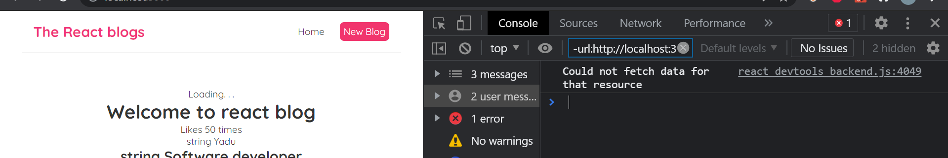
Then you can see error in console

Now store error in some kind of state and output it to browser
With usestate

const [error, setError] = useState(null);

Add above

So when we catch error instead of using console

.catch(error => {
setError(error);
});
Do like this pass it to seterror

If we have value then output it at bottom using logical and

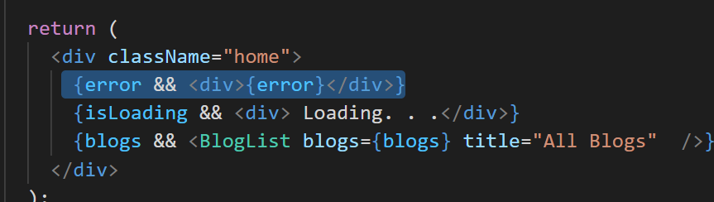
Like above

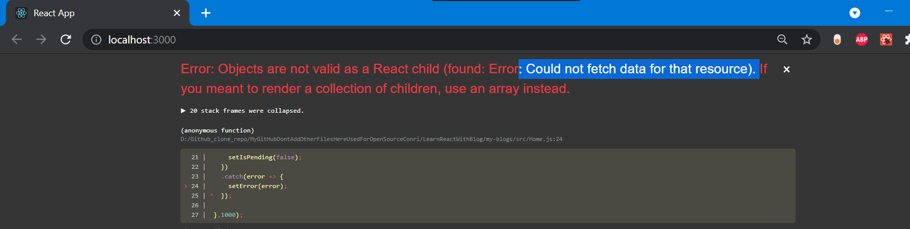
Since I added more s in url of db.json to fetch data to simulate error above error displays in page

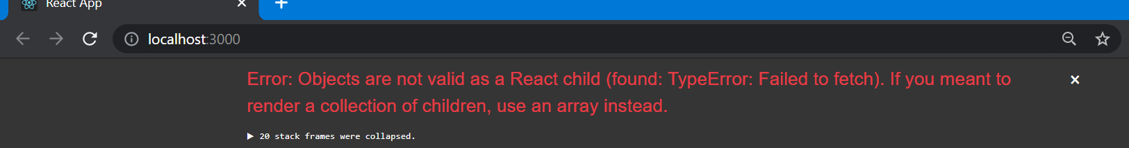
Or else when I stop the server that time

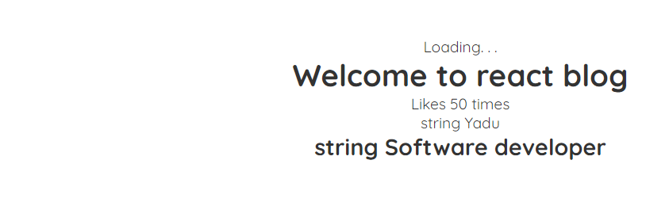
But when error is there first we get loading if we have an error we don’t want to see loading

For that we set ispending false with this when error will be there it doesn’t show error message
We can do inside catch
We also do one more thing that is set error to null inside

.then(data =>{
setBlogs(data);
setIsPending(false);
setError(null);
})
.catch(error => {
setIsPending(false);
setError(error);
});
Doing these changes inside useeffect

Seterror null if we get data because if we try to fetch data again we make request at any point so we want to get rid of the error message if it’s successful

With above code loading won’t display and seterror also null if no error is there

#20. Making a custom hook

Currently we have put all of logic inside useeffect hook and update all of the state properties and to update
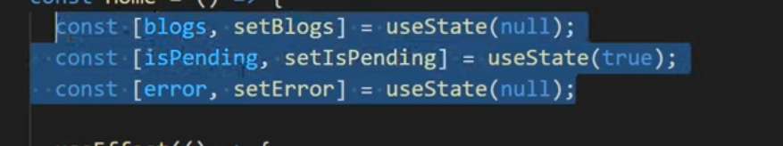
All of the state properties to output the data loading message we usestate

What if we want to do same thing in anothe component so we have rewrite all of these code for fetch data load data for errors in that component again that’s not very effecient not easy to manage if we are using this same code in many different places

So it would be good if we can use all of our old code of usestate useeffect hook again in different component so we make it reusable

So what can we do we can repeat all of this component and put it in own javascript file and then we just import that into this file to use it.
And we can also use that in any other component in future

When we do like this by externalizing the logic file we creating something called custom hook
In react usestate and useeffect have their own funtionalities

For doing this make a new file inside src and name useFEtch.js
Inside this put all of the funtionalities to fetch the data exactly as we did in home.js
But first of all we need to create a funtion here this futintion will be hook itself
Funtion is useFetch and make it equla to arrow funtion

Custom hooks in react needs to start with use otherwise it won’t work
Now cut useeffect code from home.js and paste it in useEffect.js

Now we need to do some tweaks like we need to register all usestates inside useeffect.js so cut and paste all usestate hooks from home.js
And also import them
At the end of the funtion we need to use “export default useFetch” to use it in other file in future

Change name of blogs to data because it might be different type of resource in future.

const [blogs, setBlogs] = useState(null);
Changing
const [data, setData ] = useState(null);
To above

Change all places where you have used blogs
Data in local version inside of useeffect and in usestate are same it’s ok they won’t clash

Next thing we need to do is return some values from it
When we use data with usestate it returns some values so
Inside useeffect we return an object with 3 values inside it.
return {data, isLoading, error};
Like data, isloading and error

Another thing we do : passing enpoint of url into the funtion rather than hardcoding because we use usefetch function in another file or component it can’t be same url endpoint alwasy name it as url

const useFetch = (url) =>{
Like above
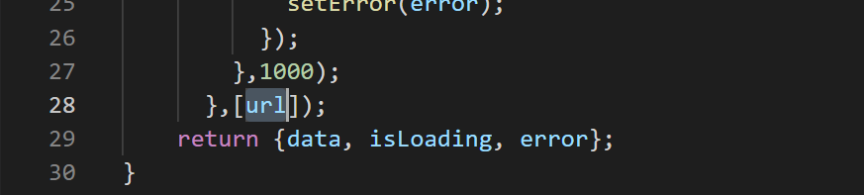
Also use url in dependency array of useeffect because whenever the url changes it’s gonna rerun useeffect funtion to get that data from that endpoint

Now import useFetch in home component and then use it

Inside home first we need to destructure output since it has 3 types of data
const Home = () => {
const {data, isLoading, error};
Like above

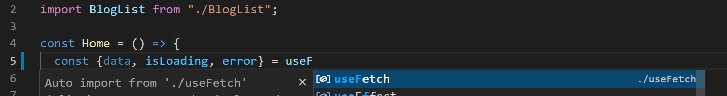
Making it equal to when we type like above it automatically imports at the top usefetch imports
And pass url for this

So that’s the result we are trying to fetch
So this should work once we get data we’re outputting it
And in div where blogs is there change it with data

{blogs && <BlogList blogs={blogs} title="All Blogs" />}
Change above to
{blogs && <BlogList blogs={data} title="All Blogs" />}
This

const {data:blogs, isLoading, error} = useFetch('http://localhost:3001/blogs');
Or pass blogs at top in front of data like this with above in div you can keep blogs itself.

Save it refresh page it works like normal
This is how we can make custom hook this is now more reusable we don’t have to copy fetch code in other component now

#21. The React Router

Now in our current page we have only single page we don’t navigate around other pages we just have single home page so we have to create different multiple pages in our react app we do this with react router

How does multi page website works:
Typical website not using react handle multiple pages
We’ll start typing the url in the address bar and send a request to server for that address and that server handle that

And server generally send a full html page which we then use in browser
Now user will click on link type on page like click on contact page then in sends brand new request to the server and then server responds by sending back a new contact html page and we view that in the browser and the cycle would continue over and over as we click on the page links in the website so we’re contstanly making requests to the server for new pages
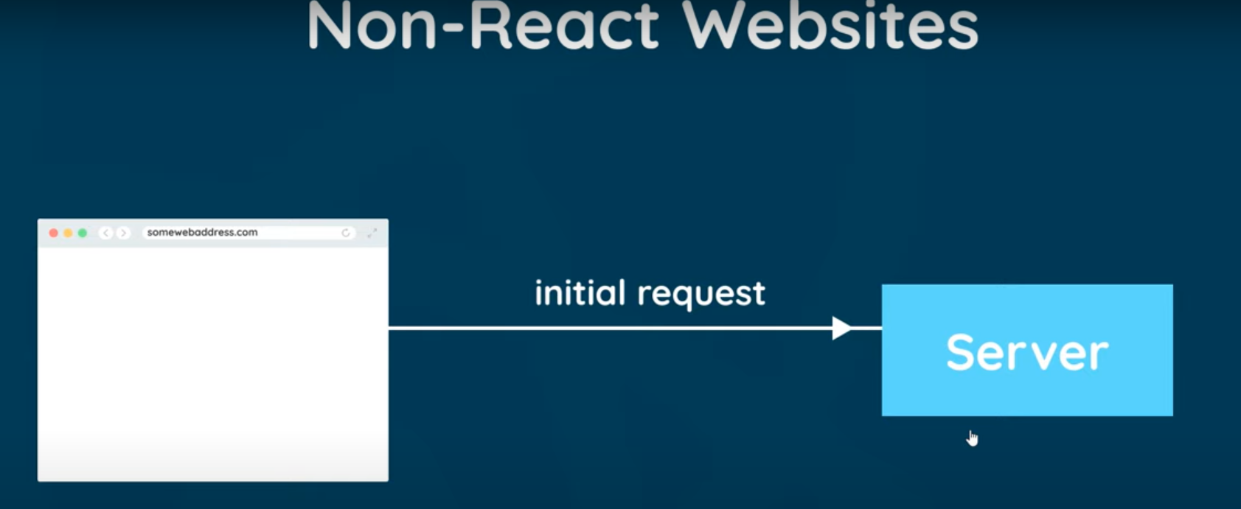
First image
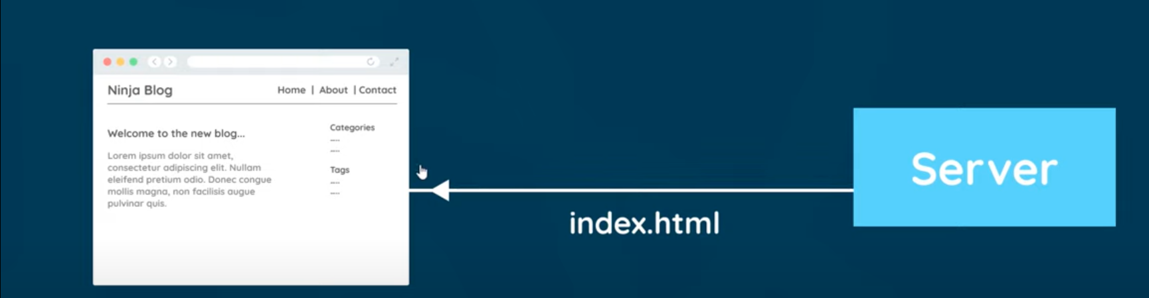
Second image
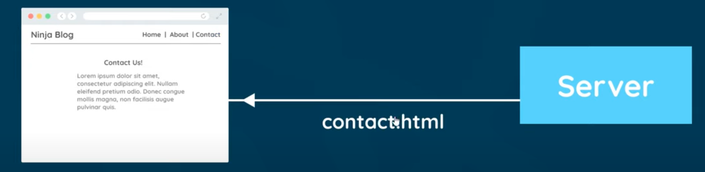
Third image

Now request apps don’t work like this they delegate all the routing and changing of page content to the browser only
And it starts the same way we make an initial request in the browser server then responds to that by sending back the html page to the browser but it also sends back our compiled react javascript files which controls our react app.

From this point on react and react router can take full control of the app
So at begin the html page below we got back is empty

Fourth image

And then react injects content dynamically using the components that we create
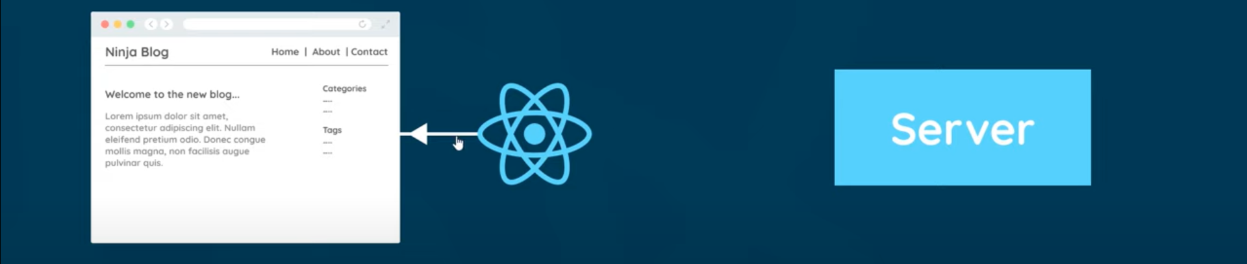
Sixth image

If we then decide to click on a link to a new page then react router is gonna step in and intercept the request to stop it from going to the server and instead it’s gonna look at the new page request and inject the required

Seventh image

inject the required content on the screen for example clicking on contact link the react router will tell react to inject the contact component into the browser if we were to click on about link it would tell react to inject the about component and so on
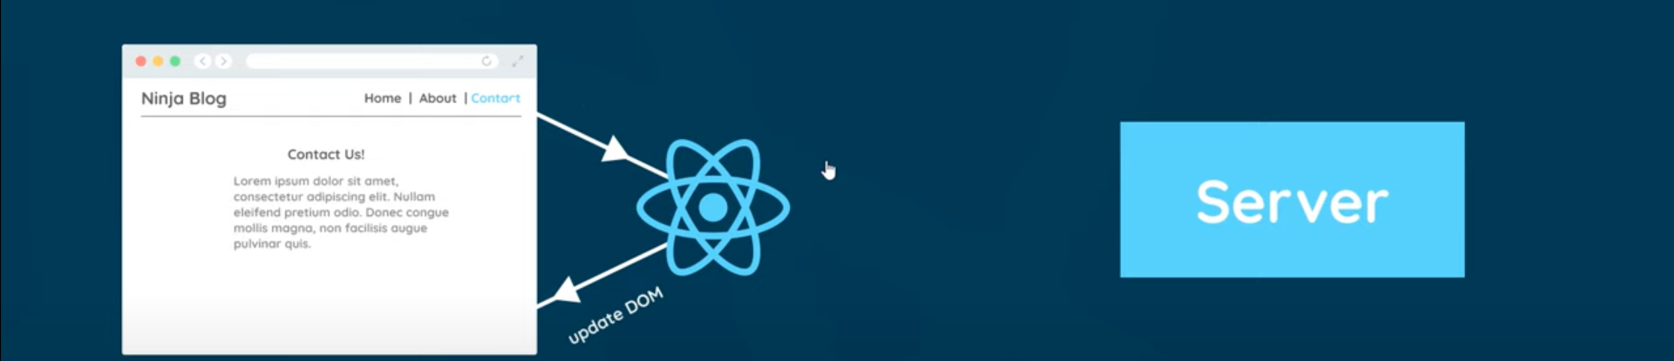
Eigth image

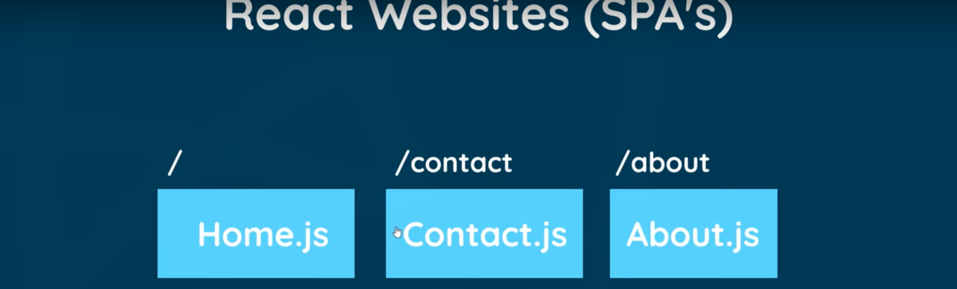
Ninth image
This is how react router works we assign top level component for each router or page and that component dynamically injected into the browser when we visit that route this whole process means we make less requests to the server and the whole websit feels faster

Set it up in our code

First step install react router package it’s not core part of the react library we need npm so we need new terminal
Click on npm and type npm install
Since version 5 is stable currently I’m using it . @5 denotes version number

npm install react-router-dom@5
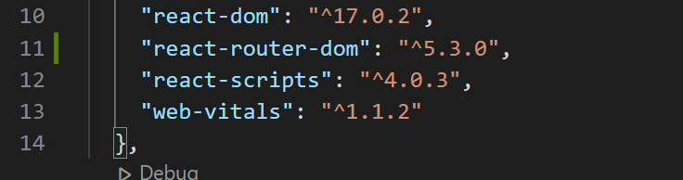
Once after install go to package.json there we should see react router
When we install something it goes insdie node_modules

How to use it:
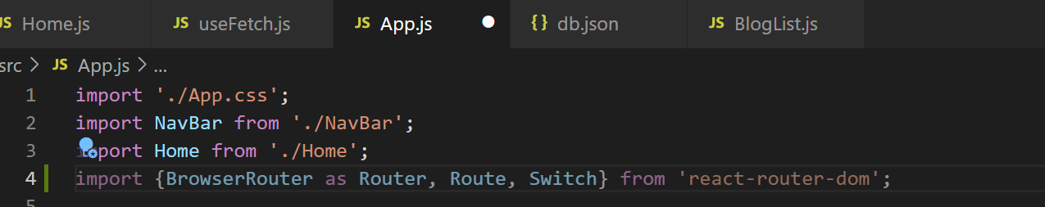
First go to root component app.js we need to import some here

Now we need to surround our entire app with router component
Means wherever all nested components inside app component ‘
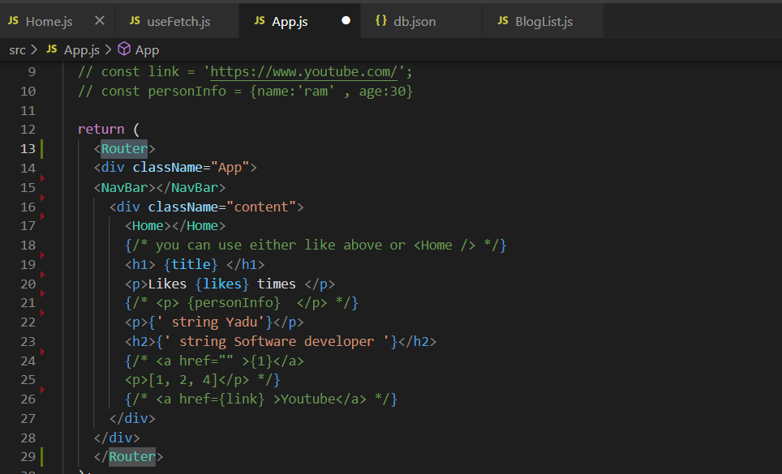
So in app.js in return use Router like above

Above is first step next step is to decide where we want our page content to go when we got different pages

<div className="content">
I want to go inside div above inside app.js so delete <Home> component
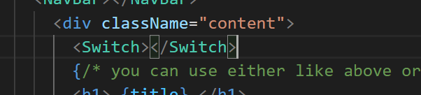
and use <Switch> component there

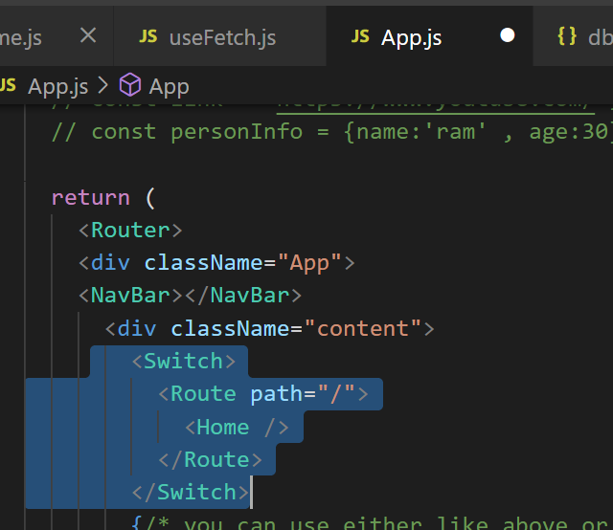
Do above

localhost:3000/
Now even when I type like above in url it works it displays data list blogs.

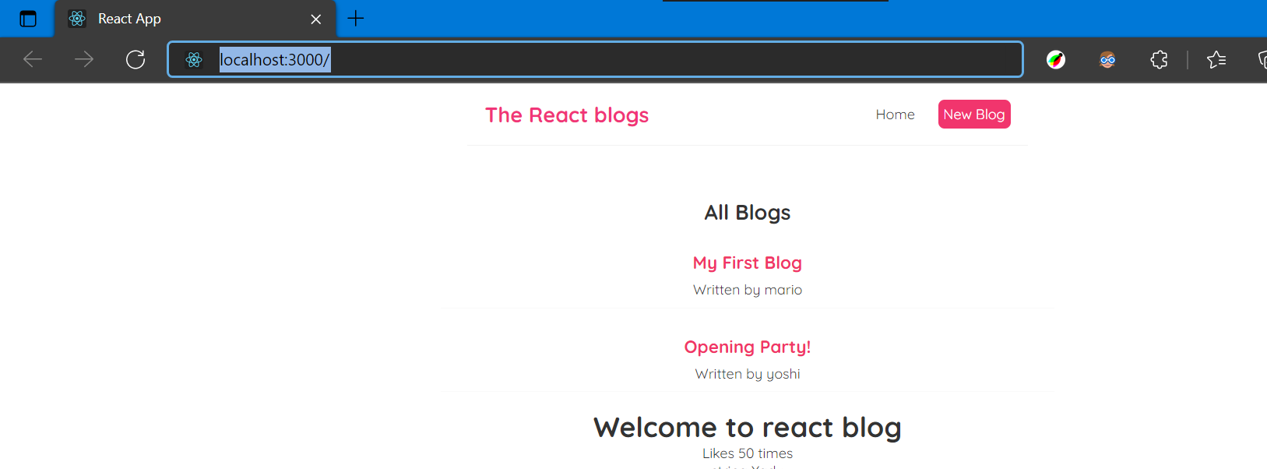
Even if you press on home it displays same since we didn’t mention anything special over there

#22. Exact Match routes

Now we have router setup now we’ll try to add another setup
To do this we need another page component this is for web form to add a new blog call this component as create so
Create a file create.js

Inside we need sfc type it
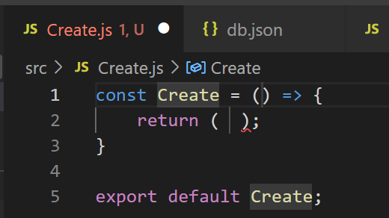
Type create
Template will be very simple div.create type this inside return inside div put title
return (
<div className="create">
<h2>Add a new Blog</h2>
</div>
);

Do like above now I want to show this create component if user goes to /create

So now we need to add this in app.js
Add another route component inside swithc this time path will be create now this will render Create component

<Route path="/Create">
<Create />
</Route>

When you type Create drop down will appear when you press enter it will auto import at the top
Now try this in url type /create and press enter check whether it works

Remember now I’m running 2 terminals one for react npm start another for npx db.json some code is there
But when I type localhost:3000/Create that will go to home page itself

So what’s the reason
This is how react looks at route paths
When we type /create in url and then it looks throough our routes and it tries to match that with one of things that is path which we typed in code
So important thing is it tries to match with first one which it finds to be correct match and it stops there and it goes from top to bottom

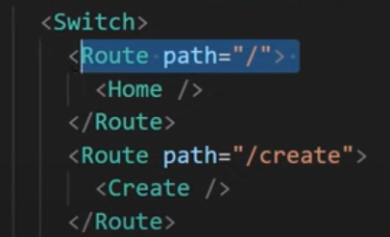
It looks at first match “/” and says yes this is match because in our route for /create there also / exists
This is how logic works
It sees / as match for /create

Another example we can imaging if there is path with /c in Route

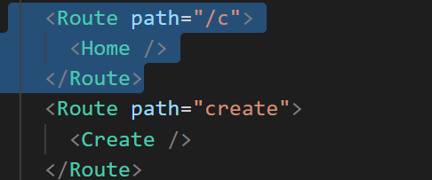
Then it tries to match with /c as /create

What we can do for thsi so I don’t want to match “/” if it is used but I want to match exact route for that we add exact prop

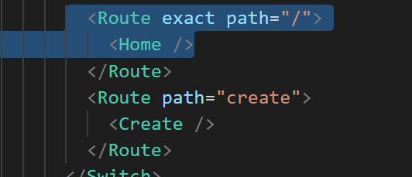
When we use like this in path then we go to our required route

Use exact

#23. Router Links

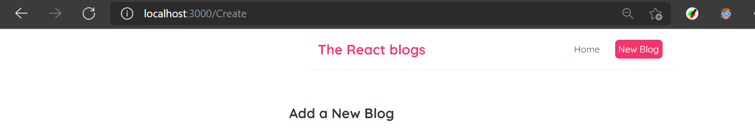
When we click on home or new blog it sends fresh request for the server

But we can say react route can intercept those request
Now we use special link tag

Now go to navbar try to use link here
First import link in navbar.js
Currently in navbar we are using a tag

But if we want only react to handle routing only in browser and to intercept those requests for new pages we need to replace this with link

<Link href="/">Home </Link>
Change a to link link component doesn’t have href instead it used “to”

Now we want to link to /

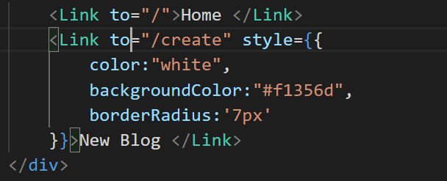
We change code in navbar to

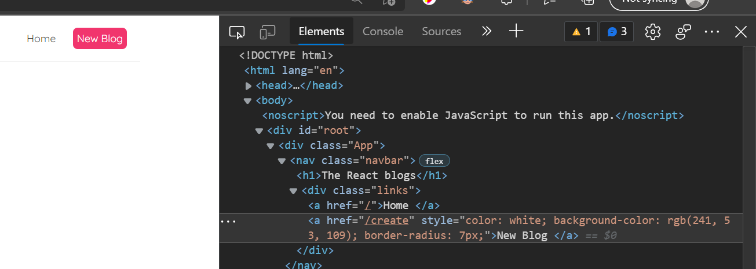
At the end of the day when react renders all of these to the browser we still see a tag in inspection you will see a tag

You can see using link is much faster than using a tag
When you click on home and new blog button it queickly goes to that page.

Refresh web page when you continuously click on home and new blog button you will get error like this

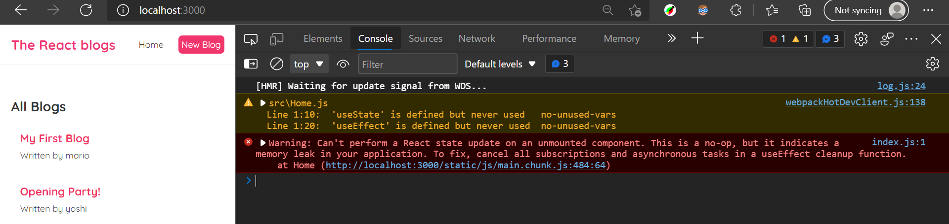
This
This is to do with our custom fetch hook which is still running in the home page is still running in the back ground even when we got a new page here it’s trying to update state of the home component after it’s been mounted from the dom and replaced with create component

#24. UseEffect cleanup

In previous we got error while clciking home and new blog button in speed

Fetch is still going on in the back ground once we switch to add a new blog and therefore when the fetch is completee it still tries to update the state in the home component
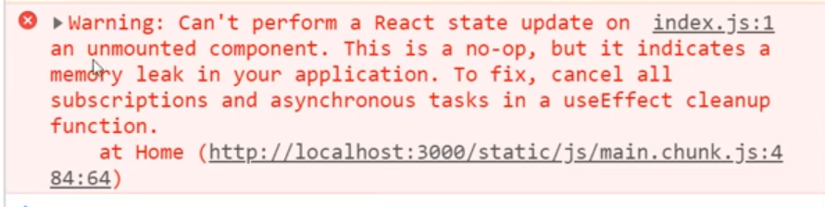
But home component isn’t in the browser anymore that’s why we get this error

Unmounted component is the home on e
So we need a way to stopping the fetch when the component is using it or mounts
So If we go home and click on new blog we wanna stop that fetch from carried on

To do this we use combination of cleanup function in useEffect hook
Something called abort controller in js

So go to useFetch.js file and first we run a cleanup funtion
When the component uses this hook
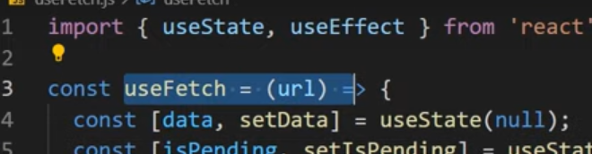
This useeffect

So how to create cleanup funtin

All we need to do is place cleanup funtion inside useeffect funtion
And we just return it we return value inside useeffect and that value is funtion

And when the component uses the useeffect or usefetch or mounts it fires that returned cleanup funtion we do this below settimer

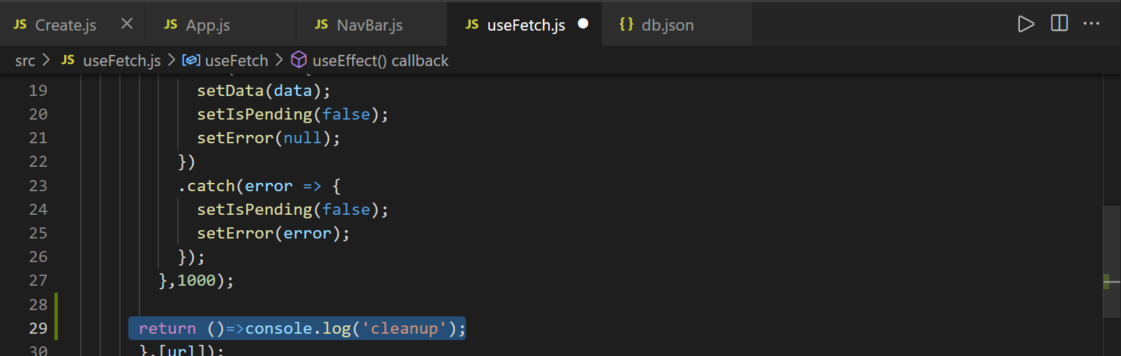
First we log to console to know when this has rum

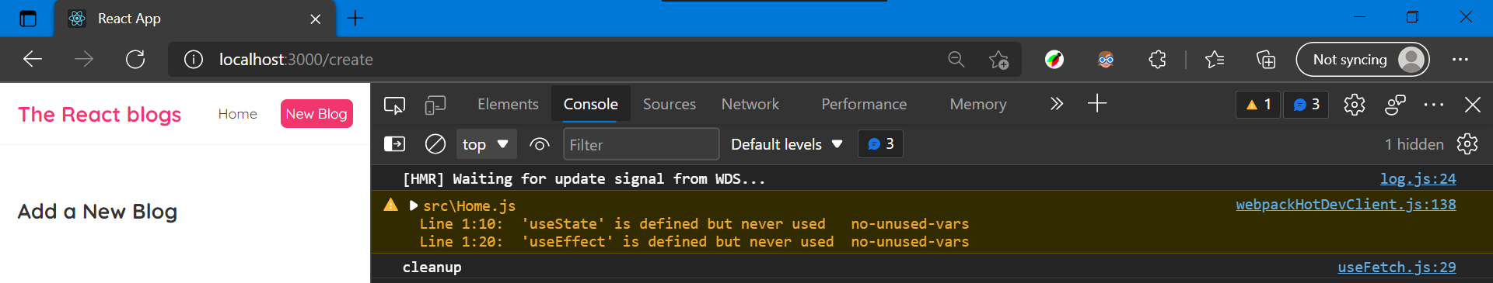
Now go to page press on home and then press on new blog now you see cleanup in console

So at this point react wants to stop the fetch going on in the back ground so that we don’t try to update the state

How to do that
So we use abort controller inside useeffect at the top name it as abortCont

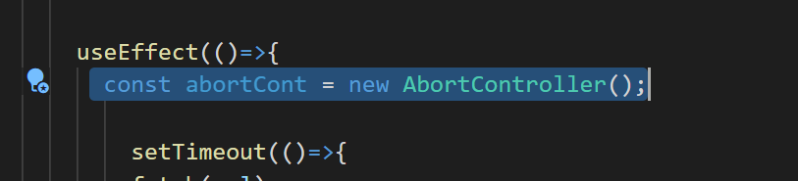
We have
Now what to do with it
We can asssociate it with specific fetch request
And then once we have associated fetch we can use the abort to stop the fetch

fetch(url, {signal:abortCont.signal})
Associating is by adding as 2nd argument to fetch which is kind of option for that fetch then we use signal property set that equal to abortCont.signal

Like above we have associated now we can use abortcont to stop that fetch we’ll do inside cleanup fuctoin at bottom where you returned cleanup at end
console.log('cleanup');
Replace
return ()=> abortCont.abort();
above with

So what this does it aborts whatever fetch is associated with which is our fetch
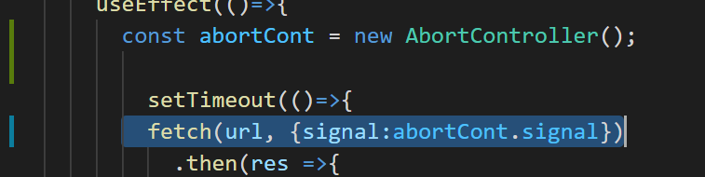
Our

So it’s not gonna carry on it’s gonna pause it

Now go to page press on home and press on new blog you still get that error
Why
When we abort a fetch what happens s fetch then throws an error

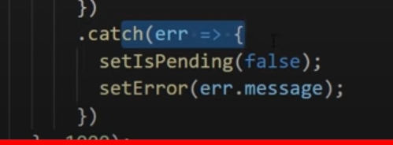
In above we catch that error and when we catchan error with then we updating the state we still updating the state

We might not be updating the data
Any more
But we are still updating the state setispending and that error

Therefore we still trying to update the home component with that state

So what we want to do we want to find that error inside that catch block
And if it’s a specific type of error if it’s an bot error then we don’t want to update the state

.catch(error => {
if(error.name === "AbortError")
setIsPending(false);
setError(error);
Doing like
If aborterror then don’t fetch otherwise update

Like if we get different error like network error then we still want user to know the error

if(error.name === "AbortError"){
console.log('fetch aborted');
}
else{
setIsPending(false);
setError(error);

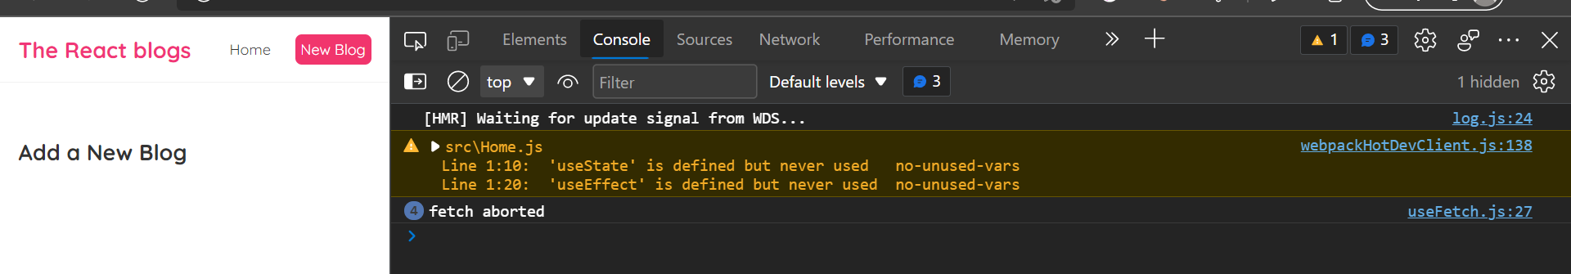
With above it doen’t give error in console

In home component remove usestate and useeffect import to get rid of that error also

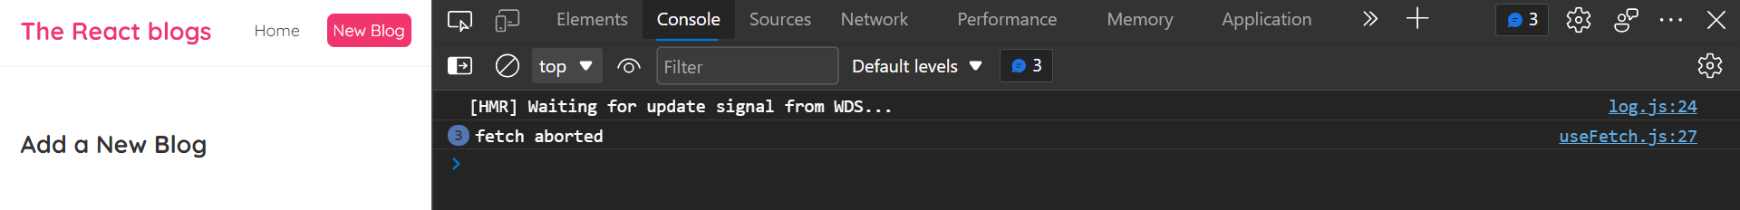
so

#25. Route Parameters

Sometimes when we have to pass dynamic values like this
/blogs/123
As part of a route a routes where certain part of it is changeable
But regardless of what that changeable part is it still renders the same page or component

Example of this is blog detail page
Route might look something like this /blogs/123
Where 123 is id of the blog that 123 could be something else like 323 or 2344

Now with this cases we still render same blog detail components
But instead we would show the blog with id 456 or 2344
Though this changeable part known as route parameter it’s like variable inside route

Now in our react app we need to be able to use route parameters and access those route parameters from our components
In the comp we can use these id so that to fetch data for that particular blog

So first create a blog detail component this is the component we’re gonna show when user visits a route which looks like something like
/blogs/id of that blog

Create file blogdetail.js inside type sfc and call it BlogDetail
And inside return simple template
const BlogDetails = () => {
return (
<div className="blog-details">
<h2>Blog details</h2>
</div>
);
}

export default BlogDetails;

Like

Now create route for this blog inside app.js

But /blog/id how do we say id of blog here
Since id is gonna changeable we can’t hardcode id here like1 or 4
Id gonna change

To do that we use : and then route parameter call it whatever you want
That represents the id of the blog it can be any number 1 or 3 …

<Route path="/blogs/:id">
<BlogDetails />
</Route>
So

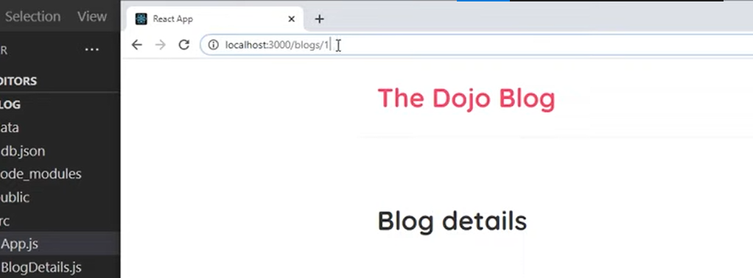
If you put 1 or 6 it shows blog details

And that id we pass in url we should able to access inside our blogdetails.js
If id is 1 then fetch the blog with id 1 or if 6 then fetch 6th blog

How to grab them
For that we use hook from react dom

I’m doing some mistakes while creating route in app.js
Find it
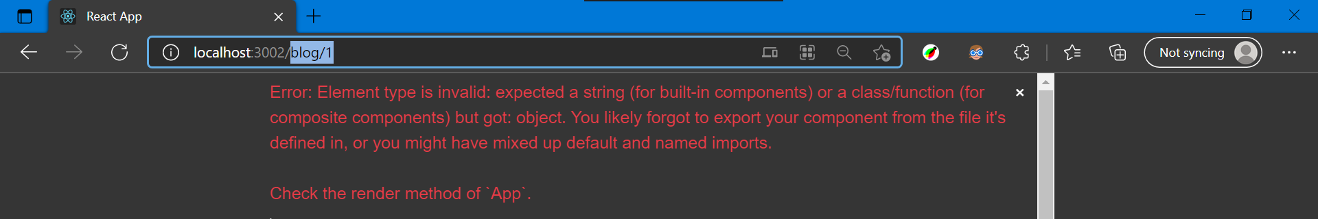
When I type localhost:3000/blogs/1 then I get error like above

const BlogDetails = () => {
return (
<div className="blog-details">
<h2>Blog details</h2>
</div>
);
}

export default BlogDetails;
Because after creating blogdetails.js file you will type above code in there

But I didn’t save that file blogdetails.js so I was getting error like that so when I save blogdetails.js file error gone in page

when you use blogdetails for route that time while typing it as component it will auto import blogdetails in app.js file

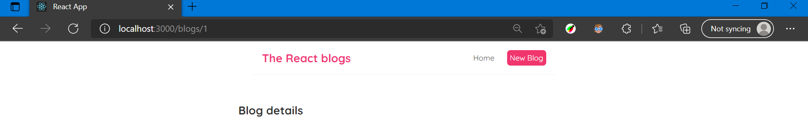
Now I can see when you type 1 or 2 or any number

But we want to grab that number which we type in url like 1 or 3 we want to fetch in blogdetails.js file

For that we use hook from react router dom

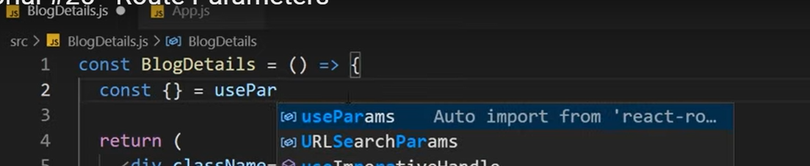
Tyep like above it auto imports useparams in blogdetails

What useparams does is allow us to route parameters from the route right there in url

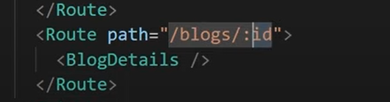

We name route as id in app.js

Pass id inside const {id} from the params inside blogdetails
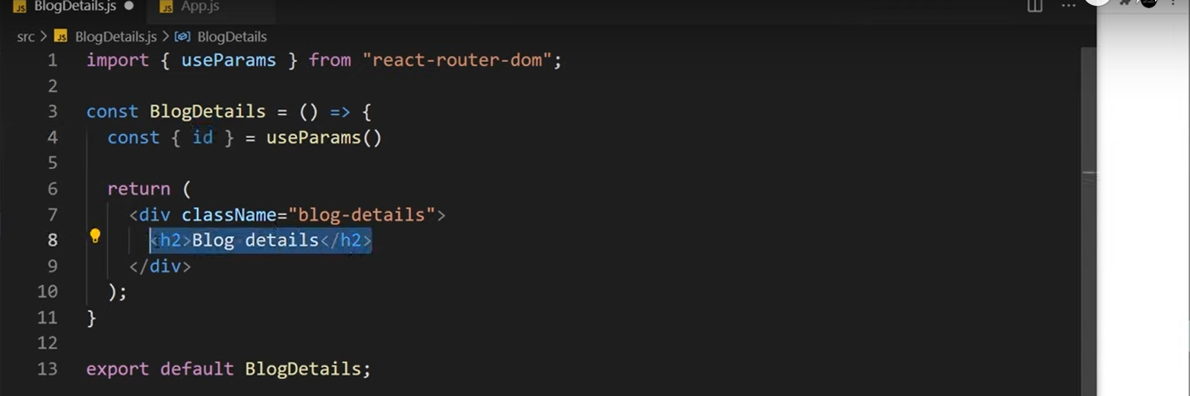
Then we can access it use it inside template
Or inside other funtion to fetch blog with the id

Now we out put it to template

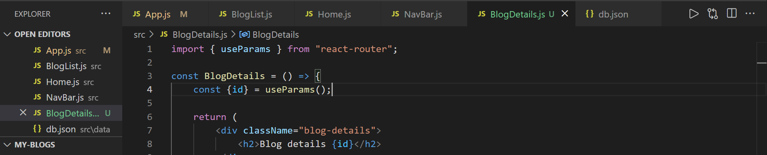
Use like id in h2 to display in page

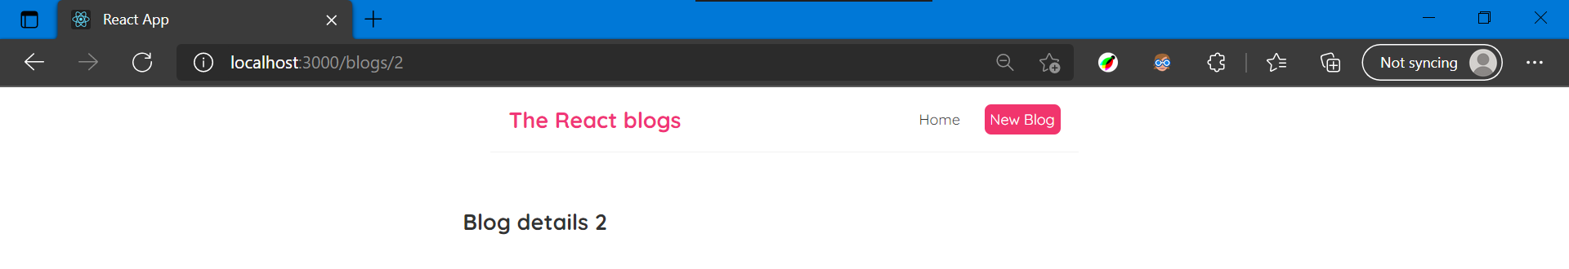
So page looks like

This is good


Next in my home page I want to add link to the blogs

Like when we click on this it goes to blog details page route
Also it goes to the id whatever blog that is

For that we go to bloglist component and try to set this

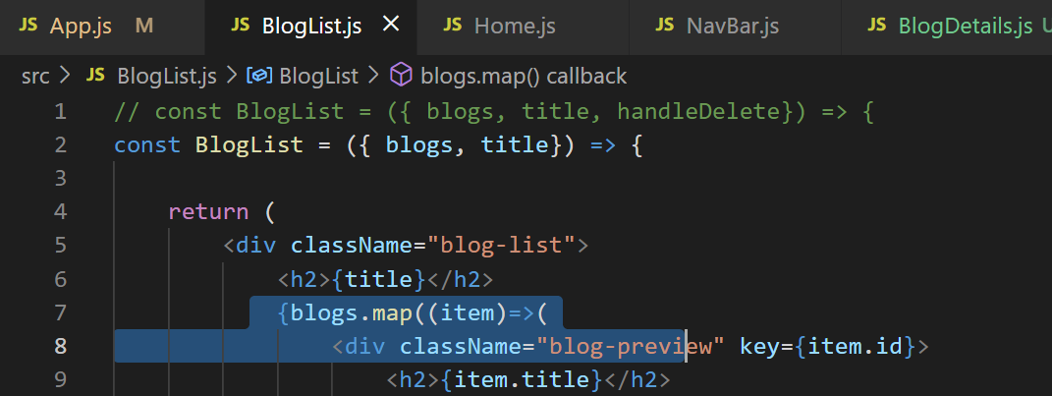
We have access to each individual blog through map method in there
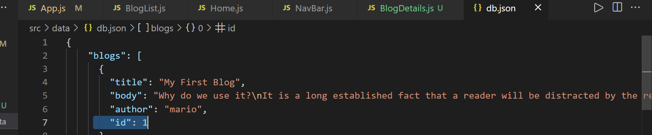
And each blog has an id

So we can access that and create a link so we can use id properety to make a link to surround may be h2

Creat link tag inside bloglist .js
When you press on drop down it auto imports at the top

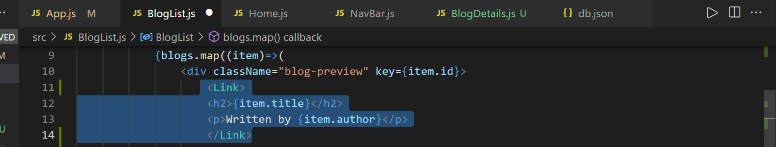
Next place h2 and p tag inside link tag

Also add to so that wherer the link is going to
In “to” don’t want to hardcode
So part of it is going to be dynamic since id changes to each blog
I’m going to use calibraces so I’ll use somekind of javascript in here
To output the string

I’m gonna use template string which are ` `
That means we can output variables inside it that’s just js feature

So use like to= <Link to={`/blogs/${item.id}`} >
Above is blogs and we can get id from map’s item
with using $ and blog.id here blog obj we have access

With above it can be anything like /blog/1 or /blog/2 etc

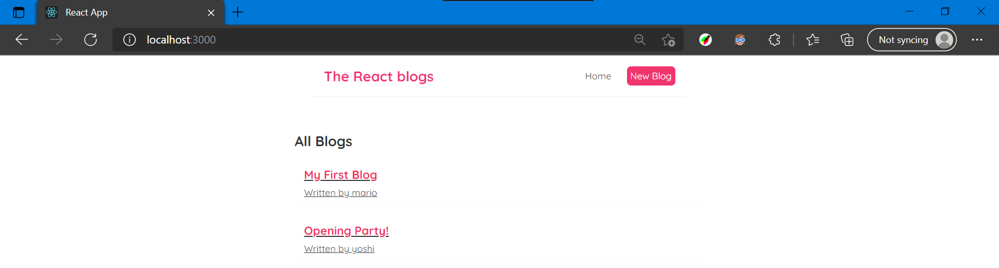
Now looks like

When we click on first blog it goes to
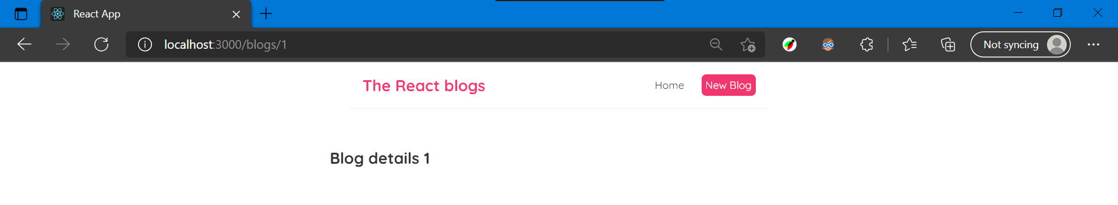
Here

When second
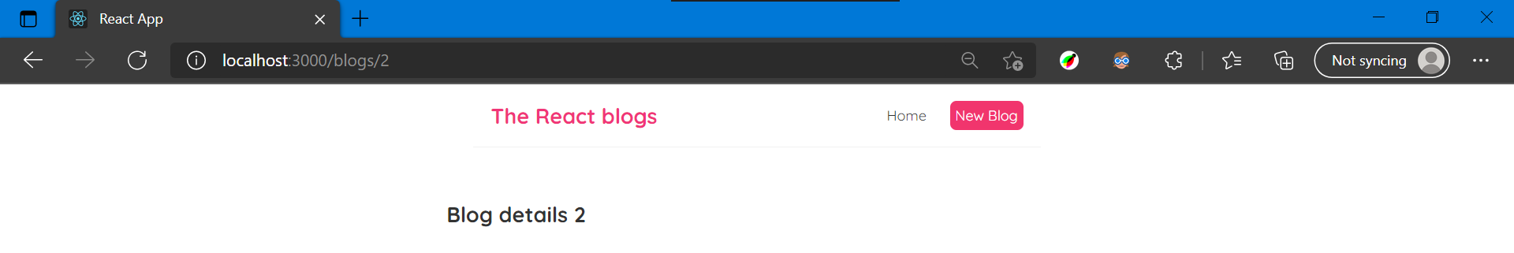
Here

We’re capturing ids in links and accessing those ids inside blogdetails component

Adding css styles for links to look better
To take off underlines present on blogs as links

Go to index.css

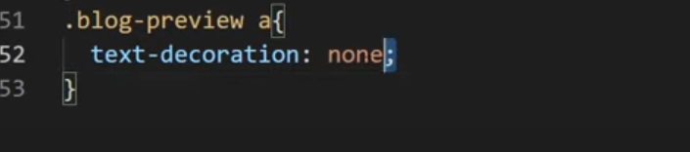
Paste above

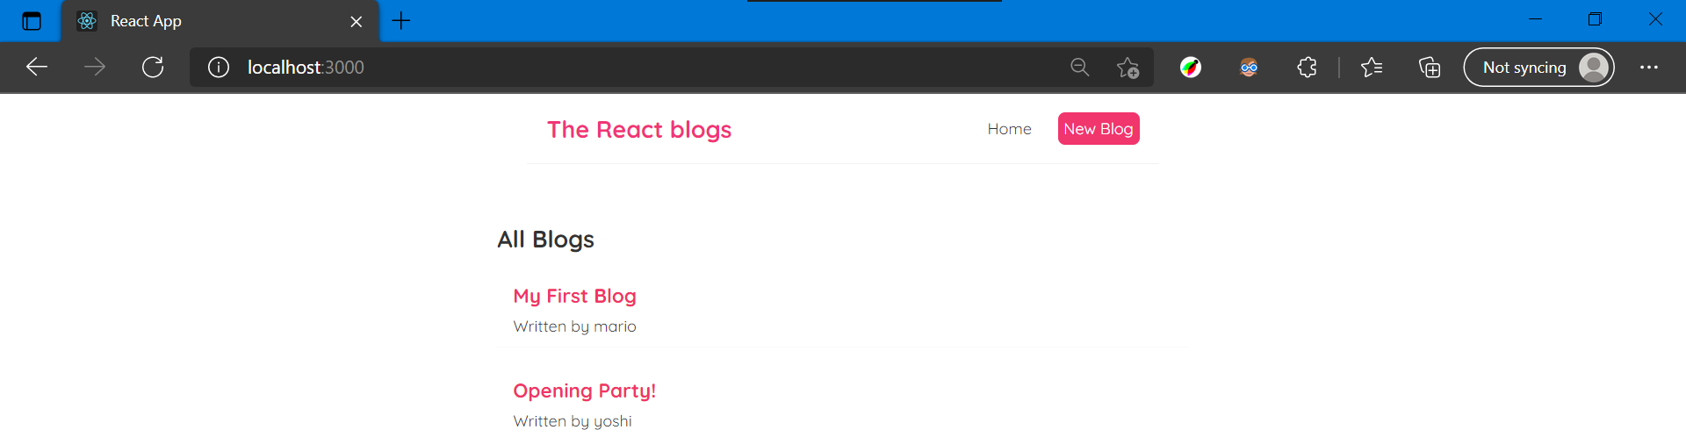
So that blog looks like

#26. Reusing custom hooks

So when we press on one blog in home page it goes to blogdetails page through but we need to display blog content like author also in blogdetails page

Now we have blog’s id property so we can use it to make fetch request
For details of that particular blog from db.json file

For doing that we’ll reuse our custom hook that is usefetch

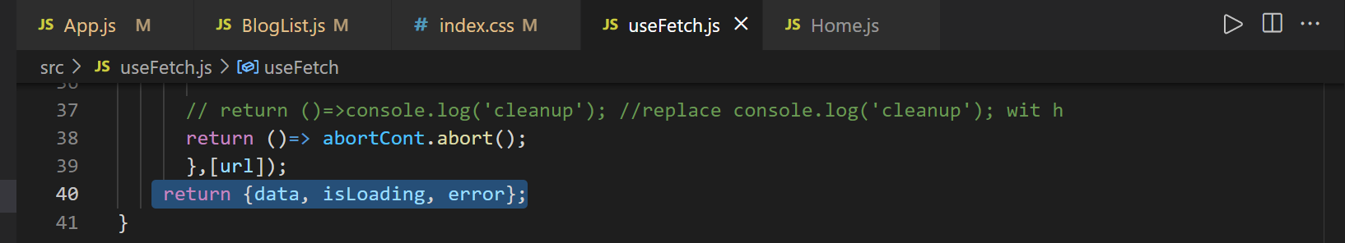
Remember usefetch returns 3 values
Data which we’re trying to fetch in our case individual blog
Ispending true or false
Error if there is one

To do use usefetch and pass an end point url
From which we want to fetch data from

We do this insdie blogdetails

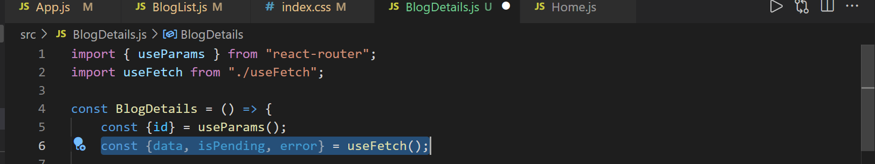
Add above line of code

Now we need to pass end point http://localhost:3000/blogs
And next /id we need to pass as id which we have access there in blogdetails.js we can add it at end by adding + at the end

const {data, isPending, error} = useFetch('http://localhost:3000/' + id );
Like

Now we’re using usefetch hook to fetch 3 properties
Now I want to call data as blog so do this

const {data : blog, isPending, error} = useFetch('http://localhost:3000/' + id );
Like

So sometime there might be errro so we will conditionallly output the data values

First is loading message if ispending is true so use logical and &&

{isPending && }
This means things on the right outputs only if things on the left is true

{isPending && <div>Loading...</div>}
{error && <div>{error}</div>}
Next displaying error if there is

Finally we need bit of template for blog itself once we have blog details once we have value for blog

Now that starts as null in data inside
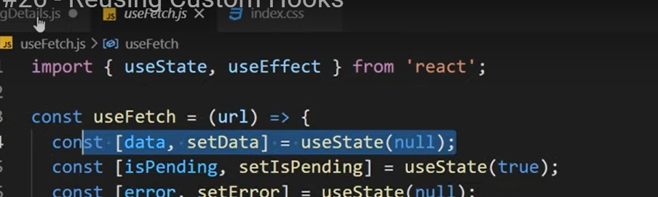
Above
So we don’t want to output if it’s null only if it has value

{blog && }
Now blog and return some kind of template inside ()

{blog && (
<article>
<h2>{blog.title}</h2>
<p>Written by {blog.author}</p>
<div>{blog.body}</div>
</article>
) }
Add like above to display all content
I was getting error

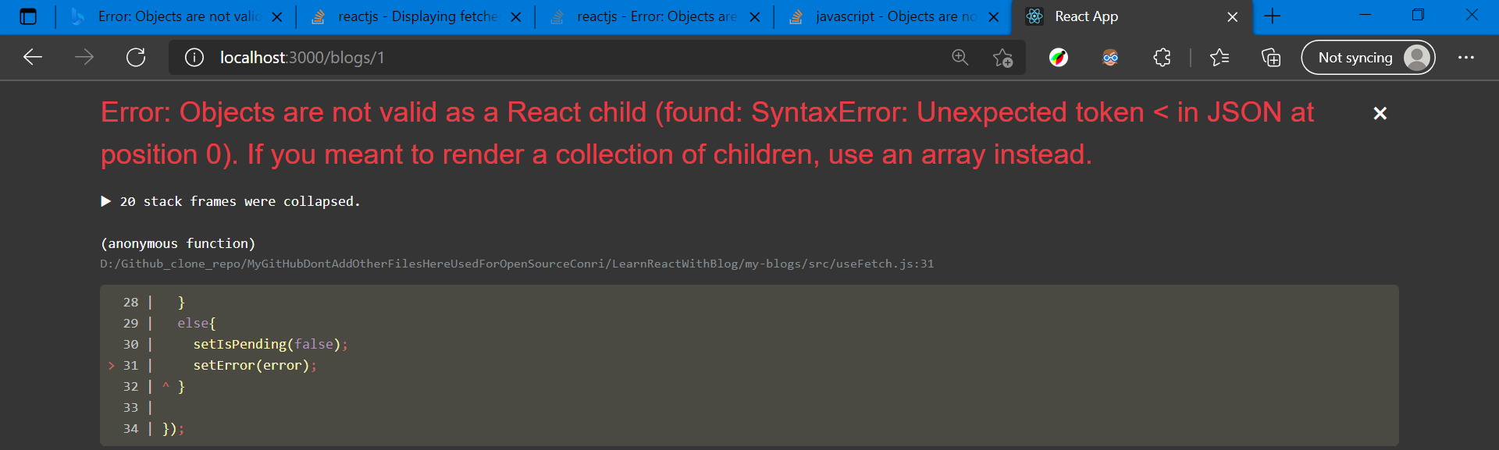
Like

Because port 3000 I used in blogdetail.js instead I have to use 30001 since we have our data in 3001 port not 3000 port.
Use this port
useFetch('http://localhost:3001/blogs/' + id);

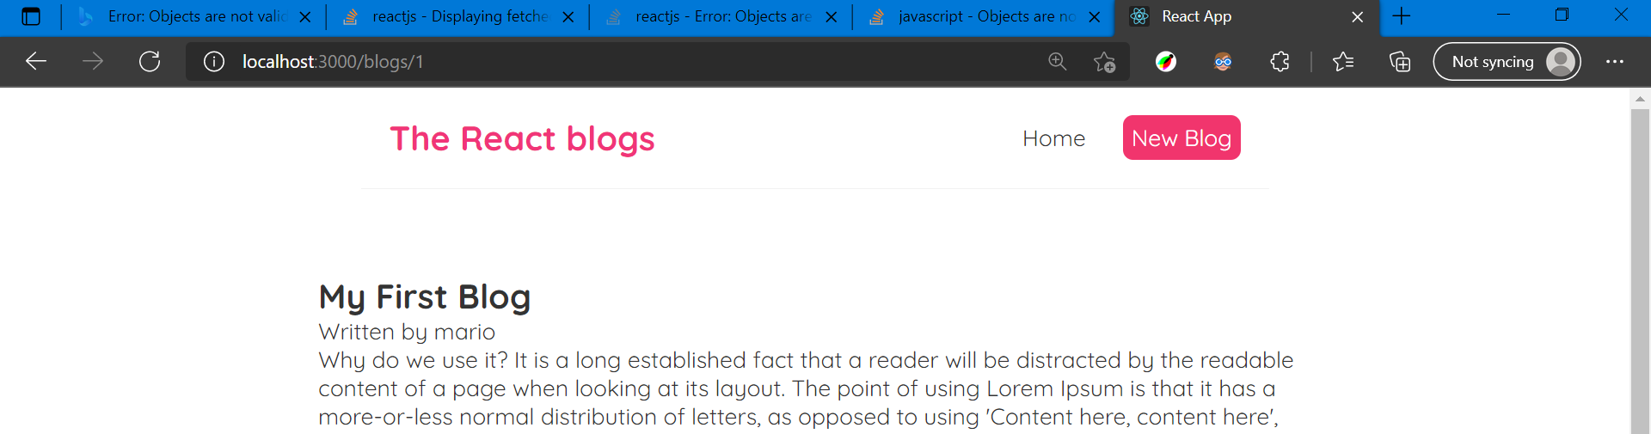
Now it displays all data

When you click on first data it displays first when clicked on second displays second

/* blog details page */
.blog-details h2 {
font-size: 20px;
color: #f1356d;
margin-bottom: 10px;
}
.blog-details div {
margin: 20px 0;
}
.blog-details button {
background: #f1356d;
color: #fff;
border: 0;
padding: 8px;
border-radius: 8px;
cursor: pointer;
}

Now making littlebit style using css
Index.css added style

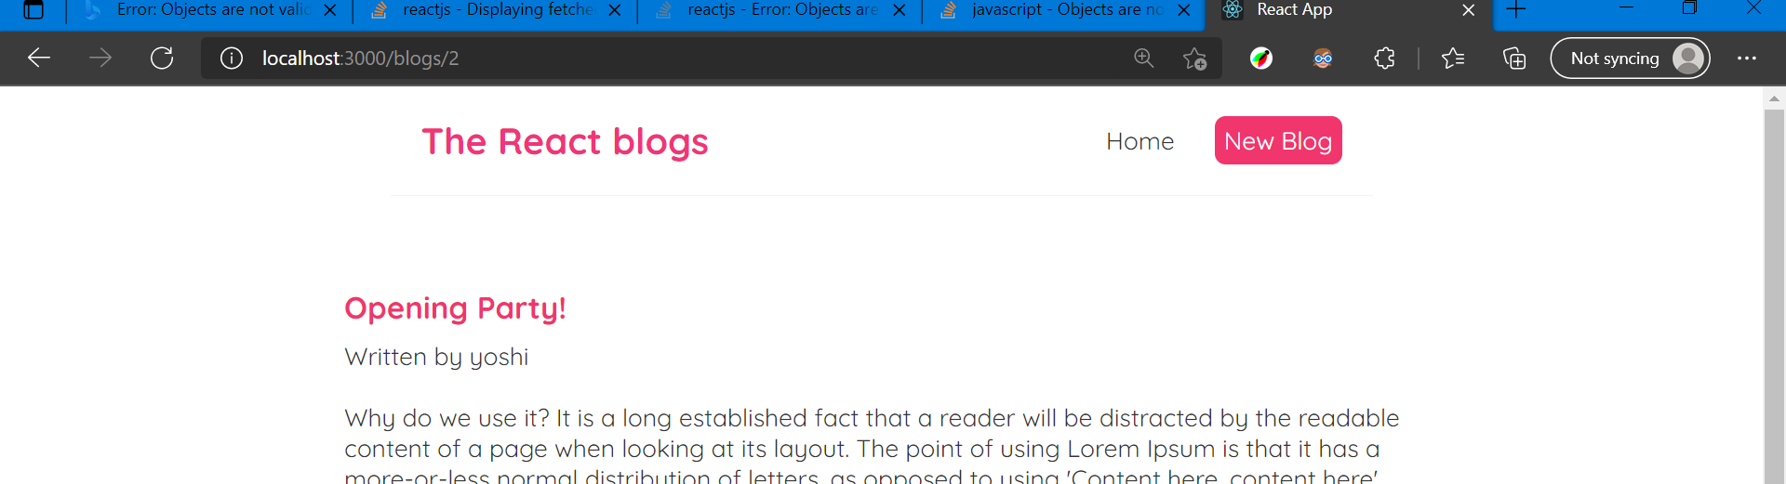
Now page looks like

This is how we reuse usefetch reusable again just by passing url as endpoint

#27. Controlled inputs

Now focussing on web form in react
So that user can type in a new blog and later send a post request so it add it to the data for doing this we need to know about controlled input s

Controlled inputs are basically a way in react to setting up input fields in forms so we can track their value s

If we have text input user can type into it
And we can store that value what they type in some kind of state so if the state changes that in turn updates the value in the input field

So we always keep our input field in state with each other

First create bit of template for this form

Go to create.js
Under the h2 add form
First add label
Next add input text field
Add required copy this bit of code and paste it use ctrl+d

Add another label with textarea
Add required

Another label for author
Add select tag with some options

At end add one button add blog

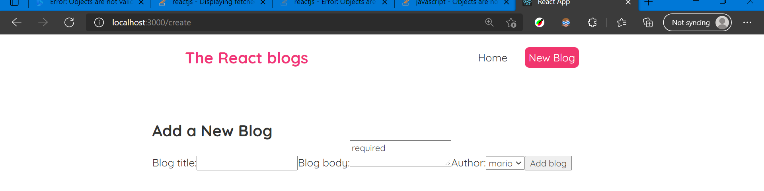
Now our form looks terrible so add style

/* create new blog form */ .create { max-width: 400px; margin: 0 auto; text-align: center; } .create label { text-align: left; display: block; } .create h2 { font-size: 20px; color: #f1356d; margin-bottom: 30px; } .create input, .create textarea, .create select { width: 100%; padding: 6px 10px; margin: 10px 0; border: 1px solid #ddd; box-sizing: border-box; display: block; } .create button { background: #f1356d; color: #fff; border: 0; padding: 8px; border-radius: 8px; cursor: pointer; }
Add above in index.css

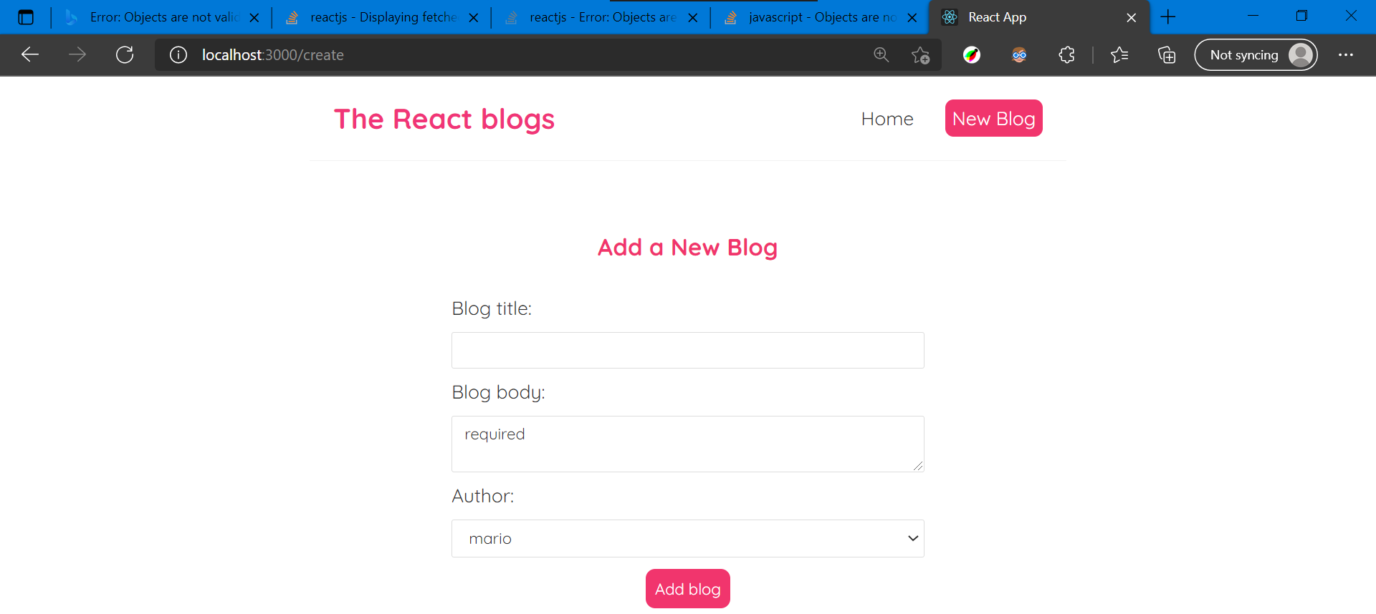
With style looks like

Now if I type welcome in blog title I should able to track and store it inside some state inside component

How to do this

First we need to set up some state for this
Create state for title body and all
Title with empty value

Now associate title value wit h
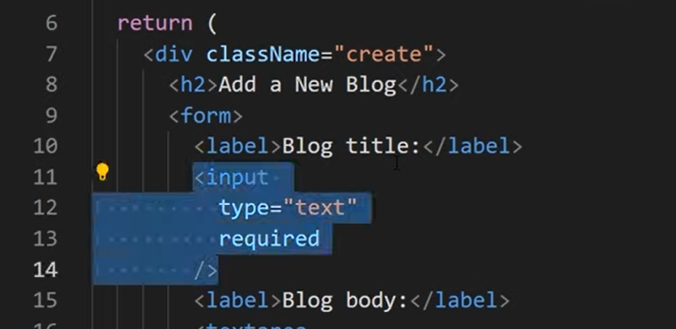
The value of input to do that type value = dynamic value so use brace
And it’s gonna be title so

<input type="text"
required
value={title}
/>
Like

Then in page
Whatever is in usestate it displays in example if you use hello like above

And you can’t change once if you define in usestate it won’t let us change value of input

So what we need to do is when we try to change value it triggers
Settitle and updates with whatever we try to change it to
We do that by using onchange event
onChange={()=> setTitle()}
This will change title when we try to change the input value

Inside () we get access to event object and we want to update whatever
this is inside onchange’s settitle(here)

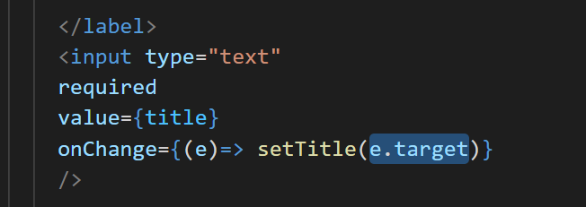
Above where target is input element
And then

Add .value to it, that’s whatever we want to type into it.
When we save this when we type something in title textbox
It’ll trigger onchange and it updates the state at top where we defined title and value of input gonna match it.

Now like this we have 2 way binding
If we want to see that we can output it at bottom after button

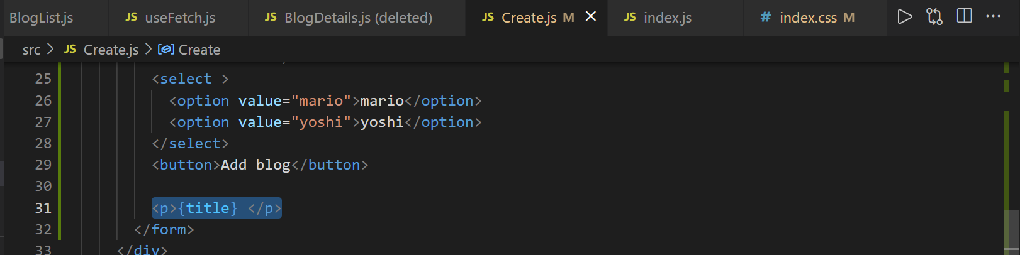
Like


As we type it displays at bottom

This is how we track when user type

Do same for other ones

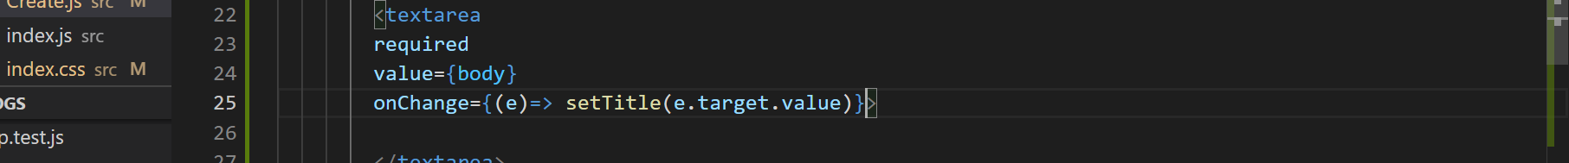
Like

And in select tag add value and onchagne 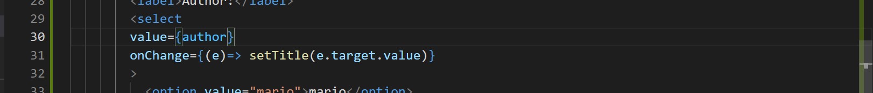
Now initial value of author gonna be one of value either mario at usestate since it’s dropdown

Also output body at bottom

#28. Submit events

Next now when we type something and we will submit it and do something with this data

When a button is pressed add button it fires a submit event on the form itself, and we can listen to that submit event and react to it

Another option would be attach click event to button itself

Preferable is reacting to submit event

Doing this by inside form
<form onSubmit={}>
Add this in form
Inside braces call one funtion

So handlesubmit method takes event object automatically
First when we press on addbutton when data is there in form page refreshes we want to prevent it

const handleSubmit = (e)=>{
e.preventDefault();
}
Above will stop it page being refresh

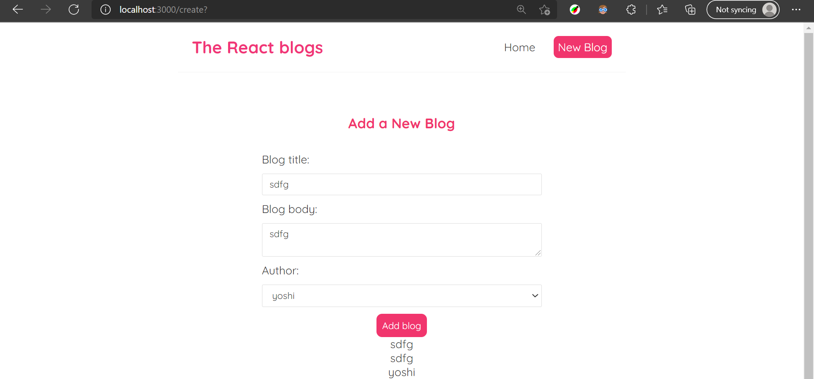
Now when pressed on add button data will not be erased and refreshed

Next step is to create a blog object
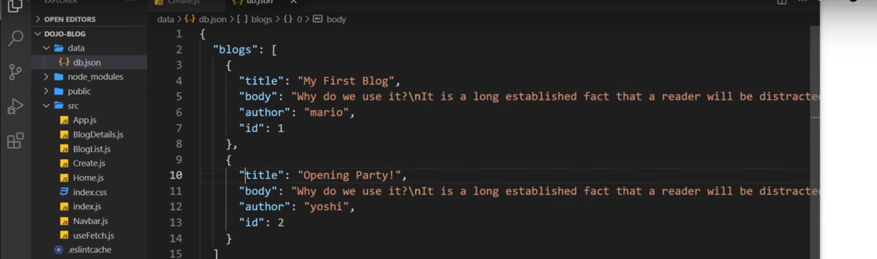
Blog object is something which will be saved in db.json file have a title body and author

When we are using json server we don’t have to give id property because when we make a post request json server will automatically add unique id

Create a new object inside handlesubmit method
const handleSubmit = (e)=>{
e.preventDefault();
const blog={title, body,author};
}
like

And we can log this to console

Now we react to submit event
Sending post request to particular endpoint so that we can add new data to db.json

#29 - Making a POST Request

Make a post request to json server
We use post request inside handlesubmit mehtod

Use fetch method
Using an fetch api and this si gonna be same endpoint as get request to get all of the blogs we have inside home.js
Use that one
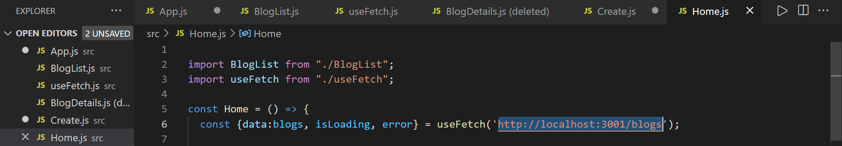
Above
http://localhost:3001/blogs
Grab above from home.js
Paste in fetch

fetch('http://localhost:3001/blogs');

Next we have to add second argumet this second arg is where we tackle the data also define type of the request for sending the method
WE ALSO need header property with content-type application json this is basically telling type of the content sending wit hthis reuqest
Next body is actual data we can’t directly pass blog obj here we need to
fetch('http://localhost:3001/blogs',{
method:'POST',
headers:{"Content-Type":"application/json"},
body:JSON.stringify(blog);
});

turn it into json string

Above will make a post request to an end point url with 3001, for this json server create id property

Since above is sync method we can tack on using .then which fires funtion when this is complete

fetch('http://localhost:3001/blogs',{
method:'POST',
headers:{"Content-Type":"application/json"},
body:JSON.stringify(blog)
}).then(()=> {
console.log('New blog added');
})
Code

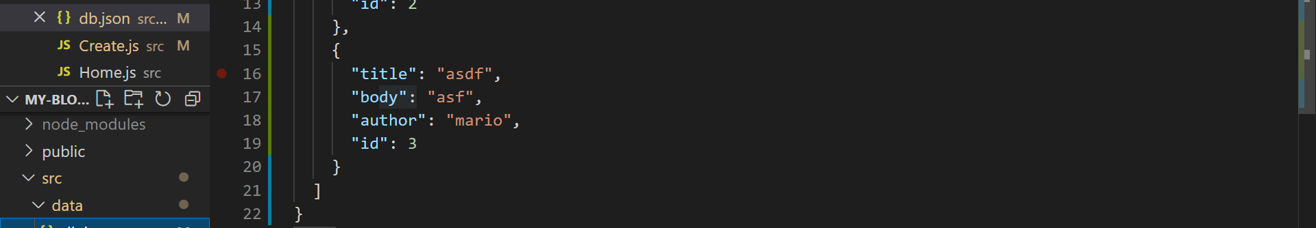
When you click on add button data added to db.json file

Check git code in branch reusing custom hooks when clicking on blog list
Now we add loading state while adding it says adding or something

const [isPending, setIsPending] = useState(false);
Create state for that fasle because when we first load page we are not making that request it’s only after we try to submit the form
Next inside method handlesubmit

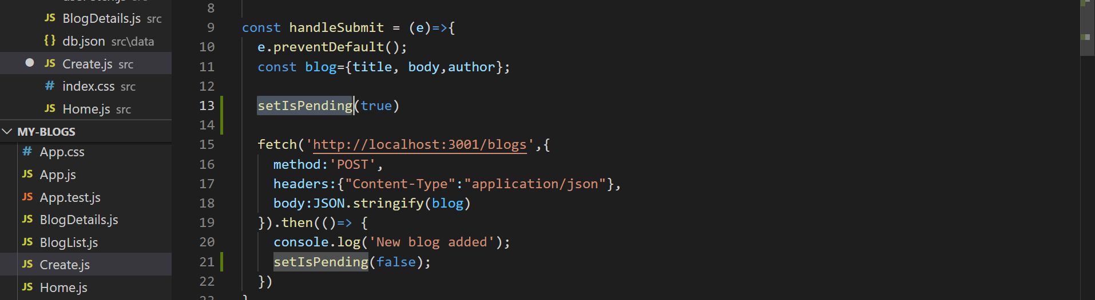
Two times setpending one when adding and other when completed making it as false

{!isPending && <button>Add blog</button>}
Doing like this because this is only gonna output if !ispending is false

{isPending && <button disabled>Adding blog . . . .. .....</button>}
Later if ispending is true we will out put disabled button
And we say with ……

Now when you enter some data and press on add button you see …. for some seconds

#30. Programatic redirects

Let’s say when we are on detail page of one blog and we click on add new blog when we add new blog so it should go to previous blog which we were on

To do that
const history = useHistory();
Add

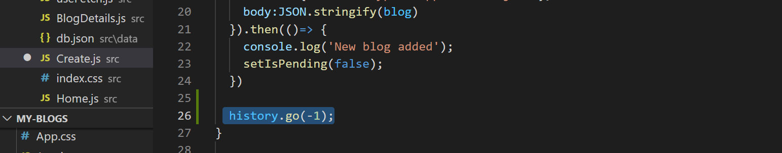
Wit hadding above it goes to previous

If you want to go forward enter 1 inside go

How to direct back to home page

#31. Deleting blogs

Add button inside blogdetails.js
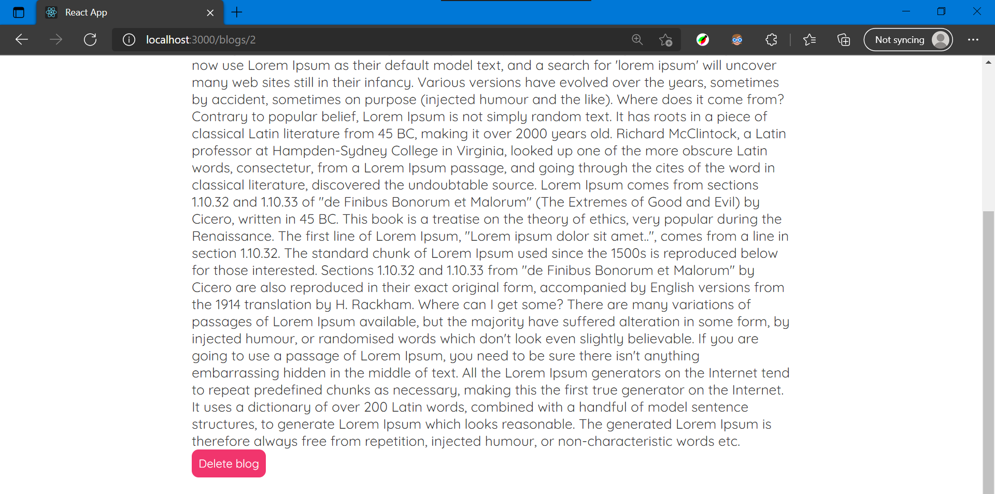
You see delte button at bottom

