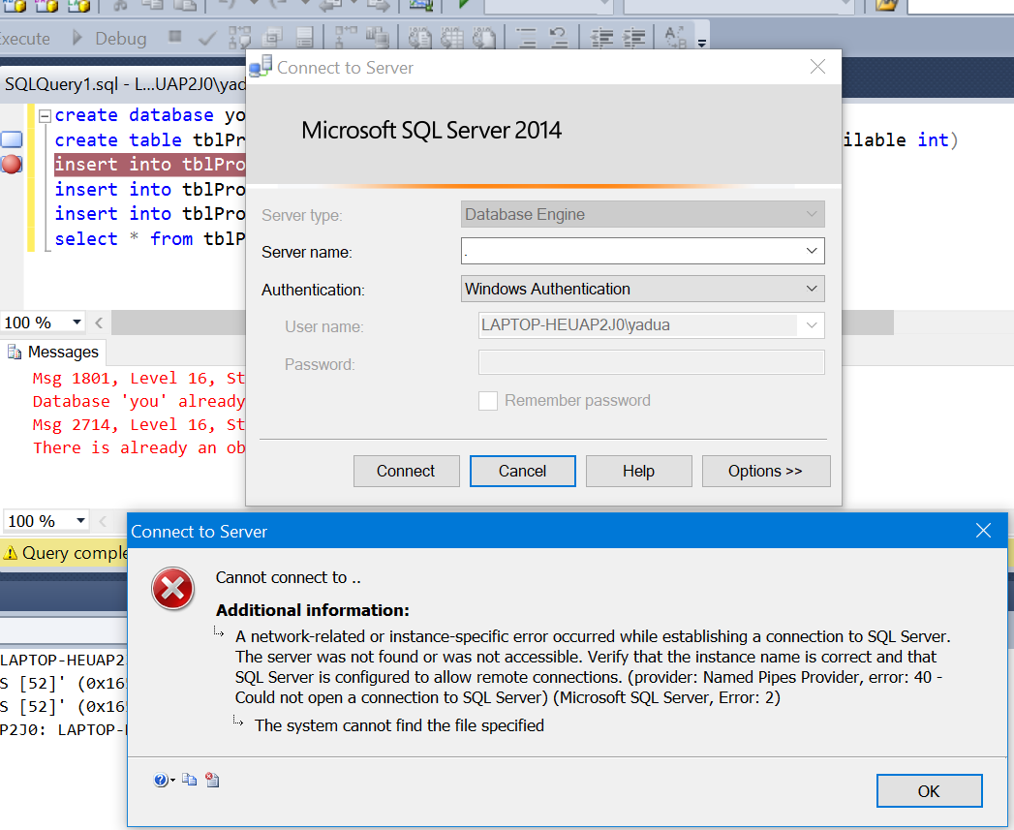

Change server name to

<https://stackoverflow.com/questions/36148435/sql-server-2014-cant-connect-to-local-db-can-not-find-server#:~:text=Put%20correct%20instance%20name%20and,select%20appropriate%20service%20and%20start.&text=Are%20you%20sure%20the%20instance,get%20the%20correct%20instance%20name>.

(local)\SQLEXPRESS or .\SQLEXPRESS

