Followed tutorial points to install sql server.
Microsft sql server express 2014:

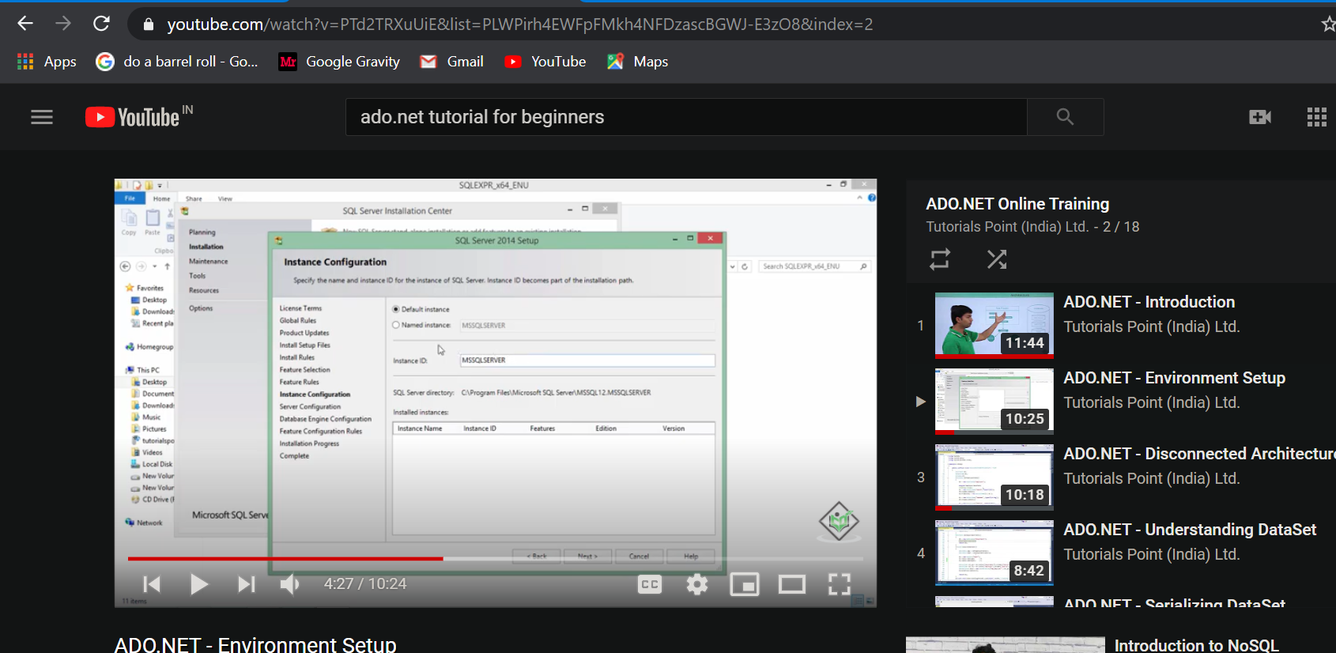

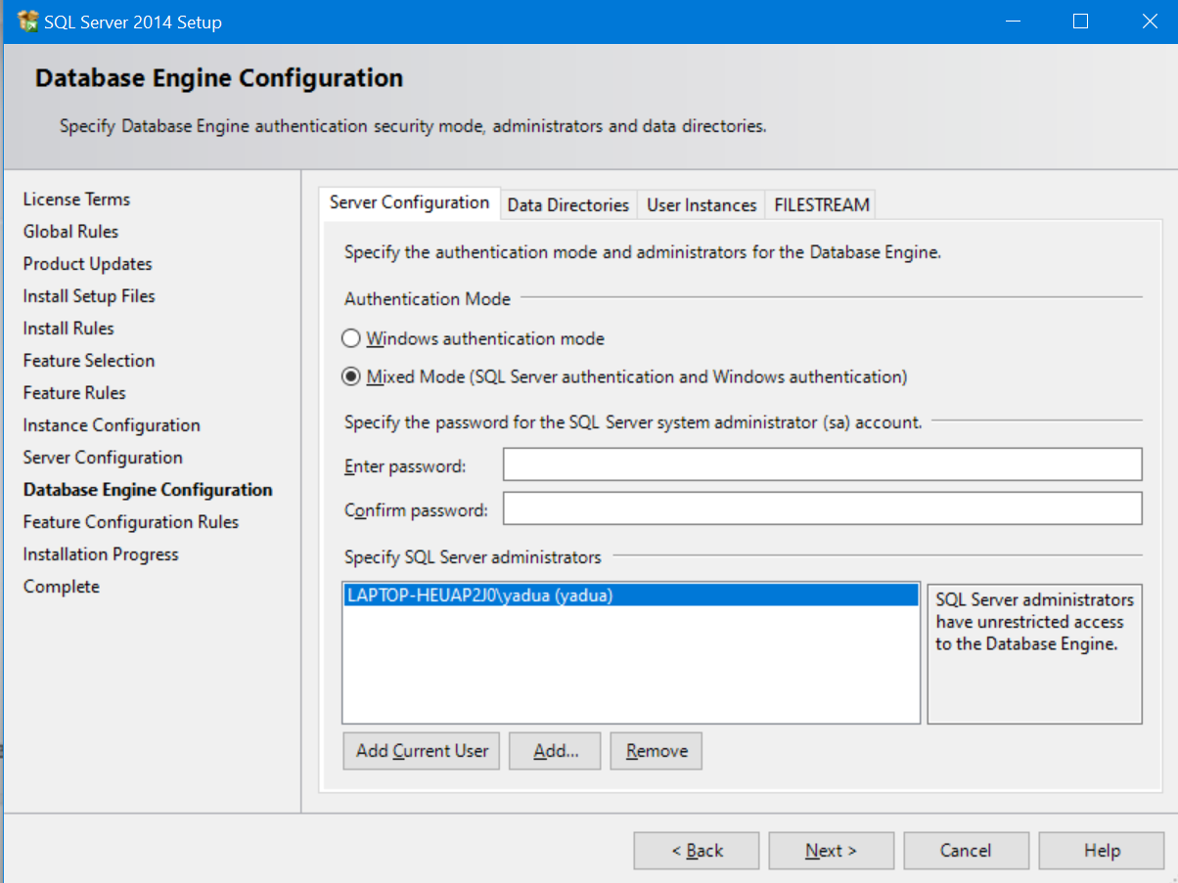
Password: 1234

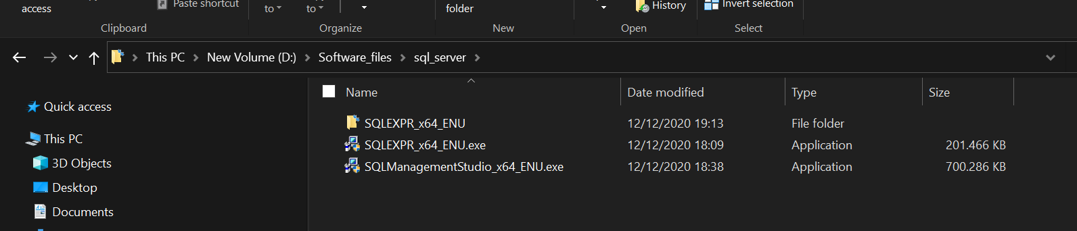

Disconnected architecture:
Once we get daat from the database and if I want to access that dataabse frequently then I can store that data by my own on client terminal I can disconnect the connection later I can sync this data with database

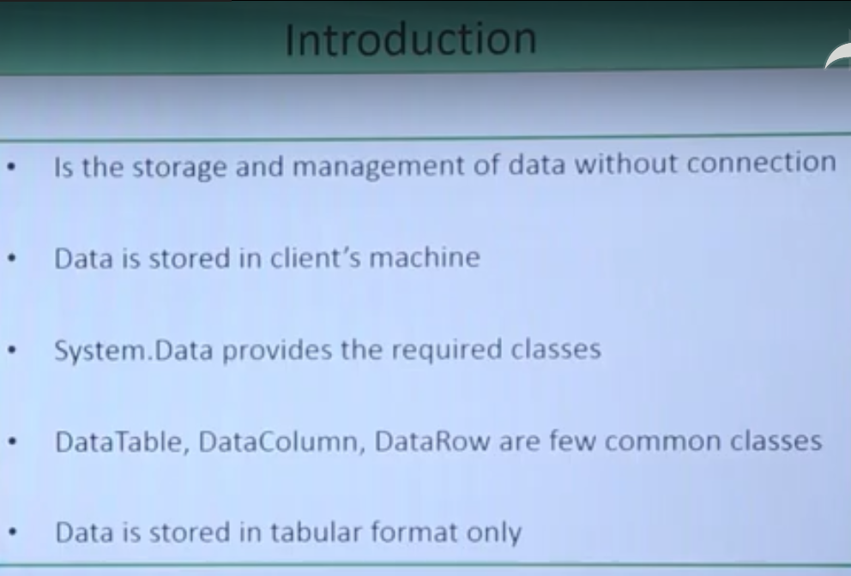

To Understand disconnected archi using
Datagrid view under tollbox:

Search window forms choose
We can use gridview to show the data which I’m goig to store in the disconnected architech

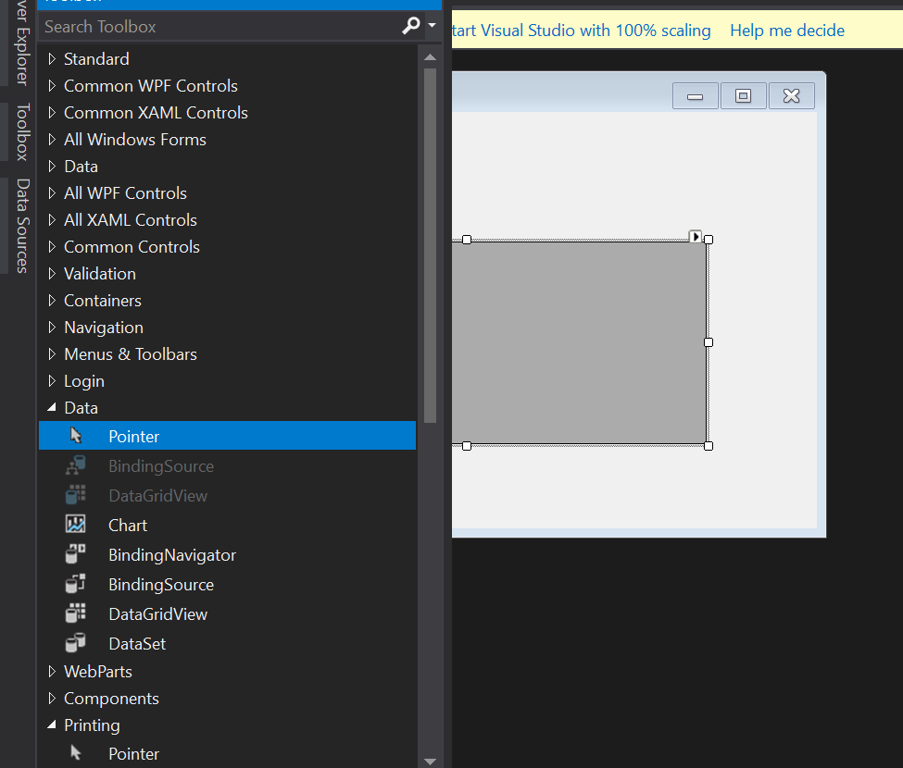

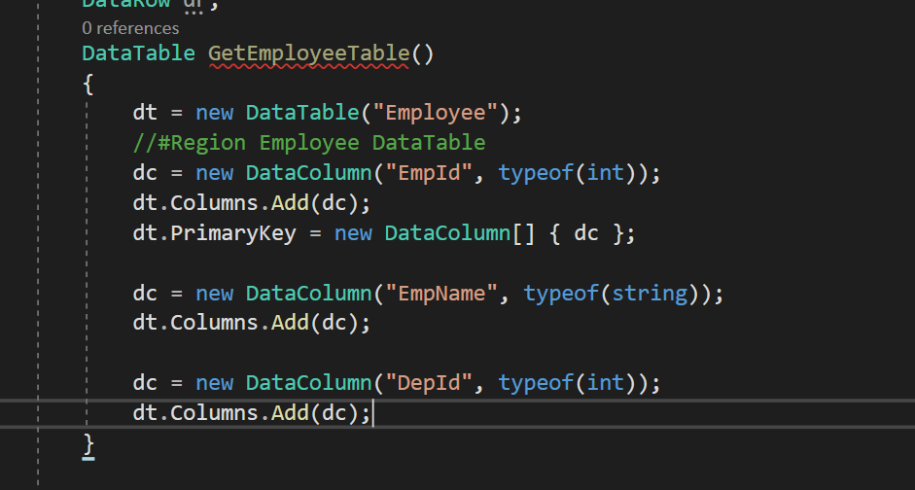
Assume like you’re creating table in database

Above code will generate table like this:
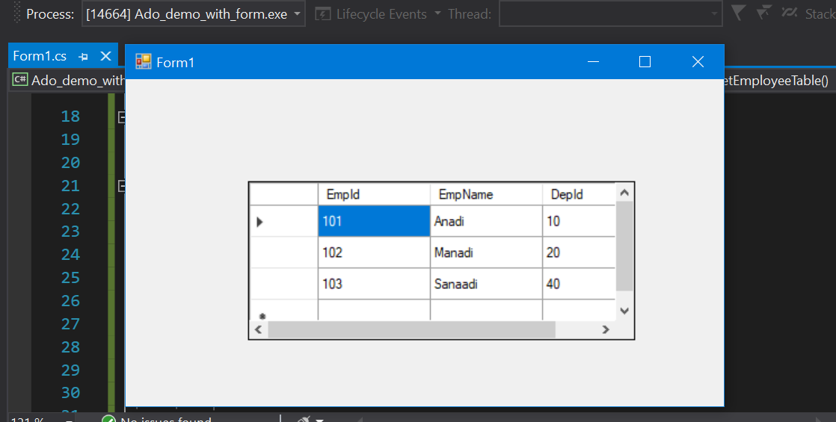

Code:

using System;
using System.Collections.Generic;
using System.ComponentModel;
using System.Data;
using System.Drawing;
using System.Linq;
using System.Text;
using System.Threading.Tasks;
using System.Windows.Forms;

namespace Ado_demo_with_form
{
public partial class Form1 : Form
{
DataTable dt;
DataColumn dc;
DataRow dr;
DataTable GetEmployeeTable()
{
dt = new DataTable("Employee");
#region Employee DataTable
dc = new DataColumn("EmpId", typeof(int));
dt.Columns.Add(dc);
dt.PrimaryKey = new DataColumn[] { dc };

dc = new DataColumn("EmpName", typeof(string));
dt.Columns.Add(dc);

dc = new DataColumn("DepId", typeof(int));
dt.Columns.Add(dc);

// Adding rows
dr = dt.NewRow();
dr[0] = 101;
dr["EmpName"] = "Anadi";
dr[2] = 10;
dt.Rows.Add(dr);

dr = dt.NewRow();
dr[0] = 102;
dr[1] = "Manadi";
dr[2] = 20;
dt.Rows.Add(dr);

dr = dt.NewRow();
dr[0] = 103;
dr[1] = "Sanaadi";
dr[2] = 40;
dt.Rows.Add(dr);
#endregion

return dt;

}

public Form1()
{
InitializeComponent();
}

private void Form1_Load(object sender, EventArgs e)
{
DataTable EmpTable = GetEmployeeTable();
dataGridView1.DataSource = EmpTable;
}
}
}

Understanding data set in ado.net:
Dataset can be database of disconnected architech

As in normal database we used to see several table, here in dataset we’re going to store no of tables

