Topics coveded and explanation

Net Ninja css:

Inline css.

Embedded css

External css

Using class and id

for span p and a tags

css conflicts and cascade

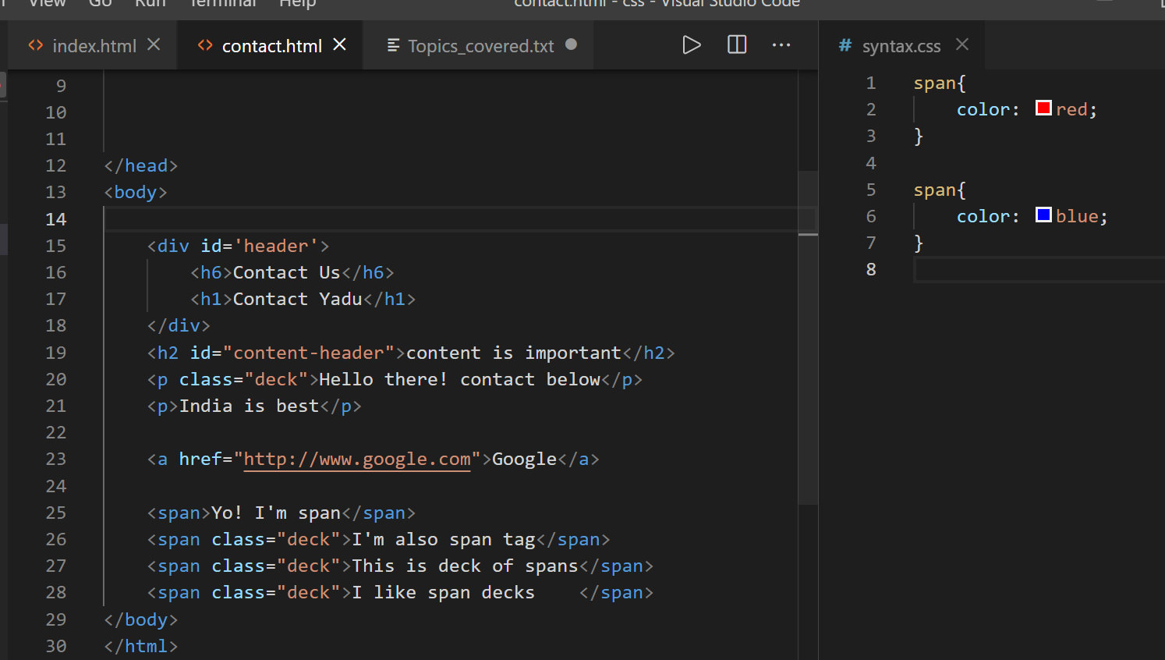

Here for span blue color will be taken:

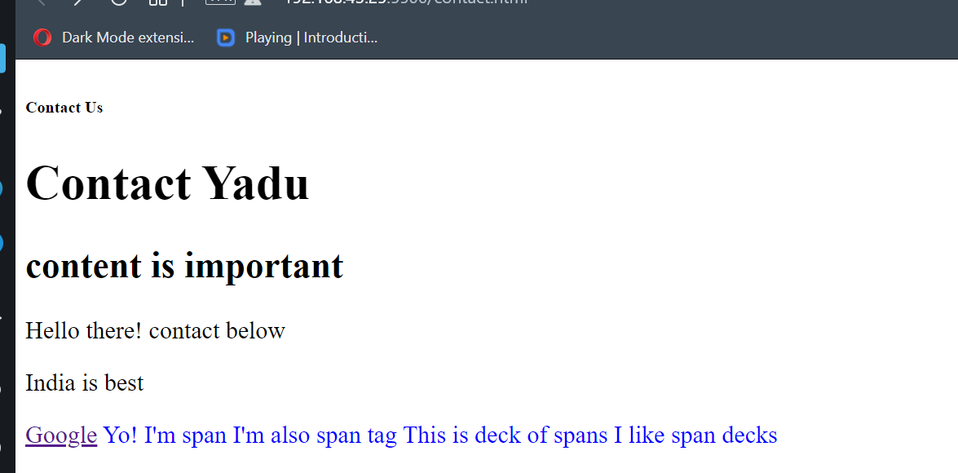

That is last one.

Below I have used span color inside html file, so that color will have more weigth.

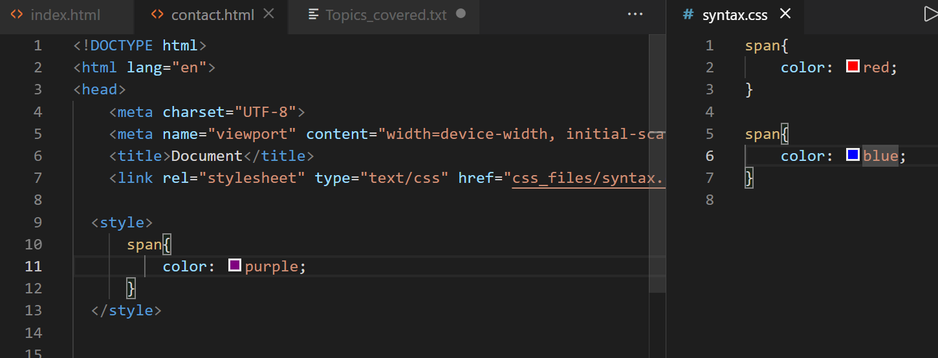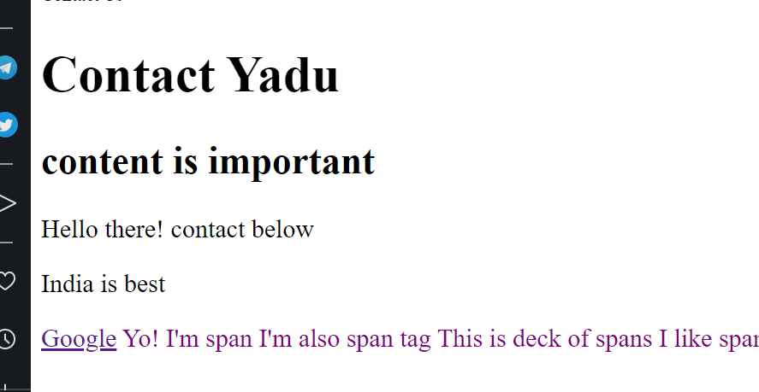

Inline color will have more final weightage:

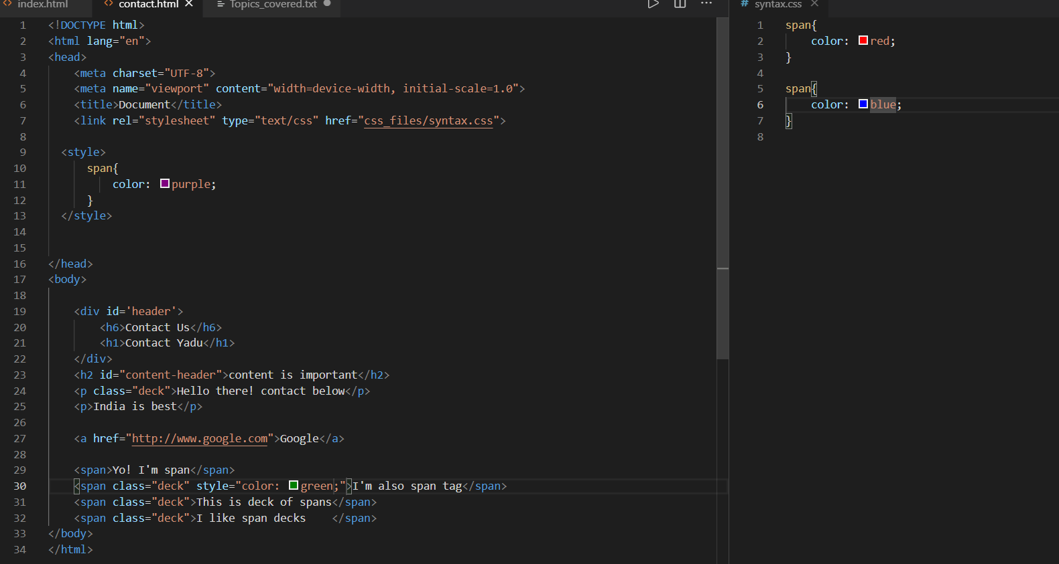

Even though you have used external, internal css.

So conflict is top to bottom weightage of css colors or properties.

Inheritance tree:

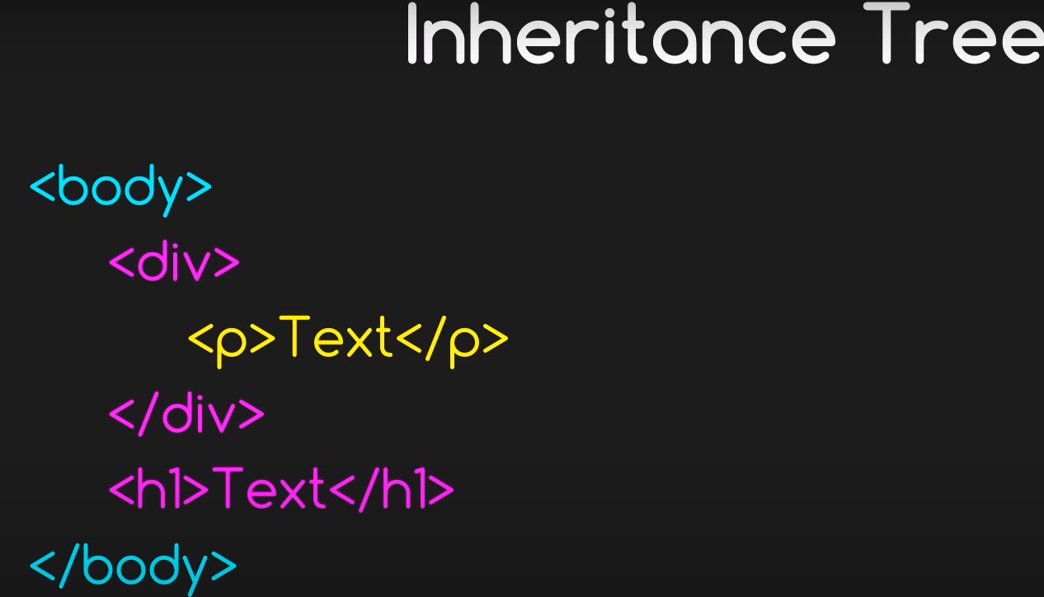

Now everything inside body becomes red. Which is div tag p tag inherits red color

Because fo body.

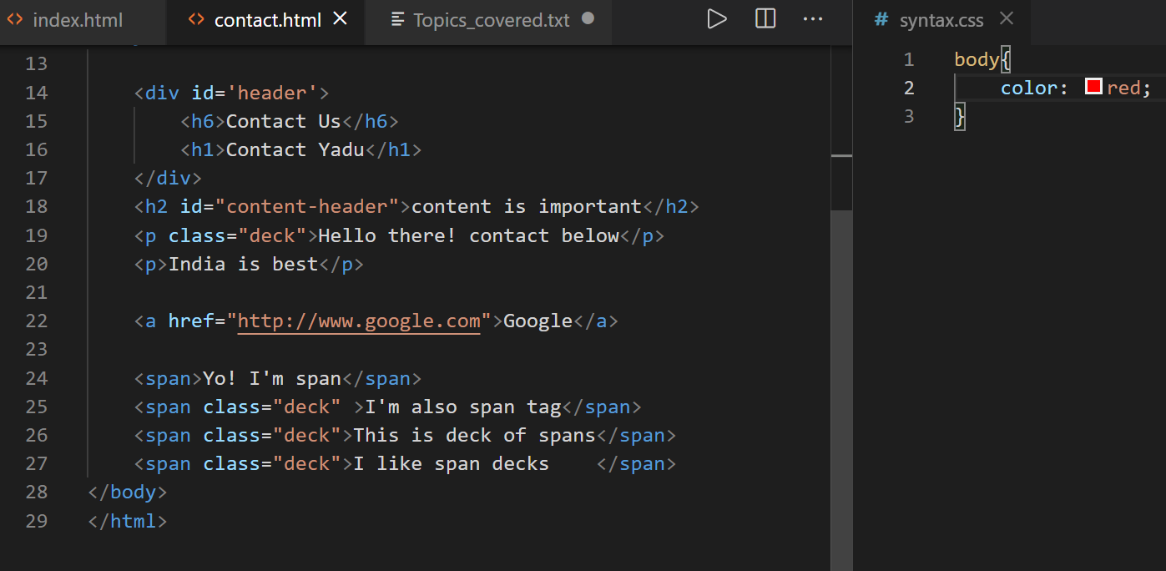

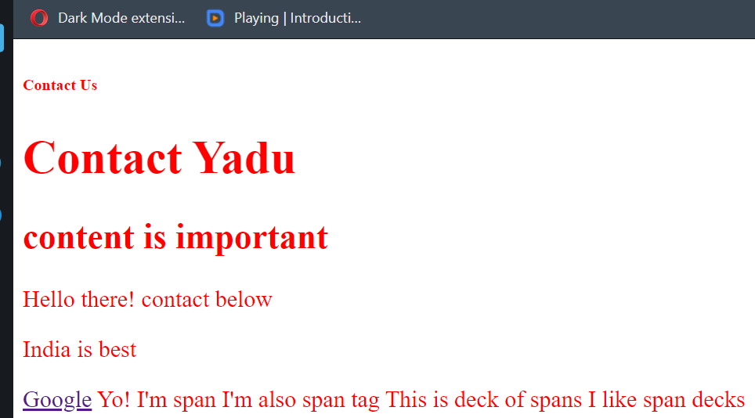

Now doing conflict by coloring div with blue where blue overrides red color

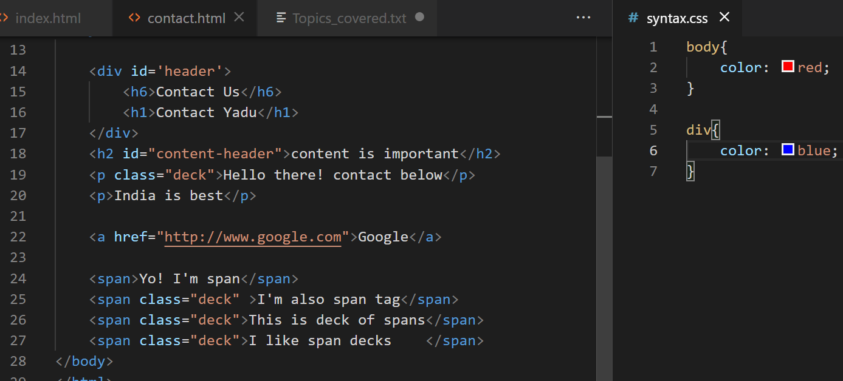

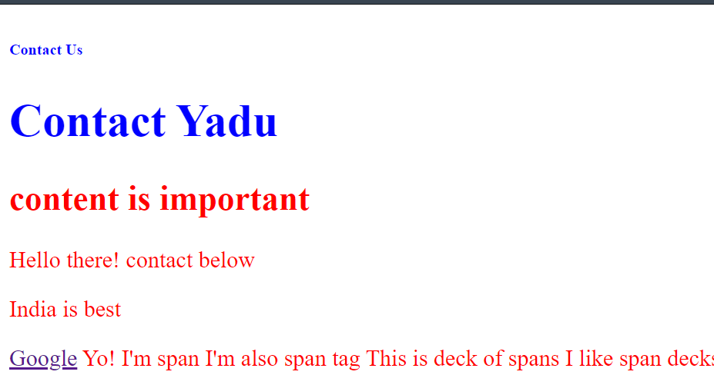

But default a tag color is blue itself it didn’t change.

On a links it will be there by default

SELECTOR SPECIFICITY:

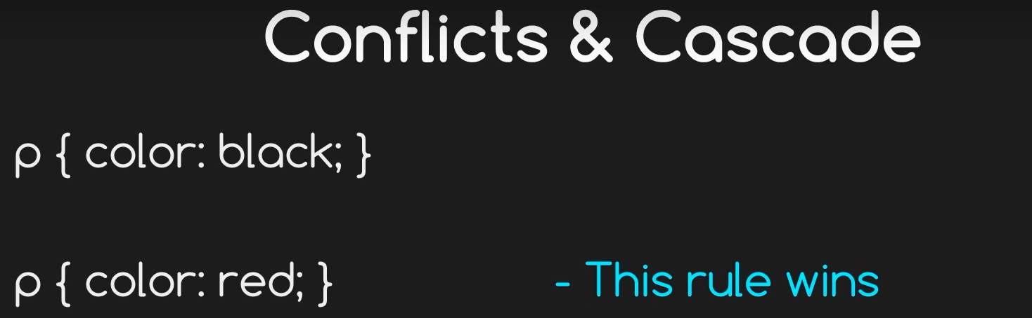

What happens with id conflict:

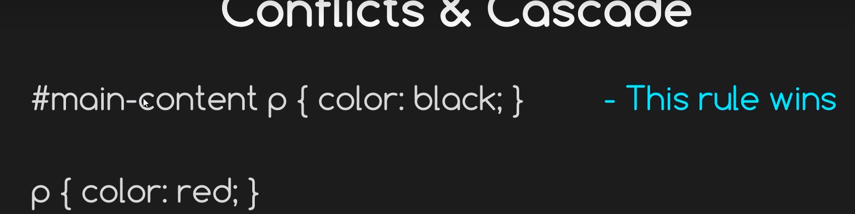

SO id ha more weightage.

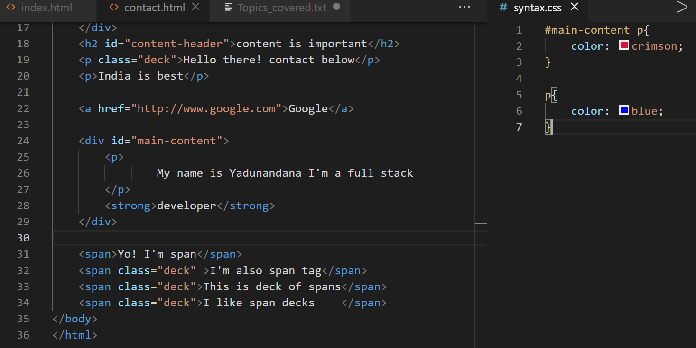

P with id will get crimson color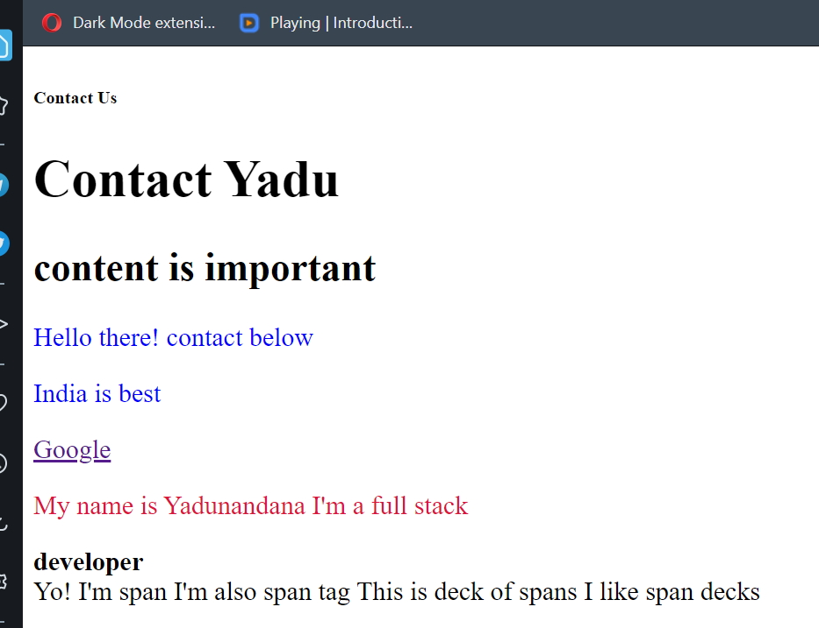

But even when we use green color with class inside p it doen’t get green it will be in crimson.



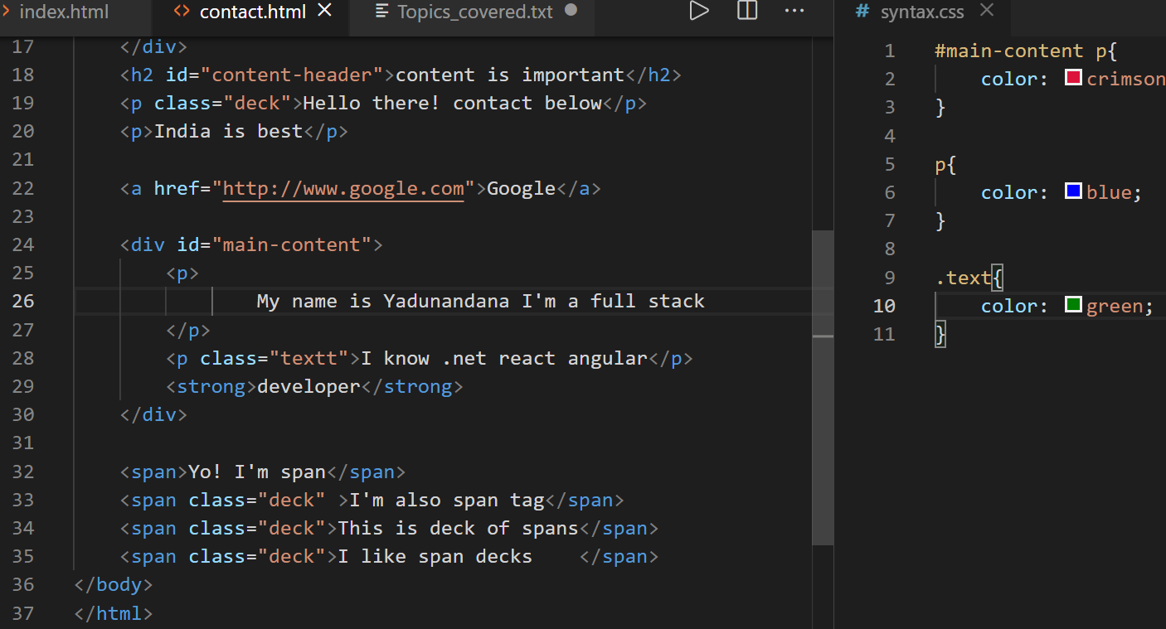

It didn’t affected developer word inside strong.

The Important declaration:

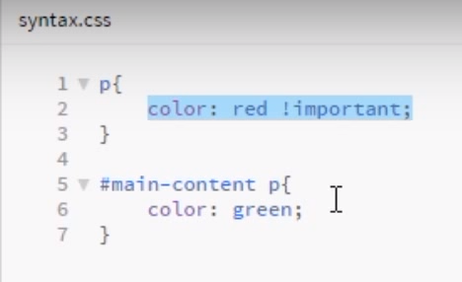

We know in conflict ids have more weightage but even though if you want your p tag to be red the you need to use !important they

Green color from id doesn’t override red color in p tag, where we’re saying like it’s very important p tag color should be red.

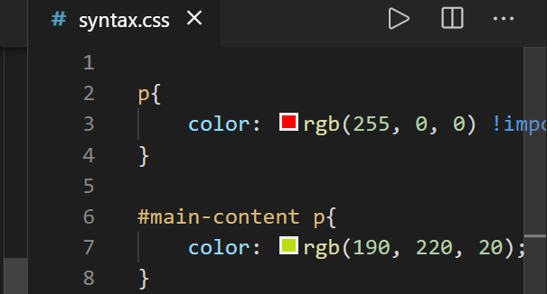

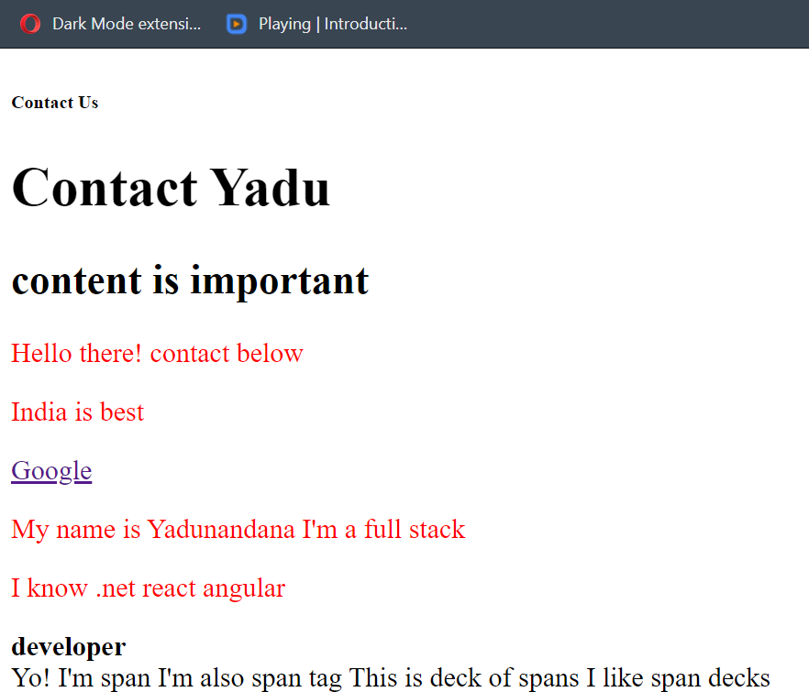

Targeting multiple elements:

When we style for different elemeents it will take lot of lines;

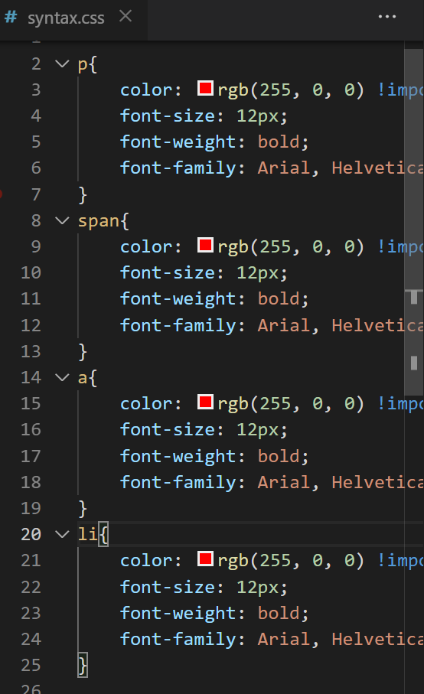

We can add them in single line for same styles.

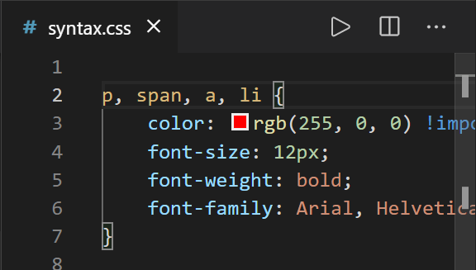

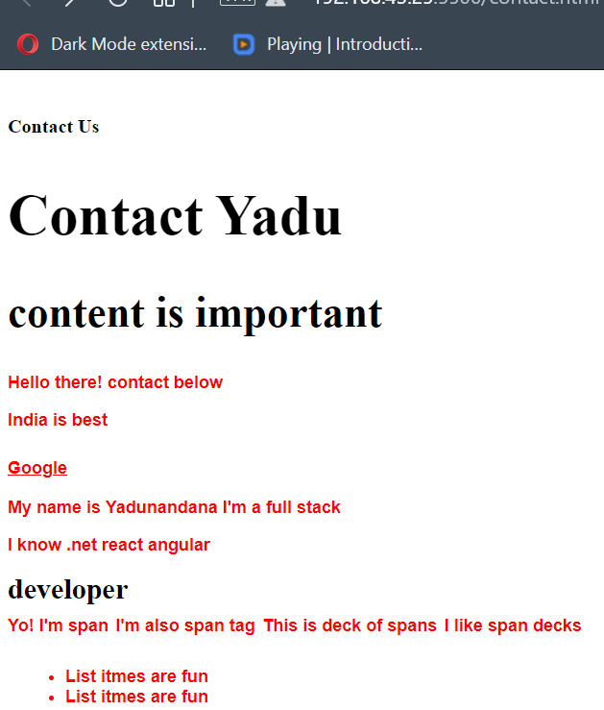

Descendents :

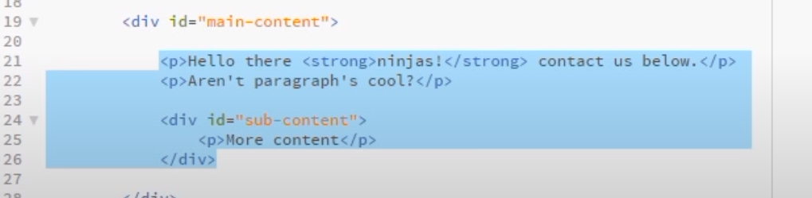

Here selected texts are descendenst of main-content

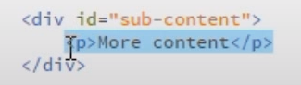

Here p tag descendents of sun-content

In css if we want to style p tag of sub-xontent that time will use descendent selectors

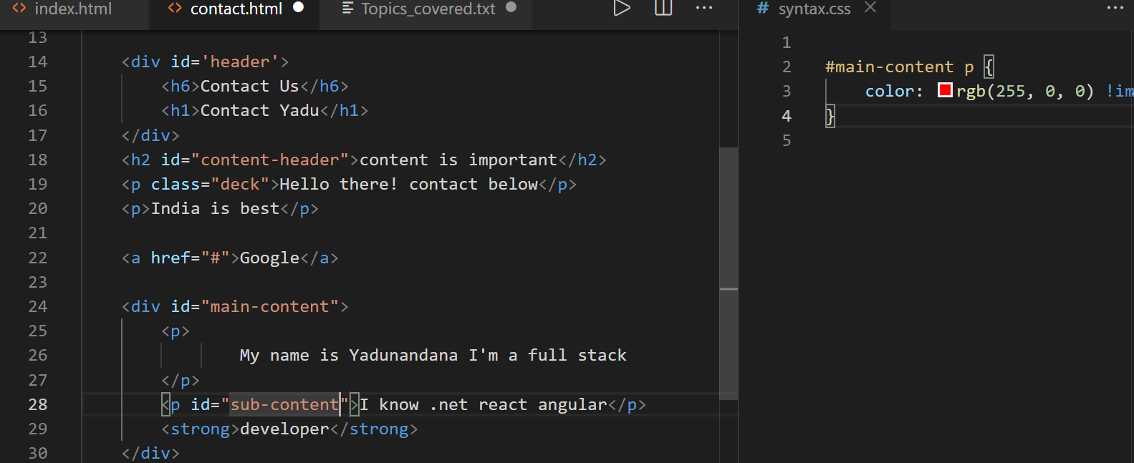

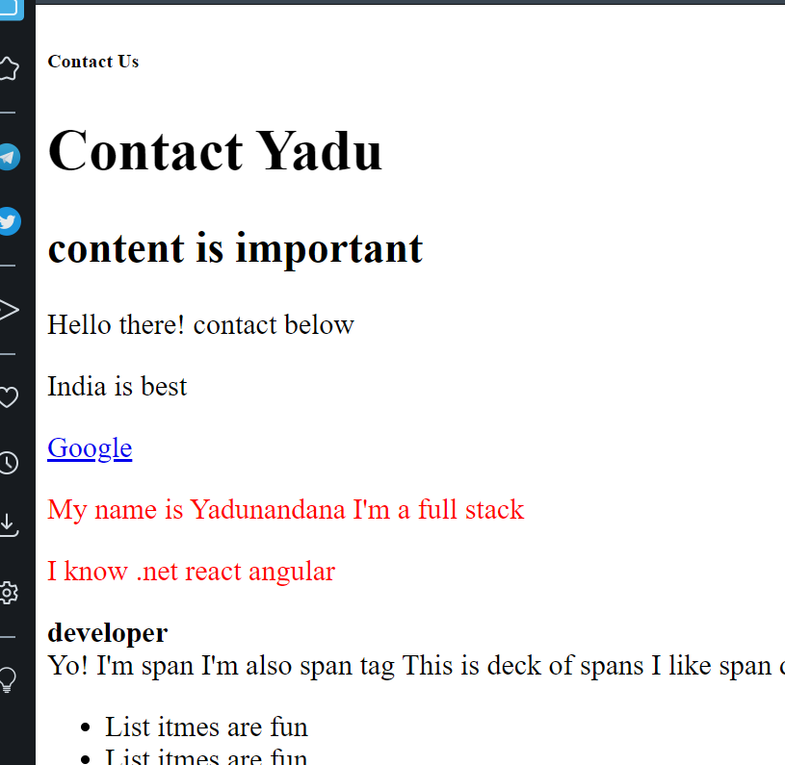

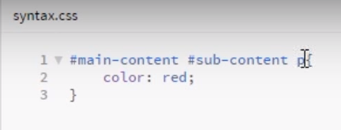

Parent child grand_child

Or else:

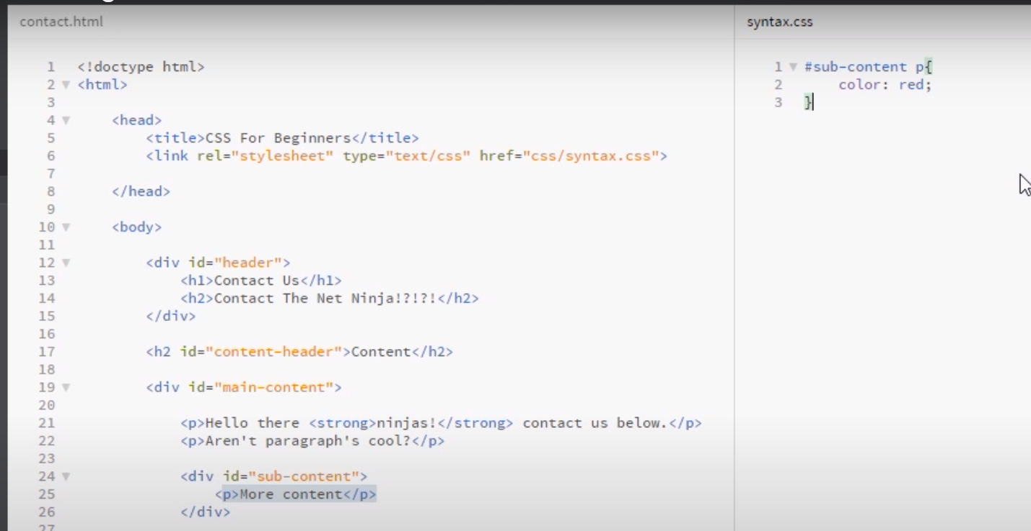

To make sub-content p red.