**Excel**

**Introduction:**

Start Microsoft Excel to start it should be installed in your system.

If it is not installed you may need to visit the Microsoft website to download Microsoft Office.

If it is installed you can open excel by three methods:

1. Go to the start option and search for excel and click on it.
2. 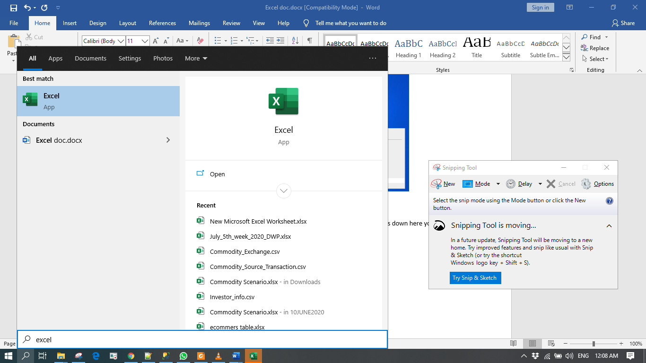
3. By using search tool look for excel and click on it.
4. By right clicking on the desktop going to new and selecting Microsoft Excel Worksheet.

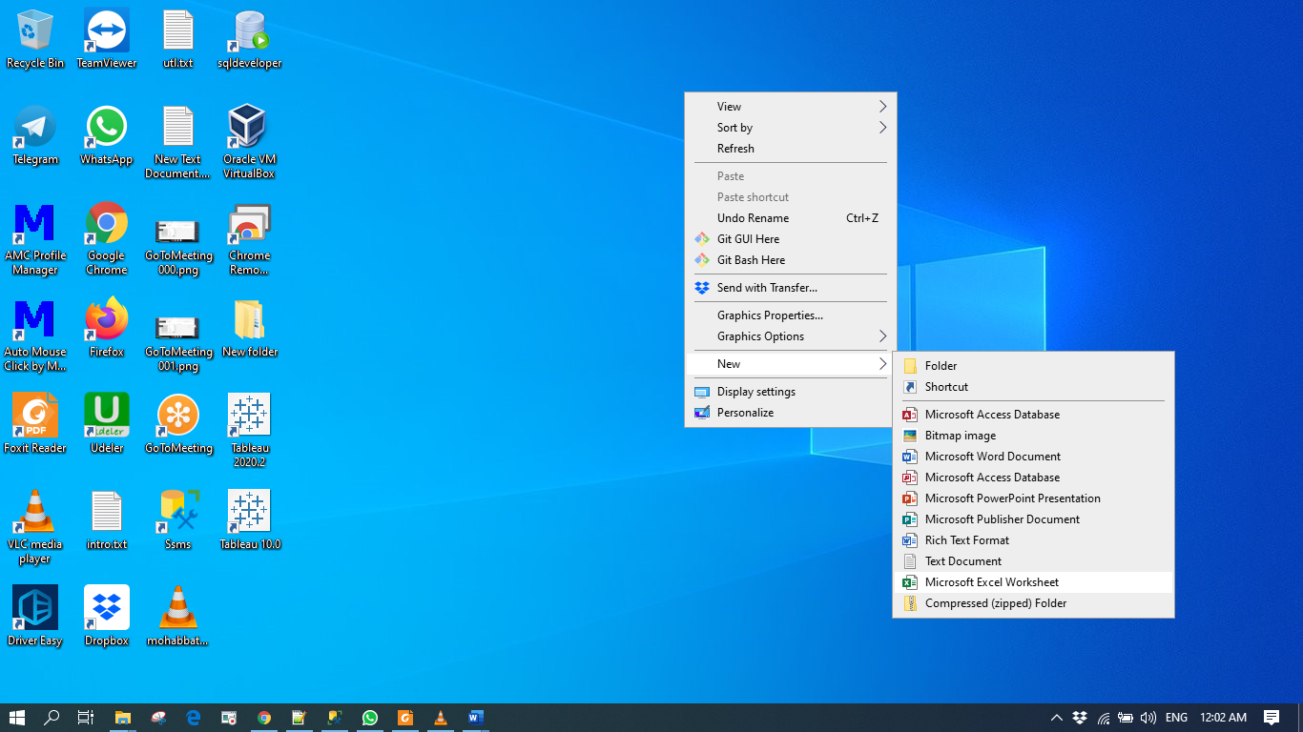

if you double click on it it opens a worksheet.

Once Excel opens you will see this window with many small rectangular boxes down here you can see your tab saying sheet one.

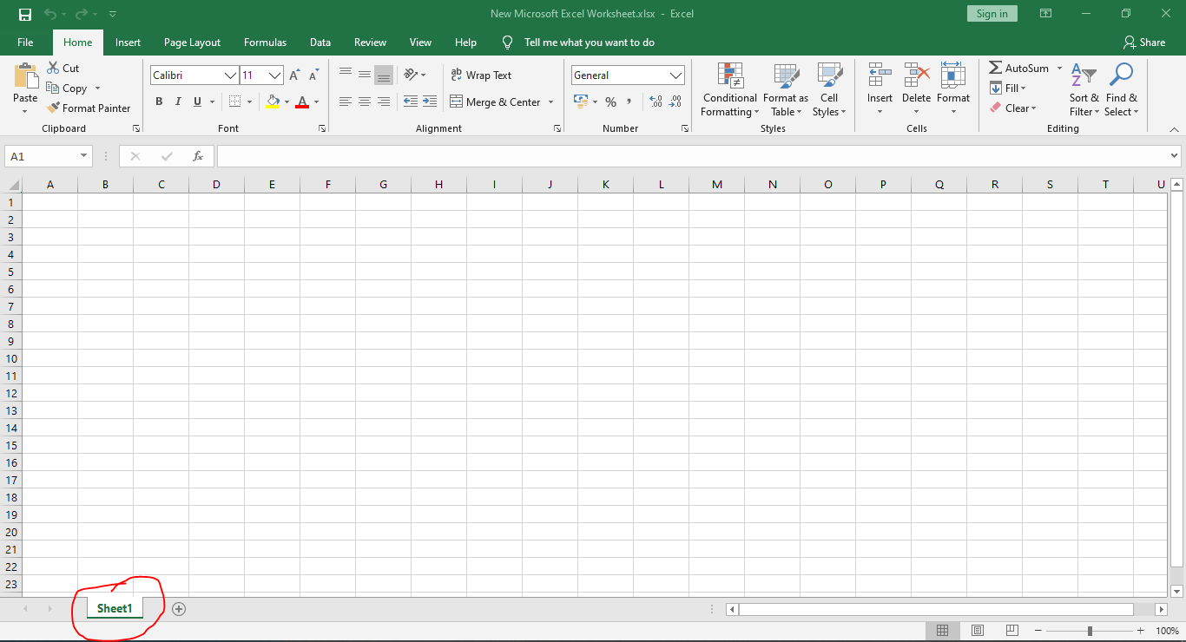

**How to add new sheet.**

You can add more sheets make clicking this plus icon. Now you can see sheet to entry also.

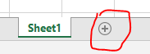

If you look closely these rectangles are formed by these vertical and horizontal lines. These vertical parts are called columns and each column has an alphabet name.

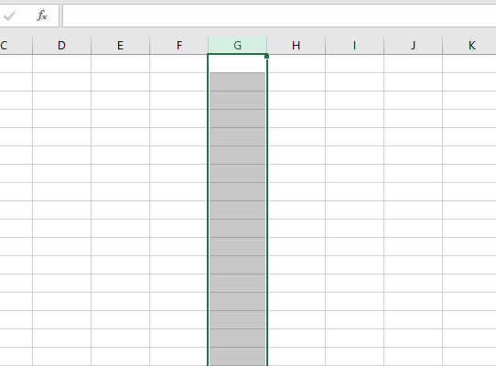

If I click on this letter G it highlights the column G in a worksheet.

NOTE: There are sixteen thousand three hundred eighty-four (60,384) such columns.

Similarly the horizontal part are called rules and are represented by numbers. If I click to the second row will be highlighted.

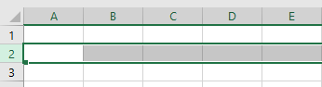

**The maximum number of rows in a worksheet is over a million.**

**What is a cell**

The **intersection of the row and column** create a rectangle. This rectangle is called a **cell.**

**Ribbon**



you can collapse the ribbon by clicking here .

**Tabs**



**Home Tab**

The first tab is the home tab

This tab contains the basic clipboard commands such as cut copy paste formatting command styling command and command to insert and delete rules or columns.



**Insert tab**

The second tab is Insert tab.

We use this tab to insert elements into a worksheet. Elements such as a table a diagram a chart a symbol and so on.

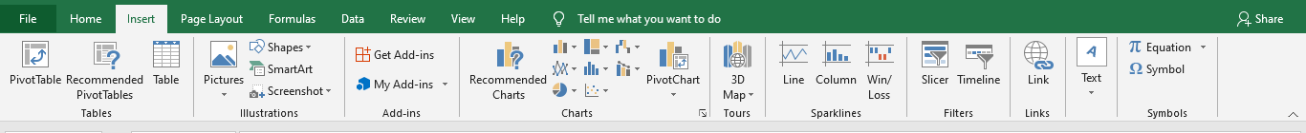

**Page Layout Tab**

Page layout tab contains commands that affect the overall appearance of your worksheet including some settings that deal with printing.

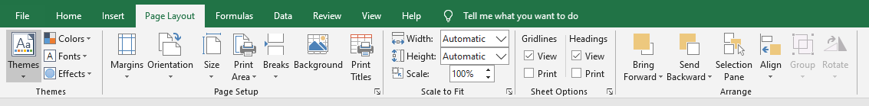

**Forumlas Tab**

The fourth tab is forumlas tab which is used to insert a formula name or cell or access, formula auditing tools etc.

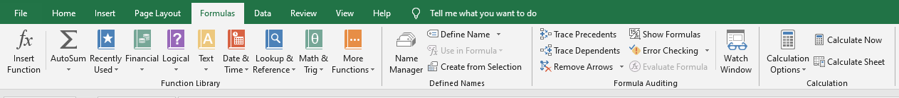

**Data Tab**

Next tab is Data tab where you will find data related commands including data validation filtering sorting and advanced analysis tools.

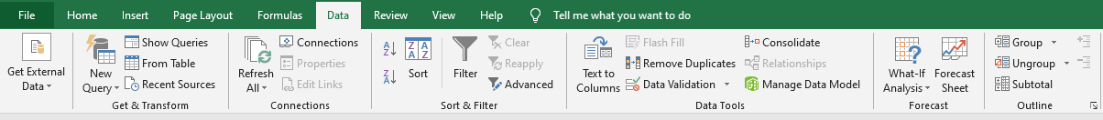

**Review Tab**

Then comes the review tab which helps to review the content in your worksheet such as do spell checking translate word or add comment.

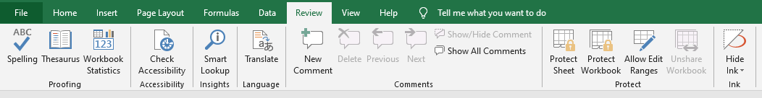

**View Tab**

The last tab is the view tab which contains commands that control various aspects of how a sheet is viewed.

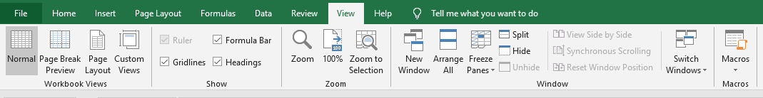

For example- zooming or freezing beans within a worksheet.

Workbook contains many worksheets and these worksheets are like pages of a notebook. Whatever we do on one sheet will not impact the other sheet.

 This is where we can find the tabs for each sheet.

Let me give you an example of how sheets are used.

Suppose you want to maintain performance record of students or standard 8. So your workbook will be for the standard 8 and in the workbook. You can have each sheet for each subject so sheet one can pour data for English she to format sheet 3 for Science and so on. In this way your data will be very organized.

Now it will be more convenient if your sheet name was English instead of Sheet 1. It's very easy to rename a sheet, double click on the Sheet1 and rename it to English.

 

**How to move the sheet to request position.**

Just drag and drop this sheet to the location that you wanted to be.

Click on match sheet Hold the click move to the position we want and leave it.

**Add Data Into Existing Rows**

if you want to add data between these existing rules say you want to add a Student C between student B and D.

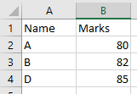

For this I need to insert a row between B and D. To insert the row we write click on the number 4 of this row for and select the insert option.

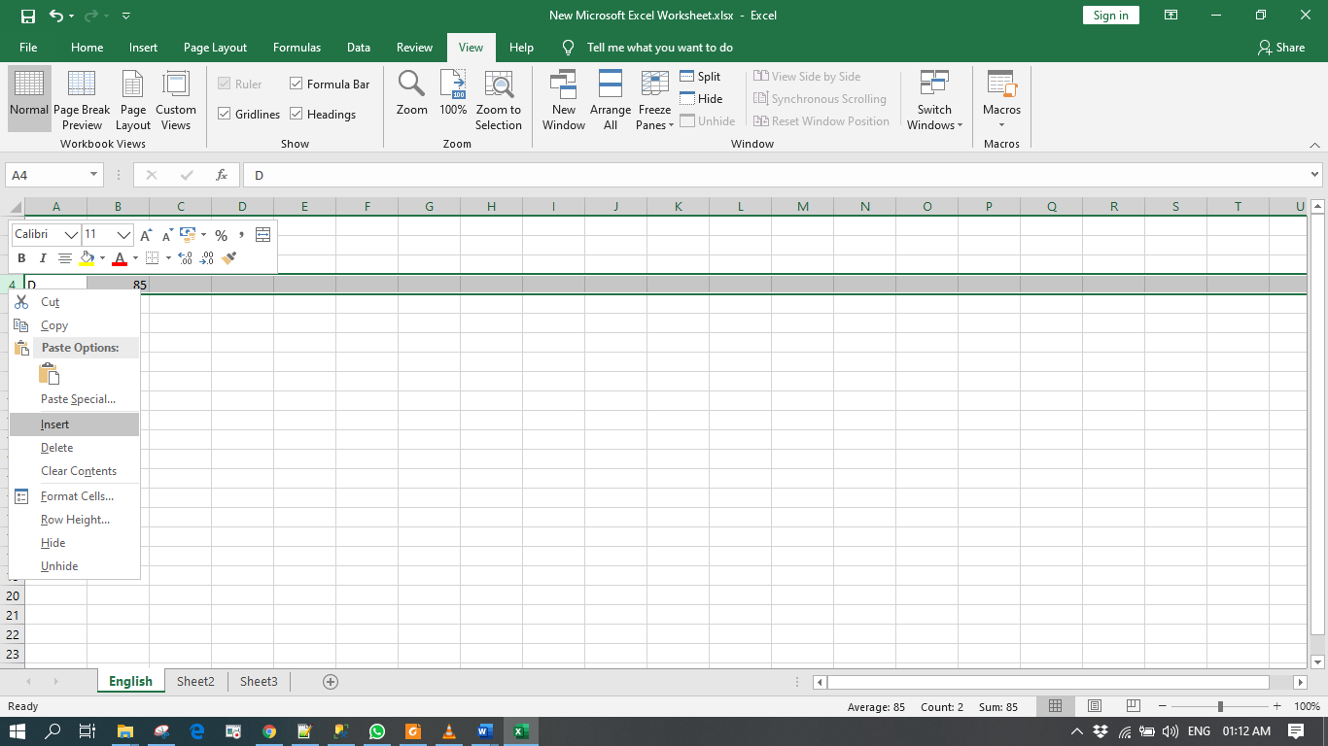

Notice that a new blank row is inserted at the 4th place and the row which was earlier a default

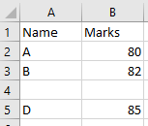

**Add Data Into Existing Columns:**

Right click on the column which row before you are inserting the column, after click on insert.

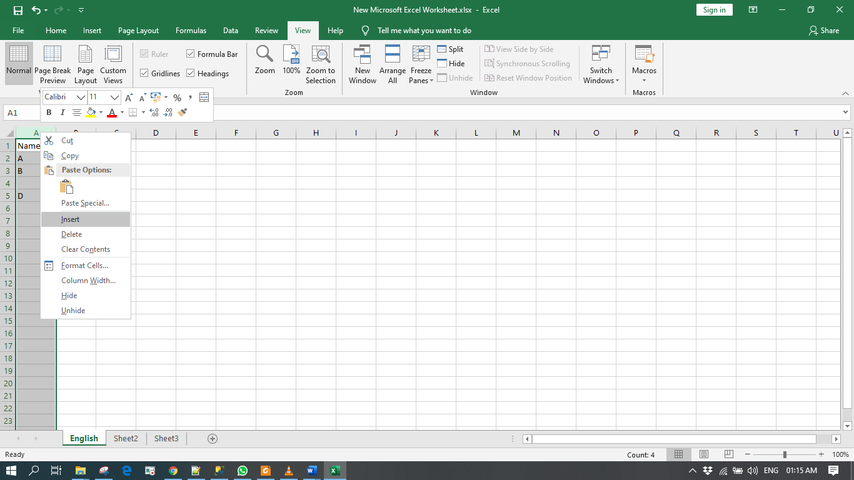

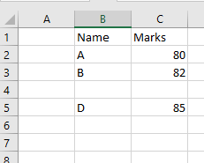

**Expand the boarder of the column**

Just drag the border and make the expand

Or you can place your mouse to the border of the column and double click on it, it will automatically expand till according to length of headline.

**Resize the rows and columns**

Click between the boarder of two rows or column mouser pointer changes to other sign then just click and drag it will resize that row or column.

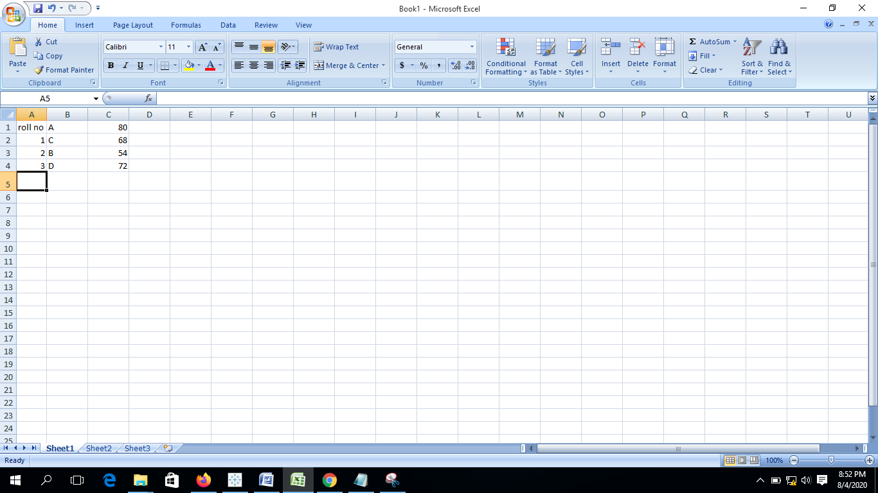

**Clear the content from the row**

Right click on that row and then clear the content.

After doing this only the content in that row will be clear.

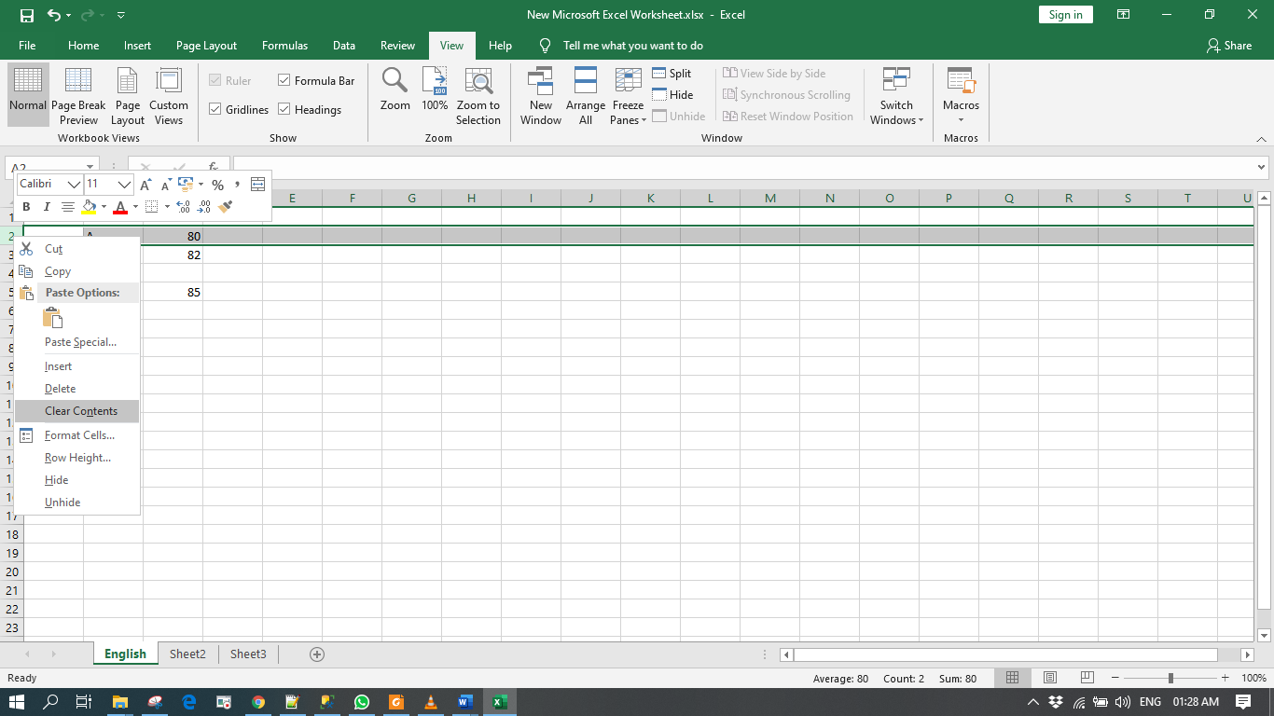

**Clear the content of the column:**

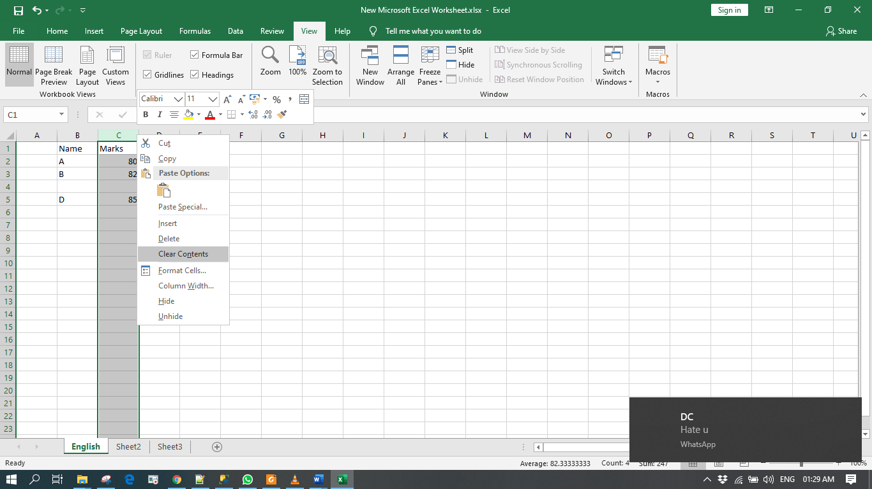

**Zoom In And Zoom Out**

If you want to zoom out you then use this plus (+) sign. Similarly if you want to zoom out you then use this minus sign. You can use this scroll bars on the right and on the bottom.



**Column Hiding**

Just right click on the column name and click on hide.

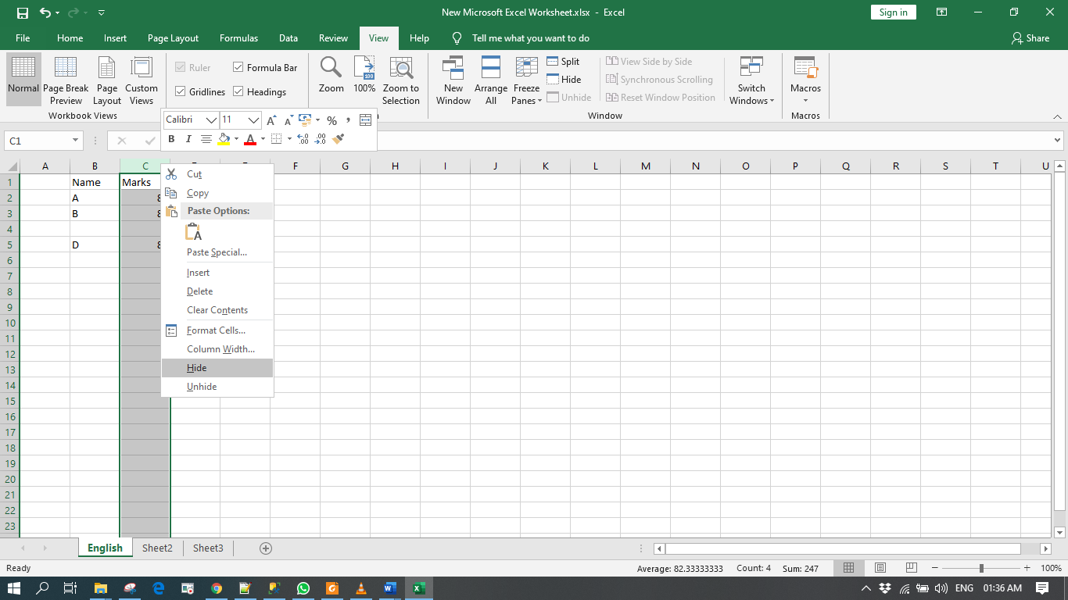

**Unhide the column**

Double click between the adjacent column of hidden column for example here double click between A and B.

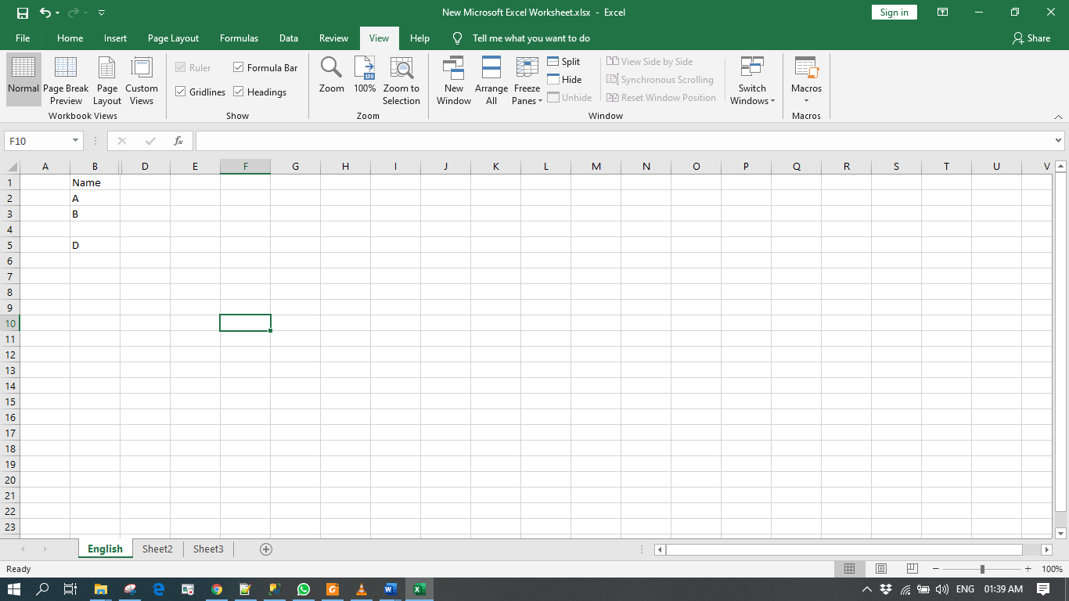

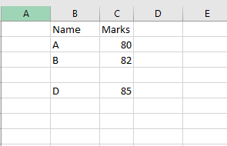

**Hide the sheets**

Right click on that sheet which you want to hide, then click on hide.

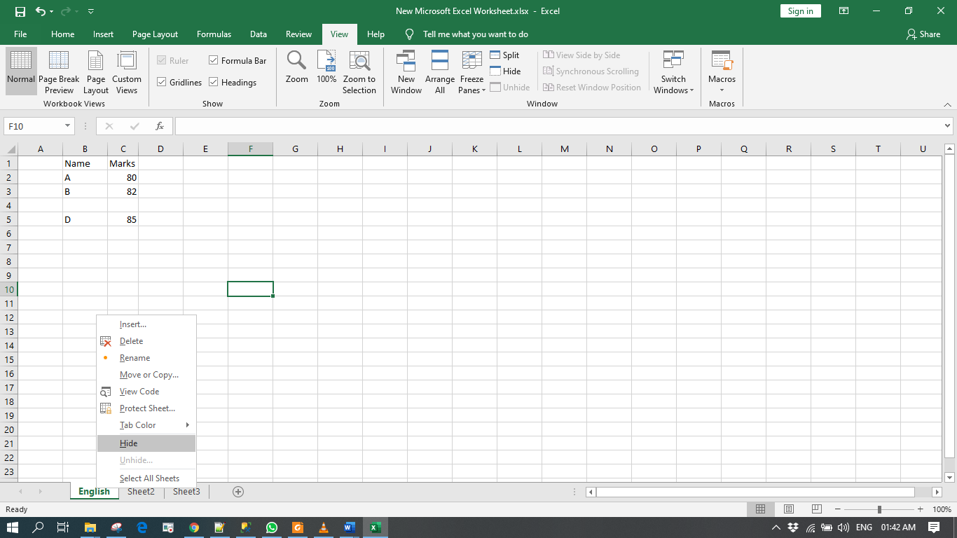

**Unhide the sheets**

Right click on the sheet and click on Unhide. 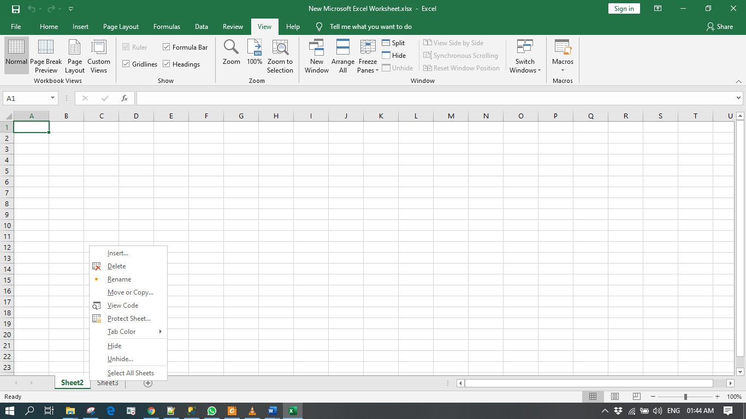

**Another way to hide column ,row, sheet**

Go to home tab -> format button -> hide unhide -> hide column or hide row etc.

->What is the meaning of being active cell:

If the cell is active whatever you type on the keyboard will be entered in that cell only.

