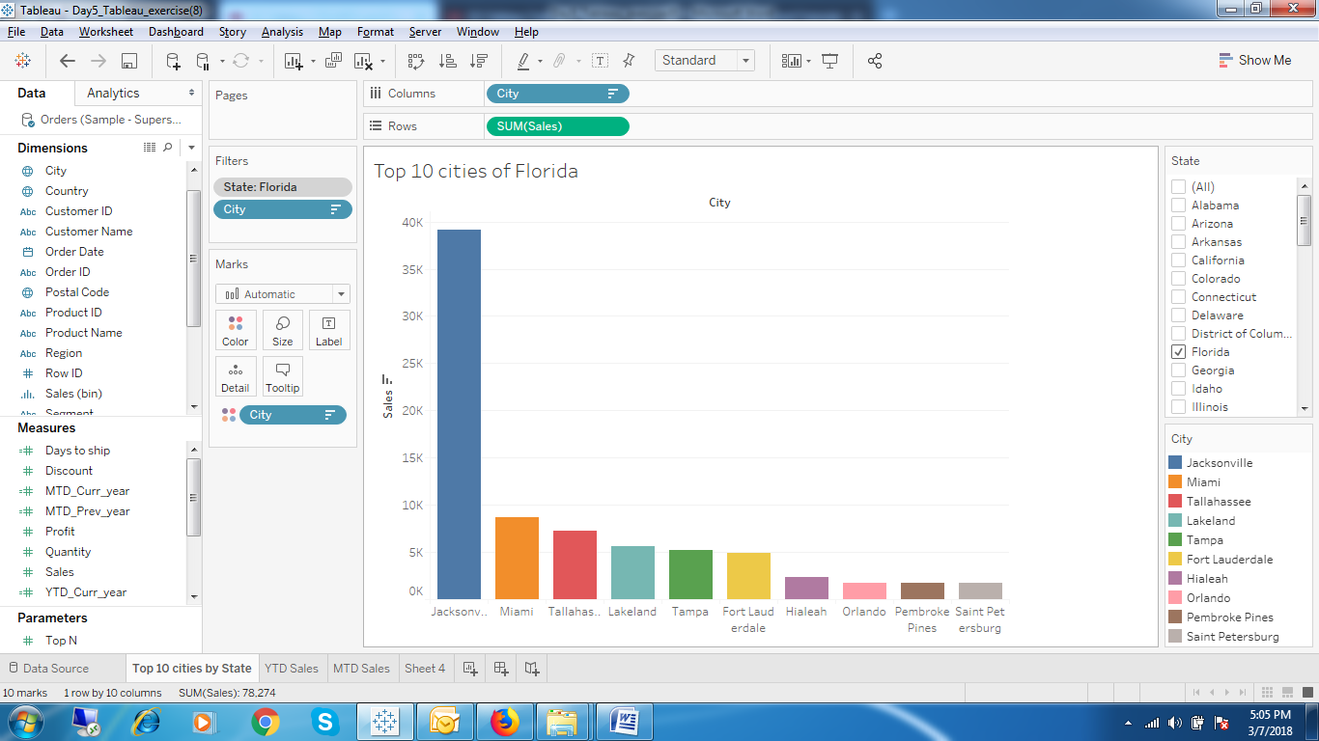

1. Top 10 Cities by passing the state at run time using Context filter.

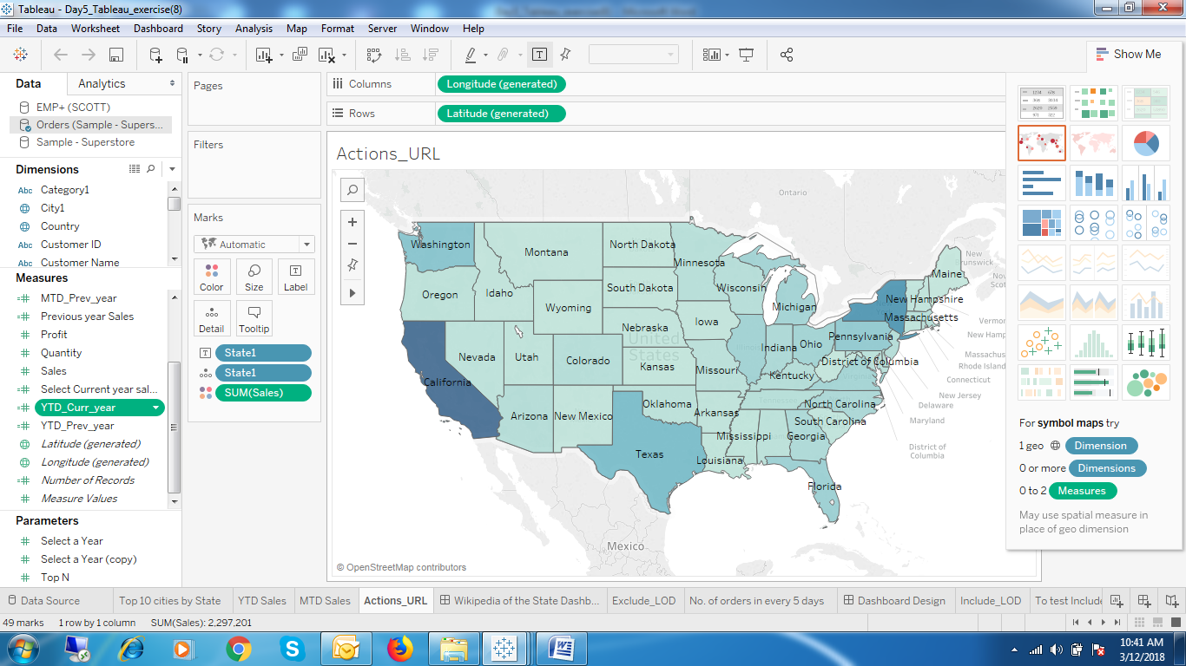

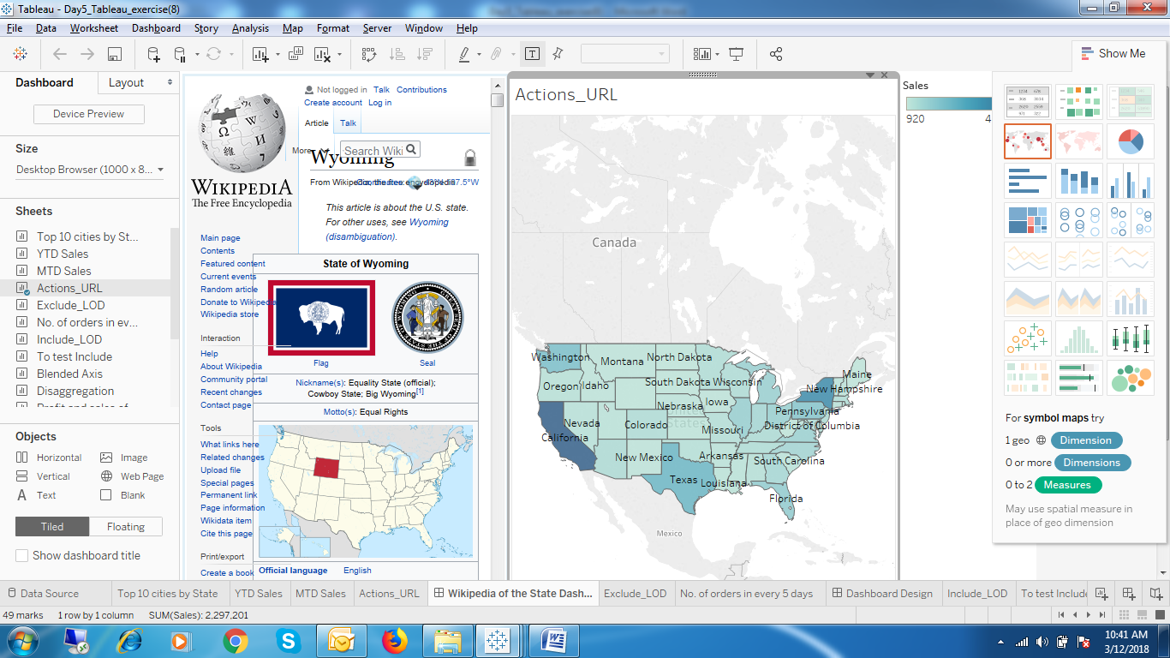

1. Wikipedia of the state using Actions URL.

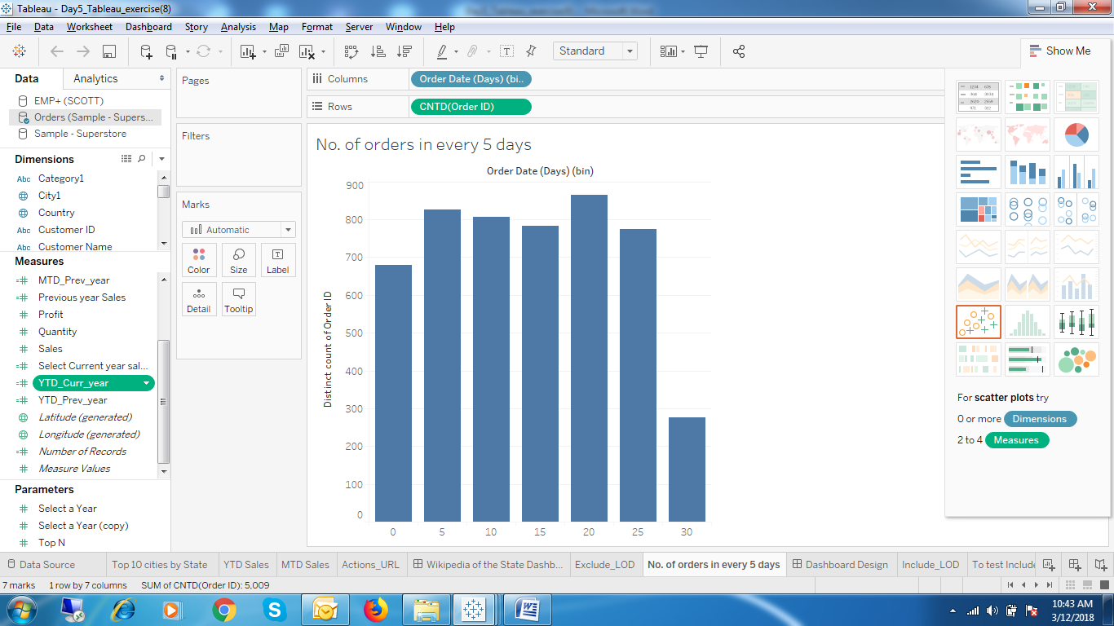

1. No. of orders in every 5 days.

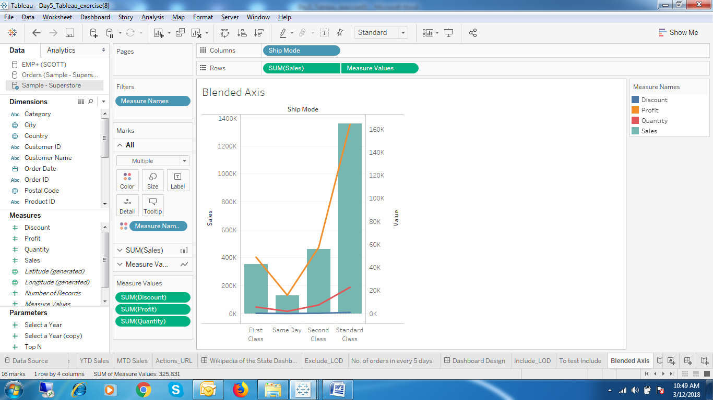

1. Sales, Discount, Profit and Quantity by Shipmode.(Blended Axis)

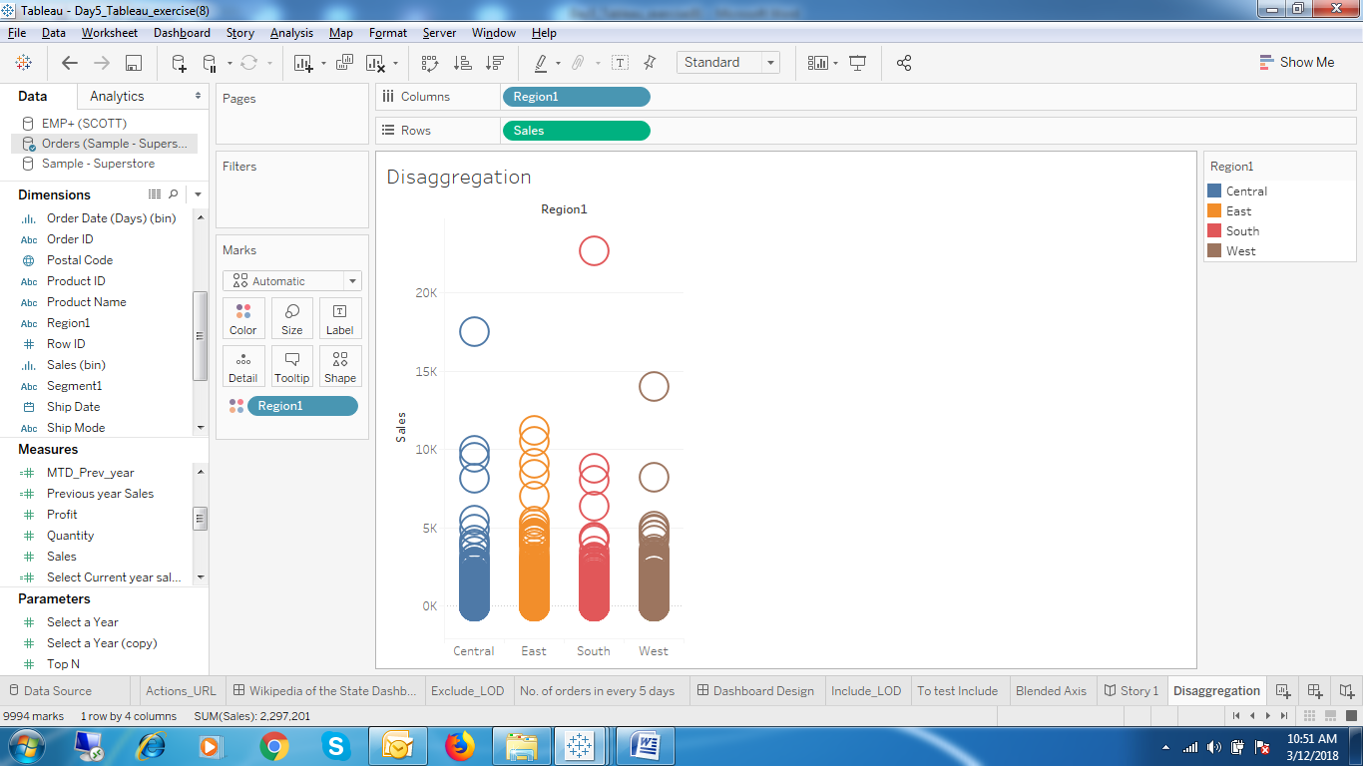

1. Region by Sales without aggregation.

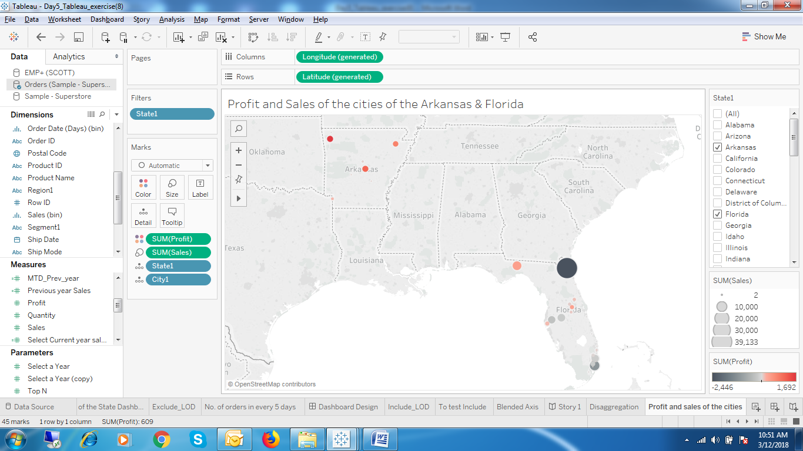

1. Sales and Profit by State.

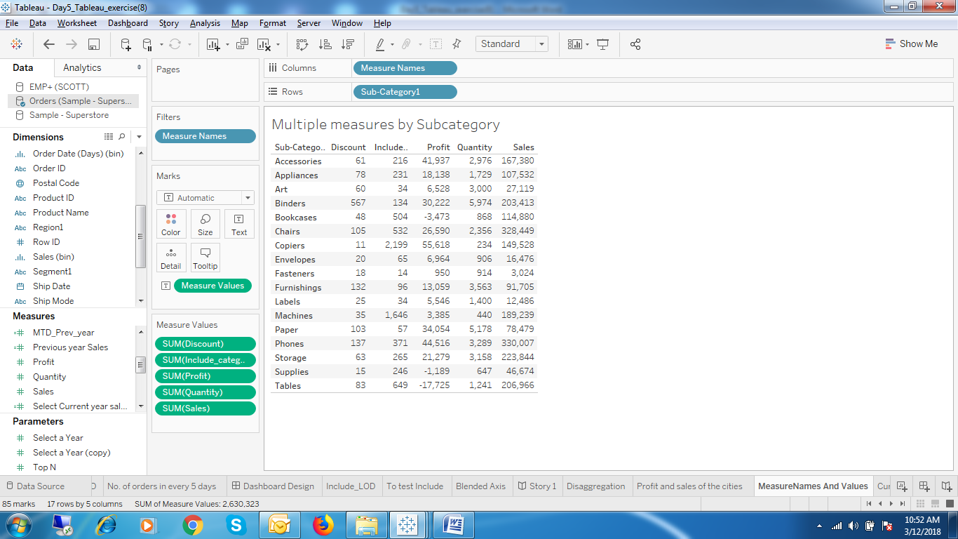

1. Using measure names and measure values by Subcategory

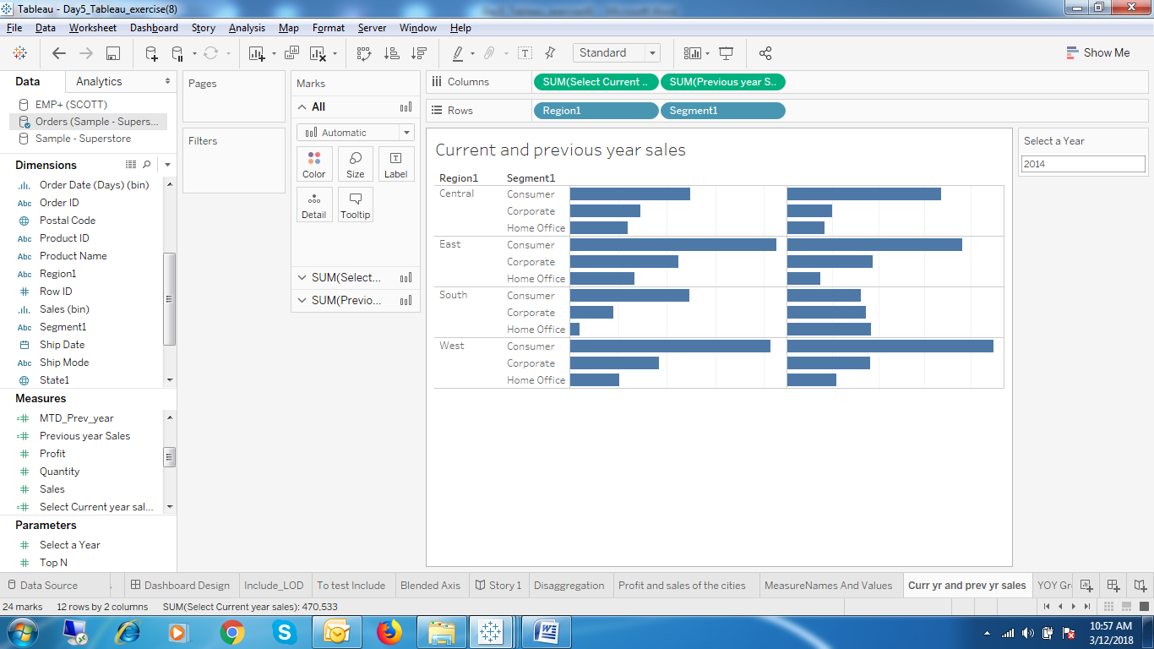

1. Current and Previous year sales

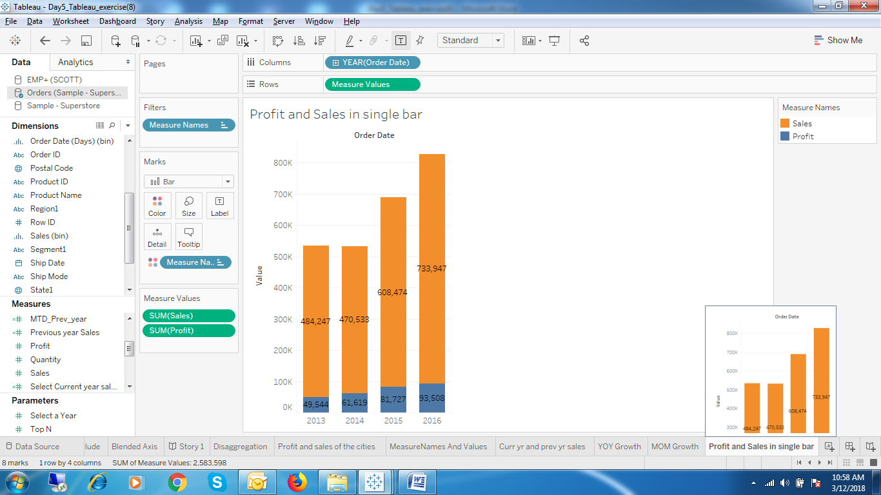

1. Profit and Sales in Single Bar.