18.6.15

1. We compare results of intensity for raw image matrices, obtained from different m codes (Dave Coffin's dcraw vs. Rob Summer's alternative)

Findings: Summer's code yield the exact size of the original file and intensity of 50% (given in DN between 0-(2^16-1) in comparison to intensity of raw image from Coffin's code.

We ran dcraw code from matlab trying to change the output color space and exclude marginal pixels but it didn't influence the intensity of the image

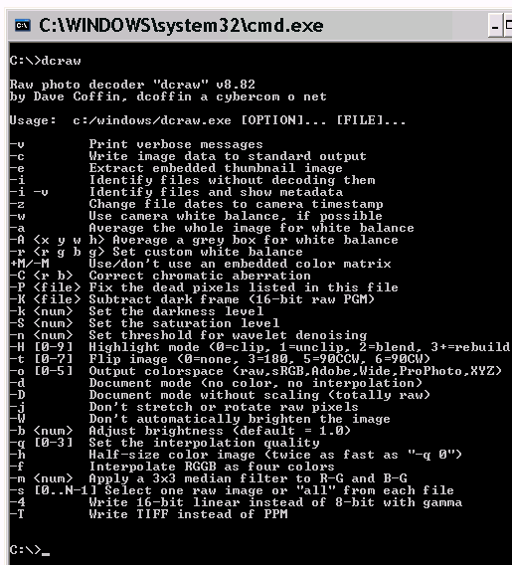

Running dcraw smoothly required setting path of all the image folders

We visually noticed and calculated correlations between PBM and I at different ranges of intensity (daytime only) and found 2700-2900 as a reasonable range where PBM is negligablely related to intensity

Tasks

Yael –read image formats conversion paper Rob Summer

Tamar –

1. run dcraw and check correlation between the intensities obtained by dcraw and DNG
2. check PBM correlation to PM only for intensities values of 2700-2900 given they are spread along the entire dayttime period

Results for june 1st:



Check if the same correlation is found between EBW/PBM of raw and jpeg

So far Tamar checked the values of PBM extracted from jpegs vs. raw files for June (NS) data

