EE420 – Digital Image Processing – Finals

Otsu’s thresholding algorithm
- The MATLAB code is attached to this PDF in a ‘/code’ folder.

- The mean gray level in the original image is 87.251125 (calculated using mean(I) function).

- The gray value associated with the Otsu threshold is 96. Comparing to the mean value of the image it’s a little larger, but because the measure is from 0 to 255, it is only ~3% difference.

- My Otsu threshold implementation results are pretty close to the to the MATLAB’s implementation of Otsu thresholding using the graythresh function – threshold of 97 (in my implementation) and 96 in the MATLAB implementation. We can see that the two results are almost similar.

- Screenshots of the original image, its histogram and the binarized image obtained using your Otsu thresholding:
The original image:
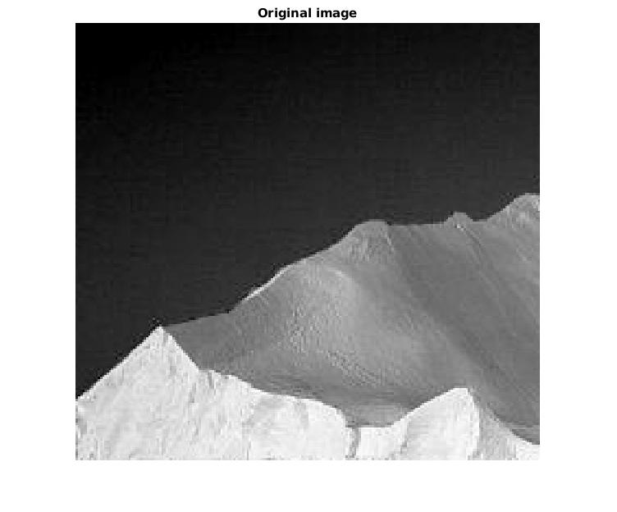

Image histogram & threshold:
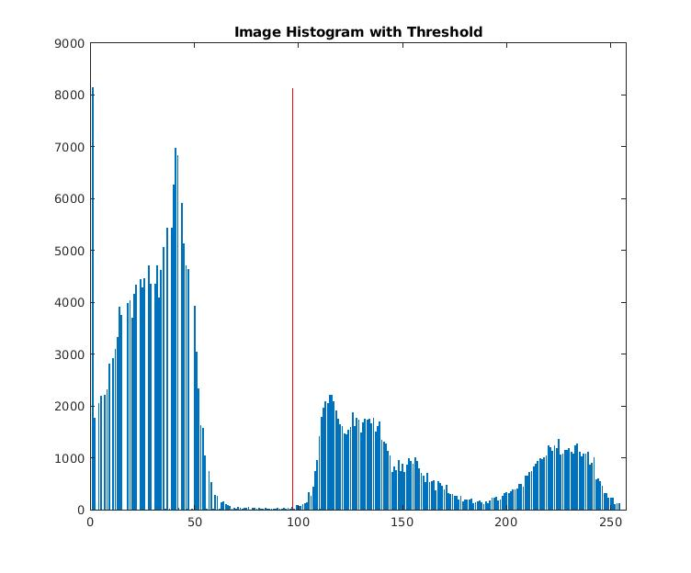

The binarized image obtained using my Otsu thresholding:
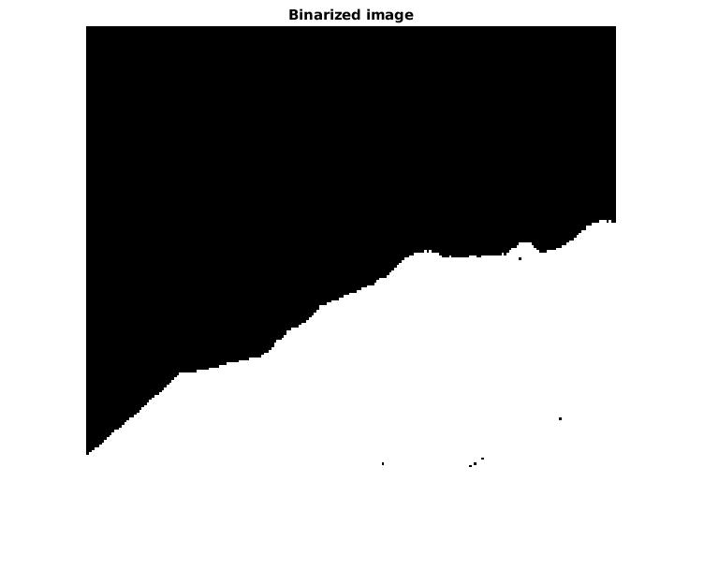

License plate recognition
- The MATLAB code is attached to this PDF in a ‘/code’ folder.

- Screenshots of the binarized license plate and the 7 detected characters:
The original image:
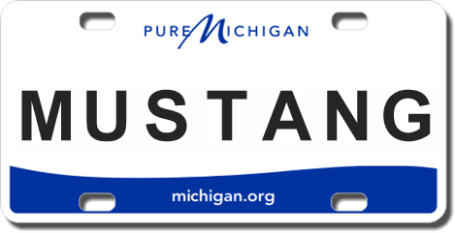

The binarized license plate:
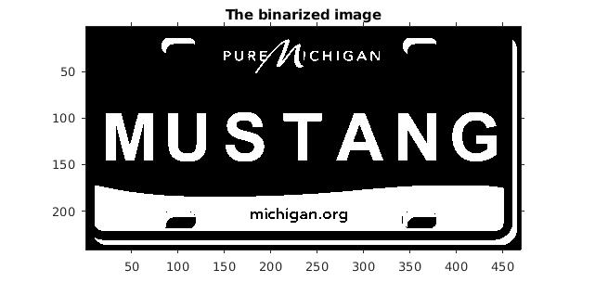

The 7 detected characters:
