EE420 – Digital Image Processing – Homework 5

Deliverables & Questions
- The MATLAB code is attached to this PDF in a ‘/code’ folder.

- The expressions for listed in Eq.(2) have different sign for and because the positive angle theta is growing in the negative direction of y. Meaning that y_{e} is growing in the negative y position. x_{e}, on the other hand, is growing with x, and there for has a positive sign (according to figure 2):
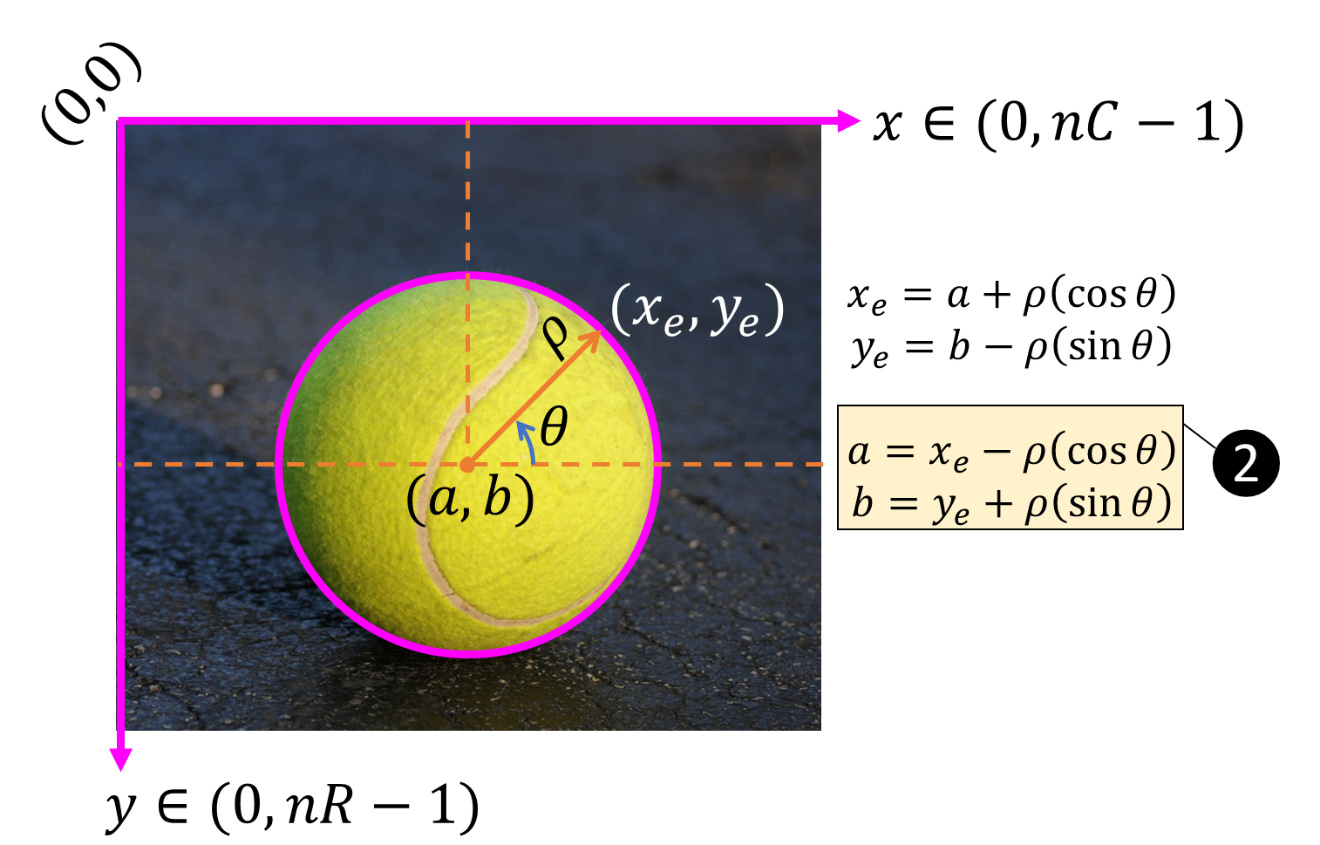

- My estimate radius of the colored chips was 24. I used the function ‘imfindcircles()’ of the image to find the radii of all the circles in the image.
My parameters for the Canny edge detector were [0.05 0.15], and I found there using trial and error – changed the values until I found the best ones.

- I was able to detect all 28 circles in the image.

- When I pick a large value for the threshold in houghpeaks, I could detect less circles.
For example, for threshold = 200, I could only detect 5 circles:
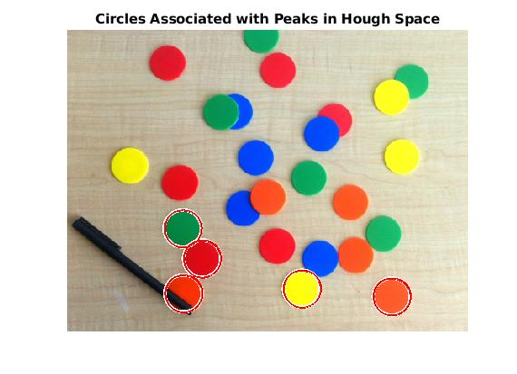

- When I pick a small value for the threshold in houghpeaks, I could detect all of the circles.
For example, for threshold = 0.0000001:
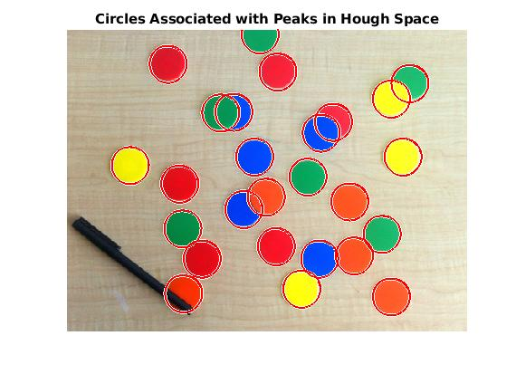

I think that with such a small threshold, with a different image, the function would recognize other non-circle shapes as circles (in this image there are not a lot of other shapes besides the coins).

- The yellow coins detected by the code:
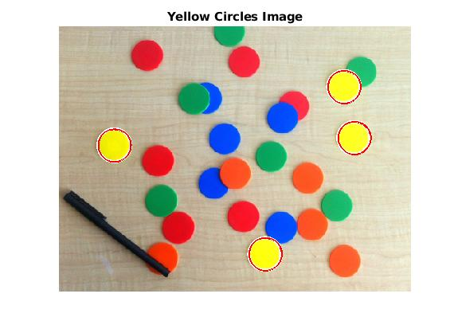

- Screenshots of the original image, output of Canny edge detector, the Hough Space diagram with the peaks overlaid:
Original image:
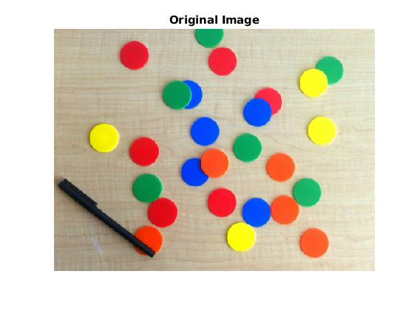

Output of Canny edge detector:
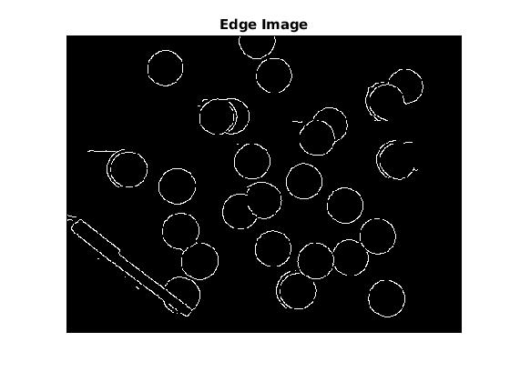

Hough Space diagram with the peaks overlaid:
