ME333 – Homework 4 – Yael Ben Shalom

Chapter 5, Exercise 3:
The code for this exercise attached in ‘/code/Ch5Q3’ folder.
- The combinations of data types and arithmetic functions that result in a jump to a subroutine are long long int, and division:

- Function for long long int with division:
The C statement:
j3 = j1 / j2;
The assembly commands it expands to:
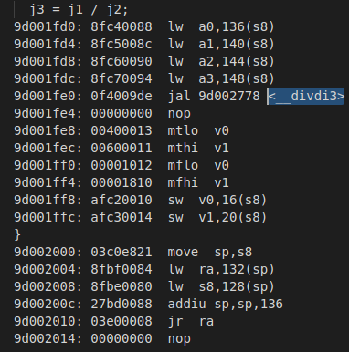

- Function for float with all operations.
- Function for long double with all operations.

- For the statements that do not result in a jump to a subroutine, the combination(s) of data types and arithmetic functions that result in the fewest assembly commands are int with addition and subtraction:
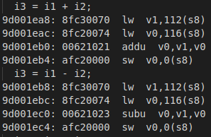

The smallest data type, char, does not involve in it, because it has an additional line “andi” for AND operation between v0 and 0xFF:
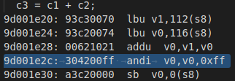

- The filled table:
 | Char | Int | long long | Float | long double
+ | 1.25 (5) | 1.0 (4) | 2.75 (11) | 1.25 (5) J | 2.0 (8) J
- | 1.25 (5) | 1.0 (4) | 2.75 (11) | 1.25 (5) J | 2.0 (8) J
* | 1.5 (6) | 1.25 (5) | 4.75(19) | 1.25 (5) J | 2.0 (8) J
/ | 1.75 (7) | 1.75 (7) J | 3.0 (12) J | 1.25 (5) J | 2.0 (8) J

- The math subroutines installed in virtual memory at:
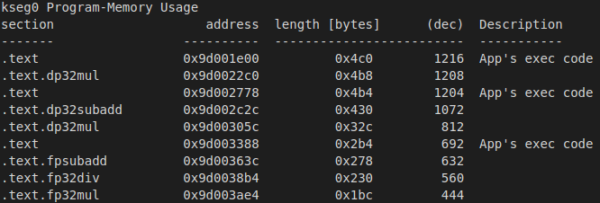

Chapter 5, Exercise 4:
The code for this exercise attached in ‘/code/Ch5Q4’ folder.
Each of the statements uses those command lines:
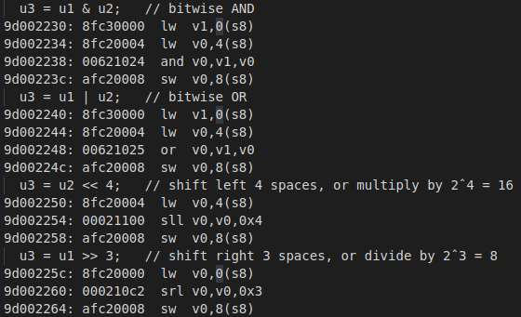
& - 4 commands

| - 4 commands

<< - 4 commands

>> - 4 commands
Chapter 6, Exercise 1:
Pros and cons of using interrupts vs. polling:
Pros | Cons
Interrupt can take place at any time, whereas CPU steadily ballots the device at regular or proper interval | Interrupts are limited
In interrupts, processor is simply disturbed once any device interrupts it. On the opposite hand, in polling, processor waste countless processor cycles by repeatedly checking the command-ready little bit of each device | Requires special non-cacheable memory allocation for SFRs
Interrupts are faster

Chapter 6, Exercise 4:
- If an IRQ is generated for an ISR at priority level 4, subpriority level 2 while the CPU is in normal execution, the CPU will attend the ISR.
- If that IRQ is generated while the CPU is executing a priority level 2, subpriority level 3 ISR, the CPU will attend the level 4 ISR and then jump back to the level 2 ISR.
- If that IRQ is generated while the CPU is executing a priority level 4, subpriority level 0 ISR, the CPU will continue attending the current level 4 ISR before moving to the new level 4 ISR.
- If that IRQ is generated while the CPU is executing a priority level 6, subpriority level 0 ISR, the CPU will continue attending the level 6 ISR before moving to the level 4 ISR.

Chapter 6, Exercise 5:
- Assuming no shadow register set, the first thing the CPU must do before executing the ISR is to save the contents of the internal CPU registers, called the “context,” to the stack (data RAM).
The last thing it must do upon completing the ISR is to restore the contexts back from the RAM into the registers and the CPU reverts to its initial state before the ISR was executed.

- Using the shadow register set changes the situation by allowing the CPU to use these extra set of registers without needing to save and restore them.

Chapter 6, Exercise 8:
- IEC0SET = 0x100; // Enabling the Timer2 interrupt
IFS0CLR = 0x100; // Setting flag status to 0
IPC2CLR = 0x1F; // Clearing IPC2 Register
IPC2SET = 0x16; // Setting priority level to 5, sub priority level to 2

- IEC1SET = 0x8000; // Enabling the Real-Time Clock and Calendar interrupt
IFS1CLR = 0x8000; // Setting flag status to 0
IPC8CLR = 0x1F000000; // Clearing IPC8 Register
IPC8SET = 0x19000000; // Setting priority level to 6, sub priority level to 1

- IEC2SET = 0x10; // Enabling the UART4 Receiver interrupt
ISF2CLR = 0x10; // Setting flag status to 0
IPC12CLR = 0x1F00; // Clearing IPC2 Register
IPC12SET = 0x1F00; // Setting priority level to 7, sub priority level to 3

- IEC0SET = 0x800; // Enabling the INT2 external input interrupt
ISF0CLR = 0x800; // Setting flag status to 0
IPC2CLR = 0x1F00000; // Clearing IPC2 Register
IPC2SET = 0xE000000; // Setting priority level to 3, sub priority level to 2
INTCON = 0x4; // Configuring to trigger on rising edge

Chapter 6, Exercise 9:
The code for this exercise attached in ‘/code/Ch6Q9’ folder.

Chapter 6, Exercise 16:
The code for this exercise attached in ‘/code/Ch6Q16’ folder.

Chapter 6, Exercise 17:
The code for this exercise attached in ‘/code/Ch6Q17’ folder.

