ME333 – Homework 6 – Yael Ben Shalom

Chapter 24.1:
2. The value of R I chose is 10kΩ.

Chapter 24.2:
- N = 1
T = 50 ns
T = (PR3 + 1) x N x 12.5 ns → PR3 = 3,999

- The program attached to the pdf in the code folder.
a+b. The OC1 waveform for duty cycle of 75%:
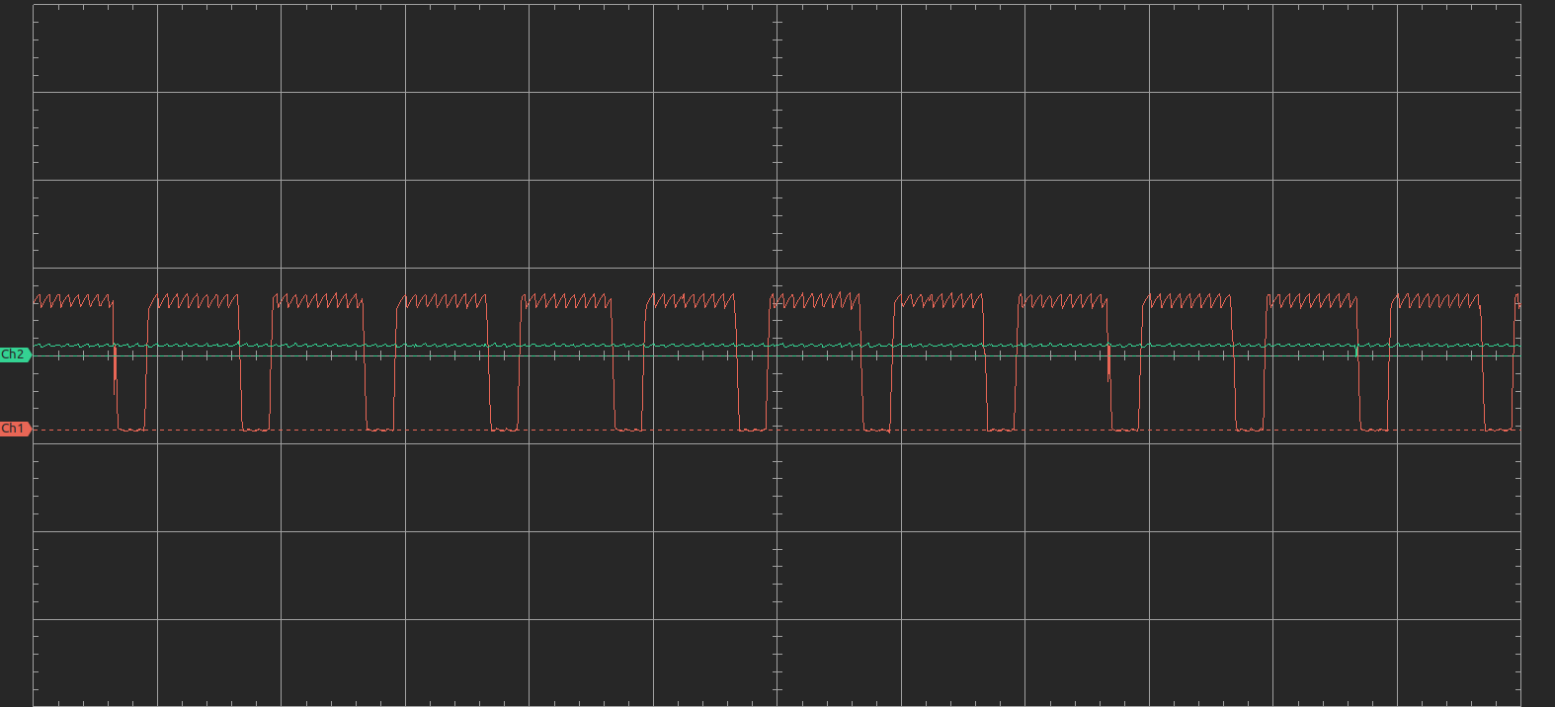
c. The sensor voltage V_{out}:
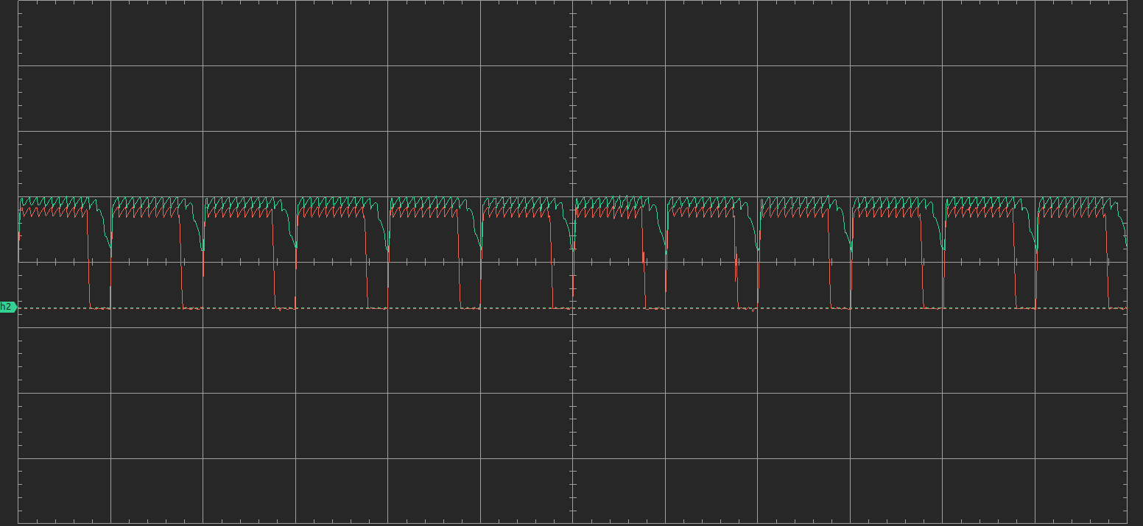
The capacitor is being charged when the input is high and doesn’t have time to discharge when the voltage is low, so it keeps the voltage high. When we removed the capacitor, there is nothing between the output pin and the ground, so the voltage does down as soon as the input goes down.

Chapter 24.3:
- A screenshot of your oscilloscope trace of Vout showing 2-4 periods of what should be an approximately square-wave sensor reading:
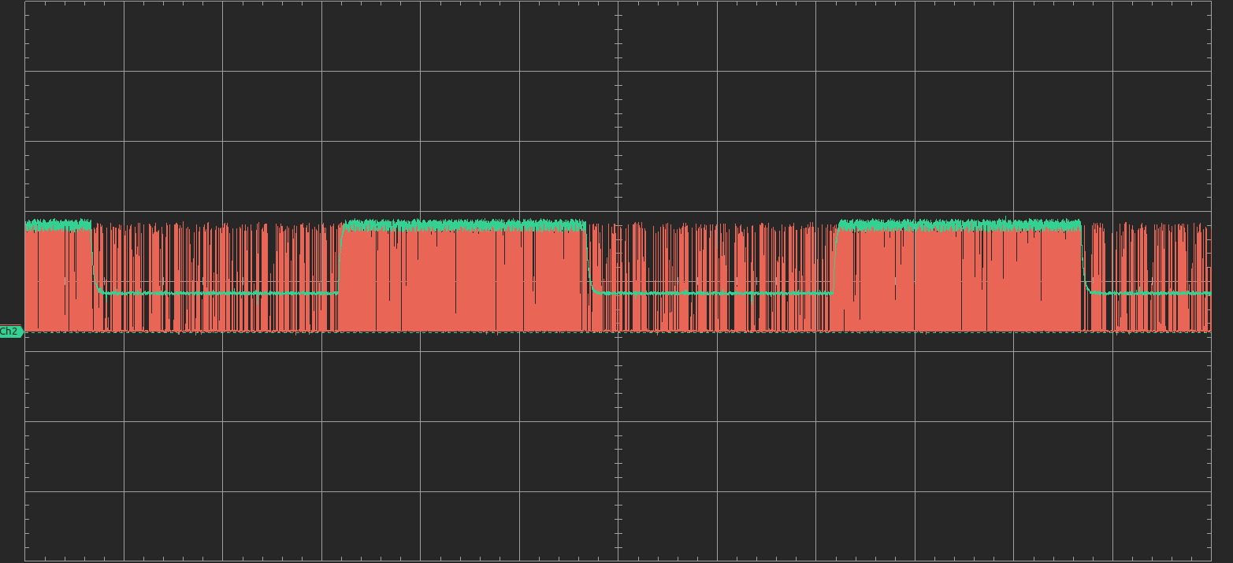
- The code is attached to the pdf in the /code/ch24.3 folder.

Chapter 24.5:
- The code is attached to the pdf in the /code/ch24.5 folder.
The python plot:
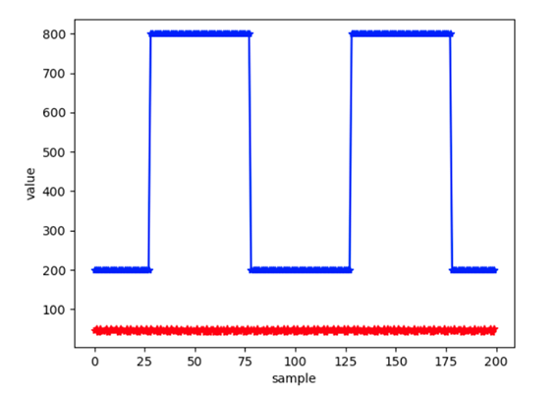

Chapter 24.7:
- The plot showing the measured ADCarray and the REFArray:
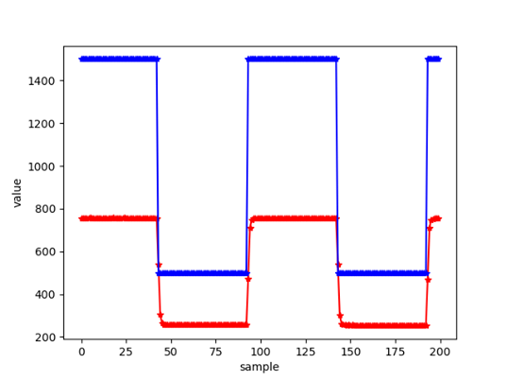

Chapter 24.8:
My gain values are – Kp = 0.2, Ki = 0.1.
My plots:
