ME333 – Final Project – Yael Ben Shalom

Chapter 28.4.1:
- For the encoder counter communication, I used SPI channel 4. It uses NU32 pins B14, F4, and F5.

- For the MAX9918 current sensor reading, I used ADC input AN3 (NU32 pin B3).

- For the DRV8835 H-bridge control, I used PWM OC1RS and Timer3 (NU32 pins RD0 and RD11).

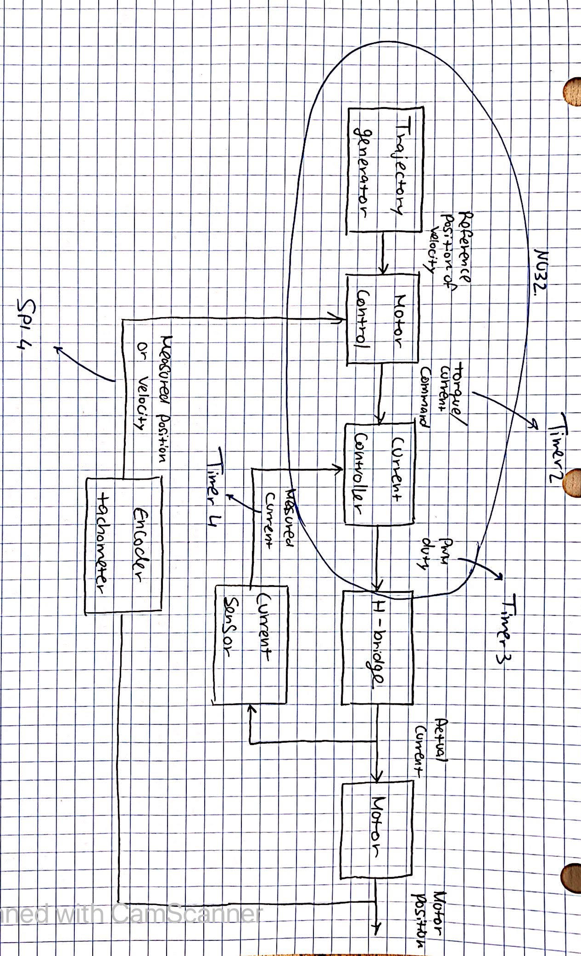
- To implement the 200Hz position control ISR I used Timer2 (priority 5), and to implement the 5kHz position control ISR I used Timer4 (priority 4).

- The annotated block diagram:

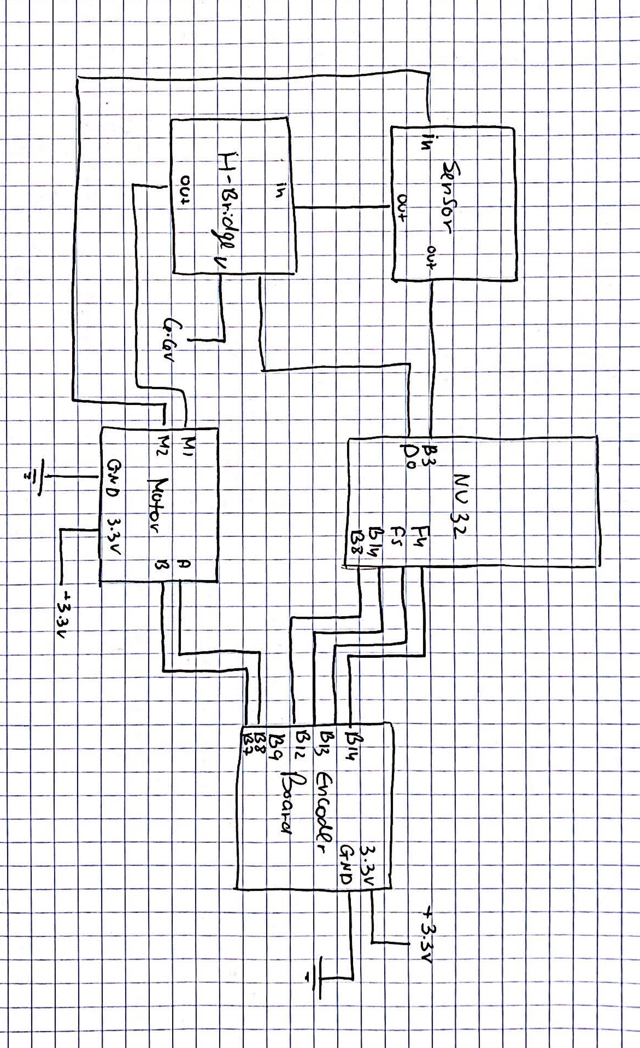
- Sketch of the proposed layout of the circuit boards relative to the NU32:

Chapter 28.4.7:
- I chose R3 to be 330 Ω.

- V = 6V
R_{motor} = 3.2 Ω
I_{max} = 2V / R_{motor} → I_{max} = 3.75 A

- I = I_{max} = 3.75 A
R = 15 mΩ
V = IR → V_{max} = 0.056 V

- 1.65V = G×V_{max} → G = 1.65V/0.056V = 29.46
G = 1+(R2/R1)
28.46 = R2/R1 → R1, R2 = 10,000 Ω, 300,000 Ω

- f_{c} = 200 Hz
f_{c} = 1/(2π RC)
RC = 0.000796 → C = 1 μF, R = 830 Ω

- A table for My particular resistances and battery:
R0 (Ω) | Expected Current (mA) | Measure Current (mA) | Sensor  (V) | ADC Counts (Count)
10 (RS+) | 600 | 520 | 1.89 | 654
20 (RS+) | 300 | 290 | 1.77 | 610
40 (RS+) | 150 | 150 | 1.71 | 587
Open Circuit | 0 | 0 | 1.64 | 560
40 (RS-) | -150 | -150 | 1.56 | 535
20 (RS-) | -300 | -290 | 1.49 | 511
10 (RS-) | -600 | -520 | 1.37 | 470

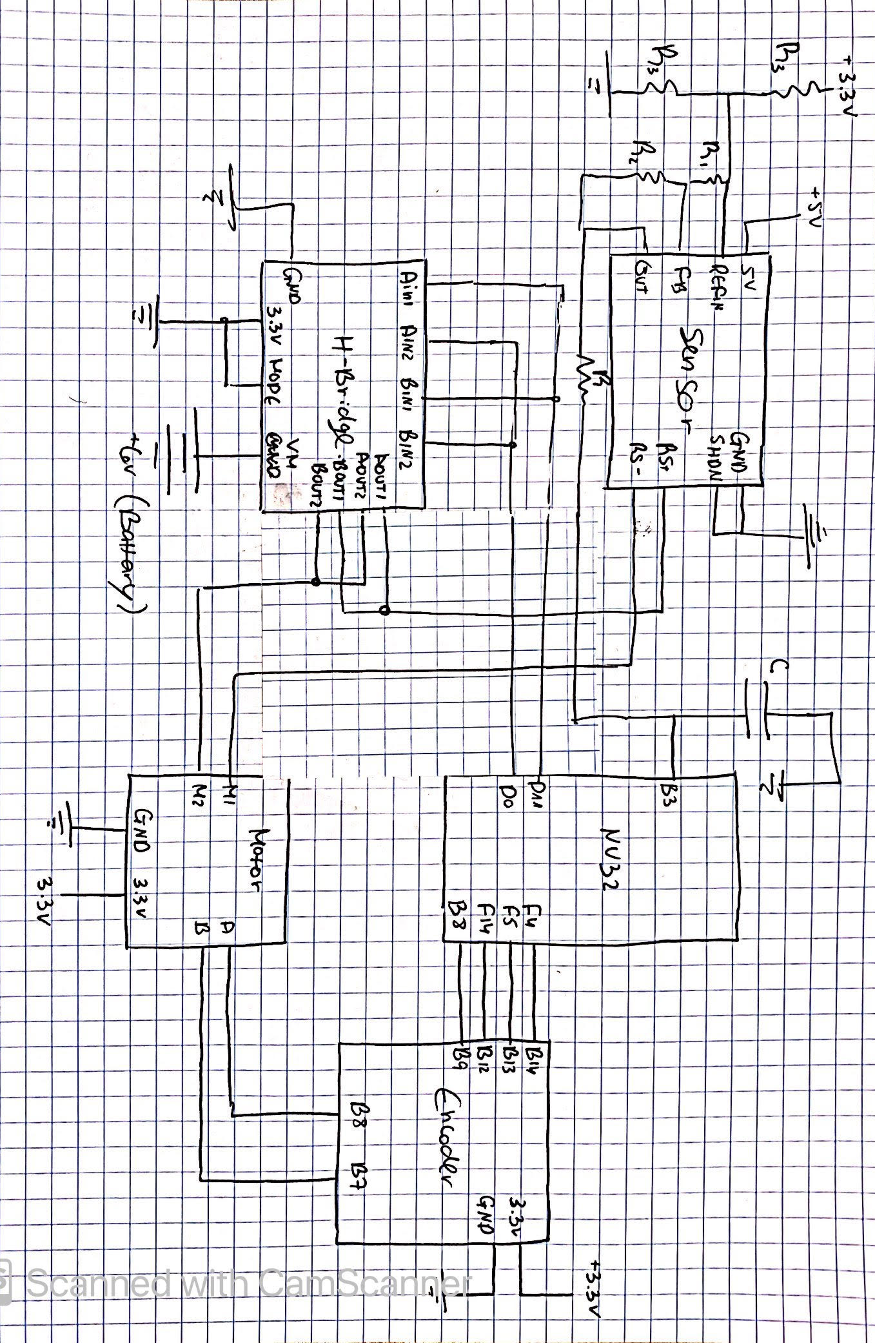
Chapter 28.4.9:
My circuit diagram showing all connections of the H-bridge to the NU32, motor, and current sensor PCB:

The conversion between count to current:
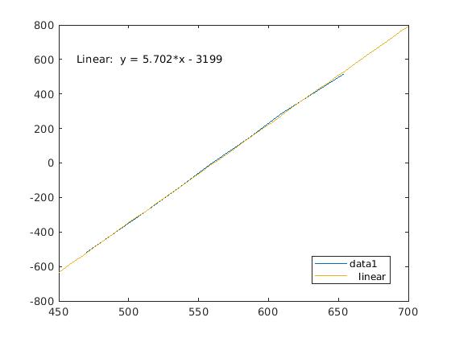

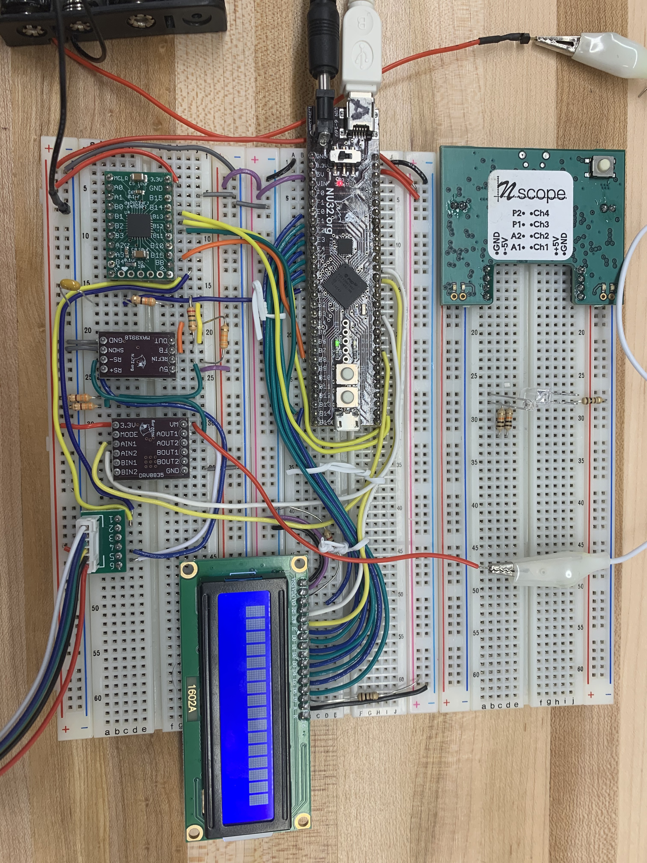
An Image om my board:

Chapter 28.4.10:
My best ITEST plot:
With the plastic blade – Kp = 0.2A, Ki = 0.022A:
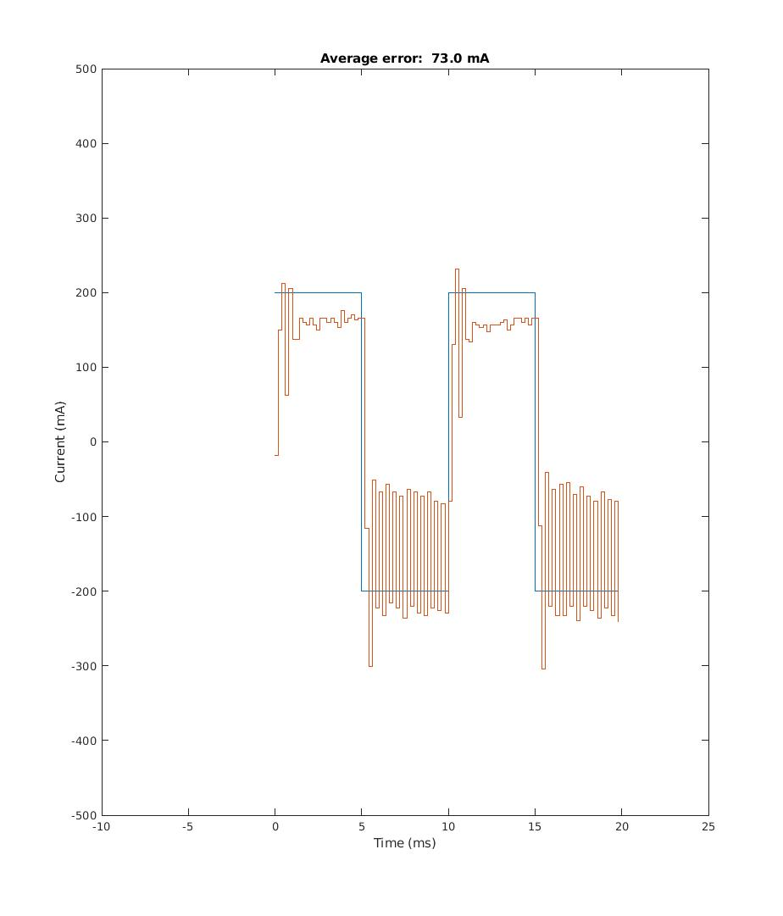

Chapter 28.4.12:
My best plots of following the step and cubic trajectories in Figure 28.5 with the load attached:
Cubic trajectory:
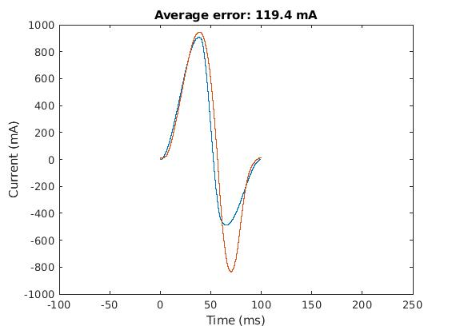

Step trajectory:


