Robotic Manipulation – Final Project - Best
For this part, I tuned the controller’s proportional and integral gains in such way that there will be no overshoot, no steady-state error and fast settling time.
I used PI controller with feedback gains of Kp = 20 and Ki = 5.
The following graph shows the error between the current and the desired states as function of time:
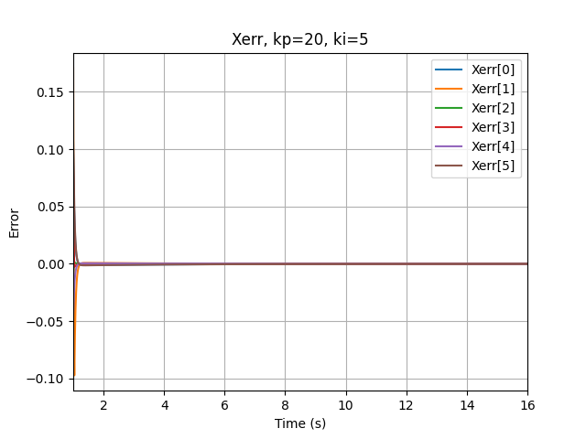

We can see that we got no overshoot and fast convergence to zero.

In this folder you can find the csv files of the robot configurations throughout the motion and the motion error. You can also find the logfile produce when running the code and the simulation video.

