Robotic Manipulation – Final Project - NewTask
For this part, I tuned the controller’s proportional and integral gains in the same way I tuned it in the “best” part, but now I changed the initial and final block configurations, and the initial robot configuration.
The changes made:
- The block initial position was (x, y, θ) = (1m, 1m, 0rad)
- The block final position was (x, y, θ) = (1m, -1m, 0rad)
- The robot initial configuration was (pi/6, -0.5, 0, 0, 0, 0.2, -1.6, 0, 0, 0, 0, 0, 0) – to ensure at least 30 degrees of orientation error and 0.2 m of position error from the first configuration on the reference trajectory.
- I used PI controller with feedback gains of Kp = 20 and Ki = 5.
- Because now the distance between the cubes is larger and to make the motion smoother, I increased the number of points in the segment between the cubes from N = 500 to N = 700.
The following graph shows the error between the current and the desired states as function of time:
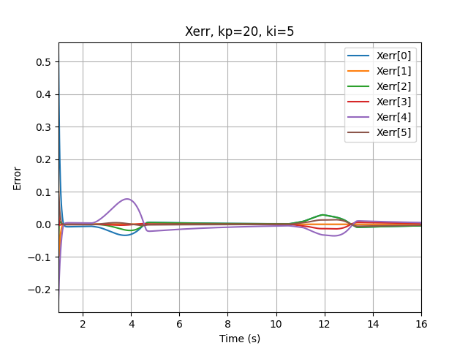

We can see that we do no have overshoot at the beginning of the motion, but as the robot goes forward there are some “jumps” in the driving parts. If I’ve made the driving parts even slower and further tuned the control gains, I could probably reduce them.

In this folder you can find the csv files of the robot configurations throughout the motion and the motion error. You can also find the logfile produced when running the code and the simulation video.

