**Comp 2052 – Micro Servicios**

**Validación de formularios en Flask con WTForms**

**Enlace a Github:**

<https://github.com/Yaelito77/COMP-2052-micro-servicios/tree/main/Modulo-02/leccion-02>

**Registro con errores**

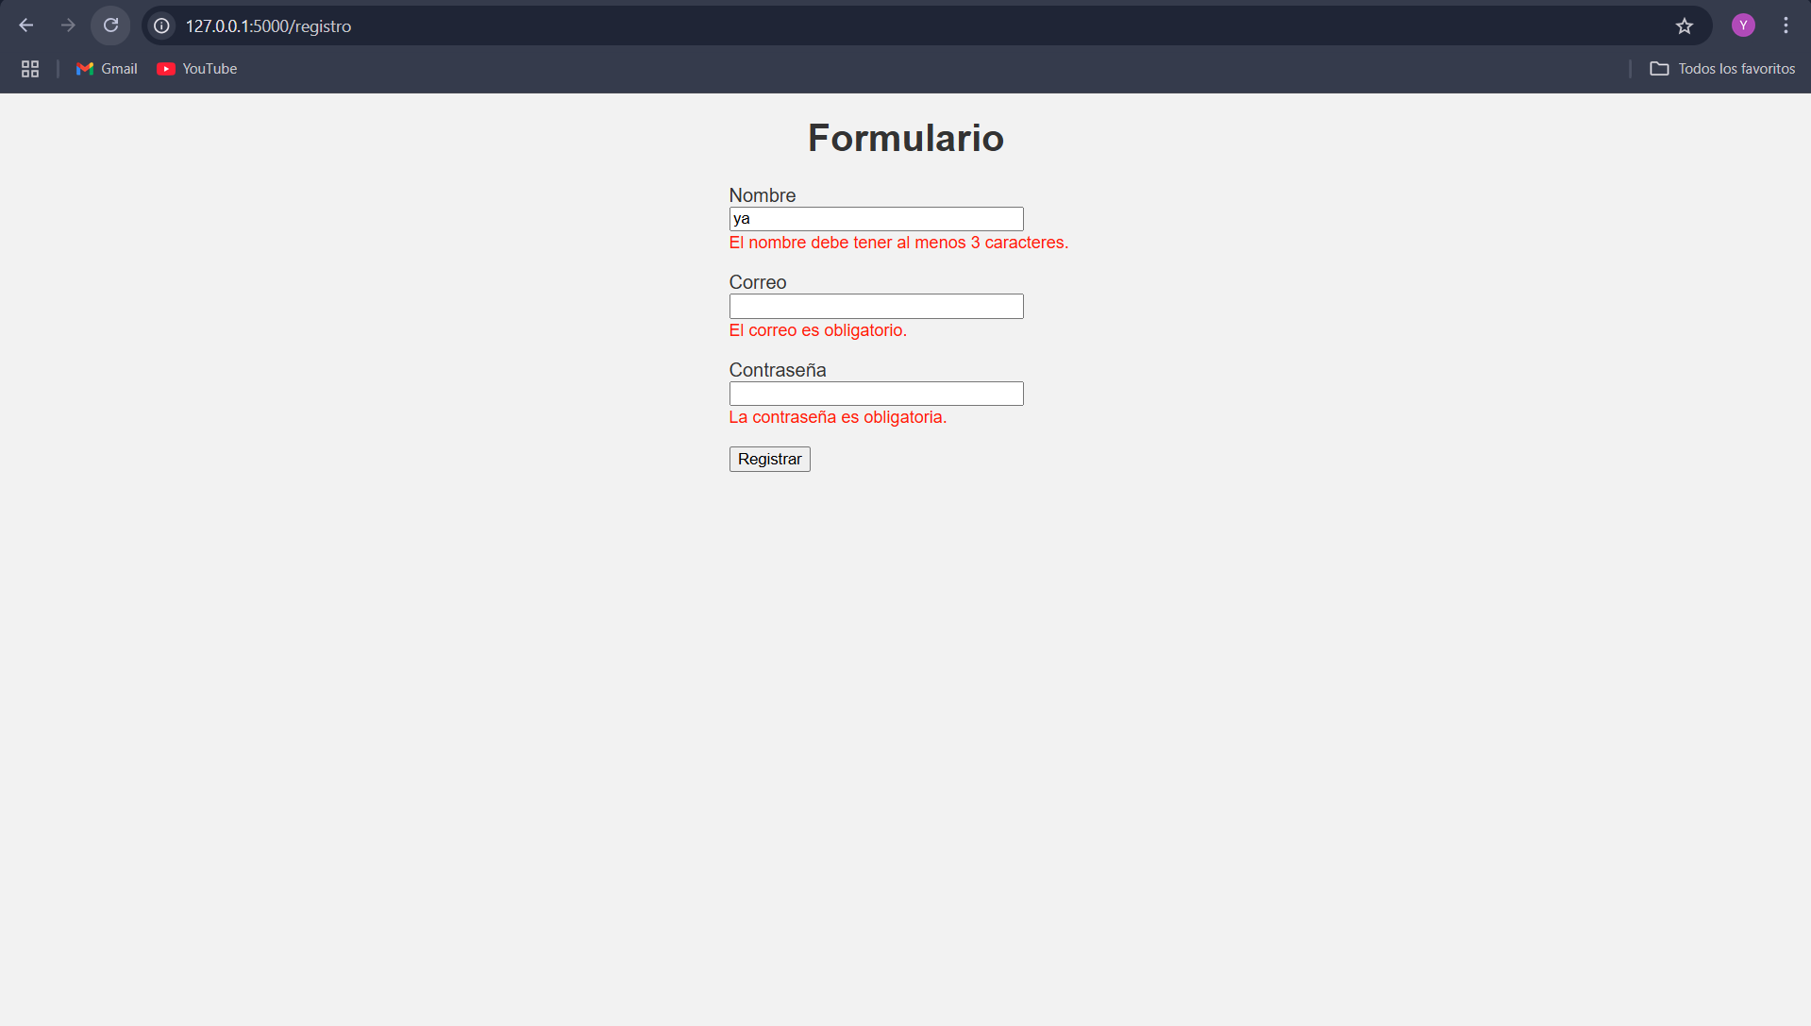

**Registro Rellenado Correctamente**

