**MS Project**

**The effect of microsaccades in the primary visual cortex: a two-phase modulation in the absence of visual stimulation**

Yarden Nativ1, Tomer Bouhnik1 and Hamutal Slovin1

[**Link to original article**](https://www.biorxiv.org/content/10.1101/2024.08.12.607606v1)

**Abstract**

“Our eyes are never still. Even when we attempt to fixate, the visual gaze is never motionless, as we continuously perform miniature oculomotor movements termed as fixational eye movements. The fastest eye movements during the fixation epochs are termed microsaccades (MSs), that are leading to continual motion of the visual input, affecting mainly neurons in the fovea. Yet our vision appears to be stable. To explain this gap, previous studies suggested the existence of an extra-retinal input (ERI) into the visual cortex that can account for the motion and produce visual stability. Here, we investigated the existence of an ERI to V1 fovea in behaving monkeys while they performed spontaneous MSs, during fixation. We used voltage-sensitive dye imaging (VSDI) to measure and characterize at high spatio-temporal resolution the influence of MSs on neural population activity, in the foveal region of the primary visual cortex (V1). In the absence of a visual stimulus, MSs induced a two-phase response modulation: an early suppression transient followed by an enhancement transient. A correlation analysis revealed an increase in neural synchronization around ~100 ms after MS onset. Next, we investigated the MS effects in the presence of a small visual stimulus, and found that this modulation was different from the non-stimulated condition yet both modulations co-existed in the fovea. Finally, the VSD response to an external motion of the fixation point could not explain the MS modulation. These results support an ERI that may be involved in visual stabilization already at the level of V1.”

**Introduction**

The data in this article are twofold: behavioral data, which include eye position and movement, and voltage-sensitive dye imaging (VSD). The VSD method provides high-resolution data on neural activity by detecting fluorescence changes corresponding to membrane potential variations. The output is a 3D matrix, with spatial dimensions representing cortical regions and a temporal dimension capturing activity over time. This method is particularly suited for analyzing population-level dynamics, such as those evoked by microsaccades.

In this project, I will focus on Figures 1 and 2. Figure 1 emphasizes behavioral data, exploring detailed relationships between microsaccade amplitude and velocity. The goal is to understand the correlation and distribution of these parameters, providing insights into microsaccade dynamics. Figure 2, on the other hand, focuses on VSD data aligned with microsaccade timing. This figure visualizes the biphasic neural modulation, showing early suppression followed by enhancement in response to microsaccades.

**Data Description for this project**

This project starts with two primary types of data, all provided as MATLAB files. The first is the session data table, which includes metadata for each session, such as Cortex trial, ms offset frame, ms amp, ms direction, ms velocity, and other parameters. This table provides a structured overview of each session. There are six sessions in the experiment, each represented by a separate file.

The second type is a three-dimensional matrix generated from the VSD method, The first dimension represents the pixel locations, the second dimension corresponds to the time frames, and the third dimension accounts for the number of microsaccades (MS).    These MATLAB files are aligned with microsaccades, ensuring that these small eye movements occur within the same time frame across all trials. This alignment allows for consistent and meaningful analysis. By leveraging the matrix data, the project aims to explore fluorescence changes and their implications, providing insights into how neural activity corresponds to microsaccade movements.

In addition, each session includes a mask file and a shuffle file. The mask file is used in the preprocessing step to identify irrelevant pixels in the VSD recordings. These may include noisy pixels or pixels outside the V1 region that are not relevant for analysis. The shuffle files were pre-generated for each session by pooling data across all trials, dissociating the original MS onset times from their matched VSD trials, and then randomly shuffling the MS times over the VSD trials. This method preserves the statistical distribution of MS onset times relative to the VSD signal. These shuffle files were used in Figure 2 to assess the significance of the suppression and enhancement amplitudes of the signal.

By focusing on data analysis and visualization, this project aims to replicate the findings of the article, emphasizing the role of both behavioral and VSD data in uncovering neural dynamics during microsaccades.

**Methods**

The structure of this project is organized on a figure-by-figure basis. Each figure is supported by two files: one containing all the functions needed for the specific analysis and the other dedicated to plotting the figure using these functions. This modular design ensures that each figure operates independently, as different analyses and requirements are addressed uniquely for each one.

For Figure 1, no preprocessing was needed. The session data table is used to compare and analyze the correlation and relationship between microsaccade amplitude and microsaccade velocity across all trials. The objective is to identify any significant connections between these variables. The data for this figure is stored in a MATLAB file with a cell structure. The challenge with this type of data arises when opening it in Python, as the information in the NumPy array format is not immediately accessible, I decided to continue working with the MATLAB file rather than converting it to a CSV file, avoiding multiple conversions. Instead, I flattened the NumPy array to extract the relevant information correctly. Once the data was extracted for each session, I created two vectors: one for microsaccade amplitude and another for microsaccade velocity across all sessions.   
Next, the focus was creating the visualizations. Figure 1B is a histogram of microsaccade amplitudes for each monkey, providing an overview of their distribution. Figure 1C, on the other hand, presents the main sequence, which is computed by plotting the maximum velocity against the amplitude of microsaccades. The continuous line in this figure represents a linear regression of the data, highlighting the relationship between these two variables.

The VSD data underwent preprocessing to remove noise and irrelevant pixels, including those outside the V1 region. This was done in a separate file for better organization. Noisy pixels were identified using a 10,000x1 vector where values of 0 and 1 indicated relevant and irrelevant pixels, respectively, in the first dimension of the 3D matrix. Similarly, another 10,000x1 vector identified pixels outside the V1 region. Using this information. A dedicated function was implemented to visualize the data before and after preprocessing, ensuring that the correct pixels were extracted. This step was crucial for verifying the removal of irrelevant and noisy pixels before proceeding with further analysis.

For graph visualization and correct compression and analysis, I subtracted a baseline from all signals to align them at a common starting point, improving comparability and visualization. This preprocessing ensured the data was clean and aligned, facilitating the analysis of neural activity and its relation to microsaccades.

Figure 2 involved visualizing the VSD temporal courses (TCs) for an example session and the grand analysis, which includes data from all sessions for both monkeys, highlighting a biphasic modulation of early suppression followed by late enhancement. Standard error of the mean (SEM) was added to these visualizations to represent variability, ensuring statistical robustness. In addition, the shuffle data was added to each graph for the significance test of the suppression and enhancement of the signal. A Wilcoxon rank-sum test was conducted between the signal and the shuffled data, with significant values (P<0.05) marked by a red star.

Additionally, Figures 2D and 2H present histograms of suppression and enhancement peak amplitudes (mean across all sessions) and the time to peak for microsaccade suppression and enhancement (mean across all sessions). Statistical significance was tested using the Wilcoxon signed-rank test for differences from zero and the Wilcoxon rank-sum test for differences between negative and positive peaks (* for p<0.05 and *** for p<0.005).

**Project structure :**

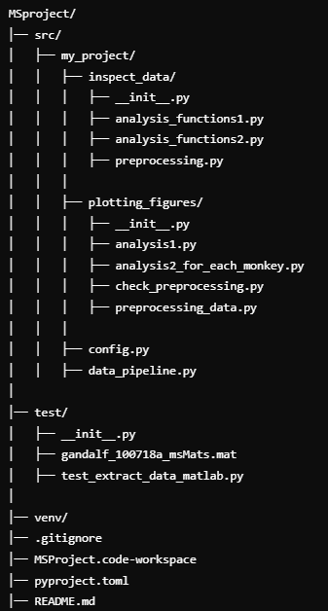

**Results & Discussion:**

Figure 1B presents the histogram of microsaccade amplitudes for each monkey, showing the percentage distribution of amplitudes.   
The original article reports the mean microsaccade (MS) amplitude as 0.45±0.04 (mean±SEM) for Monkey L and 0.37±0.02 for Monkey G. In comparison, my results yielded a mean amplitude of 0.43±0.0088 for Monkey L and 0.36±0.0084 for Monkey G. While the mean values are slightly lower than the reported values, they remain within a reasonable range of variation. For monkey G n=243 and for monkey L n=219.

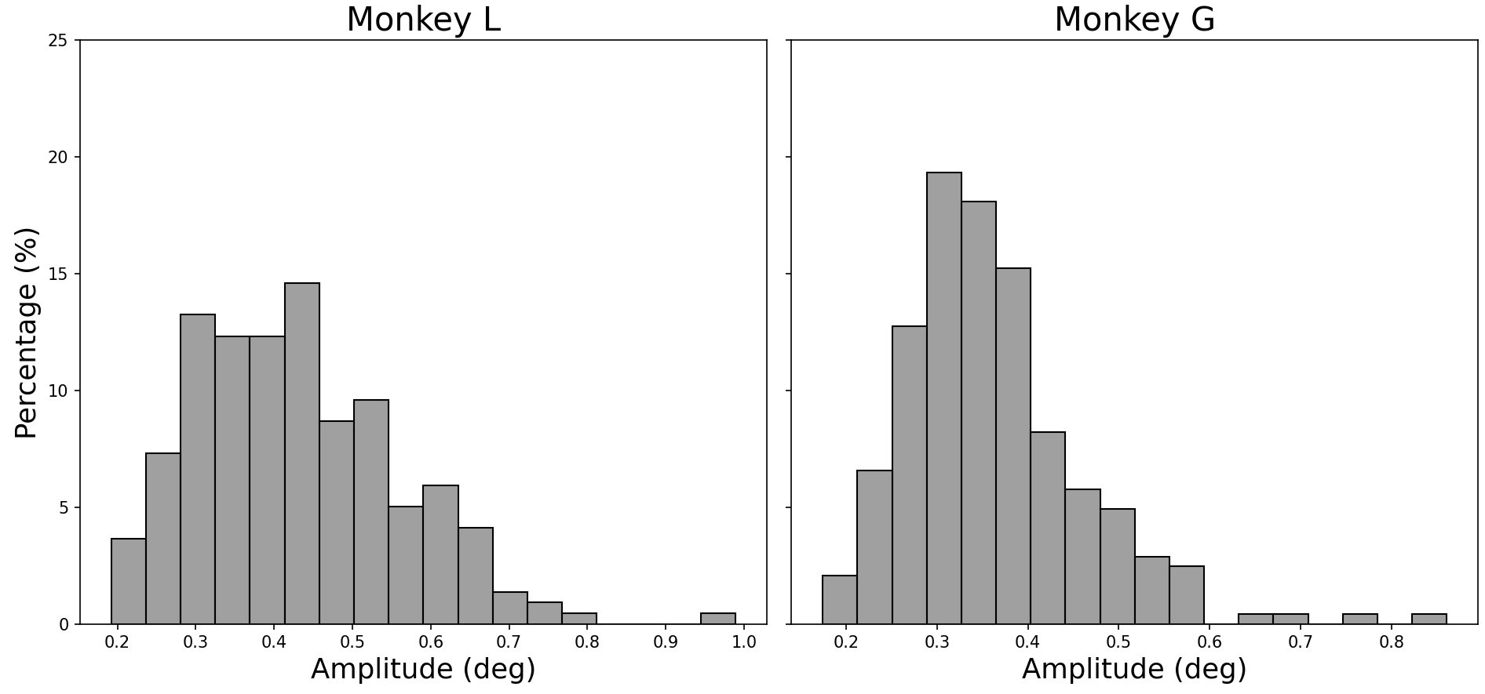

Figure 1C illustrates the relationship between microsaccade amplitude and maximum velocity, commonly referred to as the main sequence. The original article reports a correlation of r = 0.91 (p < 0.001) for Monkey L and r = 0.96 (p < 0.001) for Monkey G. My results yielded r = 0.91 (p = 2.45e-83) for Monkey L and r = 0.95 (p = 7.52e-128) for Monkey G. These values closely align with the original findings, confirming the strong positive correlation between microsaccade amplitude and velocity. This figure presents this relationship for both monkeys using scatter plots with a fitted regression line.(n same as figure 1B).

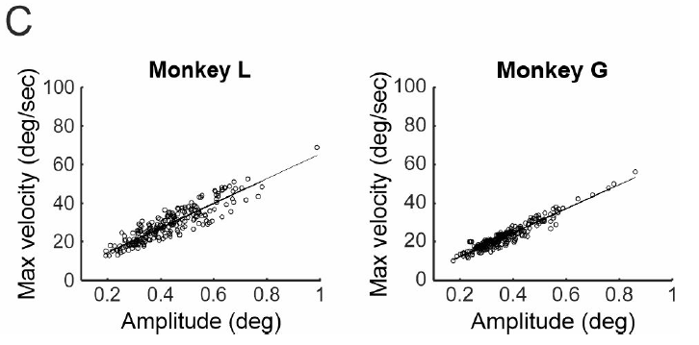

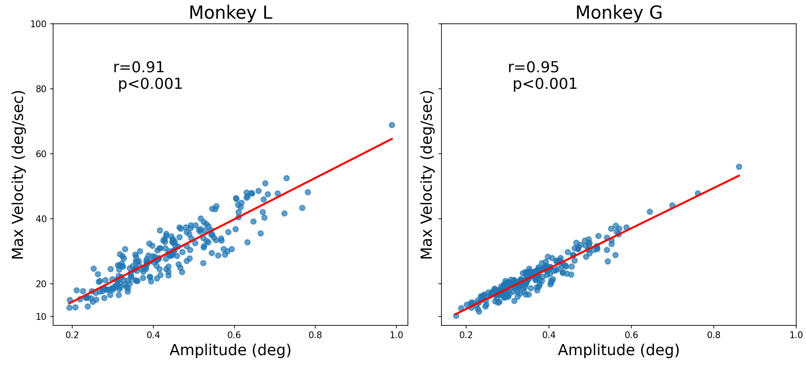

The preprocessing step aims to remove irrelevant pixels from the data. Due to the large size of the matrix, visualizing and verifying the preprocessing results is challenging. To address this, I created a function that maps the matrix in an example session and example MS. While this map does not provide detailed temporal resolution, it allows for verification that preprocessing was correctly applied before continuing with the analysis. In the provided visualization, we can observe that before preprocessing, some pixels (e.g., blood vessels) were already removed. After preprocessing, additional irrelevant pixels, such as those outside V1 (e.g., in V2) and noisy pixels, were successfully filtered out. This check was performed for one session; however, ideally, it should be conducted for every session to ensure consistency and accuracy in preprocessing.

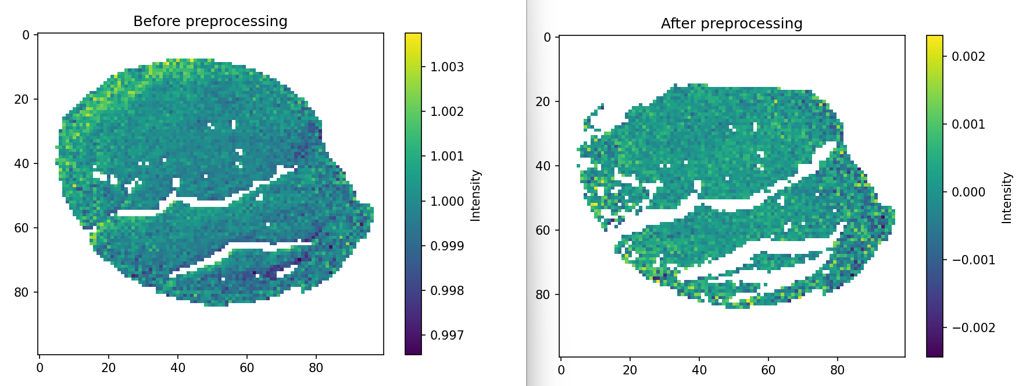

After preprocessing is completed and verified, the next step is Figure 2 analysis (analysis2_for_each_monkey’). This analysis is performed separately for each monkey, and the user is prompted to select which monkey they would like to view the analysis

for.

Figure 2 B and C fore monkey L . The original figure reveals a biphasic modulation pattern, consisting of an early suppression phase (negative peak at t = 70 ms after MS onset) followed by a late enhancement phase (positive peak at t = 160 ms).  
In the reproduced figures, the biphasic modulation is evident, with a similar trend in the early suppression and late enhancement phases. The timing of the negative and positive peaks closely aligns with the original findings. For every TC a shaded region representing the standard error of the mean (SEM) was added , providing an indication of variability.   
additionally, The shuffle data in a dashed curve for the significant test represented by the red stars above, Both the negative and positive peak responses were significantly different from the shuffled data (p value<0.005 in Wilcoxon ranksum test).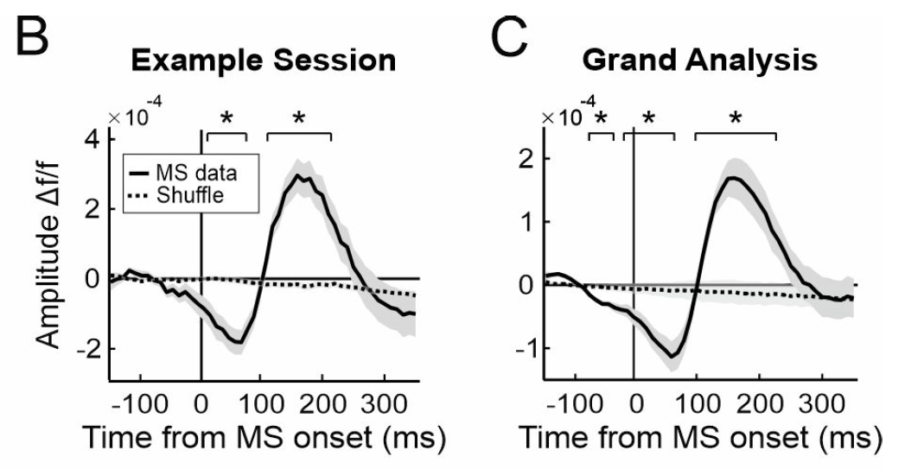 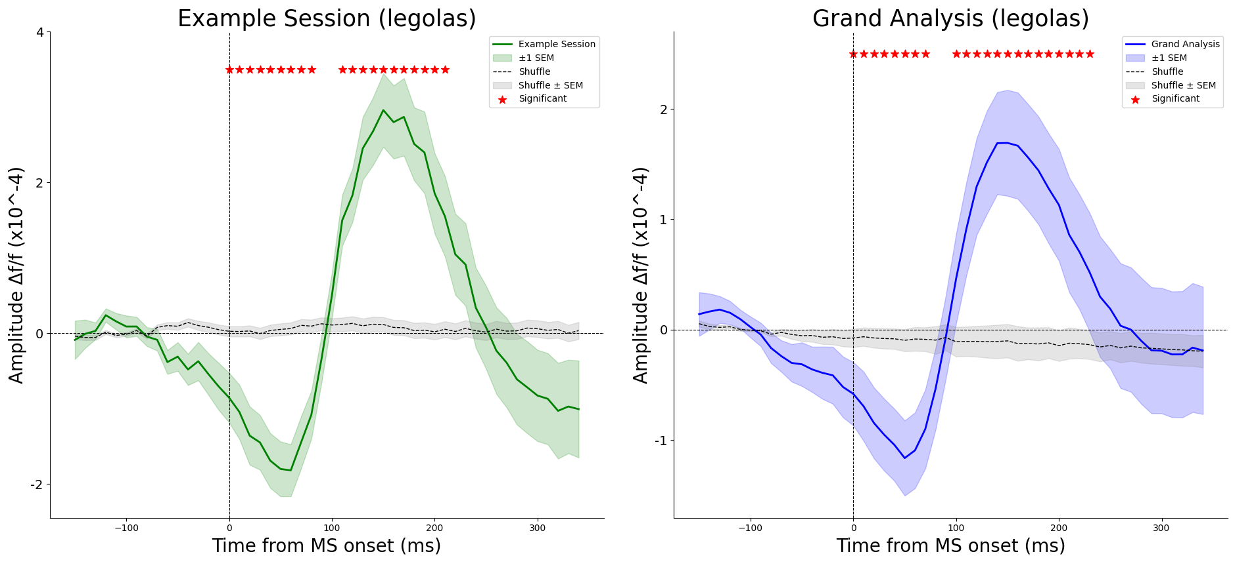

Figure 2 F and G is same as figure 2 B,C but for monkey G . Figure 2 F, G illustrate the time course (TC) of the VSD signal for Monkey G by averaging over all V1 pixels in the example session and grand analysis. Similar to the findings in Monkey L, the original figure shows a biphasic modulation pattern with an early suppression phase (negative peak at t = 70 ms after MS onset) followed by a late enhancement phase (positive peak at t = 180 ms after MS onset).

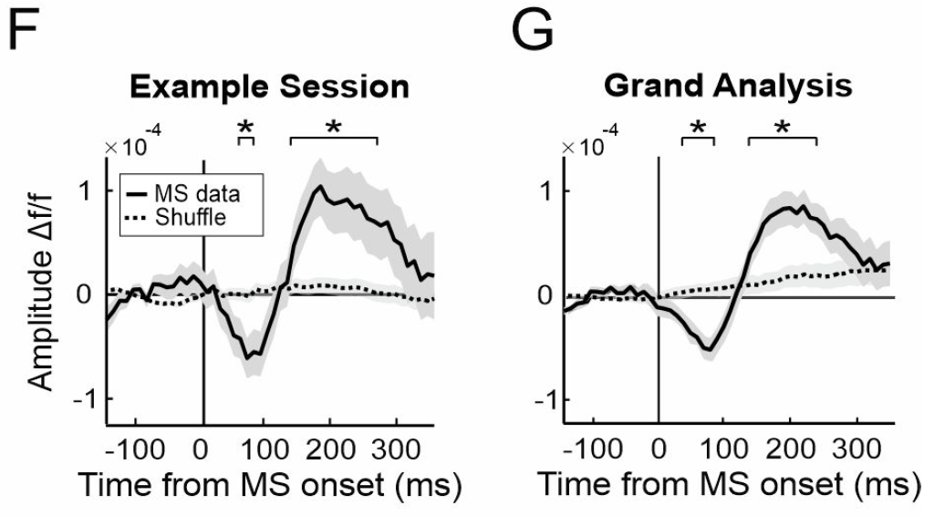

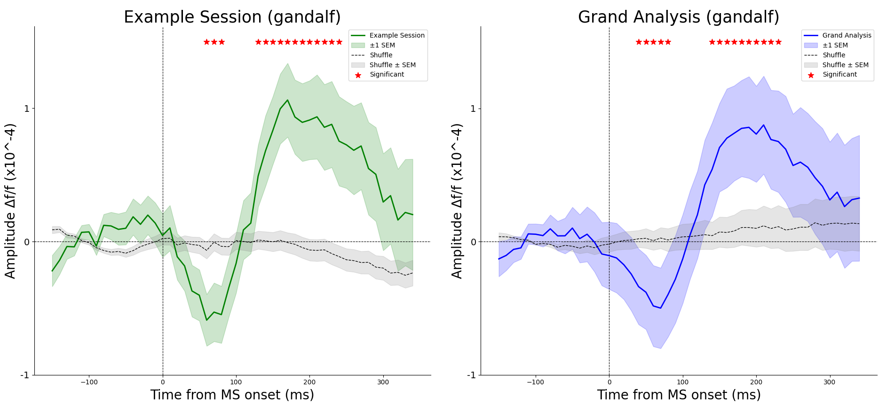

Figure 2D presents the quantification of suppression and enhancement amplitudes in the VSD signal, as well as the time to peak for these modulations. The original figure shows a significant difference between suppression and enhancement amplitudes, with suppression reaching a negative peak and enhancement reaching a higher positive peak. Statistical significance was assessed using the Wilcoxon signed-rank test (p<0.05) for differences from zero and the Wilcoxon rank-sum test (p<0.005) for comparing negative and positive peaks. In my reproduced figure, the overall trend remains consistent with the original, showing significant differences between suppression and enhancement amplitudes. The time to peak for suppression and enhancement follows the expected pattern, with suppression occurring earlier and enhancement taking longer to reach its peak. The statistical significance markers (*) and (***) are included, confirming significant differences between the conditions. The reproduced figure effectively captures the primary findings: microsaccades induce a biphasic modulation in neural activity, with distinct suppression and enhancement phases. The statistical analysis reinforces these differences, validating the overall trends observed in the original study.

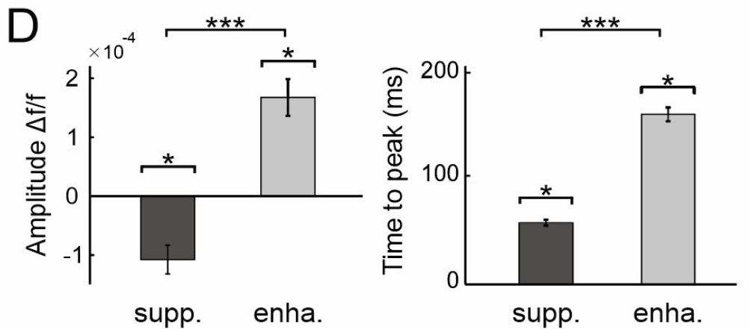

Figure H, Same as figure 2D but for monkey G.

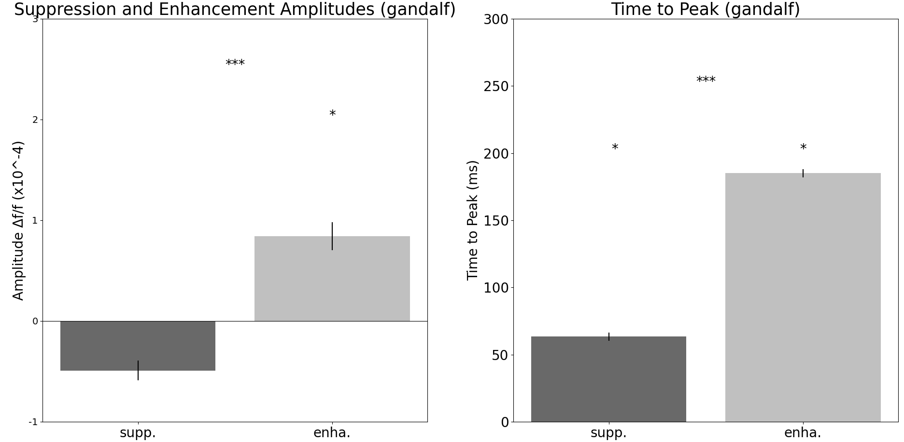

* **Add project structure to readme and fix readme**
* **Add test file for main functions of figure 2**
* **Go through the config files**