Activity 4: LeetCode Practice & Portfolio Integration
GitHub Repository: https://github.com/Yagami-akshay/leetcode-solutions.git
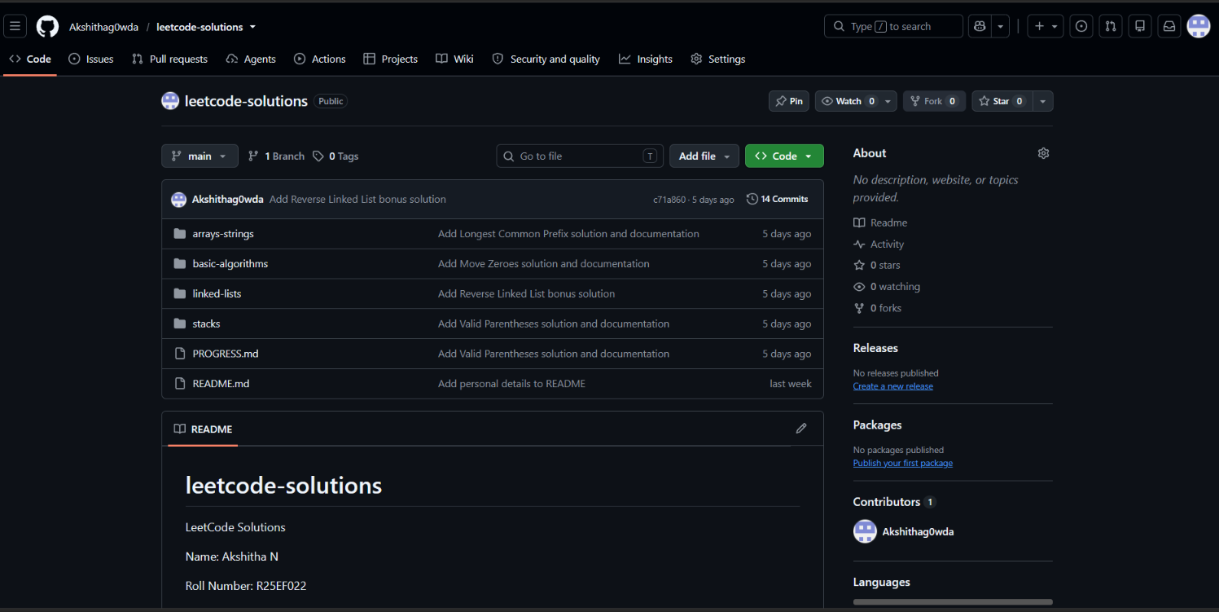

1. a)Repository Structure
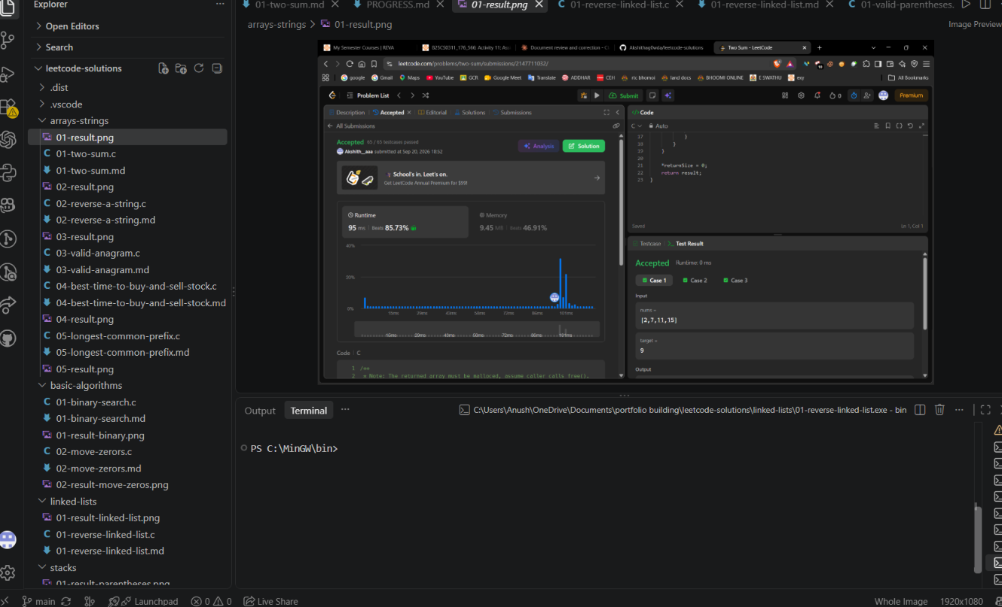
1. b)Repository Structure
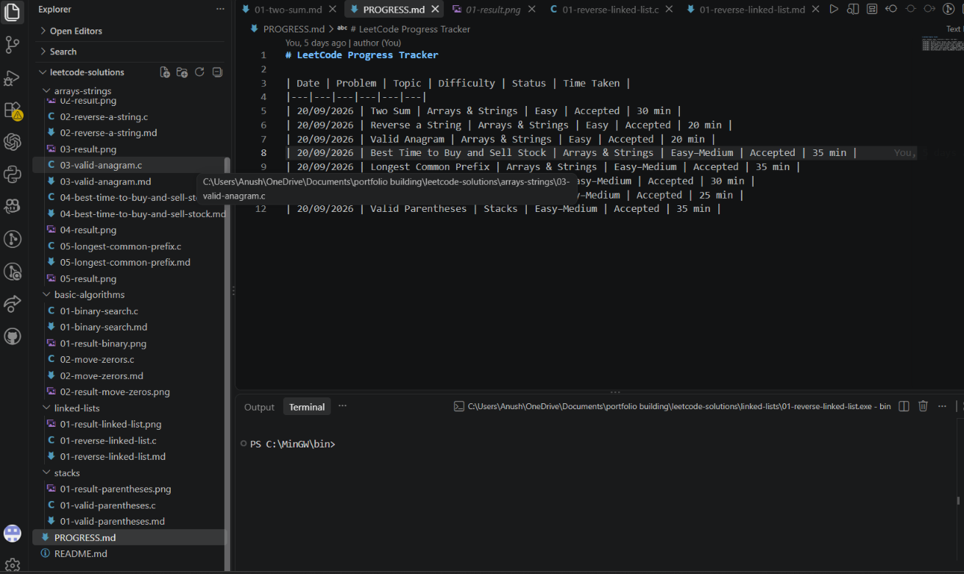

2. README and Project Documentation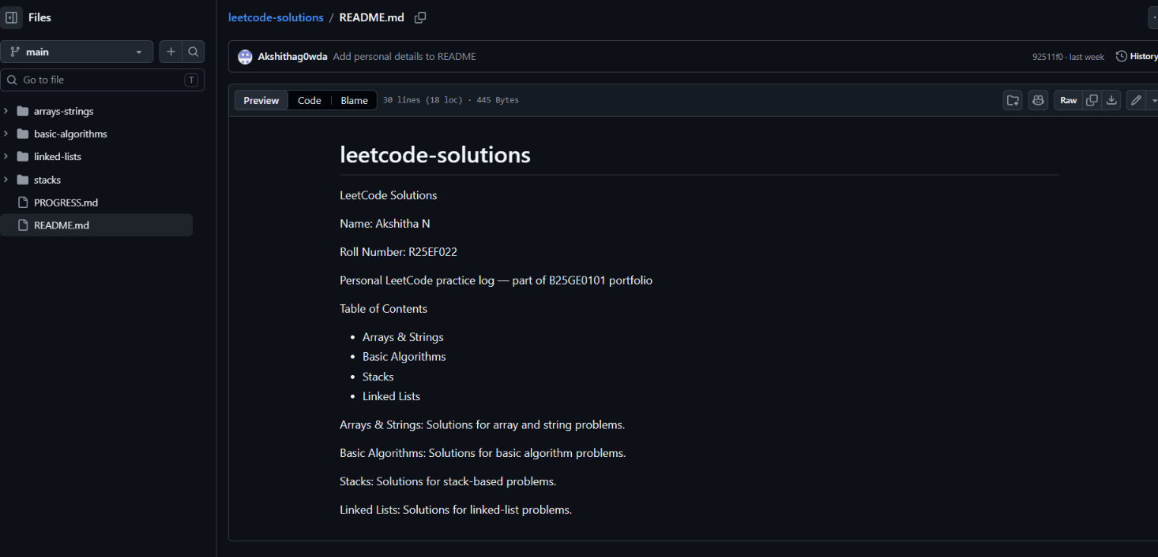

3. LeetCode Problems Completed
No. | Problem | Topic | Status
1 | Two Sum | Arrays & Strings | Accepted
2 | Reverse a String | Arrays & Strings | Accepted
3 | Valid Anagram | Arrays & Strings | Accepted
4 | Best Time to Buy and Sell Stock | Arrays & Strings | Accepted
5 | Longest Common Prefix | Arrays & Strings | Accepted
6 | Binary Search | Basic Algorithms | Accepted
7 | Move Zeroes | Basic Algorithms | Accepted
8 | Valid Parentheses | Stacks | Accepted
9 | Reverse a Linked List (Bonus) | Linked Lists | Accepted

4. Local Testing Evidence
1. Two Sum – Local Testing
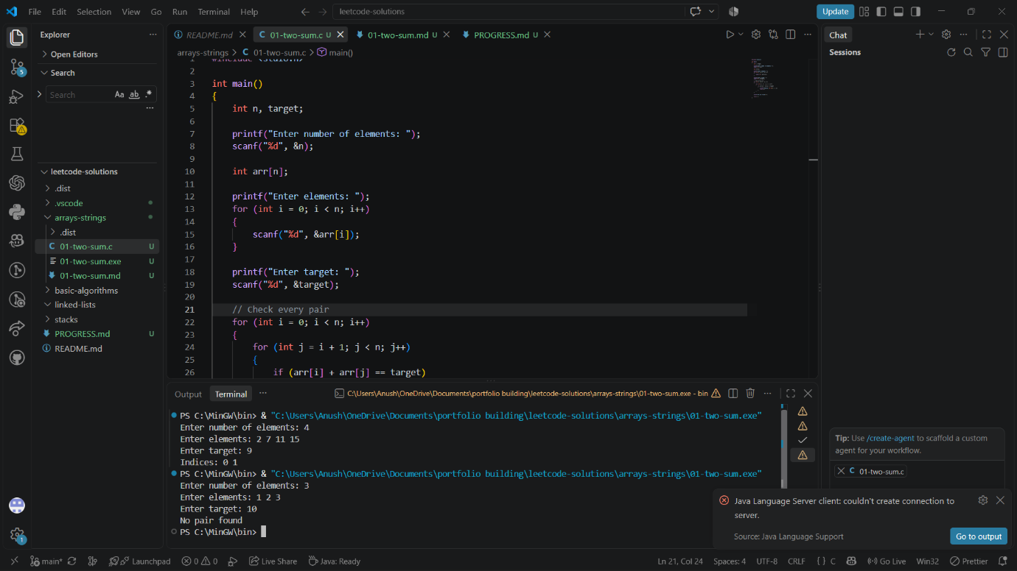
2. Reverse a String – Local Testing
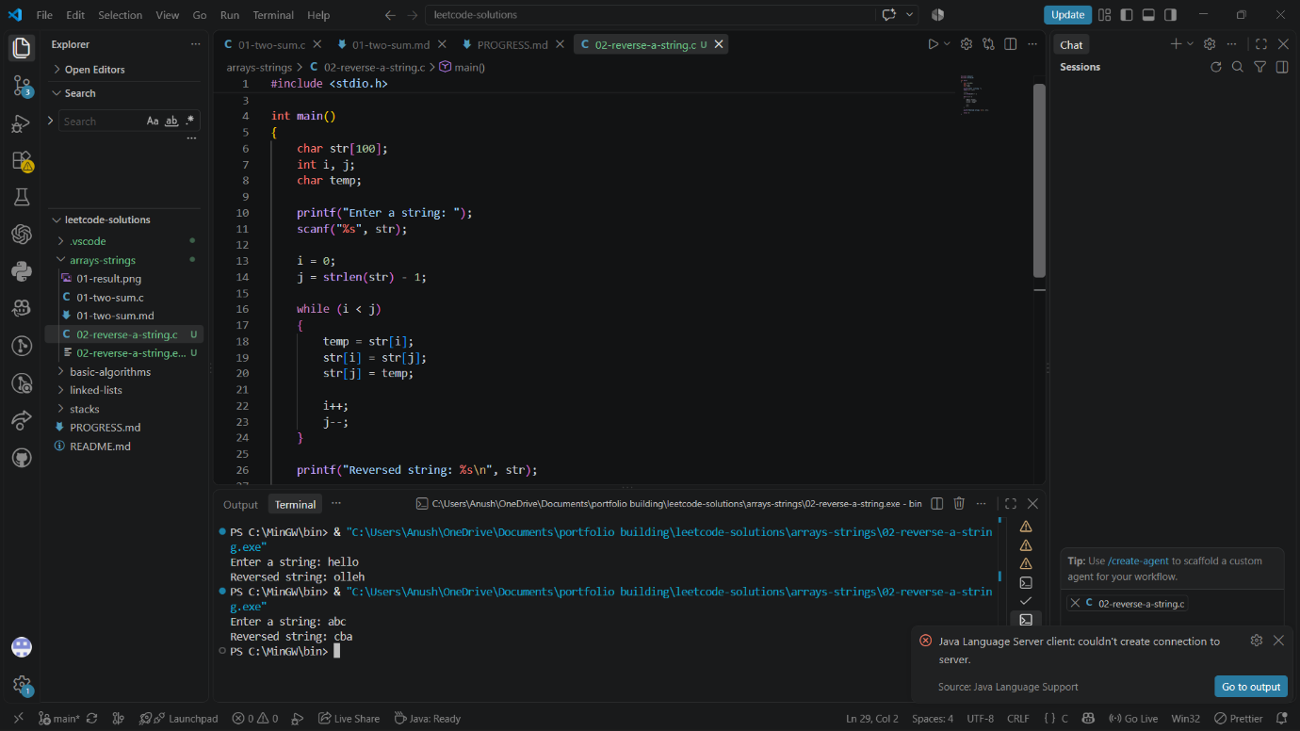

3. Valid Anagram – Local Testing
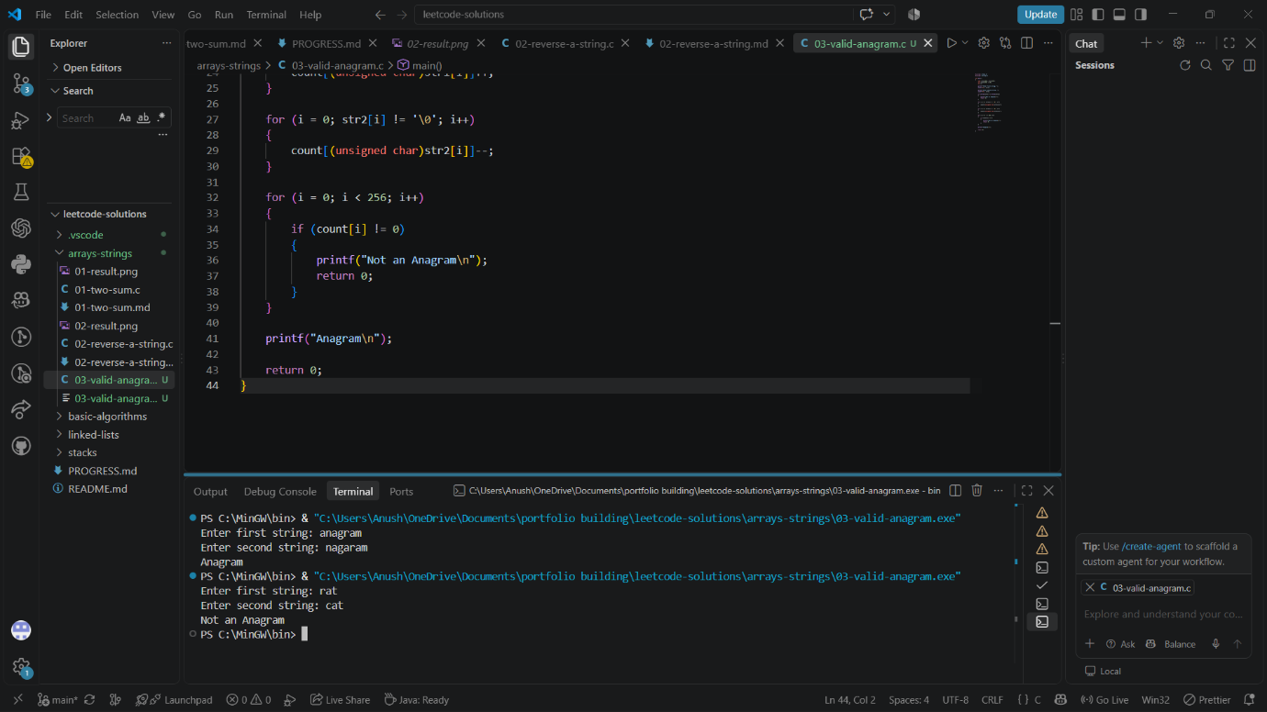

4. Best Time to Buy and Sell Stock – Local Testing
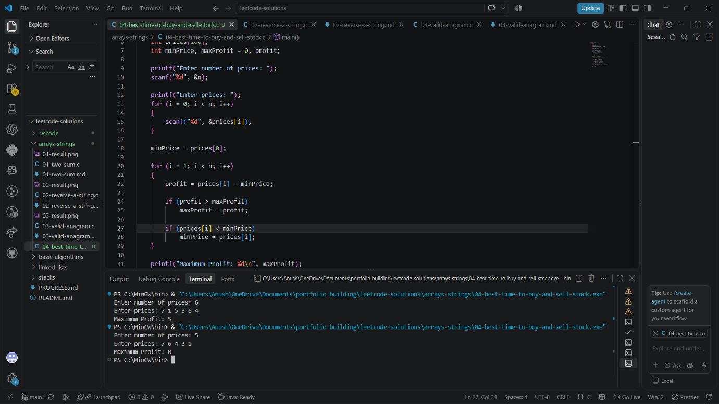

5. Longest Common Prefix – Local Testing
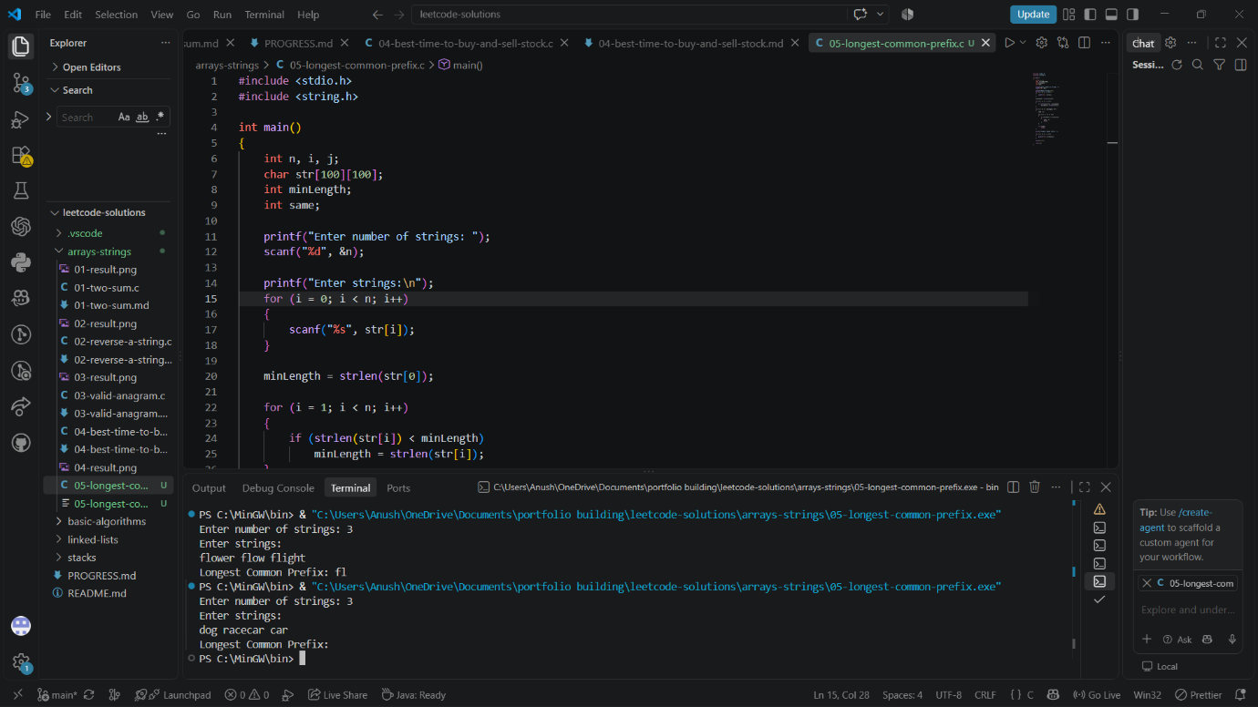

6. Binary Search – Local Testing
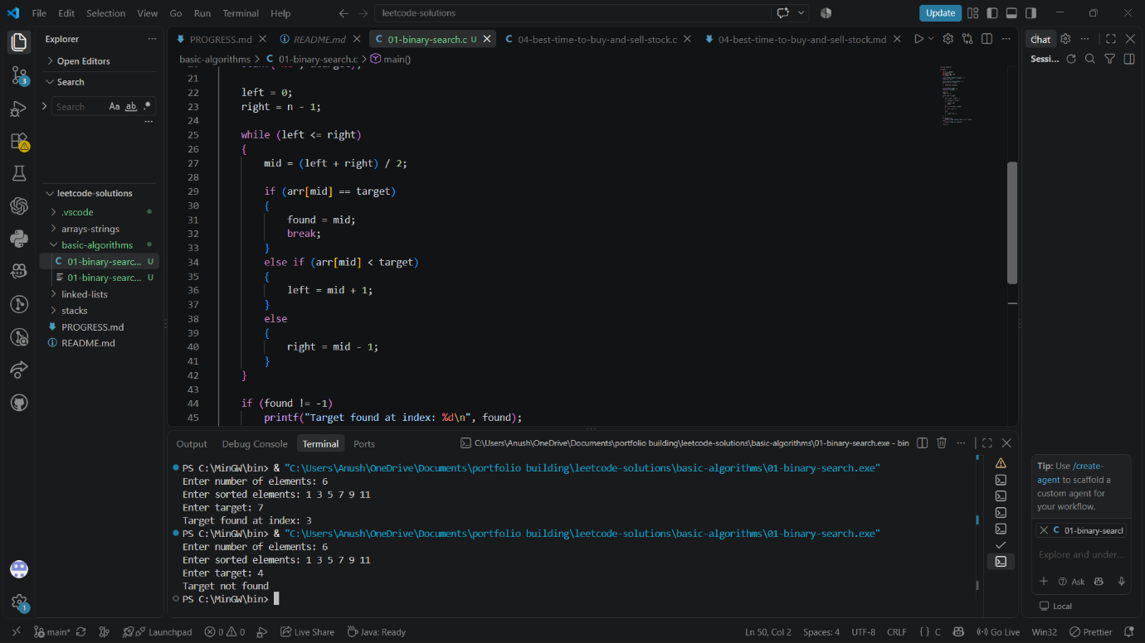

7. Move Zeroes – Local Testing
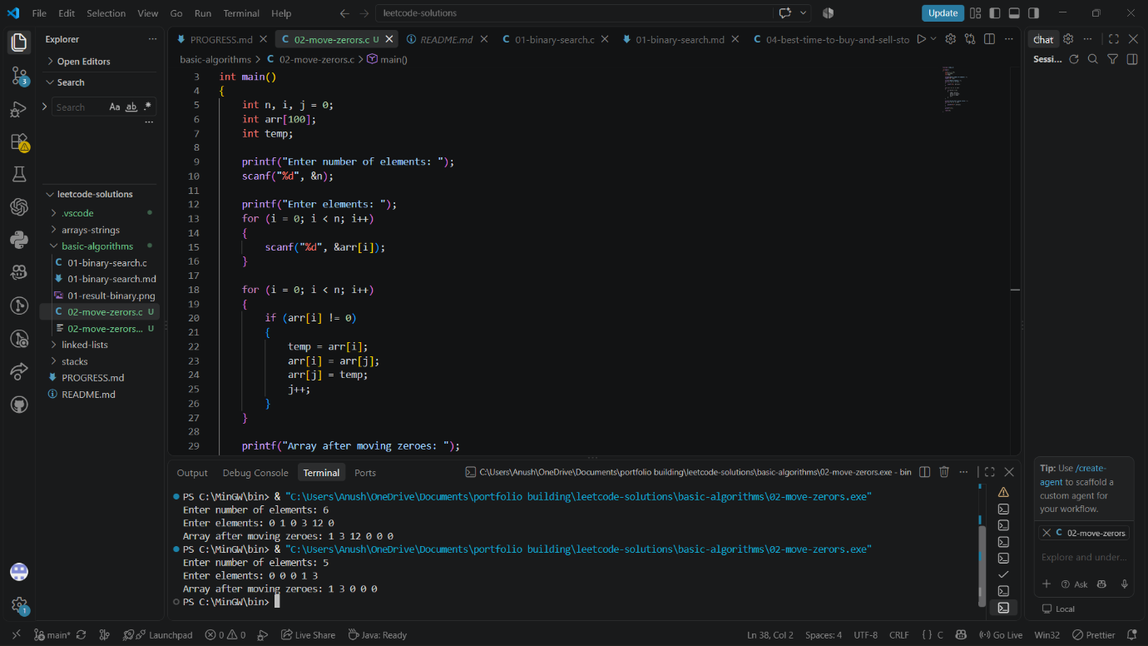

8. Valid Parentheses – Local Testing
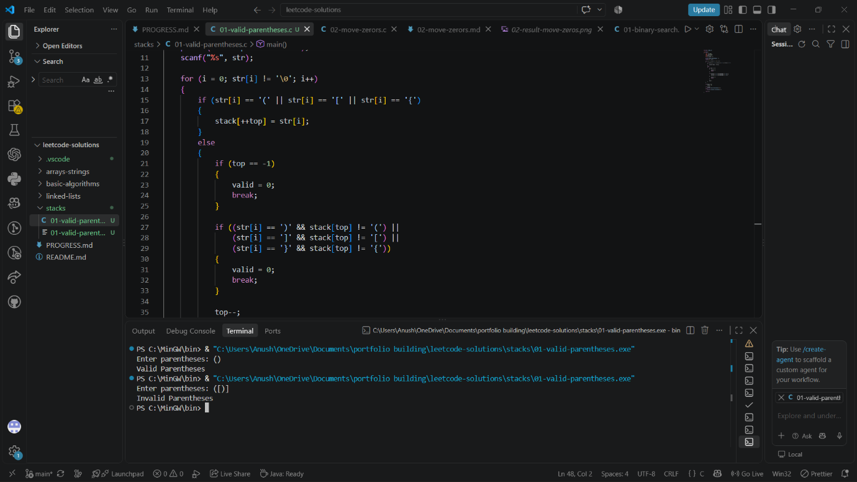

5. LeetCode Accepted Submissions
1. Two Sum – Accepted
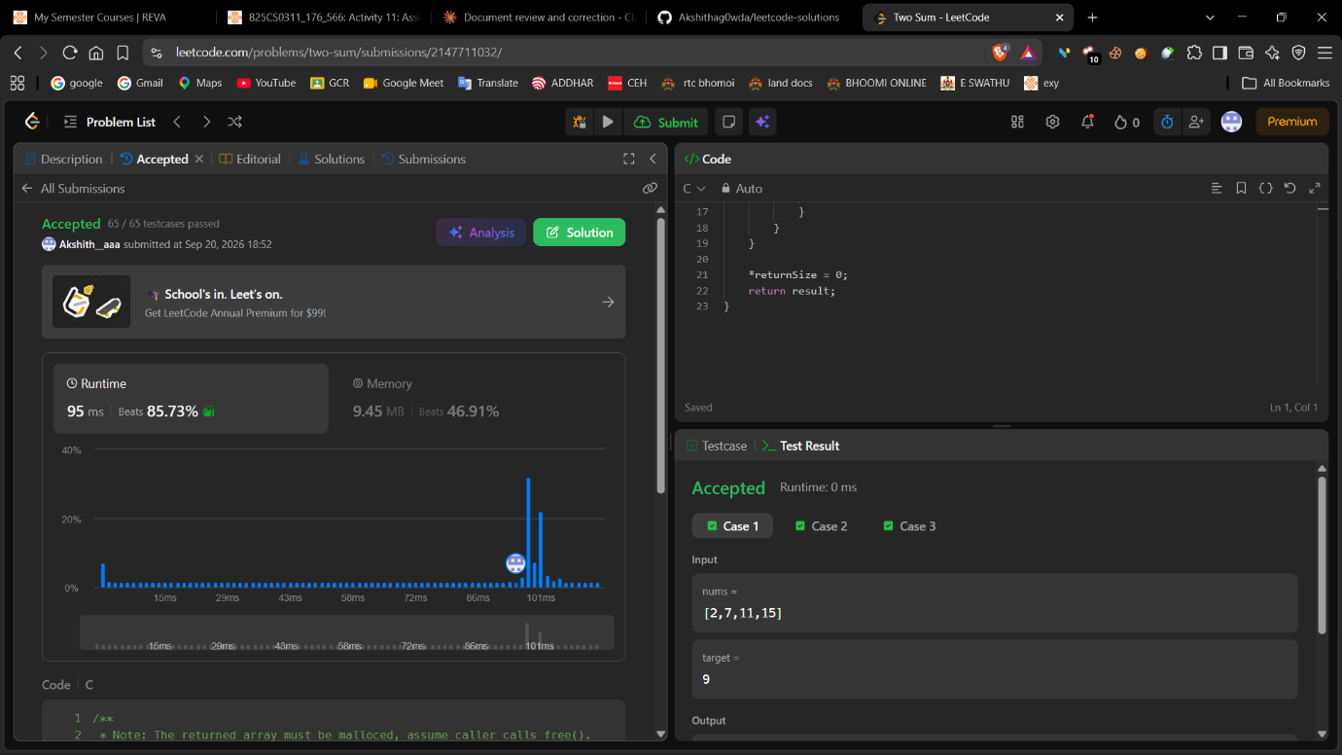
2. Reverse a String – Accepted
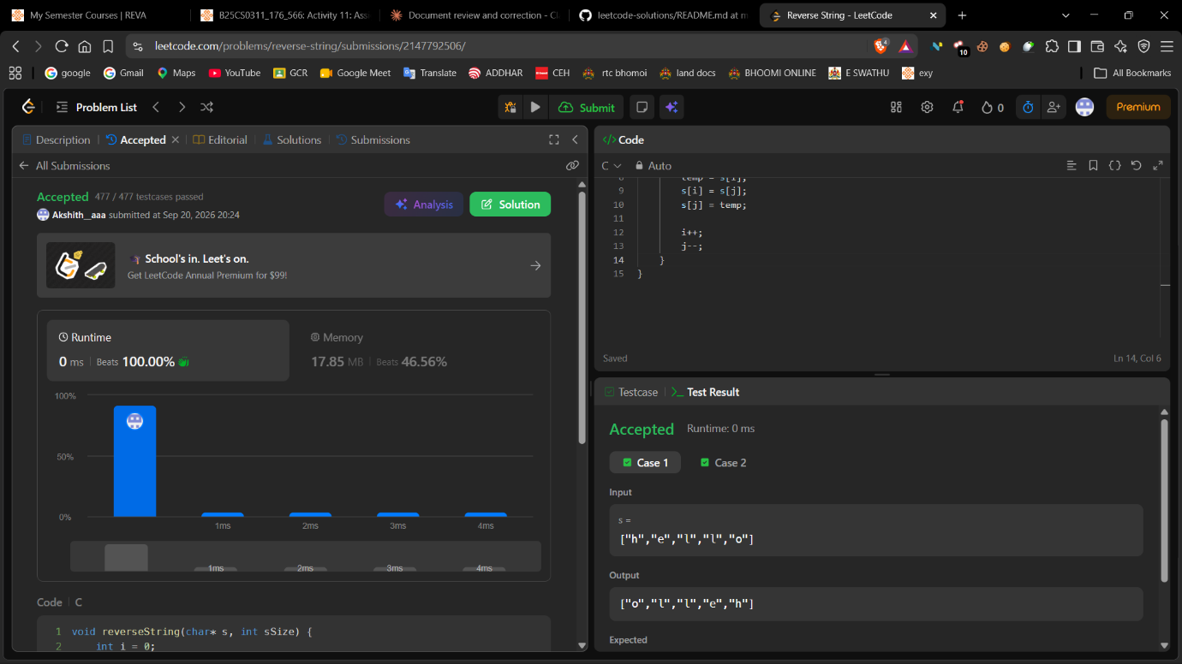

3. Valid Anagram – Accepted
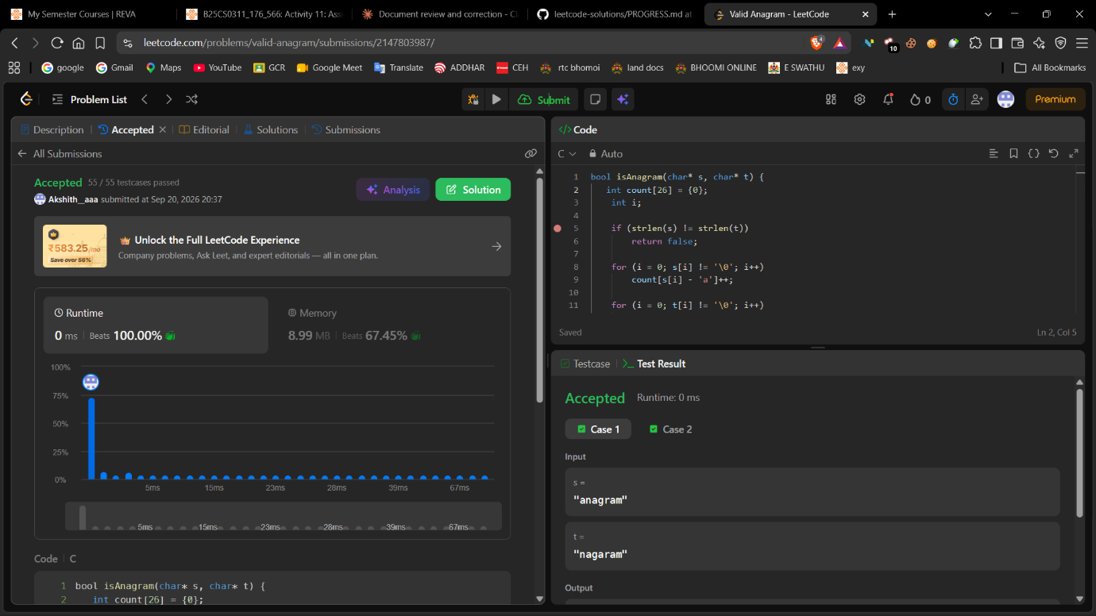
4. Best Time to Buy and Sell Stock – Accepted
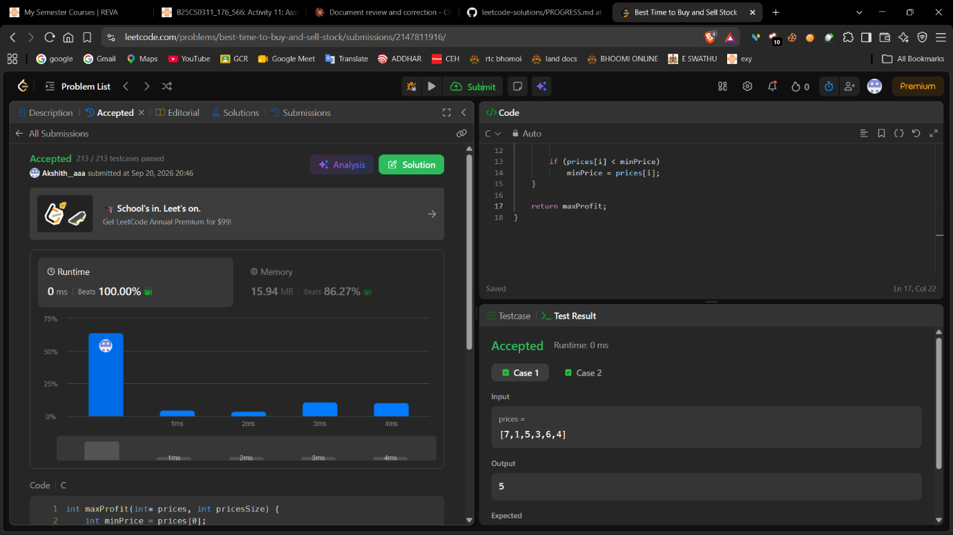

5. Longest Common Prefix – Accepted
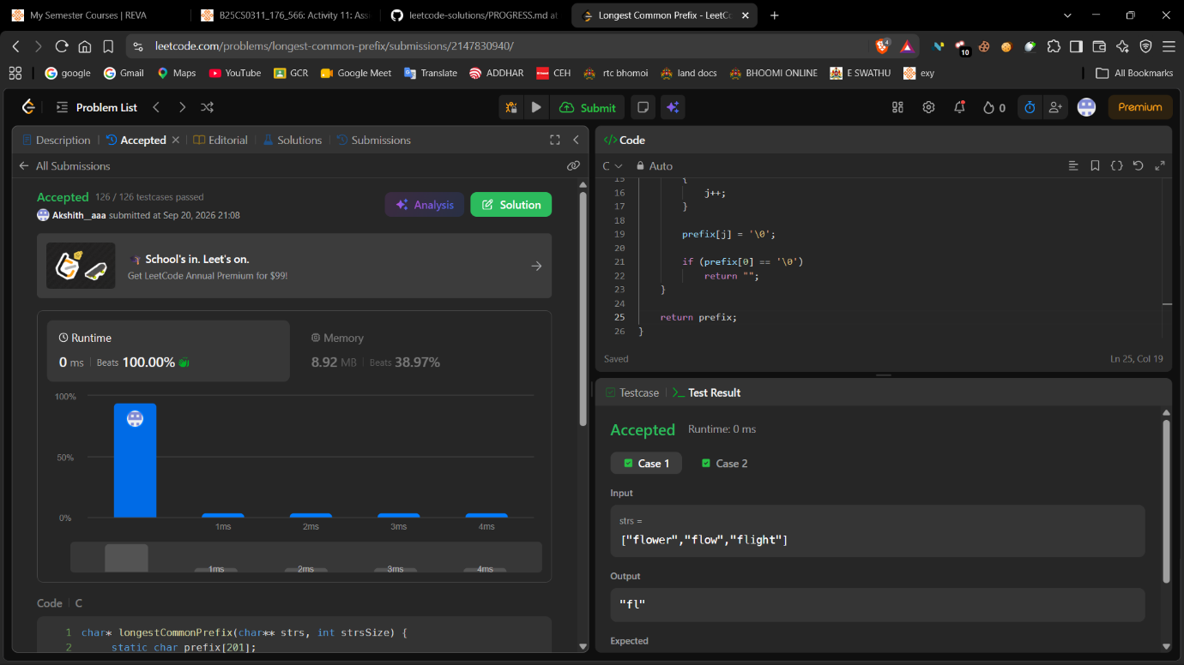
6. Binary Search – Accepted
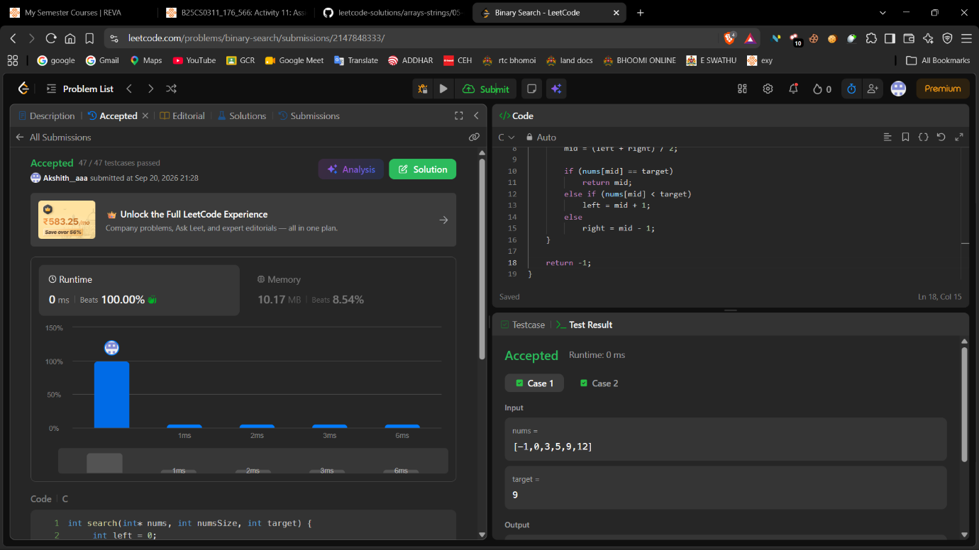

7. Move Zeroes – Accepted
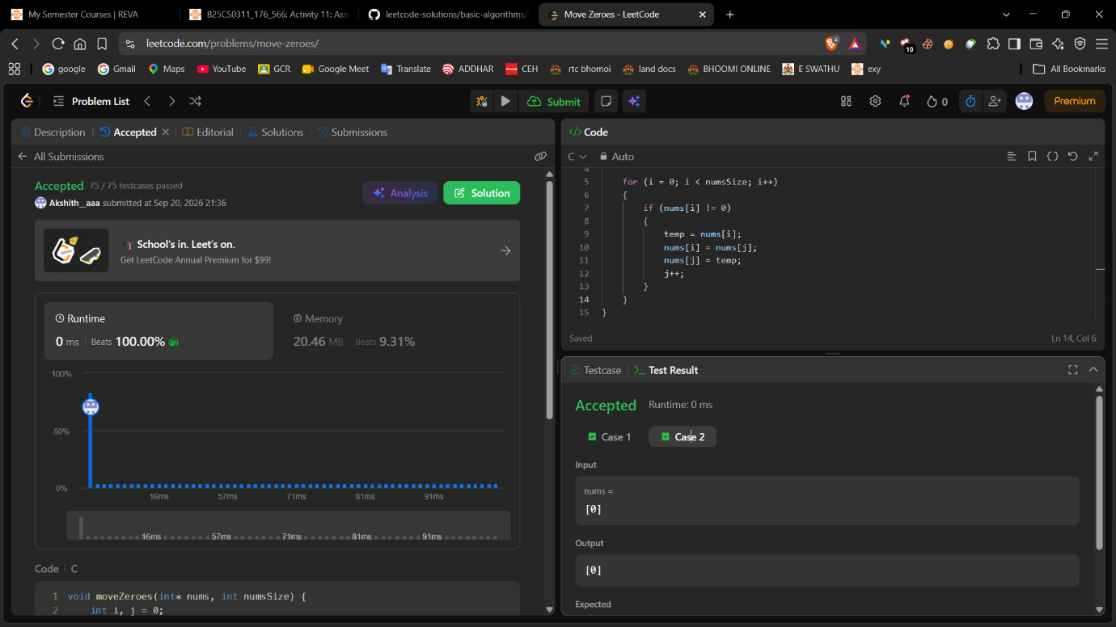

8. Valid Parentheses – Accepted
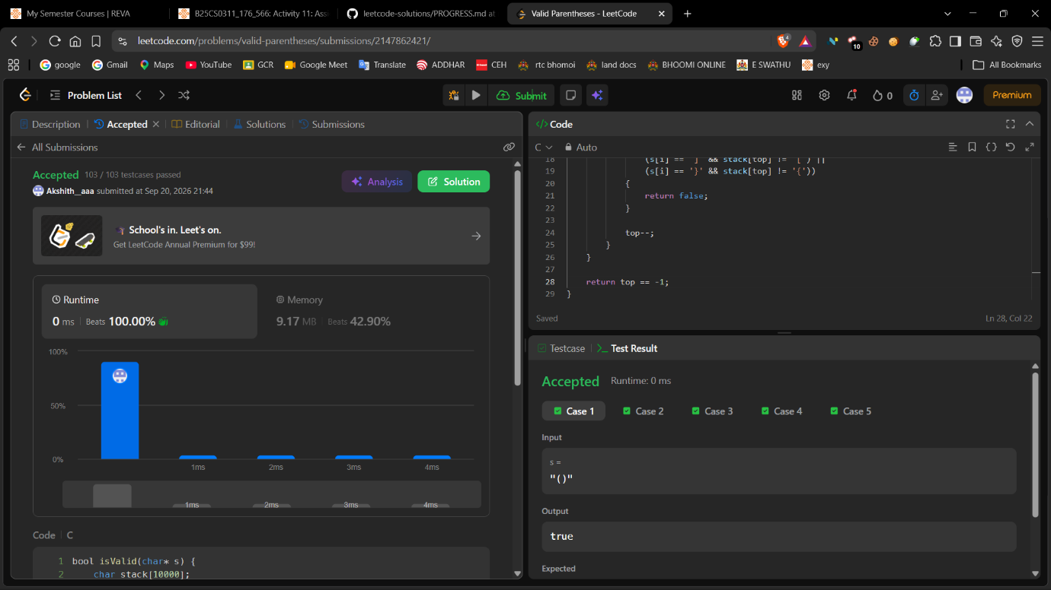

6. Problem Documentation and Complexity Analysis
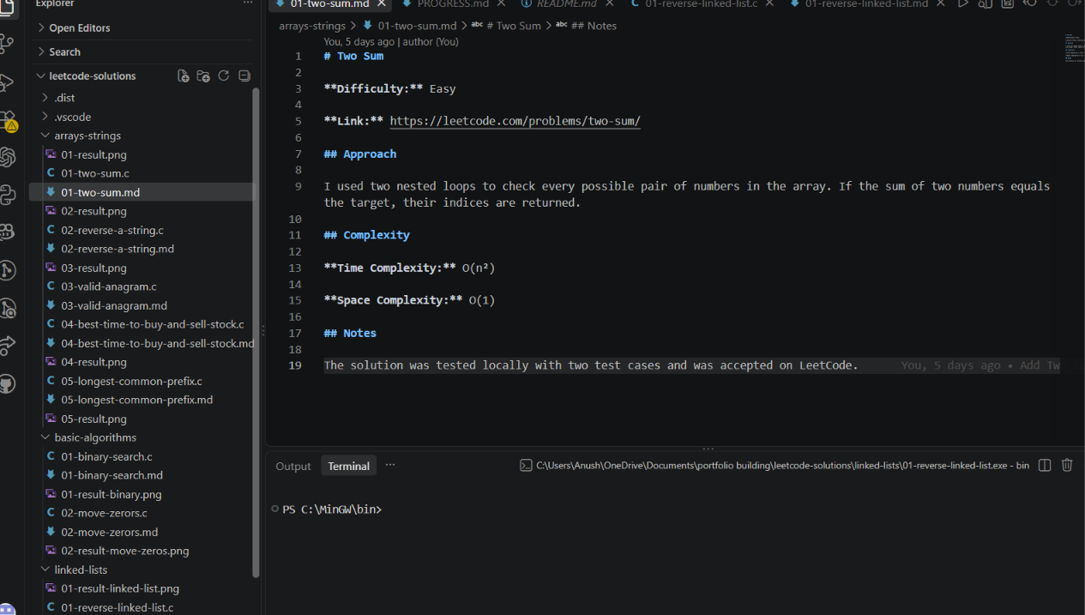

7. Progress Tracker
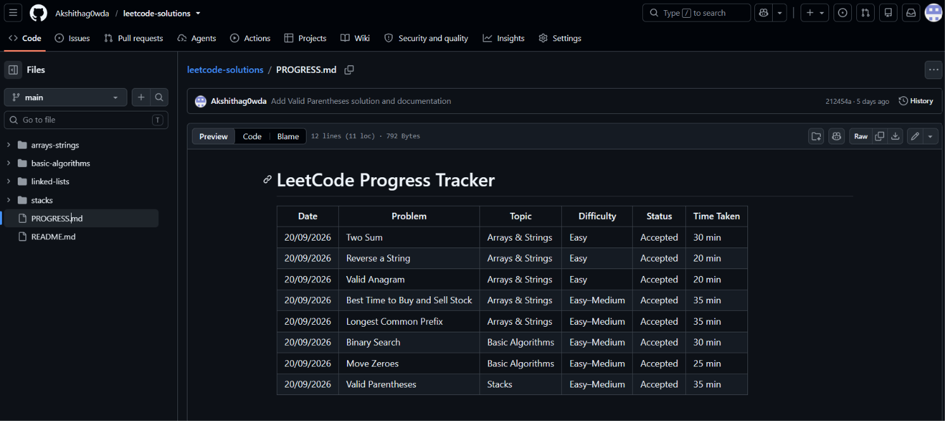

8. GitHub Commit History
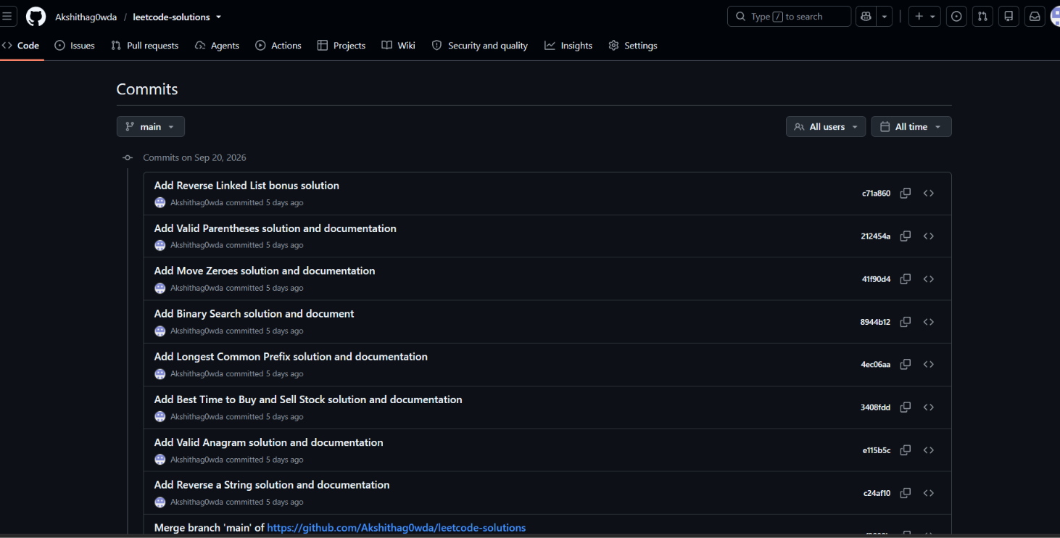

9. Bonus Problem – Reverse a Linked List
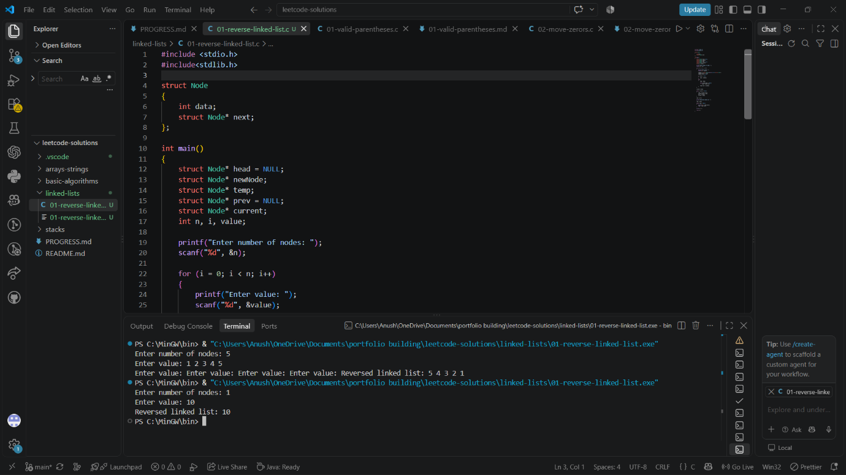
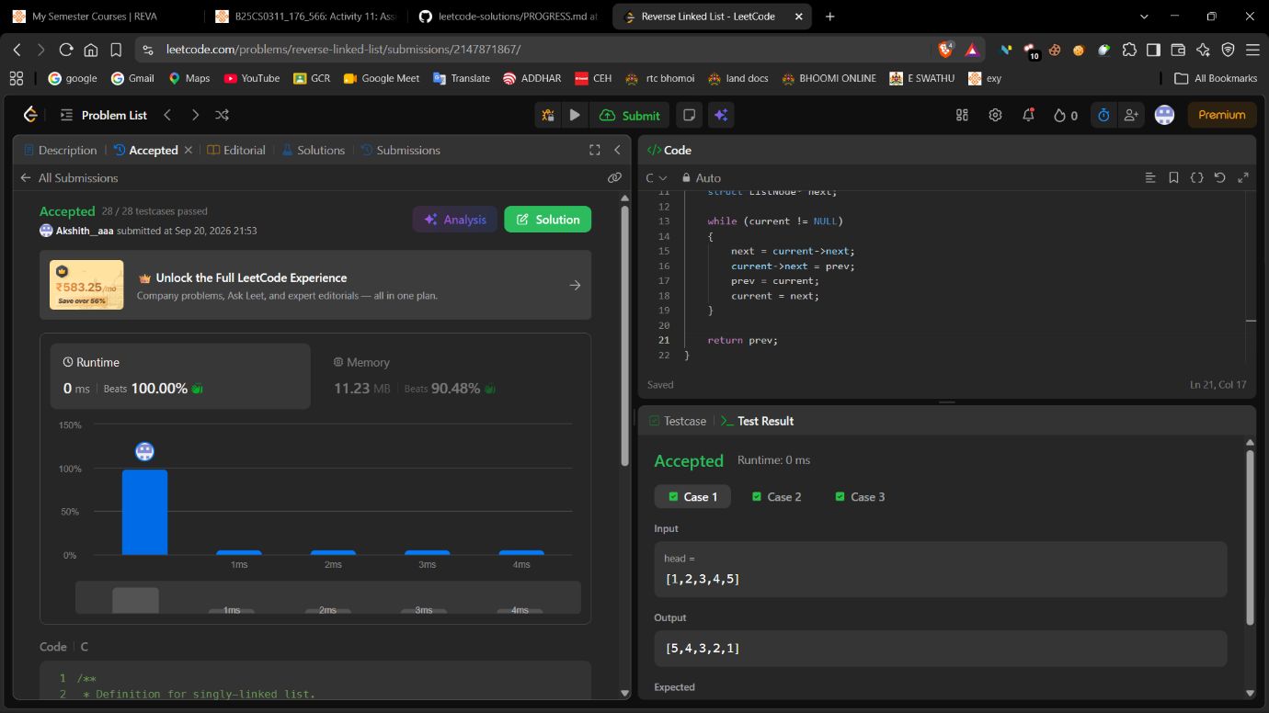

10. Conclusion / Reflection
During this activity, I practiced solving different LeetCode problems using C and learned how to approach problems step by step. I worked with arrays, strings, searching, stacks, and linked lists. Writing and testing the programs locally before submitting them to LeetCode helped me understand the logic better and find mistakes early. I also learned the importance of choosing an efficient approach by considering time and space complexity. Problems such as Binary Search helped me understand how an algorithm can reduce unnecessary operations, while Valid Parentheses helped me understand the use of stacks. I maintained separate solution files and documentation for each problem and updated my progress tracker regularly. I also learned how to use GitHub to organize my work and maintain a history of my changes through individual commits. The Accepted results on LeetCode gave me confidence that my solutions were working correctly. Overall, this activity improved my problem-solving skills, programming practice, and understanding of basic data structures and algorithms. It also helped me build a more organized coding practice portfolio that I can continue updating with new problems.

