What is Amazon Simple Queue Service
Amazon Simple Queue Service (Amazon SQS) offers a secure, durable, and available hosted queue that lets you integrate and decouple distributed software systems and components. Amazon SQS offers common constructs such as dead-letter queues and cost allocation tags. It provides a generic web services API that you can access using any programming language that the AWS SDK supports.
Benefits of using Amazon SQS
- Security
– You control who can send messages to and receive messages from an Amazon SQS queue. You can choose to transmit sensitive data by protecting the contents of messages in queues by using default Amazon SQS managed server-side encryption (SSE), or by using custom SSE keys managed in AWS Key Management Service (AWS KMS).
- Durability
– For the safety of your messages, Amazon SQS stores them on multiple servers. Standard queues support at-least-once message delivery, and FIFO queues support exactly-once message processing and high-throughput mode.
- Availability
– Amazon SQS uses redundant infrastructure to provide highly-concurrent access to messages and high availability for producing and consuming messages.
- Scalability
– Amazon SQS can process each buffered request independently, scaling transparently to handle any load increases or spikes without any provisioning instructions.
- Reliability
– Amazon SQS locks your messages during processing, so that multiple producers can send and multiple consumers can receive messages at the same time.
- Customization
– Your queues don't have to be exactly alike—for example, you can set a default delay on a queue. You can store the contents of messages larger than 256 KB using Amazon Simple Storage Service (Amazon S3) or Amazon DynamoDB, with Amazon SQS holding a pointer to the Amazon S3 object, or you can split a large message into smaller messages.
Standard Queues
- Overview: Amazon SQS Standard Queues offer high throughput and great flexibility for message queuing. They can handle a large number of concurrent message sends and receives, making them suitable for scenarios where high message volume and throughput are required.
- Message Order: However, they do not guarantee the order of message delivery. Messages may be delivered out of order to consumers, which means that the order in which messages are sent by producers may not be the same as the order in which they are received by consumers.
- Use Cases: Commonly used in scenarios where the order of message processing is not critical, such as handling asynchronous tasks like sending emails, generating reports, or performing background data processing where the exact sequence of operations doesn't matter as long as all tasks are eventually completed.
FIFO Queues
- Overview: FIFO (First-In-First-Out) Queues in Amazon SQS ensure that messages are delivered and processed in the exact order they are sent. This strict ordering makes them ideal for applications where the sequence of events or data processing is crucial.
- Message Order: Every message in a FIFO queue has a unique identifier and is guaranteed to be processed in the order it was added to the queue. This helps maintain data integrity and consistency in scenarios where the order of operations matters, such as financial transactions or sequential data updates.
- Use Cases: Particularly useful in systems where the order of message processing must be preserved, like processing orders in an e-commerce application, handling time-sensitive events, or any situation where the correct sequence of actions is necessary to ensure the integrity of the overall process.
Amazon Lambda Service
- Overview: Amazon Lambda is a serverless computing service provided by Amazon Web Services. It allows developers to run their code without having to manage servers, enabling them to focus solely on writing the business logic.
- Working Principle: It is event-driven, meaning that Lambda functions are triggered by events such as changes in Amazon S3 buckets, updates in Amazon DynamoDB tables, or API Gateway requests. The service automatically scales the computing resources based on the incoming traffic, ensuring high performance and cost-effectiveness.
- Features:
  - Pay-per-use: Users are charged only for the actual execution time and number of invocations of their Lambda functions, reducing costs significantly, especially for intermittent or bursty workloads.
  - Multiple Language Support: Supports popular programming languages like Python, Java, Node.js, etc., allowing developers to use their preferred language for coding.
  - High Availability and Scalability: Leverages Amazon's robust infrastructure to provide high availability and seamless scalability, capable of handling large-scale concurrent requests effortlessly.
- Use Cases:
  - Data Processing: Ideal for processing and analyzing data in real-time, such as handling logs or streaming data from various sources.
  - Backend Services: Can be used to build serverless backends for web or mobile applications, handling API requests and business logic without the need for traditional server management.
  - Scheduled Tasks: Enables the execution of scheduled tasks like data backups or report generation without the need for a dedicated server.
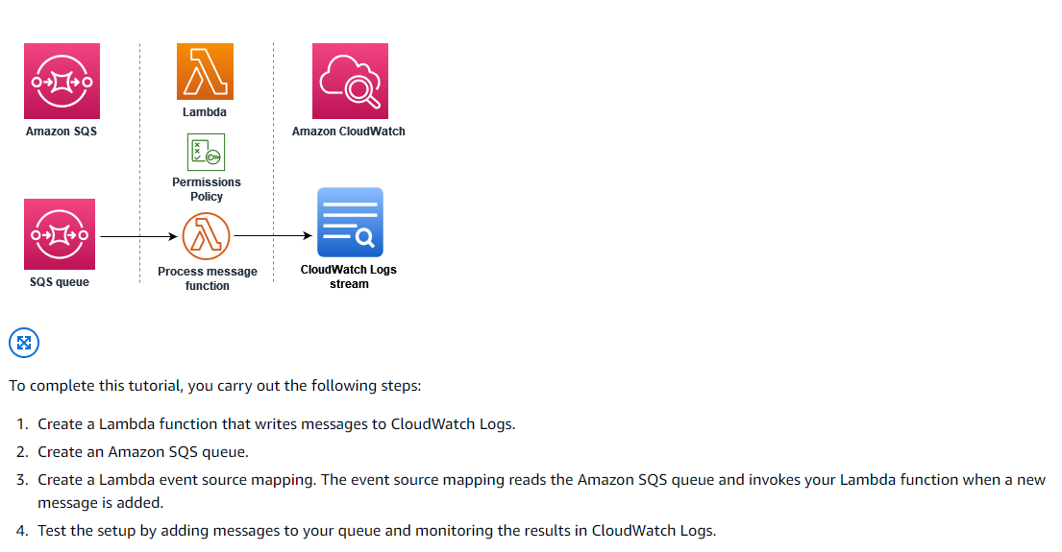
https://docs.aws.amazon.com/lambda/latest/dg/with-sqs-example.html

