Good afternoon, everyone. I'm Chen Jialin.
My last job was a cloud develop engineer.
I have used AWS Cloud Services before and I have also used many of its function.
I know that our current business also uses AWS Cloud Services,Right?
So today I would like to share with you two services on AWS. They are SQS Queue Service and Lambda Service.
Let me introduce what these two services are.
SQS (Amazon Simple Queue Service)
It is a queue service provided by AWS.
SQS queues allow communication between different services or applications through sending and receiving messages.
This design achieves decoupling and asyn processing, improving the scalability and reliability of the system.
It has two types:
First one is Standard queues.
Standard queues are suitable for various scenarios, provided that your application can handle messages that may arrive multiple times or not in order.
Another one is FIFO queues. FIFO means First-in-First-Out.
This queue is suitable for businesses that have strict requirements for the order of messages in the queue
Amazon Lambda is a serverless computing service provided by AWS.
When using Lambda, users do not need to configure or manage servers. They only need to upload a code package. Its working principle is triggered by event-driven execution.it can be linked with other AWS services. For example, S3, SQS, DynamoDB and so on. That's why I want to talk about these two services together today.
And...
These are several features of Lambda: Pay-per-use,Multiple Language Support,High Availability and Scalability..
And We can use Lambda in the following cases: Data Processing，Backend Services，Scheduled Tasks.
展示Demo部分
So, in order to better explain these two services and how they work together.
I will show you a demo on AWS. but due to policy of SCB, i can't present it on my own company laptop.
So i will present it in the form of pictures.
In the example given by AWS official, when there is a message written to SQS, after being processed by the Lambda function, the content is written to the Cloudwatch log. It uses a total of three AWS services, SQS, Lambda and Cloudwatch. Cloudwatch is a log system provided by AWS.
To complete this example, we need to do the following four steps
- Create a Lambda function that writes messages to CloudWatch Logs.
- Create an Amazon SQS queue.
- Create a Lambda event source mapping. The event source mapping reads the Amazon SQS queue and invokes your Lambda function when a new message is added.
- Test the setup by adding messages to your queue and monitoring the results in CloudWatch Logs.
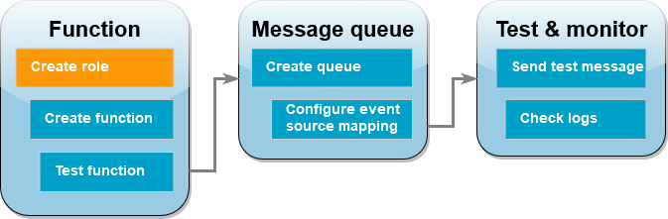
Let's start with creating SQS queue.
First, I created a standard SQS queue So we can send the message we are processing to the queue.
We can use aws console on website to simulate writing the message. If you need to write messages using the AWS SDK locally, you need to have a role with permission to write to this queue.
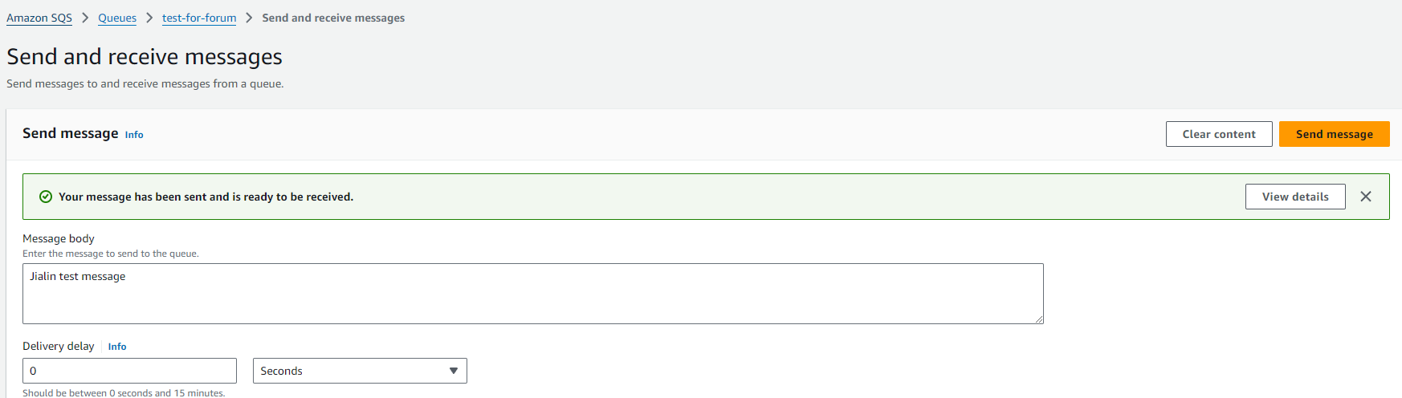
The same principle applies to creating Lambda. If we want Lambda functions to read messages from SQS queues and write logs to Cloud Watch, we need to create a role. Give this role the permisstion to perform these two operations
创建Lambda也是同样的道理，如果我们想让Lambda 函数可以读取SQS队列的消息和向Cloud watch写入日志，我们需要创建一个角色。 让这个角色拥有这两个操作的权限.
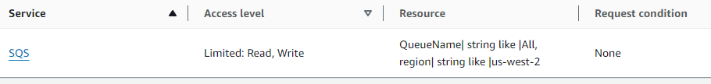
Now We can create a Lambda function by selecting the role we created
In the screenshot below, I coded the function using Node.js
Its logic is also very simple, which is to read the content of SQS message and write it to Cloud Watch.
It should be noted that after creating the function, we need to add a trigger for this Lambda function.
I have chosen SQS to trigger here, there are many other AWS services that can be chosen as triggers here.
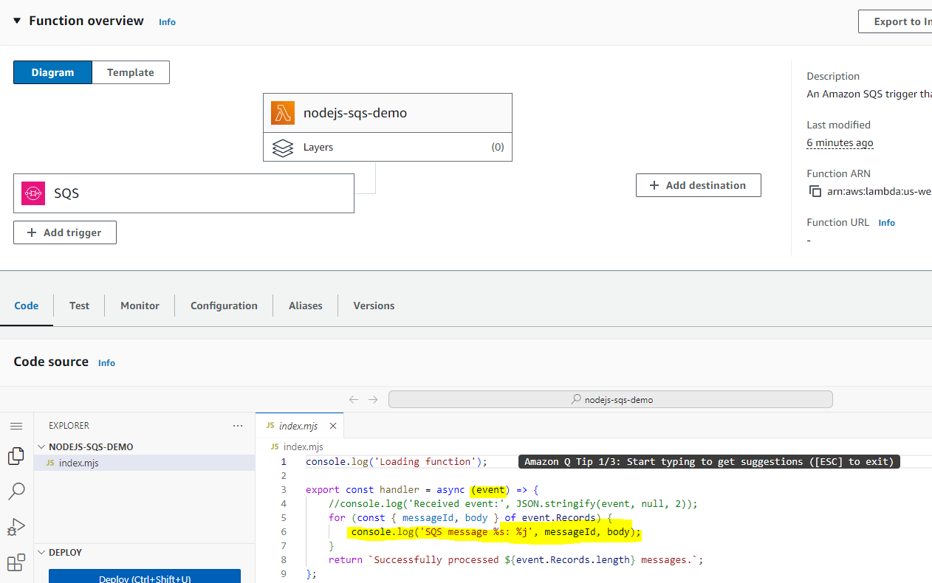
For now, both of the services we need have been created. The Cloudwatch part does not require to configure anything, as long as the role has permission, The lambda function can directly write logs.
we can test it now.
First of all, we need send a meesage to SQS queue.
you can see i sent a message to SQS queue in AWS console.
this is the message body, and next click the send message button.
Now Lambda should be triggered. Let's go directly to Cloud Watch to see if the log was successfully written.
You can see that there is a record here, and the content of the log is exactly what we sent to SQS queue.
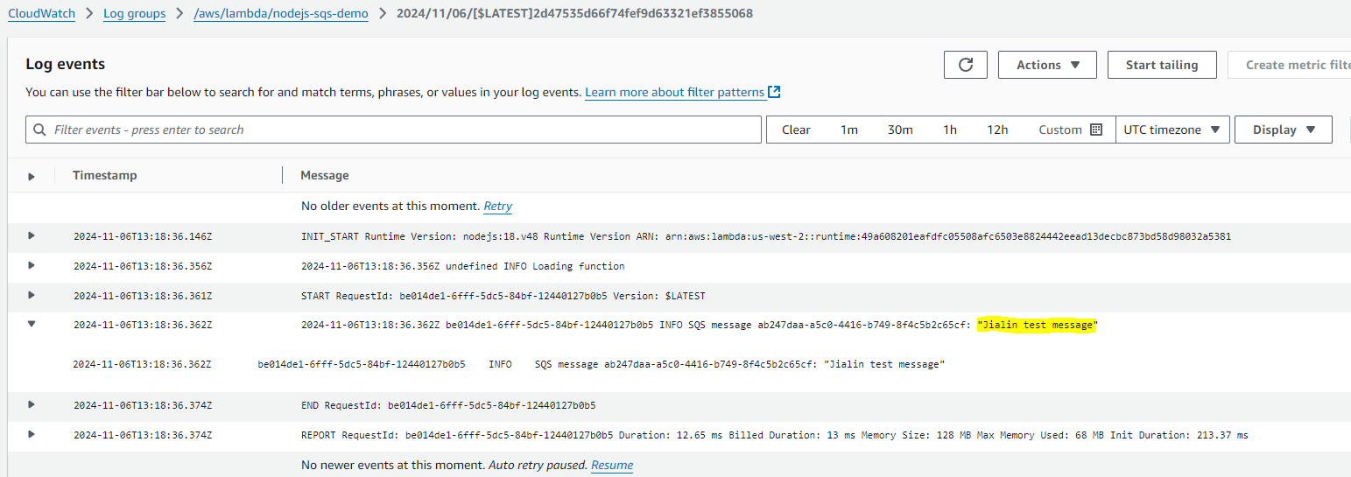
I have put the relevant links on the website.
If you are interested, you can try it out on your own computer.
You can try using different services to trigger Lambda.
Everyone can brainstorm and see if we can use Lambda functions to implement some scenarios in our current business.
比如我之前使用的场景是当S3上有一个文件被成功上传后，通知用户手机端.
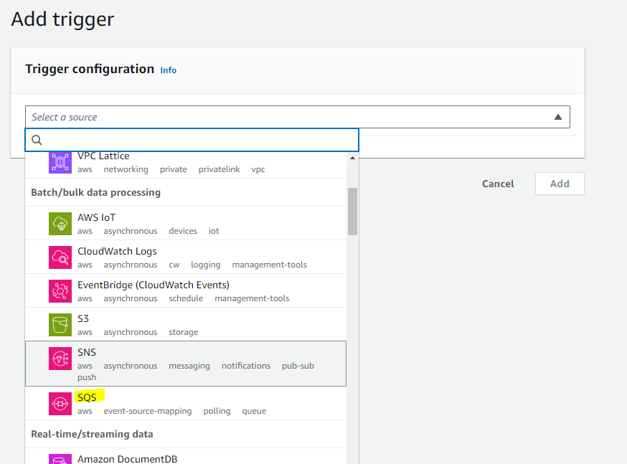
- 数据处理与分析：可以实时处理和分析从各种数据源（如传感器、日志文件等）生成的数据，例如，使用 Lambda 函数对上传到 S3 的日志文件进行实时分析，提取关键信息并存储到 DynamoDB 或其他数据存储中，以便进一步的查询和分析。
- 后端服务：作为移动应用或 Web 应用的后端服务，处理用户请求、验证用户身份、与数据库交互等，通过与 API Gateway 结合，开发者可以轻松构建出具有弹性和可扩展性的后端服务，快速响应用户请求，而无需担心服务器的管理和扩展问题。
- 定时任务：可以替代传统的定时任务调度工具，通过设置定时触发规则，定期执行特定的任务，如数据备份、报表生成等，无需维护专门的服务器来运行定时任务，降低了运维成本和复杂性。
Amazon SQS standard queues
标准消息队列适用于各种场景，前提是您的应用程序可以处理可能多次到达或不按顺序到达的消息。示例包括：
- 将@@ 实时用户请求与密集的后台工作分开 — 用户可以在系统在后台调整大小或编码媒体时上传媒体。
- 将任务分配给多个工作节点-例如，处理大量的信用卡验证请求。
- 批量处理消息以备将来处理-安排多个条目稍后添加到数据库中。
Amazon SQS FIFO queues
FIFO (First-In-First-Out) queues have all the capabilities of the standard queues, but are designed to enhance messaging between applications when the order of operations and events is critical, or where duplicates can't be tolerated.
The most important features of FIFO queues are FIFO (First-In-First-Out) delivery and exactly-once processing:
- The order in which messages are sent and received is strictly preserved and a message is delivered once and remains unavailable until a consumer processes and deletes it.
- Duplicates aren't introduced into the queue.
Additionally, FIFO queues support message groups that allow multiple ordered message groups within a single queue. There is no quota to the number of message groups within a FIFO queue.
Examples of situations where you might use FIFO queues include the following:
- E-commerce order management system where order is critical
- Integrating with a third-party systems where events need to be processed in order
- Processing user-entered inputs in the order entered
- Communications and networking – Sending and receiving data and information in the same order
- Computer systems – Making sure that user-entered commands are run in the right order
- Educational institutes – Preventing a student from enrolling in a course before registering for an account
- Online ticketing system – Where tickets are distributed on a first come first serve basis

