The imagination for traffic with FSD only

As shown in the 3 pics.

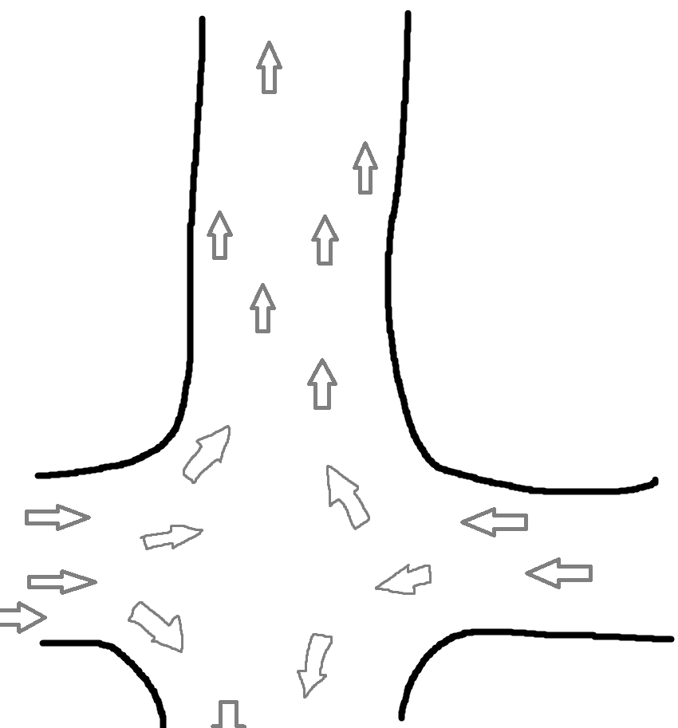
This is pic 1. It shows how cars go through an intersection. Cars on the left side turn left, while all the cars on the right side turn right. In this way, no need to stop. Traffic lights are no longer needed.

-------------------------------------------------
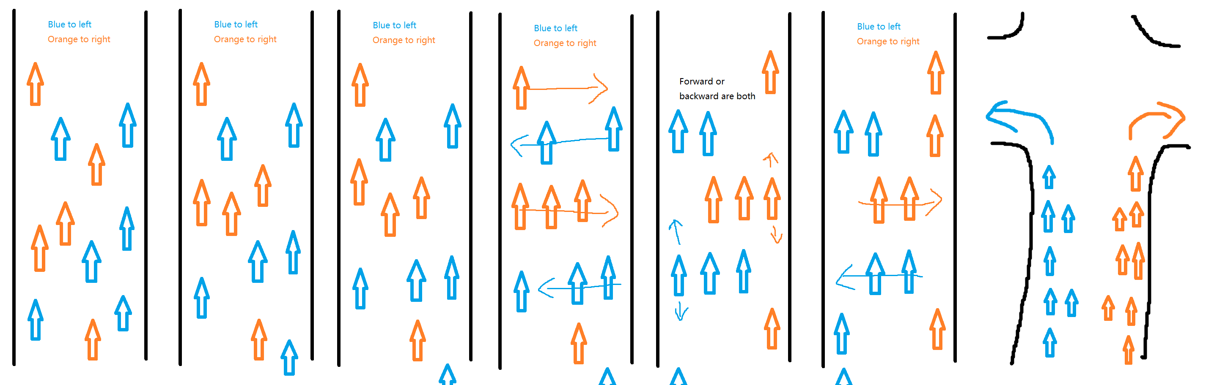
Then the pic 2. It shows how cars sort themselves in a road. The basic idea is that they form rows according to the direction they are going to steer. This strategy can take advantage of if that the FSD cars don’t need very big space between cars. Also, after they accelerate a bit, they are sparser and they can use the extra space to do this trick.

-----------------------------------------------------
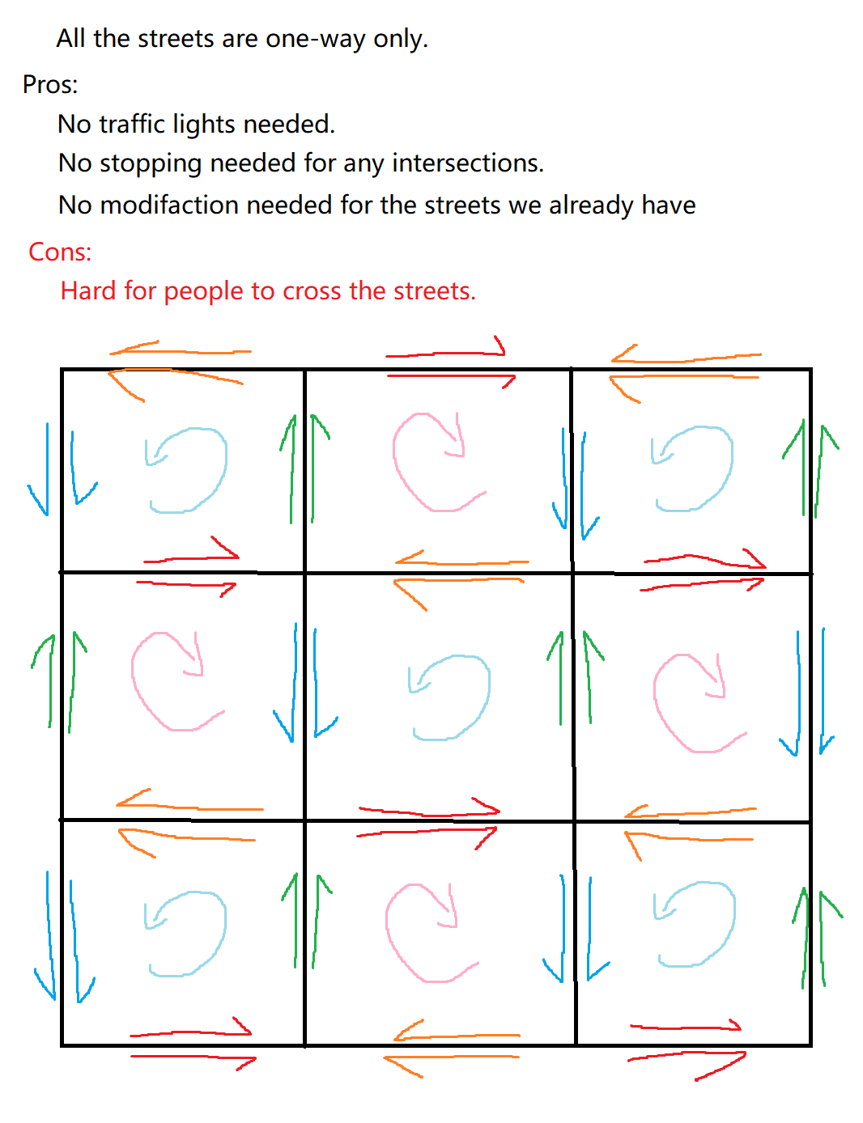
Then the pic 3
The road are oriented in such a way, that all the roads are one way. If the road network in an area is very regular, it’s very possible for FSD cars to do the trick without modify anything of the road. Pic 3 show all the directions for the roads. Also one of the cons, the distance is 1.4 times in avg. But without braking, this is possible to be faster.

Conclusions:
This strategy is not very possible for human but absolutely possible for FSD cars. This doesn’t fit the high speed roads, but possibly works perfect for general roads.
Pros:
Way less relative speed for cars, which makes the whole traffic way safer.
Less braking, less acceleration, no need for big distance between cars. Possible to be faster and more comfortable.
No traffic lights needed any more, unless they are for pedestrians.
No need to modify anything we have for road now.

Cons:
Unlikely to be friendly for ambulance, fire truck, etc.
It’s hard for pedestrians to cross the road. Probably still need lights to stop cars for pedestrians. Or they can get in cars and let cars to send them to the other side of the road, or directly to the destination.
It’s not very possible to be compatible with non self driving cars.
Unlikely to work perfectly for super short roads.
Needs laws to allow this strategy.
A bit extra work has to be done by the FSD algorithm corporate.
If people would like to ride bicycles as before, it’s dangerous to ride in the opposite direction of the cars. Also for the motorcycles if this is the case.

