TRAVELSYNC
Intelligent Travel Planning & Information Platform
PROJECT DOCUMENTATION
Data Structures and Algorithms (DSA) Project | Review-1 (CO1–CO3)
B.Tech – Computer Science
Subject Code | 25CS2103E
Team Members | 1. Y. Keerthika  2. N. Jyothirmayee  3. M. Mallika
Guide | M. Syamala Mam

Abstract
TravelSync is a web application for travel planning and travel information. It lets users explore and search destinations, view nearby places, compare destinations, plan trips and receive preference-based recommendations. Behind these features sit fifteen Data Structures and Algorithms (DSA) engines written in Java: string-search algorithms, text-comparison and sequence-alignment algorithms, dynamic-programming techniques and a network-flow activity allocator.
The frontend is built with React and Vite, and the backend with Java 21 and Spring Boot, exposing REST APIs. The application also uses external services (Open-Meteo, Wikipedia, OSRM routing and OpenStreetMap Overpass) to obtain live travel information. The algorithm implementations are verified by an automated Java test suite (14 tests passed in the latest checked report, with focused tests since added for the activity allocator).
Keywords: Travel planning, string matching, edit distance, sequence alignment, bitmask dynamic programming, network flow, Edmonds–Karp, Spring Boot, React.

1. Introduction

1.1 Overview
Travel information is large, spread across many sources and often unstructured. A traveller may misspell a destination name, want to compare two destination descriptions, need to visit several places in an efficient order, or want recommendations that fit personal preferences. Each of these is a well-defined computational problem that can be solved with a suitable data structure or algorithm.
TravelSync was developed as a DSA project to show that classical algorithms can be integrated into a practical, user-facing application. Instead of presenting algorithms in isolation, the project connects each one to a real travel feature.

1.2 Problem Statement
Modern travel platforms handle large amounts of destination, booking and descriptive information. Searching, comparing and organizing this information efficiently needs suitable data structures and algorithms. The main challenges addressed are:
- Finding relevant travel information quickly in text.
- Handling misspelled destination queries.
- Comparing destination descriptions to find shared or similar text.
- Arranging multi-stop routes in an efficient order.
- Choosing activities and destinations that fit user preferences.
TravelSync applies string matching, text comparison and dynamic programming to these tasks within one web application.

1.3 Objectives
- Build a modular web application with a separate frontend and backend.
- Apply string-search and string-matching algorithms to travel data.
- Compare travel descriptions using text-comparison and alignment algorithms.
- Optimize travel plans using dynamic programming and allocate travelers to activities using network flow.
- Integrate external travel-information and routing services.
- Test the algorithm implementations with an automated test suite and analyse their complexity.

2. Scope and Technology

2.1 Implemented Scope
- A React + Vite web interface that calls REST APIs.
- A Spring Boot backend with controllers, services, models, external API clients and DSA engine classes.
- Destination exploration and search, nearby places, destination comparison, trip planning, recommendations and algorithm insights.
- Integration with Open-Meteo, Wikipedia, OSRM and OpenStreetMap Overpass.
- Sample in-memory booking records with booking-code search.
- An activity allocator based on Network Flow (Edmonds–Karp), exposed through a REST API and the trip-planner UI.
- Fifteen DSA engines and an automated Java test suite.

2.2 Current Limitations
- There is no database; booking records are sample in-memory data.
- The application is not a complete hotel-booking system. There is no Hotel model and no hotel-search feature.
- No performance benchmarks on real-world datasets have been carried out.

2.3 Technology Stack
Table 2.1: Technology stack
Layer | Technology
Frontend | React with Vite
Backend | Java 21 with Spring Boot
Communication | REST APIs exchanging JSON between frontend and backend
Algorithms | Custom DSA engine classes written in Java
External services | Open-Meteo, Wikipedia, OSRM, OpenStreetMap Overpass
Testing | Automated Java test suite (14 tests passed in the latest checked report; focused allocator tests added)

3. System Architecture
TravelSync follows a layered, modular architecture. The React/Vite frontend calls a Spring Boot REST API. Requests pass through controllers to services, which use the DSA engines and the external API clients, and the results are returned to the frontend as JSON.
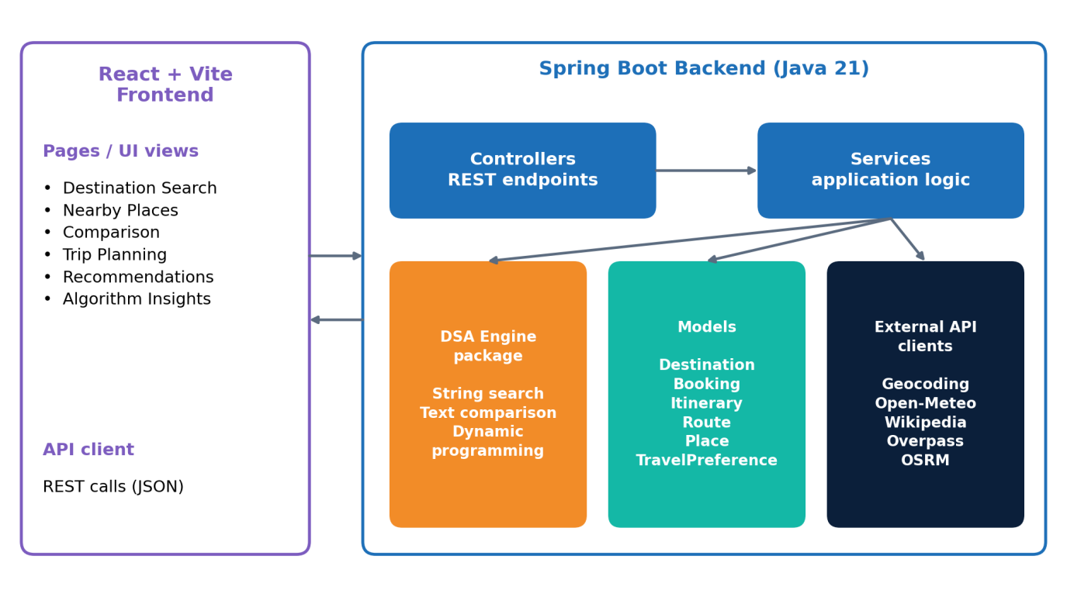
Figure 3.1: TravelSync system architecture

3.1 Architecture Layers
Table 3.1: Components and responsibilities
Component | Responsibility
Frontend | Pages for destination search, nearby places, destination comparison, trip planning, recommendations and algorithm insights, plus an API client that makes REST calls.
Controllers | Receive HTTP requests from the frontend and delegate to services.
Services | Hold the application logic. They call the DSA engines and external API clients and assemble the response.
DSA engine package | The implemented algorithms, kept independent of the web layer so that they can be tested on their own.
Models | Destination, Booking, Itinerary, Route, Place and TravelPreference.
External API clients | Clients for geocoding, weather, Wikipedia information, nearby places and routing.

4. Workflow, Features and Services

4.1 System Workflow
- The user opens the web application and selects a feature.
- The frontend sends a REST API request to the backend.
- The controller passes the request to the relevant service.
- The service calls the appropriate DSA engine and/or external API client.
- The backend returns a JSON result.
- The frontend displays the result, and the user can select another feature.
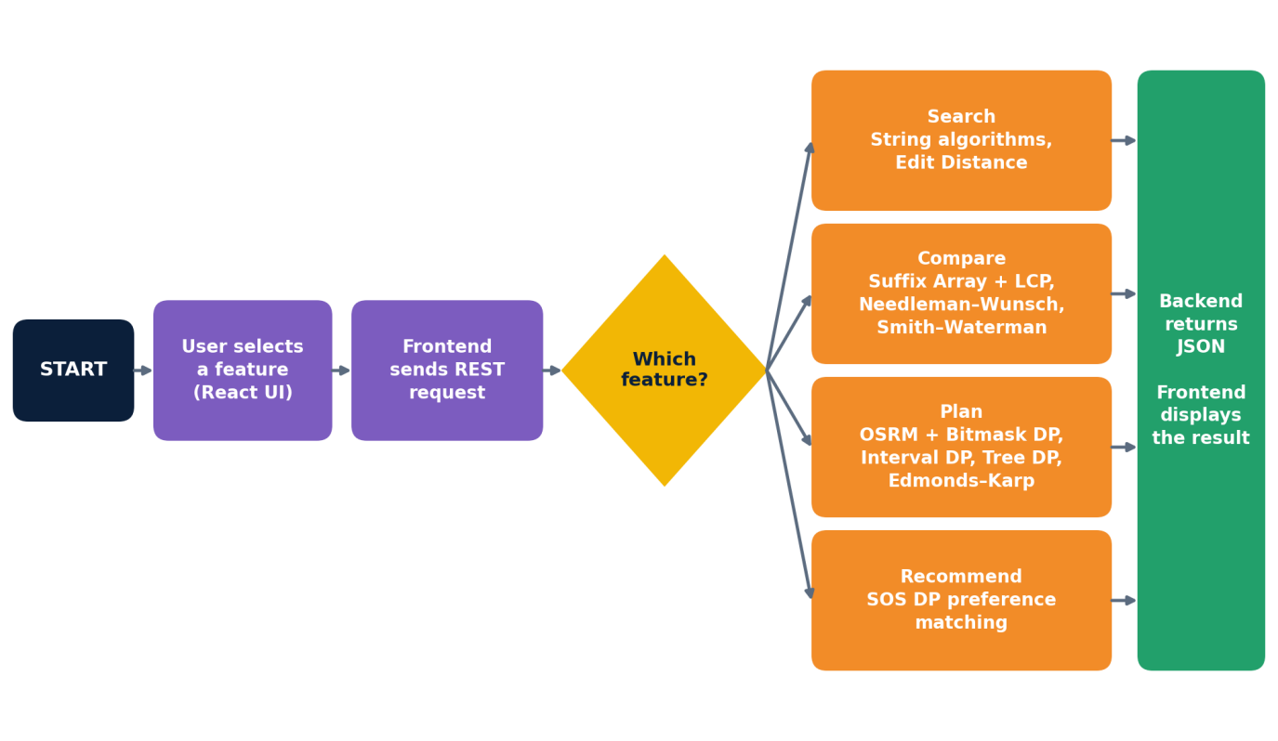
Figure 4.1: System workflow

4.2 Application Features
Table 4.1: User-facing features
Feature | Description
Destination exploration and search | Find destinations and view information about them, with suggestions when a query is misspelled.
Nearby places | Discover places around a destination using OpenStreetMap Overpass data.
Destination comparison | Compare destinations and their descriptions.
Trip planning | Order multi-stop routes, schedule activities and optimize hierarchical travel plans.
Activity allocation | Assign travelers to compatible activities within seat capacities using Network Flow (Edmonds–Karp) in the planner UI.
Recommendations | Rank destinations by the user's travel preferences.
Algorithm insights | A view that explains the algorithms used by the application.
Booking-code lookup | Search sample in-memory booking records by booking code.

4.3 External Services
Table 4.2: External services
Service | Purpose
Open-Meteo | Weather information.
Wikipedia | Descriptive information about destinations.
OSRM | Routing; supplies the route matrix used for multi-destination optimization.
OpenStreetMap Overpass | Nearby places.
The backend calls these services through dedicated client classes, so the algorithm code stays separate from network code.

4.4 Frontend–Backend Interaction
The frontend does not run the algorithms itself. Each feature sends a REST request to the backend, the backend runs the relevant service and returns a JSON response, and the frontend renders the result. This keeps the user interface thin and keeps all algorithmic logic in the Java backend, where it can be tested independently.
- Request: user input such as a search query, selected destinations or travel preferences.
- Processing: controller → service → DSA engine and/or external API client.
- Response: a JSON result that the React pages display.

4.5 Design Principles
- Separation of concerns: controllers, services, models, external clients and algorithm engines are separate components.
- Algorithm independence: the DSA engines do not depend on the web layer, so they can be tested on their own.
- External service isolation: network calls are confined to dedicated client classes.

5. Data Model
The backend uses the following model classes to carry data between the controllers, services and algorithm engines.
Table 5.1: Model classes
Model | Description
Destination | A travel destination with descriptive information and category tags.
Booking | A sample in-memory booking record identified by a booking code.
Itinerary | An ordered plan of destinations or activities.
Route | Route information between destinations, with distances or durations obtained from routing data.
Place | A nearby place of interest.
TravelPreference | The user's travel preferences, represented as categories and bit masks.

5.2 Where Each Model Is Used
Table 5.2: Model usage
Model | Typical use
Destination | Destination search, typo suggestions, description comparison and recommendations.
Booking | Booking-code search over sample in-memory records.
Itinerary | Trip planning, including ordered routes and scheduled activities.
Route | Route costs between destinations, used by multi-destination optimization.
Place | Nearby-places results.
TravelPreference | Preference masks used for recommendations.

5.3 Data Handling Notes
- Booking records are sample in-memory data; no database is used.
- Travel preferences and destination categories are encoded as bit masks so that SOS DP can compare them quickly.
- Route data is obtained from OSRM, nearby places from OpenStreetMap Overpass, weather from Open-Meteo and destination information from Wikipedia.
- Data moves through the layers as: frontend JSON request → controller → service → model objects and algorithm engine → JSON response.

6. DSA Implementation
Fifteen algorithm engines are implemented. They fall into four groups: string search and matching, text comparison and sequence alignment, dynamic programming for planning, and network flow for activity allocation.

6.1 String Search and Matching
Table 6.1: String search algorithms
Algorithm | How it works | Use in TravelSync
Naive String Search | Compares the pattern against every position of the text. | Baseline string matching
KMP | Builds a failure (prefix) table so the pattern is matched without re-reading text characters. | Pattern searching
Z-Function | For each position, finds the longest substring matching a prefix of the string; applied to pattern + text it finds occurrences. | Pattern searching
Rabin–Karp | Compares rolling hash values of the pattern and of text windows, and verifies on a hash match. | Booking-code search
Aho–Corasick | Builds a trie of many keywords with failure links and scans the text once. | Multiple keyword search

6.2 Text Comparison and Sequence Alignment
Table 6.2: Text comparison algorithms
Algorithm | How it works | Use in TravelSync
Edit Distance | Minimum number of insertions, deletions and substitutions to turn one string into another (Wagner–Fischer). | Destination typo suggestions
Suffix Array | Sorted array of all suffixes of a string. | Longest common substring (with LCP)
LCP (Kasai) | Longest-common-prefix array of adjacent suffixes, computed in linear time. | Longest common substring (with Suffix Array)
Needleman–Wunsch | Global alignment of two complete sequences using a scoring scheme. | Comparing whole destination descriptions
Smith–Waterman | Local alignment that finds the best-matching region of two sequences. | Strongest shared portion of two descriptions

6.3 Dynamic Programming for Planning
Table 6.3: Dynamic-programming algorithms
Algorithm | How it works | Use in TravelSync
Bitmask DP | State = (set of visited destinations, current destination) stored as a bit mask. | Multi-destination route ordering
Interval DP | Sorts activities and uses a predecessor lookup to choose a non-overlapping set. | Activity scheduling
Tree DP | Combines the best budget splits across the children of each node in a tree of choices. | Hierarchical travel-plan optimization under a budget
SOS DP | Computes aggregate values over all subsets of an 8-bit preference mask. | Preference-based recommendations
Edit Distance, Needleman–Wunsch and Smith–Waterman are also dynamic-programming techniques.

6.4 Network Flow
Table 6.4: Network-flow algorithm
Algorithm | How it works | Use in TravelSync
Edmonds–Karp | Repeatedly finds a shortest augmenting path with BFS in the residual graph and pushes flow along it; residual edges let earlier choices be revised. | Assigning travelers to compatible activities within seat capacities

6.5 Why These Techniques Were Chosen
Table 6.5: Problem-to-technique rationale
Problem | Technique | Reason
Typo suggestions | Edit Distance | Counts the edits separating two strings.
Shared text | Suffix Array + LCP | Finds the longest common substring efficiently.
Description alignment | Needleman–Wunsch, Smith–Waterman | Scoring handles inserted, changed or missing words.
Route ordering | Bitmask DP | Tracks visited subsets exactly for a small number of stops.
Preferences | SOS DP | Aggregates over all subsets of a preference mask.
Seat allocation | Edmonds–Karp | Maximizes assignments and revises choices through residual edges.

7. Key Workflows

7.1 Multi-Destination Itinerary Optimization

Figure 7.1: Itinerary optimization workflow
- The user selects the destinations to visit.
- The backend requests a route matrix for those destinations from OSRM.
- Bitmask DP explores combinations of visited destinations and chooses an ordering with the lowest total route cost.
- The ordered itinerary and its route totals are returned to the frontend.
Route costs come from OSRM; the algorithm selects the optimized ordering. The time complexity is O(n² · 2ⁿ), where n is the number of destinations, so the method suits a small number of stops.

7.2 Travel Preference Matching with SOS DP
There are eight preference categories, each assigned one bit of an 8-bit mask. A destination's categories and a user's preferences are both represented as masks, and SOS DP computes subset aggregates over all 2⁸ = 256 masks to rank recommendations.
Table 7.1: Preference categories and bit masks
Category | Bit position | Mask
Beach | 0 | 00000001
Historical | 1 | 00000010
Adventure | 2 | 00000100
Nature | 3 | 00001000
Food | 4 | 00010000
Nightlife | 5 | 00100000
Relaxation | 6 | 01000000
Shopping | 7 | 10000000
Illustrative example: a destination tagged Beach + Nightlife + Relaxation has the mask 00000001 + 00100000 + 01000000 = 01100001 (bits 0, 5 and 6 set; 1 + 32 + 64 = 97).

7.3 Activity Allocation with Network Flow
The activity allocator assigns each traveler to at most one compatible activity while respecting each activity's seat capacity. It is solved as a maximum-flow problem with the Edmonds–Karp algorithm.
Table 7.2: Flow-network model
Element | Meaning
Source → traveler | Capacity 1: each traveler can be assigned at most once.
Traveler → activity | Capacity 1: only where the traveler is compatible with the activity.
Activity → sink | Capacity = the activity's seats.
Maximum flow | The maximum number of travelers that can be assigned.
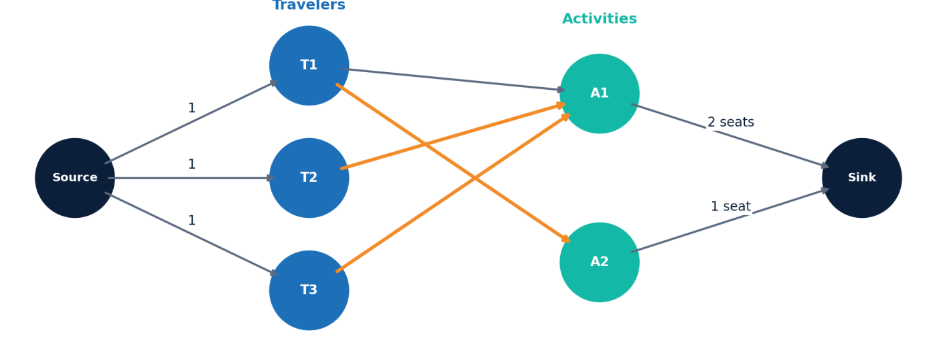
Figure 7.2: Illustrative flow network (orange edges show one maximum assignment)
- Build the network from the travelers, activities, compatibilities and seat capacities.
- Edmonds–Karp finds shortest augmenting paths using BFS and pushes flow along them.
- Residual edges let the algorithm undo and revise an earlier assignment when that frees a seat for another traveler.
- When no augmenting path remains, the flow is maximum; the assignments are read from the edges carrying flow.
The solver is part of the backend DSA engine package, is exposed through a REST API and is used by the trip-planner UI. Its time complexity is O(V · E²), where V is the number of vertices (source, travelers, activities, sink) and E is the number of edges.

8. Testing
The repository contains an automated Java test suite of 14 tests. The latest checked test report showed 14 tests passed and 0 failures. Focused tests for the Network Flow activity allocator were added afterwards.
The tests cover the algorithms listed below.
Table 8.1: Algorithm tests covered
No. | Algorithm | No. | Algorithm
1 | Naive Search | 8 | LCP
2 | KMP | 9 | Needleman–Wunsch
3 | Z-Function | 10 | Smith–Waterman
4 | Rabin–Karp | 11 | Bitmask DP
5 | Aho–Corasick | 12 | Interval DP
6 | Edit Distance | 13 | Tree DP
7 | Suffix Array | 14 | SOS DP
Note: this result is taken from the latest checked report. No tests were run while preparing this document.

8.1 Testing Approach
- Each algorithm engine is tested on its own, independent of the web layer.
- Tests use small, deterministic inputs with known expected outputs.

8.2 Coverage by Algorithm Group
Table 8.2: Tests by group
Group | Algorithms covered | Tests
String search and matching | Naive, KMP, Z-Function, Rabin–Karp, Aho–Corasick | 5
Text comparison and alignment | Edit Distance, Suffix Array, LCP, Needleman–Wunsch, Smith–Waterman | 5
Dynamic programming | Bitmask DP, Interval DP, Tree DP, SOS DP | 4
Network flow | Edmonds–Karp activity allocator | Focused tests added after the checked report

9. Complexity Analysis
Table 9.1: Time complexity of the implemented algorithms
Algorithm | Time Complexity | Variables / Notes
Naive Search | O(nm) | n = text length, m = pattern length
KMP | O(n + m)
Z-Function | O(n + m)
Rabin–Karp | Average O(n + m); worst case O(nm) | Worst case with many hash collisions
Aho–Corasick | O(total pattern length + text length + matches)
Edit Distance | O(nm) | n, m = lengths of the two strings
Suffix Array | O(n log² n) | Prefix doubling with comparison sort
LCP (Kasai) | O(n) | n = string length
Needleman–Wunsch | O(nm) | n, m = sequence lengths
Smith–Waterman | O(nm) | n, m = sequence lengths
Bitmask DP | O(n² · 2ⁿ) | n = number of destinations
Interval DP (scheduling) | O(n log n) | n = activities; sorting and predecessor lookup
Tree DP | O(N · B²) time; O(N · B) space | N = tree nodes, B = budget
Edmonds–Karp (Network Flow) | O(V · E²) | V = vertices, E = edges of the flow network
SOS DP | O(k · 2ᵏ) | k = number of preference bits (8)
No benchmark timings are reported in this document.

9.1 Notes on the Results
- KMP, Z-Function and Aho–Corasick run in time linear in the text and pattern sizes, which improves on the O(nm) naive baseline.
- Bitmask DP is exponential in the number of destinations, so it suits a small number of stops.
- Edmonds–Karp runs in O(V · E²) regardless of the capacity values.

10. Conclusion and Future Scope

10.1 Conclusion
TravelSync shows how advanced Data Structures and Algorithms can be integrated into a practical travel-planning web application. It combines a React web interface, external travel-data services and a Java Spring Boot backend with DSA-powered features: string search, typo suggestions, description comparison, route ordering, activity scheduling, hierarchical plan optimization, preference-based recommendations and activity allocation using network flow. The modular design keeps the algorithms separate from the web layer, which makes them easy to test and extend.

10.2 Future Scope
- Persistent database storage in place of in-memory booking records.
- Broader live datasets.
- More robust personalization of recommendations.
- Deployment of the application.
- Additional real-world performance evaluation of the algorithms.

10.3 Summary of Contributions
Table 10.1: Summary
Area | Contribution
Web application | React + Vite frontend and Java 21 Spring Boot backend connected through REST APIs.
Algorithms | Fifteen DSA engines: string search, text comparison, dynamic programming and network flow.
Integration | Open-Meteo, Wikipedia, OSRM and OpenStreetMap Overpass.
Planning features | Route ordering, activity scheduling, hierarchical plans, recommendations and activity allocation.
Testing | Automated Java test suite covering the algorithm engines.

10.4 Learning Outcomes
- Designing dynamic-programming solutions for routing, scheduling, hierarchical optimization and preference matching.
- Modelling an allocation problem as a flow network and solving it with Edmonds–Karp.

References
- T. H. Cormen, C. E. Leiserson, R. L. Rivest and C. Stein, Introduction to Algorithms, MIT Press.
- D. Gusfield, Algorithms on Strings, Trees, and Sequences, Cambridge University Press.
- Open-Meteo API documentation.
- Wikipedia API documentation.
- OSRM (Open Source Routing Machine) documentation.
- OpenStreetMap Overpass API documentation.
- J. Edmonds and R. M. Karp, Theoretical improvements in algorithmic efficiency for network flow problems, Journal of the ACM, 1972.
- Spring Boot, React and Vite official documentation.

Appendix A: Application Screenshots
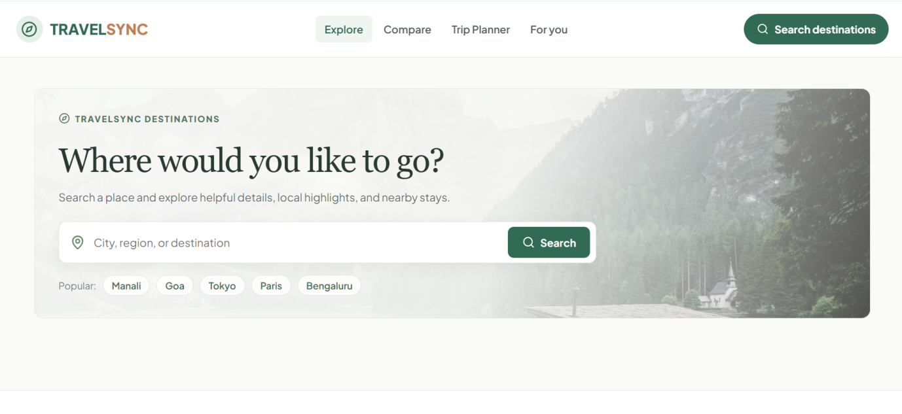
Figure A.1: Home page: destination search
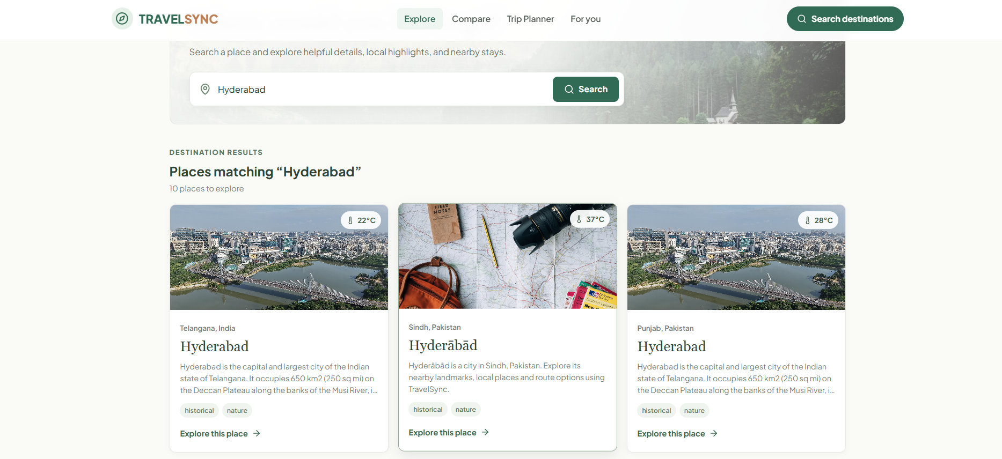
Figure A.2: Search results for “Hyderabad”
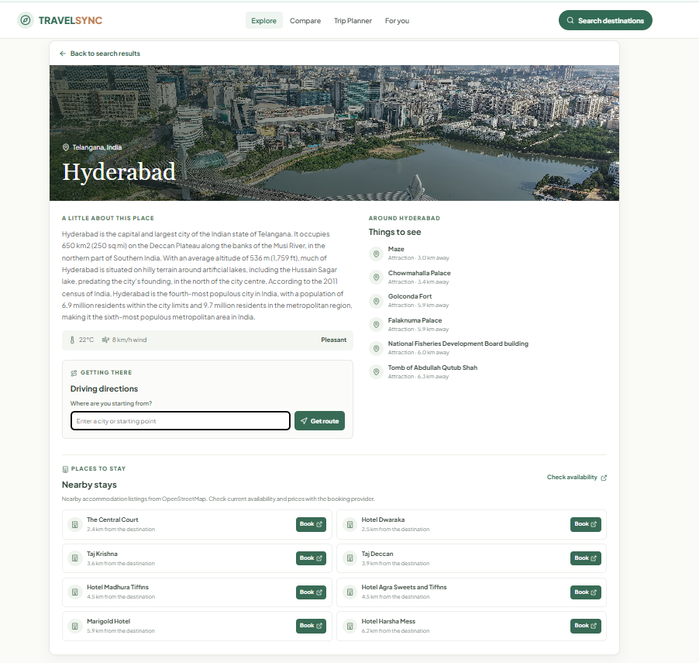  Figure A.3: Destination page with things to do and nearby stays | 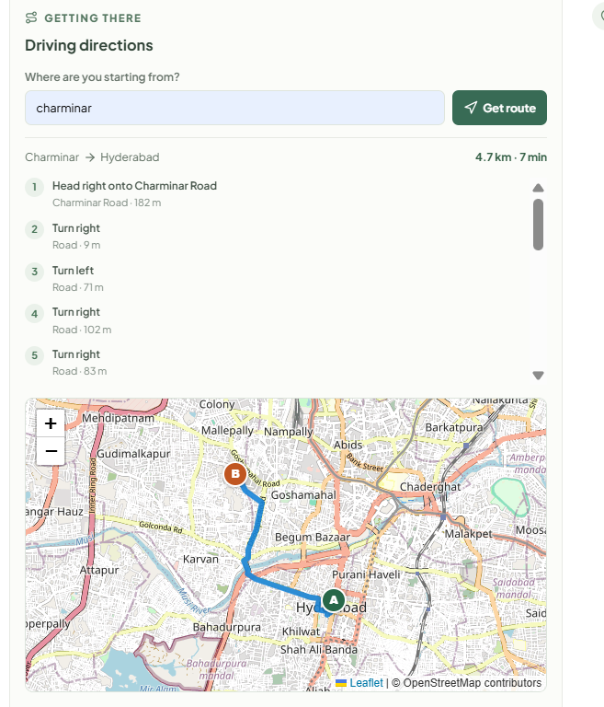  Figure A.4: Driving directions with route map

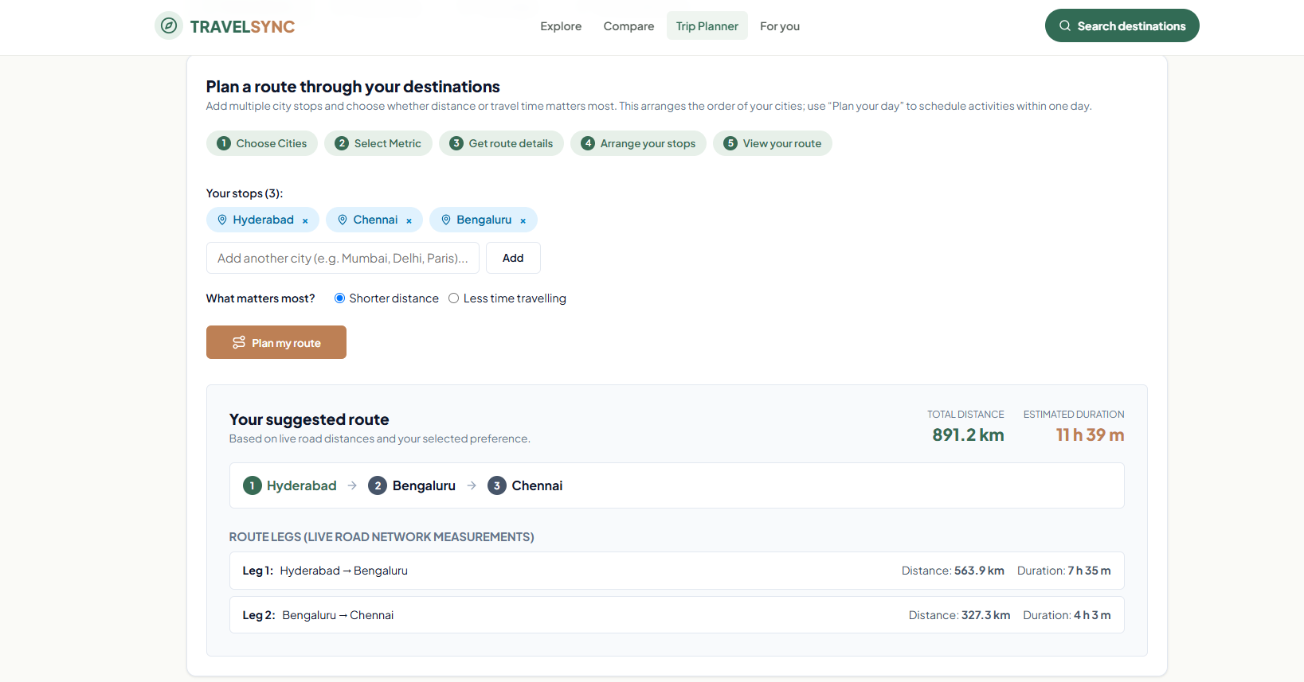
Figure A.5: Route planner: suggested multi-city route
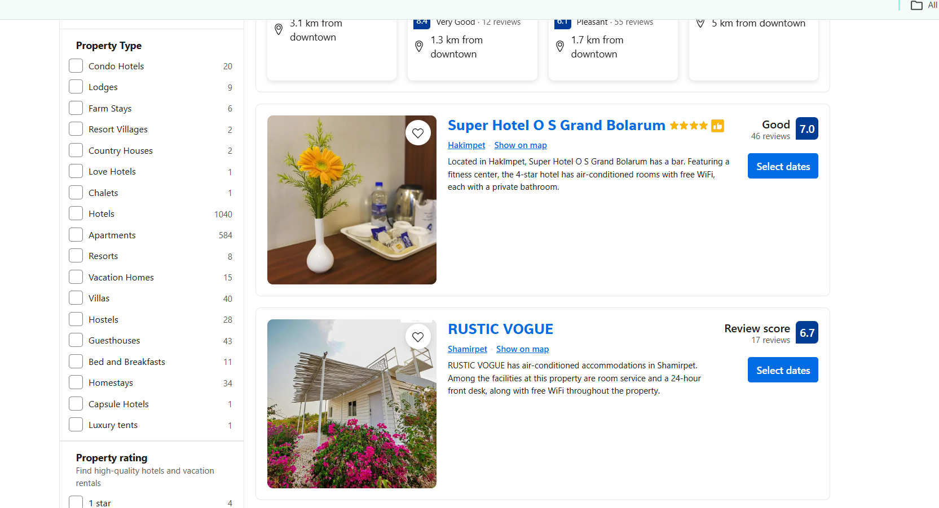
Figure A.6: Nearby stays: accommodation listing
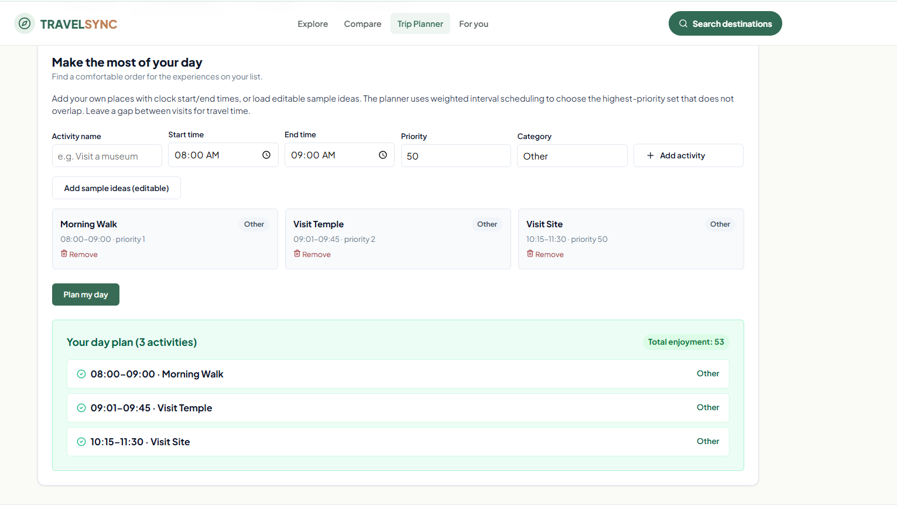
Figure A.7: Day planner: optimized daily itinerary
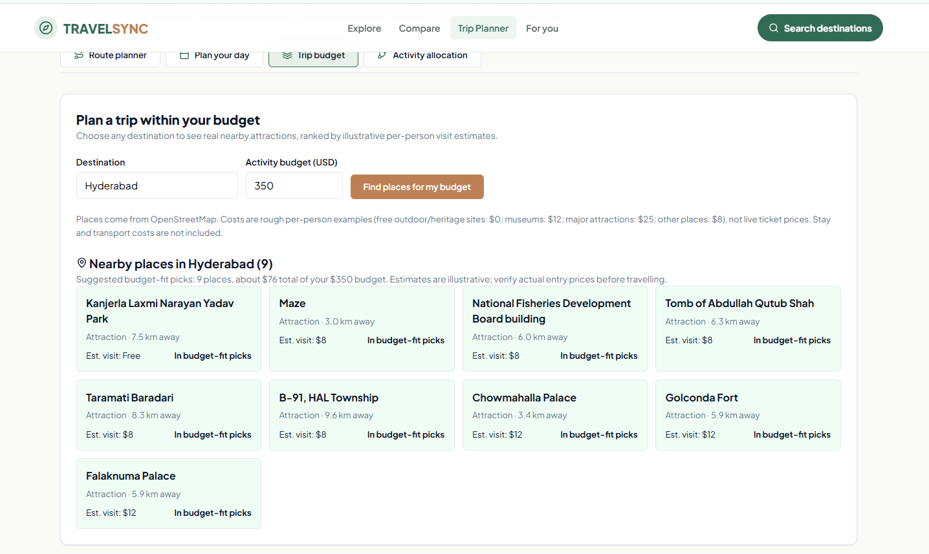
Figure A.8: Budget planner: places within budget
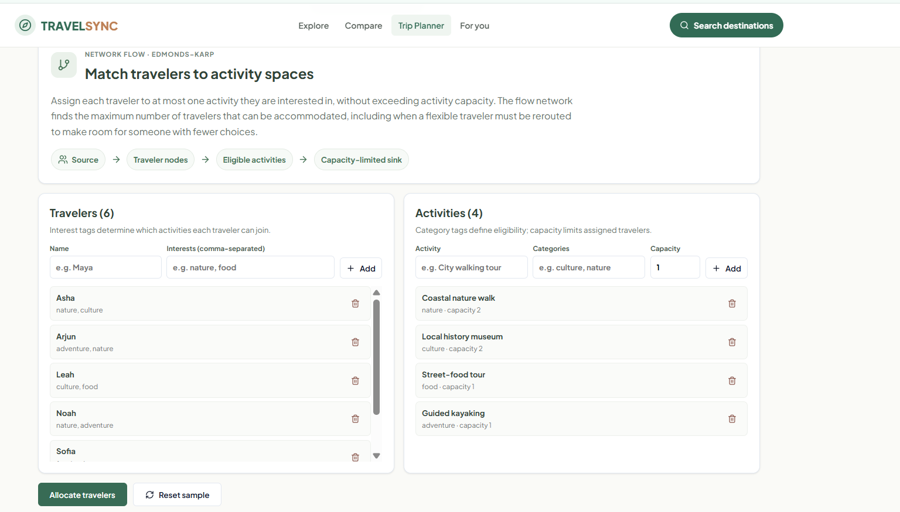
Figure A.9: Match travelers to activity spaces
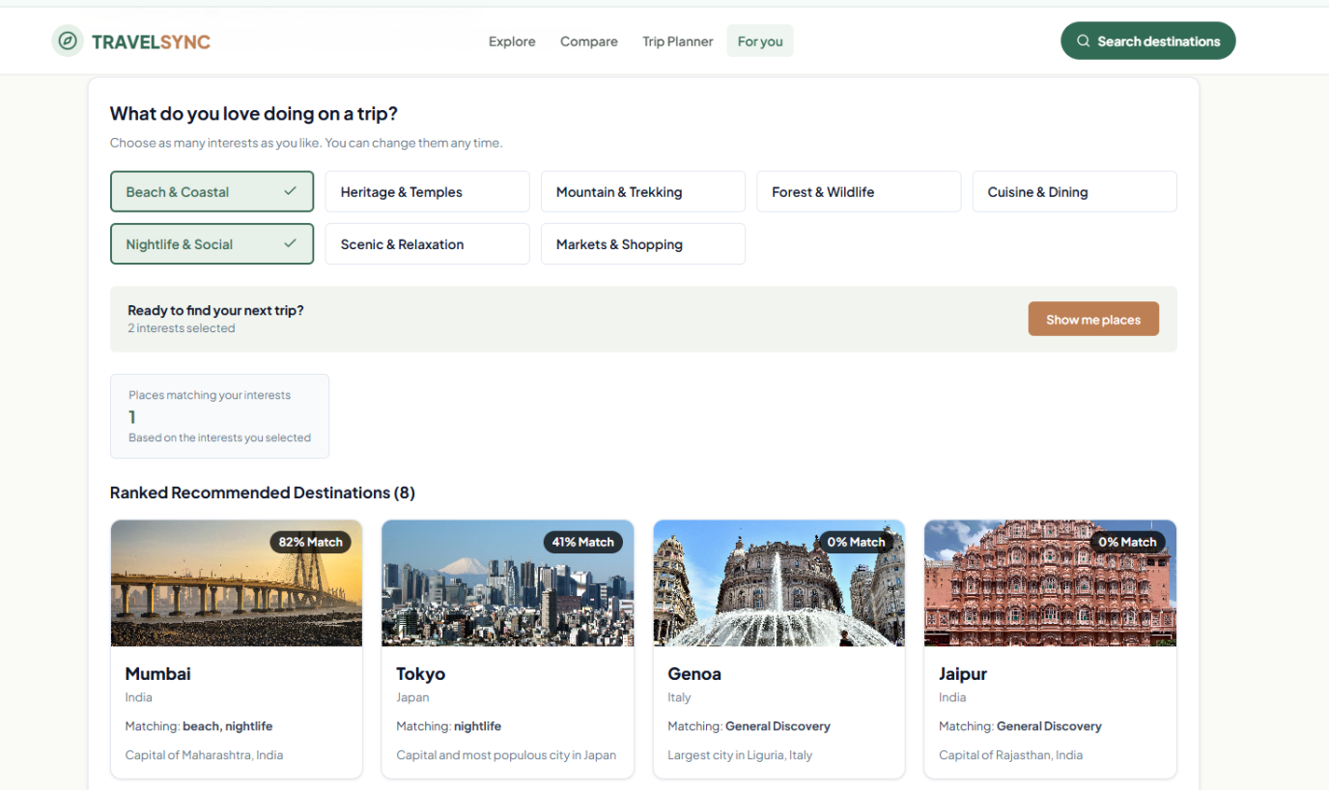
Figure A.10: For You: personalized destination recommendations

