TravelSync – Project Images
Diagrams and application screenshots, each shown with its description.
Figure 1: System Architecture
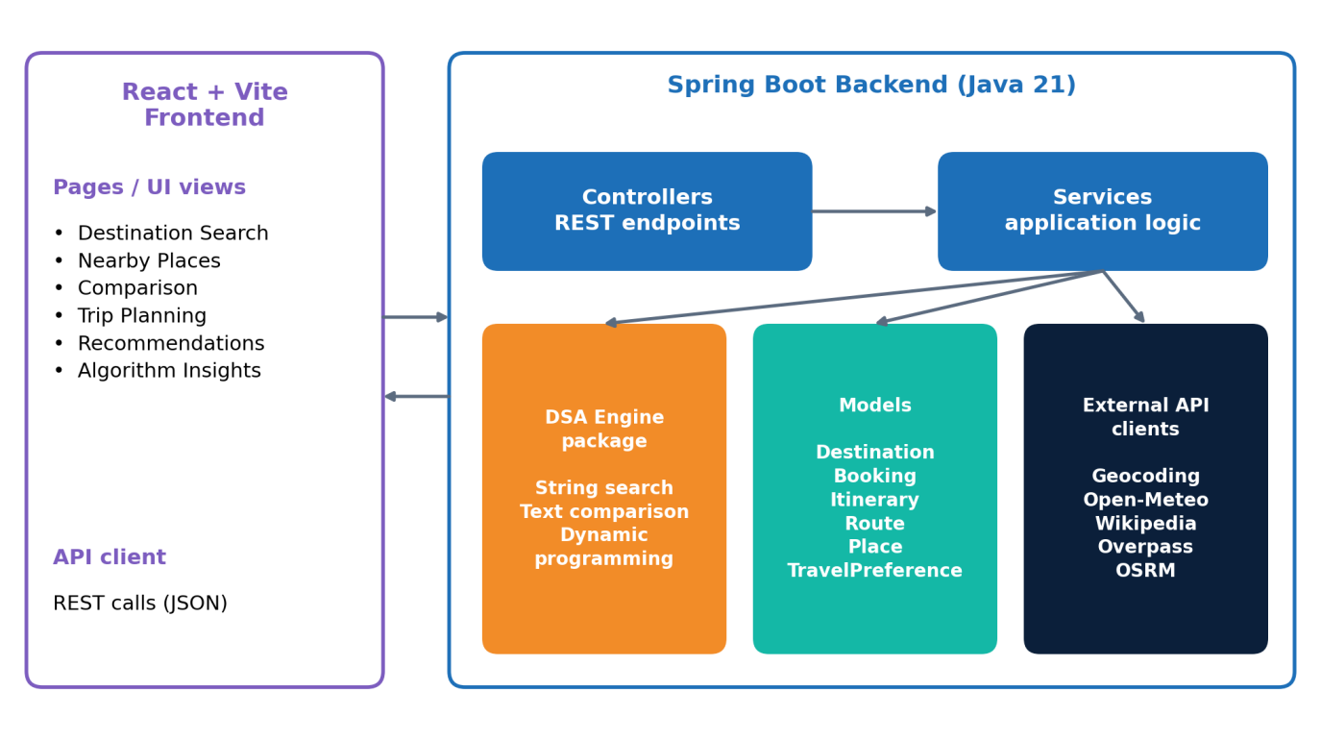
Diagram – layered architecture of the TravelSync application.
Figure 2: System Workflow
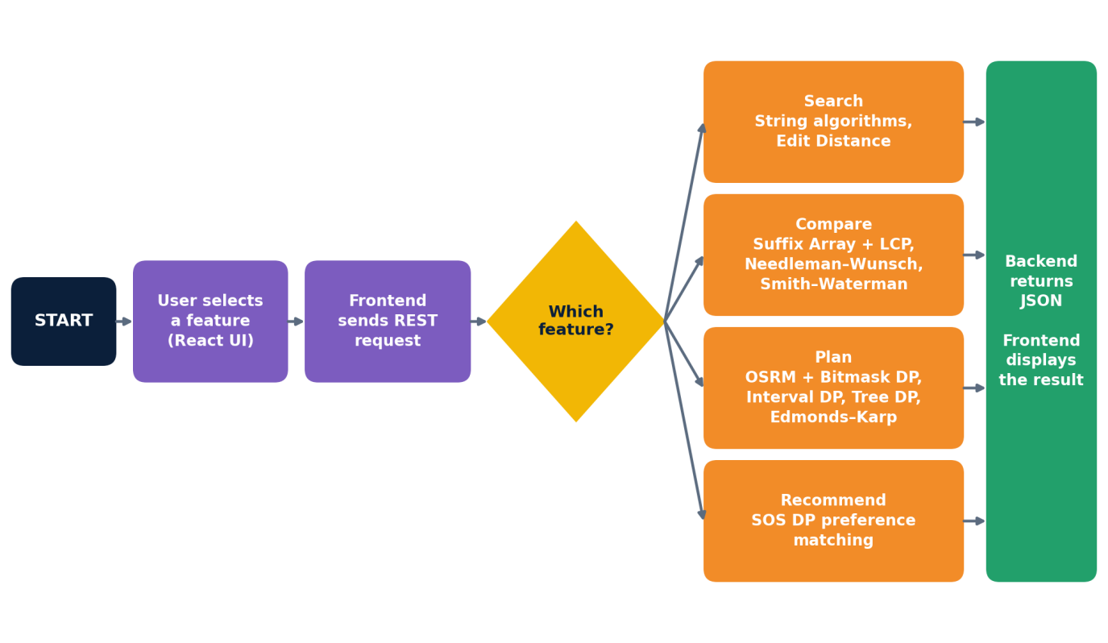
Diagram – end-to-end workflow of the system.

Figure 3: Itinerary Optimization Workflow

Diagram – steps of the itinerary optimization algorithm.
Figure 4: Flow Network
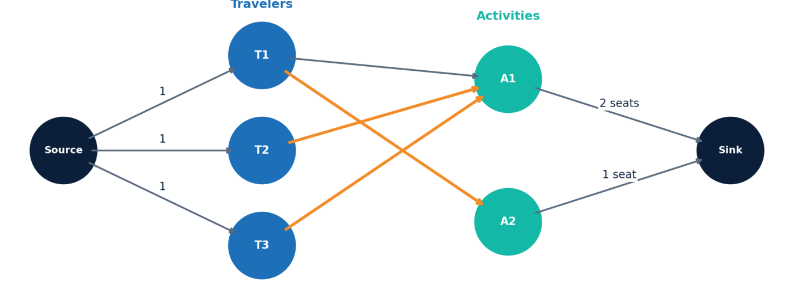
Diagram – illustrative flow network; orange edges show one maximum assignment.
Figure 5: Home Page
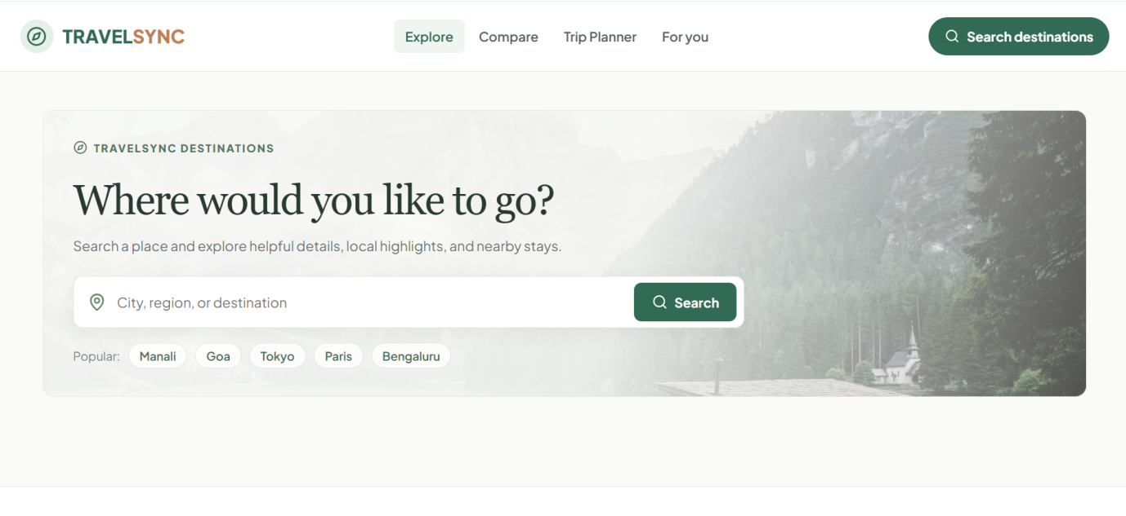
Screenshot – landing page to search for a place, region or destination.

Figure 6: Search Results
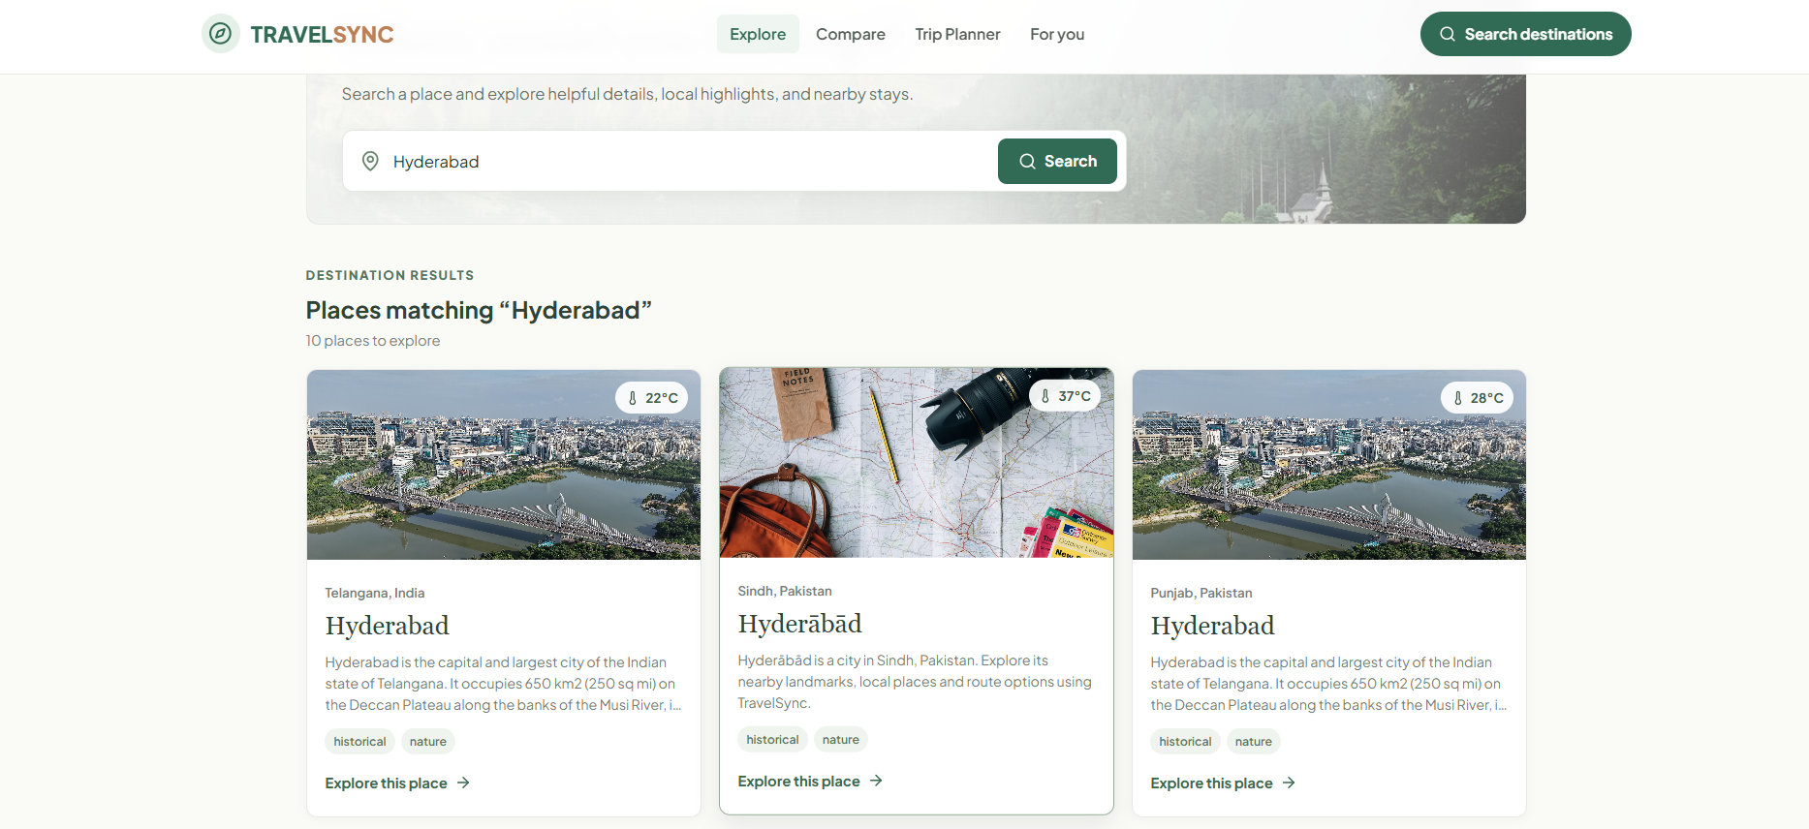
Screenshot – destination cards matching the search “Hyderabad”.
Figure 7: Destination Details
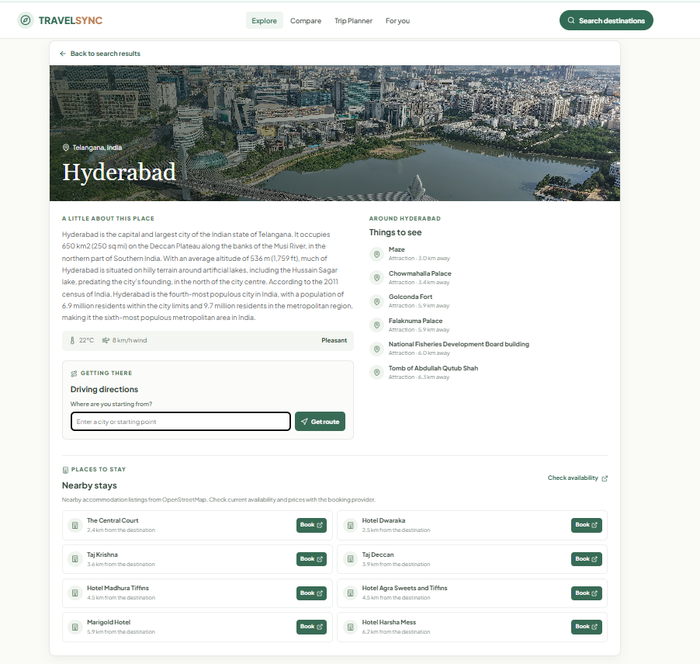
Screenshot – overview, things to do, driving directions and nearby stays.

Figure 8: Driving Directions
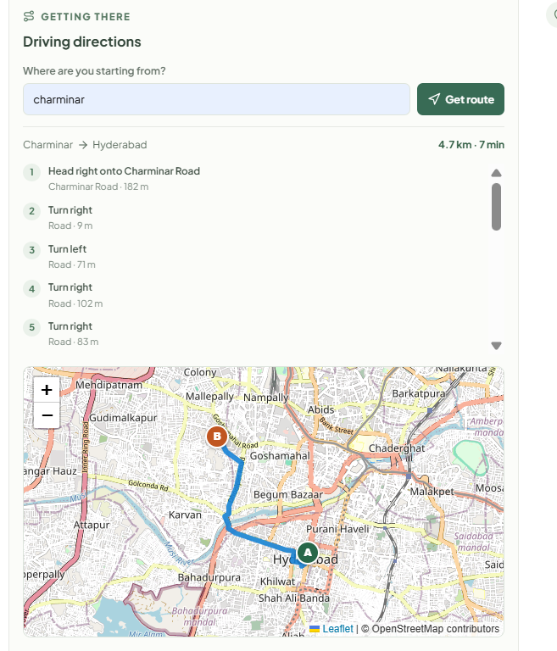
Screenshot – turn-by-turn directions with the route shown on a map.
Figure 9: Route Planner
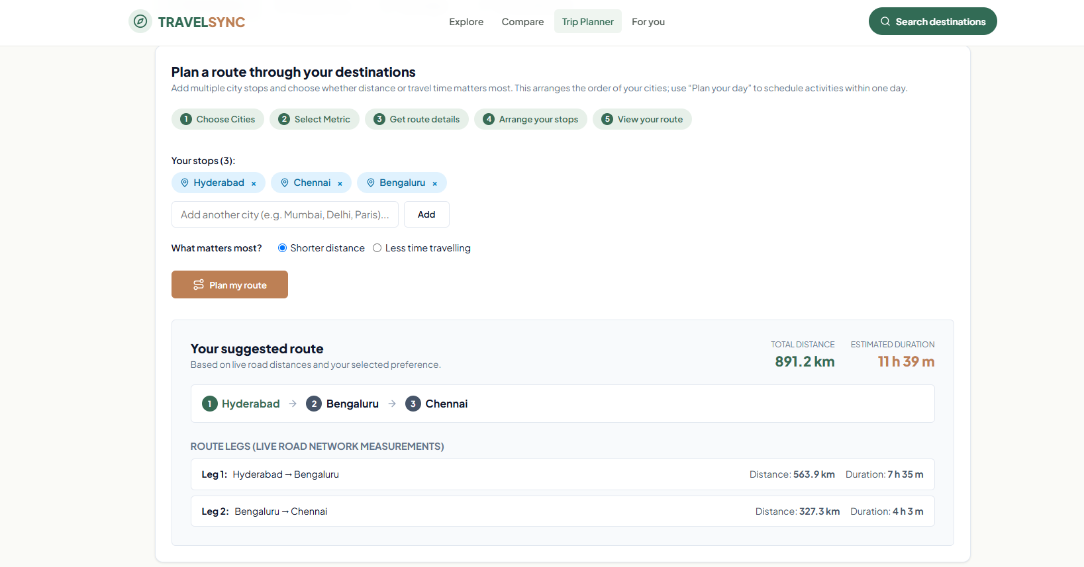
Screenshot – suggested multi-city route with distance and travel time.

Figure 10: Nearby Stays
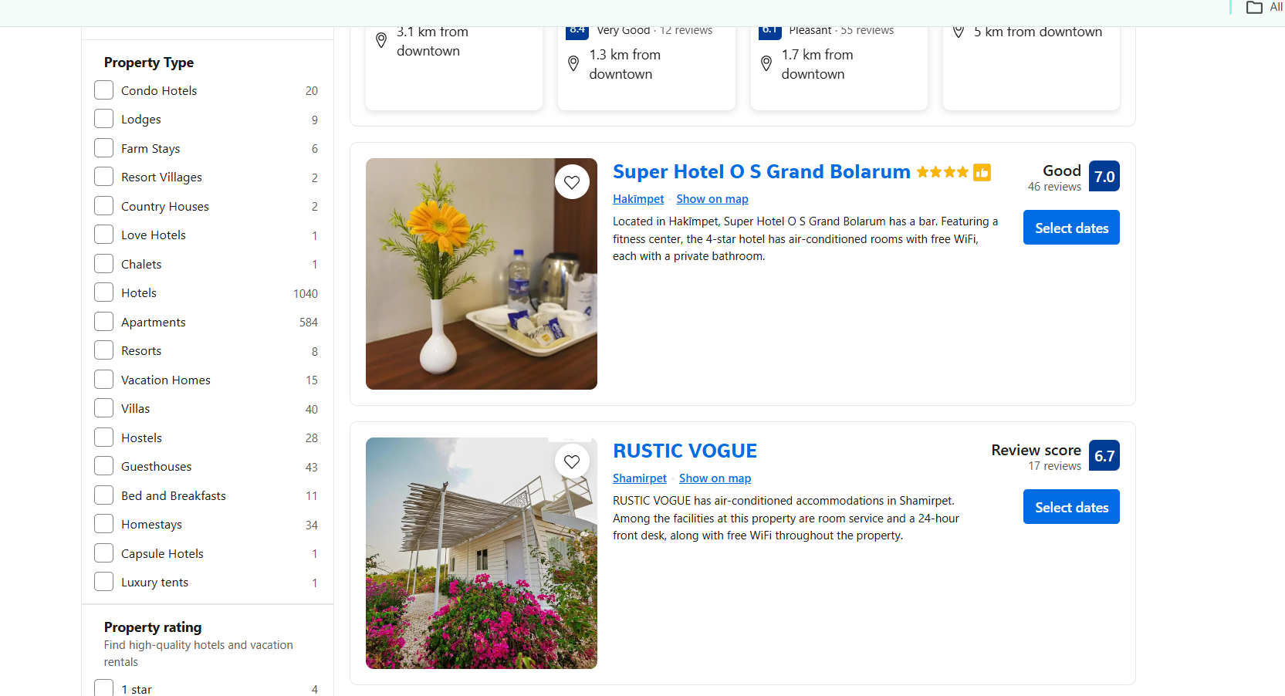
Screenshot – accommodation listing with property-type and rating filters.
Figure 11: Day Planner
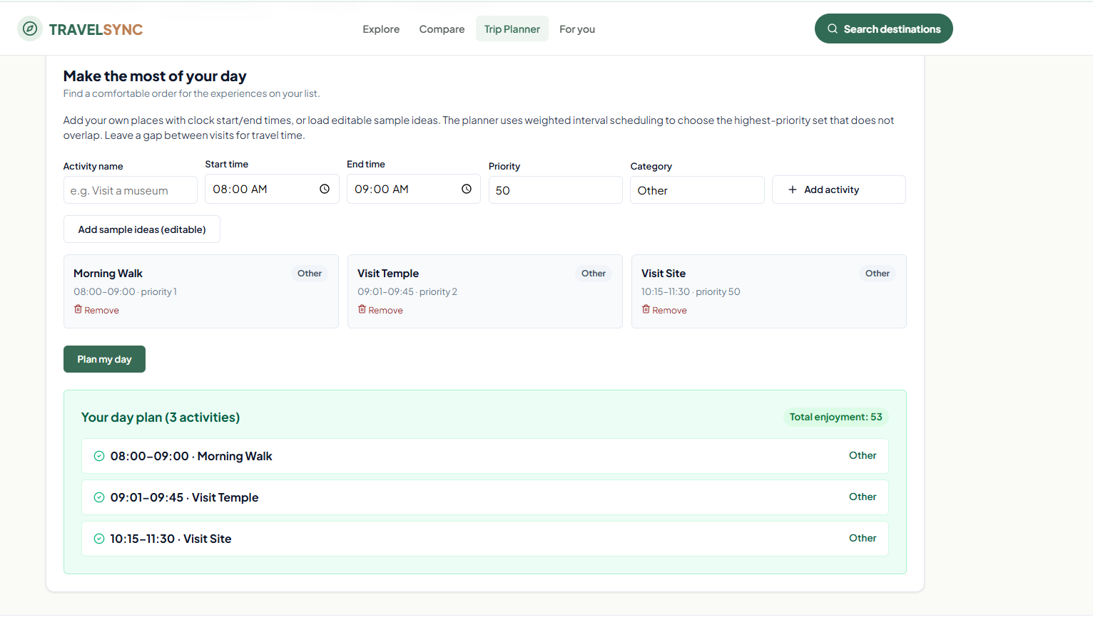
Screenshot – optimized daily itinerary built from the chosen activities.

Figure 12: Budget Planner
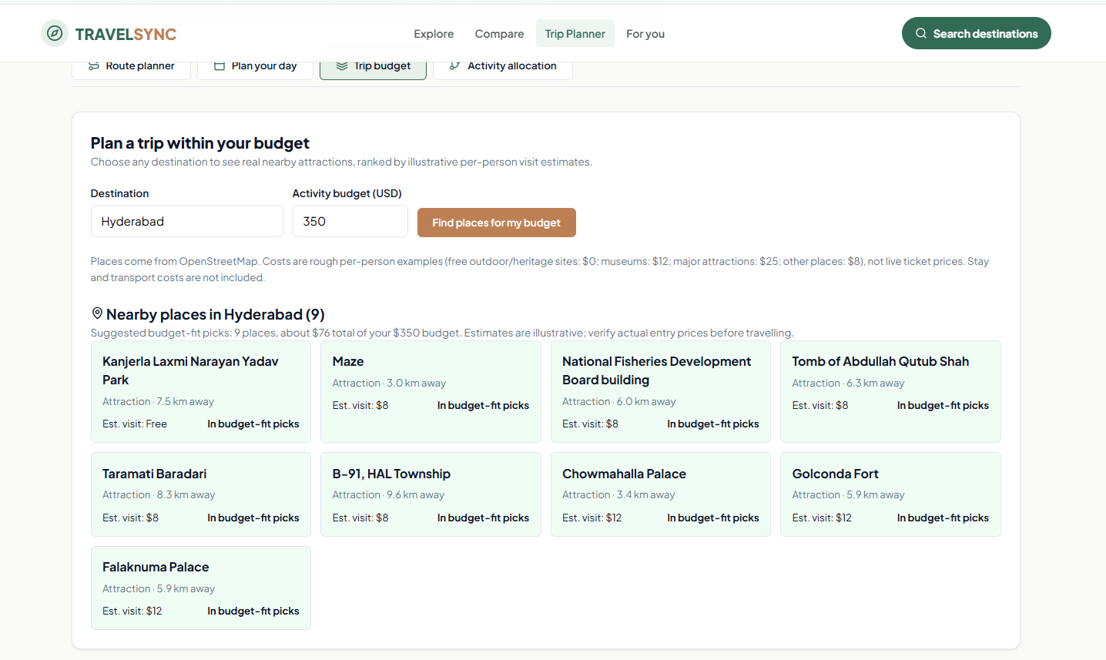
Screenshot – nearby places suggested within the entered budget.
Figure 13: Traveler–Activity Matching
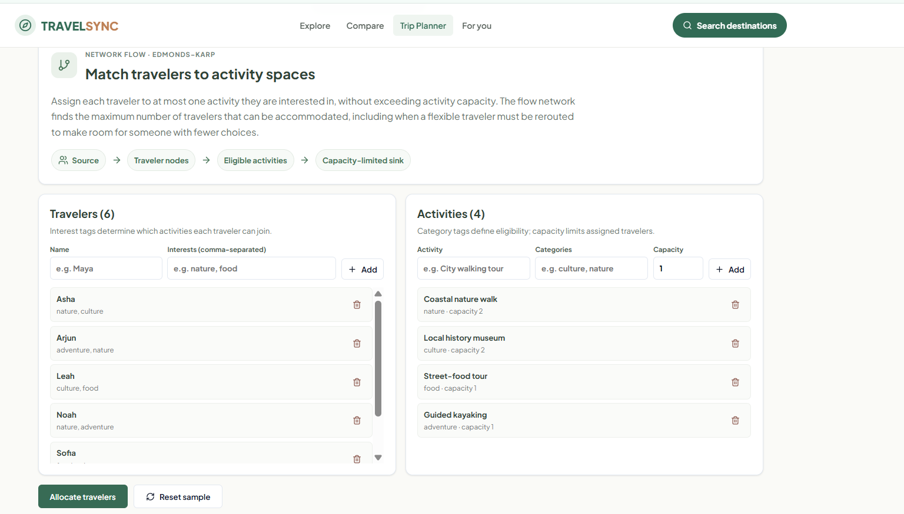
Screenshot – travelers allocated to activity spaces using network flow.

Figure 14: Personalized Recommendations
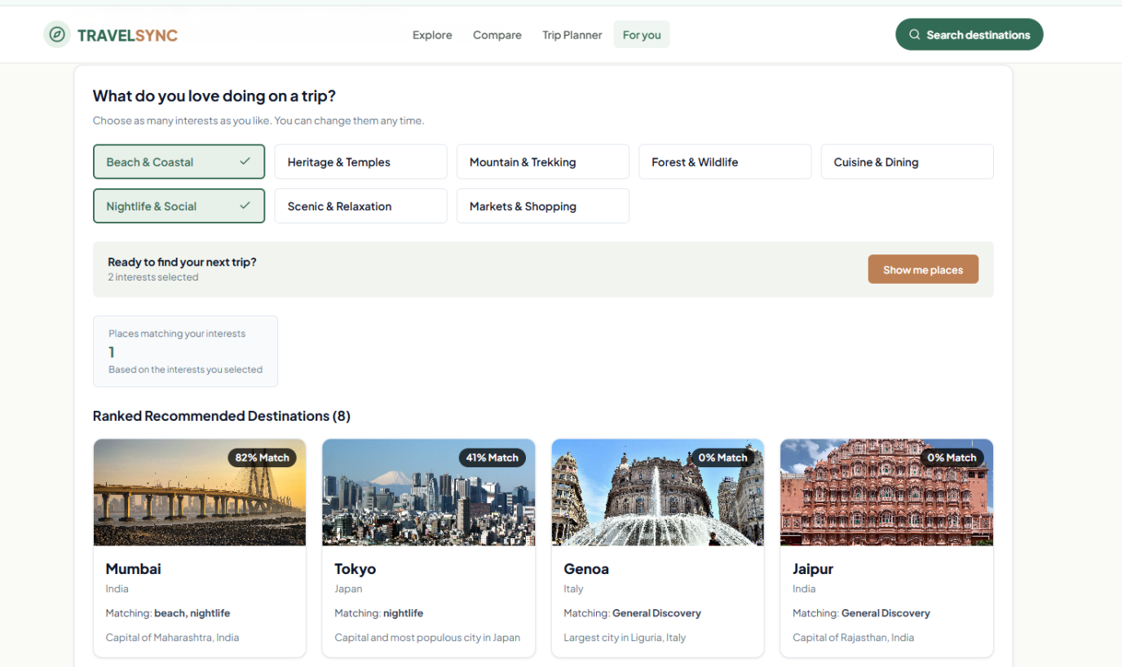
Screenshot – ranked destination recommendations based on preferences.

