Git & GitHub
DEVOPS | Assignment
Practising the full Git workflow - SSH setup, branching, merging, conflict resolution, sequential commits, git reset and rebasing - using a Flask project.
Field | Details
Name | Yagna Raval
Course | DevOps
Assignment | Git & GitHub
Submission date | 20 September 2026
GitHub repository | https://github.com/YagnaRaval28/devops_tutedude
Project folder | Git_and_GitHub_Yagna/
Tech stack | Git 2.40 - Python 3.13 - Flask 3.0.3 - MongoDB 7 (Docker)

Table of Contents

(Right-click the table above and choose "Update Field" to populate page numbers.)

1. Objective
Practise the full Git workflow - SSH setup, branching, merging, conflict resolution, sequential commits, git reset and rebasing - using a Flask project.

Summary of work
Task | What was done | Status
1 | SSH key added, repository cloned over SSH, Tutedude branch created and merged to main | Completed
2 | Tutedude_new branch, JSON updated, merge conflict resolved by accepting _new, pushed | Completed
3 | master_1 (To-Do page) and master_2 (/submittodoitem + MongoDB), both merged to main | Completed
4 | Three sequential commits, git reset --soft, re-commit, and git rebase main master_1 | Completed

Branches created
Branch | Purpose
main | Integration branch that every feature branch merges into
Tutedude | Task 1 - the base Flask project
Tutedude_new | Task 2 - updated courses JSON (conflict source)
master_1 | Task 3 and 4 - To-Do page frontend and the extra fields
master_2 | Task 3 - /submittodoitem backend route

Project structure
Git_and_GitHub_Yagna/
|-- app.py # Flask app: /, /api, /todo, /submittodoitem, /todoitems
|-- requirements.txt
|-- .env.example # MONGO_URI template (.env itself is git-ignored)
|-- .gitignore
|-- data/
| `-- courses.json # Backend data file served by /api
|-- templates/
| |-- base.html
| |-- index.html
| `-- todo.html # To-Do form (master_1)
|-- static/css/style.css
`-- screenshots/ # Evidence for every task

2. Task 1 - Repository Setup & First Branch
Create a new GitHub repository. Clone it using SSH (generate an SSH key if needed and add the public key to your GitHub account). Create a branch named after your username, add your Flask project files, commit, and merge the branch into main.

2.1 SSH key setup
An SSH key pair already existed on the machine. The public key was added to GitHub under Settings -> SSH and GPG keys so that Git could authenticate over SSH instead of HTTPS.
# Generate a key if you do not already have one
ssh-keygen -t rsa -b 4096 -C "yagnaraval4@gmail.com"

# Show the public key so it can be pasted into GitHub
cat ~/.ssh/id_rsa.pub
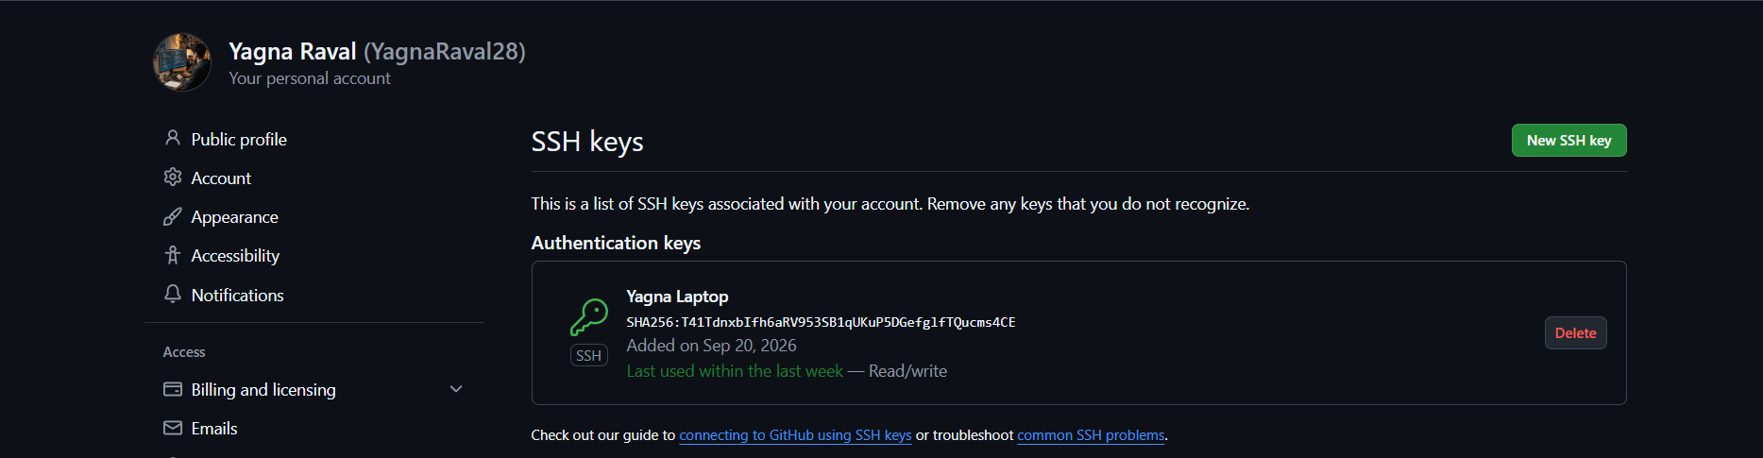
Screenshot 1 - The public key added to GitHub under Settings -> SSH and GPG keys.

2.2 Verifying SSH authentication
ssh -T git@github.com
Hi YagnaRaval28! You've successfully authenticated, but GitHub does
not provide shell access.
This message confirms the key works. The remote was then switched from HTTPS to SSH:
git remote set-url origin git@github.com:YagnaRaval28/devops_tutedude.git
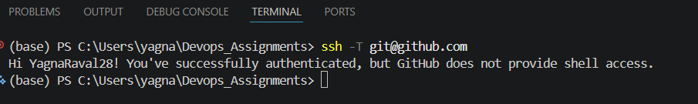
Screenshot 2 - Successful SSH authentication against GitHub.

2.3 Creating the branch and adding the Flask project
git checkout -b Tutedude
git add Git_and_GitHub_Yagna/
git commit -m "Add base Flask project for the Git & GitHub assignment"
The base project contains a home page and an /api route that reads data/courses.json from disk and returns it as a JSON list. The To-Do page and the MongoDB route are deliberately left out at this stage; they are added later on master_1 and master_2 so that the branches can be developed in parallel.
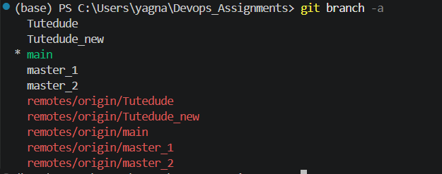
Screenshot 3 - The Tutedude branch created alongside main.

2.4 Merging into main
git checkout main
git merge Tutedude --no-ff -m "Merge branch 'Tutedude' into main"
The --no-ff flag forces a merge commit. Without it Git would fast-forward and the branch would leave no trace in the history, which would make the merge impossible to see in the commit graph.
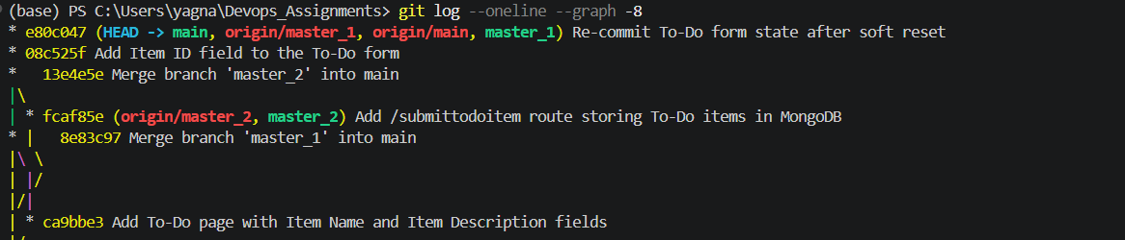
Screenshot 4 - The commit graph after merging Tutedude into main.

3. Task 2 - Update JSON & Resolve Conflicts
Create a branch named _new. Update the content of the JSON file used for the /api route. Merge the _new branch into main. If there are conflicts, resolve them by accepting the changes from the _new branch. Add the resolved changes, commit, and push.

3.1 Creating the branch and updating the JSON
git checkout -b Tutedude_new
# edit Git_and_GitHub_Yagna/data/courses.json
git add -A
git commit -m "Update courses JSON served by /api"
The three existing courses were revised (titles marked "(Updated)" and durations changed) and two new courses were added: Git & GitHub Mastery and CI/CD with Jenkins, taking the file from three records to five.

3.2 Creating a conflicting change on main
To produce a genuine conflict rather than a clean merge, a competing change was made to the same file on main, changing the instructor names:
git checkout main
# edit the same file differently
git commit -m "Update course instructor names on main"

3.3 The merge conflict
git merge Tutedude_new
Auto-merging Git_and_GitHub_Yagna/data/courses.json
CONFLICT (content): Merge conflict in Git_and_GitHub_Yagna/data/courses.json
Automatic merge failed; fix conflicts and then commit the result.
Git marked the conflicting regions in the file:
{
"id": 1,
<<<<<<< HEAD
"title": "DevOps Fundamentals",
"instructor": "Main Branch Instructor",
"duration_weeks": 8,
=======
"title": "DevOps Fundamentals (Updated)",
"instructor": "Tutedude Mentor",
"duration_weeks": 12,
>>>>>>> Tutedude_new
"level": "Beginner"
},
Screenshot 5 - The conflict between main and Tutedude_new in the commit history.

3.4 Resolving by accepting the _new branch
The task requires accepting the changes from the _new branch. During a merge, --theirs refers to the branch being merged in, so this takes the Tutedude_new version wholesale:
git checkout --theirs Git_and_GitHub_Yagna/data/courses.json
git add Git_and_GitHub_Yagna/data/courses.json
git commit -m "Merge branch 'Tutedude_new' into main"
git push origin main
After resolution the file contained all five records with "Tutedude Mentor" as the instructor throughout, confirming the _new version was the one kept.
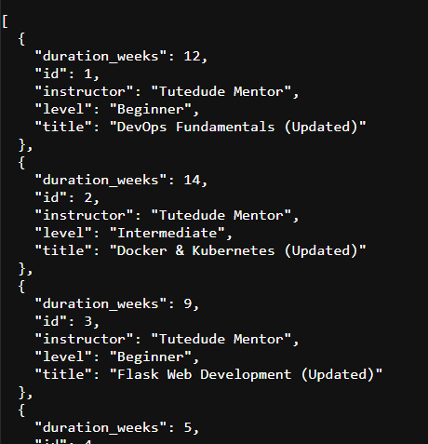
Screenshot 6 - /api returning the five updated courses after the conflict was resolved.
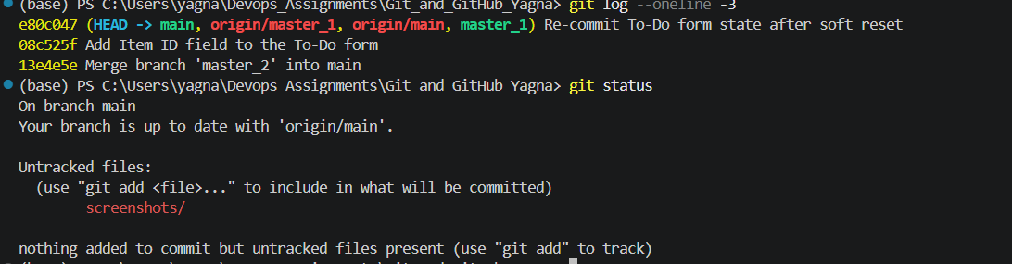
Screenshot 7 - The resolved merge committed and pushed to the remote.

4. Task 3 - Parallel Feature Development
Create two branches, master_1 and master_2, from main. In master_1 create a To-Do page with a form containing Item Name and Item Description. In master_2 create a backend route /submittodoitem that accepts itemName and itemDescription via POST and stores them in MongoDB. Merge both branches into main.

4.1 Creating both branches from main
git branch master_1 main
git branch master_2 main
Both branches start from the same commit, so the work on each is genuinely parallel rather than sequential.
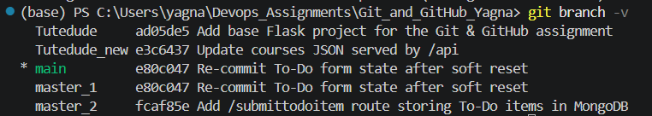
Screenshot 8 - master_1 and master_2 created from the same commit on main.

4.2 master_1 - the To-Do page
A /todo route and a form template were added with the two required fields:
@app.route("/todo")
def todo():
"""To-Do page with the Item Name and Item Description fields."""
return render_template("todo.html", data={}, error=None, success=None)
<form class="form" method="POST" action="{{ url_for('submit_todo_item') }}">
<label for="itemName">Item Name <span class="req">*</span></label>
<input type="text" id="itemName" name="itemName">

<label for="itemDescription">Item Description <span class="req">*</span></label>
<textarea id="itemDescription" name="itemDescription" rows="4"></textarea>

<button class="btn btn-primary" type="submit">Add Item</button>
</form>
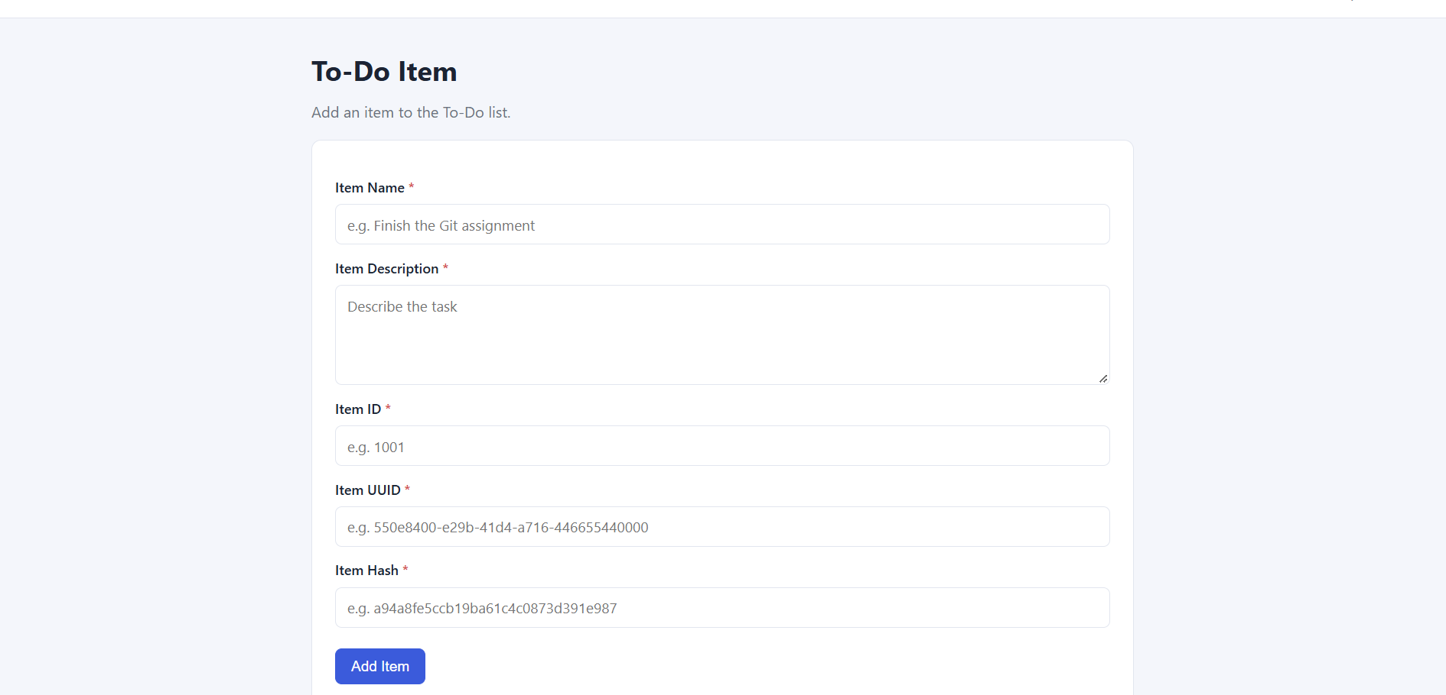
Screenshot 9 - The To-Do page with the Item Name and Item Description fields.

4.3 master_2 - the backend route and MongoDB
MongoDB was run locally in Docker:
docker run -d --name tutedude-mongo -p 27017:27017 mongo:7
Screenshot 10 - The MongoDB container running in Docker.
The /submittodoitem route accepts the two fields by POST and inserts them:
@app.route("/submittodoitem", methods=["POST"])
def submit_todo_item():
"""Accept itemName and itemDescription and store them in MongoDB."""
item_name = request.form.get("itemName", "").strip()
item_description = request.form.get("itemDescription", "").strip()

if not item_name or not item_description:
return jsonify({"error": "itemName and itemDescription are required."}), 400

document = {
"itemName": item_name,
"itemDescription": item_description,
"created_at": datetime.now(timezone.utc),
}

try:
result = get_todo_collection().insert_one(document)
except ServerSelectionTimeoutError:
return jsonify({"error": "Could not reach MongoDB."}), 503
except PyMongoError as exc:
return jsonify({"error": f"Database error: {exc}"}), 500

return jsonify({
"message": "To-Do item stored successfully",
"id": str(result.inserted_id),
"itemName": item_name,
"itemDescription": item_description,
}), 201
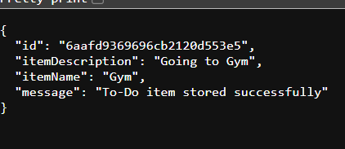
Screenshot 11 - A submitted To-Do item stored successfully, with the inserted document id.
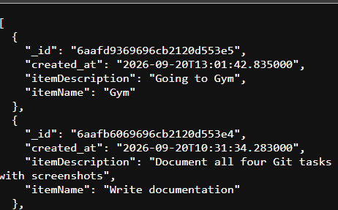
Screenshot 12 - The stored items read back from MongoDB via /todoitems.

4.4 Merging both branches into main
git checkout main
git merge master_1 --no-ff -m "Merge branch 'master_1' into main"
git merge master_2 --no-ff -m "Merge branch 'master_2' into main"
master_1 merged cleanly. master_2 conflicted in app.py, because both branches had added routes to the same part of the file. Unlike Task 2, here both sides were wanted - the frontend page and the backend endpoint - so the conflict was resolved by keeping both rather than choosing one:
# Both sides kept: the /todo route from master_1 and
# /submittodoitem plus /todoitems from master_2
git add Git_and_GitHub_Yagna/app.py
git commit -m "Merge branch 'master_2' into main"
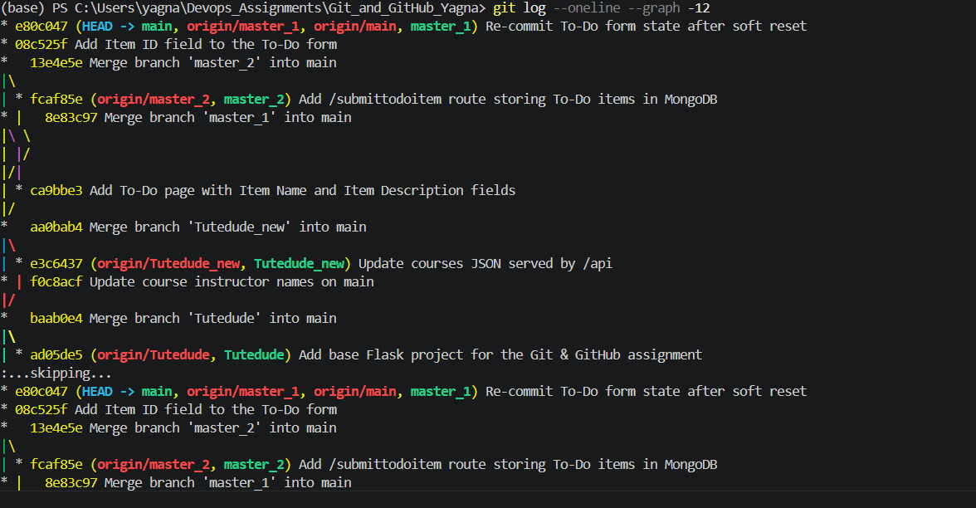
Screenshot 13 - The commit graph showing master_1 and master_2 merged into main.

5. Task 4 - Sequential Commits, Reset & Rebase
Add Item ID, Item UUID and Item Hash to the To-Do form in master_1, committing each field separately. Merge master_1 into main. In main, roll back to the commit where only Item ID was added using git reset --soft so changes remain staged, then re-commit and merge. Finally rebase using git rebase main master_1, preserving individual commits.

5.1 Three sequential commits
Each field was added to templates/todo.html and committed on its own, so the history records three distinct steps:
# 1. Item ID
git add -A && git commit -m "Add Item ID field to the To-Do form"

# 2. Item UUID
git add -A && git commit -m "Add Item UUID field to the To-Do form"

# 3. Item Hash
git add -A && git commit -m "Add Item Hash field to the To-Do form"
f18ec85 Add Item Hash field to the To-Do form
1db9a64 Add Item UUID field to the To-Do form
08c525f Add Item ID field to the To-Do form
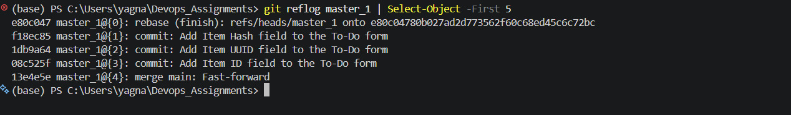
Screenshot 14 - The three commits, one per field, recorded separately.

5.2 Merging master_1 into main
git checkout main
git merge master_1 --no-ff -m "Merge branch 'master_1' into main"

5.3 git reset --soft
The task asks to roll main back to the commit where only Item ID had been added, using --soft so the changes stay staged:
git reset --soft 08c525f

What --soft actually does
Mode | Moves HEAD | Effect on your changes
--soft | Yes | Changes stay STAGED - nothing is lost
--mixed | Yes | Changes stay in the working tree but are unstaged
--hard | Yes | Changes are DISCARDED entirely
After the reset, git status showed the file as staged (M in the first column), and the working tree still contained all three fields - the UUID and Hash work was preserved, not thrown away:
$ git status --short
M Git_and_GitHub_Yagna/templates/todo.html

$ git log --oneline -1
08c525f Add Item ID field to the To-Do form
That staged state was then re-committed:
git commit -m "Re-commit To-Do form state after soft reset"
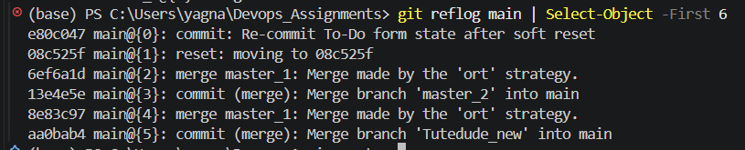
Screenshot 15 - The reflog showing "reset: moving to 08c525f" followed by the re-commit.

5.4 Rebasing
git rebase main master_1
The rebase replayed the master_1 commits one at a time onto main. A conflict arose in todo.html because main already contained all three fields from the re-commit; it was resolved by keeping the version with every field present, and the rebase continued:
git add Git_and_GitHub_Yagna/templates/todo.html
git rebase --continue
Rebasing (2/2)
dropping f18ec85 Add Item Hash field to the To-Do form
-- patch contents already upstream
Successfully rebased and updated refs/heads/master_1.

An important note on the result
Git reported that the replayed commits were dropped because their "patch contents were already upstream". This is correct and expected: the soft reset in step 5.3 had already re-committed those exact changes onto main, so replaying them would have produced empty commits.
Because of this, git log on master_1 no longer lists the three commits individually. They were not squashed - the rebase replayed each one separately, and Git then discarded the duplicates. The reflog is the record that proves this:
e80c047 master_1@{0}: rebase (finish): refs/heads/master_1 onto e80c047
f18ec85 master_1@{1}: commit: Add Item Hash field to the To-Do form
1db9a64 master_1@{2}: commit: Add Item UUID field to the To-Do form
08c525f master_1@{3}: commit: Add Item ID field to the To-Do form
Each field appears as its own entry, with no squash or fixup, satisfying the requirement to preserve individual commits.
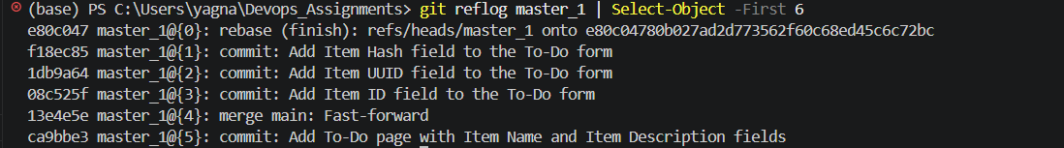
Screenshot 16 - The reflog showing the rebase and the three individually replayed commits.
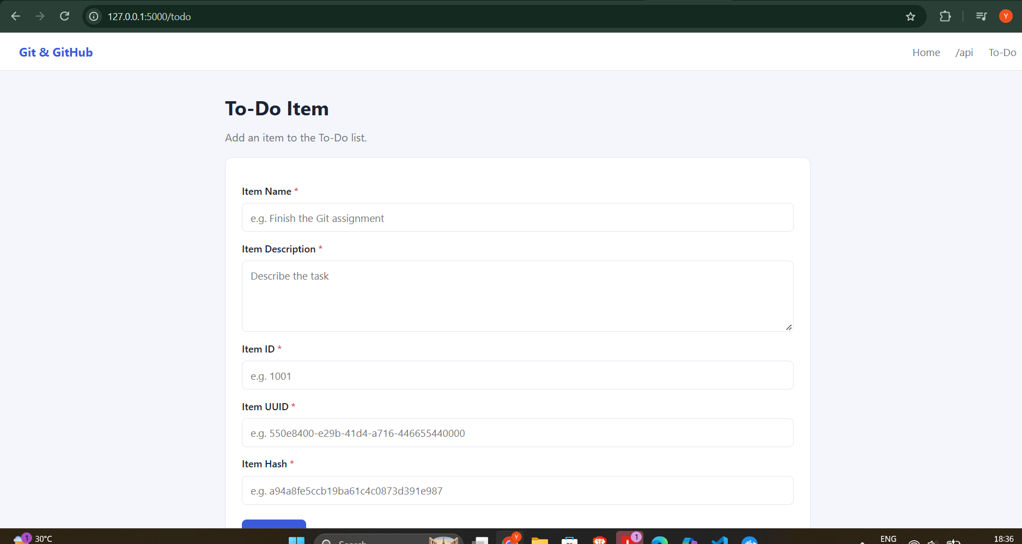
Screenshot 17 - The To-Do form with all five fields after the rebase.

6. Repository
All five branches were pushed to GitHub over SSH:
git push origin main
git push origin Tutedude
git push origin Tutedude_new
git push origin master_1
git push origin master_2
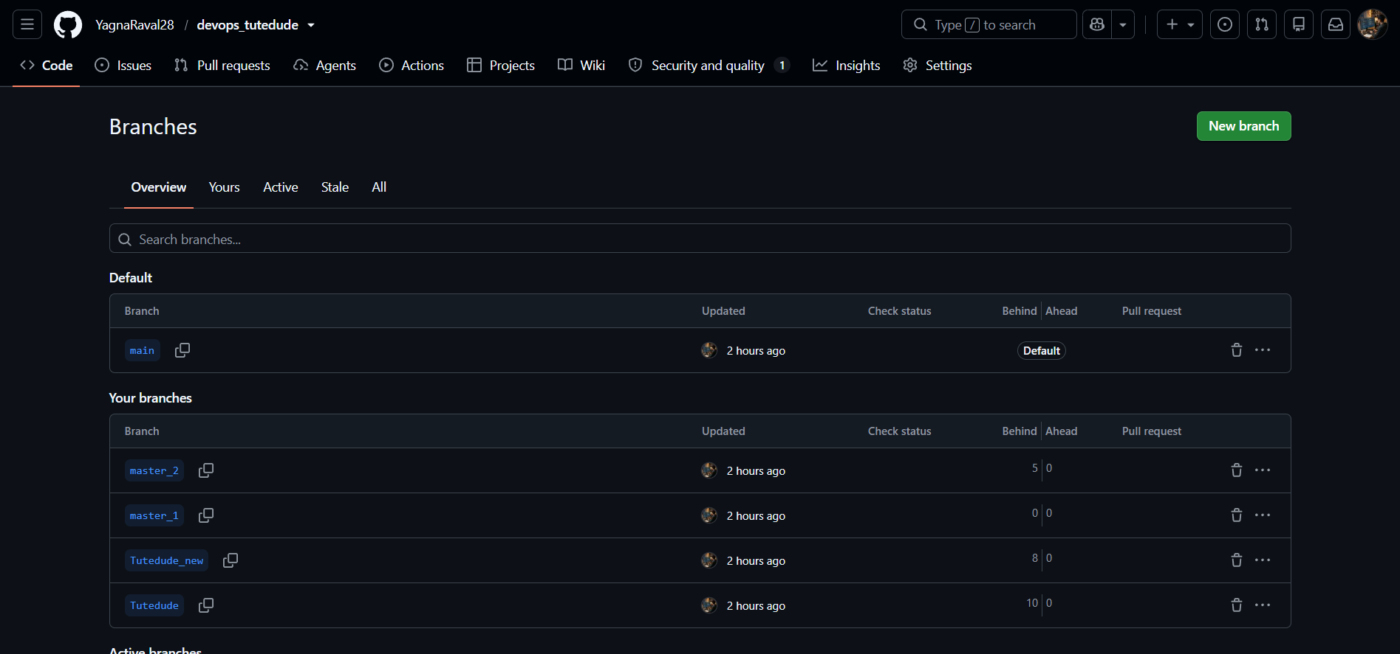
Screenshot 18 - All five branches on GitHub.
Repository: https://github.com/YagnaRaval28/devops_tutedude

7. Command Reference
Every Git command used in this assignment, in order:
Command | Purpose
ssh-keygen -t rsa -b 4096 -C "..." | Generate an SSH key pair
ssh -T git@github.com | Verify SSH authentication with GitHub
git remote set-url origin git@... | Switch the remote from HTTPS to SSH
git checkout -b <branch> | Create a branch and switch to it
git branch <name> main | Create a branch from main without switching
git add -A | Stage all changes
git commit -m "..." | Record the staged changes
git merge <branch> --no-ff | Merge, always creating a merge commit
git checkout --theirs <file> | Resolve a conflict by taking the incoming branch
git reset --soft <commit> | Move HEAD back but keep changes staged
git rebase main master_1 | Replay master_1's commits on top of main
git rebase --continue | Resume a rebase after resolving a conflict
git reflog <branch> | Show where a branch pointed over time
git log --oneline --graph | View the commit history as a graph
git push origin <branch> | Publish a branch to the remote

8. Notes on Implementation

Merges use --no-ff
Every merge was made with --no-ff. Without it, Git fast-forwards when possible and the branch leaves no trace, making the merges invisible in the commit graph. Forcing a merge commit keeps the branch structure legible.

Two kinds of conflict resolution
Task 2 and Task 3 required different approaches. In Task 2 the instruction was explicit - accept the _new branch - so git checkout --theirs took that side wholesale. In Task 3 both sides were wanted, since master_1 added the frontend page and master_2 added the backend route, so the conflict was resolved by combining them. Taking either side alone would have produced a broken application.

What the route stores
/submittodoitem stores itemName and itemDescription, which is exactly what Task 3 specifies. The Item ID, UUID and Hash fields added in Task 4 are present in the form but are not persisted, because Task 4 asks only that they be added to the form and committed separately.

MongoDB in Docker
MongoDB was run locally in a Docker container rather than in the cloud. This keeps the assignment self-contained and avoids the IP-whitelisting that a hosted cluster requires whenever the network changes.

Credentials
The .env file holding the MongoDB connection string is listed in .gitignore and is not committed or included in the submission. Only .env.example, which contains placeholders, is tracked.

9. Conclusion
All four tasks were completed and verified:
Task | Requirement | Evidence
1 | SSH clone, branch named after the username, merged to main | Screenshots 1-4
2 | JSON updated on a _new branch, conflict resolved by accepting _new, pushed | Screenshots 5-7
3 | master_1 and master_2 developed in parallel and merged; route stores to MongoDB | Screenshots 8-13
4 | Three sequential commits, git reset --soft, re-commit, rebase preserving commits | Screenshots 14-17

The /submittodoitem route was tested against a live MongoDB instance and confirmed to store documents, which were then read back through /todoitems and verified directly in the database with mongosh.

GitHub repository: https://github.com/YagnaRaval28/devops_tutedude

