Docker
DEVOPS | Assignment
Containerizing a full-stack application - a Node.js/Express frontend and a Flask backend - using Docker and Docker Compose, then pushing the images to Docker Hub and the code to GitHub.
Field | Details
Name | Yagna Raval
Course | DevOps
Assignment | Docker
Submission date | 21 September 2026
GitHub repository | https://github.com/YagnaRaval28/devops_tutedude
Docker Hub (frontend) | yagnaraval/docker-assignment-frontend
Docker Hub (backend) | yagnaraval/docker-assignment-backend
Tech stack | Node.js 20 - Express 4 - Python 3.12 - Flask 3 - Docker Compose

Table of Contents

(Right-click the table above and choose "Update Field" to populate page numbers.)

1. Objective
Containerize a full-stack application - a Node.js/Express frontend and a Flask backend - using Docker and Docker Compose, then push the images to Docker Hub and the code to GitHub.

Requirements checklist
# | Requirement | Status
1 | Create a frontend using Express and Node.js | Completed
2 | Include a form similar to the Flask assignment | Completed
3 | Configure the form to send a request to the Flask backend | Completed
4 | Flask backend handles the submission and processes the data | Completed
5 | Separate folders for frontend and backend | Completed
6 | A Dockerfile for both services | Completed
7 | Docker Compose connecting both on the same network | Completed
8 | Images on Docker Hub, code on GitHub, node_modules git-ignored | Completed

Architecture
+------------------------------------------+
Browser | docker network: app-network |
| | |
| :3000 | +----------------+ +---------------+ |
+---------------> | frontend |-->| backend | |
| | Express/Node | | Flask | |
| | :3000 | | :5000 | |
| +----------------+ +---------------+ |
| http://backend:5000 |
+------------------------------------------+
The frontend reaches the backend at http://backend:5000 - the Compose service name, resolved by Docker's internal DNS. Using localhost would fail, because inside a container localhost refers to that container itself, not to the host or to a sibling service.

2. Folder Structure
Organize the project with separate folders for the frontend and backend.
Docker_Yagna/
|-- docker-compose.yaml # Connects both services on one network
|-- .gitignore # Excludes node_modules, .vscode, .env
|-- README.md
|
|-- frontend/ # Express + EJS
| |-- Dockerfile
| |-- .dockerignore
| |-- package.json
| |-- package-lock.json
| |-- server.js # Forwards form data to the Flask backend
| |-- views/
| | |-- index.ejs # The registration form
| | |-- success.ejs
| | `-- submissions.ejs
| `-- public/css/style.css
|
|-- backend/ # Flask
| |-- Dockerfile
| |-- .dockerignore
| |-- requirements.txt
| `-- app.py # Validates and processes submissions
|
`-- screenshots/
Each service owns its folder, its dependencies and its Dockerfile, so either can be built and deployed independently of the other.

3. Frontend - Node.js with Express
Create a frontend using Express and Node.js. Include a form similar to the one from the Flask assignment. Configure the form to send a request to the Flask backend.

3.1 The server
The backend URL comes from the BACKEND_URL environment variable, which Compose sets. Hard-coding it would tie the image to one environment:
const express = require("express");
const app = express();

const PORT = process.env.PORT || 3000;
const BACKEND_URL = process.env.BACKEND_URL || "http://localhost:5000";

app.set("view engine", "ejs");
app.use(express.urlencoded({ extended: true }));
app.use(express.json());

3.2 Forwarding the form to Flask
app.post("/submit", async (req, res) => {
const courses = await fetchCourses();

let result;
try {
const response = await fetch(`${BACKEND_URL}/api/submit`, {
method: "POST",
headers: { "Content-Type": "application/json" },
body: JSON.stringify(req.body),
signal: AbortSignal.timeout(8000),
});
result = await response.json();

// The backend rejected the data: re-render the form with its
// message and the values the user typed.
if (!response.ok) {
return res.status(response.status).render("index", {
courses, data: req.body, error: result.error, backendUrl: BACKEND_URL,
});
}
} catch (err) {
return res.status(503).render("index", {
courses, data: req.body,
error: `Could not reach the backend service: ${err.message}`,
backendUrl: BACKEND_URL,
});
}

res.render("success", { result: result.data, message: result.message });
});
The form itself carries the same fields as the earlier Flask assignment - Name, Email, Phone, Course and Message - with the course list fetched from the backend rather than hard-coded in the frontend.
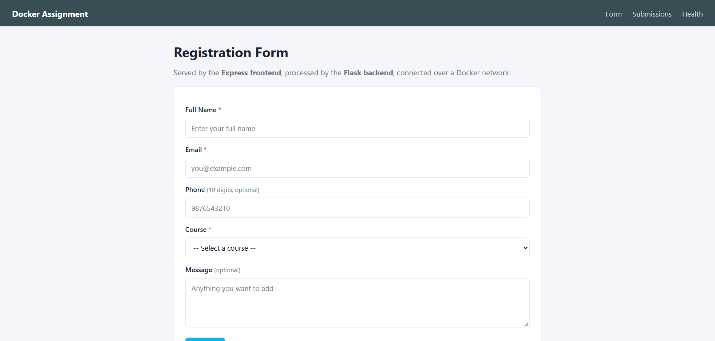
Screenshot 4 - The registration form served by the Express frontend.

4. Backend - Flask
Use the Flask backend to handle the form submission and process the data.
@app.route("/api/submit", methods=["POST"])
def api_submit():
"""Handle the form submission forwarded by the Express frontend."""
payload = request.get_json(silent=True) or request.form.to_dict()

cleaned, error = validate(payload)
if error:
return jsonify({"success": False, "error": error}), 400

cleaned["id"] = len(submissions) + 1
submissions.append(cleaned)

return jsonify({
"success": True,
"message": "Data submitted successfully",
"data": cleaned,
}), 201
Validation covers required fields, a minimum name length, email shape, a 10-digit phone number when supplied, and that the chosen course is one the backend actually offers. Anything invalid returns HTTP 400 with a message the frontend renders above the form.

Backend routes
Route | Method | Purpose
/health | GET | Used by the Compose healthcheck and the frontend status page
/api/courses | GET | The course list the frontend renders in its dropdown
/api/submit | POST | Validates and processes a form submission
/api/submissions | GET | Everything processed so far, newest first
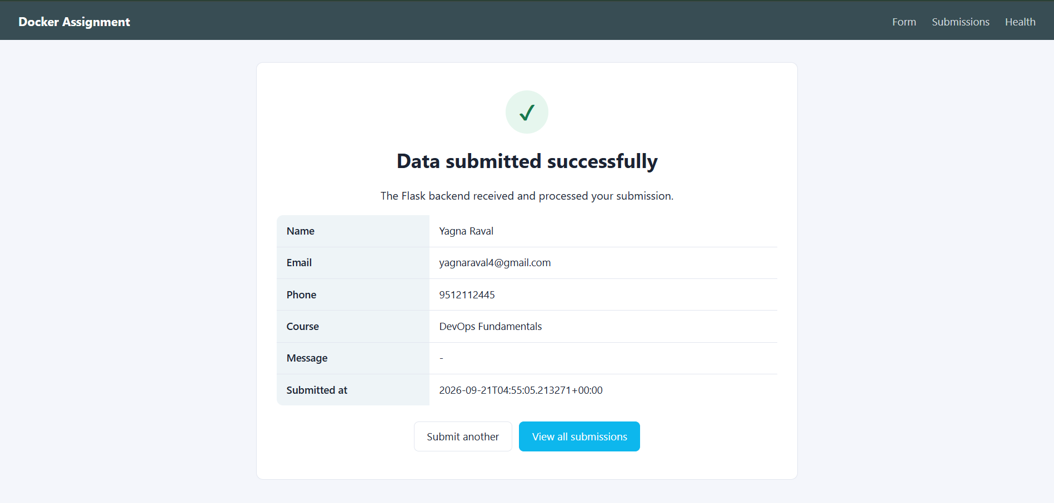
Screenshot 5 - The success page after the Flask backend processed the submission.
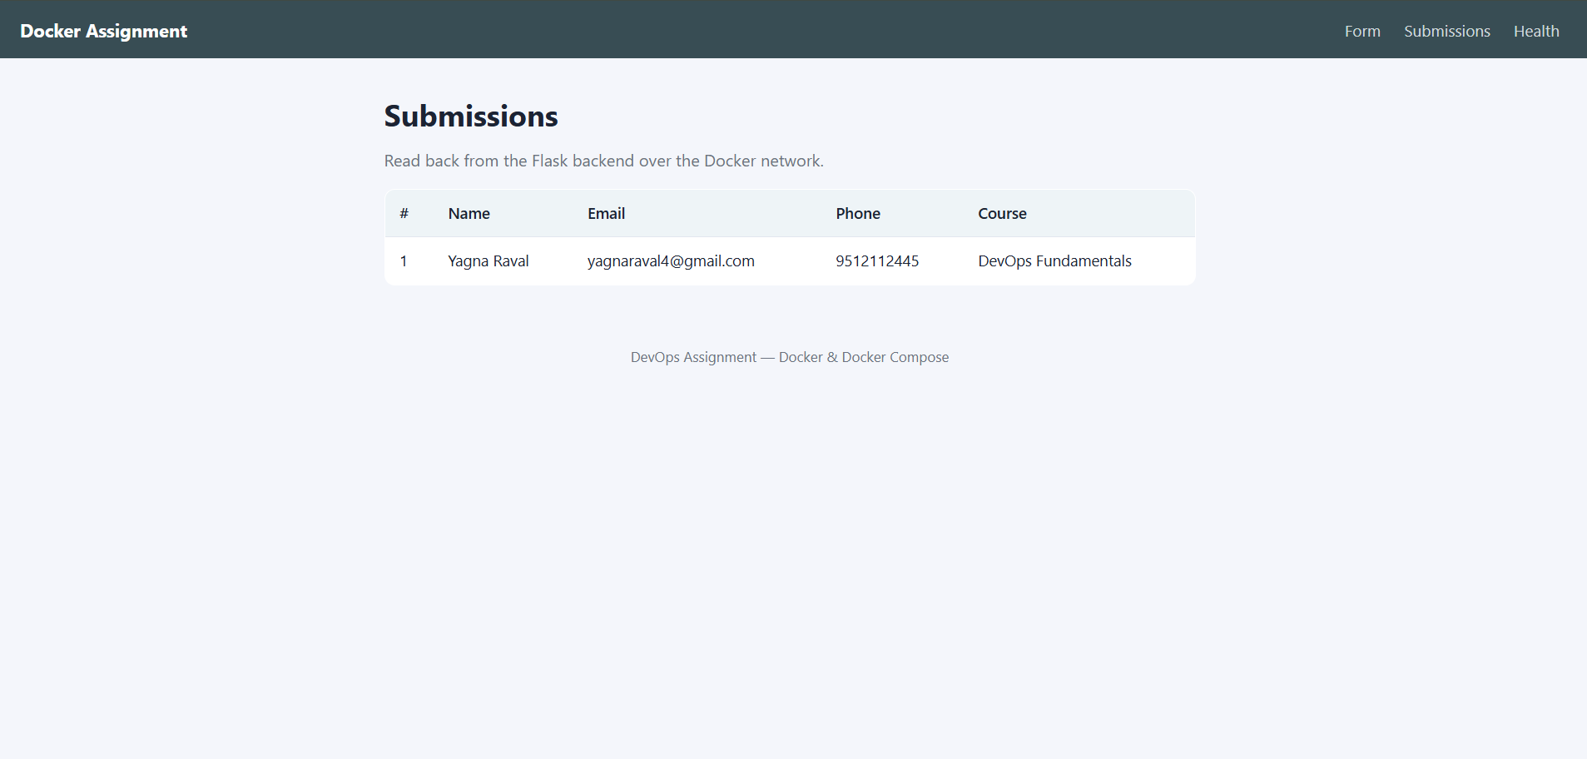
Screenshot 6 - Submissions read back from the backend through the frontend.

5. Docker Configuration
Create a Dockerfile for both the frontend and backend. Write a .yaml file (Docker Compose) to connect both services in the same network.

5.1 Frontend Dockerfile
FROM node:20-alpine

WORKDIR /app

# Copy the manifests first so this layer is cached: npm ci only re-runs
# when the dependencies actually change, not on every source edit.
COPY package*.json ./

# npm ci installs exactly what package-lock.json specifies, which makes
# the build reproducible. --omit=dev keeps devDependencies out.
RUN npm ci --omit=dev

COPY . .

# node:alpine ships a 'node' user; run as it rather than root.
USER node

EXPOSE 3000

HEALTHCHECK --interval=30s --timeout=5s --start-period=10s --retries=3 \
CMD wget --quiet --tries=1 --spider http://127.0.0.1:3000/health || exit 1

CMD ["node", "server.js"]

5.2 Backend Dockerfile
FROM python:3.12-slim

ENV PYTHONUNBUFFERED=1 \
PYTHONDONTWRITEBYTECODE=1

WORKDIR /app

COPY requirements.txt .
RUN pip install --no-cache-dir -r requirements.txt

COPY . .

RUN useradd --create-home --shell /bin/bash appuser \
&& chown -R appuser:appuser /app
USER appuser

EXPOSE 5000

HEALTHCHECK --interval=30s --timeout=5s --start-period=10s --retries=3 \
CMD python -c "import urllib.request; urllib.request.urlopen('http://127.0.0.1:5000/health')"

CMD ["gunicorn", "--bind", "0.0.0.0:5000", "--workers", "1", "app:app"]

5.3 Docker Compose
services:
backend:
build:
context: ./backend
dockerfile: Dockerfile
image: yagnaraval/docker-assignment-backend:latest
container_name: flask-backend
environment:
- PORT=5000
- FLASK_DEBUG=0
ports:
- "5001:5000"
networks:
- app-network
restart: unless-stopped
healthcheck:
test: ["CMD", "python", "-c", "import urllib.request; ..."]
interval: 30s

frontend:
build:
context: ./frontend
dockerfile: Dockerfile
image: yagnaraval/docker-assignment-frontend:latest
container_name: express-frontend
environment:
- PORT=3000
# 'backend' is the service name, resolved by Docker's DNS.
- BACKEND_URL=http://backend:5000
ports:
- "3000:3000"
networks:
- app-network
depends_on:
backend:
condition: service_healthy
restart: unless-stopped

networks:
app-network:
driver: bridge

5.4 Building and running
docker compose up --build -d
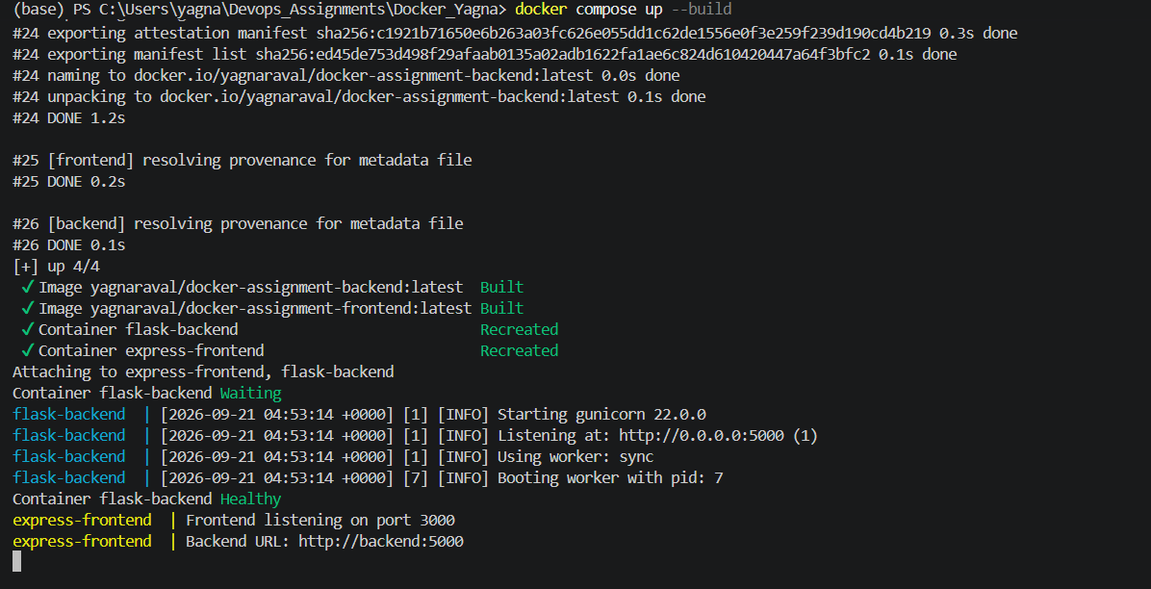
Screenshot 3 - Building both images and starting the stack.
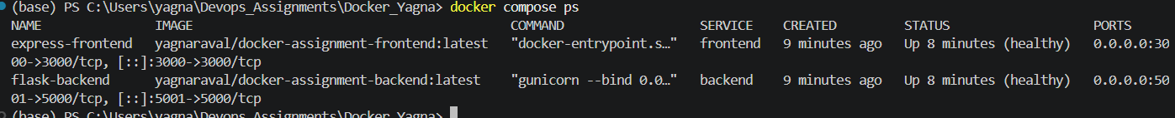
Screenshot 1 - Both containers running and reporting healthy.
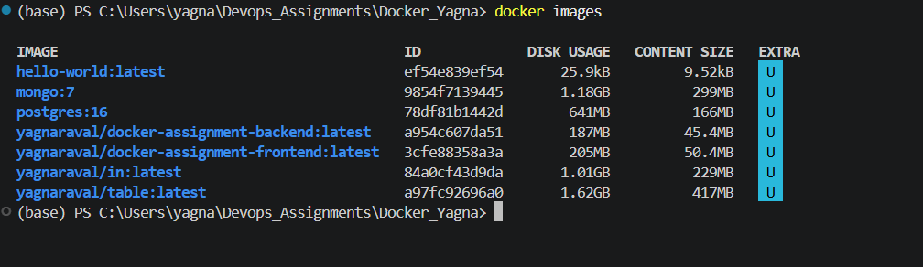
Screenshot 2 - The two images built locally.

5.5 The shared network
Both services join a user-defined bridge network, which is what gives them DNS resolution by service name. Inspecting it shows both containers attached with their own addresses:
docker network inspect docker_yagna_app-network
express-frontend -> 172.19.0.3/16
flask-backend -> 172.19.0.2/16
Verifying DNS resolution from inside the frontend container:
$ docker exec express-frontend node -e \
"fetch('http://backend:5000/health').then(r=>r.json()).then(console.log)"

{ service: 'flask-backend', status: 'healthy' }
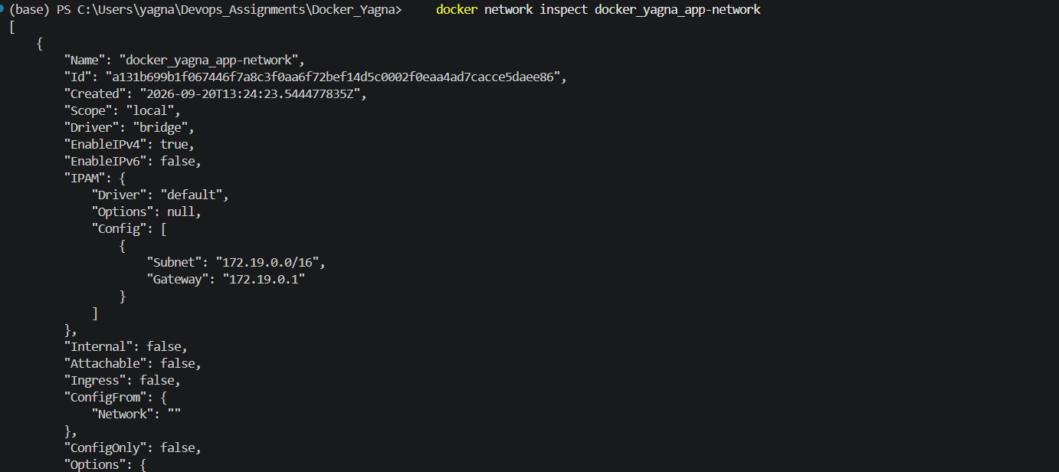
Screenshot 7 - The shared bridge network with both containers attached.

6. Docker Hub and GitHub
Upload both images to Docker Hub, and push your whole code to GitHub. Add node_modules and other non-required files (e.g. .vscode) to .gitignore.

6.1 Pushing to Docker Hub
docker login

docker push yagnaraval/docker-assignment-backend:latest
docker push yagnaraval/docker-assignment-frontend:latest

# Also tagged with a fixed version, so a specific build can always be
# pulled back: 'latest' moves every time the image is rebuilt.
docker tag yagnaraval/docker-assignment-backend:latest \
yagnaraval/docker-assignment-backend:v1.0
docker push yagnaraval/docker-assignment-backend:v1.0
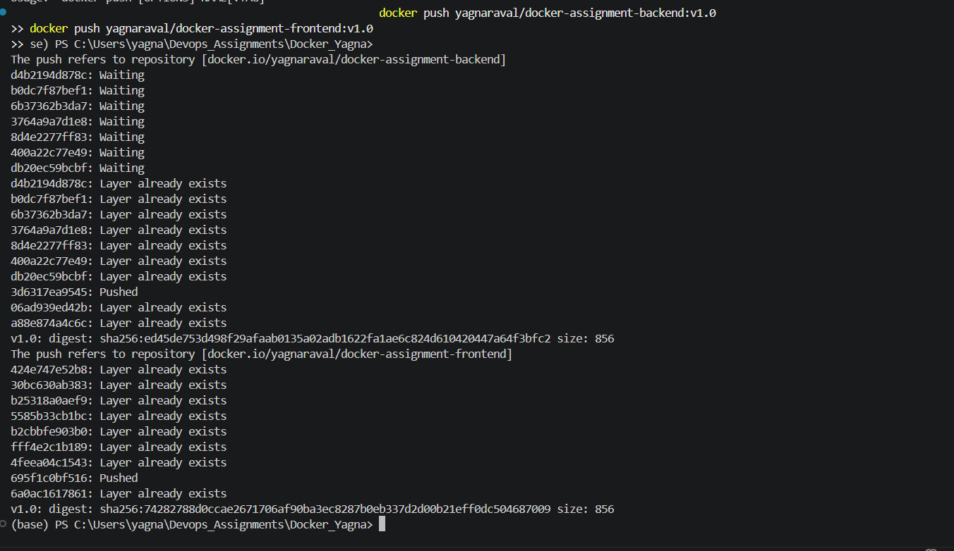
Screenshot 8 - Both images pushed to Docker Hub, with the returned digests.
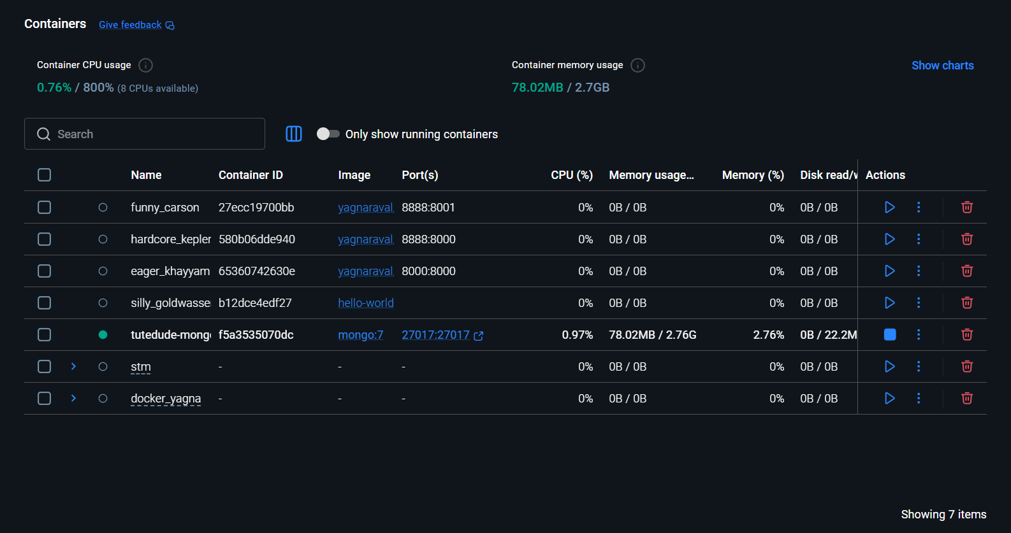
Screenshot 9 - The two repositories on Docker Hub.

Published images
Image | Tags | Size | Base
yagnaraval/docker-assignment-frontend | latest, v1.0 | 48 MB | node:20-alpine
yagnaraval/docker-assignment-backend | latest, v1.0 | 43 MB | python:3.12-slim
Anyone can now run the application without building it:
docker pull yagnaraval/docker-assignment-frontend:latest
docker pull yagnaraval/docker-assignment-backend:latest
docker compose up

6.2 .gitignore
node_modules and editor folders are excluded, as the task requires:
# Node
node_modules/
npm-debug.log*

# Python
__pycache__/
*.py[cod]
venv/

# Environment
.env

# Editors
.vscode/
.idea/
Confirmed with git check-ignore, which reports the rule that matches each path:
$ git check-ignore -v Docker_Yagna/frontend/node_modules/.test/dummy.js
Docker_Yagna/.gitignore:2:node_modules/ ...node_modules/.test/dummy.js

$ git check-ignore -v Docker_Yagna/.vscode/settings.json
Docker_Yagna/.gitignore:22:.vscode/ ...Docker_Yagna/.vscode/settings.json
Each service also has a .dockerignore, which keeps node_modules, .git and local environment files out of the build context. That makes builds faster and prevents a host-built node_modules - possibly compiled for a different platform - from being copied into the image.
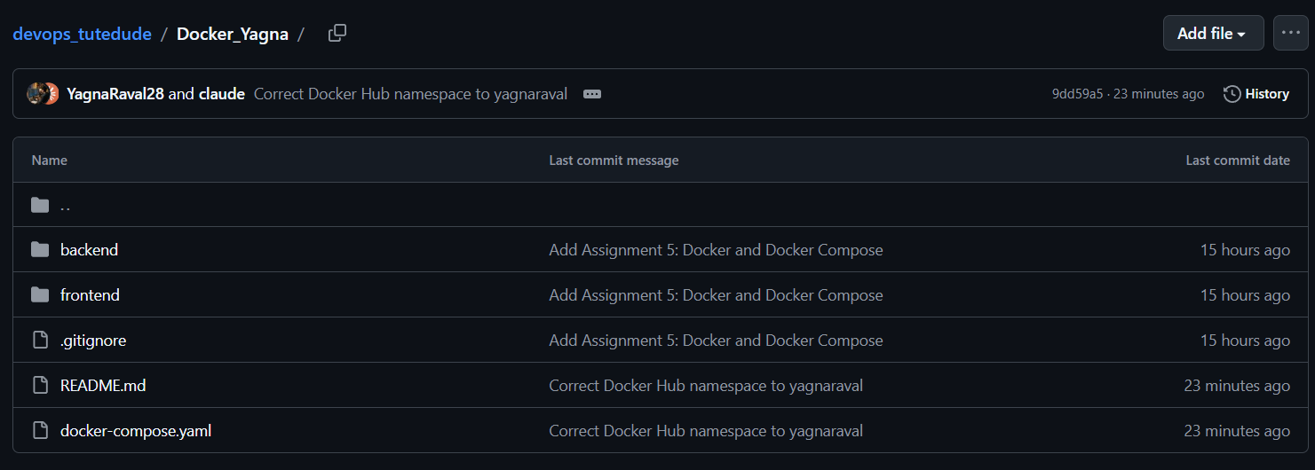
Screenshot 10 - The project pushed to GitHub.
GitHub repository: https://github.com/YagnaRaval28/devops_tutedude

7. Testing

7.1 Success path
curl -X POST http://localhost:3000/submit \
--data-urlencode "name=Yagna Raval" \
--data-urlencode "email=yagna@example.com" \
--data-urlencode "phone=9876543210" \
--data-urlencode "course=Docker & Kubernetes" \
--data-urlencode "message=Testing the containerised stack"
HTTP 200
Data submitted successfully
Reading it back from the backend confirms the data crossed the network and was processed:
$ curl http://localhost:5001/api/submissions

{"count": 1, "submissions": [{
"course": "Docker & Kubernetes",
"email": "yagna@example.com",
"id": 1,
"message": "Testing the containerised stack",
"name": "Yagna Raval",
"phone": "9876543210",
"submitted_at": "2026-09-20T13:32:42.711016+00:00"
}]}

7.2 Error path
An invalid email is rejected by the backend and the message is rendered on the same page, with no redirect:
$ curl -X POST http://localhost:3000/submit \
--data-urlencode "name=Yagna Raval" \
--data-urlencode "email=bademail" \
--data-urlencode "course=Flask Web Development"

HTTP 400
Error: 'bademail' is not a valid email address.

7.3 Health checks
$ curl http://localhost:3000/health
{"status":"healthy","service":"express-frontend","backend":"healthy"}

$ curl http://localhost:5001/health
{"service":"flask-backend","status":"healthy"}
The frontend's /health reports the backend's state as well, so a single request confirms both the service and the link between the two containers.

8. Problems Encountered
Three issues came up while building this, each worth recording because the symptom pointed somewhere other than the cause.

Port 5000 was already in use
Requests to the backend on port 5000 returned 404, even though the container was healthy. The response header read Werkzeug/3.1.8 Python/3.13.5 - but the container runs gunicorn, not Werkzeug. An unrelated Flask application on the host was already bound to port 5000 and was shadowing the published port. The backend is now published on host port 5001 instead; it still listens on 5000 inside the container, so nothing else changed.

Healthchecks failed against localhost
The frontend container reported unhealthy with "connection refused", although the service answered correctly from outside. Inside the container, 127.0.0.1:3000 worked while localhost:3000 did not. In Alpine, localhost resolves to the IPv6 address ::1 first, and a server bound to IPv4 0.0.0.0 never answers it. Both healthchecks now use the 127.0.0.1 literal.

Submissions disappeared between requests
A submission returned 200, but reading the list back reported zero records. The backend was running gunicorn with two workers, and each worker is a separate process with its own copy of the in-memory list, so a write and a later read landed on different workers. The image now runs a single worker. A production service would store the data in a database and could then scale workers freely.

Docker Hub namespace mismatch
The images were first tagged yagnaraval28 to match the GitHub username, and the push failed to authorize. The Docker Hub account is yagnaraval, and Docker Hub only accepts pushes into your own namespace. The images were retagged and pushed successfully.

9. Implementation Notes

Layer caching
Both Dockerfiles copy their dependency manifest and install before copying the source. Docker caches each layer and invalidates everything after the first change, so installing dependencies before the source means editing server.js or app.py does not reinstall every package.

Non-root users
The backend creates an appuser; the frontend uses the node user that node:alpine already provides. A process running as root inside a container that escapes its isolation is root on the host, so there is no reason to grant it.

depends_on with condition: service_healthy
Plain depends_on waits only for the container to start, not to be ready to serve. Waiting on the healthcheck means the frontend never boots against a backend that is still initialising.

gunicorn rather than the Flask development server
The Flask development server prints a warning that it is not suitable for production and handles one request at a time by default. gunicorn is a real WSGI server and is what the image runs.

Environment variables over hard-coded URLs
BACKEND_URL is supplied by Compose rather than written into the code, so the same image works unchanged in another environment where the backend lives elsewhere.

10. Conclusion
All eight requirements were completed and verified:
# | Requirement | Evidence
1-3 | Express frontend with a form that posts to the Flask backend | Screenshots 4-5
4 | Flask backend validates and processes the submission | Screenshots 5-6
5 | Separate frontend/ and backend/ folders | Section 2
6 | A Dockerfile for each service | Screenshots 2-3
7 | Compose connects both on one bridge network | Screenshots 1, 7
8 | Images on Docker Hub, code on GitHub, node_modules ignored | Screenshots 8-10

The running stack was tested end to end: a form submission travelled from the browser to the Express container, across the Docker network to the Flask container, and back as a success response, with the stored record then read back through both services. Invalid input was correctly rejected with the backend's message shown on the form.

GitHub: https://github.com/YagnaRaval28/devops_tutedude
Docker Hub: https://hub.docker.com/r/yagnaraval/docker-assignment-frontend
https://hub.docker.com/r/yagnaraval/docker-assignment-backend

