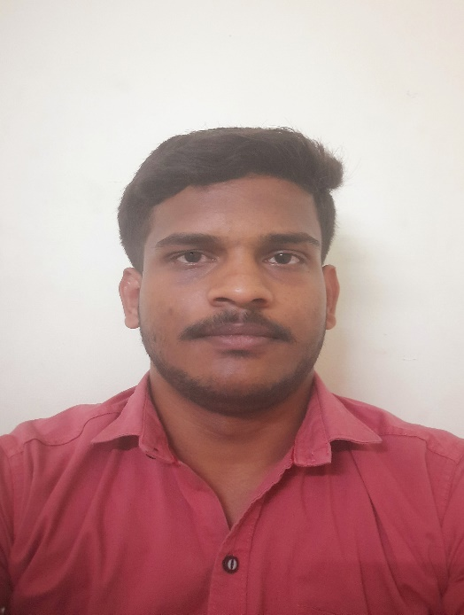

NIMMA YAGNAN

Passionate and driven Computer Science graduate seeking a challenging role in a reputable organization to learn and grow while making meaningful contributions to the team's success. Dedicated to excellence and committed to becoming a valuable and reliable team member.

TECHNICAL SKILLS

Programming Languages

Java, C, Python, and basics in C++

Web Programming

HTML, CSS, and JavaScript

Frameworks

Basics in Bootstrap, Basics in Express and React

EXTRA CURRICULAR ACTIVITIES

Acted as an Event Manager in Several Campus Events

Participated in coding contests on different platforms

Competed in various sports tournaments throughout school and college

Interested in stock market analysis

LANGUAGES

Telugu

Hindi

English

INTRESTS

Playing Chess

Reading web articles

Solving Coding Challenges

EDUCATION

Vasavi College of Engineering (2020-24) – 8.95 CGPA

Sri Chaitanya College (2018-20) – 97%

Sri Chaitanya School (2017-18) – 10.00 CGPA

ACHIEVEMENTS

Code Chef: Maximum Rating – 1600*

Hacker Rank: Gold badge in Java (5 star)

Hacker Rank: Gold badge in Problem solving (6 star)

CERTIFICATES ACCOMPLISHED

Design and Analysis of Algorithms (NPTEL)

Introduction to Machine Learning (NPTEL)

Programming in Java (NPTEL)

Python Certification from Infosys Springboard

PROJECTS

Amazon product price tracker

Space Shooter game

Ware House Monitoring (IOT)

Some basic websites using HTML, CSS, and JavaScript

CONTACT

|  |  |
| --- | --- |
| Receiver | +91 8074488916 |
| Envelope | [yagnannimma@gmail.com](mailto:yagnannimma@gmail.com) |
| Home | cherial, siddipet district, Telangana pincode-506223 |