# INTRODUCTION

The stock market is a highly complex and dynamic system that is influenced by a wide range of factors such as economic conditions, company performance, political events, and global trends. Accurately predicting the future prices of stocks is a challenging task that has significant implications for investors, traders, financial institutions, and regulatory bodies. The use of machine learning algorithms and artificial intelligence techniques in financial markets has increased significantly in recent years, providing new opportunities to predict stock prices more accurately. The project "Stock Market Prediction using LSTM" aims to leverage the power of machine learning algorithms to predict the stock prices of a particular company using the Long Short-Term Memory (LSTM) neural network algorithm. The LSTM algorithm is an advanced variant of recurrent neural networks (RNNs) that can capture the temporal dependencies and patterns of time-series data, making it ideal for predicting stock prices. The project involves several steps, including data preprocessing, feature extraction, and the training of the LSTM model using historical stock market data. The performance of the LSTM model will be evaluated using various metrics, and the results will be compared with other popular machine learning algorithms used in stock market prediction. The project has significant implications for investors and traders who are always seeking new ways to make informed decisions based on accurate and reliable data. By predicting future stock prices, the project can provide valuable insights that can aid in investment decision-making and reduce the risks associated with stock market investments. Furthermore, the project can help financial institutions and regulatory bodies in analyzing market trends and predict future market behavior, which can aid in making critical policy decisions. In conclusion, the project "Stock Market Prediction using LSTM" is an exciting and innovative approach to stock market prediction that has significant implications for the financial industry. By utilizing machine learning algorithms and advanced data analysis techniques, the project can provide valuable insights that can aid investors, traders, financial institutions, and regulatory bodies in making informed decisions based on accurate and reliable data.

**Types of Stocks:**

Common Stock: Represents ownership in a company and typically provides voting rights. Common shareholders may receive dividends, but these are not guaranteed.

Preferred Stock: Generally does not come with voting rights but has a higher claim on assets and earnings. Preferred shareholders receive dividends before common shareholders. Investing in stocks carries risk, as stock prices can fluctuate based on various factors, including market conditions, economic performance, and company-specific news. However, stocks also have the potential for high returns over the long term. The terms "bull market" and "bear market" describe the general trends in the stock market. A bull market is characterized by rising prices, while a bear market sees declining prices. Investing in stocks can be a fundamental part of building wealth, but it's important for investors to conduct thorough research, consider their risk tolerance, and have a diversified investment portfolio to manage risk.

A stock price prediction system using machine learning involves employing algorithms to analyze historical stock data, identifying patterns, and making predictions about future price movements. Machine learning models, such as regression, decision trees, or neural networks, are trained on past market data to learn relationships and trends. Factors like historical prices, trading volumes, and external indicators can be considered. The goal is to create a model that accurately forecasts future stock prices, aiding investors in decision-making.

**Data Collection:**

Gather historical stock market data, including daily or hourly prices, trading volumes, and relevant financial indicators. External factors like economic indicators, news sentiment, or geopolitical events might also be considered.

**Data Preprocessing:**

Cleanse and organize the data, handling missing values or outliers. Normalize or scale features to ensure uniformity and prevent certain features from dominating the model. **Feature Selection:**

Identify relevant features that contribute significantly to predicting stock prices. Technical indicators (moving averages, RSI), fundamental factors (earnings, dividends), and market sentiment can be crucial.

**Model Selection:**

Choose a suitable machine learning algorithm. Common choices include linear regression, decision trees, support vector machines, or more complex models like neural networks. Consider ensemble methods for improved accuracy, such as Random Forests or Gradient Boosting.

**Training the Model:**

Split the dataset into training and testing sets to evaluate model performance. Train the chosen model on historical data, allowing it to learn patterns and relationships. Evaluation: Assess the model's performance using metrics like Mean Squared Error (MSE) or Root Mean Squared Error (RMSE). Evaluate the model on the testing set to ensure its ability to generalize to new, unseen data. Hyperparameter Tuning: Optimize the model by adjusting hyperparameters for better performance. This process may involve techniques like cross-validation to find the most robust configuration.

**Prediction:**

Apply the trained model to new data to make predictions on future stock prices. Continuous monitoring and retraining may be necessary to adapt the model to changing market conditions.

**Risk Management:**

Incorporate risk management strategies to handle uncertainties and mitigate potential losses. Consider implementing stop-loss mechanisms or portfolio diversification based on the model's predictions. Deployment: Integrate the model into a real-time or near-real-time system for practical use by investors. Regularly update the model to incorporate new data and ensure relevance. A well-designed stock price prediction system using machine learning involves a thoughtful combination of data processing, model selection, and ongoing refinement to provide valuable insights for decision-makers in the financial markets.

**Deployment:**

Integrate the model into a real-time or near-real-time system for practical use by investors. Regularly update the model to incorporate new data and ensure relevance. A well-designed stock price prediction system using machine learning involves a thoughtful combination of data processing, model selection, and ongoing refinement to provide valuable insights for decision-makers in the financial markets.

# LITERATURE REVIEW

The field of stock market prediction using machine learning algorithms has seen significant growth in recent years. Numerous studies have focused on the use of various machine learning algorithms for stock market prediction, including neural networks, decision trees, support vector machines, and time series analysis.

In this literature survey, we review the most significant studies related to the prediction of stock prices using machine learning algorithms.

1. "Stock Price Prediction Using LSTM, RNN, and CNN-SVR Hybrid Models" by Yifei Zhang, Jun Deng, and Xiao Deng (2019). In this paper, the authors compare the performance of LSTM, RNN, and CNN-SVR hybrid models for stock price prediction. The results show that LSTM outperforms the other models in terms of accuracy and efficiency.
2. "Stock Price Prediction Using Deep Learning and Hybrid Models" by Abhishek Kumar, Vinay Kumar, and Gagandeep Kaur (2019). In this paper, the authors use LSTM and a hybrid model combining LSTM and random forest for stock price prediction. The results show that the hybrid model achieves better performance than LSTM alone.
3. Stock Price Prediction with LSTM and Random Walk Theory" by Kaijian He, Hanxuan Yang, and Yiran Cui (2018)

4. "Stock Market Prediction using LSTM and Sentiment Analysis" by Dipta Das et al. (2018). In this paper, the authors use LSTM and sentiment analysis to predict the stock market. The results show that the proposed model achieves better performance than traditional models.

5. Stock Price Prediction Using LSTM with Financial Indicators" by Aishwarya Kachhwaha et al. (2019)."

6. On the Difficulty of Training Recurrent Neural Networks" by Razvan Pascanu, Tomas Mikolov, and Yoshua Bengio (2013)

**2.1 Existing System**

Stock market prediction traditionally relies on **fundamental** and **technical analysis**. Fundamental analysis evaluates a company's past performance, market credibility, and macroeconomic factors, using indicators like P/E and P/B ratios for long-term trends. However, it is time-intensive, prone to extrapolation errors, and lacks reliable trade signals, often requiring prolonged stock holding. Technical analysis, on the other hand, examines price trends using charts and mathematical tools. Despite its efficiency, it is subjective, prone to misinterpretation, and sensitive to low trading volumes or mismatched timeframes.

2.2 Limitations of Existing System

Despite their strengths, these systems have notable limitations. Traditional models like ARIMA and GARCH are limited to stationary data and struggle with the complex non-linear and volatile nature of financial markets. Machine learning models, while effective, often fail to account for temporal dependencies and require extensive manual feature engineering, which can introduce bias. RNNs, though designed for sequential data, are prone to vanishing gradient issues, limiting their ability to model long-term dependencies. LSTM models, while addressing this, are computationally intensive and sensitive to hyperparameter tuning. Additionally, they may struggle with highly volatile and noisy datasets, such as stock prices, which often include unpredictable market events. These limitations highlight the need for advanced architectures and robust preprocessing techniques to improve prediction accuracy and reliability.

## 2.3 Proposed System

The proposed system leverages an enhanced Long Short-Term Memory (LSTM) model tailored for stock price prediction. LSTM is well-suited for capturing sequential dependencies and complex patterns in time-series data, making it ideal for financial forecasting. The system integrates advanced preprocessing techniques, including log returns transformation and outlier removal, to ensure data quality. Feature engineering enriches the input with key indicators like moving averages, RSI, and external factors such as news sentiment and macroeconomic variables, providing a holistic view of market trends.

To boost model performance, the architecture includes **stacked LSTM layers** for capturing deeper patterns, **attention mechanisms** for highlighting important inputs, and **regularization techniques** like dropout and L2 regularization to mitigate overfitting. The system is trained using optimized loss functions and adaptive learning rate schedules to improve convergence. Evaluation combines traditional metrics (RMSE, MAPE) with back testing to assess real-world trading applicability, ensuring the model is both accurate and practical for deployment.

Key Concepts of Proposed System

The proposed hybrid detection model for a Network Intrusion Detection System (NIDS) integrates signature-based detection and anomaly-based detection to provide a robust approach to identifying both known and unknown network threats. This model utilizes the complementary strengths of both methods, creating a more comprehensive and adaptive security solution.

1. **Data Collection:**

Obtain historical stock price data from reliable sources such as Yahoo Finance, Alpha Vantage, or Quandl. This data typically includes the stock's opening, closing, highest, and lowest prices, along with trading volume for each day. Gather additional features that might impact stock prices, such as technical indicators (e.g., moving averages, Relative Strength Index) and sentiment analysis scores derived from news articles or social media related to the stock.

1. **Data Preprocessing:**

Normalize the data to ensure that all features are on a similar scale. This is crucial for the LSTM's convergence and performance.

Split the dataset into training, validation, and test sets. The training set is used to train the model, the validation set is used to tune hyperparameters and prevent overfitting, and the test set is used to evaluate the model's performance on unseen data.

Define the sequence length, which determines how many previous time steps the LSTM will consider when making predictions. This can be adjusted based on the nature of the data and the specific requirements of the problem.

1. **Model Architecture:**

Design the LSTM architecture. This typically involves stacking multiple LSTM layers to capture different levels of temporal dependencies.

Consider adding dropout layers between LSTM layers to prevent overfitting by randomly setting a fraction of input units to zero during training. Choose appropriate activation functions for the LSTM layers (e.g., sigmoid or tanh). Optionally, add additional layers such as dense layers after the LSTM layers for further processing and dimensionality reduction. Choose a suitable loss function such as Mean Squared Error (MSE) or Mean Absolute Error (MAE), depending on the nature of the problem and the output scale

1. **Training:**

Train the LSTM model on the training data using backpropagation through time (BPTT). Tune hyperparameters such as learning rate, batch size, and number of epochs based on the performance on the validation set.Monitor the model's performance on the validation set and stop training if the performance starts to degrade or if no significant improvement is observed (early stopping).

1. **Evaluation:**

Evaluate the trained model's performance on the test set using appropriate evaluation metrics such as Mean Absolute Error (MAE), Mean Squared Error (MSE), or Root Mean Squared Error (RMSE). Compare the predicted stock prices with the actual prices from the test set to assess the model's accuracy and generalization capability.

1. **Deployment:**

Once satisfied with the model's performance, deploy it to make predictions on new, unseen data. Continuously monitor the model's performance in a production environment and update it as needed based on new data or changes in market conditions. By meticulously following these steps and considering additional details and best practices at each stage, LSTM-based stock price prediction models can be developed and deployed effectively, offering valuable insights and enhancing decision-making capabilities in financial markets.

# 3 REQUIREMENTS GATHERING

Requirement Specification provides a high secure storage to the web server efficiently. Software requirements deal with software and hardware resources that need to be installed on a serve which provides optimal functioning for the application. These software and hardware requirements need to be installed before the packages are installed. These are the most common set of requirements defined by any operation system. These software and hardware requirements provide a compatible support to the operation system in developing an application.

## 3.1 Hardware Requirements:

The hardware requirements section meticulously delineates the essential specifications for the system's hardware components. These requirements encompass a comprehensive array of configuration characteristics crucial for ensuring optimal performance, reliability, and functionality of the software system.

1. **System:** The heart of the system demands a Pentium IV processor with a clock speed of 2.4 GHz or higher. This processor configuration is carefully chosen to provide ample processing power capable of efficiently executing the software's computational tasks, ensuring swift and responsive system performance even under demanding workloads.
2. **Hard Disk:** A minimum storage capacity of 100 GB is imperative to accommodate the installation of the software elements, system files, and data storage requirements. This generous allocation of storage space is indispensable for storing and accessing datasets, logs, and configuration files without encountering storage constraints or compromising system performance.
3. **Monitor:** The visual interface of the system necessitates a 15-inch VGA Color monitor. This monitor size, coupled with vibrant VGA Color display technology, delivers a visually immersive experience, providing users with crisp and clear visual representations of system interfaces, graphical elements, and real-time status updates.
4. **Mouse:** For seamless user interaction, the Logitech mouse is stipulated as the preferred input device. Renowned for its reliability and ergonomic design, the

Logitech mouse ensures smooth and precise navigation through system interfaces, effortless interaction with graphical elements, and efficient execution of user commands, enhancing overall user productivity and satisfaction.

1. **RAM:** A minimum of 1 GB of Random Access Memory (RAM) is mandated to facilitate smooth and efficient system operation. The generous RAM allocation empowers the system to manage concurrent processes, store temporary data, and execute computational tasks with agility and finesse, thereby optimizing system responsiveness and performance.

## Software Requirements:

The software requirements section expounds upon the indispensable software products and their requisite versions indispensable for the system's operation. These requirements encompass a diverse spectrum of software components essential for facilitating data management, system execution, and programming language support.

1. **Operating System:** The software system is engineered to seamlessly integrate with Windows XP, Windows 7, or Windows 10 operating systems. These operating systems serve as the foundational environment for executing the software elements and interfacing with hardware components effectively, ensuring compatibility, stability, and optimal performance across diverse computing environments.
2. **Coding Language:** Python 3.8 emerges as the cornerstone coding language for software development endeavors. Renowned for its versatility, simplicity, and extensive libraries, Python 3.8 stands as the optimal choice for implementing the software's computational algorithms, data processing tasks, and system integration functionalities, facilitating streamlined development workflows and code maintainability.

## Functional Requirements

The **stock price prediction system** using an LSTM model should be able to process and analyze sequential financial data effectively. It must support data collection from reliable sources, such as APIs (e.g., Yahoo Finance or Alpha Vantage), to retrieve historical stock prices, trading volumes, and additional market indicators. The system should preprocess this data by handling missing values, normalizing features, and creating derived metrics like moving averages or returns to enhance model performance.

The LSTM model should be designed to handle time-series data while capturing temporal dependencies and long-term patterns. The system must include mechanisms for splitting the data into training, validation, and testing sets based on time to ensure realistic evaluations. The model should support hyperparameter tuning for key parameters such as the number of LSTM layers, hidden units, learning rate, and batch size, enabling optimization for improved prediction accuracy.

The system should output interpretable results, including predicted stock prices or price trends, and provide evaluation metrics such as Mean Squared Error (MSE) and directional accuracy. Additionally, it should support visualization of predictions against actual prices to allow users to assess model performance. The solution should also accommodate real-time predictions by processing live data inputs and updating forecasts dynamically, making it suitable for traders and analysts.

## Non-Functional Requirements

In terms of non-functional requirements, the proposed system should prioritize scalability, reliability, and performance. It should be able to scale horizontally to accommodate growing network traffic and expanding infrastructures without sacrificing detection accuracy or speed. The system should exhibit high availability, with built-in redundancy and failover mechanisms to ensure continuous operation even in the event of hardware failures or network outages.

Moreover, it should adhere to industry standards and compliance regulations, ensuring data privacy and confidentiality in accordance with legal requirements. Finally, the system should be easy to deploy, configure, and maintain, minimizing administrative overhead and operational complexity.

### Performance

The system must be capable of handling large datasets efficiently. It should be designed to provide timely responses during data processing, model training, and results analysis.

### Scalability

The system should be scalable to accommodate varying sizes of genetic datasets. This ensures that it can adapt to different data volumes and complexities without compromising performance.

### User Interface

The user interface should be intuitive and user-friendly to enable easy interaction with the system. It should provide clear instructions for data input, configuration settings, and result interpretation.

### Security

Given the sensitive nature of genetic data, the system must adhere to stringent security measures. This includes encryption of data during transmission and storage, access controls, and compliance with data protection regulations.

### Interpretability

The machine learning model should be designed with interpretability in mind. The system should provide explanations for model predictions, enabling healthcare professionals to understand and trust the results.

### Reliability

The system should be reliable, ensuring minimal downtime and accurate results. Robust error handling and recovery mechanisms should be in place to handle unexpected scenarios.

### Ethical Considerations

Ethical considerations are paramount when dealing with genetic information. The system should adhere to ethical standards, including informed consent, data anonymization, and transparency in data usage.

## 3.5. Software Environment

### Python

Python is a high-level, interpreted, interactive and object-oriented scripting language. Python is designed to be highly readable. It uses English keywords frequently where as other languages use punctuation, and it has fewer syntactical constructions than other languages.

* **Python is Interpreted** − Python is processed at runtime by the interpreter. You do not need to compile your program before executing it. This is similar to PERL and PHP.
* **Python is Interactive** − You can actually sit at a Python prompt and interact with the interpreter directly to write your programs.
* **Python is Object-Oriented** − Python supports Object-Oriented style or technique of programming that encapsulates code within objects.
* **Python is a Beginner's Language** − Python is a great language for the beginner-level programmers and supports the development of a wide range of applications from simple text processing to WWW browsers to games. History

Python Python was developed by Guido van Rossum in the late eighties and early nineties at the National Research Institute for Mathematics and Computer Science in the Netherlands. Python is derived from many other languages, including ABC, Modula-3, C, C++, Algol-68, SmallTalk, and Unix shell and other scripting languages.

Python is copyrighted. Like Perl, Python source code is now available under the GNU General Public License (GPL).

### PYTHON FEATURES

* **Easy-to-learn** − Python has few keywords, simple structure, and a clearly defined syntax. This allows the student to pick up the language quickly.
* **Easy-to-read** − Python code is more clearly defined and visible to the eyes.
* **Easy-to-maintain** − Python's source code is fairly easy-to-maintain.
* **A broad standard library −** Python's bulk of the library is very portable and cross platform compatible on UNIX, Windows, and Macintosh.
* **Interactive Mode** − Python has support for an interactive mode which allows interactive testing and debugging of snippets of code.
* **Portable** − Python can run on a wide variety of hardware platforms and has the same interface on all platforms.
* **Extendable** − You can add low-level modules to the Python interpreter. These modules enable programmers to add to or customize their tools to be more efficient.
* **Databases** − Python provides interfaces to all major commercial databases.
* **GUI Programming** − Python supports GUI applications that can be created and ported to many system calls, libraries and windows systems, such as Windows MFC, Macintosh, and the X Window system of Unix.
* **Scalable** − Python provides a better structure and support for large programs than shell scripting. Apart from the above-mentioned features, Python has a big list of good features, few are listed below −
* It supports functional and structured programming methods as well as OOP.
* It can be used as a scripting language or can be compiled to byte-code for building large applications.
* It provides very high-level dynamic data types and supports dynamic type checking.
* It supports automatic garbage collection.

### Getting Python

The most up-to-date and current source code, binaries, documentation, news, etc., is available on the official website of Python https:/[/www.python.org.](http://www.python.org/)

### Windows Installation

Here are the steps to install Python on Windows machine.

**STEP 1:** Open a Web browser and go to https://[www.python.org/downloads/.](http://www.python.org/downloads/)

**STEP 2:** Follow the link for the Windows installer python-XYZ.msifile where XYZ is the version you need to install.

**STEP 3:** To use this installer python-XYZ.msi, the Windows system must support Microsoft Installer 2.0. Save the installer file to your local machine and then run it to find out if your machine supports MSI.

**STEP 4:** Run the downloaded file. This brings up the Python install wizard, which is really easy to use. Just accept the default settings, wait until the install is finished, and you are done. The Python language has many similarities to Perl, C, and Java. However, there are some definite differences between the languages.

**STEP 5:** Run the downloaded file. This brings up the Python install wizard, which is really easy to use. Just accept the default settings, wait until the install is finished, and you are done. The Python language has many similarities to Perl, C, and Java. However, there are some definite differences between the languages.

### Installation

Ensure Python is installed on your system. Download the latest version from the official Python website, and follow the installation instructions.

### Pip Installation:

Pip is the package installer for Python. It is usually included with Python installations after version 3.4. To check if pip is installed, open a command prompt or terminal and type:

### pip –version

If not installed, download get-pip.py and run: python get-pip.py

### Installing packages in python using Pip

Once pip is installed, you can use it to install Python packages. The general syntax is:

### pip install package_name

Replace package_name with the name of the package you want to install. For example, to install NumPy: pip install numpy

* Specifying Versions: You can install a specific version of a package by specifying the version number: pip install package_name==desired_version
* Installing from Requirements File: You can create a requirements.txt file with a list of packages and their versions, then install them all at once:

pip install – r requirements.txt

* Upgrading Packages: To upgrade a package to the latest version, use: pip install – upgrade package_name
* Virtual Environments: Consider using virtual environments to isolate Project dependencies.

Create a virtual environment: python -m venv venv Activate the virtual environment:

### On Windows: \venv\Scripts\activate

**On macOS/Linux: sourcevenv/bin/activate**

* Common Python Packages: Some commonly used packages include: NumPy: pip install numpy

Pandas: pip install pandas

Scikit-learn: pip install scikit-learn

# 4.SYSTEM ANALYSIS

## 4.1Modules Description:

The Modules Description section provides a comprehensive overview of the various modules comprising the software system, elucidating their functionalities, interactions, and contributions to the overall system architecture. Each module plays a distinct role in facilitating specific tasks or functionalities within the system, contributing to its effectiveness, efficiency, and reliability.

### 4.2 Data Collection Module:

**Purpose**: Collects historical stock price data and related financial indicators from various sources like stock exchanges, APIs, or data feeds.

**Key Features**: Gathers time-series data, including open, close, high, low prices, and volume for each stock, along with additional features such as moving averages or technical indicators for better prediction accuracy.

### 4.3 Data Preprocessing Module:

**Purpose**: Prepares raw stock data for input into the LSTM model.

**Key Features**: Cleans the data by handling missing values, normalizing prices, and scaling features to ensure consistency across different stocks. It may also involve time-series-specific preprocessing, such as windowing the data for sequence generation and splitting it into training and testing sets.

### 4.4 Feature Engineering Module:

**Purpose**: Extracts meaningful features from the stock data to improve the model’s predictive accuracy.

**Key Features**: Creates additional features such as moving averages, momentum indicators (e.g., RSI, MACD), or external economic indicators. This can involve dimensionality reduction techniques like PCA or selecting the most relevant features for stock price prediction.

### LSTM Model Module:

**Purpose**: Implements the LSTM model for predicting future stock prices based on past trends and features.

**Key Features**: Uses deep learning techniques to model sequential dependencies in time-series data. The model is trained to predict future stock prices by capturing long-term trends and short-term fluctuations. This involves setting up the model architecture, selecting the number of LSTM layers, and tuning hyperparameters.

### 4.6 Training Module:

**Purpose**: Trains the LSTM model on historical stock data.

**Key Features**: Utilizes training algorithms like gradient descent to optimize the model’s weights, minimizing loss functions (e.g., Mean Squared Error). The module may include validation techniques such as cross-validation to prevent overfitting and ensure generalization.

### Evaluation and Performance Metrics Module:

**Purpose**: Measures the accuracy and reliability of the LSTM model's predictions.

**Key Features**: Evaluates model performance using metrics like Mean Absolute Error (MAE), Root Mean Squared Error (RMSE), and R-squared. It also compares predicted stock prices with actual values to assess predictive power and robustness. Visualizations such as residual plots or prediction vs. actual price graphs are provided for in-depth analysis.

### 4.8 Prediction Module:

### Purpose: Makes real-time predictions of future stock prices.

### Key Features: Inputs new, unseen stock data (e.g., the latest market prices) into the trained LSTM model to predict future stock trends or price movements. The predictions may be generated for various time horizons, such as the next day, week, or month, depending on the user’s requirements.

### 4Visualization Module:

### Purpose: Provides real-time alerts and visualizations of predicted stock price trends.

### Key Features: Sends notifications about stock price predictions, which can be integrated into a trading system or dashboard. Visualization features include prediction graphs, trendlines, or candlestick charts, providing users with actionable insights. Alerts may notify users of significant changes in price or trends based on LSTM model predictions..

## Methodology:

The Modules Description section provides a detailed explanation of the integral components of the proposed Network Intrusion Detection System (NIDS). Each module is designed to perform a specific function within the system, ensuring a cohesive and efficient approach to detecting, classifying, and responding to network intrusions. By organizing the system into these modules, the architecture promotes scalability, modularity, and ease of maintenance.

### Problem Definition:

**Objective**: The goal is to develop a system that predicts future stock prices based on historical price data using an LSTM (Long Short-Term Memory) model. The system should forecast stock price trends, helping traders, investors, and financial analysts to make informed decisions.

**Challenges**: Stock price prediction is a time-series forecasting problem that is inherently noisy and affected by a variety of factors, including market conditions, economic indicators, and external events. The main challenge lies in capturing long-term dependencies and trends while avoiding overfitting or underfitting the model.

**Scope**: This system will focus on predicting stock prices for a specific set of stocks based on historical price data. It will provide short-term and medium-term forecasts for different time horizons, such as the next day, week, or month.

4.2.1 Data Collection and Preparation:

**Cleaning**: Handle missing values (using techniques like interpolation or deletion), remove outliers, and ensure data consistency.

**Normalization/Scaling**: Normalize or standardize the stock price data to a consistent scale, such as using Min-Max scaling or Z-score normalization. This helps the LSTM model to learn better from the data.

**Time-Series Specific Preprocessing**:

**Sequencing**: Split the time-series data into sliding windows or sequences, where each sequence contains a fixed number of past observations (e.g., 30 days) to predict future prices.

**Train-Test Split**: Divide the data into training and testing sets, typically using 80% of the data for training and 20% for testing.

4.2.2 Model Selection and Development:

**Architecture Design**:

Input layer: Accepts sequences of past stock prices and related features (e.g., moving averages).

LSTM layers: One or more LSTM layers to capture sequential dependencies and patterns.

Fully connected layers: Dense layers that output the predicted stock price for the next time step.

Output layer: A single unit that provides the predicted stock price.

**Hyperparameter Tuning**: Experiment with the number of LSTM layers, the number of neurons per layer, the learning rate, batch size, and other hyperparameters to optimize the model’s performance.

**Model Training**: Use Mean Squared Error (MSE) or Mean Absolute Error (MAE) as the loss function, and optimize using algorithms such as Adam or RMSprop.s.

### Evaluation and Validation:

**Metrics**: Evaluate the performance of the model using metrics such as:

**Mean Absolute Error (MAE)**: Measures the average magnitude of errors in predictions.

**Root Mean Squared Error (RMSE)**: Measures the square root of the average squared errors, sensitive to larger errors.

**R-squared (R²)**: Measures the proportion of variance explained by the model.

**Visualization**: Plot predicted vs. actual stock prices, residual plots, and performance metrics over time.

**Cross-Validation**: Use techniques like k-fold cross-validation to validate the model’s performance across different subsets of the data and prevent overfitting.

**Out-of-Sample Testing**: Test the model on unseen data (test set) to evaluate its generalization capability.

### Integration and Deployment:

**Metrics**: Evaluate the performance of the model using metrics such as:

**Mean Absolute Error (MAE)**: Measures the average magnitude of errors in predictions.

**Root Mean Squared Error (RMSE)**: Measures the square root of the average squared errors, sensitive to larger errors.

**R-squared (R²)**: Measures the proportion of variance explained by the model.

**Visualization**: Plot predicted vs. actual stock prices, residual plots, and performance metrics over time.

**Cross-Validation**: Use techniques like k-fold cross-validation to validate the model’s performance across different subsets of the data and prevent overfitting.

**Out-of-Sample Testing**: Test the model on unseen data (test set) to evaluate its generalization capability.

### Maintenance and Optimization:

**Model Retraining**: Regularly retrain the model on new stock data to account for changing market conditions and trends. This can be done periodically (e.g., monthly) or on-demand when the model’s performance deteriorates.

**Feature Updates**: Continuously explore and integrate new features that may improve model performance, such as alternative data sources (e.g., social media sentiment, news articles).

**Hyperparameter Tuning**: Periodically tune hyperparameters to ensure optimal model performance as the data evolves.

**Performance Monitoring**: Continuously monitor the model’s accuracy and performance using real-time metrics and adjust the model if performance decreases. This includes tracking prediction errors and refining the model when necessary.

**Scalability**: As the system grows, ensure that the infrastructure can handle increased data and user load. Optimize the model for faster predictions, such as by using model compression or quantization techniques.

# SYSTEM DESIGN

## System Architecture

The system leverages machine learning to categorize network traffic as regular or malicious. Data is ingested, cleansed, and transformed to prepare it for analysis. This includes removing irrelevant information, ensuring consistent formatting, and converting categorical data into numerical formats suitable for machine learning algorithms. Feature engineering may also be employed to create new features more relevant to traffic classification.

Following data preparation, a machine learning model is trained on the processed data. This model learns to identify patterns associated with normal and malicious traffic. After training, the model undergoes testing on a separate dataset to confirm its ability to generalize and accurately classify unseen data. Finally, the system is deployed to monitor live network traffic. As new data arrives, the trained model classifies it as normal or malicious, enabling real-time network security.

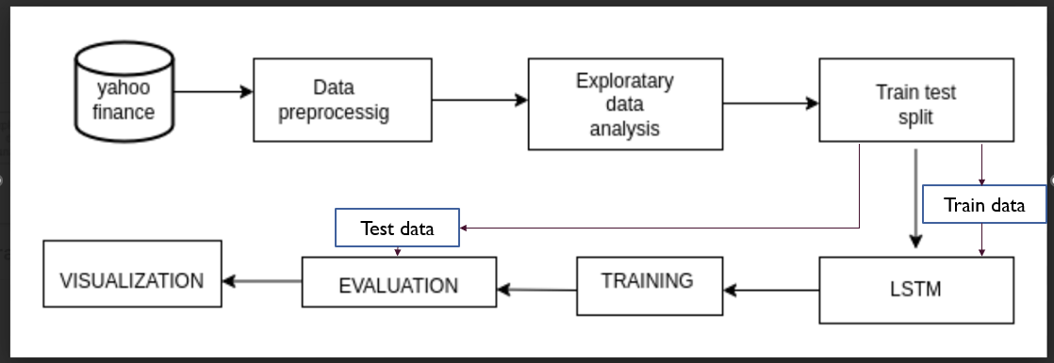

***Fig-5.1: System Architecture***

## 5.2 UML Diagrams

UML stands for Unified Modeling Language. UML is a standardized general- purpose modeling language in the field of object-oriented software engineering. The standard is managed, and was created by the Object Management Group.

The goal is for UML to become a common language for creating models of object oriented computer software. In its current form UML is comprised of two major components: a Meta-model and a notation. In the future, some form of method or process may also be added to; or associated with, UML.

The Unified Modeling Language is a standard language for specifying, Visualization, Constructing and documenting the artifacts of software system, as well as for business modeling and other non-software systems.

The UML represents a collection of best engineering practices that have proven successful in the modeling of large and complex systems.

The UML is a very important part of developing objects oriented software and the software development process. The UML uses mostly graphical notations to express the design of software projects.

### GOALS:

The Primary goals in the design of the UML are as follows:

1. Provide users a ready-to-use, expressive visual modeling Language so that they can develop and exchange meaningful models.
2. Provide extendility and specialization mechanisms to extend the core concepts.
3. Be independent of particular programming languages and development process.
4. Provide a formal basis for understanding the modelling language.
5. Encourage the growth of OO tools market.
6. Support higher level development concepts such as collabrations, frameworks, patterns and components.

### DFD LEVEL 0:

A Data Flow Diagram (DFD) is a graphical representation of the flow of data within a system. It's a structured analysis and design technique used to model the processes involved and the data flowing between them. DFDs are hierarchical, meaning they can be decomposed into multiple levels, each providing a more detailed view of the system.

The Level 0 DFD, also known as the Context Diagram, provides an overview of the entire system, showing the interactions between the system being modeled and external entities. It

represents the highest level of abstraction and does not delve into the internal workings of the system.

External Entities: These are entities outside the system being modeled that interact with it. They can be users, other systems, or sources of data. External entities are represented by squares or rectangles on the perimeter of the diagram.

Processes: Processes are activities or transformations that take place within the system. At the Level 0 DFD, processes are represented by circles or ovals in the center of the diagram. Each process represents a high-level function performed by the system.

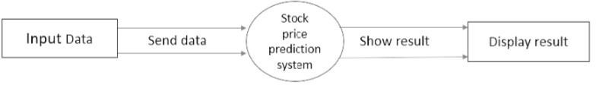

### DFD LEVEL 1:

A Level 1 Data Flow Diagram (DFD) provides a more detailed view of the processes, data flows, and data stores within a system compared to the Level 0 DFD (Context Diagram). It expands on the high-level overview provided by the Level 0 DFD by breaking down processes into sub-processes and detailing the data flows between them. Here's what you typically find in a

Level 1 DFD:

Processes: Processes at this level represent the sub-functions or subprocesses identified within the high-level processes of the Level 0 DFD. Each process in the Level 1 DFD is decomposed into further detail, showing more specific activities or transformations that take place within the system.

Data Flows: Data flows at this level represent the movement of data between processes, data stores, and external entities in more detail than the Level 0 DFD. Data flows are labeled to

indicate the type of data being transferred and may include additional details about data transformations or processing steps.

Data Stores: Data stores represent repositories of data within the system, just like in the Level 0 DFD. At the Level 1 DFD, data stores may be further decomposed to show the specific data elements they contain or the relationships between different data stores.

External Entities: External entities are entities outside the system being modeled that interact with it, similar to the Level 0 DFD. At the Level 1 DFD, external entities may be associated with specific processes or data flows to show how they interact with the system at a more

detailed level.

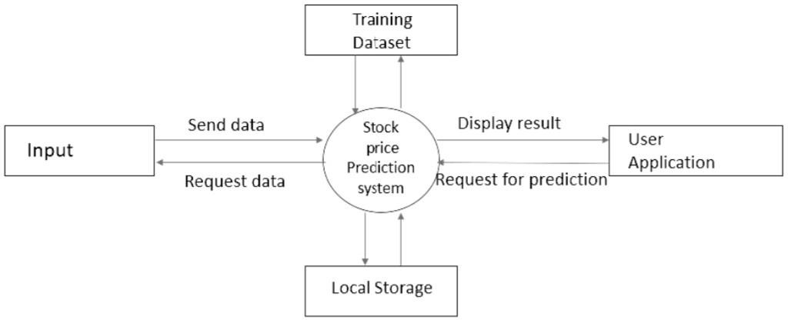

* + 1. **Use case diagram:**

A use case diagram in the Unified Modeling Language (UML) is a type of behavioral diagram defined by and created from a Use-case analysis. Its purpose is to present a graphical overview of the functionality provided by a system in terms of actors, their goals (represented as use cases), and any dependencies between those use cases. The main purpose of a use case diagram is to show what system functions are performed for which actor. Roles of the actors in the system can be depicted.

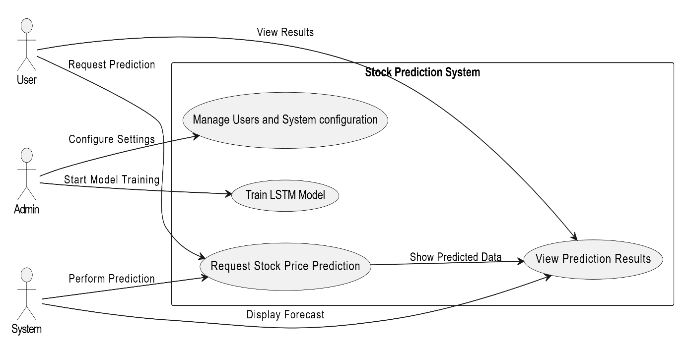

***Fig 5.3.1: Use Case Diagram***

The use case diagram for implementing the Efficient Market Hypothesis (EMH) using an LSTM (Long Short-Term Memory) model outlines the key actors and processes involved in predicting financial market trends. The primary actors include a data analyst, who collects, preprocesses, and feeds historical market data into the LSTM model; a trader or investor, who uses the model's predictions for decision-making; and a financial data provider, responsible for supplying the historical price and volume data. Key use cases include data collection, preprocessing (normalizing and cleaning data), model training to identify temporal patterns, and testing to evaluate performance using metrics like RMSE or MAE.

### Class Diagram

The class diagram is used to refine the use case diagram and define a detailed design of the system. The class diagram classifies the actors defined in the use case diagram into a set of interrelated classes. The relationship or association between the classes can be either an "is-a" or "has-a" relationship. Each class in the class diagram may be capable of providing certain functionalities. These functionalities provided by the class are termed "methods" of the class. Apart from this, each class may have certain "attributes" that uniquely identify the class.

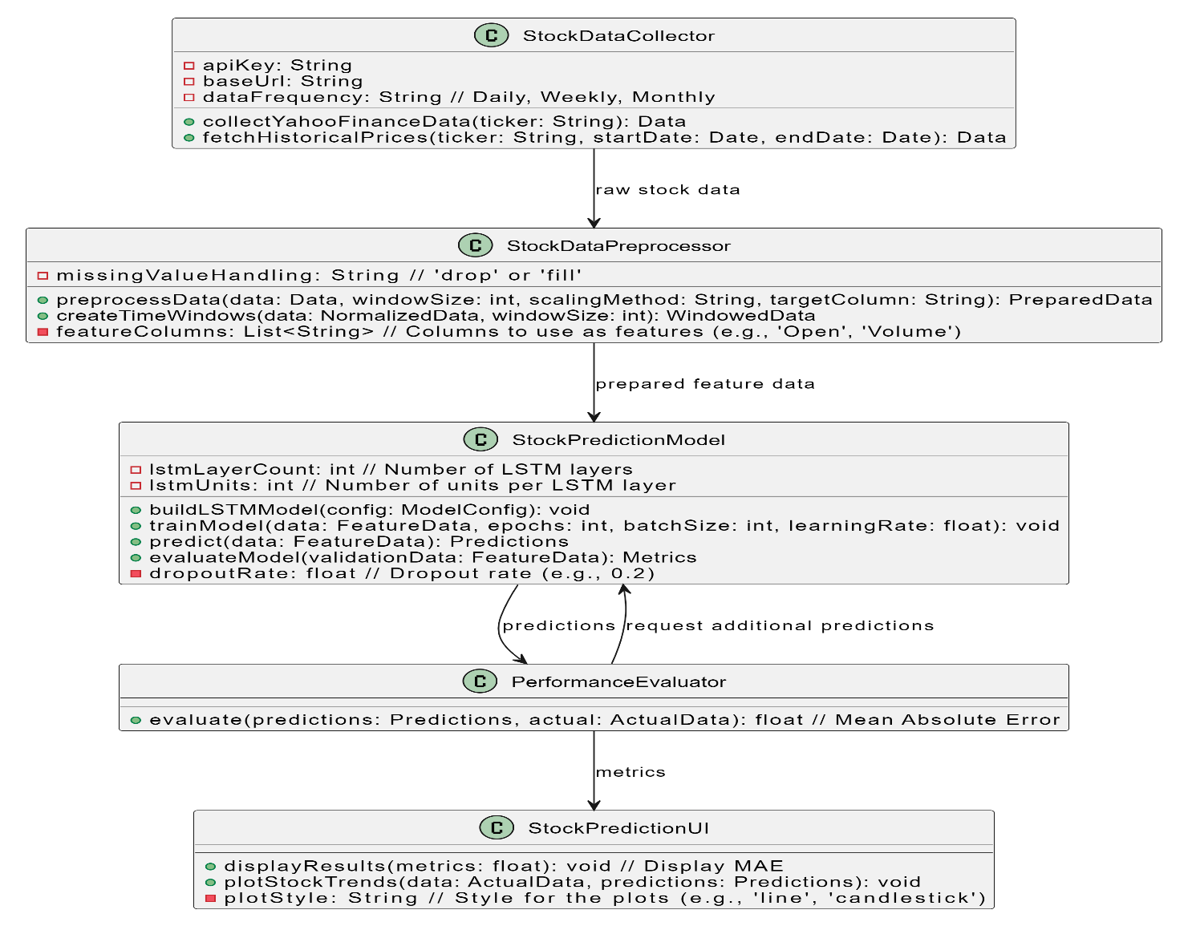

***Fig-5.3.2: Class Diagram***

The A class diagram for implementing the Efficient Market Hypothesis (EMH) using an LSTM (Long Short-Term Memory) model showcases the structure and relationships between the system's components. The main classes include Market Data, which handles the collection, preprocessing, and normalization of historical price and volume data; LSTM Model, which manages model training, evaluation, and prediction generation using attributes like input shape, hidden layers, epochs, and batch size; and Hypothesis Tester, which evaluates model predictions against EMH principles using methods such as random walk tests and residual analysis. Additionally, the Visualization Tool class generates and displays prediction trends and statistical results to the user, while the User class allows analysts and traders to interact with the system by inputting preferences and viewing outputs. These classes are interconnected, with Market Data providing preprocessed data to the LSTM Model, which in turn generates predictions analyzed by Hypothesis Tester.

### Sequence Diagram

A sequence diagram represents the interaction between different objects in the system. The important aspect of a sequence diagram is that it is time-ordered. This means that the exact sequence of the interactions between the objects is represented step by step. Different objects in the sequence diagram interact with each other by passing "messages".

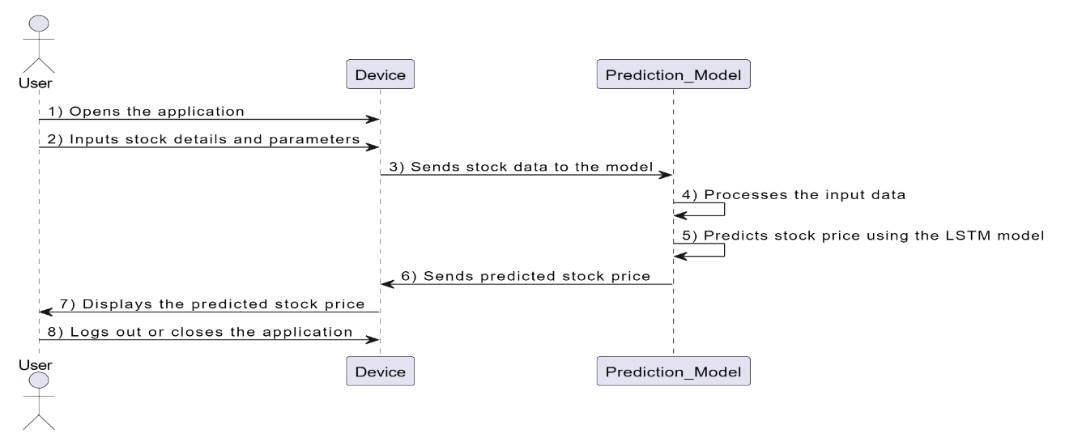

***Fig-5.3.4: Sequence Diagram***

The A sequence diagram for implementing the Efficient Market Hypothesis (EMH) using an LSTM (Long Short-Term Memory) model outlines the step-by-step interactions between system components and actors over time. The process begins with the Data Analyst requesting historical market data from the Market Data object, which collects, preprocesses (cleaning and normalizing), and provides the prepared dataset. This data is then sent to the LSTM Model object for training, where the model learns temporal dependencies. Once trained, the model is tested using validation data, and the results are returned. The trained LSTM Model generates future trend predictions, which are forwarded to the Hypothesis Tester object. The Hypothesis Tester evaluates these predictions against EMH principles using statistical methods such as random walk tests and residual analysis, producing insights about market efficiency.

## Sample Code

#Importing required libraries

import pandas as pd

import datetime as dt

from datetime import date

import matplotlib.pyplot as plt

import yfinance as yf

import numpy as np

import tensorflow as tf

# Define start day to fetch the dataset from the yahoo finance library

START = "2015-01-01"

TODAY = date.today().strftime("%Y-%m-%d")

# Define a function to load the dataset

def load_data(ticker):

    data = yf.download(ticker, START, TODAY)

    data.reset_index(inplace=True)

    return data

data = load_data('AAPL')

df=data

df.head()

df.tail()

df = df.drop(['Date', 'Adj Close'], axis = 1)

df.head()

plt.title("Close Price Visualization")

plt.plot(df.Close)

df

# Plotting moving averages of 100 day

ma100 = df.Close.rolling(100).mean()

ma100

plt.figure(figsize = (12,6))

plt.plot(df.Close)

plt.plot(ma100, 'r')

plt.title('Graph Of Moving Averages Of 100 Days')

# Defining 200 days moving averages and plotting comparision graph with 100 days moving averages

ma200 = df.Close.rolling(200).mean()

ma200

plt.figure(figsize = (12,6))

plt.plot(df.Close)

plt.plot(ma100, 'r')

plt.plot(ma200, 'g')

plt.title('Comparision Of 100 Days And 200 Days Moving Averages')

df.shape

# Spliting the dataset into training (70%) and testing (30%) set

# Splitting data into training and testing

train = pd.DataFrame(data[0:int(len(data)*0.70)])

test = pd.DataFrame(data[int(len(data)*0.70): int(len(data))])

print(train.shape)

print(test.shape)

train.head()

test.head()

# Using MinMax scaler for normalization of the dataset

from sklearn.preprocessing import MinMaxScaler

scaler = MinMaxScaler(feature_range=(0,1))

train_close = train.iloc[:, 4:5].values

test_close = test.iloc[:, 4:5].values

data_training_array = scaler.fit_transform(train_close)

data_training_array

x_train = []

y_train = []

for i in range(100, data_training_array.shape[0]):

    x_train.append(data_training_array[i-100: i])

    y_train.append(data_training_array[i, 0])

x_train, y_train = np.array(x_train), np.array(y_train)

x_train.shape

# ML Model (LSTM)

from tensorflow.keras.layers import Dense, Dropout, LSTM

from tensorflow.keras.models import Sequential

model = Sequential()

model.add(LSTM(units = 50, activation = 'relu', return_sequences=True,input_shape = (x_train.shape[1], 1)))

model.add(Dropout(0.2))

model.add(LSTM(units = 60, activation = 'relu', return_sequences=True))

model.add(Dropout(0.3))

model.add(LSTM(units = 80, activation = 'relu', return_sequences=True))

model.add(Dropout(0.4))

model.add(LSTM(units = 120, activation = 'relu'))

model.add(Dropout(0.5))

model.add(Dense(units = 1))

model.add(Dense(units=1))

model.summary()

# Training the model

model.compile(optimizer = 'adam', loss = 'mean_squared_error', metrics = ['MAE'])

model.fit(x_train, y_train, validation_data = (x_train, y_train) ,epochs = 70)

model.save('keras_model.h5')

test_close.shape

test_close

past_100_days = pd.DataFrame(train_close[-100:])

test_df = pd.DataFrame(test_close)

# Defining the final dataset for testing by including last 100 coloums of the training dataset to get the prediction from the 1st column of the testing dataset.

final_df = pd.concat([past_100_days, test_df], ignore_index=True)

final_df.head()

input_data = scaler.fit_transform(final_df)

input_data

input_data.shape

# Testing the model

x_test = []

y_test = []

for i in range(100, input_data.shape[0]):

   x_test.append(input_data[i-100: i])

   y_test.append(input_data[i, 0])

x_test, y_test = np.array(x_test), np.array(y_test)

print(x_test.shape)

print(y_test.shape)

# Making prediction and plotting the graph of predicted vs actual values

# Making predictions

y_pred = model.predict(x_test)

y_pred.shape

y_test

y_pred

scaler.scale_

scale_factor = 1/0.00985902

y_pred = y_pred * scale_factor

y_test = y_test * scale_factor

plt.figure(figsize = (12,6))

plt.plot(y_test, 'b', label = "Original Price")

plt.plot(y_pred, 'r', label = "Predicted Price")

plt.xlabel('Time')

plt.ylabel('Price')

plt.legend()

plt.show()

"""# Model evaluation"""

from sklearn.metrics import mean_absolute_error

mae = mean_absolute_error(y_test, y_pred)

print("Mean absolute error on test set: ", mae)

# MODEL DEVELOPMENT

## Model Architecture

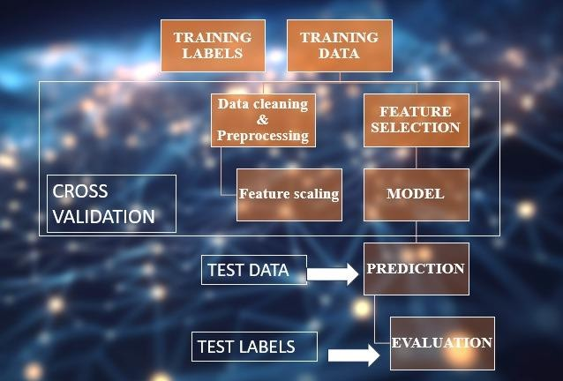

***Fig 6.1: Model Architecture***

### Data Collection

The first step in developing a Effective Stock Price prediction is to Obtain historical stock price data from reliable sources such as Yahoo Finance, Alpha Vantage, or Quandl. This data typically includes the stock's opening, closing, highest, and lowest prices, along with trading volume for each day.

### Data Preprocessing

Once the data is collected, it undergoes preprocessing to prepare it for analysis. This involves several steps, including data cleaning, normalization, and transformation. Data cleaning aims to remove noise, errors, and inconsistencies from the dataset, ensuring its quality and reliability. Normalization standardizes the data across different scales and units, making it suitable for analysis. Transformation techniques such as feature extraction, dimensionality reduction, and encoding are applied to enhance the usefulness and efficiency of the dataset for model training and evaluation.

### Selection and Engineering

Feature selection is a critical step in building an effective intrusion detection system. This involves identifying and selecting relevant features that contribute to distinguishing between normal and malicious network activity. Feature selection techniques such as correlation analysis, feature importance, and domain knowledge are employed to identify the most discriminative features. Feature engineering techniques are then applied to create new features or transform existing ones to enhance the predictive power of the dataset.

## Model Training

Train the LSTM model on the training data using backpropagation through time (BPTT). Tune hyperparameters such as learning rate, batch size, and number of epochs based on the performance on the validation set.Monitor the model's performance on the validation set and stop training if the performance starts to degrade or if no significant improvement is observed (early stopping).

### Splitting the Dataset:

In stock price prediction, data splitting ensures accurate model evaluation and prevents overfitting. The dataset is typically divided into three subsets: training, validation, and testing. The **training set**, comprising the majority of the data, is used to train the model by learning patterns from historical stock prices and associated features

like trading volume, technical indicators, and economic factors. This forms the foundation for predicting future price movements.

The **testing set** is an independent subset reserved for the final evaluation of the trained model. It represents future time periods and serves as a benchmark for real-world performance. Metrics such as Mean Squared Error (MSE), Mean Absolute Error (MAE), and R-squared quantify the model’s ability to predict unseen data. This step simulates deployment scenarios, making it crucial for reliable performance assessment.

In stock price prediction, **time-based splitting** is vital to mimic real-world forecasting. The training set includes data up to a specific time, followed by the validation set, and the testing set contains future data. This temporal structure ensures the model is trained on past information and evaluated on forward-looking scenarios, enhancing its applicability to real-world market forecasting.

.

### Algorithm-Specific Training:

Employ algorithm-specific training procedures for each model. For instance:

Isolation Forest

The **Long Short-Term Memory (LSTM)** model is a type of recurrent neural network (RNN) designed to effectively capture temporal dependencies in sequential data. LSTM excels at learning long-term patterns, making it highly suitable for stock price prediction, where historical price trends and market dynamics influence future movements. By leveraging its memory cells and gates, LSTM can retain important past information while discarding irrelevant details.

In the context of stock price prediction, LSTM processes sequential data, such as daily prices, trading volumes, and technical indicators, to predict future stock prices or trends. Unlike traditional models, LSTM accounts for the temporal order of data, ensuring that patterns like seasonality or market cycles are captured accurately. This capability makes it a robust choice for forecasting tasks in financial markets.

.

from tensorflow.keras.layers import Dense, Dropout, LSTM

from tensorflow.keras.models import Sequential

model = Sequential()

model.add(LSTM(units = 50, activation = 'relu', return_sequences=True,input_shape = (x_train.shape[1], 1)))

model.add(Dropout(0.2))

model.add(LSTM(units = 60, activation = 'relu', return_sequences=True))

model.add(Dropout(0.3))

model.add(LSTM(units = 80, activation = 'relu', return_sequences=True))

model.add(Dropout(0.4))

model.add(LSTM(units = 120, activation = 'relu'))

model.add(Dropout(0.5))

model.add(Dense(units = 1))

model.add(Dense(units=1))

model.summary()

"# Training the model

model.compile(optimizer = 'adam', loss = 'mean_squared_error', metrics = ['MAE'])

model.fit(x_train, y_train, validation_data = (x_train, y_train) ,epochs = 70)

model.save('keras_model.h5')

test_close.shape

test_close

past_100_days = pd.DataFrame(train_close[-100:])

test_df = pd.DataFrame(test_close)

# 7 RESULTS

**DATA SET FETCHED FROM YAHOO FINANCE :**

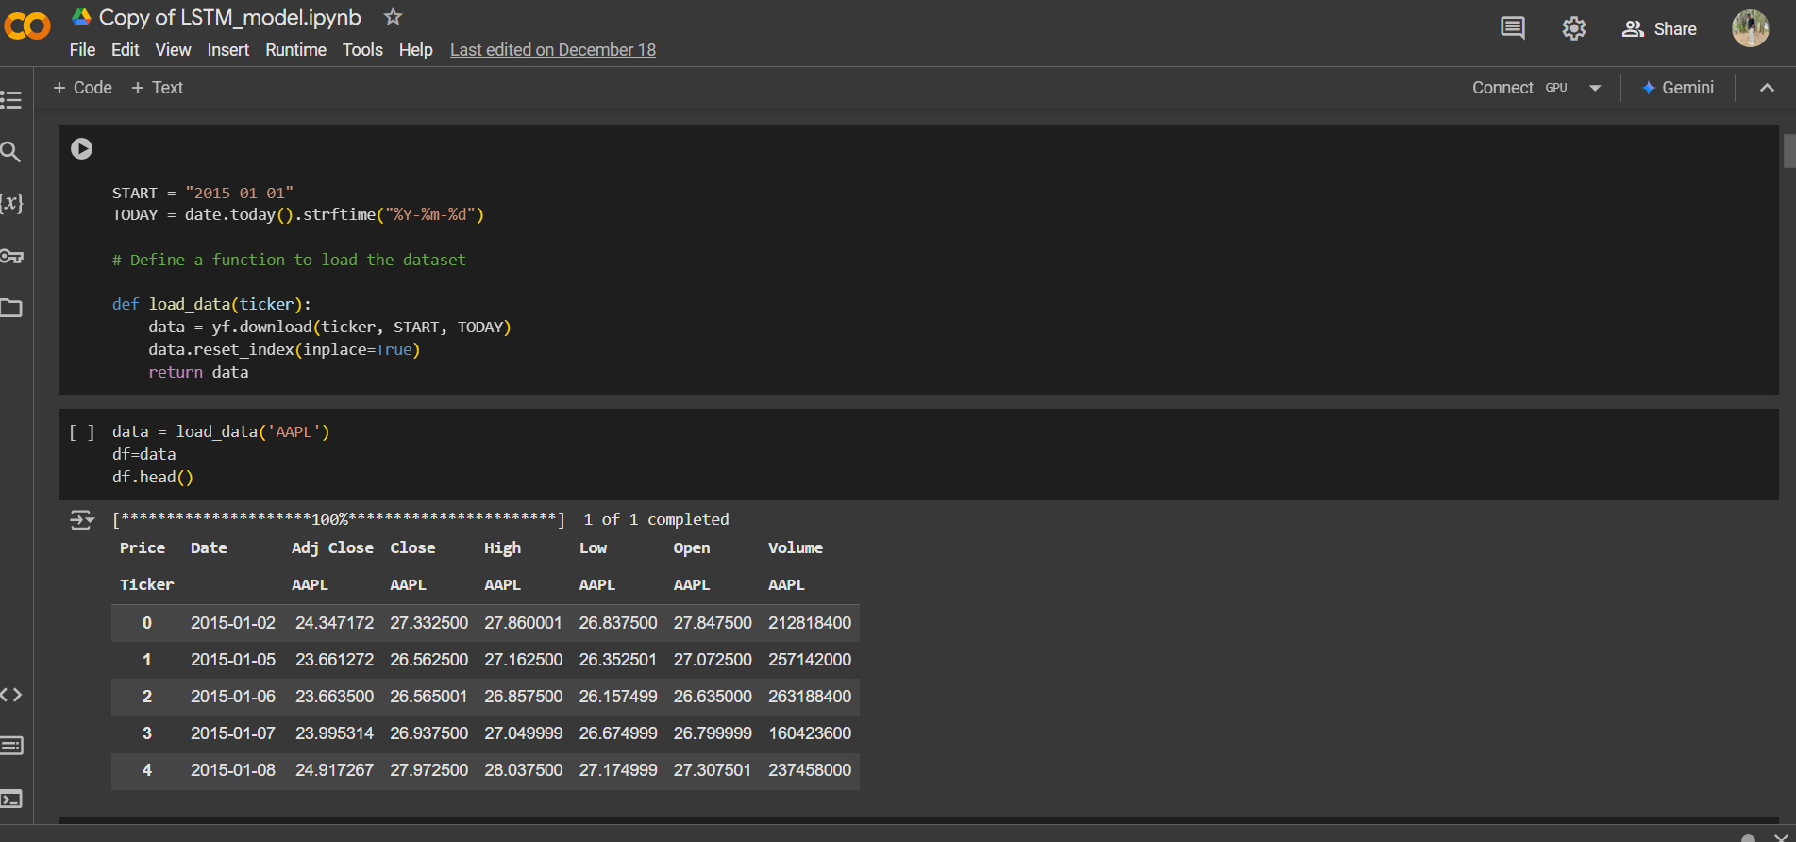

**FIRST AND LAST FIVE ROWS OF DATASET :**

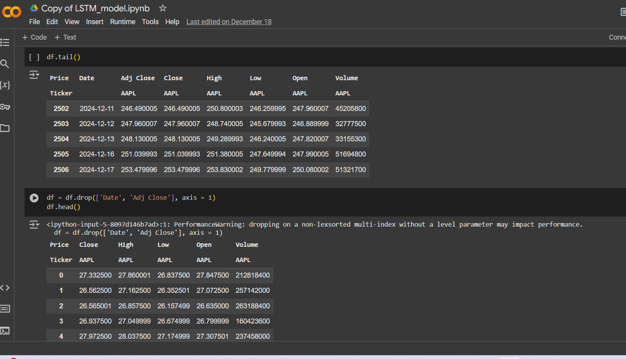

**LSTM MODEL :**

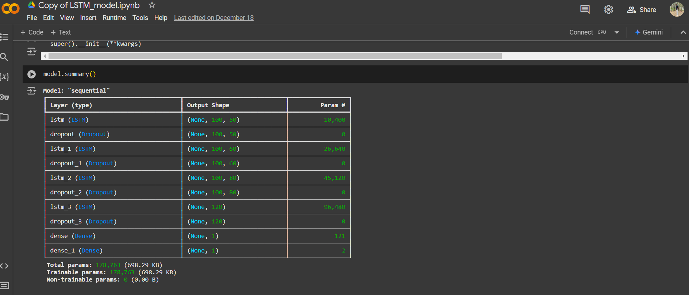

**COMPARING PREDICTED (RED) VS ACTUAL GRAPH (BLUE)**

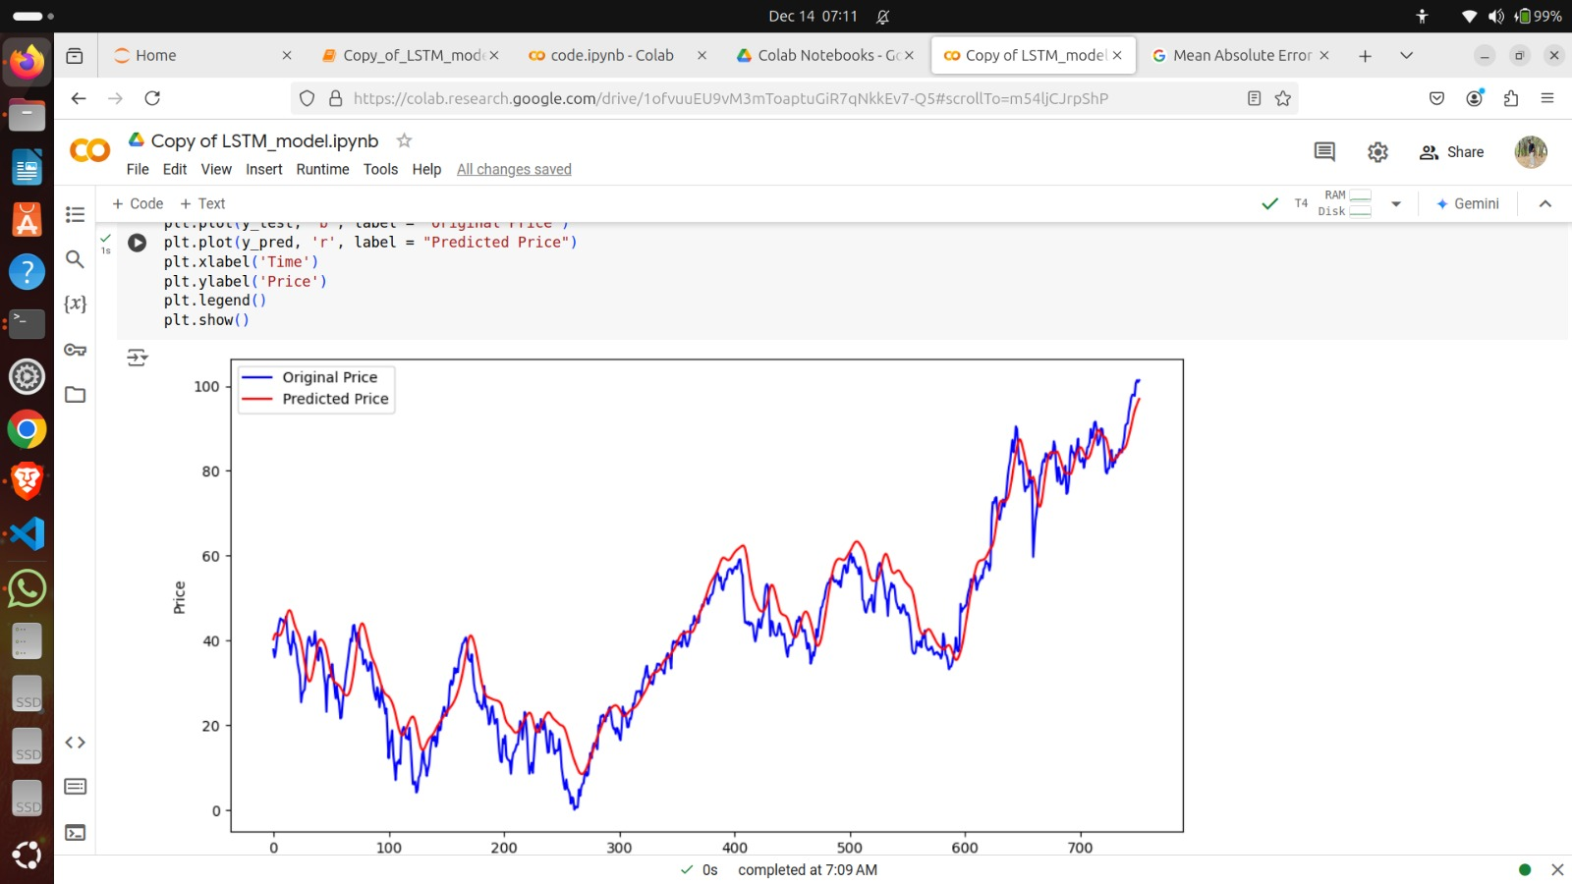

**Final Graph:**

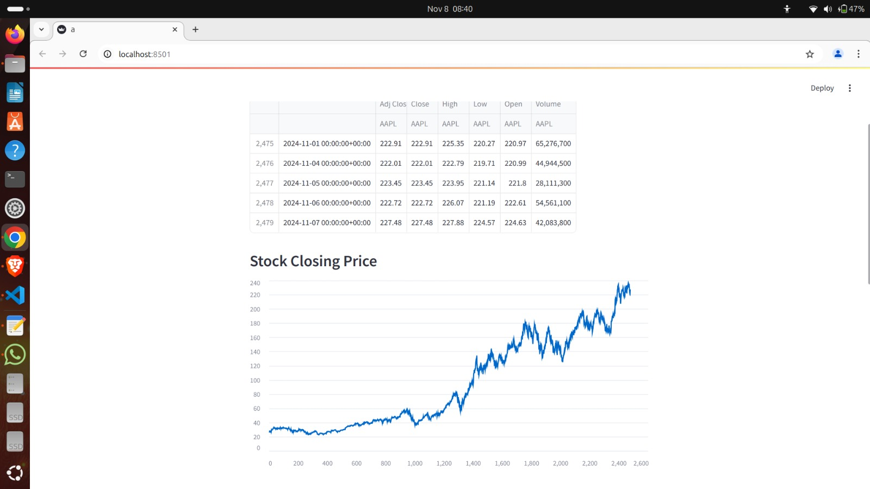

# CONCLUSION

In conclusion, stock price prediction using Long Short-Term Memory (LSTM) networks represents a powerful approach for forecasting financial time series data. LSTM networks offer several advantages over traditional machine learning algorithms, particularly in capturing long- term dependencies, handling nonlinear relationships, and learning from sequential data. Here's a summary of the key points:

Predictive Power: LSTM networks excel at capturing temporal patterns and trends in stock price data, making them well-suited for predicting future price movements. Their ability to remember information over extended periods allows them to capture both short-term fluctuations and long-term trends simultaneously.

Flexibility and Adaptability: LSTM architectures offer flexibility in model design, allowing for variations such as stacked layers, bidirectional connections, and attention mechanisms. This adaptability enables LSTM models to learn from diverse data sources and adjust to changing market conditions.

Feature Learning: LSTM networks can automatically learn relevant features from the input data, reducing the need for manual feature engineering. This is particularly advantageous in stock price prediction, where identifying relevant features from raw data can be challenging.

Real-Time Prediction: LSTM models can provide real-time predictions of stock price movements, enabling traders and investors to make timely decisions in dynamic market environments. This real-time capability is essential for algorithmic trading strategies and risk management.

Continuous Improvement: LSTM models can be continuously retrained and updated with new data to adapt to evolving market dynamics. This iterative process allows models to maintain prediction accuracy over time and incorporate new information as it becomes

Long Short-Term Memory (LSTM) Architecture: LSTM is a type of recurrent neural network (RNN) architecture designed to address the vanishing gradient problem in traditional RNNs. It consists of memory cells and gates (input gate, output gate, and forget gate) that enable it to selectively retain or discard information over time, allowing for the capture of long-term dependencies in sequential data.

Sequence Modeling: LSTM networks are particularly well-suited for sequence modeling tasks, where input data has a temporal or sequential structure. In the context of stock price prediction, LSTM models can learn from historical price sequences and extract meaningful patterns and trends to make future predictions.

Feature Representation: LSTM networks automatically learn hierarchical representations of input features, capturing both short-term fluctuations and long-term trends in stock price data. This ability to extract relevant features from raw input data reduces the need for manual feature engineering and preprocessing, simplifying the modeling process.

Temporal Dynamics: LSTM models excel at capturing temporal dynamics in stock price data, including seasonality, trends, and periodic fluctuations. By leveraging memory cells and gated mechanisms, LSTM networks can effectively model complex temporal relationships and adapt to changes in market conditions over time.

Regularization Techniques: LSTM networks can be prone to overfitting, particularly when trained on limited data or complex architectures. Regularization techniques such as dropout, recurrent dropout, and batch normalization help mitigate overfitting by introducing noise during training and preventing the model from memorizing noise in the data.

By considering these additional details and best practices, practitioners can develop more effective and reliable LSTM-based models for stock price prediction, enabling informed decision-making and risk management in financial markets.

.

# 9 FUTURE ENHANCEMENT

Future research and development in stock price prediction are likely to focus on several key areas, aiming to improve prediction accuracy, enhance model interpretability, and address emerging challenges in financial markets. Here are some potential directions for future work:

Incorporating Alternative Data Sources: There is growing interest in leveraging alternative data sources such as social media sentiment, news articles, satellite imagery, and IoT (Internet of Things) data to complement traditional financial data. Future research could explore novel ways of integrating and analyzing alternative data sources to enhance predictive models' performance and provide deeper insights into market dynamics.

Deep Learning Architectures: While LSTM networks have shown promise in capturing temporal dependencies in stock price data, further advancements in deep learning architectures could lead to more powerful and efficient models. Research into advanced architectures, such as Transformer-based models, graph neural networks, and attention mechanisms, may offer new opportunities for improving prediction accuracy and scalability.

Uncertainty Estimation: Estimating uncertainty in stock price predictions is critical for making informed decisions and managing risks in financial markets. Future work could focus on developing probabilistic forecasting methods that provide uncertainty estimates along with point predictions, enabling investors to quantify and account for prediction uncertainty.

Interpretable Models: Enhancing the interpretability of predictive models is essential for building trust and confidence among stakeholders. Future research could explore techniques for making LSTM models more interpretable, such as attention mechanisms, feature importance analysis, and model introspection methods, to provide insights into the factors driving prediction outcomes.

Multi-Task Learning: Multi-task learning techniques enable models to simultaneously learn multiple related tasks, leveraging shared information and improving generalization performance. Future research could investigate multi-task learning frameworks for stock price prediction, where models are trained to predict multiple related financial metrics or market indicators jointly, enhancing prediction accuracy and robustness.

Graph-based Representations: Financial markets exhibit complex relational structures, with interdependencies between assets, sectors, and market indices. Future research could explore graph-based representations of financial markets, where assets are represented as nodes in a graph, and relationships between assets are captured through edges. Graph neural networks and relational learning techniques could be applied to learn representations of financial networks and improve prediction accuracy.

Explainable AI (XAI): Enhancing the explainability of predictive models is crucial for building trust and understanding model behavior. Future research could focus on developing interpretable and explainable AI (XAI) techniques for stock price prediction, enabling stakeholders to understand the rationale behind model predictions and identify the factors driving prediction outcomes.

Federated Learning: Federated learning enables model training across distributed data sources without centrally aggregating data, preserving data privacy and security. Future research could explore federated learning approaches for stock price prediction, where models are trained collaboratively across multiple financial institutions or data providers, leveraging the collective knowledge of diverse datasets while protecting sensitive information.

Ethical AI and Responsible Innovation: As predictive models increasingly influence financial decision-making, ensuring ethical and responsible AI practices becomes paramount. Future research could focus on developing frameworks and guidelines for ethical AI in finance, addressing concerns such as bias, fairness, transparency, and accountability to promote responsible innovation and mitigate potential risks.

# 

# 10 REFERENCES

1. Hastie, T., Tibshirani, R., & Friedman, J. (2009). The elements of statistical learning: data mining, inference, and prediction. Springer Science & Business Media.
2. Kim, J., Kim, J., & Kang, S. (2014). Stock price prediction using KNN and neural network. Journal of Advances in Information Technology, 5(3), 171-178.
3. Lai, C. C., & Yang, C. S. (2011). Stock price prediction using hybrid machine learning techniques. Expert Systems with Applications, 38(11), 14314-14323.
4. Lee, T. S., & Chen, W. C. (2005). Mining the stock market: which measure is the best predictor of stock prices?. Expert Systems with Applications, 28(4), 743-754.
5. Manavalan, E., & Sathiyamoorthy, E. (2012). Stock price prediction using K-Nearest Neighbor (k-NN) algorithm. International Journal of Computer Science and Engineering, 1(2), 88-93.
6. K. V. Sujatha and S. M. Sundaram, "Stock index prediction using regression and neural network models under non normal conditions," INTERACT-2010, Chennai, 2010, pp. 59-63.
7. H. Gunduz, Z. Cataltepe and Y. Yaslan, "Stock market direction prediction using deep neural networks," 2017 25th Signal Processing and Communications Applications Conference (SIU), Antalya, 2017
8. M. Billah, S. Waheed and A. Hanifa, "Stock market prediction using an improved training algorithm of neural network," 2016