# Lender Registration Page.

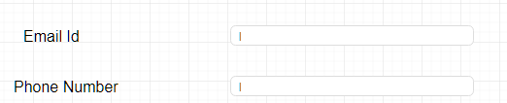

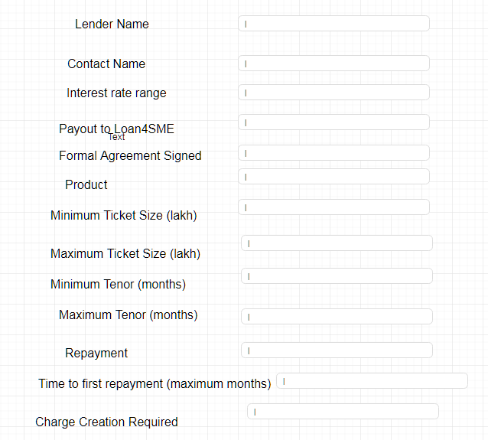

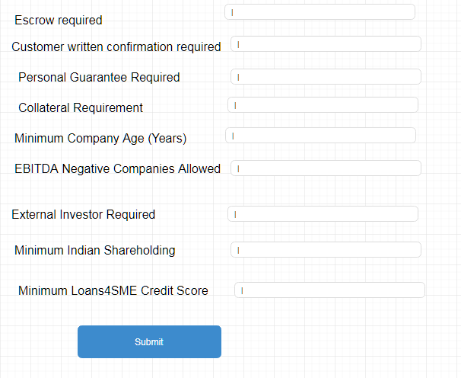

Only System Admin and Manager will have access to this form.

All fields will be mandatory.

On click of submit :- Lender Account will be registered to the system. A mail to respective Lender will be triggered with a link to verify and activate the account.

Link in mail will redirect to below page. (Account activation and Email Confirmation Page)

# Account activation and Email Confirmation Page

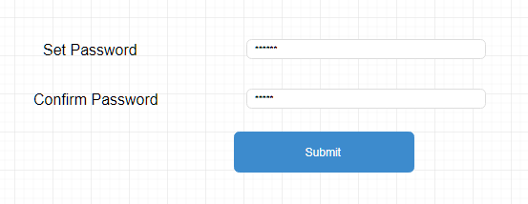

# Login Page

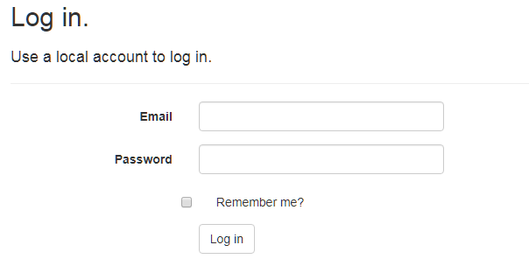

# Forgot Password Page

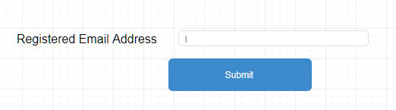

On click of submit User password will be reset and new password will be mailed to user.

# Changes Password page.

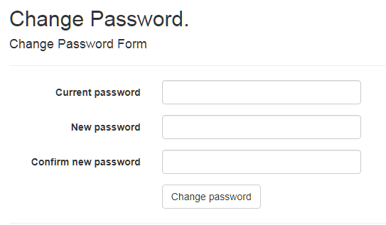

# Registration form for Sales Executive and Credit checker

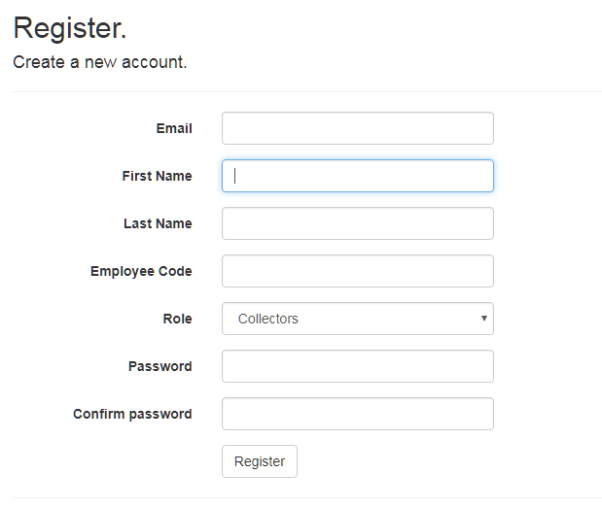

Only System Admin and Manager will have access to this form.

All fields will be mandatory.

On click of submit :- User with role Sales executive or Credit checker will be registered to the system. A mail to respective user will be triggered with a link to verify and activate the account.

Link in mail will redirect to page. (Account activation and Email Confirmation Page described above.)

# Borrower Home page.

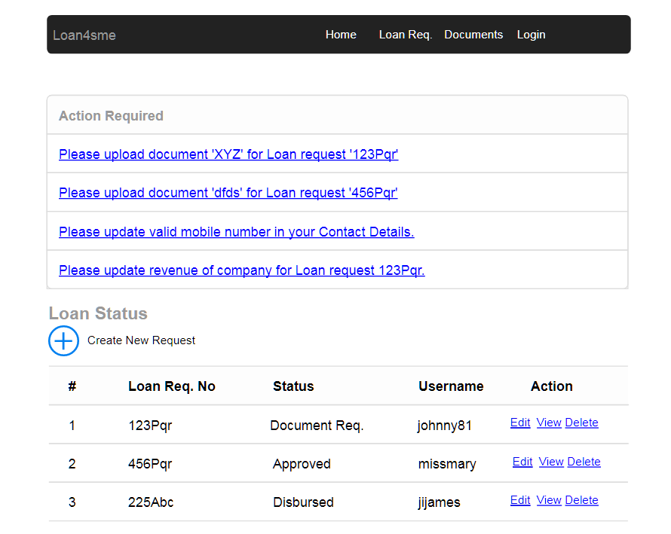

Borrower will have two sections on his home page

1. Action Required.

This section will contain list of request received from credit checker or Lender. Request will be to ask for some additional info or/and additional document. On click of this type of request borrower will be directed to ‘Action response page’ as described in below image.

Action item to upload document on completion of background check will also be listed in Action Required section. On click of this action item user will be redirected to upload document page instead of Action response page.

1. Loan Status.

This will be a list of all loan request created by this borrower.

Borrower can click on Create new request to create new loan request.

On click on edit link – User will be redirected to edit page with all page fields pre-populated with given loan request. Borrower will not be able to edit ‘How much funding do you need’ and ‘contact email Id’ other than this all the fields will be editable.

On click of Delete link – User will be redirected to detail page for confirmation of deletion. If user clicks on delete button on this page this loan request will be soft deleted and will be marked as ‘Client drop’ in whatever stage it is in. In ‘Client drop status’ no all the processing of the loan will be stopped in whatever state it was.

On click of view link – a consolidated view page for selected loan will be displayed.

# Action Response page.

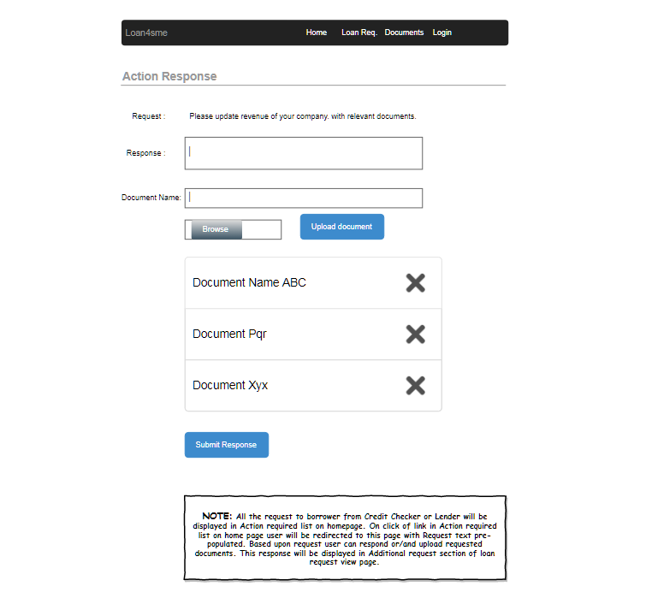

All the request to borrower from Credit Checker or Lender will be displayed in Action required list on homepage. On click of link in Action required list on home page user will be redirected to this page with Request text pre-populated. Based upon request user can respond or/and upload requested documents. This response will be displayed in Additional request section of loan request view page.

# Borrower Loan Req./Registration form.

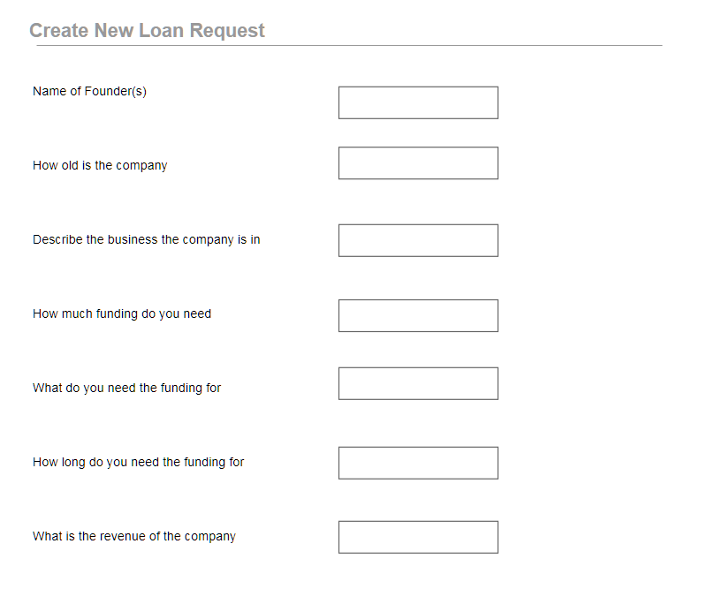

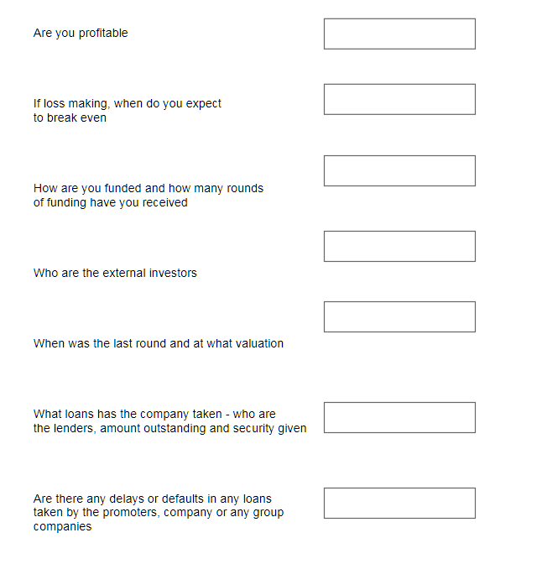

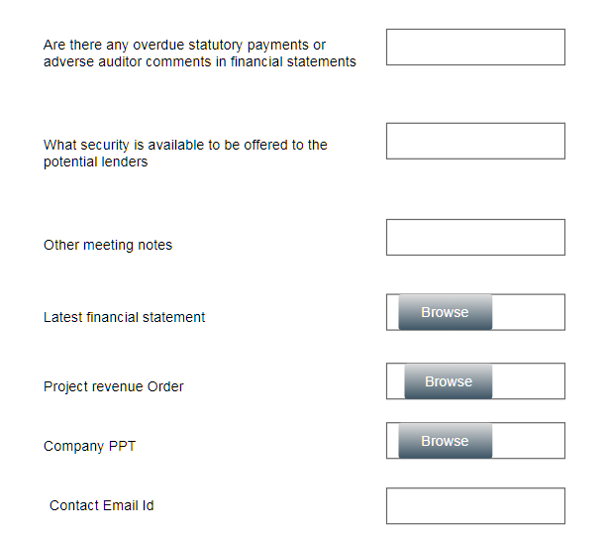



On click of submit button a new loan request will be created.

These details can be entered by borrower or by sales representative.

If request is created by sales executive this loan request gets automatically mapped to the sales executive.

If request is created by buyer then system admin will map loan request to sales executive.

# Loan request to sales executive mapping screen

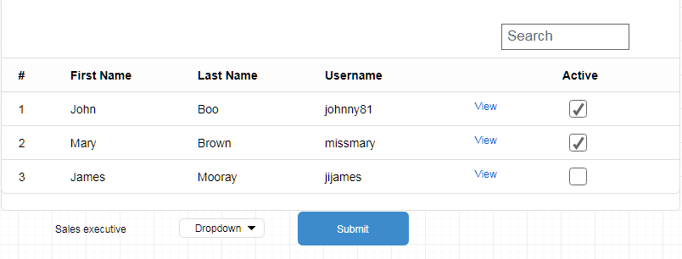

System admin will select specific loan request, select sales executive in dropdown and click on submit button to map the request to sales executive.

On click of view loan request detail page will open up.

# Loan request to Credit Checker mapping screen

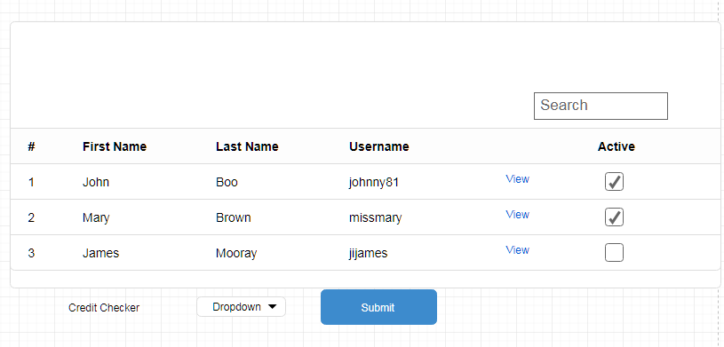

System admin will select specific loan request, select Credit checker in dropdown and click on submit button to map the request to Credit checker.

On click of view loan request, Loan request detail page will open up.

# Update ‘background check’ status

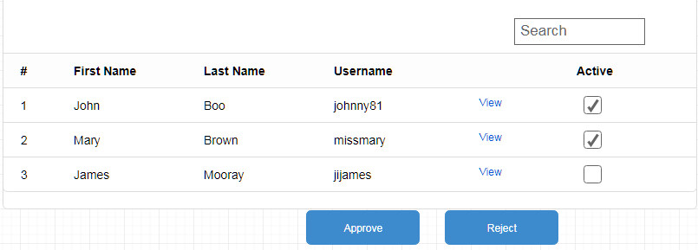

After sales executive has done his background check he will come to above page select loan request and mark them approve or reject.

On approval loan

* Mandate letter is generated by system and attached to this loan request which can be downloaded from View loan request page.
* Mail is send to buyer with a link ‘for account activation and email confirmation page’ (mentioned above) burrower clicks on the link activate his account and uploads required document.

# Document upload page.

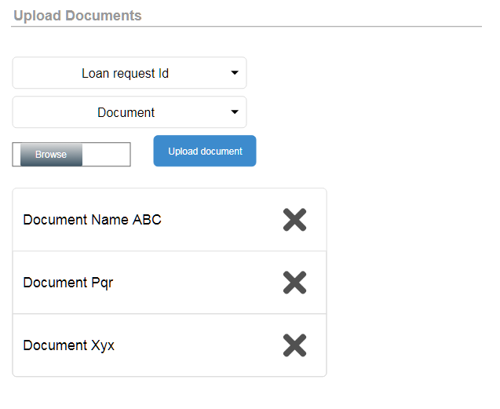

Borrower or sales representative will select Loan request Id, Name of document, browser files and upload the document. On successfully upload of document ‘document uploaded successfully’ message is displayed on top.

Document dropdown will contain documents that are mandatory and not uploaded. When all the mandatory documents are uploaded document dropdown and upload document button is disabled and loan request is forwarded to credit checker.

# Credit checker approve reject loan request List.

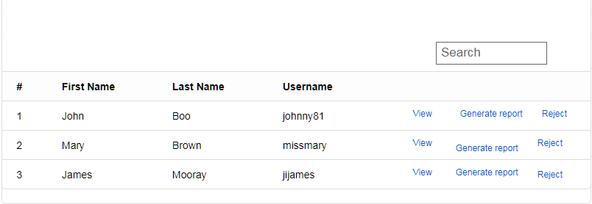

After documents are uploaded credit checker sees the list of loan request as shown in above screen after verifying document he either rejects or generates report to forward it to lenders.

# Request additional info.

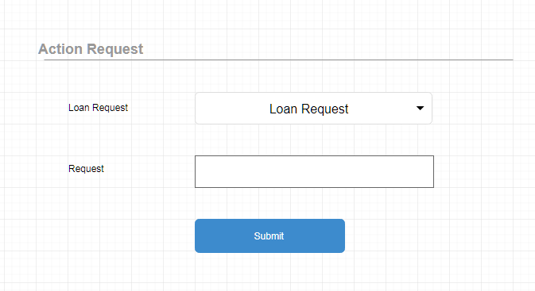

Credit checker can request additional info for loan request by filling this from for the selected loan request. Only those loan request mapped to credit checker will be visible in loan request dropdown.

On click of submit.

* This request will be visible in Action request list on borrower/sales representative screen.
* This request will be removed for Credit checker approve reject loan request list.

Borrower or respective sales representative will complete specific action after which again this request will be visible to Credit checker approve reject list.

# Credit checker Generate executive summary report.

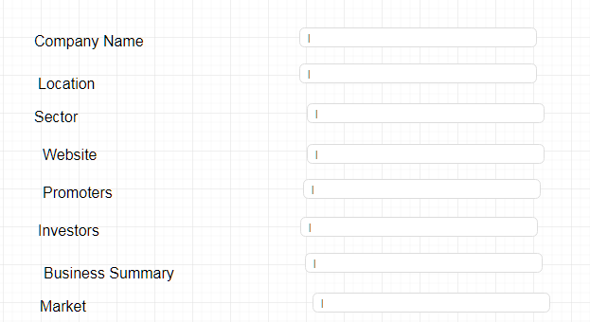

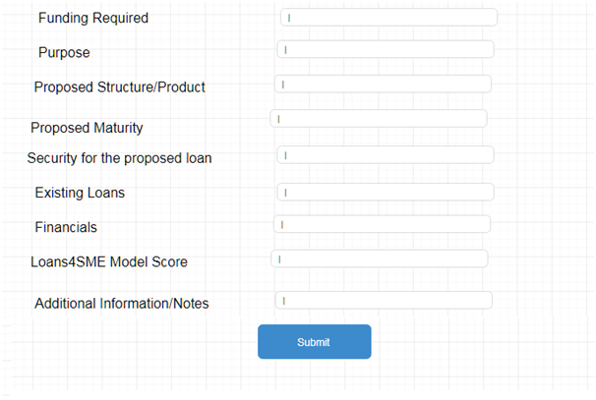

On click of submit button a pdf of executive summary report is generated and System forwards the request to all lender where Lender Minimum ticket size < borrower requested amount < Lender Maximum ticket size.

# Credit checker Edit executive summary report.

Credit checker will have a menu to edit executive summary report for all loan requests that are assigned to him and Executive summary report is already generated.

Credit checker will select loan request dropdown. Edit executive summary will have same field as Create executive summary detail page with all the fields pre-populated.

On click of submit executive summary report will be updated.

# Lender approve rejects screen

Lender on login sees below screen.

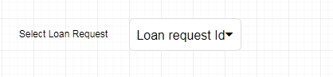

On selection of loan request loan request data is displayed.



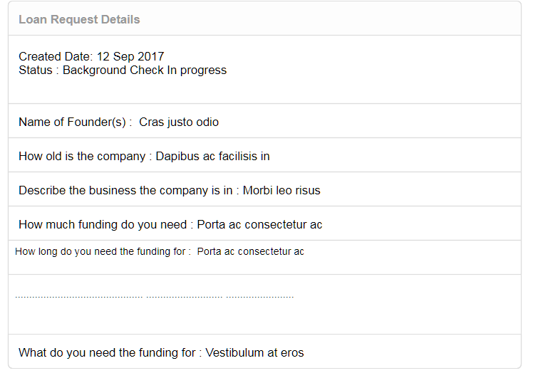

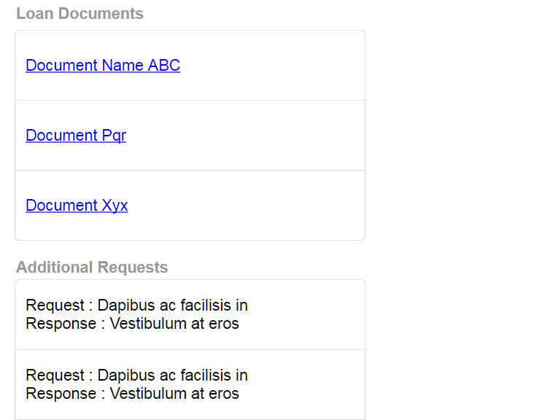

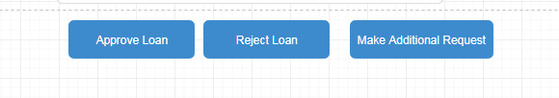

On click of Approve ‘loan loan approved’ message is displayed on the screen.

On click of Reject Loan. Loan is marked as reject by this lender.

Make additional Request. On click of this button Lender is redirected to ‘Request additional info’. Page on requesting additional loan request this request is removed from this lender list and is moved to borrower/sales rep to complete additional request.

If loan is approved by any of the lender it is considered as approved if loan is rejected by all the lenders it is marked as Rejected.

# Roles and Authorization details

|  |  |
| --- | --- |
| System Admin | Will have access to all the pages. |
| Borrower | Will have access to loan request page and upload document page. |
| Sales executive | Will have access to loan request page, upload document page, background status update page, |
| Credit checker | Will have access to Credit checker approve reject loan list and generate executive summary page. |
| Lender | Loan request approves reject screen. |