# Register as borrower.

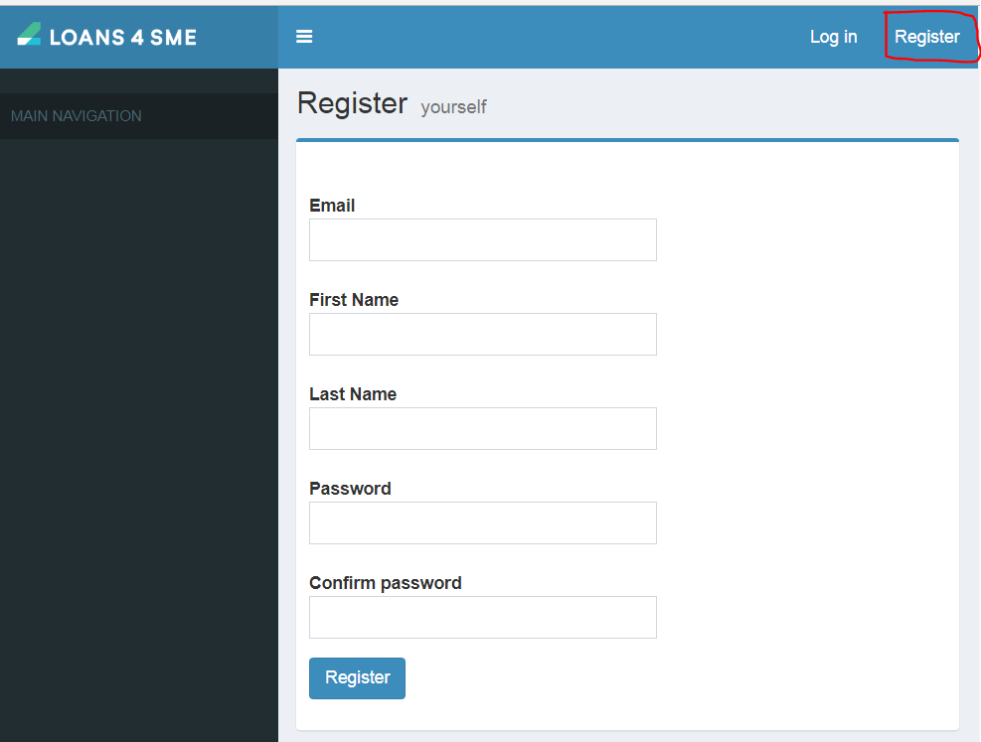

On successful registration borrower receives email with link to activate and set password.

Borrower clicks on the link in email to activate account and set password.

# Create Loan request.

Borrower or Sales executive can login and create a loan request as shown in below screen.

Loan Request created by borrower.

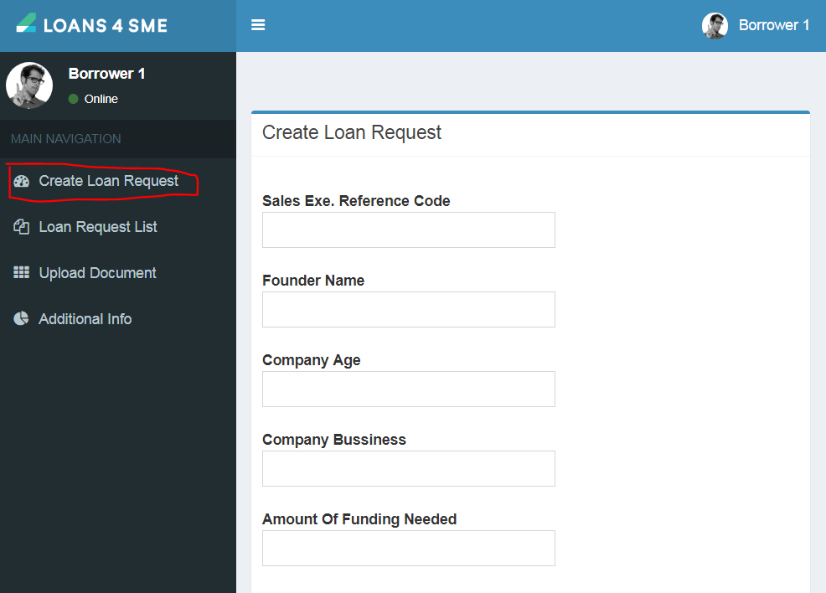

At time of creation of loan request if ‘Sales Exe. Reference code is entered then this loan request gets mapped to the sales exec.

Loan Request created by Sales executive.

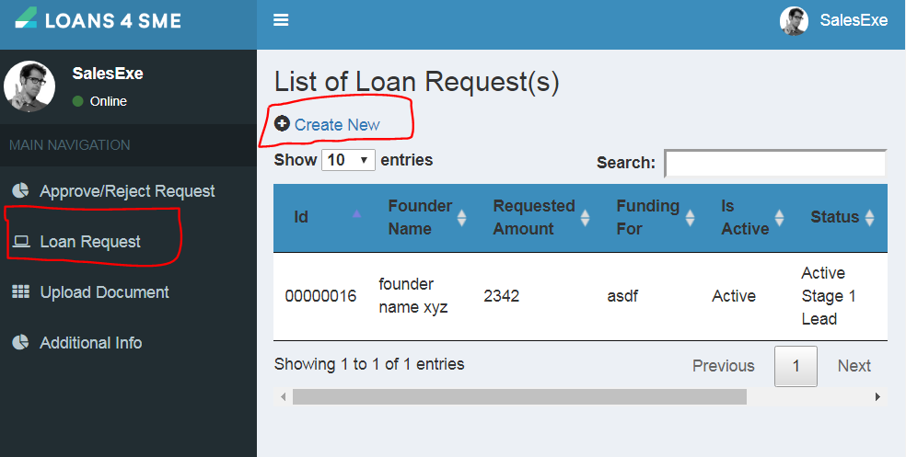

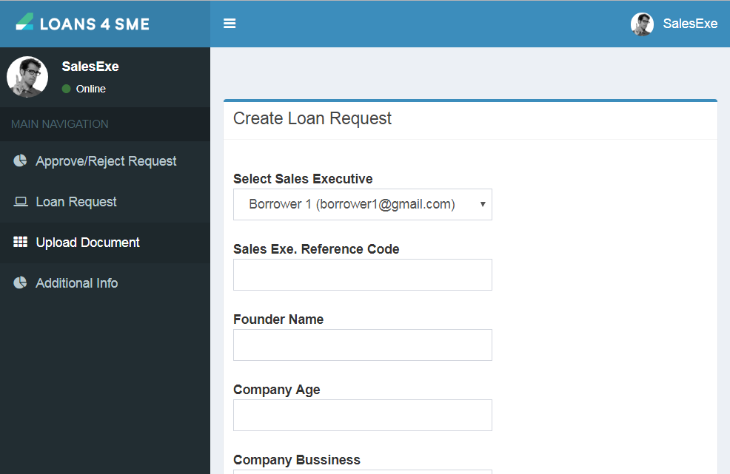

Sales executive selects borrower for which he is creating loan request. This loan request automatically gets mapped to the sales executive who is creating this loan request.

If Loan request is created by Borrower and ‘Sales Exe Reference code’ is not mentioned by the borrower then sys admin has to assignee ‘Sales Exe’ to the loan request.

# Sys Admin Assignee Sales executive.

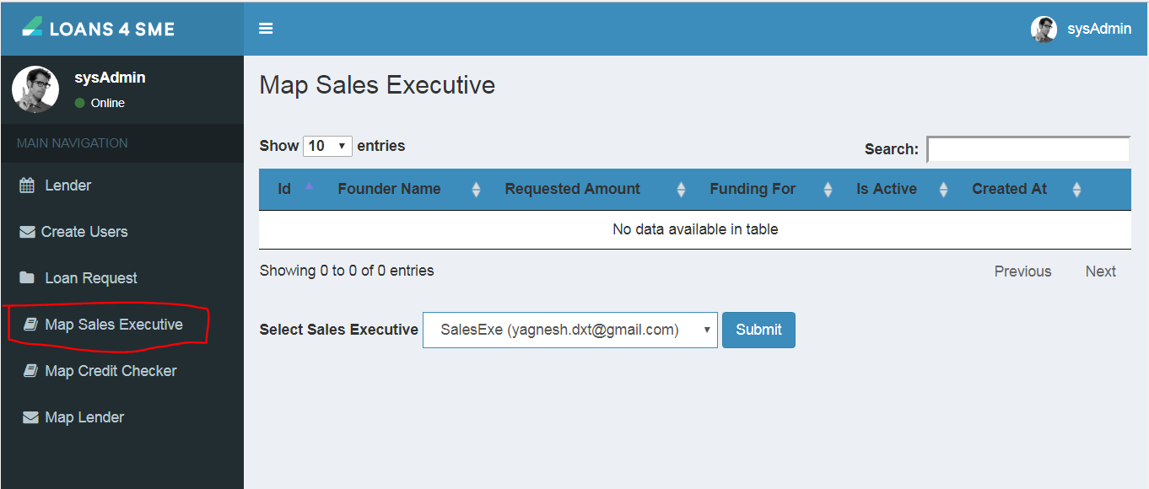

# Sales Executive Approves reject loan request

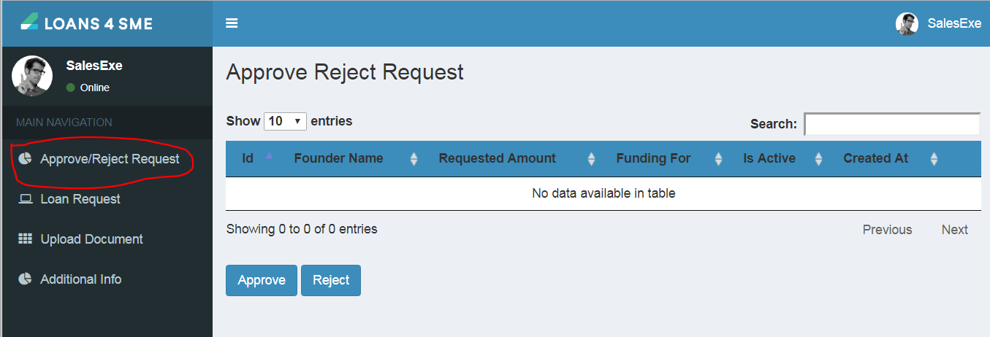

After sales executive approves loan request borrower or Sales executive has to upload further document. This document will be checked by credit checker.

# Sales executive or borrower uploads document.

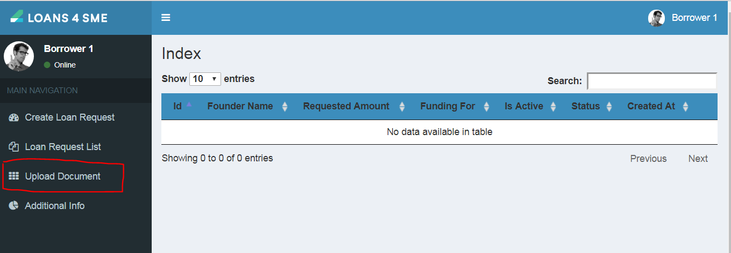

After all the documents are successfully uploaded ‘Sys Admin’ assignee this loan request to credit checker.

# Sys Admin Assignee loan request to credit checker.

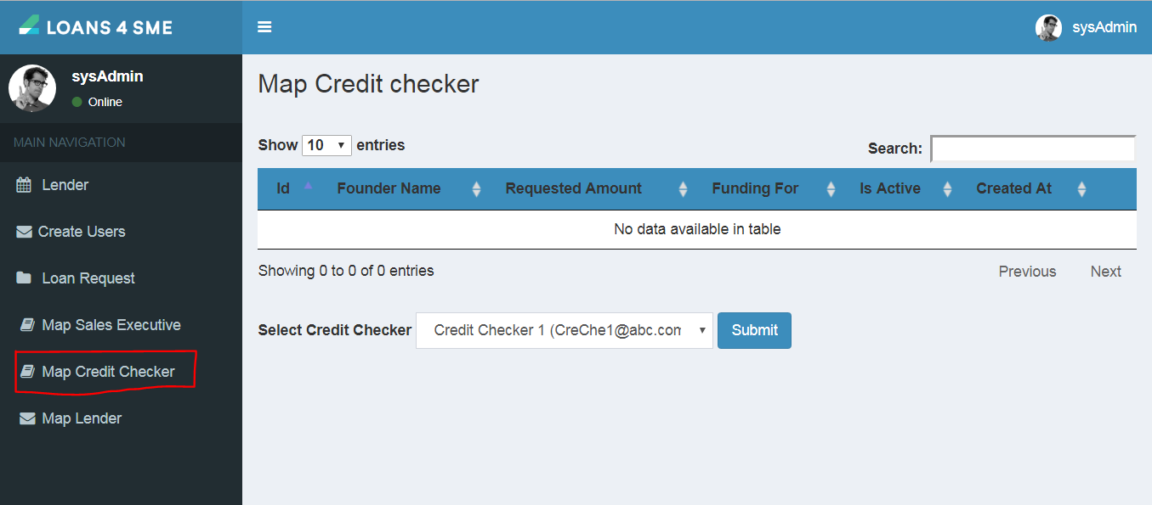

# Credit checker approves or reject loan request.

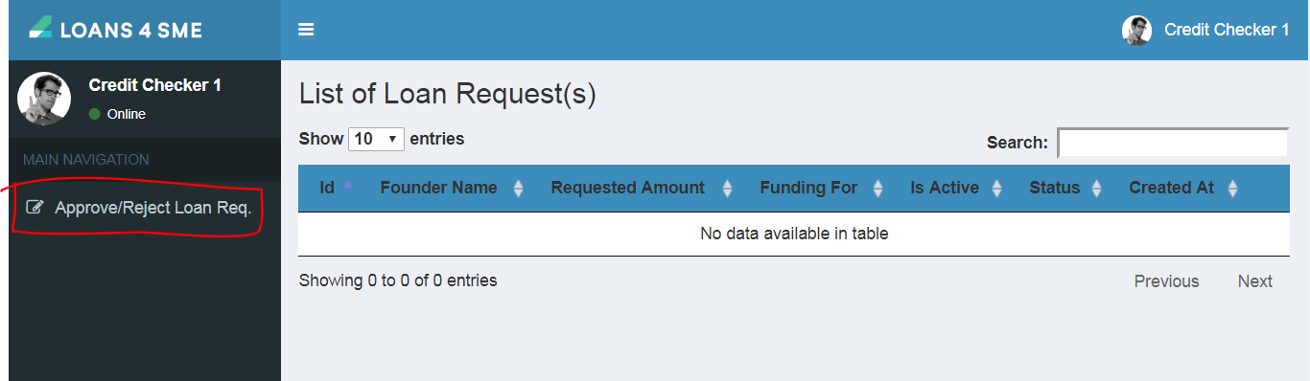

To approve loan request credit checker has to fill in executive summary of the loan request and submit it.

On successfully completion of executive summary form loan request is assigned to Lender where loan request amount is between min and max ticket size of the lenders.

# Lender login and approve reject loan request.

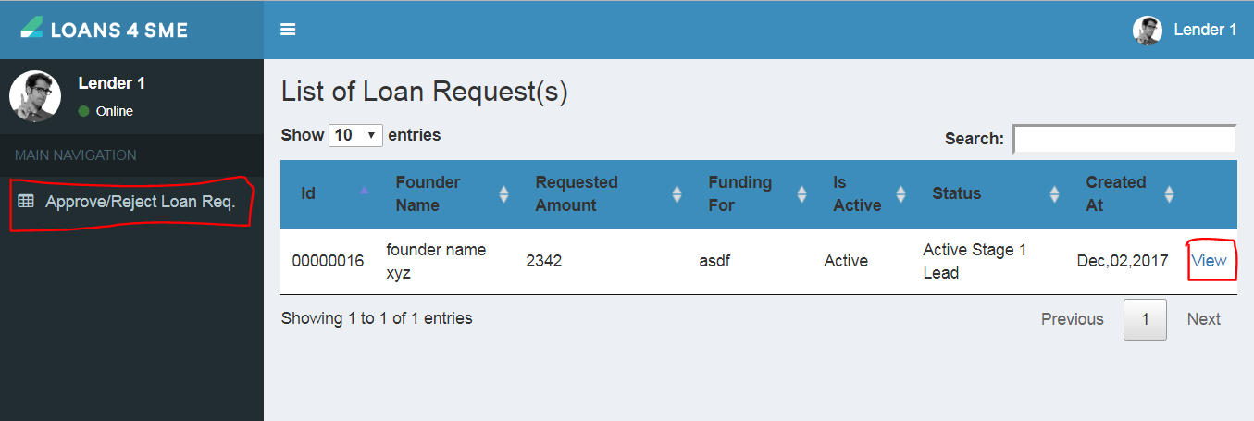

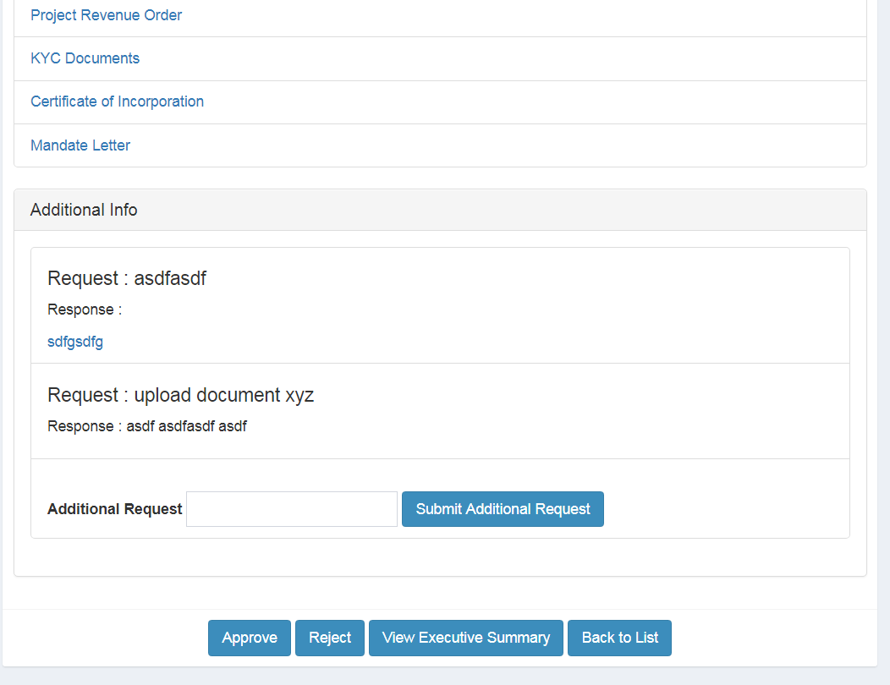

Lender can request for additional information. As shown below

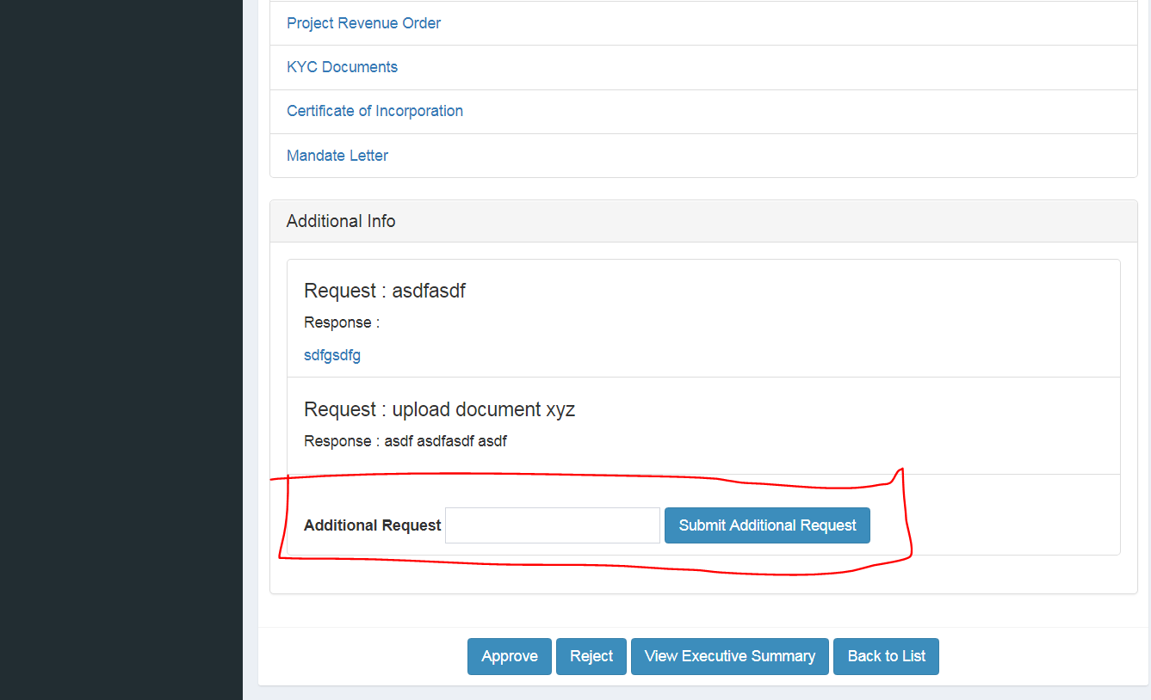

Borrower / Sales executive login and answers for additional request.

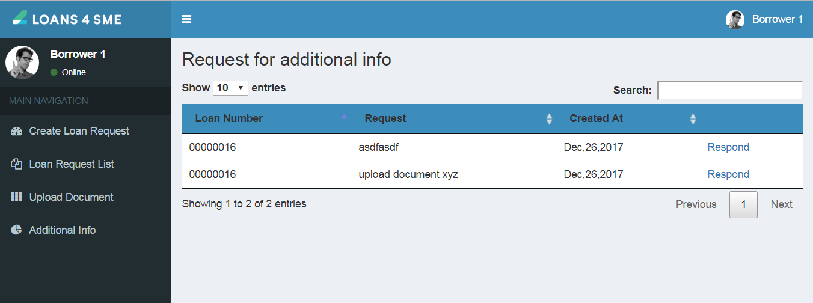

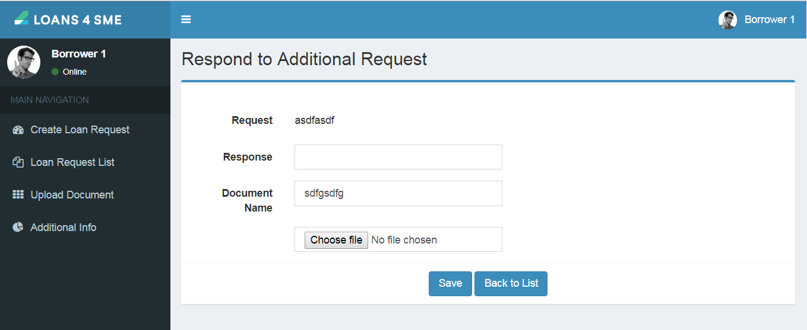

After additional information are provided lender can than approve or reject loan request.