Project Title
Student’s Name, Student ID, Student’s Email address

Abstract—The abstract of a journal article is a concise summary that provides an overview of the study or research described in the article. It should serves as a brief representation of the main objectives, methods, results, and conclusions of the research. It should be between 100 to 250 words.
Keywords— Add 3 keywords, these are the main words used throughout the journal.

Introduction
The introduction of a journal article is a crucial section that sets the stage for the reader, providing essential background, context, and motivation for the study. Provide a brief overview of the general area of study. Introduce the broader context or background of the research problem. Highlight the significance of the research question or problem.

Literature Review
First, Review relevant literature to demonstrate your understanding of existing research in the field. Identify gaps, controversies, or areas where further research is needed. Establish the intellectual context for your study. Defining the scope and selection criteria helps clarify the relevance of the chosen literature to the research. This section also justifies why specific sources were included or excluded. If the topic has a historical dimension, providing a historical background contextualizes the evolution of ideas or theories. Add citations in IEEE format of the references used while researching from journals, website, books, etc.

Methodology
Give a brief description about your data. Explain about the 6 stages of Data Analytical Life Cycle based on your dataset.

Discover

Clearly articulate the problem or question that the data analytics aims to address. Provide context for the problem, including its relevance and significance.

Data Preparation
Write about where the data is collected from and initial exploration on the data. Include initial assessment to identify patterns and potential issues within the dataset.

Explain the steps taken to prepare the data for analysis. Add screenshots of main cleaning/transformation done on the data.

Plan Model
Write about the model selected to implement and the reasons why it is suitable for the data.

Build Model
Specify the machine learning techniques that you have researched to be the most suitable for analysis of your data. Provide rationale for choosing the specific supervised or unsupervised model. (Don’t give all the details here as section 4 will have more detailed explanation)

Communicate
Discuss how what charts/graphs have been planned to implement in the dashboard and how the outcomes will be represented on PowerBI.

Measure effectiveness/Apply Live

Address ethical considerations related to data use and analysis. Discuss issues such as privacy, consent, and the responsible handling of sensitive information. Conclude the methodology section by summarizing the approach taken in the data analytics lifecycle. Reinforce the appropriateness of the chosen methods for addressing the research problem.

Results and Discussion

Start with a brief introduction to the supervised or unsupervised models used by providing an overview of the models. Provide a detailed description of the architecture of the chosen model. Highlight key variables that significantly contribute to the model's predictions/classification/cluster. Briefly introduce how data transformation, modelling, and prediction was done. Discuss how the data model integrates with the objectives set.

Highlight any trends, patterns, or insights that are immediately apparent. Interpret each visualization individually. Discuss what each chart or table is conveying. Use descriptive statistics or metrics to support your interpretation. If there are multiple visuals, compare and contrast their insights. Discuss how different visualizations complement or reinforce each other. Address any outliers or anomalies observed in the data visuals. Discuss potential causes or implications of these outliers. Discuss the practical implications of the findings.
Address how the insights derived from the prediction can inform decision-making or actions. Discuss any steps taken to validate the accuracy and reliability of the results obtained through the models. Include key visuals in the journal. Provide figure captions to guide readers through the visuals. Ensure that your discussion is clear, logically organized, and directly tied to the results presented. Use a balance of descriptive text and visual representations to convey your findings effectively.

Peer Review
Reflect the peer feedback provided and discuss the insights gained. Also provide reflection on how the peer review contributed to your continuing professional development. (2 images required: 1- your feedback to another student & 2- the feedback you received from your peer).
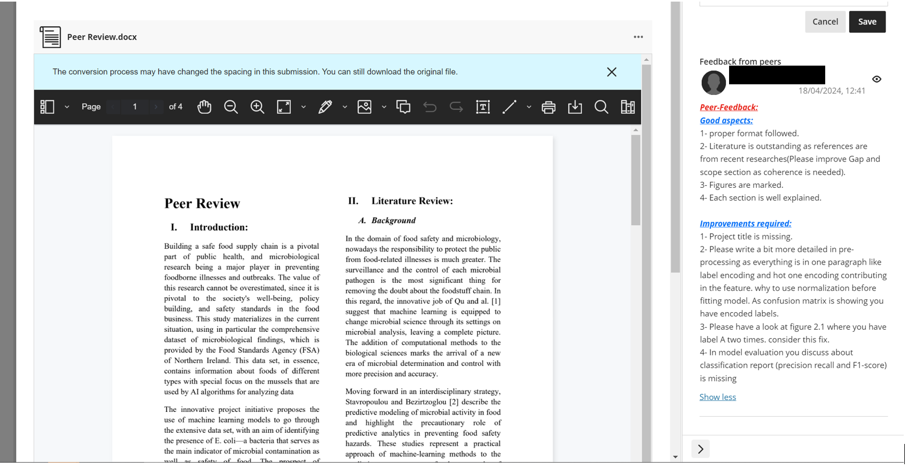
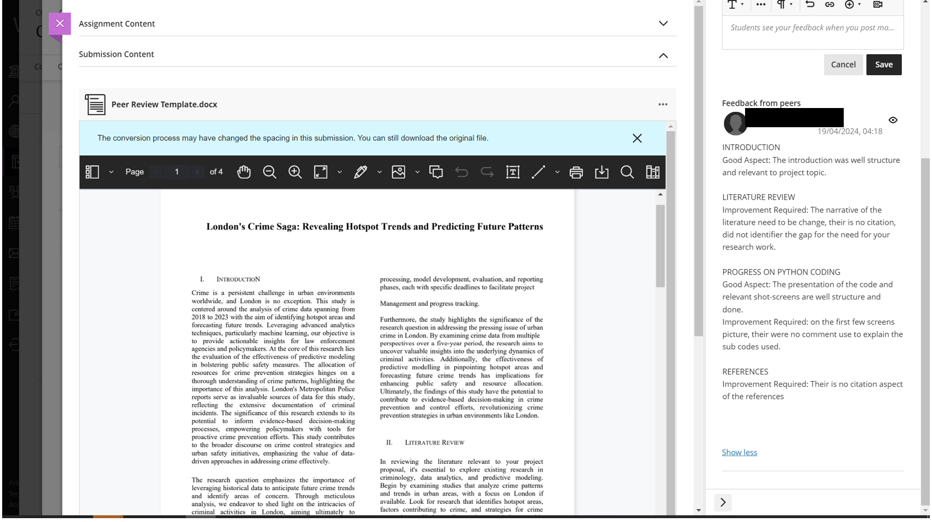

Conclusion and Recommendation
Briefly recap the key insights derived from the supervised and unsupervised model. Discuss how well the analysis achieved the initial objectives or hypotheses. Highlight any novel contributions or insights obtained during analysis. Provide some recommendations for future work based on the actionable insights revealed. If applicable, recommend improvements to the models for better clarity or usability.

References
Add references and cite them in the journal and follow IEEE format referencing [1].

- G. Eason, B. Noble, and I. N. Sneddon, “On certain integrals of Lipschitz-Hankel type involving products of Bessel functions,” Phil. Trans. Roy. Soc. London, vol. A247, pp. 529–551, April 2023. (references)

Appendix

(PowerBI Dashboard)
Submit the PowerBi dashboard on Weblearn and also here as screenshot. Eg as below:
(Please add screenshot of dashboard here and also link to you cloud version [with shared permissions])

