Name : Mehta Vishwa Hariombhai
Roll No. : 29
Remedial Practical
MSc(ICT) Sem – 3

Home Page
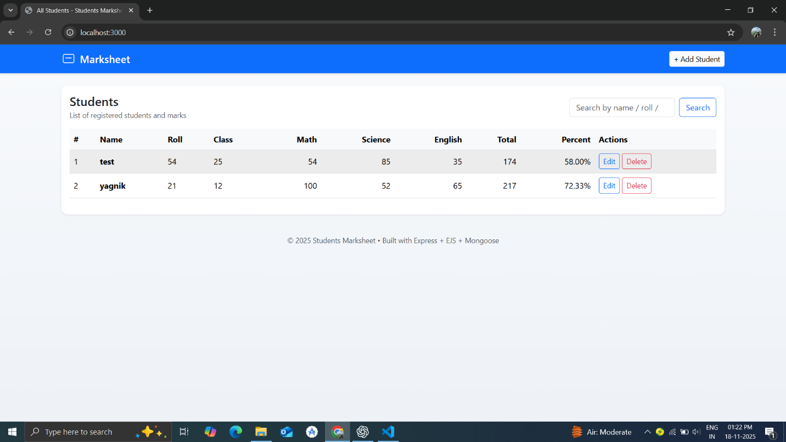

Add Student and Marks
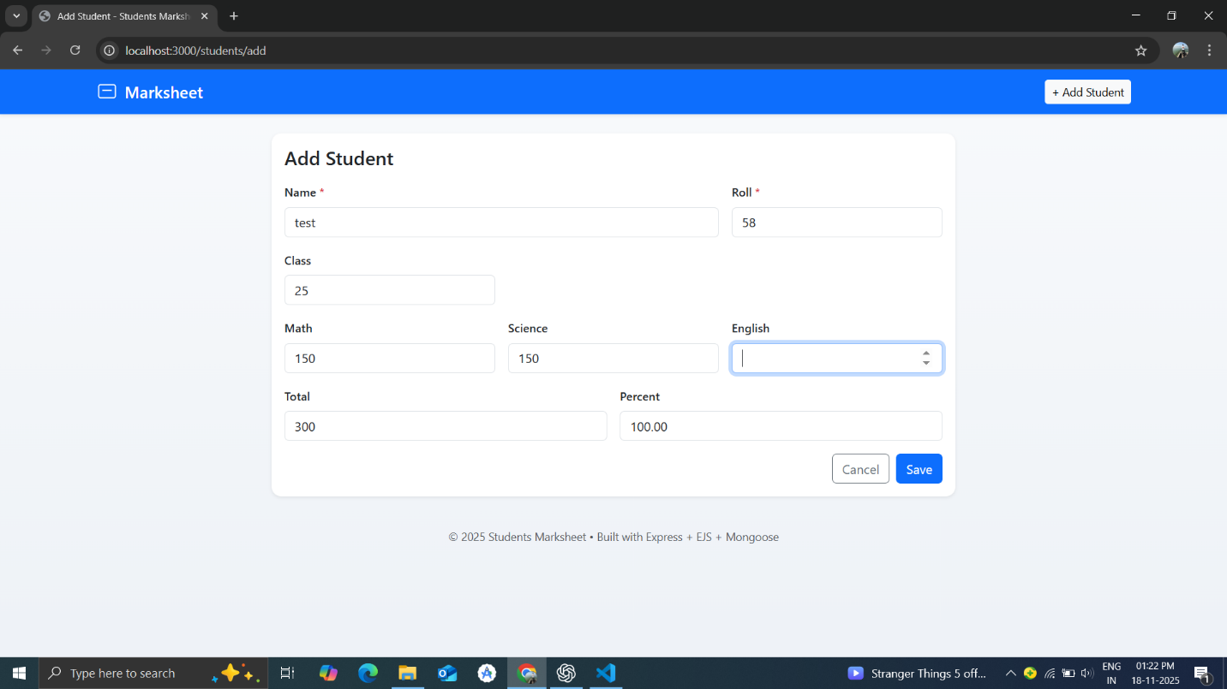
Edit Marks and Student
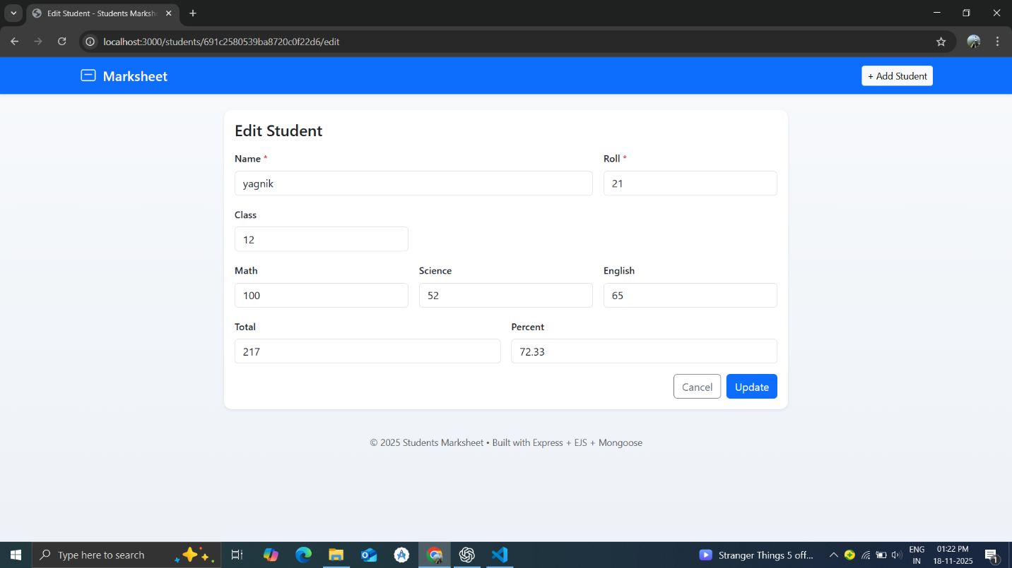

Searching
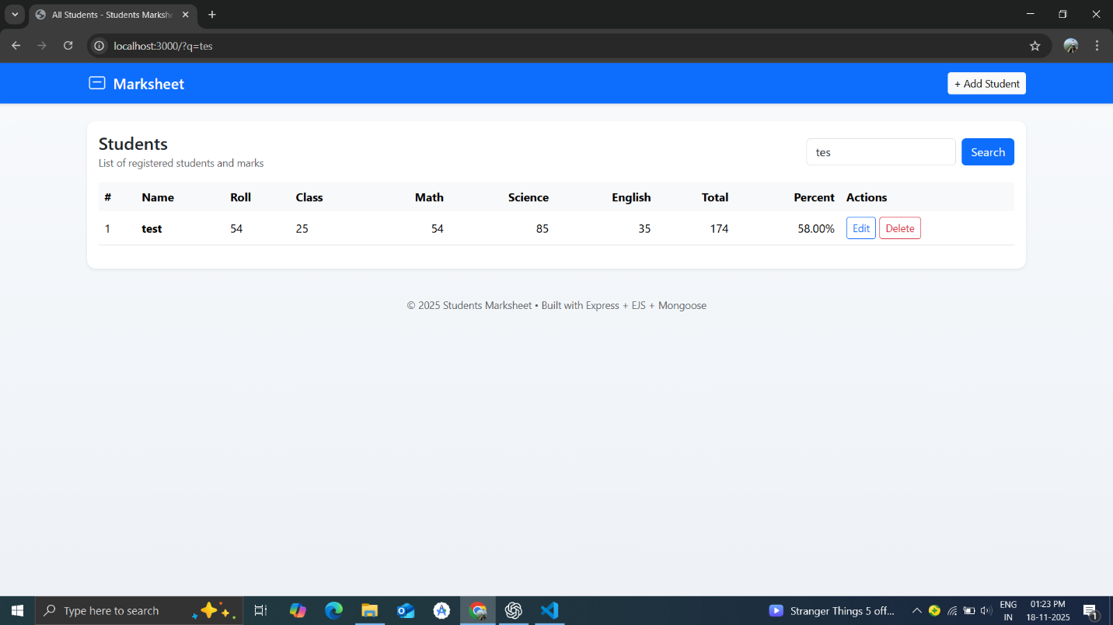
Delete Data
