Advanced Selenium

Assignments Module – 5 (Selenium IDE)

1. **What is Automation Testing?**

Automate testing refers to any approach that makes it possible to run your tests without human intervention. Traditional testing has been done manually. A human follows a set of steps to check whether things are behaving as expected. By contrast, an **automated test is created once** and then can run any time you need it.

For a long time, developers have automated their unit testing. That is, the tests that check whether a given function is working properly. Then automated testing frameworks like Selenium were developed. These allow modules or entire applications to be tested automatically.

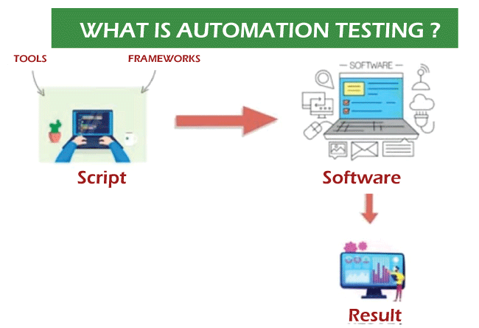

These frameworks allow a test script to interact with your UI, replicating the actions of a user. For instance, they allow you to find a specific button and click it. Or locate a text entry box and fill it out correctly. They also allow you to verify that the test has completed correctly.

As a result, automation testing reduces the time and effort needed for extensive and repetitive testing tasks.

1. **Which Are the Browsers Supported by Selenium Ide?**

Selenium supports these Browsers:

* Google Chrome.
* Mozilla Firefox.
* Safari.
* Internet Explorer.
* Microsoft Edge.

1. **What are the benefits of Automation Testing?**

* Saving Costs.
* Faster Feedback Loop.
* Better Allocation of Resources.
* Guarantees Higher Accuracy.
* Increased Test Coverage.
* Detects bugs earlier.
* Test at Scale.
* Maximizes ROI.

1. **What are the advantages of Selenium?**

**Advantages of Selenium for Automated Testing**

* Language and Framework Support. ...
* Open-Source Availability. ...
* Multi-Browser Support. ...
* Support Across Various Operations. ...
* Ease of Implementation. ...
* Reusability and Integrations. ...
* Flexibility. ...
* Parallel test execution and faster market launch.

1. **Why should testers opt for Selenium and not QTP?**

**Features of Selenium**

• Open-source tool is that performs a very specific task, in which the source code is

openly published for use and modification from its original design, free of charge.

• Frequent regression testing.

• Rapid feedback to developers.

• Virtually unlimited iterations of test case execution.

• Support for Agile and extreme development methodologies.

• Disciplined documentation of test cases.

• Customized defect reporting.

• Finding defects missed by manual testing.

**Selenium has four Components**

• Selenium-IDE

• Selenium RC

• Selenium WebDriver

• Selenium Grid

**Selenium Supported Languages**

• Java

• C#

• PHP

• Python

• Perl

• Ruby

**QTP Advantage & Disadvantage**

* **Definition -** It is a type of desktop application.
* **Open-source -** License is required.
* **Resource Consumption** - In QTP there is a high resource consumption.
* **Community Support -** Dedicated customer support from HP (Hewlett Packard) for QTP
* **Languages Supported -** QTP supports VB Script.
* **User-friendly -** QTP is user-friendly.
* **Technical Support Services -** It has technical support services.
* **Browsers Supported -** Browser supported in QTP are specific versions of Google Chrome, Mozilla Firefox and Internet Explorer.