Assignment – Module 3 (Testing on Live Application)

1. What is RDBMS

RDBMS stands for Relational Database Management System. It is a

type of database management system that stores data in a structured format, using rows and columns. The data is organized into tables, and relationships between these tables can be defined through

foreign keys. RDBMSs use Structured Query Language (SQL) for querying and managing the data.

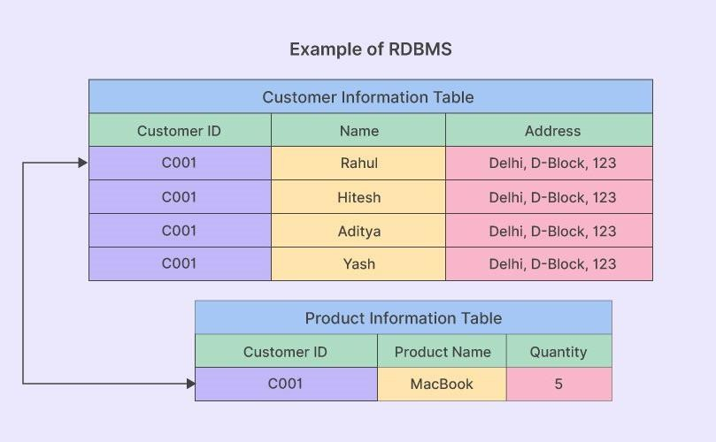

1. What is SQL?

SQL is Structured Query Language, which is a computer language for storing, manipulating and retrieving data stored in relational database.

SQL is the standard language for Relation Database System. All relational database management systems like MySQL, MS Access, Oracle, Sybase, Informix, postgres and SQL Server use SQL as standard database language.

1. Write SQL Commands

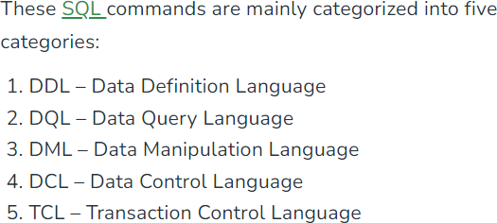

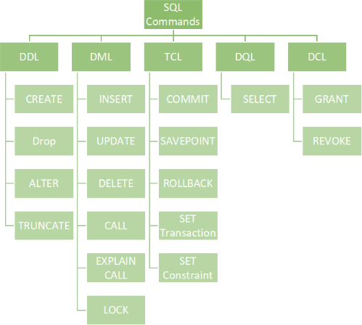

1. What is Join?

A JOIN clause is used to combine rows from two or more tables, based on a

related column between them.

Let's look at a selection from the "Orders" table:

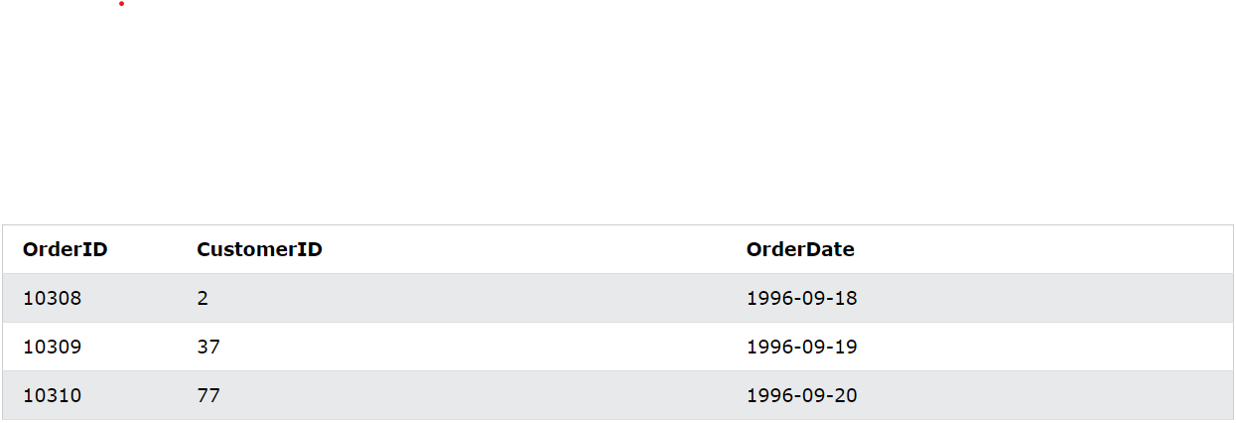

Then, look at a selection from the "Customers" table:

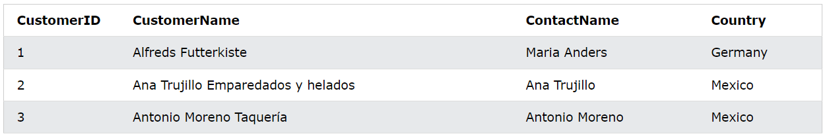

Notice that the "CustomerID" column in the "Orders" table refers to the "CustomerID" in the "Customers" table. The relationship between the two tables above is the "CustomerID" column.

Then, we can create the following SQL statement (that contains an INNER JOIN), that selects records that have matching values in both tables:

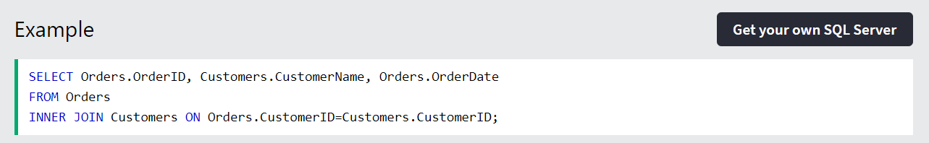

and it will produce something like this:

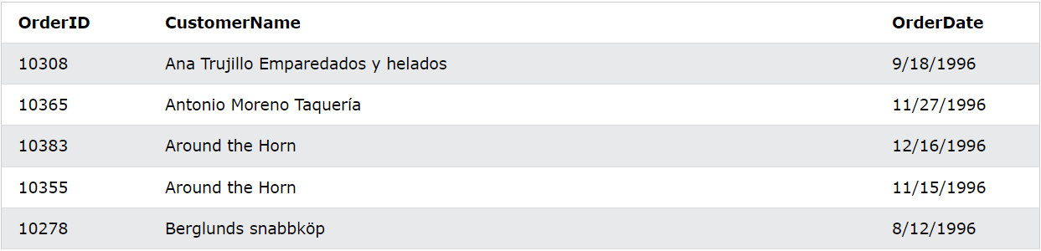

1. Write type of joins.

Different Types of SQL JOINs

Here are the different types of the JOINs in SQL:

* (INNER) JOIN: Returns records that have matching values in both tables
* LEFT (OUTER) JOIN: Returns all records from the left table, and the matched records from the right table
* RIGHT (OUTER) JOIN: Returns all records from the right table, and the matched records from the left table
* FULL (OUTER) JOIN: Returns all records when there is a match in either left or right table



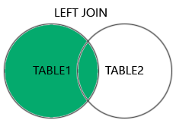

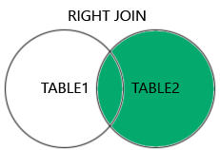

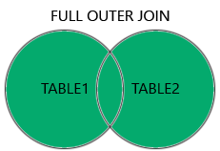

1. How Many constraint and describes it self

In SQL, constraints are rules applied to columns in a table to ensure data integrity. Here are the main types of constraints, along with brief descriptions of each:

1. **NOT NULL**: Ensures that a column cannot have a NULL value. This is used when a column must always contain a value.
2. **UNIQUE**: Ensures that all values in a column are unique across the table, preventing duplicate entries.
3. **PRIMARY KEY**: A combination of NOT NULL and UNIQUE. It uniquely identifies each row in a table and cannot contain NULL values. Each table can have only one primary key.
4. **FOREIGN KEY**: Establishes a relationship between two tables. It ensures that the value in a column (or a group of columns) matches a value in another table's primary key or unique key, maintaining referential integrity.
5. **CHECK**: Ensures that all values in a column satisfy a specific condition. For example, you could enforce that a column for age must be greater than zero.
6. **DEFAULT**: Assigns a default value to a column when no value is specified during an insert operation.
7. **INDEX**: While not a traditional constraint, indexes are often associated with constraints because they improve the performance of queries that involve a specific column.

These constraints help maintain data accuracy and integrity within a database.

1. Difference between RDBMS vs DBMS

|  |  |
| --- | --- |
| **RDBMS** | **DBMS** |
| Data stored is in table format | Data stored is in the file format |
| Multiple data elements are accessible together | Individual access of data elements |
| Data in the form of a table are linked together | No connection between data |
| Support distributed database | No support for distributed database |
| Data is stored in a large amount | Data stored is a small quantity |
| RDBMS supports multiple users | DBMS supports a single user |
| The software and hardware requirements are higher | The software and hardware requirements are low |
| Example: Oracle, SQL Server. | Example: XML, Microsoft Access. |

1. What is API?

APIs are mechanisms that enable two software components to communicate with each other using a set of definitions and protocols. For example, the weather bureau’s software system contains daily weather data. The weather app on your phone “talks” to this system via APIs and shows you daily weather updates on your phone.

In simple Words: Application Programming Interface (API) is a software interface that allows two applications to interact with each other without any user intervention

The application programming interface must be clearly distinguished from a user interface. The user interface accepts data from users, forwards it to the API for processing, and returns the results to the user. The API does not interact with the user but processes the data received from one program module and transmits the results back to the other module

1. Types of API Testing

There are mainly 3 types of API Testing

Open APIs: These types of APIs are publicly available to use like OAuth APIs from Google. It has also not given any restrictions to use them. So, they are also known as Public APIs.

These are designed to be easily accessible by any developer. They usually come with documentation and are often used to enable third-party applications to interact with the service. Examples include social media APIs and payment gateways.

Partner APIs: Specific rights or licenses to access this type of API because they are not available to the public.

These are shared with specific business partners and typically require authentication or licensing agreements. They allow companies to collaborate and share functionalities while maintaining control over their data and services.

Internal APIs: Internal or private. These APIs are developed by companies to use in their internal systems. It helps you to enhance the productivity of your teams.

These are used within an organization to streamline processes and enable different internal systems to communicate. They help improve efficiency by allowing teams to access shared functionalities without exposing them to external users.

1. What is Responsive Testing?

**The term responsive testing is a range of activities that involve it to check whether the website or any application is behaving in the right way after it is launched on different gadgets and screen sizes. The tests used to check whether the user interface changes dynamically in response to different screen resolutions, device orientations, and capabilities act as one of the major aims of testing.**

**As we are dealing with the spread of mobile devices as well as different variations regarding screen sizes and resolutions, it is now almost impossible to content the users with the same perfect screen experience – let alone the additional type of devices with nature-based handcrafted user interfaces.**

**Ethan Marcotte was an independent web designer who coined the term web responsive design in 2010. He explained that responsive design and development of web pages should be done in such a way that it behaves well on all types of devices, sizes, layouts, platforms, etc.**

**Time has changed. Earlier, there were limited browsers, so testing them was easy, but today most users browse the internet on mobile devices, tabs, etc. So to ensure that your website has a mobile/ tab version that responds well to the mobile/tab device.**

**There are so many web technologies that are used to create web applications. Web technologies in the present time have become so strong that they changed the way browsers are used to render the website code.**

**It involves HTML, JS, CSS code, which is responsible for rendering content on different devices as the user prefers to access website content.**

1. **Which types of tools are available for Responsive Testing**

**6 great tools for testing responsive design for websites**

## Google Chrome Inspect

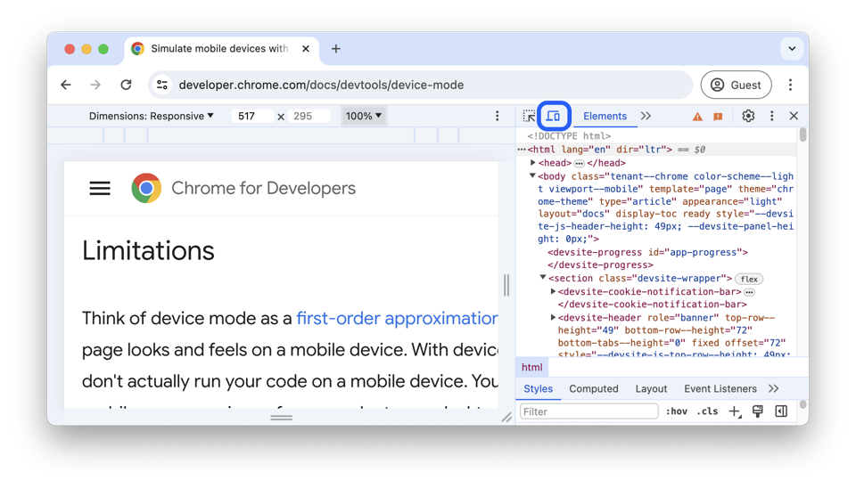

1. **Testsigma**

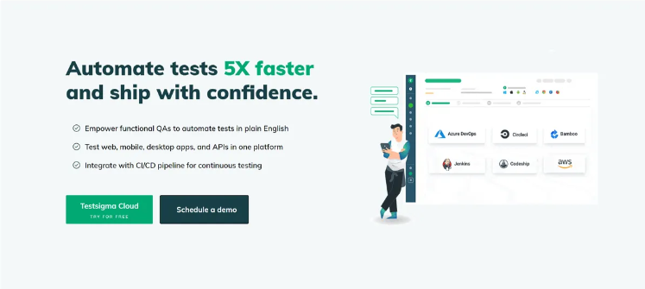

1. CrossBrowserTesting

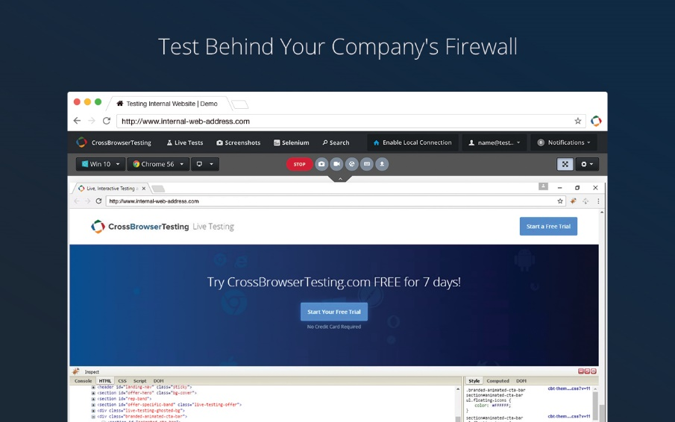

1. Browser Stack

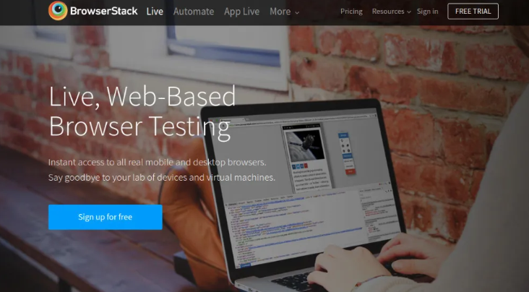

1. Google DevTools Device Mode

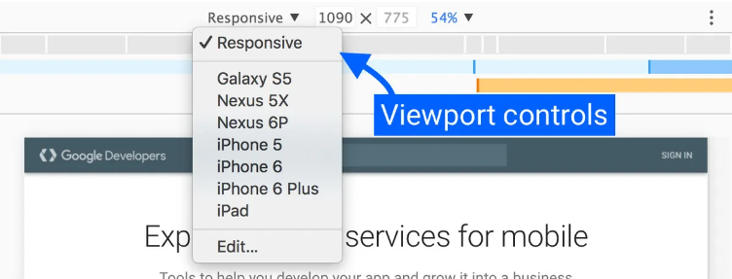

1. Responsinator



1. What is the full form of .ipa, .apk

APK stands for Android Package Kit

IPA stands for iOS Package App.

APK is the file format used for distributing and installing applications on Android devices.

IPA is the file format used for distributing and installing applications on iOS devices.

APK files can be downloaded from sources other than the Google Play Store, while IPA files are typically downloaded from the Apple App Store.

1. How to create step for to open the developer option mode ON?

To enable Developer Options on an Android device, you can:

1. Go to Settings
2. Tap About phone or About device
3. Tap Software information
4. Tap Build number seven times
5. Enter your pattern, PIN, or password to enable the menu