Insurance Claim Risk Analysis
Project report generated from the actual PySpark pipeline execution.

1. Introduction
This project builds an exploratory insurance-claim risk classification workflow. It combines Spark-based data preparation and decision-tree modelling with a reproducible evaluation and reporting pipeline.

2. Problem statement
The objective is to classify claims into rule-derived Low, Medium, or High risk levels and summarize the model's agreement with those constructed labels. This is not a validated fraud detector or a production underwriting recommendation.

3. Dataset used
Source: Data/insurance_claims.csv. Actual rows: 1,000; cleaned rows: 1,000. The source contained claim, policy, insured, and incident fields. The source does not contain a native policy-type field.
Mappings: claim_type = incident_type; customer_region = policy_state; policy_type = policy_csl (coverage-limit tier proxy).

4. Methodology and pipeline
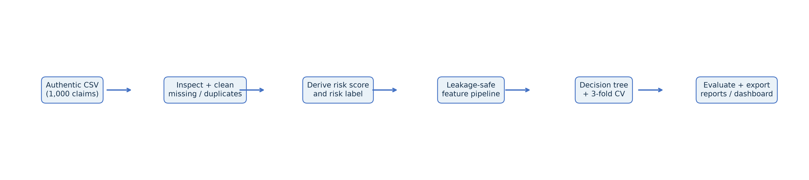
The workflow loads and inspects the authentic CSV, normalizes missing values, removes duplicates, caps claim amount outliers, derives the target, builds a leakage-safe Spark ML pipeline, tunes a decision tree with three-fold CV, evaluates on the held-out split, then exports tables, figures, and reports.

5. Risk-label rule and leakage controls
Risk score = 0.5 × normalized total claim amount + 0.3 × normalized incident severity rank + 0.2 × fraud indicator (1 for Y, else 0). Low is at or below the empirical p40, Medium is above p40 through p75, and High is above p75. Actual cutoffs: p40=0.365552, p75=0.543031.
Model features exclude total_claim_amount, injury_claim, property_claim, vehicle_claim, incident_severity, fraud_reported, risk_score, risk_level, policy_number, insured_zip, and incident_location. An explicit assertion checks this exclusion set.

6. Model and actual results
Selected parameters: {"maxBins": 32, "maxDepth": 5, "minInstancesPerNode": 5}. Tuning criterion: weighted F1 averaged over three cross-validation folds.
model | majority_class | accuracy | weighted_precision | weighted_recall | weighted_f1
majority_class_baseline | Low | 0.4074 | 0.1660 | 0.4074 | 0.2359
untuned_tree | nan | 0.5741 | 0.7087 | 0.5741 | 0.5622
tuned_tree | nan | 0.5556 | 0.6581 | 0.5556 | 0.5370
untuned_tree_train | nan | 0.5788 | 0.7490 | 0.5788 | 0.5557
tuned_tree_train | nan | 0.5728 | 0.7453 | 0.5728 | 0.5481

Per-class held-out metrics (Low / Medium / High)
class | precision | recall | f1 | support
Low | 0.9118 | 0.4697 | 0.6200 | 66.0000
Medium | 0.4513 | 0.8793 | 0.5965 | 58.0000
High | 0.5333 | 0.2105 | 0.3019 | 38.0000

Actual-by-predicted confusion matrix
actual | Low | Medium | High
Low | 31.0000 | 34.0000 | 1.0000
Medium | 1.0000 | 51.0000 | 6.0000
High | 2.0000 | 28.0000 | 8.0000
Baseline weighted precision=0.7087 exceeds weighted recall=0.5741. Precision is the share of predictions that are correct; recall is the share of actual cases found. The per-class results where precision exceeds recall are: Low: precision=1.000, recall=0.470; High: precision=0.588, recall=0.263; this indicates missed actual cases (false negatives) are lowering recall more than false positives lower precision. The weighted scores are support-weighted, so interpret them with the per-class metrics and confusion matrix.
Tuned train weighted F1=0.5481; test weighted F1=0.5370; train-minus-test gap=0.0111. The train score is higher by 0.0111; this is a modest train/test gap.

7. Captured code and actual output
results = train_evaluate(spark, cleaned, cleaning_metadata, outputs_dir)
print(f"Best CV parameters: {results['best_params']}")
print(f"Tuned held-out metrics: {results['metrics']}")
Actual output excerpt generated from this completed run:
Best params: {"maxBins": 32, "maxDepth": 5, "minInstancesPerNode": 5}
Majority baseline: {'majority_class': 'Low', 'accuracy': 0.4074074074074074, 'weighted_precision': 0.16598079561042522, 'weighted_recall': 0.4074074074074074, 'weighted_f1': 0.23586744639376214}
Baseline test metrics: {'majority_class': nan, 'accuracy': 0.5740740740740741, 'weighted_precision': 0.7086980341194307, 'weighted_recall': 0.574074074074074, 'weighted_f1': 0.562182199199701}
Tuned test metrics: {'majority_class': nan, 'accuracy': 0.5555555555555556, 'weighted_precision': 0.6581489407737311, 'weighted_recall': 0.5555555555555556, 'weighted_f1': 0.5369641317362823}
Per-class:
class precision recall f1 support
Low 0.911765 0.469697 0.620000 66
Medium 0.451327 0.879310 0.596491 58
High 0.533333 0.210526 0.301887 38
Confusion matrix:
Low Medium High
actual
Low 31 34 1
Medium 1 51 6
High 2 28 8

8. Dashboard and visual findings
Power BI Desktop screenshot placeholder (capture the user-built report here): [Insert Power BI Desktop screenshot after opening the supplied CSVs.]
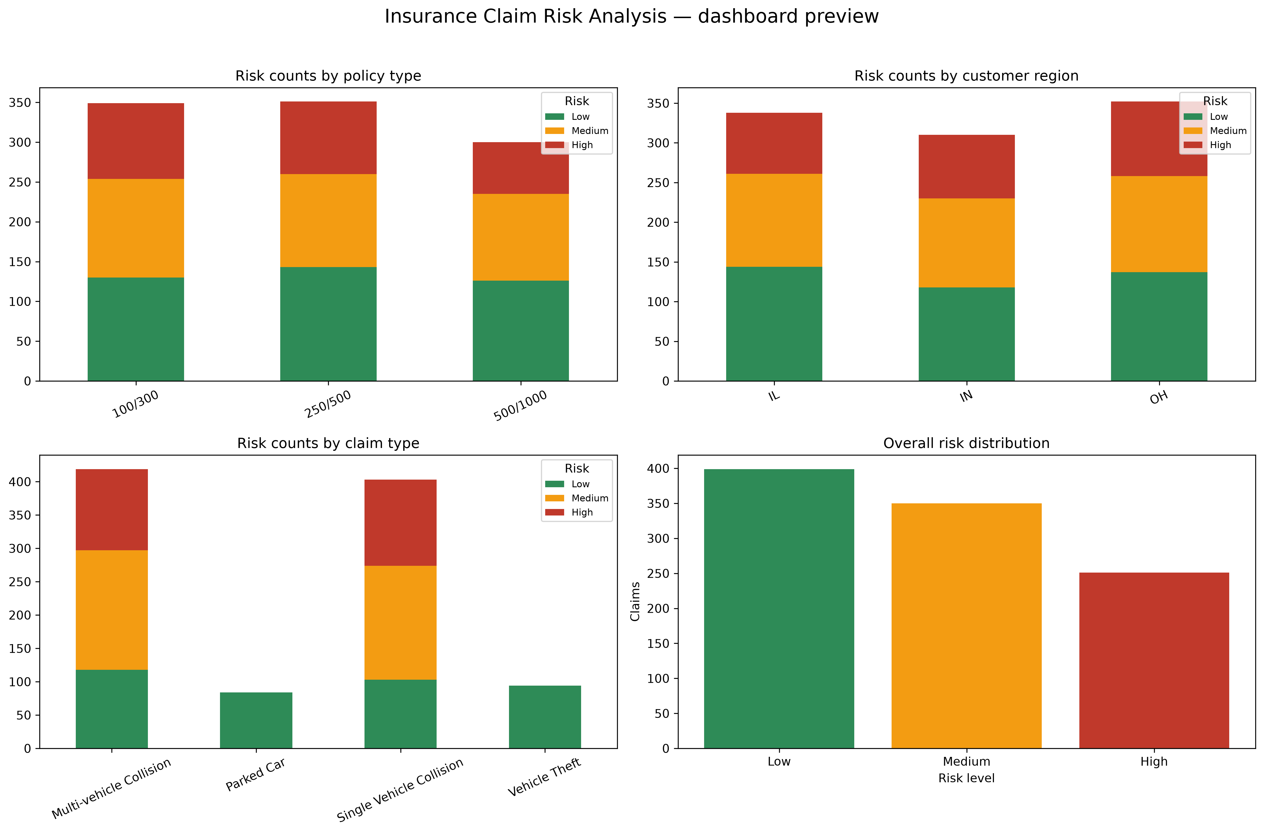
The dashboard includes KPI cards, native Excel charts, risk-by-category summaries, and cleaned records with predicted risk. Companion charts include grouped counts, 100% stacked risk share, policy/region/claim heatmaps, and the overall class distribution.

9. Conclusion, insights, and future work
The tuned held-out accuracy was 0.5556 and weighted F1 was 0.5370. The train score is higher by 0.0111; this is a modest train/test gap. Future work should validate labels against an independently defined outcome, use time-aware or external validation, compare multiple models, calibrate probabilities, and confirm policy-type semantics with domain stakeholders.

10. Limitations
The target is heuristic and reuses claim/fraud fields only to derive the label; those fields are excluded from model inputs. The 1,000-row data and random holdout do not establish external generalization. `policy_csl` is a proxy for policy type. Model save status: failed non-fatally: Py4JJavaError: Windows Hadoop local filesystem could not find winutils.exe (HADOOP_HOME is unset or incomplete)..

11. References
- Provided authentic source: Data/insurance_claims.csv.
- Apache Spark 3.5 documentation: https://spark.apache.org/docs/3.5.7/
- PySpark ML guide: https://spark.apache.org/docs/3.5.7/ml-guide.html
- pandas documentation: https://pandas.pydata.org/docs/
- XlsxWriter documentation: https://xlsxwriter.readthedocs.io/

12. Viva questions and answers
- What does the model predict?
A three-level heuristic claim-risk label: Low, Medium, or High.
- How is risk score constructed?
A weighted sum of normalized claim amount, severity rank, and fraud indicator.
- Why exclude claim amount and fraud from model features?
They are ingredients used to define the target, so including them would leak target information.
- Why is policy_type a proxy?
The source has no native policy_type field; it is mapped from policy_csl, the coverage-limit tier.
- What is the CV setup?
Three-fold cross-validation over the decision-tree parameter grid; weighted F1 is the selection metric.
- What does weighted precision mean?
Per-class precision averaged with actual class support as weights.
- How do you assess overfitting?
Compare training and held-out test weighted F1; a large positive gap suggests overfitting.
- What is the purpose of the confusion matrix?
It shows correct and incorrect predictions for each actual/predicted class pair.
- Why might model saving fail on Windows?
Spark's local Hadoop filesystem may need winutils.exe; model persistence is optional and handled non-fatally.
- What is the main limitation?
The outcome labels are constructed heuristically and are not independently validated ground truth.

