Insurance Claim Risk Analysis
Project report generated from the actual PySpark pipeline execution.

1. Introduction
This project builds an exploratory insurance-claim risk classification workflow. It combines Spark-based data preparation and decision-tree modelling with a reproducible evaluation and reporting pipeline.

2. Problem statement
The objective is to classify claims into rule-derived Low, Medium, or High risk levels and summarize the model's agreement with those constructed labels. This is not a validated fraud detector or a production underwriting recommendation.

3. Dataset used
Source: Data/insurance_claims.csv. Actual rows: 1,000; cleaned rows: 1,000. The source contained claim, policy, insured, and incident fields. The source does not contain a native policy-type field.
Mappings: claim_type = incident_type; customer_region = policy_state; policy_type = policy_csl (coverage-limit tier proxy).

4. Methodology and pipeline
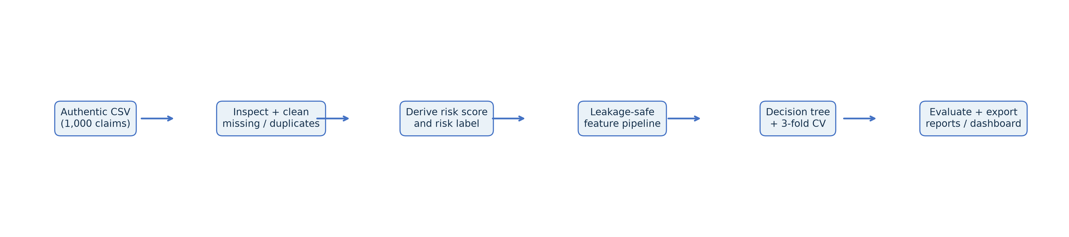
The workflow loads and inspects the authentic CSV, normalizes missing values, removes duplicates, caps claim amount outliers, derives the target, builds a leakage-safe Spark ML pipeline, tunes a decision tree with three-fold CV, evaluates on the held-out split, then exports tables, figures, and reports.

5. Risk-label rule and leakage controls
Risk score = 0.5 × normalized total claim amount + 0.3 × normalized incident severity rank + 0.2 × fraud indicator (1 for Y, else 0). Low is at or below the empirical p40, Medium is above p40 through p75, and High is above p75. Actual cutoffs: p40=0.365552, p75=0.543031.
Model features exclude total_claim_amount, injury_claim, property_claim, vehicle_claim, incident_severity, fraud_reported, risk_score, risk_level, policy_number, insured_zip, and incident_location. An explicit assertion checks this exclusion set.

6. Model and actual results
Selected parameters: {"maxBins": 32, "maxDepth": 5, "minInstancesPerNode": 5}. Tuning criterion: weighted F1 averaged over three cross-validation folds.
model | majority_class | accuracy | weighted_precision | weighted_recall | weighted_f1
majority_class_baseline | Low | 0.4074 | 0.1660 | 0.4074 | 0.2359
untuned_tree | nan | 0.5741 | 0.7087 | 0.5741 | 0.5622
tuned_tree | nan | 0.5556 | 0.6581 | 0.5556 | 0.5370
untuned_tree_train | nan | 0.5788 | 0.7490 | 0.5788 | 0.5557
tuned_tree_train | nan | 0.5728 | 0.7453 | 0.5728 | 0.5481

Per-class held-out metrics (Low / Medium / High)
class | precision | recall | f1 | support
Low | 0.9118 | 0.4697 | 0.6200 | 66.0000
Medium | 0.4513 | 0.8793 | 0.5965 | 58.0000
High | 0.5333 | 0.2105 | 0.3019 | 38.0000

Actual-by-predicted confusion matrix
actual | Low | Medium | High
Low | 31.0000 | 34.0000 | 1.0000
Medium | 1.0000 | 51.0000 | 6.0000
High | 2.0000 | 28.0000 | 8.0000
Baseline weighted precision=0.7087 exceeds weighted recall=0.5741. Precision is the share of predictions that are correct; recall is the share of actual cases found. The per-class results where precision exceeds recall are: Low: precision=1.000, recall=0.470; High: precision=0.588, recall=0.263; this indicates missed actual cases (false negatives) are lowering recall more than false positives lower precision. The weighted scores are support-weighted, so interpret them with the per-class metrics and confusion matrix.
Tuned train weighted F1=0.5481; test weighted F1=0.5370; train-minus-test gap=0.0111. The train score is higher by 0.0111; this is a modest train/test gap.

7. Captured code and actual output
results = train_evaluate(spark, cleaned, cleaning_metadata, outputs_dir)
print(f"Best CV parameters: {results['best_params']}")
print(f"Tuned held-out metrics: {results['metrics']}")
Actual output excerpt generated from this completed run:
Best params: {"maxBins": 32, "maxDepth": 5, "minInstancesPerNode": 5}
Majority baseline: {'majority_class': 'Low', 'accuracy': 0.4074074074074074, 'weighted_precision': 0.16598079561042522, 'weighted_recall': 0.4074074074074074, 'weighted_f1': 0.23586744639376214}
Baseline test metrics: {'majority_class': nan, 'accuracy': 0.5740740740740741, 'weighted_precision': 0.7086980341194307, 'weighted_recall': 0.574074074074074, 'weighted_f1': 0.562182199199701}
Tuned test metrics: {'majority_class': nan, 'accuracy': 0.5555555555555556, 'weighted_precision': 0.6581489407737311, 'weighted_recall': 0.5555555555555556, 'weighted_f1': 0.5369641317362823}
Per-class:
class precision recall f1 support
Low 0.911765 0.469697 0.620000 66
Medium 0.451327 0.879310 0.596491 58
High 0.533333 0.210526 0.301887 38
Confusion matrix:
Low Medium High
actual
Low 31 34 1
Medium 1 51 6
High 2 28 8

8. Dashboard and visual findings
Power BI Desktop screenshot placeholder (capture the user-built report here): [Insert Power BI Desktop screenshot after opening the supplied CSVs.]
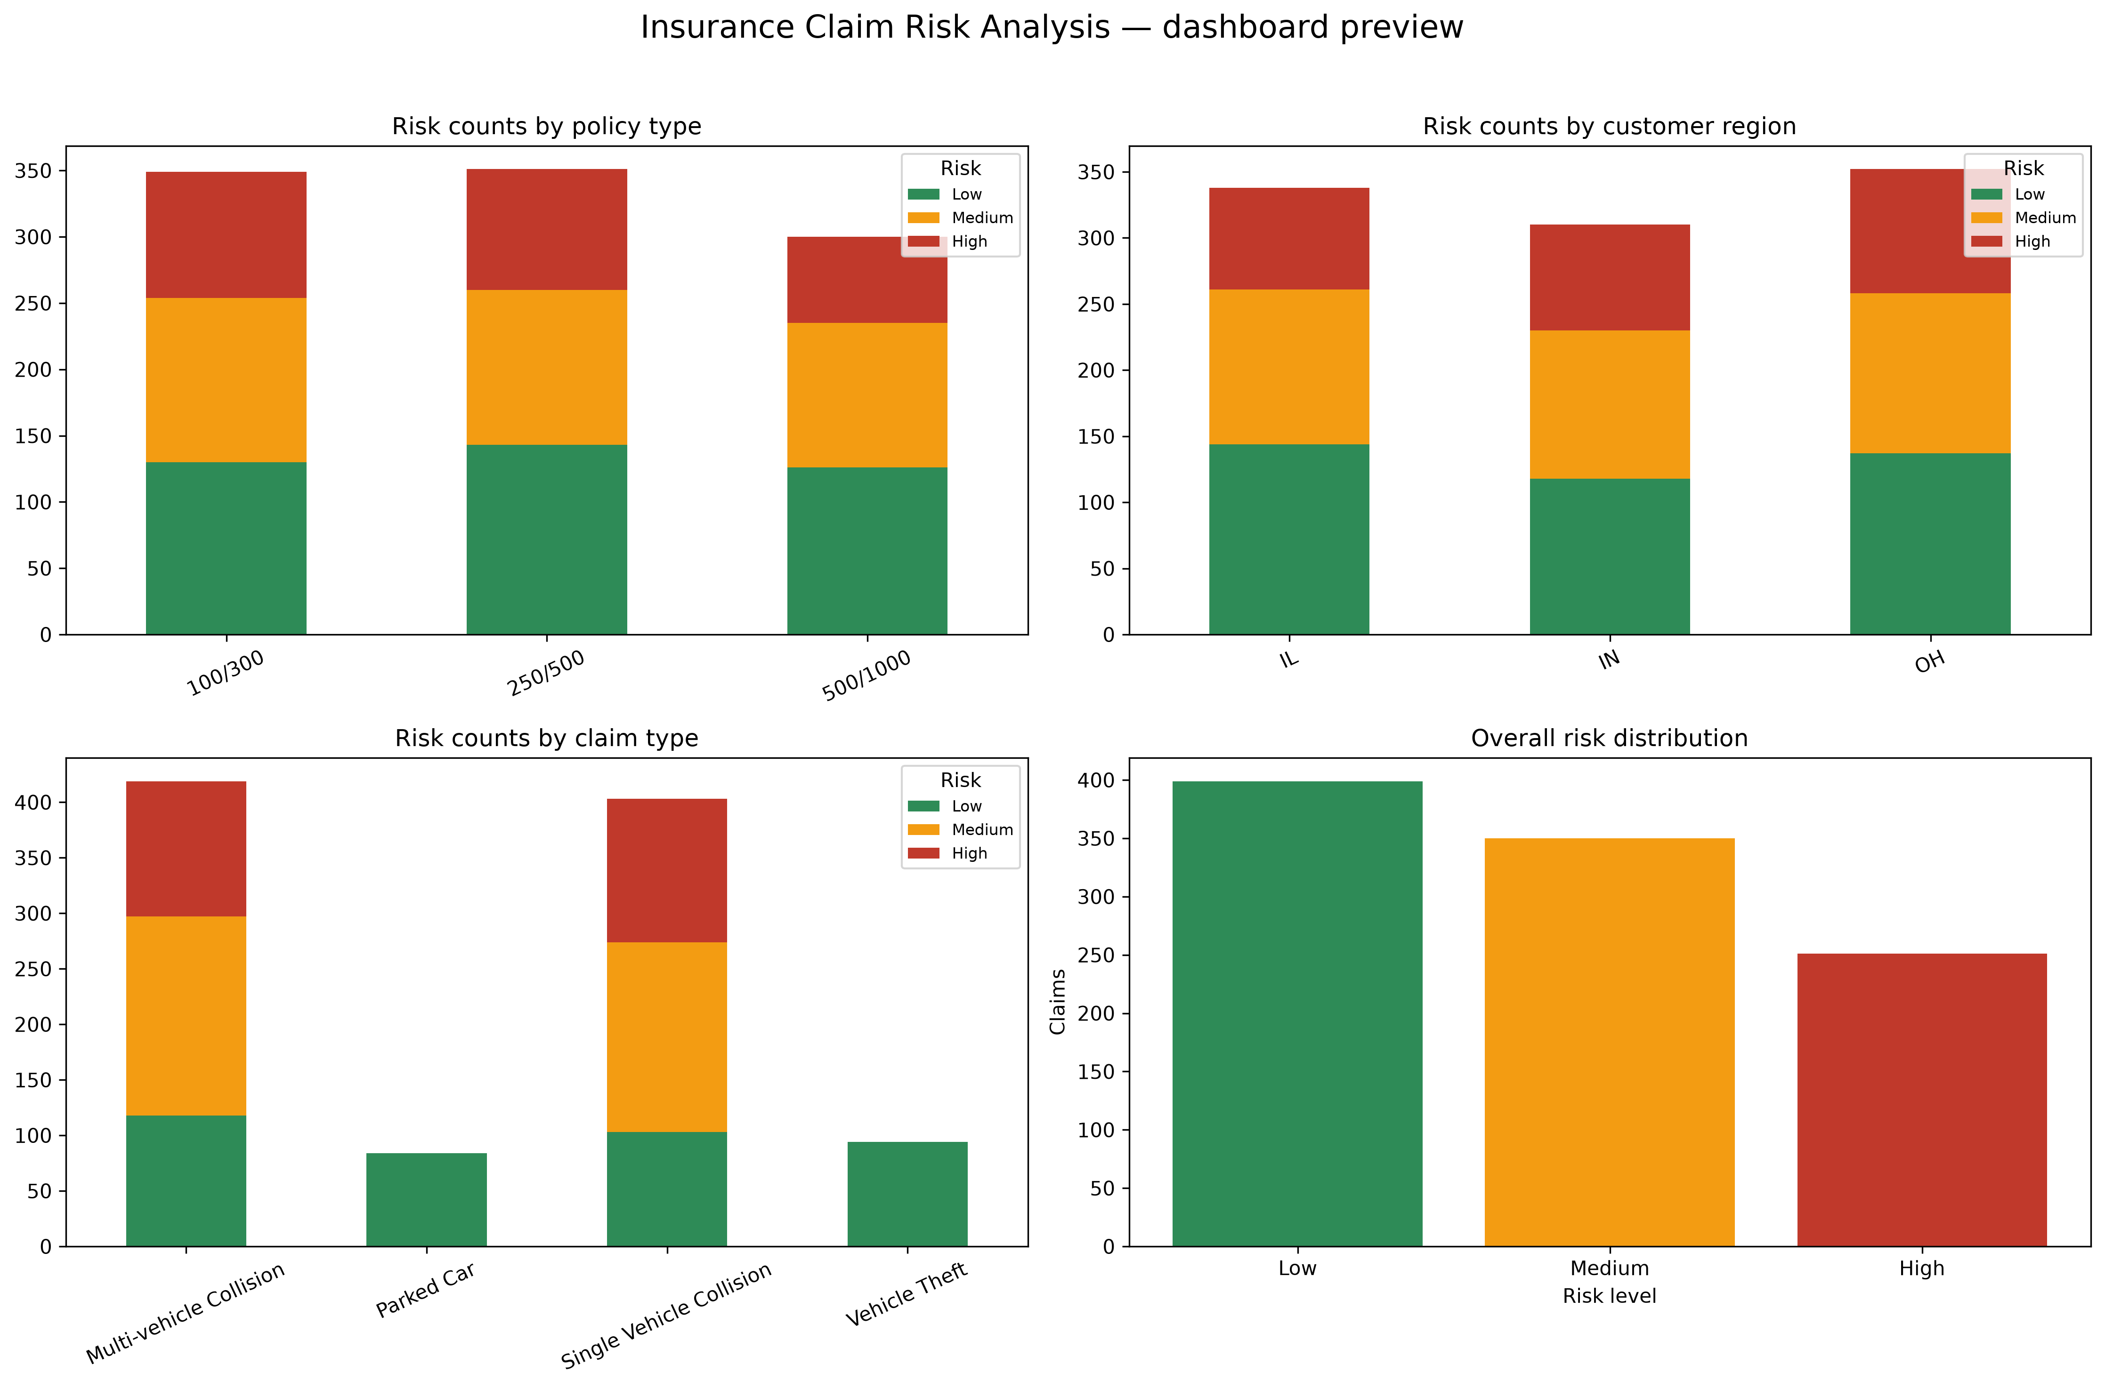
The dashboard includes KPI cards, native Excel charts, risk-by-category summaries, and cleaned records with predicted risk. Companion charts include grouped counts, 100% stacked risk share, policy/region/claim heatmaps, and the overall class distribution.

9. Conclusion, insights, and future work
The tuned held-out accuracy was 0.5556 and weighted F1 was 0.5370. The train score is higher by 0.0111; this is a modest train/test gap. Future work should validate labels against an independently defined outcome, use time-aware or external validation, compare multiple models, calibrate probabilities, and confirm policy-type semantics with domain stakeholders.

10. Limitations
The target is heuristic and reuses claim/fraud fields only to derive the label; those fields are excluded from model inputs. The 1,000-row data and random holdout do not establish external generalization. `policy_csl` is a proxy for policy type. Model save status: failed non-fatally: Py4JJavaError: Windows Hadoop local filesystem could not find winutils.exe (HADOOP_HOME is unset or incomplete)..

11. References
- Provided authentic source: Data/insurance_claims.csv.
- Apache Spark 3.5 documentation: https://spark.apache.org/docs/3.5.7/
- PySpark ML guide: https://spark.apache.org/docs/3.5.7/ml-guide.html
- pandas documentation: https://pandas.pydata.org/docs/
- XlsxWriter documentation: https://xlsxwriter.readthedocs.io/

12. Viva questions and answers
- What does the model predict?
A three-level heuristic claim-risk label: Low, Medium, or High.
- How is risk score constructed?
A weighted sum of normalized claim amount, severity rank, and fraud indicator.
- Why exclude claim amount and fraud from model features?
They are ingredients used to define the target, so including them would leak target information.
- Why is policy_type a proxy?
The source has no native policy_type field; it is mapped from policy_csl, the coverage-limit tier.
- What is the CV setup?
Three-fold cross-validation over the decision-tree parameter grid; weighted F1 is the selection metric.
- What does weighted precision mean?
Per-class precision averaged with actual class support as weights.
- How do you assess overfitting?
Compare training and held-out test weighted F1; a large positive gap suggests overfitting.
- What is the purpose of the confusion matrix?
It shows correct and incorrect predictions for each actual/predicted class pair.
- Why might model saving fail on Windows?
Spark's local Hadoop filesystem may need winutils.exe; model persistence is optional and handled non-fatally.
- What is the main limitation?
The outcome labels are constructed heuristically and are not independently validated ground truth.

Project Scope and Analytical Questions
This report documents a reproducible classification workflow for insurance claims. The analysis asks whether a compact decision tree can reproduce three risk categories constructed from claim amount, incident severity, and a fraud indicator, and how its errors differ by class. The project also produces data summaries and dashboard-ready files for review.
The work is exploratory. Its evaluation describes agreement with a constructed label on one random held-out partition. It does not estimate operational claim outcomes, causal effects, or validated fraud probability. This distinction governs how every score and recommendation should be interpreted.

Data Understanding and Field Preparation
The source file contains 1,000 records and the cleaning stage retained 1,000. The workflow reads source fields as strings first so it can inspect their values, normalize question marks and blanks, and then cast numeric fields deliberately. Duplicate removal is part of the pipeline; the reported retained count indicates no net row reduction in this run.
The source has no native policy type or customer region fields under those names. For analysis, incident_type is used as claim_type, policy_state as customer_region, and policy_csl as policy_type. These are documented proxies, not new source facts. Any dashboard label should preserve that caveat.
Missing values are handled during cleaning and modelling with explicit null treatment and numeric imputation in the feature pipeline. Total claim amount is capped using an interquartile-range rule to reduce the influence of extreme values in summaries and target construction. Capping changes the analytical representation of extreme claims; it does not amend the original source file.

Risk Score Construction
The target is a heuristic score combining three signals: normalized total claim amount receives weight 0.5, normalized incident severity rank receives weight 0.3, and a binary fraud indicator receives weight 0.2. A reported fraud value of Y maps to one; other values map to zero. The score is divided into three categories using empirical quantiles from this run.
Scores at or below p40 are Low; values above p40 through p75 are Medium; values above p75 are High. The observed cut points are p40 = 0.365552 and p75 = 0.543031. Quantile thresholds make category sizes data-dependent. A future dataset or a rerun after data changes may yield different boundaries, so these labels are not portable business thresholds.
Because the label is derived from the same source domain, the classifier learns a proxy for this formula. A strong result would demonstrate formula reproduction, not independent discovery of risk. Excluding ingredients from predictors reduces direct leakage, but it does not turn the heuristic outcome into ground truth.

Feature Engineering and Leakage Prevention
The Spark ML pipeline imputes numeric inputs, indexes categorical values, one-hot encodes indexed categories, assembles the transformed values, and scales the resulting feature vector. Keeping transformations inside the modelling pipeline supports consistent processing during cross-validation and evaluation.
The feature guard rejects risk_score and risk_level, total_claim_amount, incident_severity, fraud_reported, claim component amounts, policy_number, insured_zip, and incident_location. These fields either construct the target, disclose related information, or function as identifiers. This guard is a practical control and should be reviewed whenever the source schema or target definition changes.
Leakage review should consider more than literal target columns. Derived fields, post-event fields, and proxies can encode the same information indirectly. The accompanying leakage audit is therefore part of the deliverable and should be revisited before any new modelling use.

Training and Validation Design
A majority-class baseline predicts Low for every record. The baseline supplies a simple reference point: a decision tree should improve on it before its more detailed metrics are considered. The project compares an untuned decision tree with a tuned tree selected using three-fold cross-validation and weighted F1.
The selected parameter set is maxBins = 32, maxDepth = 5, and minInstancesPerNode = 5. Cross-validation chooses among the recorded parameter grid based on average weighted F1. The held-out test partition contains 162 records, as shown by the per-class supports of 66 Low, 58 Medium, and 38 High.
The train/test comparison is useful as a limited stability check. Tuned training weighted F1 is 0.5481 and test weighted F1 is 0.5370, a gap of 0.0111. This small gap does not prove generalization: both estimates arise from one dataset and one split, and the test sample is modest.

Results Interpretation
The tuned model reaches 0.5556 accuracy and 0.5370 weighted F1. The untuned tree scores 0.5741 accuracy and 0.5622 weighted F1, exceeding the tuned result on this held-out split. Cross-validation selection did not translate into a better test score here; the tuned configuration should not be described as the best-performing test model.
For Low claims, precision is 0.9118 and recall is 0.4697. When the model predicts Low it is usually correct, but it identifies fewer than half of actual Low records. Medium recall is 0.8793 with precision 0.4513, meaning most actual Medium records are captured but many predicted Medium records belong to another class. High precision is 0.5333 and recall is 0.2105, so the model misses most actual High cases.
The confusion matrix shows 31 of 66 Low cases correctly predicted, 51 of 58 Medium cases correctly predicted, and 8 of 38 High cases correctly predicted. Twenty-eight High cases are predicted Medium. This pattern is especially relevant if the intended use assigns a high cost to missed high-risk claims. Weighted averages can conceal this weakness because they combine classes according to support.
The baseline weighted precision of 0.1660 and weighted recall of 0.4074 reflect its single-class behavior. Its accuracy is 0.4074. Both trees improve on baseline accuracy and F1, while the untuned tree has the strongest held-out weighted F1 among the reported models. These are descriptive comparisons on the existing split, not evidence of production readiness.

Visual and Dashboard Deliverables
The project exports the overall risk distribution; grouped counts and 100-percent stacked comparisons by region, policy type, and claim type; heatmaps for the same dimensions; a confusion matrix; and feature-importance views. Counts show volume, while percentage views help compare categories of different sizes. Both views are useful because proportions alone can obscure low-volume groups.
The Excel dashboard workbook and Power BI data folder provide prepared tables for interactive review. The Power BI guide describes how to load those tables. The dashboard should identify the three proxy mappings and label the target as heuristic. A screenshot placeholder in the existing report is not an actual Power BI capture and should not be mistaken for one.
Before sharing dashboard results, check that filters preserve denominators, category labels are consistent, and unknown or missing categories are visible. Include the test evaluation period or split description near the model metrics so readers do not interpret them as ongoing live performance.

Reproducibility and Project Outputs
The workflow is launched from the project root with python main.py after installing requirements and configuring Java, Spark 3.5, and SPARK_HOME. The README describes Windows Hadoop considerations. Model persistence is optional and may fail without winutils.exe; the pipeline reports this condition without stopping other deliverables.
Outputs include run metadata and logs, classification metrics, per-class metrics, confusion matrix, cross-validation results, data dictionary, leakage audit, feature importances, figures, cleaned data, and dashboard-ready data. Retaining these files alongside the report makes the reported values traceable to the run. The optional smoke test is documented in the README.
For a new run, record the code revision, source-file version, package versions, random seed, split strategy, and timestamp. Compare regenerated metrics and row counts with the current run before updating the report. This helps distinguish genuine changes from environment or data differences.

Limitations and Responsible Use
The 1,000-row dataset and single random split limit precision and external validity. No independent ground-truth outcome or temporal validation is reported. A model trained to mimic a heuristic label cannot establish that the label predicts future loss, fraud, or claim severity.
High-class recall is low at 0.2105. If missing a High case has material consequences, this model's current operating behavior is inadequate without further evaluation and a decision rule designed around that cost. Accuracy alone would not reveal this issue.
Potential sampling bias, category imbalance, measurement error, proxy mapping, and threshold sensitivity remain. No subgroup fairness assessment, calibration study, prospective validation, or cost analysis is documented. Outputs should support exploration and coursework rather than automated decisions about claimants.

Recommended Next Steps
First, obtain an independently defined outcome such as a later adjudicated loss or verified investigation result, with clear timing and governance. Separate features available at decision time from information recorded after the outcome.
Second, use stratified repeated or nested validation and report uncertainty intervals. Compare the baseline, untuned tree, tuned tree, and suitable alternatives using per-class recall, precision, macro-F1, weighted F1, and confusion matrices. Choose a decision threshold according to documented error costs rather than a single aggregate score.
Third, evaluate calibration and subgroup performance, inspect errors with domain reviewers, and test temporal generalization on a later cohort. Monitor input drift and performance after any approved pilot. Keep a human review path and document model limitations wherever results are presented.
Finally, make the target definition configurable and versioned, preserve the source data unchanged, and generate a run manifest containing versions, seed, split, and threshold values. These steps would make comparisons across future runs more meaningful.

Conclusion
This project demonstrates an end-to-end Spark workflow from source inspection through cleaning, heuristic labeling, leakage-controlled feature transformation, decision-tree evaluation, and dashboard preparation. The tuned tree achieved 0.5556 held-out accuracy and 0.5370 weighted F1, while the untuned tree scored higher weighted F1 at 0.5622 on the same reported split.
Class-level results show a material weakness in High recall: only 8 of 38 actual High cases were correctly identified. The small train/test F1 gap is encouraging only as a limited split-level observation. Since labels are constructed from claim attributes rather than independently verified outcomes, the results support a reproducible demonstration, not deployment as a risk decision system.

