A Major Project Report On,

**“Home Automation and Monitoring With IOT (Internet of Things)”**

**Submission as a partial fulfillment of requirements of**

**The degree of Bachelor in Electrical and Electronics Engineering under**

**Pokhara University**

**Submitted By,**

**Biraj Thapa 15480130**

**Sameep Poudel 15480144**

**Yagya Prasad Adhikari 15480147**

**Under the supervision of,**

**Er. Dipak Chaudhary**

**2075**



# ACKNOWLEDGEMENT

I would like to articulate my deep gratitude to my project supervisor Er. Dipak Kumar Chaudhary and Bhairab Budha sir and other respected teachers who have always provided the technical assistance and been the source of inspiration and motivation for carrying out the project.

I wish to extend my sincere thanks to Associate Prof. Bhim Bhandari, Head of Department of Electrical and Electronics Engineering, Oxford College of Engineering and Management for providing all sorts of assistance and support to develop this model.

It is my pleasure to refer Microsoft Word exclusive of which the compilation of this report would have been impossible.

A prototype of this nature could never have been attempted without our reference and inspiration from the works of others whose details are mentioned in references section.

I acknowledge my indebtedness to all of them. Last but not the least, my sincere thanks to all of my friends and group members who have patiently extended all sorts of help for accomplishing this undertaking.

# ABSTRACT

The rapidly advancing mobile communication technology and the decrease in costs make it possible to incorporate mobile technology into home industries, scientific research, power plants etc. The project report on “Home Automation and Monitoring with IOT” gives an elaborate view and understanding of the project design and functioning.

The report is divided into parts for explaining the step by step development of the project. The first part introduces the idea behind the project and the underlying information of the technologies used. Next chapter is dedicated for information on the equipment used and how they were accommodated in the project circuitry. The working of the project with the programming code are explained after that; lastly, the merits, de-merits and future prospects of the project are given.

The completion of our project enable user to control as well as monitor the condition of home appliance by the use of mobile phone, laptop etc. The project also help in the automation of any system of load by taking the input from the sensor. Our project is based on the wifi, where both the user’s phone and load are connected to the wifi and are interconnected through the website page. This help in the controlling and monitoring the distance load by multiple user.

CONTENTS

TITLE PAGE

ACKNOWLEDGEMENT i

ABSTRACT ii

CHAPTER ONE 1

INTRODUCTION 1

1.1 Background 1

1.2 Problem statement 2

1.3 Objective 2

1.3.1 Main Objective 2

1.3.2 Specific Objective 3

1.4 Methodology Overview 3

1.5 Scope of IoT 3

1.6 Chapter Organization 4

CHAPTER TWO 5

LITERATURE REVIEW 5

2.1 HARDWARE ASPECTS 7

2.1.1 Node MCU 7

2.1.2 Arduino Uno 8

2.1.3 DTH sensor 9

2.1.4 Relay Module 10

2.1.4.1 4 channel relay module 10

2.1.4.2 Single relay 11

2.1.5 Transformer 11

2.1.6 LCD Display 11

2.1.7 Regulator IC 12

2.1.8 Capacitors 12

2.1.9 Resistors 13

2.1.10 Diodes 14

2.1.11 Transistors 14

2.1.12 Led 15

2.2 Software Aspects 15

2.2.1 Proteus Simulator 15

2.2.2 Arduino IDE 16

2.2.3 Websites 17

CHAPTER THREE 18

METHODOLOGY 18

3.1 Basic Description 18

3.1.1Design 18

3.1.2. Block diagram, Circuit diagram and flowchart 19

Circuit diagram of system (IoT) 20

3.2 Algorithm 21

3.3 Working Principle 21

3.4 Flowchart: 22

CHAPTER FOUR 23

CONCLUSION AND RECOMMENDATION 23

4.1 Conclusion 23

4.2 Advantages 23

4.3 Limitation 23

4.4Recommendation 24

4.5 Future Enhancement 24

4.6 Project Output 24

Appendix 25

Reference 25

PROGRAM CODE 26

Temperate and humidity code for LCD display 33

# CHAPTER ONE

# INTRODUCTION

## 1.1 Background

One of the buzzwords in the Information Technology is Internet of Things (IoT). The future is Internet of Things, which will transform the real world objects into intelligent virtual objects. The IoT aims to unify everything in our world under a common infrastructure, giving us not only control of things around us, but also keeping us informed of the state of the things.

The “Home Automation and Monitoring with IoT” is a new technological advancement which can control and monitor devices not only for home automation but any real life appliances remotely. Any automation project using embedded System like Node MCU provides an intelligent, low cost, energy preserving system for homes, schools, hospitals. The main objective of this paper is to design and provide implementation details of IoT based home as well as for any real life applications to automatically switch on/off lights, fans, gas, curtains, gates using sensors, which is capable of controlling and automating most of the real life appliances through an easy manageable android based interface. In addition to this the real world data can be monitored continuously for the future analysis and forecasting using such technology remotely via internet. The same project can be scaled up in distributed systems for any real life application.

The main objective of this home automation project using embedded system that uses Microcontroller which provides intelligent energy preserving system, IoT based home automation is capable of controlling and automating most of the home appliances through an easy manageable browsing based interface. The proposed system has a great flexibility which uses Wi-Fi technology to interconnect its distributed sensors to home automation server. This will reduce the deployment cost and will increase the ability of upgrading, and system reconfiguration. Our proposed IoT based automation system not only reduces overall cost because of microcontroller which when used in distributed environment drastically reduces project cost because of cheaper components used and more distinctly internet is free, also it upgrades and does auto-system reconfiguration. The use of embedded system using NodeMCU (ESP8266 CP2102 module) reduces project cost because it is cheaper in cost compared to other embedded systems controlling IoT. Already developed IoT based projects systems, faces four main challenges; these are high cost of ownership, inflexibility, poor manageability, and difficulty in achieving authorization security. In earlier IoT based projects, energy consumption reduction is also not considered as criteria. This proposed system presents a low cost and flexible using an embedded microcontroller web server, with IP connectivity for accessing and controlling devices and appliances remotely using Android based Smart phone window pc or any browsing media. This proposed and implemented system require a dedicated server PC and offers a novel communication protocol to monitor and control the home environment with more than just the switching.

With the continuing growth of the manufacturing industry and the advancement both in technology and in science, Industrial Pollution is the unfortunate effect of these. Today, many companies are finding ways to reduce, or even prevent, their degrading impact on the environment.

## 1.2 Problem statement

Technology has advanced so much in the last decade or two that it has made life more efficient and comfortable. The comfort of being able to take control of device from one particular location has become imperative as it saves a lot of time and effort. Therefore there arises a need to do in a systematic manner which we have tried to implement with our system. The system we have proposed is an extended approach to automating a control system. It is difficult to be present in the location for simple switching of load at a particular time or wait for a moment for switching. People may transport from one location to another for monitoring this home appliance, lock the door or simply to turn off/ on the load.

As the development of technology over the year, the lives of people have become more complicated and thus they have become busier than before. With the adoption of our system, we can gain control, monitor the device/ load over certain things that require constant attention. The application of our system comes in handy when people who forget to do simple things such as turn ON or OFF devices at their home or in their office, they can now do so without their presence by using their mobile phone and logging their webpage. This development ultimately save a lot of time especially when people don’t have to come back for simple things such as to turn ON/OFF switches at their home or at their office once they uses our system. Along with this the data recorded at particular place via sensors can be transmitted over the internet and can gain access to manipulate the data from any part of the world. Furthermore those data thus collected can be stored for the forecasting in the future.

The approaches for designing this system is to implement a NodeMCU module that receive instruction and command from DTH sensor and cell phone over the IoT. The microcontroller than send and receive the signal for operating the corresponding task.

## 1.3 Objective

### 1.3.1 Main Objective

The main objective of this project is to develop a device that allows for a user to remotely control and monitor multiple home/office appliances using a cellular phone (laptop) and Brower. This system will be a powerful and flexible tool that will offer this service at any time, and from anywhere with the constraints of the technologies being applied. Possible target appliances include climate monitoring, security systems, lights, anywhere with an electrical interface. The internet of things (IoT) is aimed at enabling the interconnection and integration of the physical world and the cyber space. It represent the trend of future networking, and leads the third wave of the IT revolution.

### 1.3.2 Specific Objective

#### To reduce human effort.

#### To reduce electrical hazards.

#### Remote area controlling and monitoring.

#### To automate the home appliance.

#### Can be used by anyone by sign in the browser.

## 1.4 Methodology Overview

Collection of different document for circuits, NodeMCU (Multiple control Unit), Arduino, rectifier circuits, relay driver, control circuits etc.

Representation of concept on a single block diagram.

Drawing the rough approximation circuit diagram by taking the reference of block diagram.

Preparation of the algorithm and flow chart for proper control of the components in proper time.

Programming for interfacing of microcontroller and input source using Lua language and using Arduino ide.

Testing the coding by loading into microcontroller on simulation circuit.

Simulating the circuit using PROTEUS simulator.

Comparing and analyzing the output of simulation with the desired output and modifying the circuit until that required output is obtained.

Fabricating the final circuit and testing it for confirmation with desired proper operation.

## 1.5 Scope of IoT

The Internet of Things (IoT) is a technological innovation that is creating an environment if convergence in the society. In IOT, object can be represented themselves digitally and can be controlled from anywhere. However successful IoT means navigating new technologies, multiple standards, and intense competition and security threats. The circuit can be reused with new technologies and workout. Such innovation helps further advancement of the circuit model. Some of its important scope is;

#### To eliminate the need of being physically present in any location for tasks involving the operation of appliances within a household/ office.

#### To co-ordinate appliances and other devices through browser and phone or laptop.

#### Minimize power consumption and time wastage.

#### User friendly interface.

#### User definable control logic.

## 1.6 Chapter Organization

The report has been organized in five chapters.

Chapter 1;

Cover the introduction to the essences of “Home Automation and Monitoring with IoT”. The objective and scopes along with methodologies of the projects are also defines.

Chapter 2;

Introduces the literature review including necessary hardware development and interfacing with hardware component as well as software aspect arduino compiler and proteus simulator.

Chapter 3;

Cover the methodologies of the complete system overviews, development of algorithm and flowchart. This chapter also explains the working of the system along with complete working diagram and codes. The block diagram introduces in the chapter clearly shows the working of different component to understand the system.

Chapter 4;

It covers the overall result, analysis and the report of output obtained from the project.

Chapter 5;

It covers the application of the system in the real world scenario. It also covers the conclusion recommendation and future enhancement.

Appendix as well as Bibliography is kept at the end of the report. The datasheet for microcontroller, relay is kept thereafter.

# CHAPTER TWO

## LITERATURE REVIEW

A Survey on an Efficient IoT Based Smart Home proposes an efficient implementation for IoT for monitoring and automation system and it uses the portable devices as a user interface. Portable devices can communicate with home automation network through an Internet gate, by means of low power communication protocols like zigbee, Wi-Fi etc. This project aims at controlling home appliances via Smartphone, laptop or any browsing media using Wi-Fi as communication protocol and NODE MCU. The user here will move directly with the system through a web-based interface over the web whereas home appliances like lights, fan etc. are remotely controlled through easy website. In addition to this the forecasting data recorded by sensor can be observed in website on real base environment. This paper also describes how to provide fully smart environment condition monitoring by various sensors (Temperature, Humidity, Light and Level) for providing necessary data to automatically detection and resolution of any problem in the home via buzzer in case temperature is overloaded than nominal one and gaining access over the home appliances via World Wide Web.

On reviewing some practices over the IoT based projects

The term Internet of Things is 16 years old. But the actual idea of connected devices had been around longer, at least since the 70s. Back then, the idea was often called “embedded internet” or “pervasive computing”. But the actual term “Internet of Things” was coined by Kevin Ashton in 1999 during his work at Procter &Gamble. Ashton who was working in supply chain optimization, wanted to attract senior management’s attention to a new exciting technology called RFID. Because the internet was the hottest new trend in 1999 and because it somehow made sense, he called his presentation “Internet of Things”.

Even though Kevin grabbed the interest of some P&G executives, the term Internet of Things did not get widespread attention for the next 10 years.

The concept of IoT started to gain some popularity in the summer of 2010. Information leaked that Google’s Street View service had not only made 360 degree pictures but had also stored tons of data of people’s Wifi networks. People were debating whether this was the start of a new Google strategy to not only index the internet but also index the physical world.

The same year, the Chinese government announced it would make the Internet of Things a strategic priority in their Five-Year-Plan.

In 2011, Gartner, the market research company that invented the famous “hype-cycle for emerging technologies” included a new emerging phenomenon on their list: “The Internet of Things”.

The next year the theme of Europe’s biggest Internet conference LeWeb was the “Internet of Things”. At the same time popular tech-focused magazines like Forbes, Fast Company, and Wired starting using IoT as their vocabulary to describe the phenomenon.

In October of 2013, IDC published a report stating that the Internet of Things would be a $8.9 trillion market in 2020.

The term Internet of Things reached mass market awareness when in January 2014 Google announced to buy Nest for $3.2bn. At the same time the Consumer Electronics Show (CES) in Las Vegas was held under the theme of IoT.

Early talks, In the 1990s, Internet connectivity began to proliferate in enterprise and consumer markets, but was still limited in its use because of the low performance of the network interconnect. In the 2000s Internet connectivity became the norm for many applications and today is expected as part of many enterprise, industrial and consumer products to provide access to information. However, these devices are still primarily things on the Internet that require more human interaction and monitoring through apps and interfaces. The true promise of the IoT is just starting to be realized – when invisible technology operates behind the scenes dynamically responding to how we want “things” to act. To date, the world has deployed about 5 billion “smart” connected things. Predictions say there will be 50 billion connected devices by 2020 and in our lifetime we will experience life with a trillion-node network. Those are really big numbers. How things are fundamentally deployed today is a barrier to realizing those numbers. The industry will only achieve the reality of 50 billion connected devices by simplifying how things connect and communicate today.

The Internet of Things is a novel paradigm shift in IT arena. The phrase “Internet of Things” which is also shortly well-known as IoT is coined from the two words i.e. the first word is “Internet” and the second word is “Things”. The Internet is a global system of interconnected computer networks that use the standard Internet protocol suite (TCP/IP) to serve billions of users worldwide. It is a network of networks that consists of millions of private, public, academic, business, and government networks, of local to global scope, that are linked by a broad array of electronic, wireless and optical networking technologies. Today more than 100 countries are linked into exchanges of data, news and opinions through Internet. According to Internet World Statistics, as of December 31, 2011 there was an estimated 2, 267, 233, 742 Internet users worldwide (Accessed data dated on 06/06/2013: from the Universal Resource Location http://www.webopedia.com/TERM/I/Internet.html). This signifies 32.7% of the world’s total population is using Internet. Even Internet is going into space through Cisco’s Internet Routing in Space (IRIS) program in the coming fourth years (Accessed on 10/05/2012.

While coming to the Things that can be any object or person which can be distinguishable by the real world. Everyday objects include not only electronic devices we encounter and use daily and technologically advanced products such as equipment and gadgets, but “things” that we do not do normally think of as electronic at all such as food, clothing; and furniture; materials, parts and equipment, merchandise and specialized items; landmarks, monuments and works of art and all the miscellany of commerce, culture and sophistication. That means here things can be both living things like person, animals-cow, calf, dog, pigeons, rabbit etc., plants-mango tree, jasmine, banyan and so on and non-living things like chair, fridge, tube light, curtain, plate etc. any home appliances or industry apparatus. So at this point, things are real objects in this physical or material world.

## 2.1 HARDWARE ASPECTS

### 2.1.1 Node MCU

NodeMCU is an open source LUA based firmware developed for ESP8266 wifi chip. By exploring functionality with ESP8266 chip, NodeMCU firmware comes with ESP8266 Development board/kit i.e. NodeMCU Development board.

**NodeMCU Development Board/kit**

Since NodeMCU is open source platform, their hardware design is open for edit/modify/build. NodeMCU Dev Kit/board consist of ESP8266 wifi enabled chip. The ESP8266 is a low-cost [Wi-Fi](https://en.wikipedia.org/wiki/Wi-Fi) chip developed by Espressif Systems with TCP/IP protocol. There is Version2 available for NodeMCU Dev Kit i.e. NodeMCU Development Board which usually comes in black colored PCB. NodeMCU Dev Kit has Arduino like Analog (i.e. A0) and Digital (D0-D8) pins on its board. It supports serial communication protocols i.e. UART, SPI, I2C etc. Using such serial protocols we can connect it with serial devices like I2C enabled LCD display, Magnetometer HMC5883, MPU-6050 Gyro meter + Accelerometer, RTC chips, GPS modules, touch screen displays, SD cards etc.

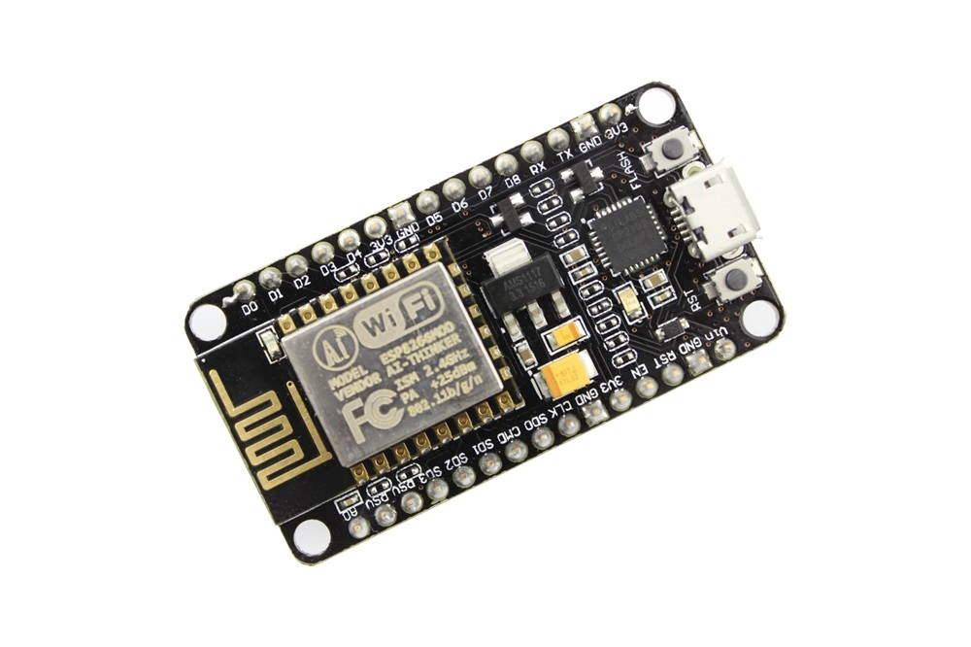

Fig 1: Node MCU

Starting with NodeMCU

NodeMCU Development board is featured with wifi capability, analog pin, digital pins and serial communication protocols.

To get start with using NodeMCU for IoT applications first we need to know about how to write/download NodeMCU firmware in NodeMCU Development Boards. And before that where this NodeMCU firmware will get as per our requirement.

There is online NodeMCU custom builds available using which we can easily get our custom NodeMCU firmware as per our requirement.

**Procedures of writing codes for NodeMCU**

Two type of IDE are generally used for writing codes in NodeMCU

**NodeMCU with Explorer IDE**

Lua scripts are generally used to code the NodeMCU. Lua is an open source, lightweight, embeddable scripting language built on top of C programming language.

**NodeMCU with Arduino IDE**

Here is another way of developing NodeMCU with a well-known IDE i.e. Arduino IDE. We can also develop applications on NodeMCU using Arduino development environment. This makes easy for Arduino developers than learning new language and IDE for NodeMCU.

### 2.1.2 Arduino Uno

Arduino Uno is a microcontroller board developed by Arduino.cc which is an open source electronics platform mainly based on AVR microcontroller Atmega328.The current version of Arduino Uno comes with USB interface, 6 analog input pins, 14 I/O digital ports that are used to connect with external electronic circuits. Out of 14 I/O ports, 6 pins can be used for PWM output. It allows the designers to control and sense the external electronic devices in the real world. This board comes with all the features required to run the controller and can be directly connected to the computer through USB cable that is used to transfer the code to the controller using IDE (Integrated Development Environment) software, mainly developed to program Arduino. IDE is equally compatible with Windows, MAC or Linux Systems, however, Windows is preferable to use. Programming languages like C and C++ are used in IDE. There are 14 I/O digital and 6 analog pins incorporated in the board that allows the external connection with any circuit with the board. These pins provide the flexibility and ease of use to the external devices that can be connected through these pins. There is no hard and fast interface required to connect the devices to the board. Simply plug the external device into the pins of the board that are laid out on the board in the form of the header. The 6 analog pins are marked as A0 to A5 and come with a resolution of 10bits.

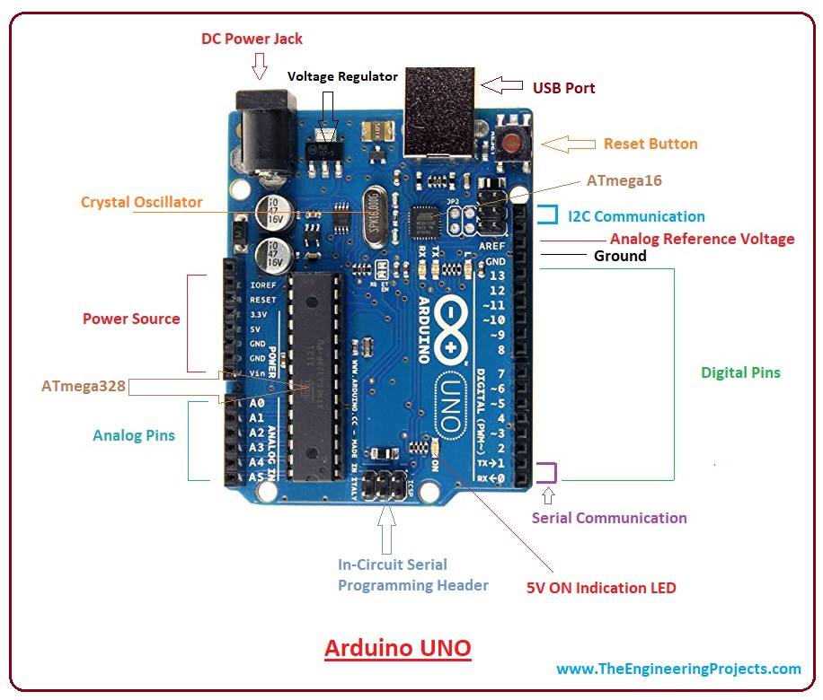

Fig 2: Arduino Uno

These pins measure from 0 to 5V, however, they can be configured to the high range using analog Reference () function and AREF pin. 13KB of flash memory is used to store the number of instructions in the form of code. Only 5 V is required to turn the board on, which can be achieved directly using USB port or external adopter, however, it can support external power source up to 12 V which can be regulated and limit to 5 V or 3.3 V based on the requirement of the project.

### 2.1.3 DTH sensor

DHT11 Temperature & Humidity Sensor features a temperature & humidity sensor complex with a calibrated digital signal output. By using the exclusive digital-signal-acquisition technique and temperature & humidity sensing technology, it ensures high reliability and excellent long-term stability. This sensor includes a resistive-type humidity measurement component and an NTC temperature measurement component, and connects to a high-performance 8-bit microcontroller, offering excellent quality, fast response, anti-interference ability and cost-effectiveness. Each DHT11 element is strictly calibrated in the laboratory that is extremely accurate on humidity calibration. The calibration coefficients are stored as programmers in the OTP memory, which are used by the sensor’s internal signal detecting process. The single-wire serial interface makes system integration quick and easy. Its small size, low power consumption and up-to-20 meter signal transmission making it the best choice for various applications, including those most demanding ones. The component is 4-pin single row pin package. It is convenient to connect and special packages can be provided according to users’ request.

Technical specifications:

|  |  |  |  |  |  |
| --- | --- | --- | --- | --- | --- |
| Item | Measurement range | Humidity accuracy | Temperature accuracy | Resolutions | Package |
| DHT11 | 15-90%RH  15-55 **°**C | ±5% RH | ±2 **°**C | 1 | 4 pin single row |

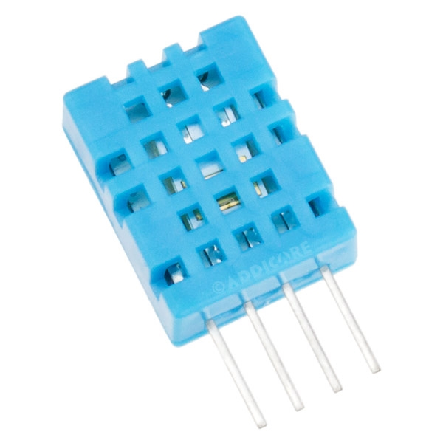

Fig 3: DTH sensor

### 2.1.4 Relay Module

Relay module is simply the combination of few relays fashioned in certain manner to connect the two difference voltage sources required in electronic circuit. It consist of 5 pins in general those are as:

#### Vcc pin

#### Signal pin

#### Common pin

#### NO pin

#### NC pin

### 2.1.4.1 4 channel relay module

This is a 5V 4-channel relay interface board, and each channel needs a 15-20mA driver current. It can be used to control various appliances and equipment with large current. It is equipped with high-current relays that work under AC250V 10A or DC30V 10A. It has a standard interface that can be controlled directly by microcontroller. The internal architecture is same as that of single relay which are grouped into a compact structure.

Table 1: Pin configuration of DTH sensor

|  |  |
| --- | --- |
| Relay module pins | Microcontroller pins |
| GND | GND |
| Vcc | 5V |
| In1 | D1 |
| In2 | D2 |
| In3 | D3 |
| In4 | D4 |

### 2.1.4.2 Single relay

This is useful electronic device which can interface two isolated voltage sources upon the reception of particular signal from the microcontroller or any human interface.

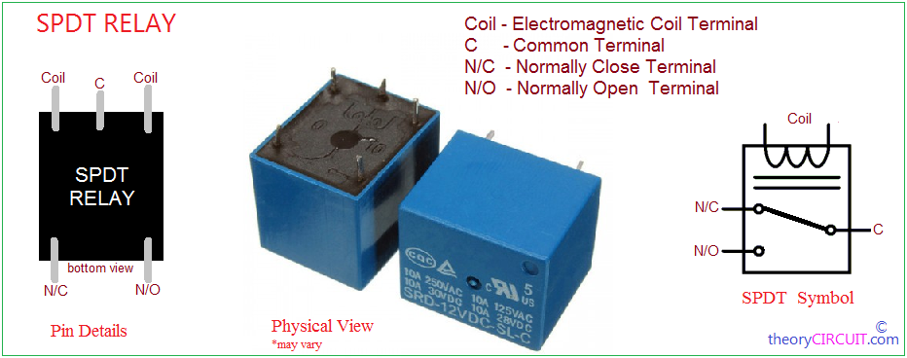

Figure 4: Relay

### 2.1.5 Transformer

A transformer is a passive electrical device that transfers electrical energy between two or more circuits through electromagnetic induction. A varying current in one coil of the transformer produces a varying magnetic field, which in turn induces a varying electromotive force (emf) or "voltage" in a second coil. Power can be transferred between the two coils, without a metallic connection between the two circuits. Faraday's law of induction discovered in 1831 described this effect. Transformers are used to increase or decrease the alternating voltages in electric power applications. For our project to receive the 12 volt for particular load 12-0-12, 1.5 amp transformer is used which is rectified into dc via rectifier bridge circuit.

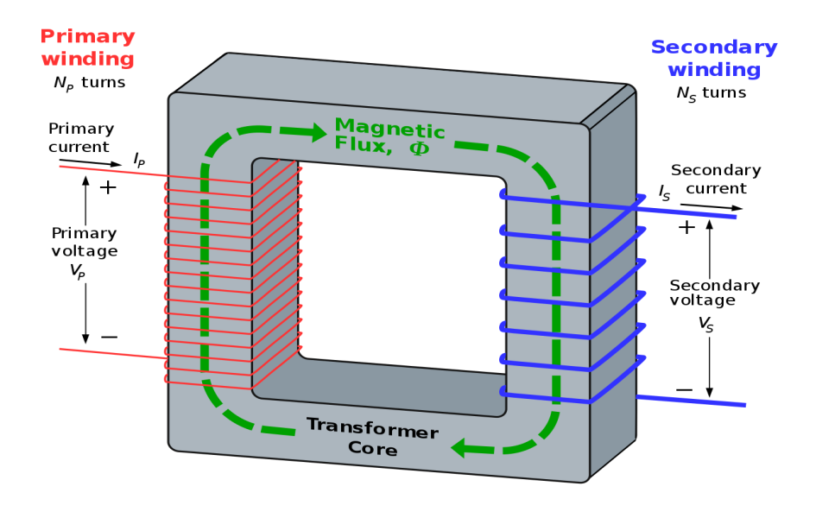

Fig 5: Transformer

### 2.1.6 LCD Display

A liquid crystal display (LCD) is a flat-panel display or other electronically modulated optical device that uses the light-modulating properties of liquid crystals. Liquid crystals do not emit light directly, instead using a backlight or reflector to produce images in color or monochrome. LCDs are available to display arbitrary images (as in a general-purpose computer display) or fixed images with low information content, which can be displayed or hidden, such as preset words, digits, and seven-segment displays, as in a digital clock. They use the same basic technology, except that arbitrary images are made up of a large number of small pixels, while other displays have larger elements.

Here we have employed 20*4 LCD display which means the data equivalent to 20 column and 4 row can be displayed .its data sheet are as:

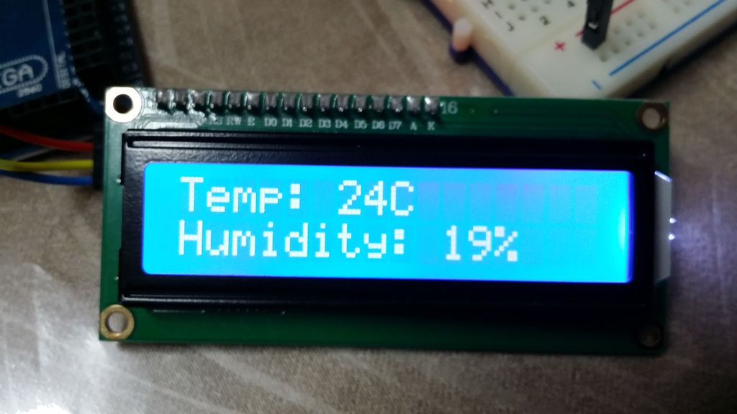

###### Fig 6: LCD display

### 2.1.7 Regulator IC

Voltage sources in a circuit may have fluctuations resulting in not providing fixed voltage outputs. A voltage regulator IC maintains the output voltage at a constant value. 7812 IC, a member of 78xx series of fixed linear voltage regulators used to maintain such fluctuations, is a popular voltage regulator integrated circuit (IC). The xx in 78xx indicates the output voltage it provides. We have used 7812 IC for 12 volt output as required by the load.

figure 7

###### 7812-pin-diagram-300x300.gif

Fig 7: Regulator IC

### 2.1.8 Capacitors

A capacitor is a passive two-terminal electrical component that stores potential energy in an electric field. The effect of a capacitor is known as capacitance. While some capacitance exists between any two electrical conductors in proximity in a circuit, a capacitor is a component designed to add capacitance to a circuit. When two conductors experience a potential difference, for example, when a capacitor is attached across a battery, an electric field develops across the dielectric, causing a net positive charge to collect on one plate and net negative charge to collect on the other plate. No current actually flows through the dielectric however, there is a flow of charge through the source circuit. If the condition is maintained sufficiently long, the current through the source circuit ceases. However, if a time-varying voltage is applied across the leads of the capacitor, the source experiences an ongoing current due to the charging and discharging cycles of the capacitor. The capacitance of a capacitor is proportional to the surface area of the plates (conductors) and inversely related to the gap between them. In practice, the dielectric between the plates passes a small amount of leakage current. It has an electric field strength limit, known as the breakdown voltage. The conductors and leads introduce an undesired inductance and resistance. Capacitors are widely used in electronic circuits for blocking direct current while allowing alternating current to pass. In analog filter networks, they smooth the output of power supplies. In resonant circuits they tune radios to particular frequencies. In electric power transmission systems, they stabilize voltage and power flow. The property of energy storage in capacitors was exploited as dynamic memory in early digital computers.

For rectifying propose 1000 microfarad and 470 microfarad capacitor are used in this project circuit.

### 2.1.9 Resistors

The resistor is a passive electrical component to create resistance in the flow of electric current. In almost all electrical networks and electronic circuits they can be found. The resistance is measured in ohms. An ohm is the resistance that occurs when a current of one ampere passes through a resistor with a one volt drop across its terminals. The current is proportional to the voltage across the terminal ends. This ratio is represented by [Ohm’s law](http://www.resistorguide.com/ohms-law/):

formula with ohm's law: R=V/I

Resistors are used for many purposes. A few examples include delimit electric current, voltage division, heat generation, matching and loading circuits, control gain, and fix time constants. They are commercially available with resistance values over a range of more than nine orders of magnitude. They can be used to as electric brakes to dissipate kinetic energy from trains, or be smaller than a square millimeter for electronics. What’s going on inside a resistor? If you break one open, and scratch off the outer coating of insulating paint, you might see an insulating ceramic rod running through the middle with copper wire wrapped around the outside. A resistor like this is described as wire-wound. The number of copper turns controls the resistance very precisely: the more copper turns, and the thinner the copper, the higher the resistance. In smaller-value resistors, designed for lower-power circuits, the copper winding is replaced by a spiral pattern of carbon. Resistors like this are much cheaper to make and are called carbon-film. Generally, wire-wound resistors are more precise and more stable at higher operating temperatures.

### 2.1.10 Diodes

A diode is a two-terminal electronic component that conducts current primarily in one direction (asymmetric conductance); it has low (ideally zero) resistance in one direction, and high (ideally infinite) resistance in the other. A diode vacuum tube or thermionic diode is a vacuum tube with two electrodes, a heated cathode and a plate, in which electrons can flow in only one direction, from cathode to plate. A semiconductor diode the most common type today, is a crystalline piece of semiconductor material with a p–n junction connected to two electrical terminals. Semiconductor diodes were the first semiconductor electronic devices. The discovery of asymmetric electrical conduction across the contact between a crystalline mineral and a metal was made by German physicist Ferdinand Braun in 1874. Today, most diodes are made of silicon, but other materials such as gallium arsenide and germanium are used. The basic propose of using diode in this project is for rectifying propose.

1N4007 diodes has been used in entire circuit in place where is needed.

### 2.1.11 Transistors

A transistor is a semiconductor device used to amplify or switch electronic signals and electrical power. It is composed of semiconductor material usually with at least three terminals for connection to an external circuit. A voltage or current applied to one pair of the transistor's terminals controls the current through another pair of terminals. Because the controlled (output) power can be higher than the controlling (input) power, a transistor can amplify a signal. Today, some transistors are packaged individually, but many more are found embedded in integrated circuits. Most transistors are made from very pure silicon or germanium, but certain other semiconductor materials can also be used. A transistor may have only one kind of charge carrier, in a field effect transistor, or may have two kinds of charge carriers in bipolar junction transistor devices. Compared with the vacuum tube, transistors are generally smaller, and require less power to operate. Certain vacuum tubes have advantages over transistors at very high operating frequencies or high operating voltages. Many types of transistors are made to standardized specifications by multiple manufacturers. BC547 NPN transistor is used to build a single channel relay module inside the circuit. Transistor is biased as a switch which turns on in case signal is received from its base.

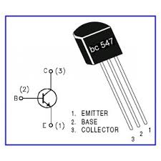

Fig 8: Transistor

### 2.1.12 Led

A light-emitting diode (LED) is a two-lead semiconductor light source. It is a p–n junction diode that emits light when activated. When a suitable current is applied to the leads, electrons are able to recombine with electron holes within the device, releasing energy in the form of photons. This effect is called electroluminescence, and the color of the light (corresponding to the energy of the photon) is determined by the energy band gap of the semiconductor. LEDs are typically small (less than 1 mm2) and integrated optical components may be used to shape the radiation pattern.

Appearing as practical electronic components in 1962, the earliest LEDs emitted low-intensity infrared light. Infrared LEDs are still frequently used as transmitting elements in remote-control circuits, such as those in remote controls for a wide variety of consumer electronics. The first visible-light LEDs were of low intensity and limited to red. Modern LEDs are available across the visible, ultraviolet, and infrared wavelengths, with very high brightness. Different type of led are were used during project to test the different points and to indicate the presence of the signal.

## 2.2 Software Aspects

Software is an important part of the projects. Hardware cannot along exist in particular advanced projects more relatively such as IoT based projects. So software development is an important aspect of running a project successfully.

Software is the collection of related programs and data that provides the instructions to the microcontroller to perform a particular function. There is various type of programming language available. In our project we have used high level programming language i.e C and Lua script for writing codes in Arduino and Node MCU respectively.

### 2.2.1 Proteus Simulator

The Proteus is electronic circuit design software which includes a schematic capture, simulation and PCB (Printed Circuit Board) Layout modules. But generally nowadays Eagle CAD is highly preferred over Proteus for PCB designing because of its flexibility. Even though if u are not using for PCB designing u can view the PCB layout of the component individually while selecting the component it helps during the soldering of components in PCB. We have tested all our circuits via proteus and then implemented into the PCB board is a software. It is a software suite containing schematic, simulation as well as PCB designing.

ISIS is the software used to draw schematics and simulate the circuits in real time. The simulation allows human access during run time, thus providing real time simulation.

ARES is used for PCB designing. It has the feature of viewing output in 3D view of the designed PCB along with components. The designer can also develop 2D drawings for the product.

Features

ISIS has wide range of components in its library. It has sources, signal generators, measurement and analysis tools like oscilloscope, voltmeter, ammeter etc., probes for real time monitoring of the parameters of the circuit, switches, displays, loads like motors and lamps, discrete components like resistors, capacitors, inductors, transformers, digital and analog Integrated circuits, semi-conductor switches, relays, microcontrollers, processors, sensors etc.

ARES offers PCB designing up to 14 inner layers, with surface mount and through whole packages. It is embedded with the foot prints of different category of components like ICs, transistors, headers, connectors and other discrete components. It offers Auto routing and manual routing options to the PCB Designer. The schematic drawn in the ISIS can be directly transferred ARES.

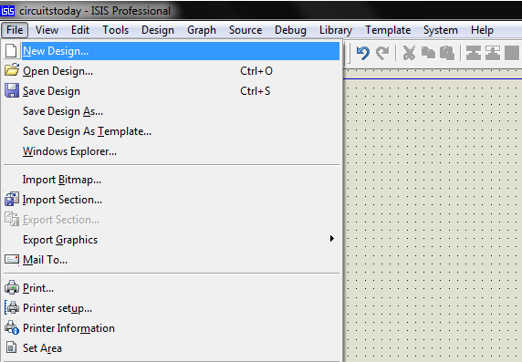

###### Fig 9: proteus simulator

### 2.2.2 Arduino IDE

The Arduino integrated development environment (IDE) is a cross-platform application (for Windows, macOS, Linux) that is written in the programming language Java. It is used to write and upload programs to Arduino board. The source code for the IDE is released under the GNU General Public License, version 2.The Arduino IDE supports the languages C and C++ using special rules of code structuring. The Arduino IDE supplies a software library from the Wiring project, which provides many common input and output procedures. User-written code only requires two basic functions, for starting the sketch and the main program loop, that are compiled and linked with a program stub main() into an executable cyclic executive program with the GNU toolchain, also included with the IDE distribution. The Arduino IDE employs the program to convert the executable code into a text file in hexadecimal encoding that is loaded into the Arduino board by a loader program in the board's firmware. Arduino Software IDE is Written in Java, C, C++Operating system Windows, macOS, Linux Platform IA-32, x86-64, ARM Type Integrated development environment License LGPL or GPL license.

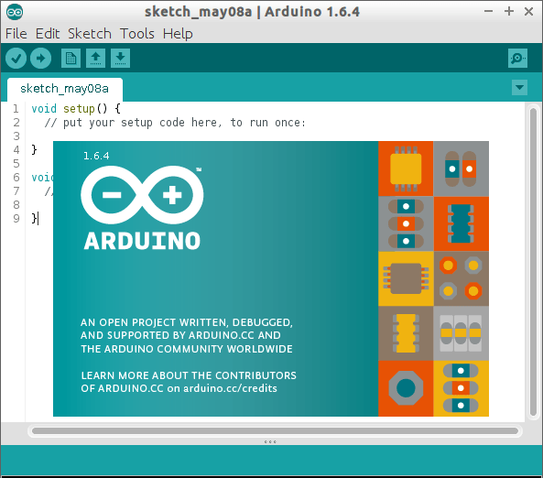

Fig 10: Arduino IDE

### 2.2.3 Websites

The website used for this IoT project is adafruit. Adafruit Industries is an open-source hardware company based in New York City. It was founded by Limor Fried in 2005. The company designs, manufactures and sells a number of electronics products, electronics components, tools and accessories. It also produces a number of learning resources, including live video electronics show. In addition to distributing third party components and boards such as the Arduino and the Raspberry Pi, Adafruit develops and sells its own development boards for educational and hobbyist purposes. In 2016, the company released the Circuit Playground, a board with an Atmel ATmega32u4 microcontroller and a variety of sensors, followed in 2017 by the more powerful Atmel SAMD21 based Circuit Playground Express. They, like many Adafruit products, are circular in shape for ease of use in education and wearable electronics projects, along with the FLORA, the company’s official wearable electronics development platform.

# CHAPTER THREE

# METHODOLOGY

## 3.1 Basic Description

This project is about controlling various electrical loads and large industrial system using internet and monitoring the various remote data (temperature and humidity for instance). The methods and procedures adopted to finalize the project are subdivided into three steps which are briefly described below.

#### Design

#### Tools and materials

#### Diagram

### 3.1.1Design

It comprises of four basic parts which can be shortlisted as the programming device or hardware interface, browsing media, sensor and the internet. Hardware part/NodeMCU is the framework where entire code is uploaded required for the project (load controlling) and data monitoring. Wifi shield attached to this device holds the wifi ssid and password along with router typical IP address which makes it identical among the billions of electronics devices operating under the same network and same server. Identity pin provided by adafruit is deployed in code as well as website which develop the two way single channel medium for communicating devices and internet.

Another important portion of the hardware is Arduino Uno which is typically a ATmega328 microcontroller interfaced with oscillator of 16 MHz frequency and few capacitors. The burner in device translates the assembly level and high level language written in Arduino ide into machine language, in readable format by microcontroller. It receives the data from sensor and sends into digital display board known as Liquid Crystal Display.

Tools

Various tools used during project implementation are as:

#### Screw driver

#### Multimeter

#### Line tester

#### Wire stripper

#### Hacksaw blade

#### Hammer

#### Soldering iron

#### Notch pliers

Materials

#### PCB board

#### Double sided tape

#### Male to female header

#### Male to male header

#### Jumpers

#### Hot glue gun

### 3.1.2. Block diagram, Circuit diagram and flowchart

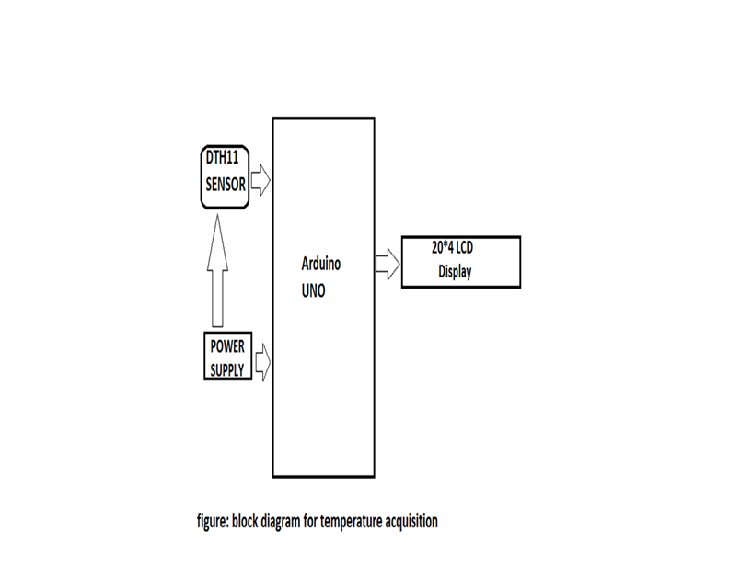

## Circuit diagram of system (IoT)

## 3.2 Algorithm

#### Algorithm for operation

#### Step 1: Start

#### Step 2: MCU initialize

#### Step 3: Get hardware software ready

#### Step 4: Connect device to wifi

#### Step 5: Send command from website

#### Step6: Check command from serial monitor

#### Step7: Control the device based on status

#### Step8: Check the load status

#### Step9: Notify end user

#### Step10: Stop

## 3.3 Working Principle

Switching and controlling commands are sent from adafruit browser which consists of user identity code. The various label of command under different feeds are sent via internet into the cloud. In our project 5 feeds are developed that is room1, room2, outdoor, fan and accessory. Each of feed has two 2 toggle commands i.e. ‘ON, or ‘OFF’. These commands are sent to the location of wifi router provided with ssid name, password and adafruit identity number with standard IP address within a NodeMCU where the entire hardware is interfaced.

Upon the reception of command from particular feeds, the MCU module determines which digital pin is to be made high or low according to the commands with respective feeds. The controlling phenomenon is facilitated by ‘SUBSCRIPTION’ keyword in MCU and data given by sensor is uploaded to the cloud is facilitated by ‘PUBLISH’ keyword in MCU. All the phenomenon and processes are clearly explained by block diagram and flowchart with relevant circuit diagram above. Similarly here in another side the temperature is being recorded by DHT11 sensor from real world environment and is continuously feeding to the ATmega328 microcontroller within Arduino UNO. Upon the data or temperature recorded the microcontroller takes an immediate action by signaling the digital pin either high or low status as per program installed in it. At the same time the recorded temperature and humidity is being displayed by 20*4 LCD displays which is interfaced with Arduino.

## 3.4 Flowchart:

Flow chart is represented below:

**Start**

**Initialize MCU**

**Get hardware software ready**

**Connect device to wifi**

**Send command from website**

**Check command**

NO

YES

**Control device based on status**

**Check load**

NO

Yes

**Stop**

# CHAPTER FOUR

# CONCLUSION AND RECOMMENDATION

## 4.1 Conclusion

A Smart Home system integrates electrical devices in a house with each other. The techniques which

are going to use in home automation include those in building automation as well as the control of domestic activities, such as TV, fan, electric tubes, refrigerator and washing machine. After studying and understanding literature survey and other existing works, we proposed better understanding of the Environmental conditions in home through smart Monitoring. Our system not only just monitors environmental conditions but it acts according to inhabitant requirement. In this paper we are planning to eliminate most of the human interaction by providing intelligent system.

Development of such Smart Home achieve by using Internet of Things technologies. By using these system we can actually manage to make low cost, flexible smart homes and resolve its errors with energy saving. After completion of our project we conclude that, this project helps to monitor and control load from distance place and really make task easier.

The practical implementation of our project can have vast level of implementation. This project is small implementation of our concept in automation and monitoring system. This small concept can be used in fields such as weather forecasting, remote sensing, robotics, home automation, and many other related fields where continuous monitoring and regulation is needed so we feel very happy to work in such challenging project which has tremendous application and possibilities.

## 4.2 Advantages

#### Can be implemented in anywhere.

#### Anyone can used the system with only the knowledge of internet.

#### Simple to control and monitor.

#### Easy for switching the load from any place by simply connecting the mobile with the internet.

#### Cheap for the installation and design.

#### Easily affordable.

## 4.3 Limitation

#### Internet connection is required on both the side of load and user controlling the load, which require charge.

#### Dependent on wifi based.

#### Can have some delay due to low internet speed.

## 4.4Recommendation

We recommend all the student, brother and sister who have studies in technical field, to work in such field, which actually gives a lot of satisfaction while working. The project gives a lot of confidence to fight out in this challenging world. The Internet of Thing is a networked infrastructure that provides a basis for interconnecting different devices anytime any place. So it find great application in the future. As one proceeds one cannot believe how much knowledge he/she can gain from the teamwork and the project work, really will have a new experience.

## 4.5 Future Enhancement

The project we have undertaken is wifi based project and wifi will have great revolution in the future. By 2020, it is estimated that there will be 21 billion connected devices to the internet. Various sensors, devices are connected to the internet. It has tremendous scope in the future. The project itself can be modified to achieve a complete Automation system which will then create a platform for the user to saves interface between user and device. The project we have undertaken can be used as a reference or a base for realizing a scheme to be implemented in other projects of greater level such as load controlling, device synchronization etc.

The future implementation of the project are very great considering the amount of time and resources.

## 4.6 Project Output

The project theme is to eradicate the problem arises during the manual control of the electric loads. Since whole system is controlled by automation, as well as monitoring the temperature and humidity of the room. It benefits for the reliable and the accurate controlling of the loads. The project output are related in the following ways;

#### Reduce unnecessary switching of load.

#### Visualizes load switching ON/OFF on the phone or laptop.

#### Easy monitoring and controlling.

#### Inference system is user friendly.

# Appendix

## Reference

#### Hwang, S. (2017). Monitoring and Controlling System for an IoT Based Smart Home. International Journal of Control and Automation, 10(2), pp.339-348.

#### https://www.researchgate.net/publication/220585836_Internet_of_Things_Objectives_and_Scientific_Challenges [Accessed 2 Nov. 2018].

#### Anon, (2018). [Online] Available at: https://www.quora.com/What-is-the-scope-and-future-of-the-Internet-of-Things [Accessed 3 Nov. 2018]

#### Christian, T., Daniel, T. and Anaclet, F. (2018). NodeMCU in Patient’s Data Transfer to IoT Platform. Journal of Biomedical Engineering and Medical Imaging, 5(3).

#### Store.arduino.cc. (2018). Arduino Uno Rev3. [Online] Available at: https://store.arduino.cc/usa/arduino-uno-rev3/ [Accessed 3 Nov. 2018].

#### [Accessed 3 Nov. 2018].  File.scirp.org. (2018). [Online] Available at: http://file.scirp.org/pdf/JCC_2015052516013923.pdf

#### En.wikipedia.org. (2018). Capacitor. [Online]Available at: https://en.wikipedia.org/wiki/Capacitor [Accessed 3 Nov. 2018].

#### En.wikipedia.org.(2018). Transformer. [Online]Available at:https://en.wikipedia.org/wiki/Transformer [Accessed 3 Nov. 2018].

#### GitHub. (2018). Nodemcu/nodemcu-firmware [Online] Available at: https://github.com/nodemcu/nodemcu-firmware [Accessed 3 Nov. 2018].

#### Learn.adafruit.com. (2018). Introduction | Home Automation in the Cloud with the ESP8266 & Adafruit IO | Adafruit Learning System. [Online] Available at: https://learn.adafruit.com/home-automation-in-the-cloud-with-the-esp8266-and-adafruit-io/introduction [Accessed 4 Nov. 2018].

## PROGRAM CODE

Two program codes are separately sketched for two propose; one is for internet communication using NodeMCU and another is for temperature acquisition in module home using Arduino Uno.

5.2.1. Program code for NodeMCU

#include <ESP8266WiFi.h> // header file for wifi shield

#include "Adafruit_MQTT.h"// library for adafruit server

#include "Adafruit_MQTT_Client.h"

#include <Adafruit_Sensor.h>

#include <DHT.h> //library for temperature sensor

#define DHT11_PIN 15 // GPIO pin or digital pin 8 for temperature sensor

#define DHTTYPE DHT11 // distinguishing the sensor type

#define LED0 D0 // defining digital pin for use

#define LED1 D1

#define LED2 D2

#define LED3 D3

#define LED4 D4

#define HIGH 1

#define LOW 0

DHT dht(DHT11_PIN, DHTTYPE);

//wifi parameter

#define WLAN_SSID "CMCC-YMwM"

#define WLAN_PASS "calculator"

#define AIO_SERVER "io.adafruit.com"

#define AIO_SERVERPORT 1883 // use 8883 for SSL

#define AIO_USERNAME "biraj2211"

#define AIO_KEY "9b690e26f1b64784ac8ccee7e5d55656"// user identity key

WiFiClient client;

Adafruit_MQTT_Clientmqtt(&client, AIO_SERVER, AIO_SERVERPORT, AIO_USERNAME, AIO_USERNAME, AIO_KEY);

// Notice MQTT paths for AIO follow the form: <username>/feeds/<feedname>

Adafruit_MQTT_Subscribe Room1= Adafruit_MQTT_Subscribe(&mqtt, AIO_USERNAME "/feeds/Room1");

Adafruit_MQTT_Subscribe Room2 = Adafruit_MQTT_Subscribe(&mqtt, AIO_USERNAME "/feeds/Room2");

Adafruit_MQTT_Subscribe Outdoor = Adafruit_MQTT_Subscribe(&mqtt, AIO_USERNAME "/feeds/Outdoor");

Adafruit_MQTT_Subscribe Fan = Adafruit_MQTT_Subscribe(&mqtt, AIO_USERNAME "/feeds/Fan");

Adafruit_MQTT_Subscribe Accessory = Adafruit_MQTT_Subscribe(&mqtt, AIO_USERNAME "/feeds/Accessory");

Adafruit_MQTT_Publish temperature = Adafruit_MQTT_Publish(&mqtt, AIO_USERNAME "/feeds/temperature");

Adafruit_MQTT_Publish humidity = Adafruit_MQTT_Publish(&mqtt, AIO_USERNAME "/feeds/humidity");

voidMQTT_connect(); // connection attempt with internet

void setup()

{

Serial.begin(9600);

pinMode(LED0, OUTPUT); // indicating these pins for output

pinMode(LED1, OUTPUT);

pinMode(LED2, OUTPUT);

pinMode(LED3, OUTPUT);

pinMode(LED4, OUTPUT);

digitalWrite(LED0,LOW);

digitalWrite(LED1,LOW);

digitalWrite(LED2,LOW);

digitalWrite(LED3,LOW);

digitalWrite(LED4,LOW);

Serial.begin(115200); // baud rate of the system

delay(10);

Serial.println(F("Adafruit MQTT demo"));

Serial.println();

Serial.println();

Serial.print("Connecting to ");

Serial.println(WLAN_SSID);

WiFi.begin(WLAN_SSID, WLAN_PASS);

while (WiFi.status() != WL_CONNECTED)

{

delay(500);

Serial.print(".");

}

Serial.println();

Serial.println("WiFi connected");

Serial.println("IP address: ");

Serial.println(WiFi.localIP()); //holds ip address of wifi router

// switching feed for load

mqtt.subscribe(&Room1);

mqtt.subscribe(&Room2);

mqtt.subscribe(&Outdoor);

mqtt.subscribe(&Fan);

mqtt.subscribe(&Accessory);

}

uint32_t x=0;

void loop()

{

intchk = dht.read(DHT11_PIN);

float h=dht.readHumidity();

float t=dht.readTemperature();

Serial.print("Temperature = ");

Serial.println(t);

Serial.print("Humidity = ");

Serial.println(h);

delay(5000);

MQTT_connect();

Adafruit_MQTT_Subscribe *subscription;

// publishing into the internet

temperature.publish(t);

humidity.publish(h);

while ((subscription = mqtt.readSubscription(5000)))

{

if (subscription == &Room1) // subscribing from internet

{

Serial.print(F("Room1 Bulb: "));

Serial.println((char *)Room1.lastread);

if (strcmp((char *)Room1.lastread, "ON") == 0)

{

digitalWrite(LED0, HIGH);

}

if (strcmp((char *)Room1.lastread, "OFF") == 0)

{

digitalWrite(LED0, LOW);

}

}

if (subscription == &Room2)

{

Serial.print(F("Room2 Bulb: "));

Serial.println((char *)Room2.lastread);

if (strcmp((char *)Room2.lastread, "ON") == 0)

{

digitalWrite(LED1, HIGH);

}

if (strcmp((char *)Room2.lastread, "OFF") == 0)

{

digitalWrite(LED1, LOW);

}

}

if (subscription == &Outdoor)

{

Serial.print(F("Outdoor Bulb: "));

Serial.println((char *)Outdoor.lastread);

if (strcmp((char *)Outdoor.lastread, "ON") == 0)

{

digitalWrite(LED2, HIGH);

}

if (strcmp((char *)Outdoor.lastread, "OFF") == 0)

{

digitalWrite(LED2, LOW);

}

}

if (subscription == &Fan)

{

Serial.print(F("Fan Bulb: "));

Serial.println((char *)Fan.lastread);

if (strcmp((char *)Fan.lastread, "ON") == 0)

{

digitalWrite(LED3, HIGH);

}

if (strcmp((char *)Fan.lastread, "OFF") == 0)

{

digitalWrite(LED3, LOW);

}

}

if (subscription == &Accessory)

{

Serial.print(F("Accessory : "));

Serial.println((char *)Accessory.lastread);

if (strcmp((char *)Accessory.lastread, "ON") == 0)

{

digitalWrite(LED4, HIGH);

}

if (strcmp((char *)Accessory.lastread, "OFF") == 0)

{

digitalWrite(LED4, LOW);

}

}

}

if(! mqtt.ping())

{

mqtt.disconnect();

}

}

voidMQTT_connect() {

int8_t ret;

if (mqtt.connected())

{

return;

}

Serial.print("Connecting to MQTT... ");

uint8_t retries = 3;

while ((ret = mqtt.connect()) != 0)

{

Serial.println(mqtt.connectErrorString(ret));

Serial.println("Retrying MQTT connection in 5 seconds...");

mqtt.disconnect();

delay(5000);

retries--;

if (retries == 0)

{

while (1);

}

}

Serial.println("MQTT Connected!");

}

## **Temperate and humidity code for LCD display**

#include <dht.h>

#include <LiquidCrystal.h>

constintrs = 12, en = 11, d4 = 6, d5 = 4, d6 = 3, d7 = 2;

LiquidCrystallcd(rs, en, d4, d5, d6, d7);

dht DHT;

#define DHT11_PIN 9

void setup(){

lcd.begin(16, 4);

pinMode(8,OUTPUT);

pinMode(8,LOW);

}

void loop()

{

intchk = DHT.read11(DHT11_PIN);

lcd.setCursor(0,0);

lcd.print("Temp: ");

lcd.print(DHT.temperature);

lcd.print("C");

lcd.setCursor(0,1);

lcd.print("Hum: ");

lcd.print(DHT.humidity);

lcd.print("%");

delay(10000);

lcd.setCursor(0,2);

lcd.print("IOT Home Aut.");

lcd.setCursor(0,3);

lcd.print("BSY Group");

if(DHT.temperature>=25)

{digitalWrite(8,HIGH);

}

else if(DHT.temperature<25)

{

digitalWrite(8,LOW);}

}