**Insights Writing for the Baby Products Sales Dataset Analysis**

**1.Context**

Sales Dataset Analysis examines retail transactions from Nov 2020 to Oct 2023 to identify trends, top products, and key revenue sources. Using PivotTables, What-If Analysis, and Macros in Excel, it helps optimize sales strategies and boost profitability.

**2.Objective**  
The primary goal of this analysis is to evaluate sales performance over the past three years, identify trends, and uncover opportunities for growth. We aim to provide actionable insights for the sales management team to optimize strategies and improve performance. Key areas of focus include high-performing products, sales channels, and the impact of Average Price on revenue.

**3.Scope**  
The analysis covers sales data from November 2020 to October 2023, focusing on essential metrics such as total sales, sales trends over time, sales by product category, and channel performance. This dataset integrates information from various sources, including sales transactions, customer segments, and product categories.

**4.Audience**  
This analysis is intended for the sales management team and decision-makers who require data-driven insights to guide their strategies and actions. It is also beneficial for business analysts, marketing teams, and finance professionals who need a clear understanding of sales trends and revenue drivers to make proper strategic decisions.

**5. Techniques Used**

* **PivotTables:** Summarization of sales data.
* **PivotCharts:** Bar, line, and pie charts for visualizing trends.
* **Slicers:** Interactive filtering for in-depth analysis.
* **Dashboards:** Consolidated insights for better decision-making.

**6. Data Cleaning**

Cleaned the dataset by removing duplicates, handling missing values, ensuring consistency, freezing the top row, formatting date and currency columns, and excluding irrelevant data.

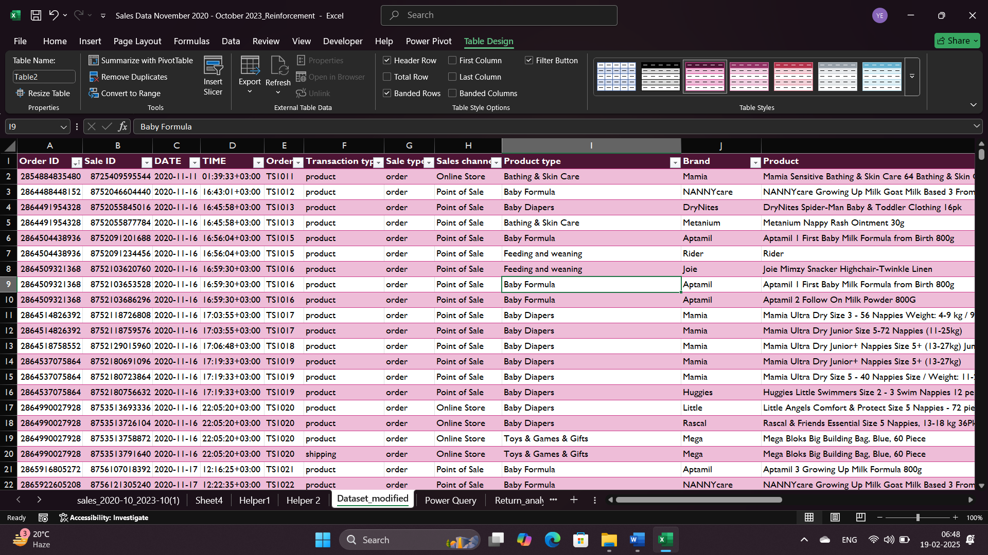

**7. Key Metrics & Formulas**

**a. Total Sales**

* **Formula:** SUM(Total Sales), ABS(SUM(DISCOUNT))
* **Purpose:** Measures overall revenue generated.

**b. Count Orders by Transaction Type / Sale Type**

* **Formula:** COUNTIFS(Transaction_Type_Range, "Online", Sale_Type_Range)
* **Purpose:** Counts the number of orders by specific transaction type and sale type.

**c. Calculate Average Discount per Order by Sale Type or Channel**

* **Formula:**AVERAGEIFS(Discount_Amount_Range,Sale_Type_Range, "Discounted", Channel_Range, "Online")
* **Purpose:** Calculates the average discount per order for each sale type or channel.

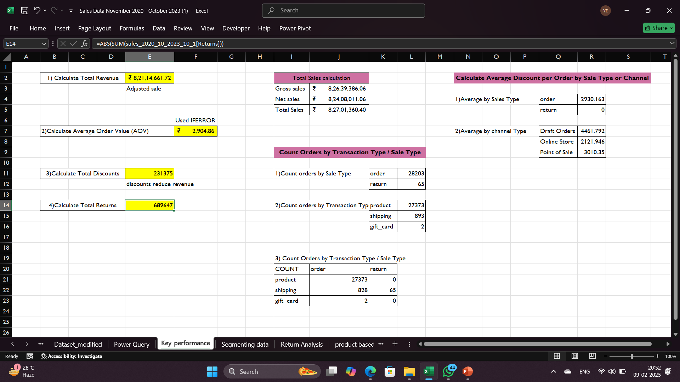



**8. Sales Trends Over Time**

To track sales trends over time, use **PivotTables** and then calculate the month-over-month or year-over-year comparisons

* **Highest Sales Year:** 2023 has highest sales nearly **8.2Cr.**
* **Lowest Sales Year:** 2021 has Lowest Sales.
* **Highest Sales Month:** January (**₹508,910**) and March (**₹513,973**) show strong performance.
* **Lowest Sales Month:** February (**₹459,457**) indicates a potential seasonal dip.
* **Quarterly Trends:** Sales seem steady across Q1, suggesting to Analysis demand’s of the customers
* **Date Functions:** Used MONTH(), YEAR(), WEEKDAY(), and [EOMONTH() – End of the month function] to analyze sales performance across different periods.

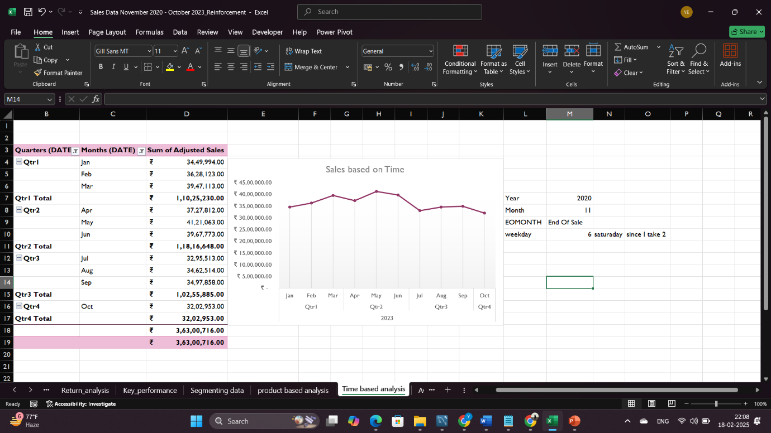

**9. Sales Channel and Product Type Analysis**

**a. Highest Sales Channel**

* The **POS** channel is the highest revenue driver, contributing **₹7 Crore+** in net sales, compared to much lower sales from **Draft Orders**.

**b.** **Most Profitable Product**

* **Baby Formula** generates the most revenue, contributing ₹3 Crore in net sales, and sees the highest sales volume in both the **POS** and **Online** channels.

**c. Best-Selling Products**

* 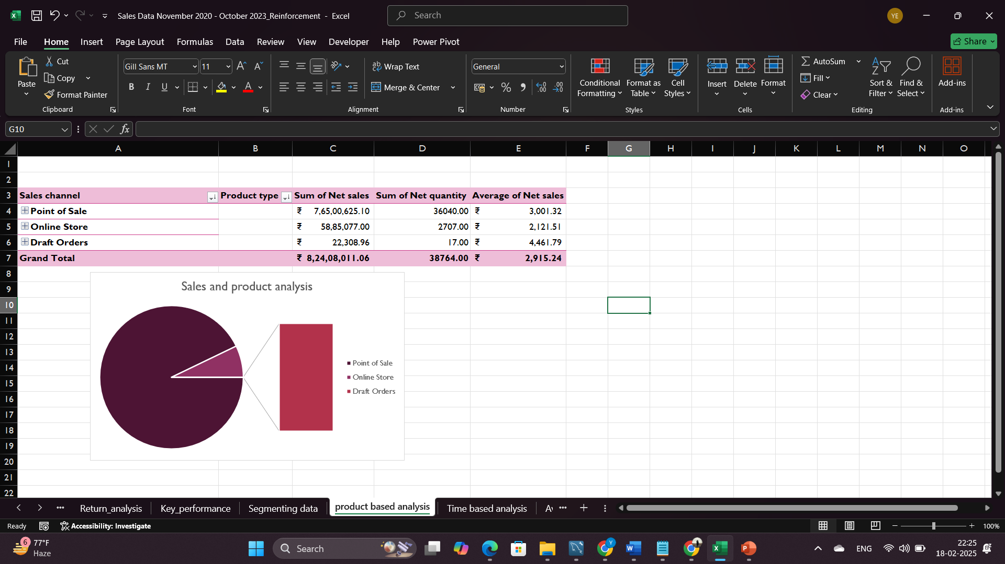**Aptamil** and **Nanny Care** are the top-selling products in the **Baby Formula** category.

**10. Return Analysis**

**a. Overall Returns vs. Sales**

* Total gross sales: ₹9,75,075
* Total returns: ₹6,89,647
* Total net sales (after returns): ₹2,88,978

**b. Key Observations**

* The **Online Store has a high return rate**, significantly reducing net sales.
* The **Point of Sale channel is more stable**, with fewer returns and higher net sales.
* 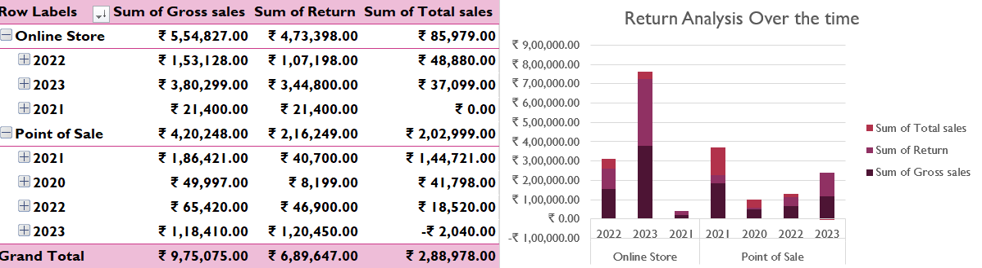**2023 had the highest returns**, impacting overall profitability.

**11. What-If Analysis & Goal Seek**

**a. What-If Analysis:**  
This helps predict how changes affect revenue.

* If sales increase by **10%**, revenue rises from **₹5,31,472.57 to ₹5,84,619.83**.
* Selling more units (from **250 to 275**) increases total revenue while price stays the same.

**b. Goal Seek Analysis:**  
This finds how many units need to be sold to reach a target revenue.

* To earn **₹9,00,00,000**, we need to sell **42,335 units** at the current price of **₹2,125.89**.

This helps in planning sales targets and pricing strategies.

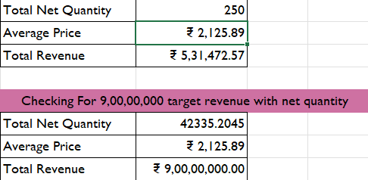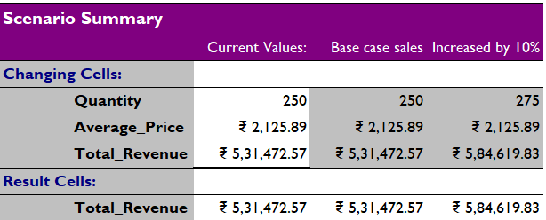

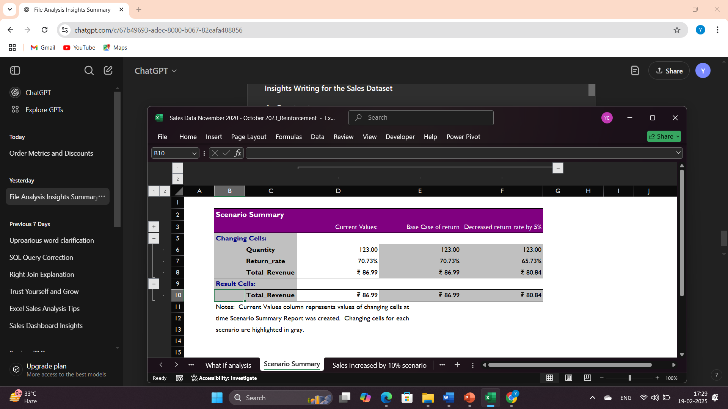

**12. Pivot Tables and Pivot Charts**

**a. Top 5 Brands Sales**

* Aptamil leads with the highest sales (44%).
* A donut chart visualizes brand-wise sales contribution.

**b. Sales Over Time**

* Monthly and quarterly sales trends analyzed.
* A line chart represents performance variations.

**c. Top 5 Products by Average Selling Price**

* The **Car Seat** has the highest average selling price: ₹17,231.93.
* Other high-value products include **Baby Stroller**, **Baby Monitor**, and **Kids Tablet**.
* A bar chart visualizes price differences among the top products.

**d. Top 5 Products Based on Sales**

* **Baby Formula** leads in total sales (₹11,750.00).
* Other high-selling products: **Feeding & Weaning, Bathing & Skin Care, Swim Nappies, and Baby Diapers**.
* A **pivot chart** highlights product-wise sales distribution.

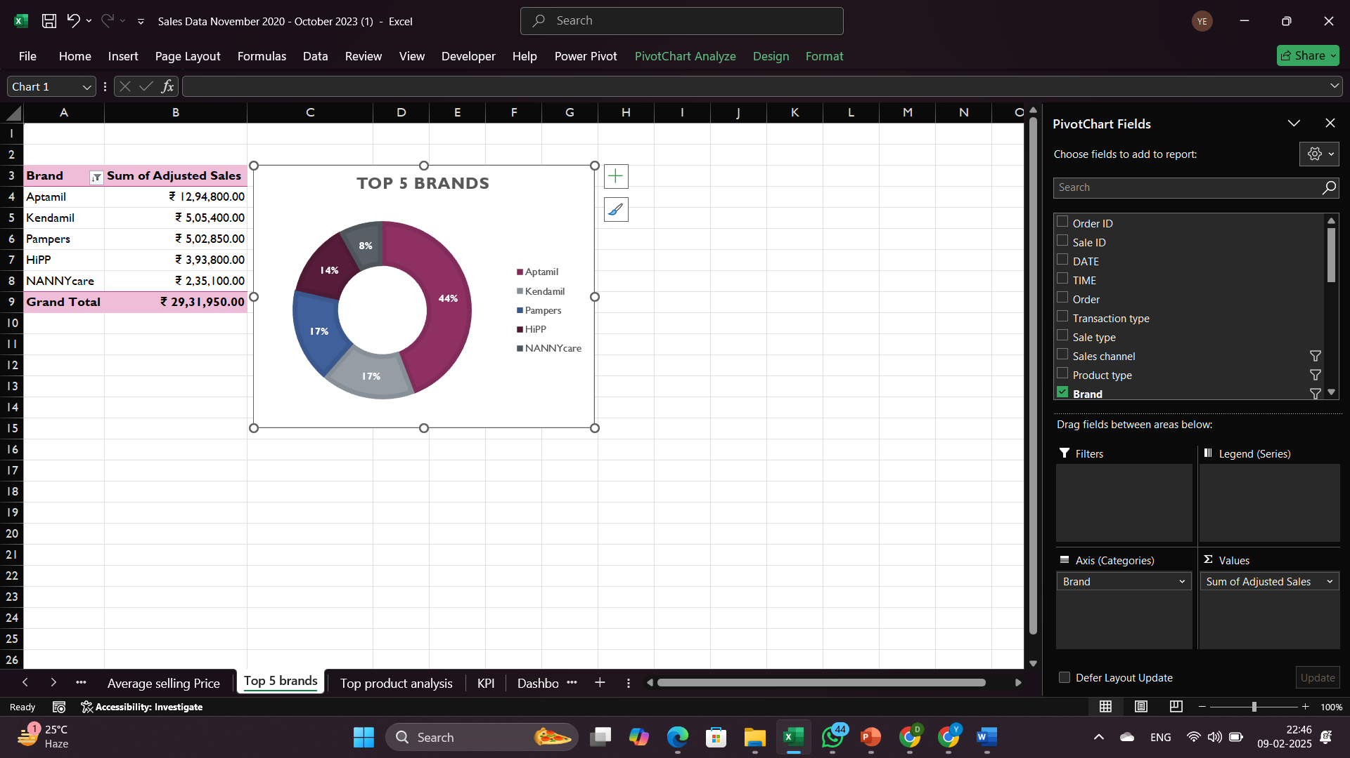

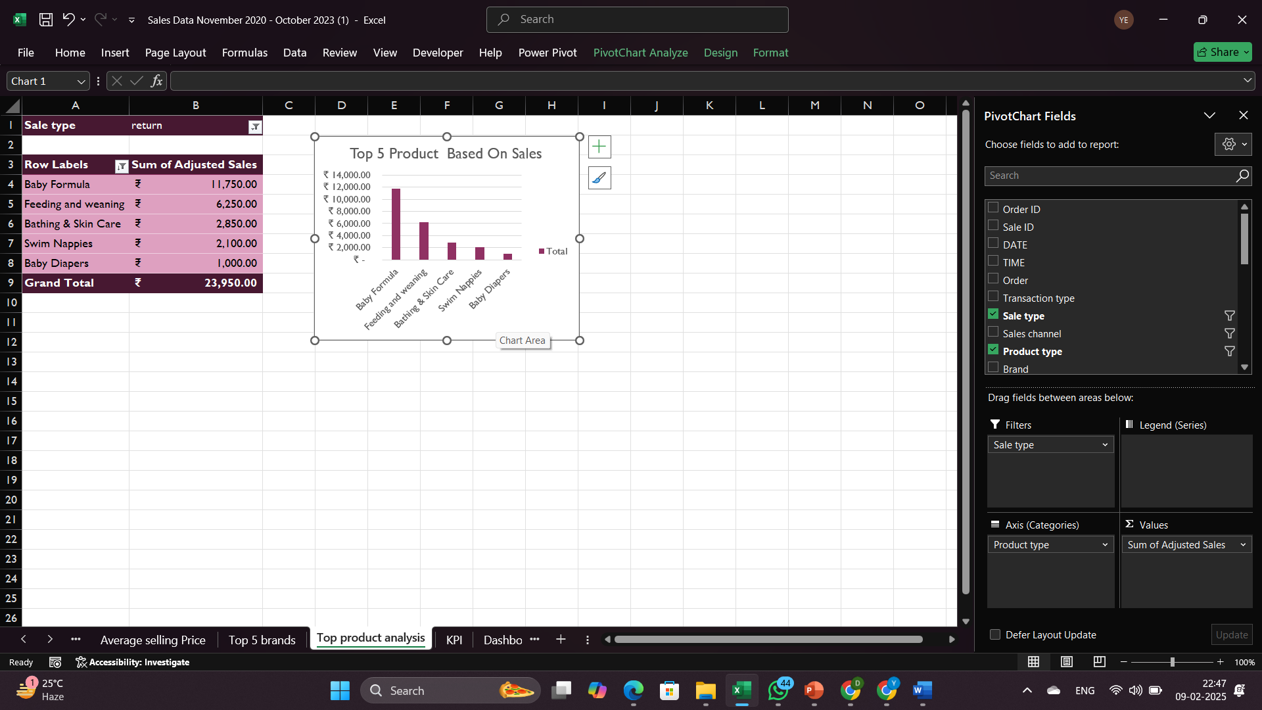

**13. Create a Sales Dashboard**

* **Total Sales**: ₹8,21,14,661.72
* **Average Sales Value**: ₹2,925.62
* **Top-Selling Product**: Baby Formula
* **Top 5 Brands Market Share**:
  + Aptamil leads with 47%
  + Followed by NANNYcare, Kendamil, Pampers, and HiPP

1. **Key Visual Insights**

* **Top 5 Products Based on Sales**
  + Baby Formula dominates the market with the highest sales.
  + Other high-selling products: Feeding & Weaning, Bathing & Skin Care, Swim Nappies, and Baby Diapers.
* **Sales Over Time Trend**
  + A line chart shows fluctuations in sales across different months and quarters.
* **Impact of Average Price on Sales**
  + Car Seats, Baby Strollers, and Baby Monitors have the highest average prices.
* **Sales Channel Performance**
  + Draft Orders, Online Store, and Point of Sale are analyzed for sales contributions.

**b. Interactive Features for Analysis**

* **Filters & Sorting**: Analyze sales by **brand, product, month, or quarter**.
* **Pivot Tables & Charts**: Provide an **in-depth breakdown** of sales data.
* **Slicers**: Enable easy data exploration in Excel.

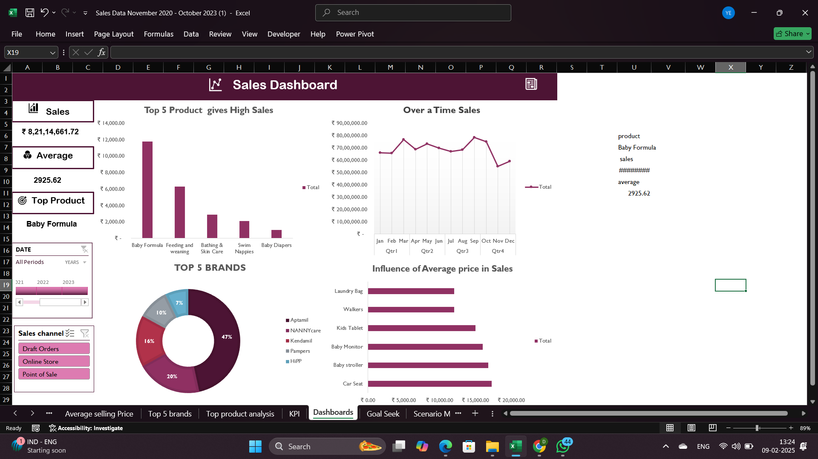This dashboard makes it easy to track trends, identify top-selling products, and optimize business strategies.

**14. Macros and Automation**

Macros were used to **automate repetitive tasks** in Excel, including:

* **Formatting worksheets -** Automatically applying currency formatting, bolding headers, and freezing panes.
* **Updating Pivot Tables -** Running calculations and refreshing PivotTables whenever new data is added.

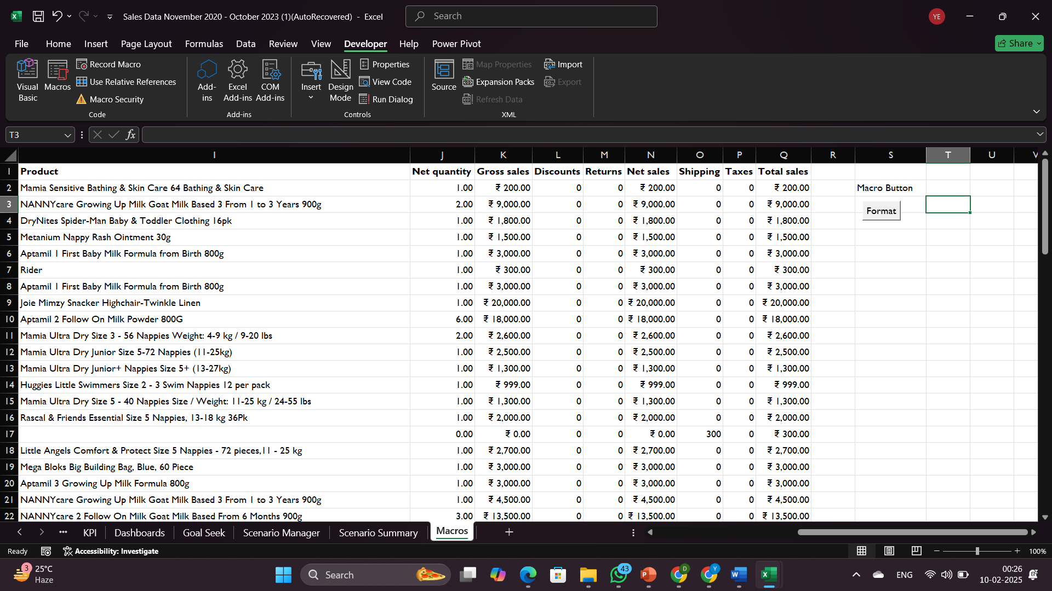 **a. Benefits of Automation**

* Saves Time
* Increases Accuracy
* Improves Efficiency

**15. Power Pivot & Data Modeling**

* 1. **Created Table Relationships**
* Linked two tables using a common field (Sales ID).
  1. **Used Power Pivot to Build a Pivot Table**
* Imported data into Power Pivot.
* Created a Pivot Table for better analysis.
  1. **Benefits of Using Power Pivot**
     + Handles large datasets efficiently.
     + Enables better data relationships without duplication.
  2. **Key Features Used**
     + **Data Model**: Combined multiple tables into one model.
     + **Pivot Table Analysis**: Filtered and summarized data easily.

This setup makes analysis faster, easier, and more dynamic.

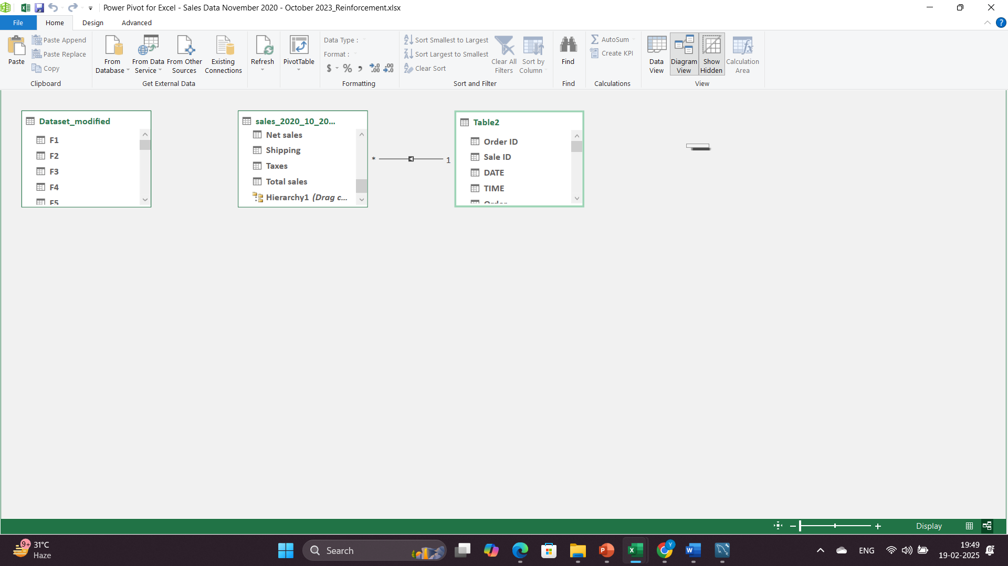

**16. Findings**

* **Total Sales Performance**  
  Our total sales over the past year reached **₹8,21,14,661.72**, showing a significant increase. The average sale value was **₹2,925.62**.
* **Category Analysis**  
  The top-selling product was **Baby Formula**, followed by **Feeding & Weaning, Bathing & Skin Care, Swim Nappies, and Baby Diapers**. These products contribute the most to our revenue.
* **Sales Trends**  
  Sales fluctuated throughout the year, with noticeable peaks and dips. Understanding these trends helps in stock management and strategic planning.
* **Brand Performance**  
  The leading brand was **Aptamil**, accounting for **47% of sales**, followed by **NannyCare, Kendamil, Pampers, and Hipp**. These brands significantly impact overall sales.
* **Impact of Pricing on Sales**  
  Certain product categories, like **Laundry Bags, Walkers, Kids Tablets, Baby Monitors, Baby Strollers, and Car Seats**, showed strong sensitivity to price changes.
* **Sales Channel Performance**  
  Sales were generated through three key channels: **Draft Orders, Online Store, and Point of Sale**. Each channel's contribution can guide future marketing strategies.

**17. Conclusion**

* Sales growth has been steady, with Baby Formula leading in revenue.
* Seasonal trends indicate the need for strategic stock management and promotions.
* Brand performance suggests strong customer loyalty toward top-performing brands.

**18. Key Takeaways**

* Certain product categories dominate sales, highlighting customer preferences.
* Price adjustments can impact demand, requiring data-driven pricing strategies.
* Understanding sales channels can help refine customer engagement strategies.

**By,**

**Yahavarshini E**