Course 35 ---- DS1302 and LCD1602

**The purpose of the experiment:**

In this course we mainly study the use of DS1302 module

The actual object is shown below.

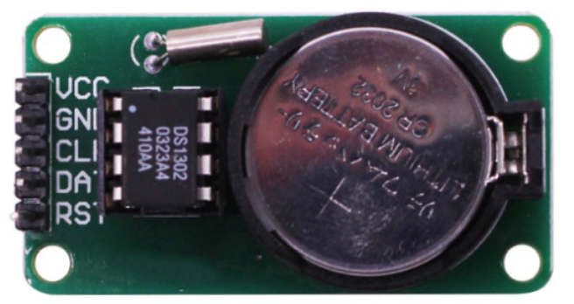

**List of components required for the experiment:**

Arduino UNO board *1

USB cable *1

DS1302 module *1

Breadboard *1

Dupont line *1 bunch

**Actual object connection diagram：**

We need to connect the circuit as shown in the figure below.

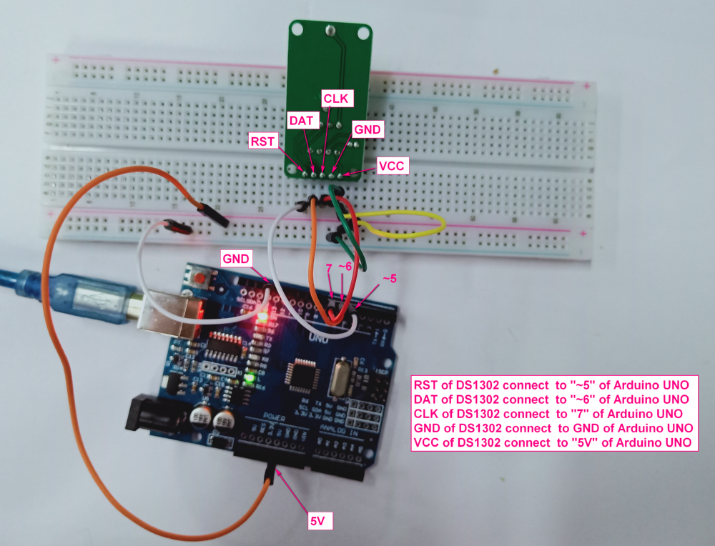

**Experimental code analysis:**

/**

* @par Copyright (C): 2010-2019, Shenzhen Yahboom Tech

* @file 35.DS1302 Serial port display time

* @author liusen

* @version V1.0

* @date 2017.11.14

* @brief Arduino connect to DS1302

Serial input: 2017,11,10,11,59,20,6

Note: 1-7 Sunday - Saturday

* @details

* @par History

*

*/

#include <stdio.h>

#include <string.h>

#include <DS1302.h>

uint8_t CE_PIN = 5;

uint8_t IO_PIN = 6;

uint8_t SCLK_PIN = 7;

char buf[50];

char day[10];

String comdata = "";

int numdata[7] ={0}, j = 0, mark = 0;

DS1302 rtc(CE_PIN, IO_PIN, SCLK_PIN);

/**

* Function print_time

* @author liusen

* @date 2017.11.14

* @brief Serial printing time

* @param[in] void

* @retval void

* @par History

*/

void print_time()

{

Time t = rtc.time();

memset(day, 0, sizeof(day));

switch (t.day)

{

case 1: strcpy(day, "Sunday"); break;

case 2: strcpy(day, "Monday"); break;

case 3: strcpy(day, "Tuesday"); break;

case 4: strcpy(day, "Wednesday"); break;

case 5: strcpy(day, "Thursday"); break;

case 6: strcpy(day, "Friday"); break;

case 7: strcpy(day, "Saturday"); break;

}

snprintf(buf, sizeof(buf), "%s %04d-%02d-%02d %02d:%02d:%02d", day, t.yr, t.mon, t.date, t.hr, t.min, t.sec);

Serial.println(buf);

}

/**

* Function setup

* @author liusen

* @date 2017.11.14

* @brief Initialization configure

* @param[in] void

* @retval void

* @par History

*/

void setup()

{

Serial.begin(9600);

rtc.write_protect(false);//turn off write protection

rtc.halt(false);

}

/**

* Function loop

* @author liusen

* @date 2017.11.14

* @brief Serial port timing and display

* @param[in] void

* @retval void

* @par History

*/

void loop()

{

while (Serial.available() > 0)

{

comdata += char(Serial.read());

delay(2);

mark = 1;

}

if(mark == 1)

{

Serial.print("You inputed : ");

Serial.println(comdata);

for(int i = 0; i < comdata.length() ; i++)

{

if(comdata[i] == ',' || comdata[i] == 0x10 || comdata[i] == 0x13)

{

j++;

}

else

{

numdata[j] = numdata[j] * 10 + (comdata[i] - '0');

}

}

Time t(numdata[0], numdata[1], numdata[2], numdata[3], numdata[4], numdata[5], numdata[6]);

rtc.time(t);

mark = 0;j=0;

comdata = String("");

for(int i = 0; i < 7 ; i++) numdata[i]=0;

}

print_time();

delay(1000);

}

**Experimental steps:**

1. We need to open the program for this experiment:

**code_DS1302.ino**, click “**√**”under the menu bar,compile the program, and wait for the words of **Done compiling** in the lower left corner, as shown in the following figure.

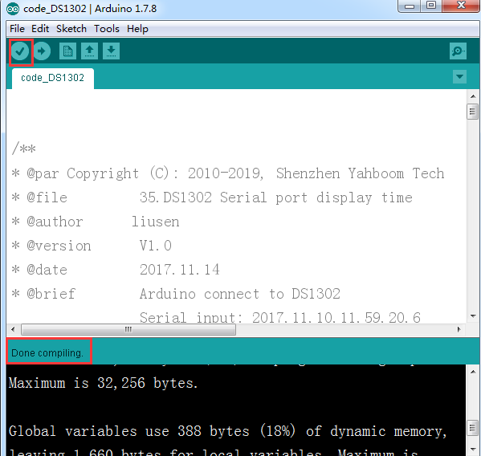

1. In the menu bar of Arduino IDE，you need to select the 【Tools】---【Port】--- select the port that the serial number displayed by the device manager just now.for example:COM6,as shown in the following figure.

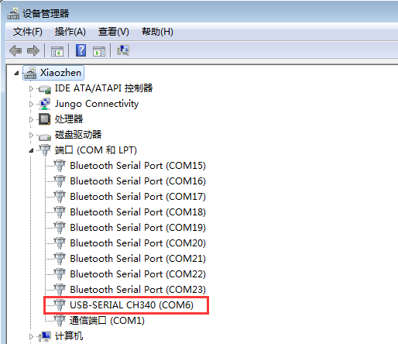

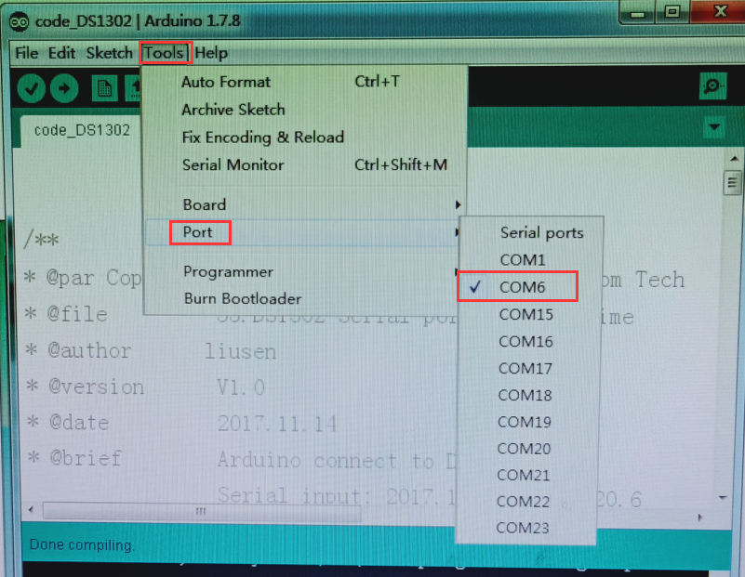

1. After the selection is completed, you need to click “**→**”under the menu bar,and upload the program to the Arduino UNO board, when appears to **Done uploading** on the lower left corner , that means that the program has been successfully uploaded to the Arduino UNO board, as shown in the following figure.

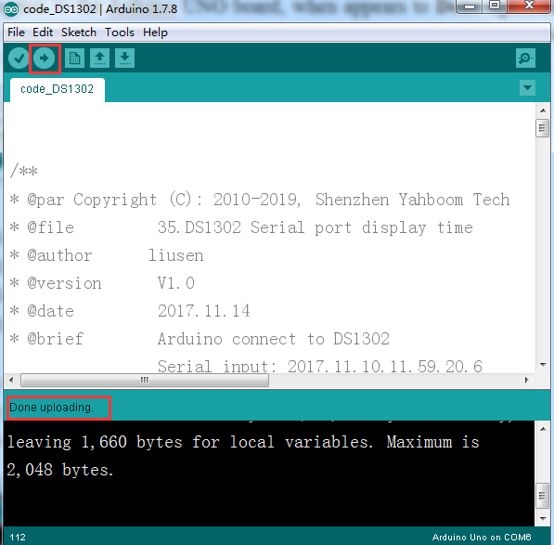

4.After the code is uploaded.You need to open the serial monitor of the Arduino IDE and print out the date and time of initialization. You can also send the current date and time through the serial port and print it out, as shown below.

(Note: The format of inputting the date and time, as shown in the following figure.)

