**Steps to add a library file**

Note:Before you compile the code, you must look at this steps.

1.We need to add DS1302 file, as shown in the figure below.

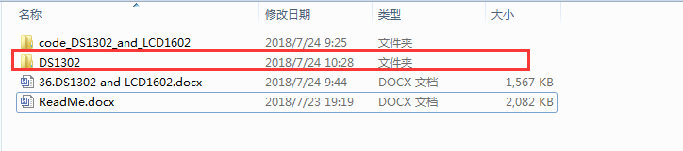

2.You need to find the installation path of Arduino. As shown in the figure below.( just for example)

This is my Arduino installation path.

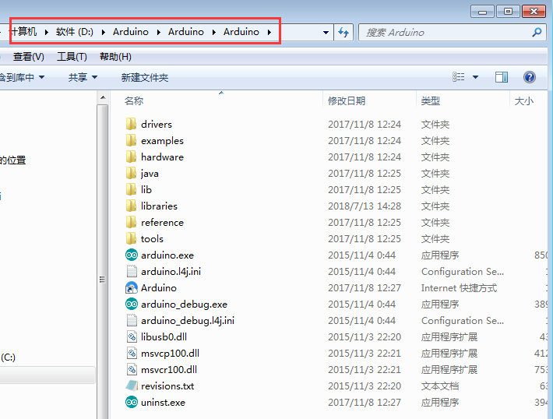

1. You need to copy this file into the libraries folder in the Ardunio installation path.

As shown in the figure below.

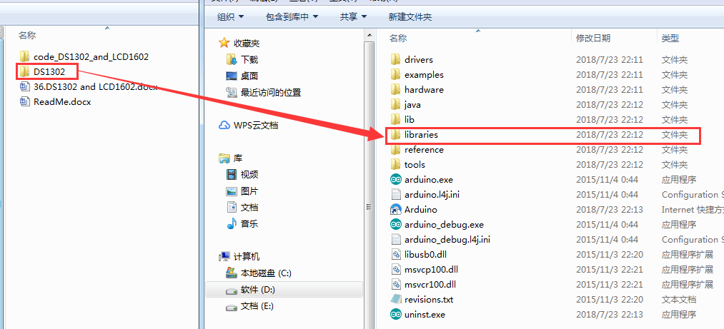

4.You need to open Arduino IDE and click 【Sketch】---【Import library】---【Add library】. As shown in the figure below.

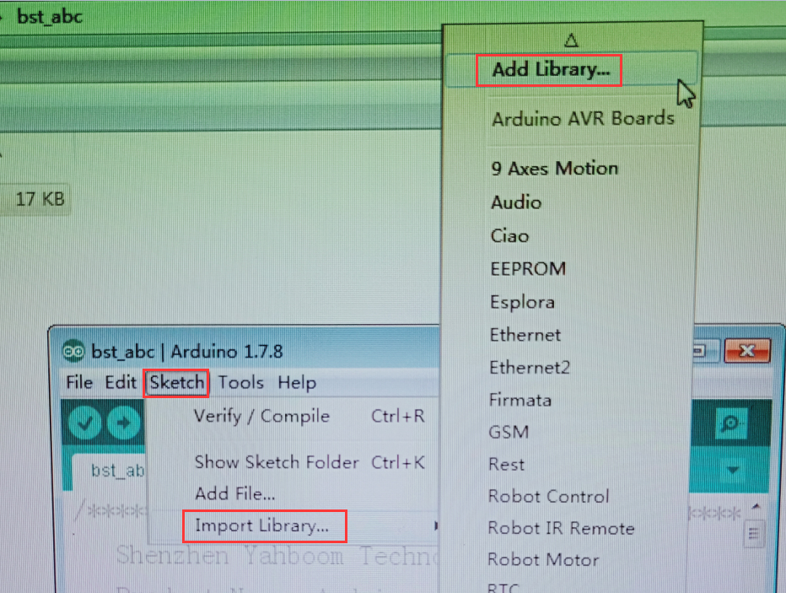

5.You need to add 【Adafruit_GFX】 and 【Adafruit_SSD1306】to here. As shown in the figure below.

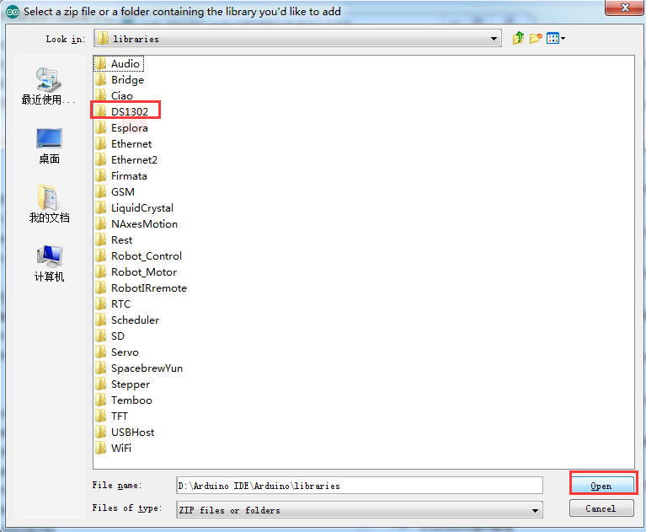

6.After the addition is completed, the words “Library added to your libraries.” will appear in the lower right corner of the Arduino IDE. As shown in the figure below.

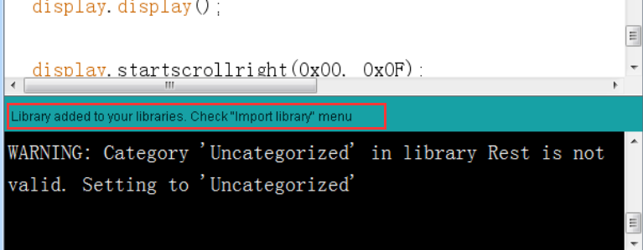

7. You can see these library files on the Arduino IDE. As shown in the figure below.

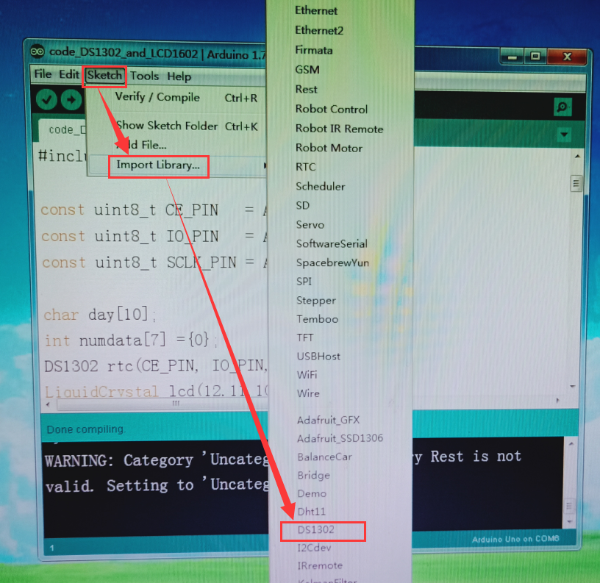

8.After completing the above steps, you can compile and upload this code successfully .