Static Analysis with bug report

**For this project we have chosen two bugs to fix:**

First bug chosen is to remove the “throw statement” from the code shown in the following screenshot:

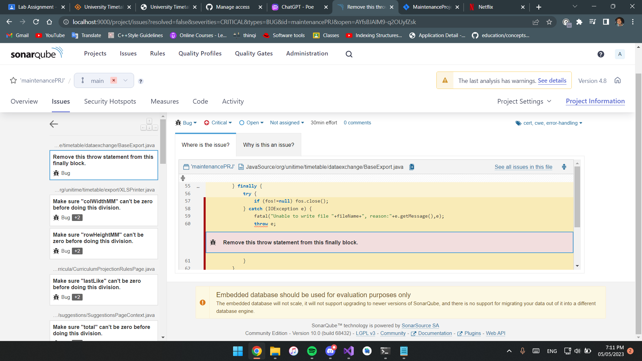

**How we plan to fix this bug:**

All we need to do is open the code where the bug is and remove the “throw e;” statement.

Second bug chosen is to make sure the “maxPoints” variable can’t be of zero value before doing the division:

**How we plan to fix this bug:**

We’ll need to add an if statement that makes sure that the “maxPoints” variable cannot be of value zero so that the code would run correctly.