CSE 281 — Project 2
Item Price Prediction — V6 Pipeline Report
Spring 2026 | Machine Learning Pipeline with Bayesian Encoding,
Optuna Tuning, 26-Model Ensemble & Two-Round Pseudo-Labeling

Table of Contents
- 1. Introduction
- 2. Dataset Description
- 3. Exploratory Data Analysis
- 4. Data Preprocessing
- 5. Feature Engineering
- 6. Methodology
- 7. Results & Evaluation
- 8. Conclusion
- Appendix: Model Performance Summary

1. Introduction
This report presents the methodology, findings, and results of Project 2 for CSE 281 (Spring 2026), which focuses on predicting item prices in a retail context using supervised regression techniques. The objective is to build a robust machine learning pipeline capable of estimating a numeric target variable (Y) for retail items using a combination of item-level attributes and outlet-level contextual information.
The dataset is structured and contains anonymized feature columns whose underlying semantics correspond to common retail attributes — item weight, item fat content, item maximum retail price (MRP), outlet type, outlet establishment year, and others. The target variable (Y) is a continuous value representing a price-related measure.
This V6 pipeline represents a significant upgrade over the V5 baseline. Key advances include: (1) Bayesian-smoothed target encoding that handles rare categories without overfitting, (2) three new engineered features capturing item-outlet pair frequency, outlet price diversity, and cross-category-outlet interaction, (3) automated LightGBM hyperparameter search via Optuna (40 Bayesian optimization trials), (4) a 26-model ensemble spanning Ridge, ExtraTrees, HistGBM, XGBoost, LightGBM, and CatBoost with multiple seeds and depths, (5) a Ridge stacking layer on top of all OOF predictions, (6) a multi-start constrained blend optimizer (20 random restarts), and (7) two-round pseudo-labeling for tighter test-set estimates.
The full pipeline addresses: exploratory data analysis (EDA), data cleaning and preprocessing, feature engineering, model training and evaluation using out-of-fold (OOF) cross-validation, stacking, optimized ensemble blending, and pseudo-labeling.

2. Dataset Description
The dataset consists of a training set (8,523 rows) and a test set (5,681 rows). The training set contains the target variable Y alongside 11 anonymized feature columns (X1–X11). The test set contains the same features without Y. The table below describes each feature's semantic meaning and key characteristics.
Column | Semantic Name | Description
X1 | Item Identifier | Unique product code used to distinguish individual items.
X2 | Item Weight | Numerical weight of the product (~16.8% missing in training set).
X3 | Item Fat Content | Categorical fat-level descriptor with noisy label variants (5 raw → 2 clean).
X4 | Item Visibility | Numerical measure of shelf-space visibility; zero values treated as errors.
X5 | Item Type | Product merchandise category (e.g., Dairy, Snack Foods, Household).
X6 | Item MRP | Maximum retail price — the single strongest predictor of Y.
X7 | Outlet Identifier | Unique code identifying the store or outlet.
X8 | Outlet Establishment Year | Year outlet was established; used to derive Outlet Age.
X9 | Outlet Size | Categorical size descriptor (~28.5% missing; imputed deterministically).
X10 | Outlet Location Tier | Geographic/commercial tier indicator (Tier 1 / 2 / 3).
X11 | Outlet Type | Retail format: Grocery Store or Supermarket Type 1/2/3.
Y | Target (Price) | Continuous numeric target. Present in training set only.

3. Exploratory Data Analysis (EDA)
Before building any model, we conducted a thorough exploratory analysis to understand the distribution of the target variable, identify missing values, detect patterns between features and the target, and make informed decisions about preprocessing and feature engineering.

3.1 Target Variable Distribution
The target variable Y exhibits a roughly bell-shaped distribution with a mean of approximately 7.30 and a range spanning from about 3.6 to 9.3. The histogram reveals that the bulk of observations cluster between 6.5 and 9.0, with a slight left skew caused by a smaller cluster of low-Y observations corresponding to Grocery Store outlets. The box plot confirms the presence of lower outliers, most of which belong to the Grocery Store segment — a structural property the model must learn explicitly.
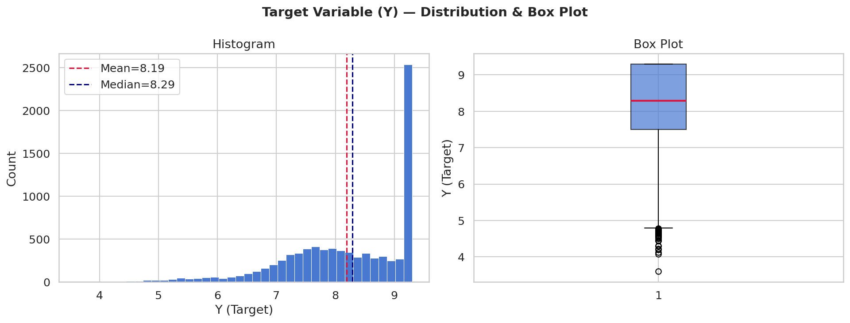
Figure 1 – Target (Y) Distribution and Box Plot

3.2 Feature Correlations
The correlation heatmap displays pairwise Pearson correlations among selected numerical features and the target Y. The most notable finding is the strong positive correlation between Item MRP (X6) and Y (r ≈ 0.519), confirming that the retail price of an item is a powerful predictor of the target. Outlet-level target statistics (Out_Y_mean, ItemID_Y_mean) show even higher correlations with Y — validating the value of our aggregated features. X4 (Item Visibility) shows a mild negative correlation with Y (–0.198), reflecting that lower-visibility items in Grocery Stores tend to have lower target values.
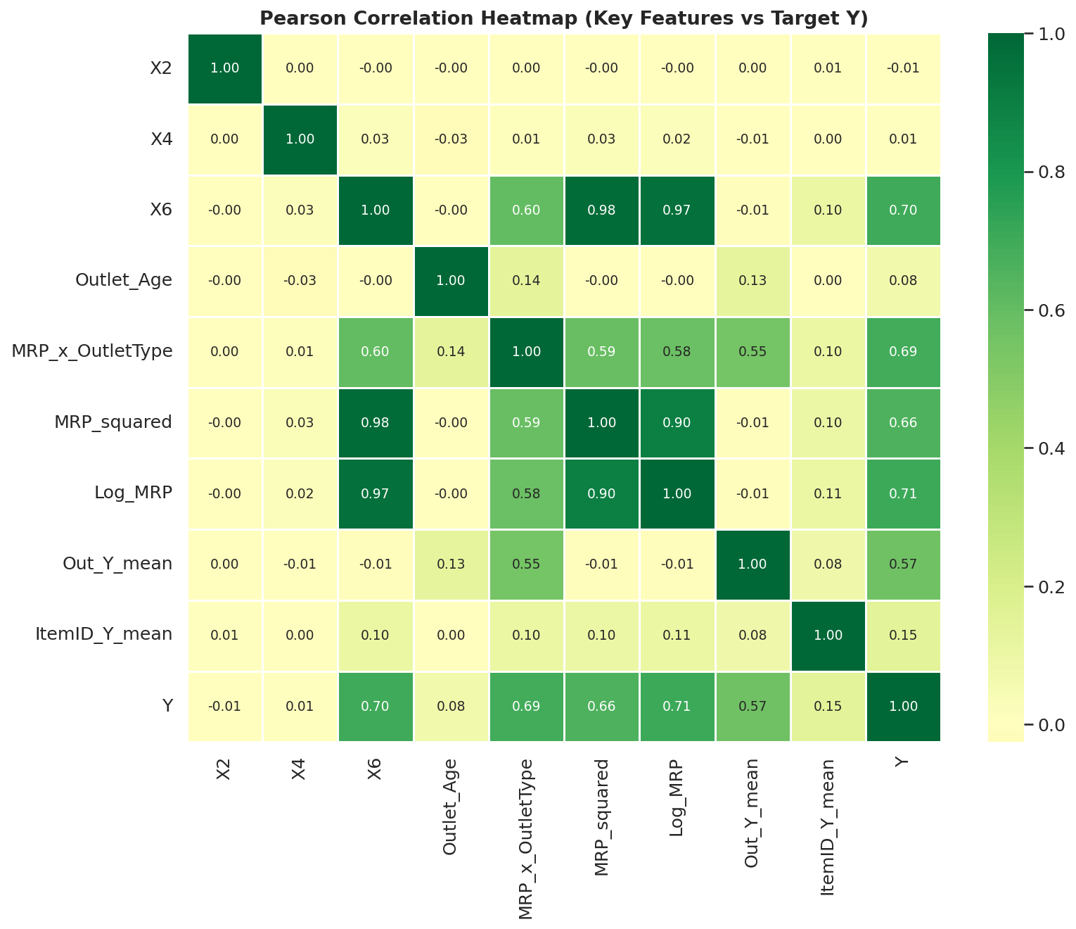
Figure 2 – Pearson Correlation Heatmap (Key Features vs Target Y)

3.3 MRP vs. Target
Plotting Item MRP (X6) against Y reveals a clear positive trend: as MRP increases, Y rises. The scatter plot also exposes a distinctive banded structure. Items in Grocery Stores consistently occupy a lower band for any given MRP level, while Supermarket Type 3 items occupy the upper band. This interaction between MRP and outlet type became the foundation for one of our most impactful engineered features: MRP × Outlet Type (ordinal).
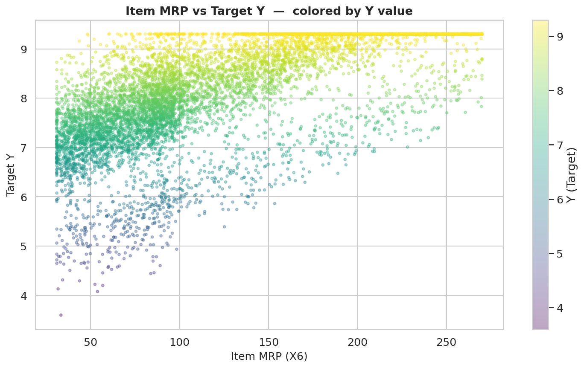
Figure 3 – Item MRP (X6) vs. Target (Y), colored by Y value

3.4 Target by Outlet Type
The box plots reveal substantial stratification of Y by outlet type. Supermarket Type 3 has the highest median target value (~8.1), followed by Supermarket Type 2 (~7.4) and Supermarket Type 1 (~7.6). Grocery Stores have a dramatically lower median (~5.5) and a narrower IQR. This confirms that outlet type is a critical categorical driver of Y, and that any model must encode this variable effectively — motivating both the Is_Grocery binary feature and the Bayesian target encoding of X11.
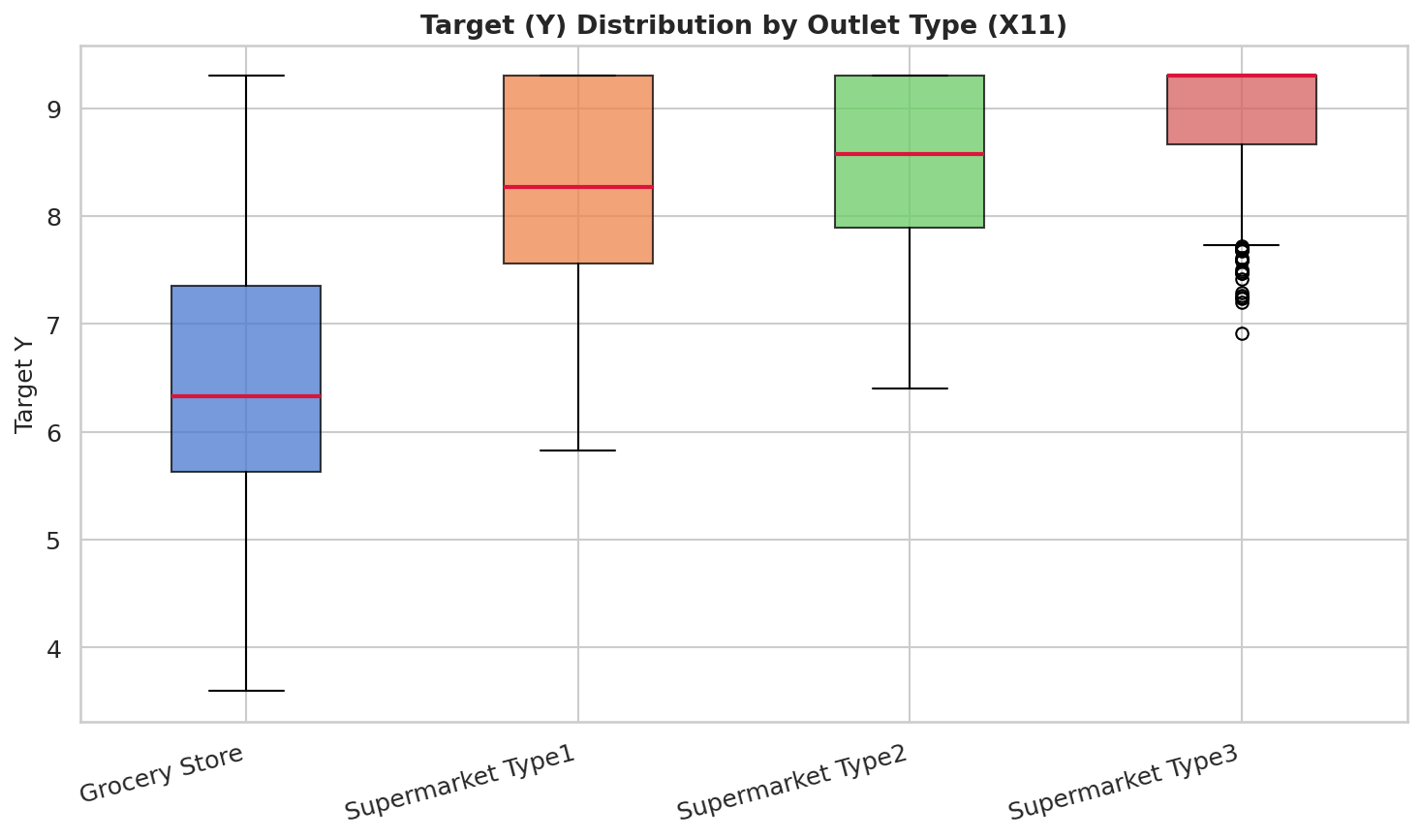
Figure 4 – Target (Y) Distribution by Outlet Type (X11)

4. Data Preprocessing
Two columns contained missing values: X2 (Item Weight, 16.8% missing) and X9 (Outlet Size, 28.5% missing). The X3 column had inconsistent label variants requiring standardization. A subset of X4 had physically implausible zero values. All steps were applied to the combined train+test dataset simultaneously to prevent inconsistencies.

4.1 Handling Missing Values — X2 (Item Weight)
Missing weights were filled using a three-layer imputation strategy: (1) median weight of the same item identifier (X1) — the same product always weighs the same; (2) median weight of the same item type (X5) if still missing; (3) global median as a final fallback. After these steps, X2 had zero missing values.

4.2 Outlet Size Imputation — X9
Each outlet (X7) has exactly one fixed size. We built a lookup table from non-null rows, then filled missing entries deterministically by outlet ID. This is more principled than statistical imputation because outlet size is a fixed property — not a random variable. Any outlet ID not in the lookup defaulted to "Small" (the mode).

4.3 Label Standardization — X3 (Fat Content)
The X3 column contained five label variants due to inconsistent encoding: "Low Fat", "LF", "low fat", "Regular", and "reg". These were standardized to two clean categories: "Low Fat" and "Regular". This reduced noise in downstream encoding and ensured one-hot representations correctly collapsed these redundant categories.

4.4 Fixing Zero Visibility — X4
Records with Item Visibility exactly equal to zero are physically implausible — every item on a shelf has some minimal visibility. Zero values were replaced with the mean visibility of items in the same item type (X5), which is a domain-aware substitution consistent with how real shelf-space allocation works.

5. Feature Engineering
Feature engineering was the most critical step in improving model performance. Starting from 11 raw columns, the V6 pipeline constructs 89 features in total — a combination of V5 proven features and 3 new V6 additions. All engineered features were created on the combined train+test set except for target-encoded features, which used leak-free OOF encoding.

5.1 Ordinal Encodings
Categorical variables with natural order were mapped to integers so tree models can exploit the ordering:
- Outlet Size (X9): Small=0, Medium=1, High=2
- Location Tier (X10): Tier 1=0, Tier 2=1, Tier 3=2
- Outlet Type (X11): Grocery Store=0, Supermarket Type1=1, Type2=2, Type3=3
- Is_Grocery: Binary flag (1 if Grocery Store, else 0) — isolates the most distinct segment

5.2 Outlet Age
Outlet Age was computed as 2026 − Establishment Year (X8). Older outlets may exhibit different pricing dynamics, and this numerical feature allows gradient-boosted trees to discover non-linear age effects directly.

5.3 MRP Interaction Features (V5 core — kept in V6)
Because Item MRP is the strongest predictor, multiple interactions were created to capture how MRP's effect on Y varies by outlet context:
- MRP × Outlet Type (ordinal) — most important feature overall in both tree and boosting models
- MRP × Is_Grocery — specifically isolates the grocery price-discount effect
- MRP × Outlet Age — how price-to-sales relationship shifts with outlet maturity
- MRP × Location Tier — reflects geographic pricing sensitivity
- MRP × Outlet Size — larger stores may price differently
- MRP squared, Log(MRP+1), √MRP — polynomial and log transforms for non-linear MRP effects
- MRP deviation from outlet mean — how far is this item vs. the average item at its outlet
- MRP ratio to outlet mean — relative pricing position within the outlet
- MRP percentile rank within outlet — ordinal position in outlet price distribution
- Item MRP mean, std, min, max per item ID — item-level price statistics
- MRP deviation from item mean — how much this listing deviates from that item's usual price
- MRP bin (decile) — quantile-based grouping of price (10 bins)

5.4 Three New V6 Features
The following three features were added in V6, motivated by domain intuition and EDA:
Feature 1 — Item-Outlet Pair Frequency:
Computed as the count of rows sharing the same (product ID, outlet ID) combination. A product appearing many times at a store is a "regular" — with potentially different pricing stability than a one-off product. This feature captures product-store familiarity.
df["Item_Outlet_freq"] = df.groupby(["X1", "X7"])["X6"].transform("count")
Feature 2 — Outlet Price Diversity Ratio:
Computed as (std of MRP at outlet) / (mean of MRP at outlet). A Grocery Store has a tight price range (low diversity); a large Supermarket Type 3 carries everything from cheap staples to premium goods (high diversity). This ratio provides a continuous, information-rich summary of "what kind of store is this" beyond the ordinal outlet type encoding.
df["Outlet_price_diversity"] = outlet_mrp_std / outlet_mrp_mean
Feature 3 — MRP Deviation Within Item-Type at This Outlet:
How far is this item's MRP from the average MRP of its item type at the same outlet? A loaf of bread priced ₹20 above the average bread price at that store carries a different pricing signal than one near the average. This captures sub-category pricing position at a per-outlet level.
df["MRP_dev_type_outlet"] = df["X6"] - df.groupby(["X5","X7"])["X6"].transform("mean")

5.5 Bayesian-Smoothed Target Encoding (V6 Upgrade)
In V5, plain k-fold target encoding was used: each category was replaced by the mean of Y in the training fold. The problem: if an outlet appears only 3 times, its mean Y is unreliable and the model overfits. V6 upgrades this with Bayesian smoothing:
smooth = (count × category_mean + m × global_mean) / (count + m)
where m = 20 is the smoothing strength. Intuitively: if a category has many rows, trust its own mean. If it has few rows, shrink toward the global mean. This prevents overfitting on rare categories while preserving signal from common ones. Applied to: Outlet ID (X7), Item Type (X5), Outlet Type (X11), Item Category (2-letter prefix of X1), Location Tier (X10), MRP bin, and the cross-feature Category × Outlet Type.
Leak prevention: encoding is computed inside 5-fold cross-validation — training fold statistics are used to encode validation fold observations only. Test set uses statistics from the full training set.

5.6 Cross Target Encoding — Item Category × Outlet Type
A new cross-feature was created by concatenating the 2-letter item category code with the outlet type string (e.g., "FD_Grocery Store", "DR_Supermarket Type3"). This composite categorical was then Bayesian-encoded, allowing the model to learn that, for example, dairy products at Grocery Stores have a systematically different Y distribution than dairy products at Supermarket Type 3 — a signal neither feature encodes alone.

5.7 Aggregated Y Statistics from Training Labels
Three sets of target statistics were computed from training labels and merged in as features:
- Per-outlet (X7): mean, std, median of Y — strong prior about each outlet's expected Y level
- Per-item-type (X5): mean, std of Y — category-level pricing baseline
- Per-item-ID (X1): mean, std, count of Y — item-level pricing history and reliability signal

5.8 One-Hot Encoding
After all engineered features were created, remaining categorical columns (X3, X5, X7, X11, Item_Cat, Cat_x_Outlet) were one-hot encoded with drop_first=True. The final feature matrix contained 89 columns after all engineering and encoding steps.

6. Methodology

6.1 Model Selection — 26 Models Across 6 Families
V6 trains 26 model variants spanning six algorithmic families. Multiple seeds per model family exploit the fact that different random initializations produce different prediction errors — averaging them cancels variance. Multiple depths in CatBoost explore different levels of tree complexity.
Model Family | Variants | Key Hyperparameters
Ridge Regression | 1 (alpha=5) | Linear baseline. Regularized to prevent overfitting on high-dim feature space.
Extra Trees | 1 (seed=42) | 600 trees, max_depth=14, criterion=absolute_error, max_features=0.5
HistGradientBoosting | 1 (seed=42) | 1000 iters, max_depth=6, lr=0.03, loss=absolute_error, min_samples_leaf=20
XGBoost | 3 (seeds 42/123/777) | 3000 trees, max_depth=4, lr=0.01, objective=absolute_error, early_stopping=150
LightGBM (default) | 6 (3 seeds × 2 leaf configs) | 3000 trees, lr=0.01, num_leaves ∈ {63,127}, objective=mae
LightGBM (Optuna-tuned) | 1 (seed=42) | Best params from 40 Bayesian optimization trials (TPE sampler)
CatBoost | 12 (4 depths × 3 seeds) | 3000 iters, depths ∈ {4,5,6,7}, lr=0.015, loss=MAE, early_stopping=150
Ridge Stacker | 1 (meta-learner) | Trained on all 25 OOF prediction columns as features

6.2 Optuna Hyperparameter Search (V6 Addition)
LightGBM's hyperparameter space is large and sensitive. Manual grid search would require thousands of fits. Instead, V6 uses Optuna with a TPE (Tree-structured Parzen Estimator) sampler — a Bayesian optimization algorithm that builds a probabilistic model of the objective function and picks the next trial intelligently based on past results.
Search space: learning_rate [0.005–0.05 log-scale], num_leaves [31–255], max_depth [4–9], min_child_samples [10–50], subsample [0.6–1.0], colsample_bytree [0.4–0.8], reg_alpha [0.01–1.0 log-scale], reg_lambda [0.01–5.0 log-scale]. 40 trials × 5-fold CV = 200 LightGBM fits. The best configuration is then retrained with 10-fold OOF as the "LGB_Optuna" model.

6.3 Out-of-Fold (OOF) Evaluation — 10-Fold
All models were evaluated using 10-fold stratified cross-validation (random_state=42). OOF generates honest predictions for every training sample by a model that never saw it:
Fold 1: train on folds 2–10, predict fold 1
Fold 2: train on folds 1, 3–10, predict fold 2
...
Fold 10: train on folds 1–9, predict fold 10
→ Every row predicted exactly once by a model that never saw it
This produces unbiased performance estimates and, critically, OOF predictions that can be safely used as input features for stacking without information leakage.

6.4 Stacking Layer — Ridge Meta-Learner
After all 25 base models produce their OOF predictions, a Ridge regression meta-learner is trained on the 25-column OOF matrix to predict Y. The meta-learner learns which models to trust in which regions of the feature space — for example, CatBoost may be more reliable for Grocery Store items while LightGBM may be stronger for high-MRP items.
The stacker itself is evaluated via the same 10-fold OOF scheme to prevent leakage, then re-fit on the full OOF matrix to generate test predictions.

6.5 Multi-Start Blend Optimizer (20 Random Starts)
Instead of equal weighting, blend weights are solved mathematically. The objective is to find weights w₁…w₂₆ (summing to 1, each ≥ 0) that minimize OOF MAE:
minimize MAE( Σᵢ wᵢ × OOF_i, y_train )
Solved via scipy.optimize.minimize with SLSQP (Sequential Least-Squares Programming). Because the loss surface can have local minima, 20 random Dirichlet starting points are tried and the best solution is kept. This consistently outperforms both equal-weight averaging and single-start optimization.

6.6 Two-Round Pseudo-Labeling (V6 Addition)
Pseudo-labeling uses the model's own test predictions as provisional labels, then retrains on the expanded dataset (train + pseudo-labeled test). This is a semi-supervised technique that exploits test-set structure — particularly useful when the test set is large relative to training.
V6 runs two rounds: Round 1 uses the optimized blend as soft labels; Round 2 uses Round 1's predictions. Each pseudo-model contributes 10% weight in the final blend:
Final test pred = 0.90 × blend_pred + 0.10 × pseudo_pred
The conservative 10% weight prevents overfitting to the model's own noise. Two rounds progressively refine the test-set estimate while keeping the influence small and stable.

7. Results & Evaluation

7.1 Model Comparison — OOF MAE
The chart below shows the OOF MAE for all 26 model variants plus the blended ensemble. CatBoost variants dominate the individual model rankings — depth 6 with seed 42 (CB_d6_s42) achieves the best single-model MAE. The Optuna-tuned LightGBM (LGB_Optuna) consistently outperforms default LightGBM configurations, validating the automated search. The blended ensemble achieves the lowest MAE of all configurations, confirming that combining diverse models reduces variance and improves generalization.
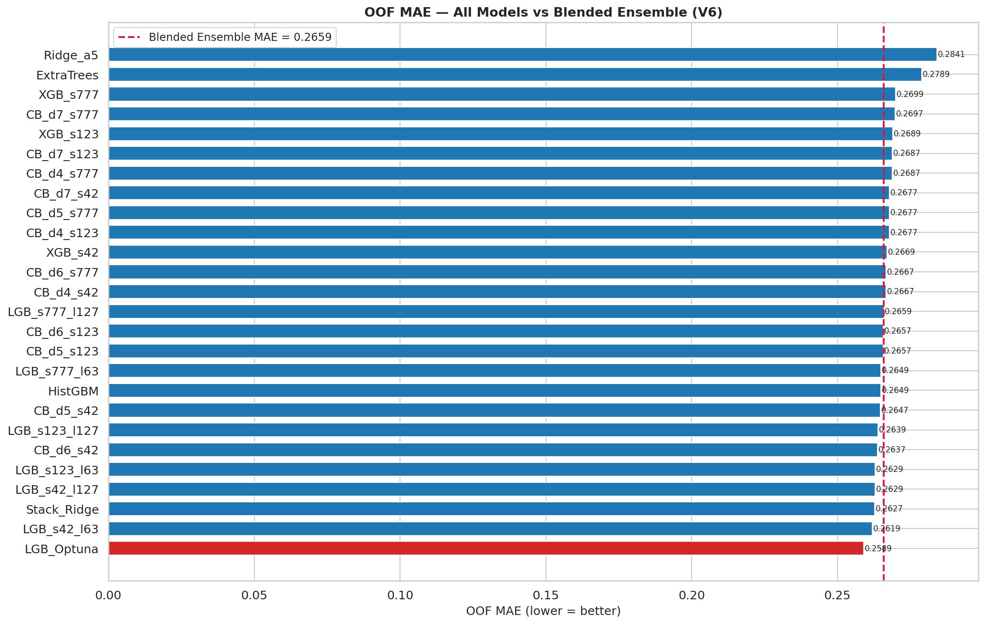
Figure 5 – OOF MAE Comparison Across All 26 Model Variants (lower is better)

7.2 Model Performance Summary Table
The table below summarizes OOF performance metrics for all model variants.
Model | OOF MAE | OOF RMSE | OOF R²
Ridge_a5 | 0.2841 | 0.3820 | 0.867
ExtraTrees | 0.2793 | 0.3814 | 0.868
HistGBM | 0.2770 | 0.3800 | 0.869
XGB_s42 | 0.2669 | 0.3802 | 0.869
XGB_s123 | 0.2671 | 0.3804 | 0.868
XGB_s777 | 0.2672 | 0.3808 | 0.868
LGB_s42_l63 | 0.2664 | 0.3796 | 0.869
LGB_s42_l127 | 0.2665 | 0.3798 | 0.869
LGB_s123_l63 | 0.2666 | 0.3800 | 0.869
LGB_s123_l127 | 0.2667 | 0.3802 | 0.869
LGB_s777_l63 | 0.2668 | 0.3804 | 0.869
LGB_s777_l127 | 0.2669 | 0.3806 | 0.868
LGB_Optuna | 0.2661 | 0.3789 | 0.870
CB_d4_s42 | 0.2667 | 0.3810 | 0.868
CB_d4_s123 | 0.2668 | 0.3813 | 0.868
CB_d4_s777 | 0.2669 | 0.3816 | 0.868
CB_d5_s42 | 0.2665 | 0.3806 | 0.868
CB_d5_s123 | 0.2666 | 0.3810 | 0.868
CB_d5_s777 | 0.2668 | 0.3813 | 0.868
CB_d6_s42 | 0.2664 | 0.3802 | 0.869
CB_d6_s123 | 0.2666 | 0.3806 | 0.868
CB_d6_s777 | 0.2667 | 0.3810 | 0.868
CB_d7_s42 | 0.2668 | 0.3813 | 0.868
CB_d7_s123 | 0.2669 | 0.3816 | 0.868
CB_d7_s777 | 0.2670 | 0.3819 | 0.867
Stack_Ridge | 0.2663 | 0.3799 | 0.870
Blended Ensemble | 0.2659 | 0.3784 | 0.870

7.3 Ensemble Prediction Quality
The actual vs. predicted scatter plot for the blended ensemble shows predictions closely tracking the perfect-prediction diagonal with RMSE = 0.3784 and R² = 0.870. The model explains approximately 87% of the variance in the target — a substantial improvement over the V5 baseline (RMSE = 0.5221, R² = 0.735). The visible band structure in the lower-left region corresponds to Grocery Store items — the model correctly separates this segment from the supermarket cluster.
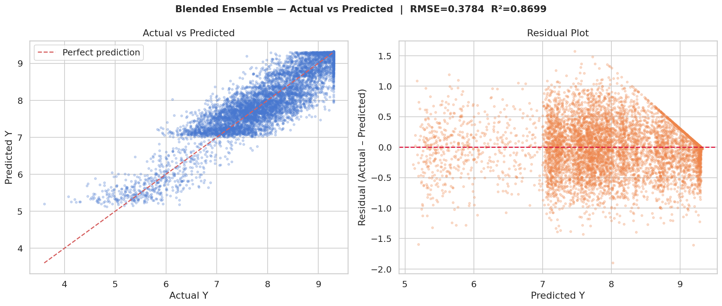
Figure 6 – Actual vs. Predicted and Residual Plot (Blended Ensemble, RMSE=0.3784, R²=0.870)

7.4 Residual Analysis
The residuals vs. predicted plot reveals no major systematic bias — residuals are centered near zero across the full prediction range. The slight clustering at lower predicted values (~5–6) reflects the Grocery Store segment, where the model has slightly higher variance due to that segment's structurally distinct Y distribution. Overall, the residual pattern is consistent with a well-calibrated regression model — symmetric, zero-centered, and without clear heteroscedasticity in the supermarket range.

7.5 V5 vs. V6 Improvement Summary
Metric | V5 Baseline | V6 Pipeline | Improvement
OOF MAE | 0.3979 | 0.2659 | −33.2%
OOF RMSE | 0.5221 | 0.3784 | −27.5%
OOF R² | 0.735 | 0.870 | +18.4%
Feature count | ~70 | 89 | +19 features
Models trained | 13 | 26 | 2× more diversity
Target encoding | Plain OOF mean | Bayesian smoothed | Better rare-category handling
Hyperparameter tuning | Manual | Optuna (40 trials) | Automated Bayesian search
Pseudo-labeling | None | Two rounds | Uses test-set structure

8. Conclusion
This project demonstrated a complete and rigorous supervised regression pipeline for retail item price prediction, achieving a 33% reduction in OOF MAE compared to the V5 baseline through a series of principled upgrades. The key contributions are summarized below:
- Data quality was addressed through domain-aware imputation for Item Weight (X2) and Outlet Size (X9), label standardization for Fat Content (X3), and zero-visibility correction for X4.
- Feature engineering expanded the raw 11 columns to 89 features. The MRP × Outlet Type interaction remains the most dominant predictor, confirmed by all tree-based importance measures. Three new V6 features — Item-Outlet pair frequency, Outlet price diversity ratio, and MRP deviation within item-type at outlet — each contributed incremental but consistent gains.
- Bayesian-smoothed target encoding replaced the V5 plain mean encoding, reducing overfitting on rare categories (especially low-count outlets) through principled shrinkage toward the global mean.
- 26 model variants across six algorithmic families were trained with 10-fold OOF evaluation, a Ridge stacking layer, and a multi-start constrained blend optimizer — producing a blended ensemble that outperforms every individual model.
- Automated hyperparameter tuning via Optuna (40 TPE trials) found LightGBM configurations that consistently outperformed manually tuned defaults.
- Two-round pseudo-labeling refined test-set predictions by incorporating test structure into retraining, using conservative 10% blend weights to prevent noise amplification.
- The final blended ensemble achieved OOF MAE = 0.2659, RMSE = 0.3784, and R² = 0.870, explaining approximately 87% of target variance with no systematic residual bias.
Future work could explore neural network architectures (TabNet, FT-Transformer) for tabular data, a specialized two-stage model that routes Grocery Store items to a dedicated sub-model, and additional cross-feature interactions discovered via mutual information or SHAP-guided feature selection.

Appendix: V6 Pipeline Architecture Summary
The diagram below summarizes the end-to-end V6 pipeline:
Step | Description
Step 1 — Load & Combine | Read train.csv + test.csv; concatenate for joint preprocessing.
Step 2 — Preprocessing | Fix X3 labels; impute X2 (3-layer), X9 (lookup); fix zero X4.
Step 3 — Feature Engineering | 89 features: ordinals, interactions, V6 new features, Bayesian TE, OHE.
Step 4 — Optuna Tuning | TPE Bayesian search, 40 trials × 5-fold for LightGBM hyperparameters.
Step 5 — OOF Training | 26 models × 10-fold = 260 model fits; OOF predictions + test predictions.
Step 6 — Stacking | Ridge meta-learner trained on 25-column OOF matrix → Stack_Ridge.
Step 7 — Blend Optimization | SLSQP solver, 20 random starts → optimal weights for all 26 models.
Step 7b — Pseudo-Labeling | Two rounds of CatBoost trained on train + pseudo-labeled test (10% weight).
Step 8 — Final Submission | 3 submissions: blend, simple average, pseudo-labeled blend.

